brainerd’s hawthorn
Crataegus brainerdii Sarg.
Plant Symbol = CRBR3

Contributed By: USDA NRCS National Plant Data Center

Uses
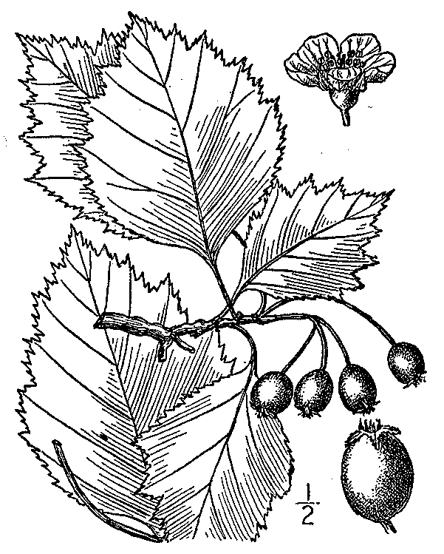
from Britton & Brown (1913)
by Kentucky Native Plant Society
@ PLANTS
Erosion Control: Because it tolerates a wide variety of sites, it can be planted to stabilize banks, for shelterbelts, and for erosion control.

Timber: Although the wood is hard and strong, it has no commercial value except for tool handles and other small items.

Wildlife: It provides excellent cover and nesting sites for many smaller birds. The small fruits are eaten by birds, rodents and other smaller mammals. White tailed deer browse the young twigs and leaves.

Beautification: Excellent for environmental plantings including small specimen tree, shrub border.

Status

Please consult the Plants Web site and your State Department of Natural Resources for this plant’s current status, such as, state noxious status and wetland indicator values.

Description
Shrub or small tree that grows to thirty feet tall and seven inches in diameter at breast height, with thorns 1.2-1.6 inches along the branchlets. Leaves are broadest near the base, sometimes triangular shaped, shallowly lobed, hairy at first becoming smooth at maturity. Flowers in clusters of three to fifteen. Fruits are globe-shaped to broadest above the mid-section, usually bright red with juicy flesh.

Description: Brainerd’s hawthorn is a native to Quebec and New England to North Carolina and west to Michigan.

Adaptation

Although Crataegus brainerdii will succeed in partial shade and different soil types, it grows best in full sunlight, well-drained loamy soils. Brainerd’s hawthorn will tolerate wet soils becoming drought tolerant once established. It is also wind tolerant making it a good tree species in shelterbelt planting. It is also tolerant of atmospheric pollution and performs well in urban settings.

Establishment
Propagation from Seed or Grafting: Brainerd’s hawthorn can be propagated by either seeds or grafting. Successful propagation using seeds requires acid scarification followed by warm stratification and prechilling. Seeds, whose numbers per lb. varies with species, are planted early in the fall, in drill rows eight to twelve inches apart and covered with 1/4 inch of soil. Seedlings must not be kept in the nursery longer than a year.

Containerized trees should be planted when they are no more than eight feet tall, in the fall or spring. Balled and burlapped trees should be planted in early spring.

Grafting on seedling stock of Crataegus oxyacantha or Crataegus monogyna is best carried out in the winter to early spring.

Management
Pruning should be done in the winter or early spring in order to maintain a clear shoot leader on young trees and/or remove the weakest branches to allow more light to pass through. Suckers or stems arising from the roots should be removed when they become noticeable.

Pest and Potential Problems
Although pests and diseases seldom affect it, it is susceptible to fireblight, cedar-hawthorn rust, cedar-quince rust, leaf blight and fruit rot, and leaf spot.

Cultivars, Improved and Selected Materials (and area of origin)
Consult your local nurseries to choose the right cultivar for your specific landscape. Contact your local Natural Resources Conservation Service (formerly Soil Conservation Service) office for more information. Look in the phone book under ”United States Government.” The Natural Resources Conservation Service will be listed under the subheading “Department of Agriculture.”

References
Britton, N.L. & A. Brown 1913. An illustrated flora of the northern United States, Canada and the British possessions. Charles Scribner’s Sons, New York, New York. Scanned by Kentucky Native Plant Society and made available through PLANTS.

Dirr, M.A. 1990. Manual of woody landscape plants: their identification, ornamental characteristics, culture, propagation and uses. 3rd ed. Stipes, Champaign, Illinois.

Duncan, W.H. & M.B. Duncan 1988. Trees of the Southeastern United States. University of Georgia Press, Athens, Georgia.

Elias, T.S. 1989. Field guide to North American trees. Revised ed. Grolier Book Clubs Inc., Danbury, Connecticut.

Flint, H.L. 1983. Landscape plants for eastern North America. John Wiley and Sons, Inc, New York, New York.

Harrar, E.S. & J.G. Harrar. 1962. Guide to southern trees. 2nd ed. Dover Publications, Inc., New York, New York.

Little, E.E. 1996. National Audubon Society field guide to North American trees: Eastern region. Alfred A. Knopf, New York, New York.

USDA Forest Service 1974. Seeds of woody plants in the United States. Agricultural Handbook 450. USDA, Washington, DC.

USDA Forest Service 1990. Silvics of North America. Agricultural Handbook 654. Forest Service, USDA, Washington, DC.

Young, J. A. & C.G. Young. 1992. Seeds of woody plants in North America. Revised and enlarged ed. Dioscorides Press, Portland, Oregon.

Prepared By
Alfredo B. Lorenzo
Formerly, Southern University and A&M College, College of Agricultural, Family and Consumer Sciences
Baton Rouge, Louisiana

Species Coordinator

Lincoln M. Moore
USDA, NRCS, National Plant Data Center, Baton Rouge, Louisiana

Edited: 09jan02 jsp;31jan03ahv; 09jun03 ahv; 05jun06 jsp

For more information about this and other plants, please contact your local NRCS field office or Conservation District, and visit the PLANTS Web site<http://plants.usda.gov> or the Plant Materials Program Web site <http://Plant-Materials.nrcs.usda.gov>

The U.S. Department of Agriculture (USDA) prohibits discrimination in all its programs and activities on the basis of race, color, national origin, sex, religion, age, disability, political beliefs, sexual orientation, and marital or family status. (Not all prohibited bases apply to all programs.) Persons with disabilities who require alternative means for communication of program information (Braille, large print, audiotape, etc.) should contact USDA's TARGET Center at 202-720-2600 (voice and TDD).
To file a complaint of discrimination write USDA, Director, Office of Civil Rights, Room 326-W, Whitten Building, 14th and Independence Avenue, SW, Washington, DC 20250-9410 or call 202-720-5964 (voice or TDD). USDA is an equal opportunity provider and employer.
Read about Civil Rights at the Natural Resources Convervation Service.

