OMB CIRCULAR A-133

COMPLIANCE SUPPLEMENT

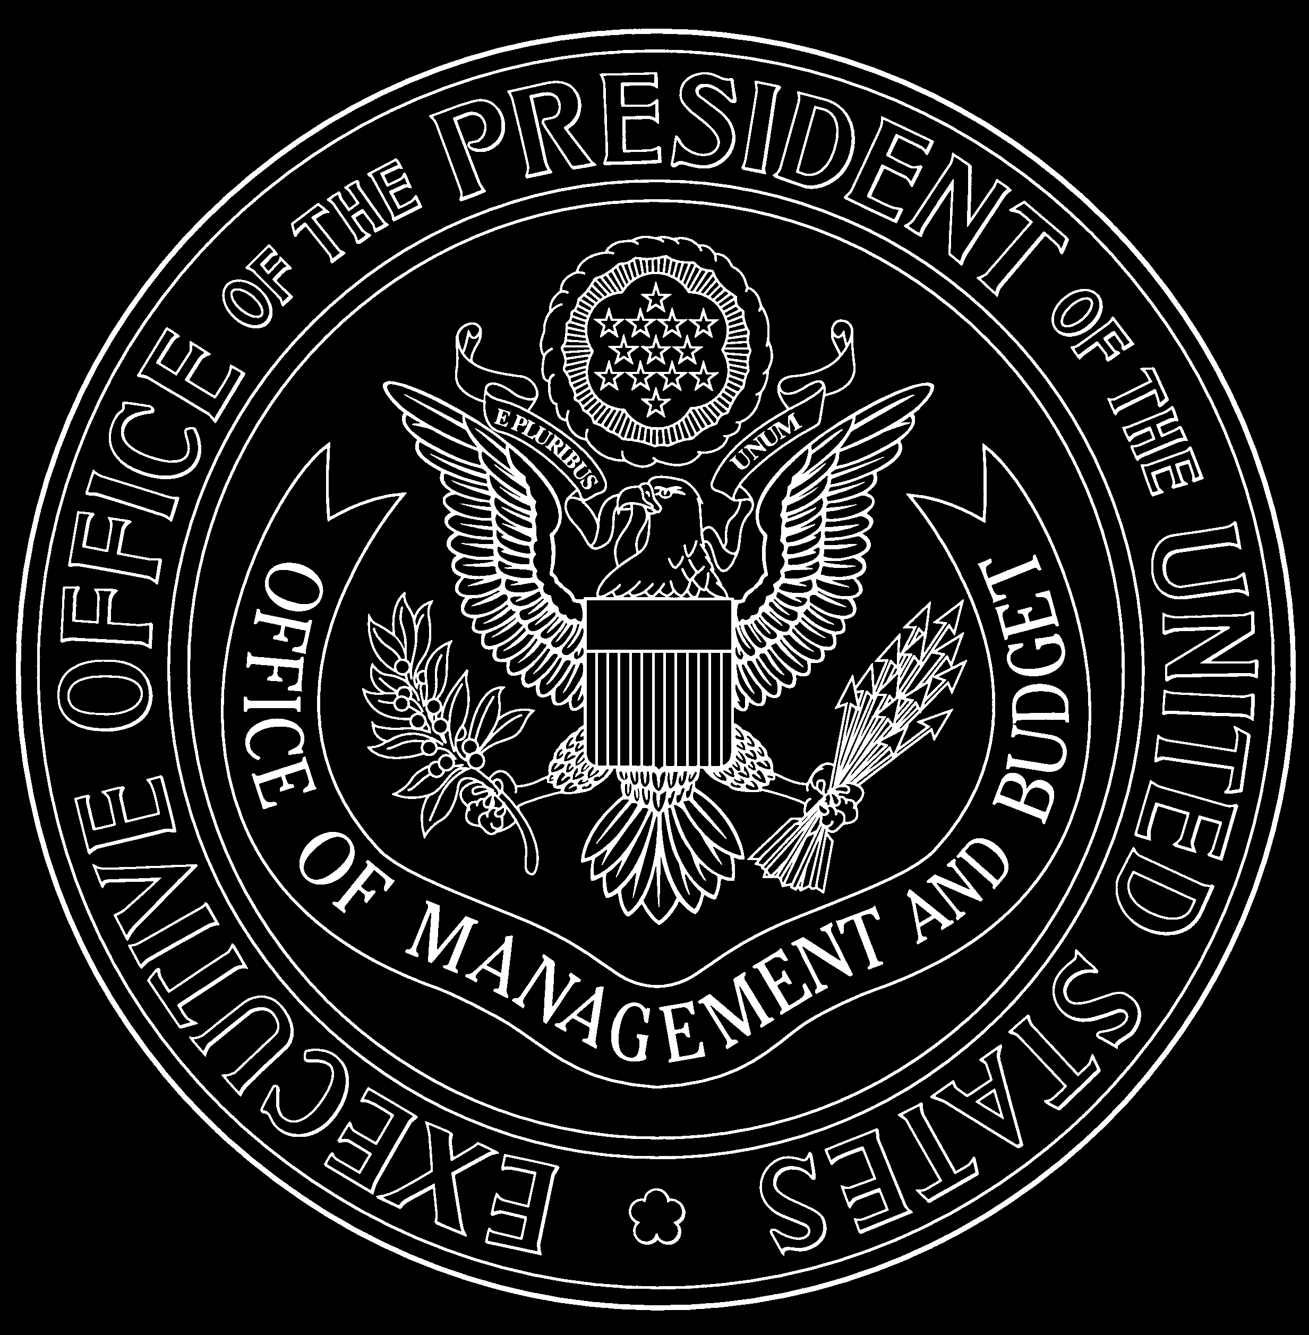

2007

EXECUTIVE OFFICE OF THE PRESIDENT
OFFICE OF MANAGEMENT AND BUDGET

TABLE OF CONTENTS

PART 1 – BACKGROUND, PURPOSE, AND APPLICABILITY
Background 1-1
Purpose and Applicability 1-3
Overview of this Supplement 1-5
Technical Information 1-8
How to Obtain Additional Guidance 1-9
PART 2 – MATRIX OF COMPLIANCE REQUIREMENTS 2-1

PART 3 – COMPLIANCE REQUIREMENTS
Introduction 3-1
A. Activities Allowed or Unallowed 3-A
B. Allowable Costs/Cost Principles 3-B
OMB Circular A-87 3-B-4
OMB Circular A-21 3-B-23
OMB Circular A-122 3-B-41
C. Cash Management 3-C
D Davis-Bacon Act 3-D
E. Eligibility 3-E
F. Equipment and Real Property Management 3-F
G. Matching, Level of Effort, Earmarking 3-G
H. Period of Availability of Federal Funds 3-H
I. Procurement and Suspension and Debarment 3-I
J. Program Income 3-J
K. Real Property Acquisition and Relocation Assistance 3-K
L. Reporting 3-L
M. Subrecipient Monitoring 3-M
N. Special Tests and Provisions 3-N

PART 4 – AGENCY PROGRAM REQUIREMENTS
Introduction 4-1
No. Agency Name

10 United States Department of Agriculture (USDA)
None – Food for Progress Program 4-10.001
None – Section 416(b) Program 4-10.001
10.500 – Cooperative Extension Service 4-10.500
10.551 – Food Stamps 4-10.551
10.553 – School Breakfast Program (SBP) 4-10.553
10.555 – National School Lunch Program (NSLP) 4-10.553
10.556 – Special Milk Program for Children (SMP) 4-10.553
10.557 – Special Supplemental Nutrition Program for Women, Infants,
and Children (WIC) 4-10.557
10.558 – Child and Adult Care Food Program (CACFP) 4-10.558
10.559 – Summer Food Service Program for Children (SFSPC) 4-10.553

10.561 – State Administrative Matching Grants for
Food Stamp Program 4-10.551
10.566 – Nutrition Assistance for Puerto Rico 4-10.566
10.568 – Emergency Food Assistance Program
(Administrative Costs) 4-10.568
10.569 – Emergency Food Assistance Program
(Food Commodities) 4-10.568
10.665 – Schools and Roads—Grants to States 4-10.665
10.666 – Schools and Roads—Grants to Counties 4-10.665
10.760 – Water and Waste Disposal Systems for Rural
Communities 4-10.760
10.766 – Community Facilities Loans and Grants 4-10.766

11 Department of Commerce (DOC)
11.300 – Grants for Public Works and Economic Development
Facilities 4-11.300
11.307 – Economic Adjustment Assistance 4-11.300

12 Department of Defense (DOD)
12.401 – National Guard Military Operations and Maintenance (O&M)
Projects 4-12.401

14 Department of Housing and Urban Development (HUD)
14.157 – Supportive Housing for the Elderly (Section 202) 4-14.157
14.169 – Housing Counseling Assistance Program 4-14.169
14.181 – Supportive Housing for Persons with Disabilities
(Section 811) 4-14.181
14.182 – Section 8 New Construction and Substantial
Rehabilitation 4-14.182
14.195 – Section 8 Housing Assistance Payments Program—
Special Allocations 4-14.182
14.218 – Community Development Block Grants/Entitlement
Grants 4-14.218
14.219 – Community Development Block Grants/Small Cities
Program 4-14.218
14.228 – Community Development Block Grant/State’s Program 4-14.228
14.231 – Emergency Shelter Grants Program 4-14.231
14.235 – Supportive Housing Program 4-14.235
14.238 – Shelter Plus Care 4-14.238
14.239 – HOME Investment Partnerships Program 4-14.239
14.241 – Housing Opportunities for Persons with AIDS 4-14.241
14.249 – Section 8 Moderate Rehabilitation Single Room
Occupancy 4-14.182
14.850 – Public and Indian Housing 4-14.850
14.856 – Lower Income Housing Assistance Program-Section 8
Moderate Rehabilitation 4-14.182
14.862 – Indian Community Development Block Grant Program 4-14.862
14.866 – Demolition and Revitalization of Severely Distressed
Public Housing (HOPE VI) 4-14.866
14.867 – Indian Housing Block Grants 4-14.867
14.871 – Section 8 Housing Choice Vouchers 4-14.871
14.872 – Public Housing Capital Fund (CFP) 4-14.872

15 Department of the Interior (DOI)
None – BIA Cross-Cutting Section 4-15.000
15.021 – Consolidated Tribal Government Program 4-15.021
15.022 – Tribal Self-Governance 4-15.022
15.030 – Indian Law Enforcement 4-15.030
15.042 – Indian School Equalization Program 4-15.042
15.605 – Sport Fish Restoration 4-15.605
15.611 – Wildlife Restoration 4-15.605
15.614 – Coastal Wetlands Planning, Protection, and
Restoration Act 4-15.614

16 Department of Justice (DOJ)
16.710 – Public Safety Partnership and Community Policing
Grants (COPS) 4-16.710
16.738 – Edward Byrne Memorial Justice Assistance
Grant Program 4-16.738

17 Department of Labor (DOL)
17.207 – Employment Service/Wagner-Peyser Funded Activities 4-17.207
17.225 – Unemployment Insurance (UI) 4-17.225
17.235 – Senior Community Service Employment Program 4-17.235
17.245 – Trade Adjustment Assistance 4-17.245
17.258 – WIA Adult Program 4-17.258
17.259 – WIA Youth Activities 4-17.258
17.260 – WIA Dislocated Workers 4-17.258
17.263 – Youth Opportunity Grants 4-17.263
17.264 – National Farmworker Jobs Program 4-17.264
17.265 – Native American Employment and Training 4-17.265
17.801 – Disabled Veterans’ Outreach Program (DVOP) 4-17.207
17.804 – Local Veterans’ Employment Representative Program
(LVER) 4-17.207
20 Department of Transportation (DOT)
20.106 – Airport Improvement Program 4-20.106
20.205 – Highway Planning and Construction 4-20.205
20.500 – Federal Transit—Capital Investment Grants 4-20.500
20.507 – Federal Transit—Formula Grants 4-20.500
20.509 – Formula Grants for Other than Urbanized Areas 4-20.509
20.600 – State and Community Highway Safety 4-20.600
20.601 – Alcohol Traffic Safety and Drunk Driving Prevention
Incentive Grants 4-20.600

20.602 – Occupant Protection 4-20.600
20.603 – Federal Highway Safety Data Improvements Incentive
Grants 4-20.600
20.604 – Safety Incentive Grants for Use of Seatbelts 4-20.600
20.605 – Safety Incentives to Prevent Operation of Motor
Vehicles by Intoxicated Persons 4-20.600
20.609 – Safety Belt Performance Grants 4-20.600
20.610 – State Traffic Safety Information System Improvements
Grants 4-20.600
20.611 – Incentive Grant Program to Prohibit Racial Profiling 4-20.600
20.612 – Incentive Motorcyclist Safety Grants 4-20.600
20.613 – Child Safety and Child Booster Seat Incentive Grants 4-20.600
21 Department of the Treasury
21.020 – Community Development Financial Institutions Program 4-21.020
23 Appalachian Regional Commission (ARC)
23.003 – Appalachian Development Highway System 4-20.205
45 National Endowment for the Humanities (NEH)
45.129 – Promotion of the Humanities—Federal/State Partnership 4-45.129
66 Environmental Protection Agency (EPA)
66.458 – Capitalization Grants for Clean Water State
Revolving Funds 4-66.458
66.468 – Capitalization Grants for Drinking Water State
Revolving Funds 4-66.468
81 Department of Energy (DOE)
81.042 – Weatherization Assistance for Low-Income Persons 4-81.042
84 Department of Education (ED)
None – Cross-Cutting Section 4-84.000
84.002 – Adult Education—State Grant Program 4-84.002
84.010 – Title I Grants to Local Educational Agencies (LEAs) 4-84.010
84.011 – Migrant Education—State Grant Program 4-84.011
84.027 – Special Education—Grants to States (IDEA, Part B) 4-84.027
84.032 – Federal Family Education Loans (FFEL) -
(Guaranty Agencies) 4-84.032-G
84.032 – Federal Family Education Loans (FFEL) - (Lenders) 4-84.032-L
84.041 – Impact Aid 4-84.041
84.042 – TRIO—Student Support Services 4-84.042
84.044 – TRIO—Talent Search 4-84.042
84.047 – TRIO—Upward Bound 4-84.042
84.048 – Vocational Education-Basic Grants to States (Perkins III) 4-84.048
84.066 – TRIO—Educational Opportunity Centers 4-84.042

84.126 – Rehabilitation Services—Vocational Rehabilitation Grants to
States 4.84.126
84.173 – Special Education—Preschool Grants (IDEA Preschool) 4-84.027
84.181 – Special Education—Grants for Infants and Families with
Disabilities 4-84.181
84.186 – Safe and Drug-Free Schools and Communities—
State Grants 4-84.186
84.217 – TRIO—McNair Post-Baccalaureate Achievement 4-84.042
84.282 – Charter Schools 4-84.282
84.287 – Twenty-First Century Community Learning Centers 4-84.287
84.288 – Bilingual Education—Program Development and
Implementation Grants 4-84.288
84.290 – Bilingual Education—Comprehensive School Grants 4-84.288
84.291 – Bilingual Education—Systemwide Improvement Grants 4-84.288
84.298 – State Grants for Innovative Programs 4-84.298
84.318 – Education Technology State Grants (Ed Tech) 4-84.318
84.357 – Reading First State Grants 4-84.357
84.365 – English Language Acquisition Grants 4-84.365
84.366 – Mathematics and Science Partnerships 4-84.366
84.367 – Improving Teacher Quality State Grants 4-84.367
84.938 – Hurricane Education Recovery 4-84.938

93 Department of Health and Human Services (HHS)
93.044 – Special Programs for the Aging--Title III, Part B—Grants for
Supportive Services and Senior Centers 4-93.044
93.045 – Special Programs for the Aging–Title III, Part C—
Nutrition Services 4-93.044
93.053 – Nutrition Services Incentive Program 4-93.044
93.210 – Tribal Self-Governance Program--Planning and Negotiation Cooperative Agreements and IHS Compacts/
Funding Agreements 4-93.210
93.217 – Family Planning – Services 4-93.217
93.224 – Consolidated Health Centers (Community Health Centers,
Migrant Health Centers, Health Care for the Homeless,
Public Housing Primary Care, and School-Based
Health Centers) 4-93.224
93.268 – Immunization Grants 4-93.268
93.556 – Promoting Safe and Stable Families 4-93.556
93.558 – Temporary Assistance for Needy Families (TANF) 4-93.558
93.563 – Child Support Enforcement 4-93.563
93.566 – Refugee and Entrant Assistance – State Administered
Programs 4-93.566
93.568 – Low-Income Home Energy Assistance 4-93.568
93.569 – Community Services Block Grant 4-93.569
93.575 – Child Care and Development Block Grant 4-93.575
93.596 – Child Care Mandatory and Matching Funds of the Child Care
and Development Fund 4-93.575
93.600 – Head Start 4-93.600
93.645 – Child Welfare Services – State Grants 4-93.645
93.658 – Foster Care—Title IV-E 4-93.658
93.659 – Adoption Assistance 4-93.659
93.667 – Social Services Block Grant 4-93.667
93.767 – State Children’s Insurance Program (SCHIP) 4-93.767
93.775 – State Medicaid Fraud Control Units 4-93.778
93.776 – Hurricane Katrina Relief 4-93.778
93.777 – State Survey and Certification of Health Care Providers
and Suppliers 4-93.778
93.778 – Medical Assistance Program 4-93.778
93.794 – Reimbursement of State Costs for Provision
of Part D Drugs 4-93.794
93.889 – National Bioterrorism Hospital Preparedness Program 4-93.889
93.914 – HIV Emergency Relief Project Grants 4-93.914
93.917 – HIV Care Formula Grants 4-93.917
93.918 – Grants to Provide Outpatient Early Intervention Services
with Respect to HIV Disease 4-93.918
93.958 – Block Grants for Community Mental Health Services 4-93.958
93.959 – Block Grants for Prevention and Treatment of
Substance Abuse 4-93.959
93.991 – Preventive Health and Health Services Block Grant 4-93.991
93.994 – Maternal and Child Health Services Block Grant
to the States 4-93.994

94 Corporation for National and Community Service (CNCS)
94.006 – AmeriCorps 4-94.006
94.011 – Foster Grandparent Program 4-94.011
94.016 – Senior Companion Program 4-94.011

96 Social Security Administration (SSA)
96.001 – Social Security--Disability Insurance (DI) 4-96.001
96.006 – Supplemental Security Income (SSI) 4-96.001

97 Department of Homeland Security (DHS)
97.004 – State Domestic Preparedness Equipment Support
Program (State Homeland Security Grant Program) 4-97.067
97.008 – Urban Areas Security Initiative 4-97.008
97.036 – Public Assistance Grants 4-97.036
97.039 – Hazard Mitigation Grant (HMGP) 4-97.039
97.067 – Homeland Security Grant Program 4-97.067
98 U. S. Agency for International Development (USAID)
98.007 – Food for Peace Development Assistance Program 4-98.007
98.008 – Food for Peace Emergency Program 4-98.007

PART 5 – CLUSTERS OF PROGRAMS
Introduction 5-1
Research and Development 5-2
Student Financial Assistance 5-3
84.007 – Federal Supplemental Educational Opportunity Grants (FSEOG)
84.032 – Federal Family Education Loans (FFEL)
84.033 – Federal Work-Study Program (FWS)
84.038 – Federal Perkins Loan Program-Federal Capital Contributions (FPL)
84.063 – Federal Pell Grant Program (PELL)
84.268 – Federal Direct Student Loans (Direct Loan)
84.375 – Academic Competitiveness Grants (ACG)
84.376 – National Science and Mathematics Access to Retain Talent Grant (National SMART Grant)
93.342 – Health Professions Student Loans, Including Primary Care
Loans/Loans for Disadvantaged Students (HPSL)
93.364 – Nursing Student Loans (NSL)
93.925 – Scholarships for Health Professions Students from Disadvantaged
Backgrounds (SDS)
Other Clusters 5-4

PART 6 – INTERNAL CONTROL
Introduction 6-1
A. Activities Allowed or Unallowed 6-A
B. Allowable Costs/Cost Principles (Same as Activities Allowed
or Unallowed) 6-A
C. Cash Management 6-C
D. Davis-Bacon Act 6-D
E. Eligibility 6-E
F. Equipment and Real Property Management 6-F
G. Matching, Level of Effort, Earmarking 6-G
H. Period of Availability of Federal Funds 6-H
I. Procurement and Suspension and Debarment 6-I
J. Program Income 6-J
K. Real Property Acquisition and Relocation Assistance 6-K
L. Reporting 6-L
M. Subrecipient Monitoring 6-M
PART 7 – GUIDANCE FOR AUDITING PROGRAMS NOT INCLUDED
IN THIS COMPLIANCE SUPPLEMENT 7-1
APPENDICES
I Federal Programs Excluded from the A-102 Common Rule 8-1
II Federal Agency Codification of Certain Governmentwide Grants
Requirements 8-2
III Federal Agency Contacts for A-133 Audits 8-3
IV Internal Reference Tables 8-4
V List of Changes for the 2007 Compliance Supplement 8-5
VI Disaster Waivers and Special Provisions Affecting Single Audits 8-6
VII Other OMB Circular A-133 Advisories 8-7
VIII SAS 70 Examinations of EBT Service Organizations 8-8
IX Compliance Supplement Core Team 8-9

