Healthy Waters

“The connection between forests and rivers is like that between father and son. No forest, no rivers.” - Gifford Pinchot, First Chief of the Forest Service

World Water Resources
About 99 percent of Earth’s water is contained in oceans and ice, leaving less than 1 percent available as freshwater for people, plants and animals (Gleick 1996).

Worldwide, more than 1 billion people are deprived of access to water of sufficient quantity and quality to meet minimum levels of health, income, and freedom from drudgery (www.water.org).

Twenty percent of the world’s freshwater fishes is either endangered or extinct, largely due to polluted water (World Resources Institute).

Riparian ecosystems (those areas adjacent to rivers, streams, and lakes) have much higher species richness than the terrestrial ecosystems worldwide.

About 80 percent of wildlife species (birds, reptiles, amphibians, mammals and insects) utilize water associated with streams during some portion of their lifecycle.

Waters of the United States
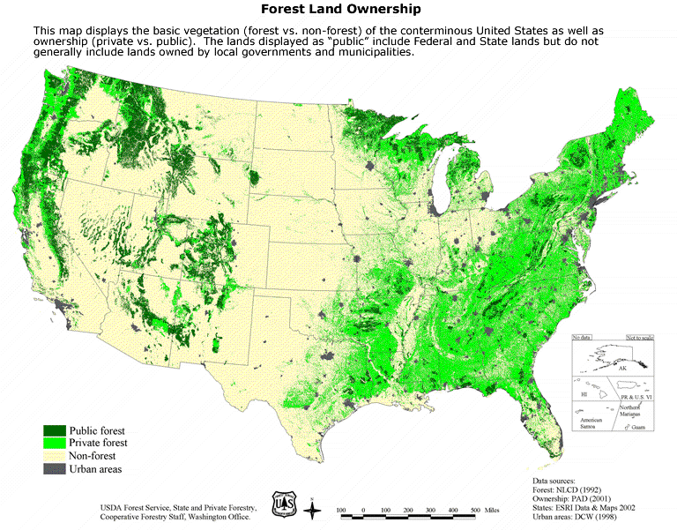
Almost two-thirds of this Nation’s freshwater resources originate on forested lands.

The United States uses 408 billion gallons of water per day for public supply (11%), domestic supply (<1%), irrigation (34%), livestock (<1%), aquaculture (<1%), industry (5%), mining (<1%), and thermoelectric power (48%) (Huston and others 2000).

Forest lands provide a source of drinking water to about 180 million people in the United States (Stein and others 2005).

Properly functioning forests, including healthy conditions of stream channels and associated riparian and aquatic biota, are the key to production and delivery of clean and sustainable water resources to the American Public.

An estimated 75 percent of our Nation’s outdoor recreation, which is the fastest growing segment of the tourism industry, takes place within one-quarter mile of streams or other waters.

Excessive sediment is the leading cause of impairment to the Nation’s surface waters (U.S. Environmental Protection Agency 2002).

Water & the Forest Service
The 1897 Organic Act establishes the care and management of forests to secure “favorable conditions of water flow” as a principle purpose of the Forest Service.

National Forests and Grasslands are the largest single source of water in the continental U.S., contributing nearly 20 percent of the Nation’s water supply. In the western U.S., National Forests and Grasslands provide over 50 percent of this regions water supply (U.S. Forest Service 2000).

The clear, cool waters of the National Forests provide habitat for over 140 threatened and endangered aquatic and amphibian species (U.S. Forest Service 2000).

About 15 million users annually access recreational fishing opportunities on lands managed by the Forest Service, including over 220,000 miles of streams and rivers and more than 2.3 million acres of lakes, ponds, and reservoirs.

More than 3,400 communities get most of their water from supplies originating on the National Forest System, including Atlanta, Denver, Portland, San Francisco, and Washington DC.

The estimated value of water flowing from NFS lands is $7.2 billion per year from both instream and offstream uses (Brown 2004).

Forest Service aquatic education programs throughout the U.S. provide activities and opportunities that reconnect both children and adults with water and aquatic resources on their National Forests.
Lands managed by the Forest Service support about 200 hydroelectric projects, which provide enough energy to meet demands for approximately 18.5 million average homes.

References:
Brown, T.C. 1999. Past and future freshwater use in the United States: A technical document supporting the 2000 USDA Forest Service RPA Assessment, RMRS-GTR-39. Fort Collins, Co: U.S. Department of Agriculture, Forest Service, Rocky Mountain Research Station, 47 p. (http://www.fs.fed.us/rm/pubs/rmrs_gtr039.pdf).

Brown, T.C. 2004. The Marginal Economic Value of Streamflow from National Forests. Discussion Paper DP-04-1, RMRS-4851. USDA Forest Service, Rocky Mountain Research Station, Fort Collins, CO, 28 December 2004. 97 p.

Gleick, P.H., 1996: Water resources. In Encyclopedia of climate and Weather, ed. By S.H. Schneider, Oxford University Press, New York, vol. 2, pp. 817-823.

Hutson, S.S., Barber, N.L., Kenny, J.F., Linsey, K.S., Lumia, D.S., and Maupin, M.A., 1004, Estimated use of water in the United States in 2000: U.S. Geological Survey Circular 1268, 46 p. accessed online 10/19/2007 at http://pubs.usgs.gov/circ/2004/circ1268/

Stein, S.M.; McRoberts, R.E.; Alig, R.J.; Nelson, M.D.; Theobald, D.M.; Eley, M.; Dechter, M.; Carr, M.. 2005. Forests on the edge: housing development on America’s private forests. Gen. Tech. Rep. PNW-GTR-636. Portland, OR: USDA Forest Service, Pacific Northwest Research Station. 16 p. (http://www.fs.fed.us/pnw/pubs/pnw_gtr636.pdf).

U.S. Environmental Protection Agency, Office of Water, 2002, National water quality inventory; 2000 Report (EPS-841-R-02-001) accessed online 10/19/2007 at http://www.epa.gov/305b/2000report/

U.S. Department of Agriculture, Forest Service, 2000, Water & the Forest Service, FS-660. (http://www.fs.fed.us/pub/water/water.pdf).

