

Burst Advocate Guide

PSU-OPS-002

Version 0.8

Date: 15 July 2004
Rev: 15 July 2004

Approved by:

John Nousek, PSU Date
MOC Director

REVISION SUMMARY

REV | RELEASE DATE | BRIEF DESCRIPTION/REASON FOR CHANGE | EFFECTIVE PAGES
0.1 | 30 June 2003 | Initial draft. | All
0.2 | 11 August 2003 | Revision, including section by Kevin Hurley | All
0.3 | 15 August 2003 | Following review by Leisa Townsley | All
0.4 | 22 August 2003 | Additions to Section 4, by John Nousek | 10 - 11
0.5 | 12 September 2003 | Additions to Section 3.2, 4.5.3, 7 by Neil Gehrels | 9-10, 13-14, 19
“ | “ | Additions to Section 4.1.3, 4.2.3 by Pete Roming
“ | “ | Additions to Section 4.4.2 by Padi Boyd
“ | “ | Additions to Section 5 by Kevin Hurley
“ | “ | Additions to Section 4.1.1, 4.2.1 by Ann Parsons
“ | 17 September 2003 | Section 3.1 by Bing Zhang
0.6 | 8 October 2003 | Revisions based on comments at Burst Advocate Workshop | All
0.7 | 14 January 2004 | Inclusion of Swift Afterglow Observing Plan, Internal MOC interfaces by John Nousek
0.8 | 15 July 2004 | Version to support FOR

1 Scope 4
1.1 Burst Advocate Mission 4
1.2 Purpose of Guide 6
2 Burst Advocate Management 7
2.1 BA Appointment 7
2.2 BA Succession 8
2.3 BA Handoff 9
3 Burst Advocate Science Issues 9
3.1 Brief GRB Science Overview 9
3.2 Swift Key Projects 15
3.3 Recognizing ‘Special’ Bursts 16
4 Swift Operations and Data 16
4.1 TDRSS Data 16
4.1.1 BAT 16
4.1.2 XRT 17
4.1.3 UVOT 17
4.1.4 Observing Scenarios 22
4.2 Standard Ground Pass Data 25
4.2.1 BAT 25
4.2.2 XRT 26
4.2.3 UVOT 26
4.3 Spacecraft and Other Infrastructure Data 26
4.3.1 Figure of Merit (FoM) 26
4.3.2 Spacecraft 27
4.4 Data Paths 27
4.4.1 TDRSS Data Path 27
4.4.2 Ground Pass Data Path 28
4.5 Rapid Response Framework 29
4.5.1 Internal Interaction Interfaces of Ops Center 29
4.5.2 Mission Ops Center Daily Routine 30
4.5.3 External Interaction Interfaces of Ops Center 30
4.5.4 Rapid Response Data Products/Publications 31
5 Follow-Up Team Communications 33
6 Burst Summary Report 37
7 Publications for Each Burst 37
8 Appendices 38
8.1 Swift Follow-Up Team Members And Associate Scientists 38
8.2 Swift GRB Afterglow Observing Plan 41
9 Abbreviations 42
10 Burst Advocate ‘To-Do’ List 44

Scope

This document provides a Guide, intended to serve as a basic training tool, and a reference manual for individuals who will participate in the Swift Gamma-Ray Burst Explorer mission by serving as Burst Advocates. Burst Advocates are individuals assigned by the Swift Executive Committee to take personal responsibility for an individual burst, and who (available on a 24 hour per day, 365 day per year basis) monitor the Swift reaction to that burst (starting as soon as the burst report reaches the ground) and support the Swift operations team and the external follow-up teams to ensure that both the Observatory and the ground follow-up are as scientifically productive as possible.

This document serves as a Guide, so it does not serve as a definitive reference for any of the instruments, spacecraft, operations or Observatory data or procedures. Such information provided here is to be used for training and convenience. Please refer to the appropriate definitive documentation within the Swift library, if needed.

Burst Advocate Mission
Swift is a totally unique astrophysical observatory. Its primary mission is to rapidly respond to Gamma-Ray Bursts (GRBs), maneuvering the spacecraft and operating the instruments to respond to new GRBs without ground intervention. This autonomous response allows Swift to collect important data with the XRT and UVOT within just 20-70 seconds of the discovery of a new GRB by the BAT.

As GRBs occur randomly on the sky and without warning, Swift ground operations must be prepared to deal with the science challenges of this prompt data in a highly agile and efficient manner. Moreover, the GRBs and their afterglows rapidly fade from observability, so the premium on rapid response applies equally to the scientific response of Swift, its instruments and the expected ground followup activities.

Most previous observatories have relied on the concept of a ‘Guest Observer’, or similar term, who had the responsibility to define the scientific requirements of an observation and provide inputs to the observatory technical staff on how that observation should be carried out. The random nature of the GRB phenomenon, and the rapid nature of the swiftly changing target properties of GRBs, precludes using a Guest Observer approach prior to the discovery of a new GRB, and the rapid requirement for followup precludes a selection process after discovery.

Burst Advocates (BA) provide the scientific guidance normally provided by Guest Observers, but with the immediate response and pre-planned knowledge required by the Swift mission. The key elements of the Burst Advocate role are:

- Before the burst –
BAs are expected to be trained to understand the basic capabilities of the Swift spacecraft, the Swift instruments, Swift ground operations and the Follow-up Team.

BAs are expected to serve in a standby succession pattern and be on call to respond to the next burst occurring during a one week long duty window. During this time they must be prepared to respond on a 24 hour per day basis.

BAs are expected to be knowledgeable about how to receive and send information about GRBs, Swift (including spacecraft, instruments and mission operations), and the Follow-up team planned activities. They are expected to be aware of and be prepared to follow Swift Project policy with regard to this information.

BAs will be available for questions and discussions concerning pre-planning the observing strategy for bursts in concert with other, non-Swift activity. This may include Targets of Opportunity (ToO) activities with other spacecraft, or ground based observatories; or coordinated observing programs.

- During the immediate (minutes to hours) response to a new burst –
BAs are expected to acknowledge that they have assumed responsibility for the new GRB, and to inform their successor as next-in-line to be prepared to respond to the next GRB.

BAs are expected to promptly establish regular, direct communication with the current Swift Observatory Duty Scientist (ODS), and inform the ODS of any issues relating to the scientific importance (or lack thereof) of the new burst, the activities of the Swift Follow-up team, and the general scientific community.

BAs are expected to file GCN notices, IAU Circulars, Astronomer’s Telegrams, or other rapid scientific communication, as needed, on behalf of the Swift team. BAs will conform to any guidelines established by the PI on publication, authorship and content of such communications made on behalf of the Swift team.

BAs will serve as the Swift scientific interface to the Swift Follow-up team and the general science community to explain the Swift response to the new burst, and to collect scientific inputs for the ODS which might pertain to the Swift operations or Swift observing schedules.

BAs are expected to examine the newly arriving data from the recent burst, and assess the data for science content and quality.

- During the longer period (tens of hours) response to a new burst –
BAs will propose optimum observing strategies for their assigned bursts to the MOC Science Planners, to facilitate the preparation of a Swift pre-planned target list (typically the day following the discovery of a new GRB) and update their proposal on a daily basis while the burst remains a viable target.

BAs continue to serve as the Swift science point of contact for the burst to which they are assigned.

BAs are expected to keep Follow-up team members and the Swift operations team mutually informed on significant issues relating to their burst.

BAs are expected to continue to examine the newly arriving data from the recent burst, and assess the data for science content and quality.

- During the later period (days or weeks) response to a new burst –
BAs will monitor the continuing Swift observations of their burst, and recommend when no further data are valuable.

BAs review the data collected from their burst and verify that all data collected from that burst are processed and properly accessible, and that all data have been analyzed. They will file a summary report on their burst data, which will be archived by the MOC.

BAs continue to respond to community questions concerning their bursts.

- Overall –
The essential requirement on Burst Advocates is to assure that every burst receives the appropriate level of observation by the Swift mission, that Swift is optimally configured to collect data, and that the Swift mission both receives and provides to the follow-up team, and general community, accurate and understandable information about the Swift mission and the data for the GRB assigned to the Burst Advocate.

Purpose of Guide
Because the BAT is more sensitive than any previous GRB detector, we cannot predict with certainty how many GRBs will be discovered during the Swift era. Pre-launch predictions suggest that we might expect to find perhaps 100 bursts per year (with an uncertainty of a factor of 2-3 in either direction). As we expect GRBs to remain visible to Swift for periods from days to weeks, and we wish to have a unique BA for every burst, we will need to train at least 50, to perhaps 150 BAs over the lifetime of the mission. In addition, the assignment of BAs goes across the entire Swift science team, which includes a mixture of nationalities, scientific expertise and experience level. Moreover, BAs are not expected to travel to the MOC on a routine basis, but will operate out of their home institution or possibly a central site much closer to their home than the MOC.

Thus we require means to assure that all Burst Advocates have levels of knowledge and training commensurate with the tasks we expect them to carry out. This Guide serves as the basic training tool and reference guide for people serving as BAs. To supplement this Guide, we will conduct training sessions and workshops at the MOC to provide ‘hands-on’ training for a sub-set of the total BA pool, who will then serve as trainers at their home institution. During pre-launch Mission Simulations we will offer a small number of BAs actual experience with carrying out the BA function, to test the soundness of the BA approach and our training plan.

By providing a standard document for all BAs to study, we are creating guidelines for reporting, communication, data analysis and documentation that will result in a higher level of standardization and a lower level of human errors or misunderstanding.

Finally, we plan to revise and update this document to incorporate the lessons learned and new procedures as they are developed. Thus our distributed and homogeneous science team will deliver the highest quality scientific performance on a continuing basis.

Burst Advocate Management

Management of the Burst Advocate activity is structured around the organization of the principal institutions which carried out the creation and development of the Swift mission. The makeup of these institutions closely follows the composition of the Swift Executive Committee. It is expected that top level policy considerations will be developed and considered by the Executive Committee, and that final decisions on all policy questions shall be the responsibility of the Swift PI. Direction of the Burst Advocates shall be carried out by the managers of the principal institutions, following policy set out by the PI.

For the purposes of BA management, the Swift team is composed of five institutions: Goddard Space Flight Center (GSFC; led by Neil Gehrels); Penn State University (PSU; led by John Nousek); University of Leicester (UL; led by Alan Wells until launch and Martin Ward after launch); Mullard Space Flight Center (MSSL; led by Keith Mason); and the Brera-ASI Italian team (OAB; led by Guido Chincarini). The leaders of each institution shall be referred to as ‘Institutional Managers’ (IM), in the rest of this document.

Institutional Managers may be replaced at the discretion of the PI. It is expected that Alan Wells will step down as IM at Leicester when he retires, and will be replaced by Martin Ward.

Institutions associated with Swift, which are not included in the five principal institutions above, are included in the BA process by being associated with one of the principal institutions as an ‘Affiliated Institution’. Examples of affiliated institutions are Los Alamos National Lab (LANL; affiliated with GSFC), the Institute for Space and Astronautical Sciences (ISAS; affiliated with GSFC) and Max Planck Insitut für Extraterresiche Physik (MPE; affiliated with UL). Management and integration of the affiliated institution BAs shall be the responsibility of the IM of the principal institution to which they are affiliated.

Individuals who wish to serve as Burst Advocates who are not associated with either principal or affiliated institutions shall be attached individually to one of the principal institutions. This attachment will be mutually accepted by the IM and the attached scientist. Such attached scientists agree to accept the BA management by the IM, and the IM will be responsible for integrating the participation of the attached scientist into the overall BA activities of that institution.

BA Appointment
Appointment of BAs shall be carried out on a weekly basis. Each week of Swift BA operation is assigned to one of the principal Swift institutions according to the following rotation: 2 weeks assigned to GSFC; 1 week assigned to PSU; 1 week assigned to the UK; and 1 week assigned to Italy. The week assigned to the UK will alternate between MSSL and UL, yielding a 10 week rotation in that case. The Italian week shall be handled by the OAB/ASI IM. The exact phasing of the initial weekly assignments will be made by the PI, with Exec Committee consent, prior to launch.

A succession chain, at least three positions deep, identified by name, shall be delivered to the MOC by the IM responsible for that week at least one week prior to the duty week. IMs may choose to sub-divide the week, or sub-divide the day, or use a tiered responsibility as suits their convenience, as long as the list provided to the MOC is unambiguous and can be implemented by the MOC remote paging capability.

Handover between institutions occurs at 10 AM US time on Wednesday (usually 3 PM UK time and 4 PM Italy time). When the week ends, the BA succession immediately reverts to the BA succession of the new institution. Any BAs in the old succession who do not receive bursts are free of BA responsibilities. They may be assigned to a later week at the discretion of their IM.

For bursts occurring close to a weekly change boundary, the burst will be assigned according to the time of the BAT burst trigger message. Bursts prior to 10 AM Wednesday follow the old succession; bursts on or after 10 AM follow the new succession.

On rare occasions the PI (in consultation with the Exec Committee) may designate a burst to have extraordinary importance, and override the standard BA succession list. In these cases the GRB observations and analysis will be co-organized by the PI and the assigned institution, with participation of other members of the science team as appropriate. Should this happen, the IM responsible for the current succession list will revise the succession list (for any following bursts) as fits the situation and provide the new list to the MOC as soon as possible.

It is the responsibility of the IM to determine how frequently any BA should appear in succession lists, and to assure that BAs carry out their duties (in both the near and longer term periods). The IM may choose to provide assistance to a BA, to transfer responsibility for a given burst to a new BA, or subdivide the BA duties as needed.

BA Succession
When a burst occurs the MOC automated paging service will send paging messages to the BA at the top of the current institution succession. It is the responsibility of the new BA to inform the MOC that he/she has received the page, and that the BA is able to carry out his/her BA duties. The MOC has an automated confirmation process using a Web-based interface, which will log the commencement of BA responsibilities.

If the BA is unable to carry out his/her responsibilities, he/she is expected to notify the MOC, and the MOC will initiate paging of the next person on the current succession list. If the BA fails to respond to the page within one hour (TBR), then the MOC paging system will automatically initiate paging of the next person on the succession list.

If the current succession list ever becomes empty (either due to BA disability, communication failure or an unexpectedly large number of bursts) then the MOC will contact the IM (or designate) to request a new succession list. If the IM is unavailable, the MOC Director (or designate) will create a succession list.

If bursts are discovered by non-Swift sources, then the MOC will initiate BA paging and assignment in the same way as a Swift discovered burst, except the assignment time will be based on the ToO message time sent to Swift. BA duties for bursts being followed by the ToO mechanism are essentially the same as for Swift bursts.

BA Handoff

Upon starting duty with a new burst, the new BA shall notify the next in line on the succession list that they are on call for the new burst. The BA shall notify the MOC that they have assumed the BA duty for that burst.

The BA will also consult the Follow-up team instructions to see what actions are requested by the Follow-up team relevant to the new burst. These actions may include contacting critical observatories or analysis teams, perhaps based on special characteristics of the new burst. In some cases pre-existing arrangements for coordinated observations or triggering ToOs on other observatories may exist. The BA should be acquainted with these arrangements and be prepared to rapidly take action as needed.

The BA will prepare any rapid communications (such as GCN notices, IAU Circulars, etc.) on behalf of the Swift team. The BA will follow guidelines established by the PI on publications, and inform the ODS, IM, PI and appropriate Key Project and Follow-up team members when a communication is issued.

Burst Advocate Science Issues

Brief GRB Science Overview
Gamma-Ray Bursts (GRBs) are, by definition, electromagnetic signals in the gamma-ray band (in the spectral domain) with short durations (in the temporal domain). The adventure of understanding the nature of these objects has been bumpy, mainly due to the limited information contained in these abrupt gamma-ray episodes. Since their discovery, many big steps were made to achieve our current understanding of the phenomenon. Among these, two major breakthroughs were ground-breaking. The first followed the launch of the Compton Gamma-Ray Observatory (CGRO) in 1991. The BATSE instrument on CGRO collected over 2700 bursts during its 10-year operation and led to the dramatic results that the GRB spatial distribution is isotropic, and that GRBs have two distinct sub-groups: the long and short bursts. The second breakthough came from the BeppoSAX satellite, which resulted in the discovery of GRB afterglows in the X-ray, optical and radio bands. From these discoveries we now believe that GRBs are cosmological events, likely associated with the deaths of massive stars.

As GRBs are high energy phenomena which also include afterglows across a broad band (gamma-ray to radio), and possibly non-electromagnetic signals (such as cosmic rays, neutrinos and gravitational waves), the GRB field is an intersection of many branches of astrophysics. The association of long GRBs with the deaths of massive stars, makes GRB study related to the fields of stellar structure and evolution, supernovae, and supernova remnants. Progenitor study has simulated stellar population work. Central engine study has promoted study of mechanisms for extracting energy from accretion disks or spinning black holes. GRB afterglow light curves and spectral features probe properties of the ambient interstellar medium (ISM) and the progenitor stellar wind. Study of the GRB host galaxies and the GRB locations within the hosts reveals information about the global star formation history of the Universe and the nature of GRB progenitors.

GRBs are also important objects in the cosmological context. They can be used in the same way as AGNs to probe the low-redshift range, but they hold the potential (if they are also formed at high redshifts) to see much farther into the early Universe, possibly into the epoch of re-ionization (z~6-15). GRBs may be the source of ultra-high energy cosmic rays (UHECRs), as well as high energy neutrinos and LIGO or LISA detectable gravitational wave signals.

There may be no other field that could have such a broad interaction across the branches of astrophysics. Comprehensive reviews of GRBs include: Fishman & Meegan (Ann.Rev.A&A 33, 415 (1995) [for GRB prompt emission observations]), van Paradijs, Kouvelioutou & Wijers (Ann.Rev.A&A 38, 379 (2000) [for afterglow observations]), Piran (Phys.Rep. 314, 575 (1999)) and Mészáros (Ann.Rev.A&A 40, 137 (2002)) [for GRB theories], Hurley, Sari & Djorgovski (astro-ph/0211620 (2002)) [for afterglow theory and observations], and Zhang & Mészáros (Int.J.Mod.Phys.A in press, 2003)) [for a general review of GRB/afterglow theory and observations).

- Observational Progress
GRB main characteristics are summarized in the following:

  - Prompt emission characteristics:
    - Temporal properties:
Duration (T₉₀: time interval during which 90% of burst energy is released): 0.01 to 1000 s, typical ~20 s for long bursts, ~0.2 s for short bursts

Lightcurves: Very irregular. Some are erratic, spiky, while others are smooth with only one or two components.

Widths of individual pulses (δt) vary over a wide range: shortest δt ~ millisec.

Pulse symmetry: Most are asymmetric, with sharper leading edge than trailing.
    - Spectral properties:
Continuum: Non-thermal, characterized by smoothly-joined broken power law, known as GRB-function or Band-function (Band et al. ApJ 413, 281 (1993)). There is usually a spectral energy peak, called E_{p}.

E_{p} distribution: Found to be narrow for a sample of bright BATSE bursts.

High energy components: Some GRBs seen in GeV and TeV range.

Spectral features: Absorption and emission features reported in GRB prompt emission prior to BATSE have not been confirmed. Only recent report was a 3.8 keV absorption feature in GRB990705 (Amati et al. Science 290, 953 (2000)).

    - Polarization properties:
At least for GRB021206, prompt gamma-ray emission is strongly polarized.

    - Global properties:
Angular distribution: Isotropic, both for entire GRB population and long and short bursts taken separately.

Intensity distribution: Log N-Log S distribution is a power law with slope of -3/2 at high flux and turn over at lower fluxes; consistent with cosmological origin.

Event rate: BATSE rate ~ 1/day. Total rate may be ~600/year. Average birth rate is then ~7.5 Gpc⁻¹ yr ⁻¹. Local GRB rate is lower due to drastic decrease in star formation rate at low redshift, resulting in local GRB birth rate of 0.5 Gpc⁻¹ yr ⁻¹. Beaming factor is estimated as 500, making ‘true’ GRB rate of ~1/100 seconds, or ~200 Myr⁻¹ galaxy⁻¹ mean and ~12.5 Myr⁻¹ galaxy⁻¹ locally.

  - Taxonomy:
Duration classification: Long burst (T₉₀>2 s) are 75% of total; short (T₉₀<2 s) are 25%.

Temporal classification: No well defined classes have been defined based on light curves.

Spectral hardness: “X-ray rich”, and “X-ray Flashes” (XRF) have been used, but recently XRFs are thought to be the natural extension of GRBs to soft/faint regime.

“Long-lag” class: Long-lag bursts (such as GRB 980425/SN 1998bw) may belong to a sub-type of long bursts at closer distance, and may be associated with the super-galactic plane.

  - Empirical laws for prompt emission:
GRB power density spectrum: Power law with index of -5/3 over two decades of frequency, with a break near 1 Hz.

Pulse width and pulse interval distributions: log-normal

Temporal variability: Positively correlated with burst luminosity

Burst pulse spectra: For asymmetric pulses, pulse peak times migrate to later times at lower energies and pulse widths turn wider. Spectral lag is found to be negatively correlated with the isotropic luminosity.

E_{p} distribution: Positively correlated with variability parameter; and hence, with the luminosity.

Long GRB standard energy: After correction for beaming, long GRBs seem to have a standard energy.

  - Afterglow emission characteristics:
    - Global properties:
All current data come exclusively from long bursts

After glows are broad-band, with detections in X-ray, optical/IR & radio

Light curves usually show power-law decay, but there are various deviations (steepenings, bumps, wiggles, etc.) in various bands.

X-ray afterglows are most commonly detected. About 60% of bursts have optically detected afterglows. Radio afterglows are seen in about 50% of GRBs.

Essentially every GRB with afterglow detection has been found with an underlying host galaxy, and the properties of host and GRB location within the hosts are consistent with GRBs being associated with star forming regions.

GRBs are cosmological events, with redshifts spanning from 0.168 for GRB 030329 (or 0.0085 for GRB 980425) to 4.5 for GRB 000131. See Greiner, http://www.mpe.mpg.de/~jcg/grb.html for a database of afterglow data.

At least some GRBs are associated with supernova explosions. Most famous are GRB980425/SN1998bw and GRB030329/SN2003dh.

Modeling of broadband afterglow behavior yields a consensus on the following parameters. The GRB immediate environment typically resembles a constant density, rather than a stellar wind (although a few GRB are consistent with a wind model). In the shock region, the energy fraction carried by electrons is typically ~ 0.1 or less. Most energy is contained in baryons (likely protons).
    - X-ray afterglows
Continuum spectra: Power law F_{x}(t,ν) = k · t^{-α} · ν^{-β}; where α ~ -0.9 and β ~ -1.4, but with a wide scatter in both.

X-ray emission lines: As of August 2003, X-ray emission line features have been claimed in afterglows of 6 bursts at moderate significance (< 5σ).

    - Optical afterglows
Continuum spectrum: F_{opt}(t,ν) = k · t^{-α} · ν^{-β}; where α ~ -1 (at early times) and β ~ -0.7, but with wide scatter in both.

In some bursts, a clear achromatic light curve steepening is seen, with temporal index after the break of -2 (with some scatter). This break is attributed to the “jet break”. At later times the decay rate gradually slows until finally reaching a constant level due to the contribution from the host galaxy.

Other irregular temporal features are also seen. These include a substantial rebrightening in GRB 970508; an achromatic bump signature in GRB 000301C; wiggles in GRB 021004; and step-like features in GRB 030329.

Polarization: As of August, 2003, 8 GRB optical afterglows have been detected to be polarized. The detected degree of polarization is small, typically several per cent. Changes in polarization angle have been seen.

Early Afterglows: In 4 GRBs, optical afterglows have been detected within 5 minutes after the burst trigger. These four show diverse behavior; GRB 990123 reached ~9 mag optically during the gamma-ray prompt emission.

    - Radio afterglows
Light curves: Radio afterglows do not follow a simple power law decline. Sources can be followed for years, and a late-time flattening (in excess of standard fireball models) is observed.

Flares: Prompt, short-lived radio flares have been detected in several GRBs.

Early time variation: Radio afterglows show strong fluctuations, which can be interpreted as interstellar scintillation.

    - Taxonomy
Optically dark bursts: About 40% of GRBs with precise localizations do not have bright enough optical afterglows to be detected.

Fast-fading GRBs: Several bursts (e.g., GRB 980519, GRB 980326) follow a steep decay (index ~ -2) in the early phase. They do not fit the “standard energy reservoir” scenario, and may constitute a peculiar class of GRB.
- Theoretical Progress

The “Fireball Shock Model” is a standard theoretical framework that has successfully interpreted the GRB and afterglow phenomenology. As early as 1975, a generic argument was raised for the “compactness problem”. The idea is that the observed non-thermal gamma-rays from GRBs are incompatible with a very high luminosity (for cosmological GRBs L_{γ} ~ 10⁵¹ to 10⁵⁴ erg/s), since the gamma-rays are subject to strong photon-photon pair production. The only way to avoid this problem is if the source has relativistic bulk motion. A first cosmological model of GRBs (Paczynski, ApJ 308, L43 (1986); Goodman, ApJ 308, L47 (1986)), where a pure photon-pair fireball was found to expand relativistically, leaving only a quasi-thermal photospheric emission component, in contrast with the non-thermal spectrum observed. Later it was found that by including a small amount of baryon contamination, the fireball thermal energy is essentially converted to kinetic energy, not radiation.

An essential step toward a realistic GRB model was the realization that the kinetic energy has to be re-converted back to radiation via dissipation shocks. This suggestion laid the foundation of the current fireball-shock model. GRB emission could, in principle, result from two types of shock. In the “external shock”, a shock results when the fireball is decelerated by the ambient interstellar medium. In the “internal shocks” model, these shocks are formed via collisions among individual shells in the fireball wind. From various combinations of these shocks predictions can be made which agree with observations from the X-ray to the radio. A standard afterglow model is now widely used to interpret the broad afterglow from dozens of GRBs (Sari, Piran & Narayan, ApJ 497, L17 (1998)).

The Fireball Shock Model is generic, regardless of the progenitor or central engine. Paralleling its development, several major GRB progenitor models have been developed. Leading scenarios include neutron star-neutron star mergers, “failed” supernovae (now called the “collapsar” model), millisecond magnetars (neutron stars with surface magnetic fields of ~10¹⁵ Gauss), and a two-step collapse “supranova” model. Accumulating evidence suggests that long GRBs are associated with supernova explosions, and at least for several well-studied events, the SN/GRB association is consistent with the collapsar scenario, while the GRB-SN delay is highly constrained.

The standard model has several solid theoretical ingredients, listed below:

- Relativistic bulk motion:
The compactness argument suggests that the GRB fireball must be initially relativistic.
- Relativistic shocks:
The collision between the relativistic fireball and the ISM, and the collisions between the individual shells in the fireball excite relativistic shocks. For external shocks, a long-lived forward shock propagates into the ISM and keeps decelerating the fireball, and a short-lived reverse shock propagates into the fireball shell itself during the initial stage of the fireball deceleration. For internal shocks, there are both a forward and a reverse shock propagating into both colliding shells for each collision.
- Synchrotron radiation:
Relativistic electrons are accelerated from the shocks (both forward and reverse), usually assumed to have a power-law distribution with a spectral index denoted as p. It is believed that there are random magnetic fields in the shocked region, and the relativistic electrons radiate in these magnetic fields via synchrotron radiation. A typical synchrotron spectrum is a four-segment broken power law, separated at three characteristic electron frequencies: the self-absorption frequency, ν_{a} (above which the emission is optically thick), the typical injection frequency, ν_{m} (the characteristic frequency emitted by the shock-injected electrons with the lowest energy), and the cooling frequency, ν_{c} (the lowest frequency resulting from electrons that have cooled). The case of ν_{m} < ν_{c} is called “slow cooling”, and the synchrotron emission power-law indices in the four segments are [2, 1/3, -(p-1)/2,-p/2] respectively. The case of ν_{m} > ν_{c} is called “fast cooling”, and the synchrotron emission power-law indices are [2, 1/3, -1/2, -p/2] respectively.
- Simplest afterglow model:
Minimum complications result if one assumes: a) isotropic fireball, b) constant ambient density ISM, c) constant energy per solid angle in the fireball, d) relativistic fireball, e) synchrotron emission by the electrons, and f) constraints on the microphysics parameters (such as no evolution, p > 2, etc.). In this case, the fireball Lorentz factor, Γ, evolves with radius, r, and the observer’s time, t, as Γ proportional to r^{-3/2} and t^{-3/8} for an adiabatic expansion of the fireball. The temporal dependencies of the maximum specific flux and the critical frequencies can then be quantified, and the light curve in a fixed observational band can be predicted. In this model, by writing F_{ν}(t,ν) = k · t^{-α} · ν^{-β}, the relations of α and β in various regimes are well predicted. This model gives a successful first-order interpretation of the broad-band data for most GRB afterglows.
- Modifications to the simplest model:
In order to fully explain observations the simplest afterglow model requires modification by relaxing some of the assumptions. In the literature, the following generalizations have been applied:

- Reverse shock emission:
- GRB prompt emission:

Swift Key Projects

The Swift science team core science program is organized by Key Projects that cover both GRB and non-GRB topics. Each Key Project has a small number of Swift science team members assigned to it. A full list of Key Projects and their descriptions can be found at http://swiftsc.gsfc. A list of the GRB Key Project topics and science teams is given in Table 3.2. The name listed first is the lead for each project. Two names listed first separated by an "&" indicates co-leadership.

Table 3.2 Swift Team GRB Key Projects

Project Title Project Team

GRB catalog Gehrels, & Angelini, Roming, Hurley
Extended Swift observations of bright GRBs Gehrels, Swift team
Extended Swift observations of random ~30 GRBs/yr Angelini, White
Multivariate statistical analyses of GRBs Roming, Feigelson, Hunsberger, Chester
Luminosity functions of GRBs & afterglows Antonelli, Burderi, Chincarini, Ghisellini, Stella, Vietri.
GRB Hubble Diagram Schaefer, BAT team, Norris, Fenimore
IGM studies with the XRT and UVOT Fiore & White, Parsons
Short GRB studies with Swift Gehrels, Barthelmy, BAT team, Coletta, Hurley
X-ray rich GRB studies with Swift Parsons, BAT team

BAT studies of GRB classifications Barthelmy, BAT team, Mason/Cropper
BAT GRB temporal studies including precursors Cline, Barthelmy, BAT team
BAT variability / luminosity studies Fenimore, Schaefer
BAT spectral lag / luminosity studies Norris, Bonnell, Schaefer
BAT filling factor analysis Fenimore
BAT searches for repeating and lensed GRBs Barthelmy, BAT team

XRT Fe line studies of GRBs Burrows & Ghisellini, Meszaros, Vietri,
White, Angelini, Gehrels
XRT absorption signatures in GRBs Tagliaferri & Nousek, Meszaros, Marshall, Brandt
XRT search for spectral features in early afterglow Osborne, Wells, Rees, Gehrels, Takahashi
XRT studies of the decay profile of GRBs Ghisellini, Antonelli, Angelini/White, Cline
Mason, Takahashi

UVOT absorption signatures in GRBs Marshall, Mason, Gehrels
UVOT searches for prompt UV flashes from GRBs Meszaros, Roming, Cropper, Hunsberger
UVOT spectral signatures of high-z GRBs Mason, Meszaros, Marshall, Parsons, Gehrels, Covino
UVOT studies of the optical decay profile of GRBs Antonelli, Angelini/White, Mason, Covino,
Cline, Roming, Hunsberger
UVOT arc searches for lensed GRBs Palmer

Recognizing ‘Special’ Bursts
The procedures to be followed when a ‘special’ burst will be developed by the Swift Science Team, with final approval from the Principal Investigator (Neil Gehrels). When a Burst Advocate, Observatory Duty Scientist, or Instrument Duty Scientist recognizes a burst which has special or unique characteristics, they should immediately contact the PI and Mission Director in parallel, using the manual paging system as required. The PI and Mission Director are listed in the SERS paging system, so that contact information will always be available. When the PI and Mission Director expect to be temporarily unavailable, they will provide surrogates who are on-call to respond to such extraordinary situations.

Swift Operations and Data

TDRSS Data

BAT
BAT GRB messages are transmitted via TDRSS and distributed immediately to all interested observers by the GRB Coordinates Network (GCN):
Data available within seconds, via TDRSS:

1) GRB alert (includes trigger time and burst significance). These contain no position information or no guarantee that a position will be found.
2) GRB position message. In addition to the sky location, this message includes trigger time, burst significance, peak intensity, burst and background fluence, and the burst and background time intervals used to produce burst location. This is the information that follow-up observers will use to determine whether they can and choose to try to observe the burst or afterglow.
3) TDRSS light curves (not background subtracted). Four channel light curves from 24 seconds before to 186 seconds after the burst trigger. Available in FITS, GIF, JPEG and PS formats.
4) Scaled maps. Used to produce a background subtracted sky image for the burst trigger interval.
All of these TDRSS messages are made available through the GCN in a variety of formats (e.g. email attachments, web access, etc.).
See end of message for TDRSS FITS file headers and other info

XRT

UVOT
The UVOT is a modified Ritchey-Chrétien telescope with a 30 cm aperture and an f-number of 12.7 operating in the wavelength range of 170-600 nm. It is mounted on the optical bench (OB) with the BAT and the XRT as shown in Figure 1 and co-aligned with the XRT. An 11-position filter wheel houses UV and optical grisms, a 4x magnifier, broadband UV and optical filters, a clear “white-light” filter, and blocking filter. Photons register on a micro-channel plate intensified charged-coupled device (MIC). These MICs can operate in a photon counting mode and are capable of detecting very low light levels. When flown above the atmosphere the UVOT will possess the equivalent sensitivity of a 4 m ground-based telescope, capable of detecting a 24th magnitude B-star in 1000s using the white-light filter. An outline of the UVOT’s characteristics can be found in Table 1.

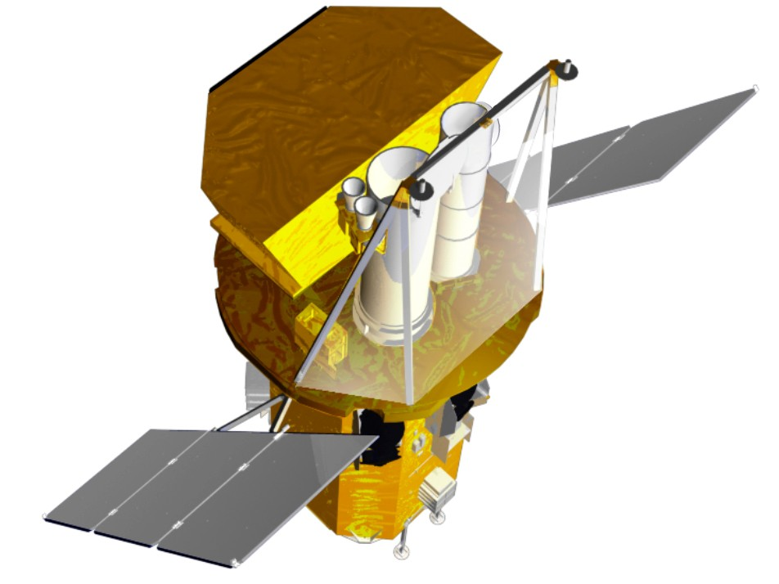
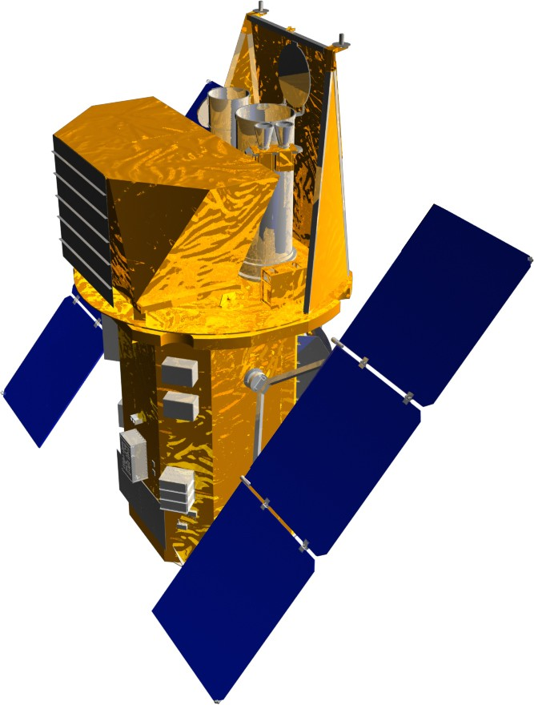
Figure 1. UVOT Placement on the OB
UVOT

Telescope | Modified Ritchey-Chrétien
Aperture | 30 cm diameter
F-number | 12.7
Detector | Intensified CCD
Detector Operation | Photon Counting
Field of View | 17 x 17 arcmin²
Detection Element | 256 x 256 pixels
Sampling Element | 2048 x 2048 after centroiding
Telescope PSF | 0.9 arcsec FWHM @ 350nm
Wavelength Range | 170-600 nm
Filters | 11
Sensitivity | m_{B}=24.0 in white light in 1000s
Pixel Scale | 0.5 arcsec

The UVOT consists of 5 units (Figure 2): a Telescope Module (TM) containing a UV/optical telescope, a Beam Steering Mirror (BSM), two filter wheel mechanisms, two photon counting detectors, power supplies, and electronics; two Digital Electronics Modules (DEMs), each one containing a Data Processing Unit (DPU), an Instrument Control Unit (ICU), and power supplies for the DPU and ICU; and two Interconnecting Harness Units (IHUs) to connect the TM to the two DEMs.

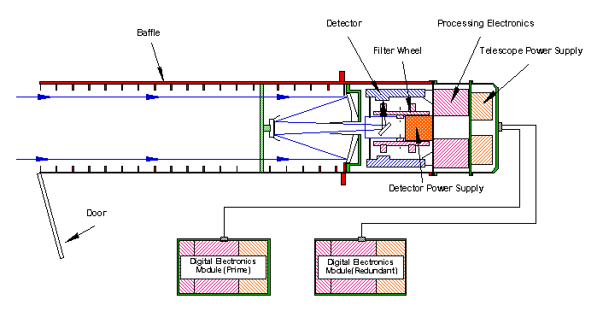
Figure 2. UVOT Schematic

Optics

The telescope tube contains a 30 cm primary and 7.2 cm secondary mirror which are both made from Zerodur. The telescope is a modified Ritchey-Chrétien design. The optical train has a primary f-ratio of f/2.0 increasing to f/12.72 after the secondary. The primary mirror is mounted on a strong back for stability and the secondary mirror is mounted onto spider arms. To maintain focus the mirrors are separated by thermally stable INVAR metering rods. The boresight is near the center of the CCDs.

For light rejection there are internal and external baffles. The external baffles are forward of the secondary mirrors and help prevent scattered light from reaching the detectors. The internal baffle lines the inner walls of the telescope tube between the primary and secondary mirrors. Secondary/primary baffles also surround the secondary mirror and the hole at the center of the primary. Behind the primary mirror is the Beam Steering Mirror (BSM) which directs light to one of the two detectors.

Before the light enters the detector it passes through a filter housed in a filter wheel. Each filter wheel contains the following elements: a blocked position for detector safety, UV-grism, UVW2-filter, V-filter, UVM2-filter, optical-grism, UVW1-filter, U-filter, magnifier, B-filter, & White-light-filter. The characteristics of the UVOT lenticular filters can be found in Table 2. The lenticular filter response (Figure 3) and the anticipated grism profiles (Figure 4) are also provided. The grisms supply a low spectral resolution. The magnifier offers a 4x increase in the image scale which increases the f-ratio to f/54 in the blue and provides diffraction-limited images. It does not operate in the UV because of transmission limitations in this part of the spectrum. Because the focal plane is curved, the filters are weakly figured and the surface of the detector window is concave. The PSF of the UVOT filters can be found in Table 3. These values were determined during the UVOT instrument level calibration. They have not been deconvolved from the collimator’s PSF. Significant changes in PSF should be reported to the instrument team immediately.

Filter | λ_{c} (nm) | FWHM (nm)
V | 544 | 75.0
B | 439 | 98.0
U | 345 | 87.5
UVW1 | 251 | 70.0
UVM2 | 217 | 51.0
UVW2 | 188 | 76.0
White | 385 | 260.0
Table 2. UVOT Lenticular Filter Characteristics

Channel | UVW2 | UVM2 | UVW1 | U | B | V | White | Magnifier
A | 1.74 | 1.63 | 1.59 | 1.28 | 1.31 | 1.24 | 1.06 | 1.04
B | 1.76 | 1.76 | 1.66 | 1.52 | 1.40 | 1.17 | 1.12 | 1.00
Table 3. UVOT Filter PSF

Figure 3. UVOT Lenticular Filter Response
Figure 4. UVOT Anticipated Grism Response

Detectors

Housed in the BMT are the two detector assemblies. Each detector assembly consists of detector window, a S20 photocathode, three Micro-Channel Plates (MCPs), a phosphor screen, tapered fiber-optics, and a CCD (Figure 5). The CCD has 385 x 288 pixels, 256 x 256 of which are usable for science observations. Each pixel has a size of 4 x 4 arcsec² on the sky thus providing a 17 x 17 arcmin² FOV. The first MCP has pore sizes of 8 μm with a distance of 10 μm between pore centers. The second and third MCPs have pore sizes of 10 μm with a distance of 12 μm between pore centers. The photocathode is optimized for the UV and blue.

Photons arriving from the BSM enter the detector window and hit the photocathode. Electrons emitted from the photocathode are then amplified by the three successive MCPs which in turn illuminate the phosphor screen. The photons from the phosphor screen are then sent through the fiber-optics to the CCD. This affords an amplification of 10⁶ of the original signal. The detection of photons is accomplished by reading out the CCD at a high frame rate and determining the photon splash’s position using a centroiding algorithm. The detector attains a large format through this centroiding algorithm by sub sampling each of the 256 x 256 CCD pixels into 8 x 8 virtual pixels, thus providing an array of 2048 x 2048 virtual pixels with a size of 0.5 x 0.5 arcsec² on the sky. Faint residuals of a pattern (referred to as Mod-8) formed by creating the 8 x 8 virtual pixels are removed by ground processing. Unlike most UV/optical telescopes, because UVOT’s CCD is read out at a high frame rate, the UVOT is operated in a photon-counting mode.

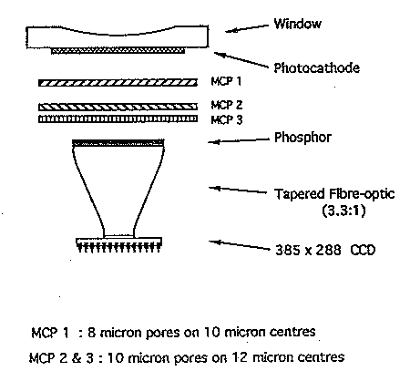
Figure 5. UVOT Detector
As with all photon-counting devices there is a maximum count rate limit. The frame rate of the UVOT detectors is 11.1 ms for a full 17 x 17 arcmin² frame; therefore, for count rates above ~10 counts/s (for point sources) a dead time or coincidence loss correction needs to be applied during the data processing. Details of this dead time correcting will be provided after launch. In addition, care must be taken when observing bright sources as the local sensitivity of the photocathode is permanently depressed. Autonomous operations diminish the time spent on bright sources (see next Section). The detector’s dark noise is extremely low and can be ignored when compared to other sources of background noise.

Detector Safety

The Swift mission requires the UVOT to have autonomous functionality in order to protect itself against potentially damaging bright sources. This is accomplished through the use of a bright source catalogue and a real time system for monitoring the raw pixel data from the camera and automatically reducing the detector gain when a signal above a programmable threshold is seen.

Software

Both digital electronics units in the UVOT contain microprocessors running custom flight software. The ICU software is responsible for controlling and managing all aspects of the UVOT's operations, including:

  - autonomous instrument safing in off-nominal observatory conditions,
  - autonomous protection of the detector from fields containing bright stars,
  - interacting with the Figure of Merit computer to select & execute appropriate science observations.

Many ICU behaviors, most notably the exposure sequences used to observe targets, can be reconfigured via simple table uploads. ICU capabilities are implemented via a combination of compiled Ada code and a custom interpreted scripting language.

The DPU software is responsible for reducing and packaging the detector event stream for transport to the ground. Data reduction tasks include spatial windowing of event data (to control telemetry volume), compression of event data, binning of event data into images, compression of images, transformation of engineering data streams into calibration products, and construction of a Finding Chart (which involves source detection). The DPU contains significant data buffering capacity to accommodate variation in the science data & telemetry production rates.

Observing Scenarios

There are six observing scenarios for the UVOT: slewing, settling, finding chart, automated targets, pre-planned targets, and safe pointing targets.

Slewing. As the spacecraft slews to a new target, the UVOT does not observe in order to protect itself from bright sources slewing across its FOV and damaging the detector.

Settling. After notification from the spacecraft that the intended object is within ten arcminutes of the target the UVOT begins observing. All UV photons in the entire 17 x 17 arcmin² FOV are recorded in an event list. During this phase pointing errors are off-nominal, i.e., the target is moving rapidly across the FOV as the spacecraft settles. The positional accuracy is only known to a few arcmin based on the BAT’s centroided position.

Finding Chart. If the intended target is a new GRB and the spacecraft is sufficiently settled, i.e., the pointing errors are small, the UVOT begins a 100 second exposure in the V filter to produce a finding chart. The finding chart is telemetered to the ground in order to assist ground based observers in pinpointing the burst. This is typically accomplished in less than 300 seconds while the afterglow is still bright. The positional accuracy of the finding chart will be approximately 0.3 arcsec relative to the background stars in the FOV. It is anticipated that for most bursts the XRT will have reported a better than 5 arcsec position for the target before the end of the finding chart observation (see Figure 6).

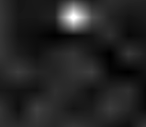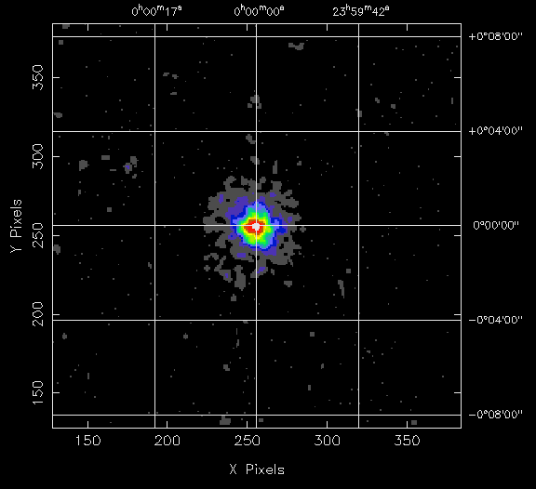
BAT Burst Image
T<10 sec
BAT Error
Circle
XRT Image
T<90 sec
T<300 sec
UVOT Image
Figure 6. Rapid Position Determination of GRBs

Automated Targets (ATs). Once a finding chart has been produced, a several thousand-second automated sequence of exposures, which uses a combination of filters, is executed. The sequence is based on the optical decay profile of the GRB afterglow and time since the initial burst. Currently, two automated sequences will be launched: bright and dim GRB sequences (Figures 7 & 8; BB, UU, W1, GV, M2, VV, W2, & GU in the figures are the B, U, UVW1, Visual Grism, UVM2, V, UVW2, & UV Grism filters respectively; gaps in the figures are due to earth occultation). For bright bursts the filter sequence includes grisms. For fainter targets (17.0 < m_{V} < 24.0), light curves are acquired by cycling through the six broadband filters. Source variability during exposures is monitored by collecting data in event mode.
Although only two sequences will be loaded at launch, new sequences can be added and existing ones modified as GRB afterglows become better understood.

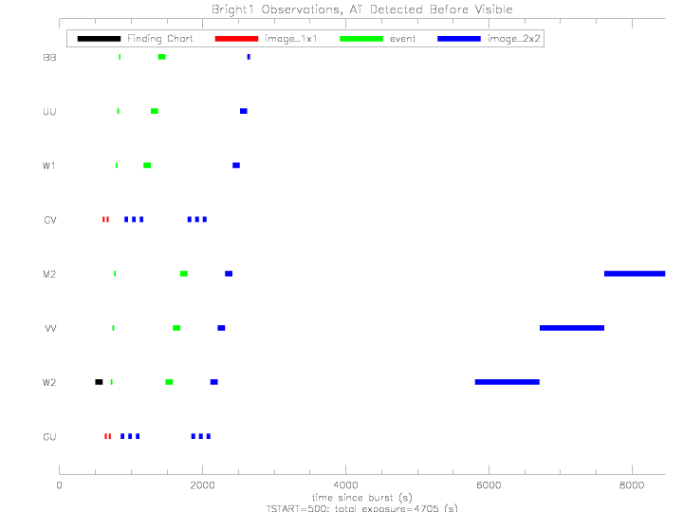
Figure 7. Bright GRB Sequence (Early GRB Detection)
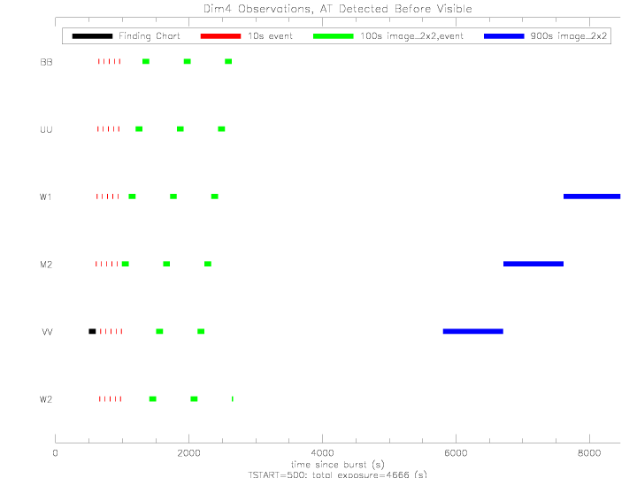
Figure 8. Dim GRB Sequence (Early GRB Detection)
Pre-Planned Targets (PTs). When there are no automated targets, observation of planned targets (which have been uploaded to the spacecraft) begin. Follow-up of previous automated targets, targets-of-opportunity, and survey targets are included as planned targets. Because the UVOT filter wheels are limited life items, many of the PTs will only use one filter in order to minimize the wear on the filter wheel motors. Scientific justification will need to be provided to the UVOT scientists in order to increase the number of filters used for a PT observations.

Safe Pointing Targets. When observing constraints do not allow observations of automated or pre-planned targets the spacecraft points to predetermined locations on the sky that are observationally safe for the UVOT.

Data Products

The UVOT can produce seven types of data products: event lists, images, finding charts, intensifier characteristics, channel boundaries, and centroid confirmation images.

Event List. Each photon event is reported by its position on the detector and the associated CCD frame time-stamp. The accuracy of photon arrival time is dominated by the ambiguity of the CCD frame integration period (11ms).

Image. Image data consist of a 2-D histogram (image) of the event stream, taken over the specified integration period (generally 10-1000s). Image pixels can span 1x1, 2x2, or 4x4 detector sub-pixels. For large numbers of events, image data require much less telemetry than event data, at the expense of greatly reduced time resolution.

Finding Chart. Finding Chart data consist of a small subset of the pixels in an image, carefully chosen to lie under and near the brightest point sources. A "sparse" version of the full image can be constructed on the ground, providing a coarse representation of the detected point sources while consuming modest telemetry volume. Finding chart data are sent immediately via TDRSS to the GCN, whereas most other science data is stored for later downlinks via a ground station.

Dark Burst Image. All the data in the NxN Finding Chart pixels around the XRT position are sent to the ground. This image will facilitate solving the question of “dark” GRBs. The Dark Burst Image is sent immediately after the Finding Chart via TDRSS to the GCN.

Intensifier Characteristics. Intensifier Characteristics data consist of a histogram of the "pulse height" of a set of events obtained with an internal calibration lamp. Examination of these data on the ground assists in adjusting the gains in the detector.

Channel Boundaries. Channel Boundaries data consist of a set of calibration threshold values which, when loaded into the detector electronics, would produce the optimal sub-pixel positioning calculation. The detector data used in the computation of Channel Boundaries are obtained with an internal calibration lamp.

Centroid Confirmation Image. Centroid Confirmation Image data consist of a 2-D histogram which characterizes the bias of the sub-pixel positioning calculation (which is driven by the Channel Boundaries values) across 64 regions of the detector. The detector data used in the computation of a Centroid Confirmation Image are obtained with an internal calibration lamp.

Data Analysis Software

The Swift Science Center (SSC) has developed FTOOLs for UVOT data analysis which will be available for public download after launch. The tools will operate as stand-alone FTOOLs, within the processing pipeline, or within the user meta-tool “UVOTCHAIN.” Once the telemetery has been converted into FITS format, FTOOLs will operate on the data. Since the UVOT produces both event and image data products, two sets of tools have been provided.

Telemetry volume

Because of limitations in the Spacecraft data storage capabilities and the telemetry bandwidth between the UVOT-and-Spacecraft and the Spacecraft-and-Malindi, the type of data generated is constrained. Full frame event data can only be obtained for short periods of time. In general, the smaller the window size, the longer event data can be obtained.

Standard Ground Pass Data

BAT
Data available within hours via ground link through Malindi:

1) Background subtracted light curves derived from the event files in four energy channels. These will include the time covering the S/C slew to the burst.
Time binning:
uniform 64 ms
uniform 1 sec
Bayes blocks.
2) Counts spectra on various time scales during and after the burst. Response matrix for each spectrum. Spectral fit parameters from XSPEC.
3) Burst summary parameters:
- Burst durations: T50 and T90.
- Energy fluences (10-25 keV, 25-50 keV, 50-100 keV, 100-300 keV, 2-2000 keV).
- Variability *.
- Time lags between fiducial energy bands *.
(* May not be calculated in the pipeline)
4) Event files (~10 minutes around the burst trigger time).
5) Short time scale (~1 minute) survey histograms until the next S/C slew.
6) Images of the burst and surrounding sky before, during and after the burst.

Burst advocate generated products a few days later (possible examples):
- Revised burst location
- Estimate of red shift from lag-variability analysis
- Spectral fits for additional time intervals
- Comparisons between BAT and Swift narrow field instrument analysis.
- Lists of follow-up observations and links to any publicly available data from follow-ups
- Gamma-ray burst catalog.
- Longer time scale (weeks) overall summary web page for each burst.
All BAT data (except for the hard X-ray survey) will be made publicly available within two hours of receipt at the Swift Science Data Center (SDC).
- Available through SDC Quicklook web site for the first week.
- Available through HEASARC after one week.
- Hard X-ray survey available in HEASARC after release
- All Swift products will also be available through European mirror sites.

XRT

UVOT

Spacecraft and Other Infrastructure Data

Figure of Merit (FoM)
Swift utilizes a novel approach to responding to new gamma-ray bursts. In order to eliminate the substantial delay that would be caused by waiting for ground intervention, Swift responds to BAT discovered bursts by autonomously superceding its pre-planned target list by substituting an automated response.

The way this works is that when the BAT discovers a new burst, it generates a new burst message. Internal to the BAT processor is a software module called the Figure of Merit (FoM) process. When the BAT burst message occurs the FoM process evaluates a numerical quantity called the Figure of Merit. The Figure of Merit value results from a calculation based on input parameters generated by the BAT (and possibly the UVOT and XRT as well). The form of the calculation is an algebraic formula, including weights for the significant of the input parameters. The definition of the FoM calculation can be changed in flight by uploading new weights, without making a software patch.

The FoM value is used by comparing it to the FoM value of any current existing automated target (AT). An AT may be a recent burst, for which Swift has not yet completed the initial sequence of observations, or a burst or other Target of Opportunity (ToO) target which has been uploaded from the ground via the TDRSS link as an AT. If the FoM for the new burst exceeds the FoM value for the current AT (or if no current AT is in the system), then the new burst becomes the current AT. When the AT changes, Swift will no longer autonomously return to the old AT. Old ATs can only be rescheduled by ground control.

When the AT changes, the FoM process then compares the FoM value for the new AT, and compares it to the priority for the Pre-Programmed Target (PPT) scheduled to be observed at that time. If the AT FoM value exceeds the Priority value of the current PPT, then the FoM process sends a slew request to the spacecraft. If the AT FoM value is less than the the PPT priority, then the FoM does not request a slew and Swift continues to observe the PPT target.

When the current target snapshot is completed (either because Swift can no longer view the target, or because the target reaches the complete observation time requested) then the FoM reevaluates the FoM of the AT, and again checks whether the next PPT is observed, or to have the new AT take precedence.

The net effect is that Swift will observe the highest FoM/PPT priority as assigned by the formula on board the spacecraft and the ground assigned PPT priority.

Spacecraft

Data Paths

Data, commands and ancillary information are up and downloaded to Swift via complementary paths. Because of the critical science driver of rapid response to bursts, Swift must have a continuous capability to download information about new bursts, and to upload potential ground instructions to point Swift at new bursts discovered by non-Swift means. On the other hand, Swift produces large amounts of important but less time critical data for download, and has the need to upload lengthy observing schedules and command loads.

The Swift mission provides to both needs by complementary data paths. High criticality, low volume data are sent to and from Swift via the Tracking Data Relay Satellite System (TDRSS) Demand Access System (DAS). DAS will transmit Swift messages reporting the discovery of a new burst, and critical science results from the BAT, XRT and UVOT, down to the ground within seconds. Similarly the TDRSS DAS allows uploading of Target of Opportunity (ToO) targets and ground loaded FoM targets within minutes. (The longer latency for uploads is due to the need to schedule the TDRSS data channels.)

The TDRSS data link is available on demand on a 24 hour per day basis. The final throughput of the Swift DAS link will be at least 1 kbps minimum requirement, and is expected to be 3 kbps typically, depending on link margins.

The TDRSS data path cannot carry the full volume of Swift data. Moreover it is too slow for efficient upload of Swift command loads. For these activities Swift employs ground stations. While Swift is in view of the Malindi ground station, Swift is able to dump data from the on-board solid-state recorders at 2.25 Mbps.

Swift’s orbit is expected to offer approximately 13 ground passes of at least 5 minute duration, every day. The Swift data management plan assumes that 7 ground passes per day will be used for data download and command loads. During these passes, Swift is in direct two-way communication with the ground, and commands, software patches and parameter table uploads can be verified in real-time. It is planned to conduct all normal Swift command uploads during ground passes so that the MOC can verify proper receipt by Swift of these critical data.

TDRSS Data Path

Ground Pass Data Path

Data Analysis and Processing Software
Swift software tasks needed to produce scientifically useful data files from BAT, XRT and UVOT are defined and explained. These tasks are required for data processing performed on data that is delivered from the MOC to the SDC, through the SDC processing pipeline. Data products appear on the Swift Quick Look Data area until complete, after which time they are delivered to the HEASARC for acquisition and analysis by the Swift user community.

Swift Software Overview
Each software task will run in the Swift processing pipeline in the SDC and in the Swift FTOOLs package provided to the science user by the SSC. The SDC can and do make modifications to the analysis scripts to optimize the pipeline performance, though the algorithms of the tasks themselves are unchanged. This way, Swift users can reprocess/reanalyze data by themselves, and reproduce the pipeline processing results if using identical input and calibration information.
All the software that operates on Level I FITS files to produce the Level II and Level III FITS data files and products in the pipeline will be distributed to Swift users. In particular, it is important to distribute the software for calibration so that Swift users can quickly re-calibrate their data when new calibration information is made available, instead of needing to wait for eventual reprocessing. All the distributable Swift software is included in the Swift FTOOLS package.

Swift Data Center (SDC)
The SDC, located at NASA/GSFC, converts Swift Level 0 data products received from the MOC into Flexible Imaging Transport & System (FITS) files and standard data products using a semi-automatic processing pipeline. As part of this process, the SDC checks the format of the telemetry and checks for missing data. The format of the FITS files is consistent with Office of Guest Investigator Programs (OGIP) standards. The SDC generates level 1, 2, and 3 data products. The data sets are organized by observation to facilitate later scientific analysis. Quick-look data products are made on a shorter time scale using less complete telemetry and the same processing pipeline.

The Space Science Data Operations Office, Code 630, at GSFC is implementing the SDC. Additional development support is provided from the Information Systems Center (Code 580) at GSFC.

Swift Science Center (SSC)
The SSC assists the science community in the scientific analysis of Swift data. The SSC has the lead role in developing the software tools needed to perform scientific analysis of the Swift data. Many of these tools are also used in the pipeline processing in the SDC. This effort is supported by the instrument teams and the ASDC. After launch, the SSC updates the analysis tools as the understanding of the techniques utilized improves with experience. In addition, the SSC maintains documentation of the Swift data and analysis techniques for the use of the science community. The SSC also produces documentation in support of the Swift GI program and provides technical support for reviewing GI proposals.
The SSC is part of the Office of Guest Investigator Programs (OGIP), which also contains High Energy Astrophysical Science Archive Research Center (HEASARC) and similar support centers for other high-energy astrophysics missions. The Information Systems Center (ISC) (Code 580) is supporting the software effort in the SSC.

Rapid Response Framework

Internal Interaction Interfaces of Ops Center

Burst
MOC
BA
DS
FOT
FollowUp
SDC
Sci. Plan
Data
Command Loads, ToO
QL, Ground Pass
New Loads, ToO
H/K
Sci Data
BA: Burst Advocate
DS: Obs. Duty Scientist
FOT: FOT Duty Officer

Figure 4.7.1 – MOC Functional Schematic

The MOC is organized into two closely inter-related teams: the Flight Operations Team (FOT) and the Science Operations Team (SOT). The primary duty of the FOT is to assure the health and safety of the Swift Observatory at all times. It does this by continuous monitoring of the spacecraft telemetry through automated software, with on-demand paging of the FOT during spacecraft or instrument anomalies. In addition, the FOT has responsibility for uploading and verifying the Command Loads which are sent to the spacecraft. The FOT also tracks the successful download of data from the spacecraft.

The SOT is responsible for the scientific functioning of the Swift observatory. They prepare Pre-Planned Science Timelines (PPST) which direct the Swift observing program in those times when the on-board Figure of Merit (FoM) process does not override the PPST by detecting an Automated Target (AT) – typically a new BAT discovered GRB.

Figure 4.7.1 shows the working interfaces between the duty elements of the MOC. The Burst Advocate (BA), has responsibility for monitoring the current Swift response to active GRBs. This includes being the point of contact between Swift and the Follow-Up team and the general GRB community interested in the assigned burst. The BA will work closely with the Observatory Duty Scientist (ODS; who is a member of the SOT), to keep the ODS informed of the scientific significance of the burst, and what Swift actions might enhance the science return. The ODS also is charged with assuring that proper data are being collected, and that the instruments appear to be functioning as expected.

The FOT duty officer is responsible for receiving the PPST from the SOT, and properly converting the PPST into a Command Load which is loaded and run on the spacecraft. The FOT duty officer also monitors instrument and satellite health and safety.

Mission Ops Center Daily Routine
The MOC will be routinely staffed on a 8 hour per day, 5 day per week schedule. During the initial Launch & Early Orbit (L&EO) period the MOC will be continuously staffed. When the MOC is staffed below the continuous 24 hour per day level, the FOT and SOT will have duty personnel responsible for responding to paging alerts automatically generated by the SERS software to detect spacecraft emergencies, and newly discovered GRBs.

On a typical work day the MOC schedule is expected to work like this:
8 AM – SOT arrives and consults logs, GCN and other records of overnight activity and current spacecraft telemetry
9 AM – Science Planning telecom – SOT Lead moderates a discussion including the on-duty Instrument Duty Specialists, all BAs with recently active bursts, and the current Science Planner for that day. Goal is to review all current bursts and spacecraft activity to set priority for targets in Science Plan.
10 AM – Science Planner generates PPST for following week.
12 AM – PPST is passed to UVOT and BAT IDSs for review. UVOT monitors the planned targets for UVOT bright source problems and filter wheel rotation and changes UVOT modes as required. BAT monitors targets for bright gamma-ray sources in BAT field of view and creates appropriate table loads to modify trigger thresholds as required.
1 PM – PPST is delivered to FOT
6 PM – PPST is converted to ATS load for spacecraft, and successfully uploaded to Observatory.

External Interaction Interfaces of Ops Center
The Ops Center has external interfaces to the Swift science team and the community. Interactions will flow in both direction for both of these groups.

Rapid response inputs coming from the community and the science team to the Ops Center will take the form of Targets of Opportunity (ToOs) requests to repoint Swift. They will be submitted to the Ops Center Director and approved by the Principal Investigator. A web form for requesters to fill out is provided at http://xxxxxxxx. An example of a GRB ToO would be a request to point the XRT and UVOT at the position of a GRB detected by another observatory such as HETE-2, INTEGRAL or the IPN.

Rapid response outputs to the science team will be through e-mails and phone calls. The science team web site, which can be accessed through the Swift main page at http://swift.gsfc.nasa.gov has e-mail exploders for the full science team and various subgroups. Phone and e-mail information for individuals can also be found there. Outputs to the community will take the form of GCNs, IAU Circulars and ATELs discussed in the next section. Outputs to the public, such as
press releases and interviews, will be coordinated through the Swift Press Officer at Sonoma State University, with approval by the Principal Investigator.

Emergency contact information is as follows:

Position Name e-mail phone cell phone

MOC Console
MOC Director John Nousek nousek@astro.psu.edn 814-865-7747
Principal Investigator Neil Gehrels gehrels@gsfc.nasa.gov 301-286-6546 301-526-9288
GCN Lead Scott Barthelmy scott@lheamail.gsfc.nasa.gov 301-286-3106
Press Officer Lynn Cominsky lynnc@charmian.sonoam.edu 707-664-2655

Rapid Response Data Products/Publications
There are currently three principal, independent methods of distributing time-critical data rapidly to large numbers of astronomers and other interested scientists: Gamma-Ray Burst Coordinates Network (GCN) circulars, International Astronomical Union (IAU) Circulars, and Astronomer’s Telegrams (ATEL’s). There is some overlap in the subscribers and subjects covered, but the bare essentials of each method are summarized in the following table, and each method is discussed in detail in the following paragraphs. Note that, depending on the exact nature of a discovery, it may be appropriate to use more than one method to distribute information. Unlike the refereed literature, it is acceptable to circulate identical announcements via different methods.

 | GCN Circulars | IAU Circulars | ATEL
Website | gcn.gsfc.nasa.gov/gcn | http://cfa-www.harvard.edu/cfa/ps/cbat.html | atel.caltech.edu
Approx. # of readers | 600? | 300 paid subscribers, but much wider readership | 500
Cost | Free | $20/line + $50/item | Free
Sign-up/registration required? | Yes | Not required, but possible, mainly for billing purposes | Yes
Primary data distributed | GRB, SGR observations | SNe, novae, comets, satellites of planets, CV’s | SNe, novae, X-ray pulsars, QPOs
Approx. time delay | Practically instantaneous | 1 day | Practically instantaneous
Filtering/Error checking/Editing? | No | Yes | No
Citeable in the literature? | Yes | Yes | Yes
Approx. number issued/year | TBD | 260 | 30

GCN CIRCULARS

(Scott to write, but I do want to emphasize one thing, from our HETE experience. It is essential to write a GCN circular for each burst, because the automatically generated GCN notices have no author, and are difficult to cite.)

IAU CIRCULARS

IAUC’s are no longer the method of choice for circulating GRB and SGR information (GCN circulars replaced them several years ago for this purpose), but they may still be appropriate for announcing certain Swift discoveries. Such discoveries might include, but not be limited to, new X-ray sources, or the flaring or unexpected behavior of previously known ones. In general, the purpose of issuing an IAUC is to call the attention of the astronomical community to a phenomenon which would benefit from rapid, but not instantaneous, multiwavelength observations. The advantages of IAUC’s are first, that they are read by a very large audience (don’t be fooled by the small number of paid subscribers – many are large institutions, and the circulars are posted and/or passed around), and second, that they go out to many astronomers/observers who may not be particularly interested in GRB-type phenomena, but who are actively involved in other high energy astrophysics areas. The disadvantages are first, that they are quite expensive to send (several hundred dollars), and second, that they do not go out instantly (they are filtered, and often revised, and you do not always get a chance to see the final version – in principle, they can also be rejected).

All burst advocates are strongly encouraged to visit the IAUC website (http://cfa-www.harvard.edu/cfa/ps/cbat.html) and read the instructions carefully well in advance of their first shift as an advocate, because the instructions are lengthy, specific, and somewhat arcane, and non-adherence to them will delay acceptance (in some cases, indefinitely). Also, submission of an IAUC implies that you, or your institution, is prepared to pay for the circular; burst advocates must be prepared to receive an invoice for their submissions.

Astronomer’s Telegrams (ATEL’s)

ATEL’s are the invention of Robert Rutledge (now at Caltech). They were initially used on occasion for announcing GRB’s, but that function is now served almost exclusively by GCN circulars. Instead, ATEL’s announce other high energy astrophysical phenomena, such as QPO’s, XTE and INTEGRAL discoveries of new X-ray sources, and discoveries of radio and optical counterparts to new X-ray sources. Just as for the IAUC’s, ATEL’s may be appropriate for announcing Swift discoveries such as new X-ray sources, or the flaring or unexpected behavior of previously known ones. The advantages of ATEL’s are that they are free and practically instantaneous. The only disadvantage is that they do not seem to have been embraced as widely by the community as GCN’s and IAUC’s.

ATEL’s are not filtered or refereed in any way, but you must be registered and have a password to submit them. Burst advocates are urged to sign up at the ATEL website (atel.caltech.edu) well in advance of their first shift in order to receive a password and review the procedures for submission. ATEL’s are somewhat more structured than GCN’s and IAUC’s, but are easy to write. A good rule of thumb might be to submit an ATEL in addition to, or even in place of, an IAUC.

Follow-Up Team Communications

As of this writing, the Swift follow-up team consists of 31 people who have agreed to commit a significant amount of their time, or their observing time, to GRB’s discovered by Swift, or to X-ray sources which Swift observes. They have also agreed, at least in principle, to allow certain Swift team members, in particular the BA’s, to know about their observing plans and their preliminary results, in order to assist Swift planning. Conversely, it is also possible that BA’s will be contacted by follow-up team members to get information on Swift observations of a particular GRB, so that they can use their observing time more efficiently. The principles which define the interaction between follow-up team members and the Swift team are given in Appendix TBD. This appendix also discusses Swift Associate Scientists, but it is expected that there will be relatively little urgent communication between Associate Scientists and BA’s.

Table TBD lists the follow-up team members, and figure TBD shows their geographical locations. Note that the on-line version of this manual contains hyperlinks to the e-mail addresses of the team members, and to the websites containing instrumentation descriptions. The instrumentation available to follow-up team members may be roughly sorted into four categories as follows.

- Automated telescopes. These instruments slew automatically to a GRB position to observe it whenever possible. They include AEOS, Faulkes, KAIT, LOTIS, REM, Super-LOTIS, TAROT, and WASP.
- Non-steerable facilities. These are instruments which observe a large fraction of the sky more or less continuously. LIGO and MILAGRO are in this category.
- Space-based telescopes. These can in principle respond to Swift GRBs on a ToO basis. HST and INTEGRAL are in this category.
- Steerable ground-based telescopes. Apache Point, CTIO, ESO, Galileo, HET, Isaac Newton, Keck, KPNO, LBT, McDonald, NASA IRTF, NOT, Palomar, SALT, SAAO, Tenerife IRTF, and VLT are in this category. It is expected that most, although not all, of the interactions between the BA and the follow-up team will take place with people using these instruments.

Exactly how the BA’s and the follow-up team members interact remains to be determined. An attempt has been made to provide a website for follow-up team members to post information about their ongoing observations. This site is password-protected, and BA’s should be aware that all information on it is proprietary and only for their use in managing Swift observations; it should not be given out to anyone (including other follow-up team members) without the express permission of the person who posted it. That said, it is not at all certain that the follow-up team members will actually use this site; in the trials which have taken place to date, the reception to it has been lukewarm at best. The url, username, and password for this website are TBD, TBD, and TBD.

Other possible means of interaction are by telephone or e-mail. Even though all Swift data are public, follow-up team members who are observing, or planning to observe, may not have the time or desire to retrieve and analyze data, and may want to get an “instant analysis” of Swift data from the BA, or may want to know how long Swift will continue to observe a particular event. Conversely, the BA may want to contact follow-up team members to inquire about their observing plans in order to make decisions. Table TBD gives the phone numbers of those team members who have agreed to be contacted, and the local times when they will take calls. No entry means that the member has not agreed to be contacted by phone; in these cases, e-mail should be used. The names of the team members are hyperlinked to their e-mail addresses. All information given to a BA by a follow-up team member should be considered proprietary unless otherwise stated; this information should not be passed along to anyone else.

BA’s should keep in mind that they may be contacted not only by follow-up team members, but also by associate scientists and institutional scientists, and by “outside” observers.

NAME | INSTITUTE | INSTRUMENTS | PHONE; LOCAL TIME (ALL TBD AT THIS STAGE)
Angelo Antonelli | Rome Observatory | ESO, REM, FAME
Michel Boer | CESR, France | TAROT
David Buckley | SAAO, S. Africa | 9 m SALT telescope
Michael Busby | Tennessee State U. | Misc. automated telescopes (24 - 81”)
Andrea Cimatti | Arcetri, Italy | LBT
Malcolm Coe | Southampton, UK | Tenerife IRTF, SAAO
Stefano Covino | Brera, Italy | ESO, REM
Thierry Courvoisier | ISDC, Switzerland | INTEGRAL
Massimo Della Valle | Arcetri, Italy | VLT, LBT, Galileo
Brenda Dingus | LANL, USA | Milagro
Alex Filippenko | UC Berkeley, USA | KAIT, Keck
Sam Finn | Penn. State U., USA | LIGO
Fabrizio Fiore | Rome Observatory, Italy | VLT
Andy Fruchter | STScI, USA | HST
Gabriele Ghisellini | Brera, Italy | VLT, LBT, Galileo
Roberto Gilmozzi | VLT, Chile | VLT
Shri Kulkarni | Caltech, USA | Keck, Palomar
Bruce Margon | STScI, USA | ARC, Apache Point
Hye-Sook Park | LLNL, USA | LOTIS, Super-LOTIS
Holger Pedersen | Copenhagen U. Observatory, Denmark | NOT La Palma, ESO
James Rhoads | STScI, USA | KPNO, CTIO, NASA IRTF
Brad Schaefer | UT Austin, USA | McDonald, HET
Don Schneider | Penn. State U., USA | HET
Mark Skinner | Maui Air Force Site, USA | AEOS
Ian Smith | Rice U., USA | AEOS, Misc. IR, sub-mm
Chris Stubbs | U. Washington, USA | ARC, Apache Point
Chris Thompson | CITA, Canada | ????
Fred Vrba | USNO, USA | 1 m, 1.3 m telescopes
Nic Walton | Cambridge, UK | Isaac Newton Telescopes
Peter Wheatley | Leicester, UK | WASP, Faulkes
Filippo Zerbi | Brera, Italy | REM

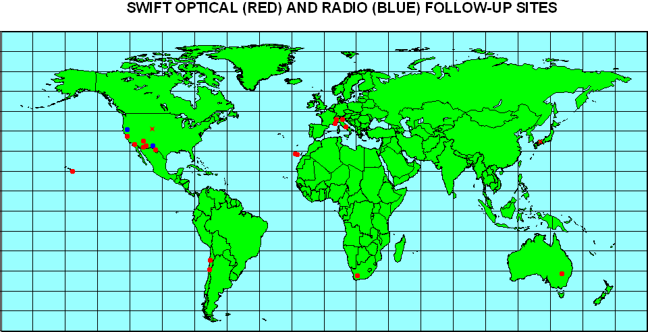

Figure TBD. The geographical locations of the radio and optical telescopes available to the follow-up team.

It is possible that the BA’s will encounter conflicts of interest, and situations which require difficult choices. Some examples follow.

-one follow-up team member requests that Swift continue to observe a GRB to complete or enhance his or her dataset; another follow-up team member requests that Swift slew to a new burst because his or her instrument is prepared to take data on it.

-a follow-up team member makes one request, while an observer who is not on the follow-up team makes a conflicting request, e.g., “slew to the position of this amazing INTEGRAL/IPN/HETE burst that LIGO just observed gravitational radiation from!”.

-an associate scientist or an institutional scientist requests a slew to an X-ray source position, because the source is exhibiting interesting behavior; but a GRB observation is in progress.

-a BA’s friend/colleague/close collaborator/spouse requests something which conflicts with another request which has already been granted.

- Rapid Response Data Products
Some follow-up team members may require "instant data analysis" in order to trigger or conduct their observations. Even though all Swift data are made public, such analysis can, in some cases, be done faster and better by the BA. Some examples follow.

-notify me when you have a burst with an XRT position which is good to 2 arcseconds, but which has no detectable optical counterpart

-notify me when you have an optical transient which appears to be decaying with a power law index greater than -2

-notify me when the X-ray counterpart flux for a GRB is greater than 10^-13 erg/cm2 s in the 2-10 keV band two hours after the burst

These examples are all hypothetical. In fact, no follow-up team member has yet requested such analysis. But in principle, the team members are entitled to make such requests, if they entail a reasonable amount of work from the Swift team and the BA.

Prior to the start of Swift operations, the follow-up team leader will notify the members of the follow-up team that requests for data analysis must be submitted TBD days in advance. These requests will then be circulated to the appropriate personnel, such as instrument team members and software engineers, for consideration and implementation. It will be the responsibility of the BA to ensure that the analyses are carried out, and that the follow-up team members are notified.

Burst Summary Report
For each burst the responsible Burst Advocate shall provide entries and review a Burst Summary Report. The form for this report is being developed by the HEASARC, under the direction of Lorella Angellini. The report form is available as a Web page. It contains quick results and standardized data pertaining to that burst. Details are available from Dr. Angellini.

Publications for Each Burst
The general publication philosophy of the Swift team is to have scientists who contribute to a project be co-authors on the publications from that work. Recognition will be given to people who developed the hardware or specific software that enabled that project either in authorship or acknowledgement. It is expected that some major results from the mission, particularly obtained in the early phases of the mission, will have longer lists of authors, The question of first authorship and order of authors will be decided by the team working on that project following the basic principle that recognition is given to members who contribute the most.

To ensure the quality of team publications, the Swift PI will be notified of all pending papers written by Swift team members using Swift data and will implement a rapid internal review of the paper. Opportunities will be provided for Swift team members to contribute to and thereby join any paper in progress. A sentence will be put in the acknowledgement of the paper to the effect that it is a Swift team paper. Swift team publications will be listed in a web-based publication list.

For GRBs, there will be GCNs for each burst. Early in the mission, first authorship on the GCNs will be given to Swift team members who have contributed most to the development of the mission. It is expected at later stages of the mission that the Burst Advocates will be the first authors on GCNs.

Questions or disputes concerning publications and authorship will be addressed by the Swift PI.

Appendices

Swift Follow-Up Team Members And Associate Scientists

The Swift team recognizes two categories of collaborators, in addition to co-investigators: follow-up team members and associate scientists. This document explains their roles and responsibilities in the project.

FOLLOW-UP TEAM MEMBERS

Follow-up team members are individuals who have a particular interest or expertise in observing the multi-wavelength or non-electromagnetic counterparts to GRBs. In general they must have access to ground- or space-based observing facilities or experiments to carry out these observations. Such access may either be through proposals to guest investigator programs, or through fixed blocks of observing time reserved for members of a particular institution. In many, but not all, cases, their main contributions to the project will be made after Swift has been launched.

Their roles will be:

a. to observe Swift GRB positions, and/or
b. to observe Swift SGR positions, and/or
c. to observe sources detected in the all-sky survey or pointed observations.

Their responsibilities will be:

a. To request observing time at the appropriate facilities for
Swift follow-up studies as needed,

b. To inform the Swift project in a timely manner about their observing plans;
such information may be posted on the Swift website in an area whose access is
restricted to Swift co-investigators and other follow-up team members,

c. To collaborate as needed with Swift co-investigators in the analysis and public
dissemination of their results.

Follow-up team members are also strongly encouraged to attend Swift science team meetings, both prior to and after launch, and present their projects.

Since much of the basic Swift data on GRBs must be made public, the Swift team's responsibility to follow-up team members will be

a. to perform any supplementary analysis of Swift data which is required to enhance the results of the follow-up observations. In case of a conflict between observers who are not members of the follow-up team and observers who are members, such analysis will be carried out preferentially for follow-up team members.

b. To consult with follow-up observers in planning pointed observations of GRBs in a way which will maximize the scientific output and minimize any redundancy in the observations.

c. As far as possible, to minimize competition between follow-up members for any particular observatory or experiment by limiting the number of follow-up team members who have access to that particular facility.

Currently there are 31 members of the follow-up team, selected to assure good multi-wavelength coverage of GRBs, multiple observing sites, a wide geographical distribution, and access to the most appropriate facilities for following up Swift GRBs.

Members may be added or deleted to the team according to the following rules.

a. An individual wishing to join the follow-up team must be nominated by a member of the Swift Science Working Group (SWG)

b. Upon nomination, the individual must write a short (~1 page) statement of his or her research interests, access to any relevant instruments, experiments, or facilities, and potential contributions to the Swift project. This statement must be submitted to the follow-up team leader.

c. The SWG will consider the application at its following semiannual meeting and vote on it; the applicant will be informed of the decision following the meeting. This letter
should be received no later than one month prior to the SWG meeting in question.

An individual who is a follow-up team member, who changes his or her institutional affiliation, must write a short note (~1 page or less) to the follow-up team leader, re-affirming his or her intent to continue participating in the project. If, as a result of such a change of institution, the individual loses access to an instrument, experiment, or facility, and/or gains access to a different instrument, experiment, or facility, this must be explained.

Such changes of institution will be considered by the SWG in one of its semiannual meetings and the individual will be notified thereafter.

An individual who wishes to resign from the follow-up team for any reason is requested to write a short note of explanation to the follow-up team leader.

ASSOCIATE SCIENTISTS

Associate scientists are individuals who have a particular expertise in an area of use to the project. Areas of expertise include, but are not limited to,

a. theory
b. data reduction and/or analysis
c. modeling of experiment performance
d. construction of experiments
e. verification and testing of experimental parameters
f. organization of results into a database or other repository
g. outreach and education

Their roles will be to enhance all aspects of the mission, its performance, and/or the utilization of its data. Their main contributions to the project may be made before and/or after Swift has
been launched. Currently there are 14 associate scientists.

Their responsibilities will be:

a. To carry out specific tasks as requested by the Swift PI,

b. To advise the project on issues related to the mission,

c. To inform the Swift project in a timely manner about their plans and progress; such information may be posted on the Swift website in an area whose access is restricted to Swift co-investigators and other associate scientists, and

d. To collaborate as needed with Swift co-investigators for the public dissemination of their results.

Associate scientists are also strongly encouraged to attend Swift science team meetings, both prior to and after launch, and present their projects.

Since much of the basic Swift data on GRBs must be made public, the Swift team's responsibility to associate scientists will be to perform any supplementary analysis of Swift data which is required to enhance the results of their studies. In case of a conflict between individuals who are not associate scientists and individuals who are, such analysis will be carried out preferentially for associate scientists.

The rules for adding and deleting associate scientists are identical to those for follow-up team members. In general, individuals who work at a co-I institution are eligible to become associate scientists, if they are senior scientists at their institution.

FINANCIAL SUPPORT

In general, follow-up team members and associate scientists are not eligible for financial support from the Swift project.

Swift follow-up team members and associate scientists are eligible to apply for financial support from the Swift Guest Investigator program, if they apply to that program with a U.S. Principal Investigator-led proposal, and win a competitive peer-reviewed selection process.

Swift GRB Afterglow Observing Plan

When Swift discovers a new GRB, it will commence an automated target (AT) set of observations which continue until 20,000 seconds of observing (non-SAA) time on target are accumulated. Following completion of these automated observations, the on-duty Observatory Duty Scientist will extend these automated observations by uploading the GRB location as a ground loaded AT target, unless another GRB occurs (creating a new automated AT target; either as a BAT trigger or as a non-Swift discovered burst) or unless extending the AT observations will prevent afterglow followup of a previous burst. Such extensions will continue until the Science Planners can create a new schedule, and that new schedule takes effect through an uploaded Command Load.

Swift Science Planners will meet on every normal workday and produce a new Science Plan which will schedule PPT targets. PPT targets are observed according to a strict timeline which is not changed by the occurrence of GRBs, but will be superceded by AT targets, when or if they are visible within the Swift observing constraints.

Science Plans are created using the TAKO software, which includes knowledge of the orbital elements, thus ensuring that the PPT targets are visible at the scheduled times. Science Plans will also fill all available time.

Science Planners will create the Science Plan through the following steps:

1) All required, non-routine afterglow observations are inserted into TAKO, using the required integration times. Examples of non-routine observations are calibrations, ToO observations, and GRB afterglow observations which exceed the routine category. Non-routine observations are assigned priorities below the default AT value, but higher than the routine priority. (If or when a BAT hard X-ray transient or Galactic plane survey is conducted, those pointings will also be non-routine.)

2) The Science Planners will determine the observation length for routine afterglow observations. The observation length will be the total available time (total time minus time for non-routine observations) divided by the number of afterglow targets. The Science Planners will determine the number of afterglow targets through a telecom with the BAs of recent bursts. Typically each afterglow will be observed for a minimum of 10 days (TBR [To Be Revised], based on experience). Afterglow targets include both Swift and non-Swift discovered GRBs.

3) The Science Planners will run TAKO using all the non-routine targets, all the routine targets (inserted at 90% TBR of the routine observation length and medium priority), and all the routine targets again (inserted now at 20% TBR of the routine observation length and low priority).

4) The TAKO-produced draft Science Plan will be reviewed for gaps (i.e. times without targets) or dropped targets (i.e. afterglow targets which do not get scheduled). Gaps will be filled by adding repeat observations of routine GRBs or Fill-in targets (from the list of BAT Survey targets). Dropped targets will be corrected by applying time windows to alternate days between competing targets.

5) The TAKO scheduling process will be repeated until a Science Plan results which has no gaps, and all available routine and non-routine targets are observed within the run of the schedule uploaded as the new Command Load.

Abbreviations

AEOS | Advanced Electro-Optical System
ARC | Astrophysical Research Consortium
ATEL | Astronomer’s Telegram
BA | Burst Advocate
BAT | Burst Alert Telescope
CESR | Centre d’Etude Spatiale des Rayonnements
CITA | Canadian Institute for Theoretical Astrophysics
CTIO | Cerro Tololo Interamerican Observatory
CV | Cataclysmic Variable
ESO | European Southern Observatory
FAME | Fast Alert MachinE
FoM | Figure of Merit
GCN | Gamma-Ray Burst Coordinates Network
GI | Guest Investigator
GRB | Gamma-Ray Burst
HET | Hobby-Eberly Telescope
HST | Hubble Space Telescope
IAUC | International Astronomical Union Circular
IM | Institutional Manager
INTEGRAL | International Gamma Ray Astrophysics Laboratory
IRTF | InfraRed Telescope Facility
ISDC | INTEGRAL Science Data Center
KAIT | Katzman Automatic Imaging Telescope
KPNO | Kitt Peak National Observatory
LANL | Los Alamos National Laboratory
LBT | Large Binocular Telescope
LIGO | Laser Interferometer Gravitational Wave Observatory
LLNL | Lawrence Livermore National Laboratory
LOTIS | Livermore Optical Transient Imaging Survey
MOC | Mission Operations Center
NASA | National Aeronautics and Space Administration (duh)
NOT | Nordic Optical Telescope
ODS | Observatory Duty Scientist
PI | Principal Investigator (Neil Gehrels of GSFC)
PSU | The Pennsylvania State University
QPO | Quasi-Periodic Oscillation
REM | Rapid Eye Mount
SAAO | South African Astronomical Observatory
SALT | South African Large Telescope
SNe | Supernovae
STScI | Space Telescope Science Institute
TAROT | Télescope à Action Rapide pour les Objets Transitoires (Rapid Action Telescope for Transient Objects)
USNO | United States Naval Observatory
UVOT | Ultra-Violet/Optical Telescope
VLT | Very Large Telescope
WASP | The UK Wide-field Automated Survey Programme
XRT | X-Ray Telescope instrument

Burst Advocate ‘To-Do’ List

- Check automated GCNs for information on GRB (BA will be paged by second BAT GCN)
- If normal hours, contact Swift Observatory Duty Scientist to acknowledge assumption of BA duty and inform successor Burst Advocates they are on-call for next GRB.
- Use web-form to enter GCN circular on new burst.
- Initiate new chat-room for new GRB information within team.
- If after hours, decide if GRB is interesting enough to page duty scientists and assistants
- If GRB is interesting, contact Swift Duty Scientist to recommend future Swift observations
- Check BAT flux, T90, Epeak and hardness ratio to determine type of GRB
- Check XRT flux and spectral parameters to determine x-ray properties
- Check UVOT flux and finding chart to determine optical properties
- If GRB is exceptional, contact MOC Director and PI
- Provide UVOT counterpart (with position & magnitude) to GCN, if found at XRT position of counterpart, or based on rapid variation
- Provide inputs to SDC web site
- Monitor community GCNs and Follow-up Team web site to determine what observations are being made
- If appropriate, contact Follow-up Team members to alert them to developments or ask them for advice.
- Monitor state of data products and contact SDC if products are late, or instrument teams if instrument data looks incorrect
- Provide input to MOC for UVOT modes for this GRB during Preplanned Target (PT) observations
- Collect data products for GRB and fill in HEASARC web site for GRB
- Contact key project leads, as appropriate
- Fill in problem/short report form at end of shift
- Participate in publication of results, as appropriate

In each case where two units are specified, one unit is a “cold” redundant unit.
See http://heasarc.gsfc.nasa.gov/ftools/
The home page for the SSC can be found at http://swiftsc.gsfc.nasa.gov.

