7. Recognition of Adverse Reactions

The overall risk of serious complications following vaccination with vaccinia vaccine is low. Complications occur more frequently in persons receiving their first dose of vaccine, and among young children (<5 years of age). The most frequent complications of vaccination and their descriptions are listed below. Additional information about adverse reactions from smallpox vaccination can be found on the CDC Smallpox Web site.

Inadvertent inoculation at other sites
This is the most frequent complication of vaccinia vaccination and accounts for about 50% of all complications following primary and revaccination. This complication occurs at a rate of 27.1-532 per million primary vaccinations and usually results from auto-inoculation when the virus is transferred by hand from the site of vaccination to other areas. The most common sites involved are the face, eyelid, nose, mouth, genitalia, and rectum (Figure 5). Most lesions will heal without specific therapy, but Vaccinia Immune Globulin (VIG) may be useful for some cases of severe inadvertent inoculation (see Indications and Guidelines for VIG Use below). Inadvertent inoculation can be prevented by good hand washing after touching the vaccination site or materials contaminated from the site.

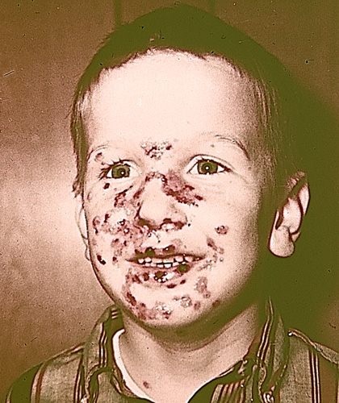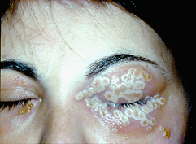

Figure 5. (Left) Six year old with multiple inadvertent inoculation sites on face which healed without scarring [Reproduced with permission of J. Michael Lane, M.D.]; (Right) Severe vaccinial blepharitis [ Reproduced with permission of the American Journal of Ophthalmology (Photograph by Deborah Pavan-Langston, M.D.)]

Generalized vaccinia
This complication is characterized by a vesicular rash of varying extent resulting from blood-borne dissemination of vaccinia virus (Figure 6). It is most frequently seen following primary vaccination and occurs at a rate of 17.5-222.8 per million primary vaccinations. Lesions occur between 6 to 9 days following vaccination and can be few or generalized. The rash is generally self-limited in persons with no underlying illnesses (immune deficiencies) and usually requires no treatment with VIG except in patients who are seriously ill or who have serious underlying medical conditions.

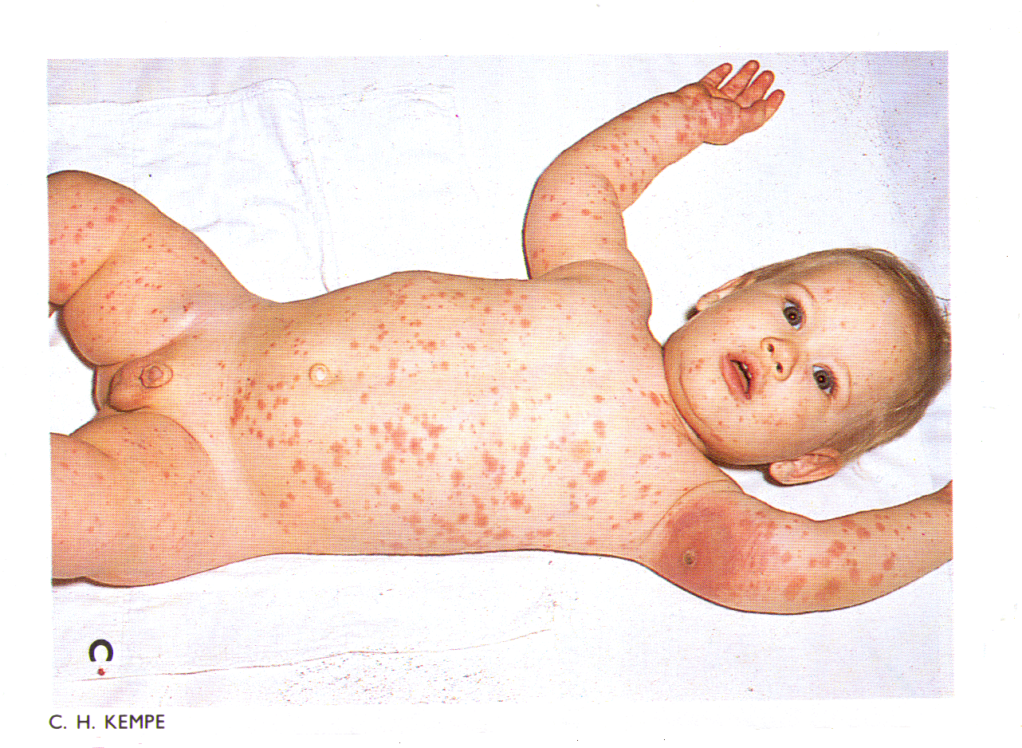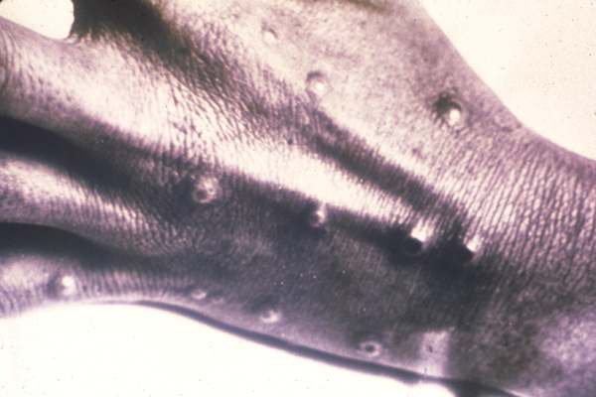

Figure 6. (Top) Generalized vaccinia, 10 days after vaccination, benign course, no scarring. [Fenner F, Henderson, DA, et al. Smallpox and its Eradication. WHO. 1988, Reprinted with permission of WHO]; (Bottom) The lesions of generalized vaccinia at times can be difficult to distinguish from variola (smallpox) infection. Generalized vaccinia does not follow a centrifugal distribution which is characteristic of smallpox lesions. [Reproduced with permission of J. Michael Lane, M.D.]

Eczema vaccinatum
This complication is seen in vaccine recipients who have active or healed eczema or atopic dermatitis or other active chronic skin conditions. It can also occur in persons with these conditions who come into contact with a recently vaccinated individual. Vaccinial skin lesions can become confluent and progress to cover all or most of the area(s) that are or were affected by the eczema or chronic skin condition (Figure 7). Fever and generalized lymphadenopathy may also occur. The illness is usually self-limited, but can be severe and occasionally fatal. The most serious cases appear to occur in primary vaccinee and close contacts of vaccinees that have eczema or atopic dermatitis independent of the activity of the underlying eczema or atopic dermatitis. Previous studies have indicated that this complication occurs at a rate of 10.6-41.5 per million primary vaccinations. VIG is effective in treating serious cases of eczema vaccinatum.

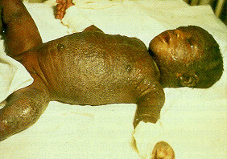

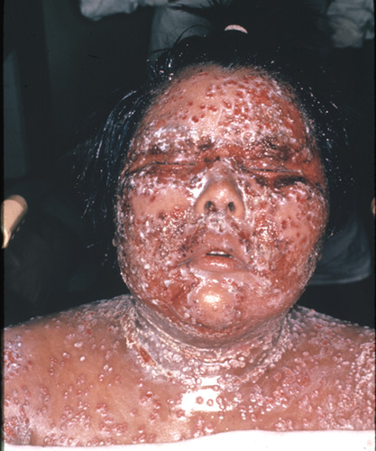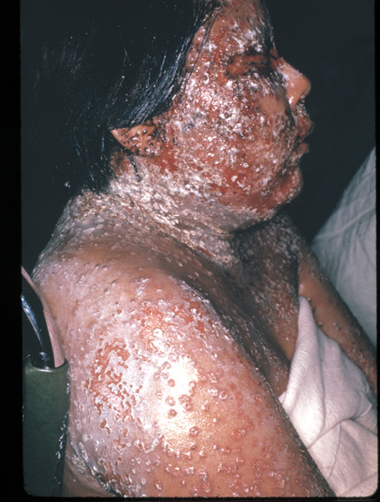

Figure 7. (Top) Eczema vaccinatum in an unvaccinated child resulting from contact with a recently vaccinated sibling. [Fenner F, Henderson, DA, et al. Smallpox and its eradication. WHO. 1988, Reprinted with permission of WHO]; (Bottom left) A 22-year-old woman with eczema vaccinia acquired from a close contact. She became critically ill, with nearly total involvement of her body, and required thiosemicarbazones, as well as large doses of VIG; (Bottom right) side view. [Reproduced with permission of J. Michael Lane, M.D.]

Progressive vaccinia (vaccinia necrosum or vaccinia gangrenosa)
This severe and potentially fatal complication occurs in persons with underlying immune deficiencies and can occur following primary or revaccination. It is characterized by failure of the vaccine site lesion to heal, with progressive necrosis of the vaccination site and surrounding areas (Figure 8). Secondary lesions may appear at other sites of the body and also exhibit progressive necrosis. Previous studies have indicated that this complication occurs at a rate of 1.0-1.7 per million primary vaccinations. VIG has been used to treat this complication with varying success.

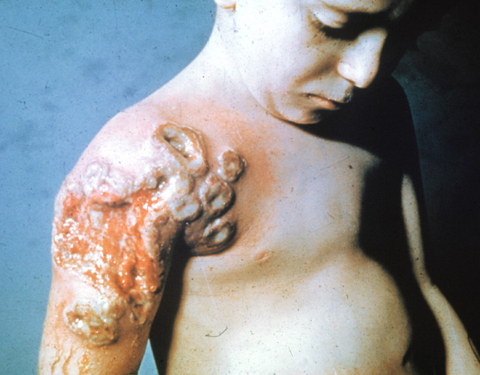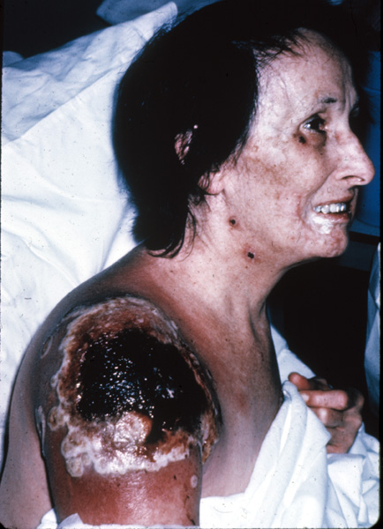

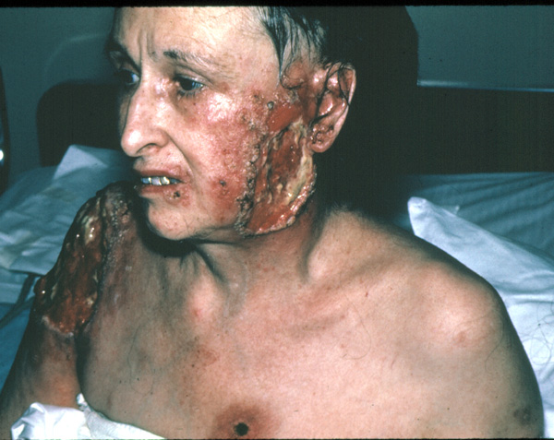

Figure 8. (Top left) Progressive vaccinia, which was fatal, in a child with an immunodeficiency. ; (Top right and bottom) Progressive vaccinia in a 62-year-old woman with chronic lymphocyte leukemia. Note the distant lesions on her face, neck and chest and the progression of the vaccination site over time. [Reproduced with permission of J. Michael Lane, M.D.]

Postvaccination encephalitis
Encephalitis, characterized by fever, headache, vomiting, drowsiness, and occasional spastic paralysis, meningeal signs, convulsions, or coma, occurred between 8 and 15 days postvaccination at a rate of 2.4-8.6 per million primary vaccinations. This complication has a bimodal distribution with the majority of cases occurred in primary vaccinees <1 year of age followed by increase incidence with increasing age after 1 year of age. There are no other known predisposing factors for this complication. Approximately 15 to 25% of cases with postvaccination encephalitis died and an additional 25% had permanent neurological sequelae. There is currently no known treatment for postvaccination encephalitis, and VIG is not effective or indicated for this complication.

8. Indications and Guidelines for Vaccinia Immune Globulin (VIG) Administration

The generally recommended dosage of VIG for treatment of complications due to vaccinia vaccination is 6000 units/kg. Dosages may vary slightly depending upon the formulation of VIG (intramuscular [IM] or intravenous [IV]) VIG should be administered as early as possible after the onset of symptoms. Doses may be repeated at 2 to 3 day intervals until no new lesions appear.

Postvaccination complications for which VIG may be indicated include:

- Eczema vaccinatum
- Progressive vaccinia (vaccinia necrosum)
- Severe generalized vaccinia
- Severe inadvertent inoculation (e.g., large number of lesions, toxicity of affected person, or substantial pain)
- Severe ocular complication (except isolated keratitis)

VIG is not indicated for the treatment of:

- Postvaccinial encephalitis or postvaccinial encephalomyelitis
- Non-severe inadvertent inoculation
- Mild or limited generalized vaccinia
- Nonspecific rashes, erythema multiforme, or Stevens-Johnson syndrome

The currently limited supplies of VIG do not allow for its concomitant administration with vaccine for the prevention of potential complications. VIG use should be reserved for treatment of the most serious or life-threatening complications.

