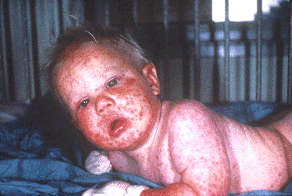
Fig. 8 - Generalized vaccinia in an apparently normal child.
Recovered without sequelae. Photo courtesy of John M. Leedom, M.D.

C. Eczema vaccinatum – This complication is seen in vaccine recipients who have active or healed eczema or other chronic skin conditions. It can also occur in persons with these conditions who come into contact with a recently vaccinated individual. Vaccinial skin lesions can progress to cover all or most of the area(s) that are or were affected by the eczema or chronic skin condition (Fig.9). Fever and generalized lymphadenopathy may also occur. The illness is usually mild and self-limited, but can be severe and occasionally fatal. The most serious cases appear to occur in primary vaccines and close contacts with eczema of vaccinees, and are independent of the activity of underlying eczema. Previous studies have indicated that this complication occurs at a rate of about 1 in 26,000 primary vaccinations. VIG is effective in treating serious cases of eczema vaccinatum.

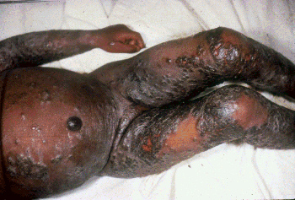
Fig. 9 - Eczema vaccinatum. Photo courtesy of John M. Leedom, M.D.

D. Progressive vaccinia (vaccinia necrosum or gangrenosa) – This severe and potentially fatal complication occurs in persons with underlying immune deficiencies and can occur following primary or revaccination. It is characterized by failure of the vaccine site lesion to heal, with progressive necrosis of the vaccination site and surrounding areas
Secondary lesions may appear at other sites of the body and also exhibit progressive necrosis. VIG has been used to treat this complication with varying success.

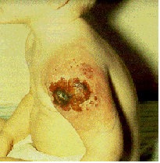

Fig. 10 – Progressive vaccinia, that was fatal, in a child with an immunodeficiency. [Fenner F, Henderson, DA, et al. Smallpox and its eradication. WHO. 1988, Reprinted with permission of WHO]

E. Post-vaccination encephalitis – Encephalitis, characterized by fever, headache, vomiting, drowsiness, and occasional spastic paralysis, meningeal signs, convulsions, or coma, occurred between 8-15 days post-vaccination at a rate of 1 case per 300,000 vaccinations. The majority of cases occurred in primary vaccinees <1 year of age. The incidence of post-vaccination encephalitis in primary vaccinees also increased with increasing age. There are no other known predisposing factors for this complication. Approximately 15 to 25% of cases with post-vaccination encephalitis died and an additional 25% had permanent neurological sequelae. There is currently no known treatment for post-vaccination encephalitis and VIG is not effective or indicated for this complication.

Indications and Guidelines for Vaccinia Immune Globulin (VIG) Administration

The recommended dosage of VIG for treatment of complications due to vaccinia vaccination is 0.6 mL/kg of body weight. VIG must be administered intramuscularly (IM) and should be administered as early as possible after the onset of symptoms. Because the therapeutic dose of VIG may be large (e.g., 42 mL for a 70-kg person), the product should be given in divided doses over a 24- to 36-hour period. Doses may be repeated at 2 to 3 day intervals until no new lesions appear.

Post-vaccination complications for which VIG may be indicated include:
- Eczema vaccinatum
- Progressive vaccinia (vaccinia necrosum)
- Severe generalized vaccinia if the patient has a toxic condition or serious underlying illness.
- Inadvertent inoculation of the eye or eyelid without vaccinial keratitis

*VIG is not indicated for the treatment of post-vaccination encephalitis and is contraindicated for vaccinial keratitis as it may increase corneal scarring.

The currently limited supplies of VIG do not allow for its concomitant administration with vaccine for the prevention of potential complications. VIG use should be reserved for treatment of the most serious or life-threatening complications.

VIG is only available for civilian use through the Centers for Disease Control and Prevention (CDC) and can be requested from the National Center for Infectious Diseases Drug Services, 404-639-3670 during the day and 404-639-3311 during evenings, weekends, and holidays.

