 | OLDC Quarterly
October 16, 2007 | Volume 5, Number 1
In this issue:  - New OLDC Release  - Forms  - Issues and Resolutions  - FAQs  Help/FAQ Site  For prompt responses from the Custom Application Support and Training help desk, when entering a question using the Help/FAQ site, remember to include your full name and phone number, not just your e-mail address.  Internet Issues  The Internet makes report form submission easier and more convenient. However, please save often while entering report data to avoid losing your work. Internet glitches or network connectivity problems do occasionally occur. Save to be safe.  To read back issues of the OLDC Quarterly, or to view/ print help sheets, go to the OLDC News and Tips website at https://extranet.acf.hhs.gov  /oldcdocs/materials.html.  Send comments via e-mail to the Custom Application Support and Training (CAST) help desk or call 1-866-577-0771. | The OLDC Quarterly  The “OLDC Quarterly” presents Online Data Collection (OLDC) information, upcoming changes, and helpful tips for using OLDC. If there is a need to communicate important information in between Quarterly editions, special bulletins are distributed.  New! - OLDC Version 3.0  The new OLDC Version is scheduled for release October 22, 2007. Please exit OLDC Production on Friday, October 19, at 8 p.m. EDT and start up fresh on Monday, October 22, at 8 a.m. EDT. Several changes, additions, and enhancements are included in OLDC Version 3.0. These are listed in detail in the following sections.  New Look and Feel  OLDC is getting a face lift! All OLDC screens are being modified to present a new Grant systems uniform look. Menu items and functionality remain unchanged. Below is a sneak peek at the new OLDC Home page.  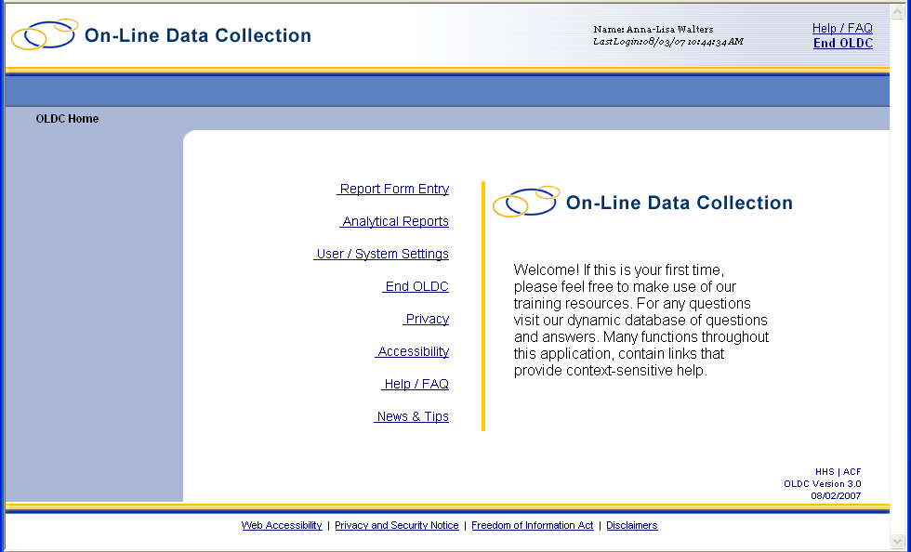  Assignment Delegation  The Assignment Delegation module is updated for greater ease of use. The changes provide additional flexibility for administrators, such as combining the “Assign Programs” and “Assign Job Types” pages to one screen. Additionally, new screens offer an improved visual representation of customer’s permissions.  To ensure a smooth transition in using the new Assignment Delegation module, a training schedule will be announced following the release of OLDC version 3.0. Customers continue to use the existing Assignment Delegation module until their training is completed.  Important Note!  To accommodate all of our customers, the current Assignment Delegation module remains available to users with accessibility requirements. If you have accessibility concerns, please contact the Custom Application Support and Training (CAST) help desk to ensure you retain the Assignment Delegation module that best meets your needs.  CAST Help Desk  Phone: 1-866-577-0771  E-mail: app_support@acf.hhs.gov  Assignment Delegation module improvements are detailed below.  Updated Roles and Assignment Screen  The “Roles and Assignments” screen is modified so that the Edit Current User list and the Add New User function appear side by side on the screen. The purpose of this change is to encourage administrators to search for existing users prior to creating new IDs, and also to reduce the need to scroll down the page.  Additionally, a new Search Users box is added just above the Edit Current Users list. The new search box enables customers to search for an existing user by typing both their last name and first name. As each letter is typed, the names in the Edit Current User list update to reflect the entry. This improvement reduces the amount of time an OLDC Lead spends scrolling for existing users.  Ability to Add Federal Staff to OLDC  Federal OLDC Leads with appropriate permissions are now able to create other federal users without first contacting their GATES PA or OLDC technical staff. Additionally, it is no longer required for federal staff to first have a GATES account before using OLDC. Instructions for adding federal users are available in the new Help Sheet “Add Federal Staff”. The new help sheet can be found by going to https://extranet.acf.hhs.gov/oldcdocs/materials.html and clicking the link “Add Federal Staff”.  Primary Contacts  The checkbox Primary Contact is added to the new “Roles and Assignments – Assign Programs” screen. If the Primary Contact checkbox is selected, then the user’s name and contact information displays on their Report Form Status page under Contacts.  Restructured Assignment Screens  No longer do OLDC Leads need to step through multiple pages to delegate permissions. The new screens contain an assignment “tree” which easily allows them to directly navigate to the permissions they want to assign. An updated OLDC Assignment Delegation guide will be posted to the OLDC New and Tips site shortly after the release.  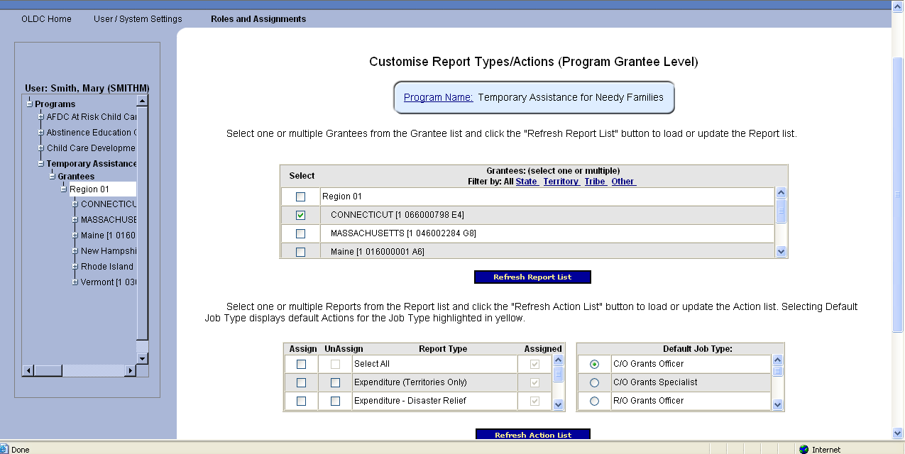  Improved View Assignments Screen  The “View Assignments” screen, located under User/System Settings – View Assignments, is updated for ACF Central Office and Regional Office customers. A selection screen is added to allow users to choose which of their permissions they wish to view, instead of having to scroll through a cumbersome list.  Grant Application Packages  In a limited release, full grant application packages are available to view in OLDC. Electronic packages are submitted via Grants.gov and transmitted to OLDC. For those customers with appropriate permissions, the new menu item “Grant Application Form” displays as an option from the OLDC Home page. For more information regarding this feature, please contact the Custom Application Support and Training Help Desk via phone at 1-866-577-0771 or by e-mail at app_support@acf.hhs.gov.  New Notification and Information Message  An e-mail notification is now sent to the appropriate ACF Grants Office staff when a previously submitted report form is unsubmitted. The Grants Office is notified because report information may have already been included in a prepared report by the government.  A pop-up information message also appears when a user unsubmits a report form. This message alerts users that if the report due date has passed; they may not be able to re-submit without contacting the Regional or Central Office representative to approve an extension. The message also alerts the user that a notification has been sent to their ACF Grants Office.  Forms  ADD-02B: Replaces the 269A and ADD-02 forms. The 269A and ADD-02 forms remain available in OLDC so customers may view archived information to reference prior year data.  SF-269 for Discretionary Programs: An ACF program office will soon begin testing this discretionary form in OLDC. More information will be provided as it becomes available.  Coming Soon!  Shortly after the release of OLDC 3.0, the following forms will be added to OLDC. A bulletin will be sent to appropriate staff once the forms are available.  ACF – 204: Annual report on TANF Programs and State Maintenance-of-Effort Programs.  ACF – 196TR: TANF Territory Financial Report.  Issues and Resolutions  Time-Out Errors  Due to a change with NIH’s firewall (NIH houses some OLDC data); OLDC users have experienced intermittent time-out messages when trying to submit a report. OIS staff is currently working with NIH to resolve this issue. If you encounter this problem, either try clicking the Submit button a second time or log or End OLDC, log back in, and click Submit.  System Outages  The ACF Office of Information Services apologizes for recent system outages due to system upgrades and building electrical improvements. OLDC staff continues to strive to provide ample notification for any downtime, and would like to thank customers for their patience.  Corrections  ADD PPR – The issue where a Java error appears when a user tries to create a second iteration of “Section 2 - County List” is now resolved.  FAQs  Question: I have already saved my report form. Why don’t I see the Submit button?  Answer: In order for a report form to be submitted, it must first be validated. To validate, or check against policy or mathematical requirements, click the Validate button. Some report forms also require an electronic signature before they can be submitted. A person with the Certify with Signature Authority role can click the Certify button. To determine if your report form needs to be certified, please view the Report Progress bar located towards the top of the “Report” screen. The Report Progress bar details what steps need to be taken before the Report form process is complete.  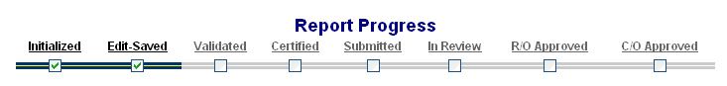  If the form has been certified but the Submit button does not appear, you may not be assigned the Submit role. If you are assigned the Submit role and the report is certified but you still do not see the Submit button, the report form may be past its due date. If the report due date has passed, please contact your ACF Grants Office for assistance.

