MEMORANDUM

TO: All NDEP Partner Organizations

DATE: September 7, 2001

FROM: NDEP Executive Committee

RE: 1. NDEP Adoption of A1C – a Simple Name for Hemoglobin A1c

2. New NDEP Diabetes and Cardiovascular Disease Campaign

1. NDEP Adoption of A1C – a Simple Name for Hemoglobin A1c

The National Diabetes Education Program (NDEP) Steering Committee has agreed to adopt a simple name for the hemoglobin A1c test that is used to monitor long-term blood glucose control. The new name “A1C” will be used in all NDEP communications with people with diabetes. NDEP’s market research with consumers and health care providers indicated a need for a simple name for the test and that A1C was the most acceptable choice. As a result:

- All NDEP partners are urged to use the simple name A1C in all communications with people with diabetes that mention the test.
- All NDEP partners are urged to inform their constituents/members that NDEP is promoting use of the simple name A1C with people with diabetes and to ask for their support of the name’s use.

A newsletter article is attached for your convenience to promote the simple name A1C. Please adapt it as necessary to meet your needs.

2. Promoting New NDEP Diabetes and Cardiovascular Disease Campaign

As you know, NDEP launched the Be Smart About Your Heart: Control the ABCs of Diabetes campaign in June. November is National Diabetes Month and an ideal time to promote the Be Smart campaign. Please share the following article with your colleagues in your organization’s newsletter. Feel free to adapt it as needed.

Thank you in advance for your collaboration. Please direct any comments or questions to Joanne Gallivan at 301 496-6110 or GallivanJ@hq.niddk.nih.gov.

Newsletter Article Announcing New A1C Name

National Diabetes Education Program Adopts A1C Name for the Hemoglobin A1cTest

The National Diabetes Education Program (NDEP) Steering Committee has agreed to adopt a simple name for the hemoglobin A1c, the test that is used to monitor long-term blood glucose control. The new name A1C will be used in all NDEP communications with people with diabetes.

“People with diabetes and their health care providers told us that use of this simple name will help reduce confusion and make consumers more familiar with this important test,” said Dr. Charles M. Clark, Jr., chair of the NDEP. “We hope that as more people with diabetes become familiar with the A1C, they will take an active role in asking for the test and its results and work with their health care providers to reach their target A1C number,” he added.

As an NDEP partner, the (name of organization) encourages its members to use the name A1C in all communications with people with diabetes concerning the test. To help standardize use of the new name, the two letters on either side of the number “one” should be capitalized.

NDEP encourages partners to disseminate the following information about the A1C to increase awareness about the test. Please include it in newsletters articles or on your web site.

What is the A1C test?
A1C (pronounced A-one-C) refers to a lab test that measures the average level of blood glucose (sugar) in your body over the last 3 months. It is the best way for you and your health care team to know if your blood glucose is under control. The A1C test shows if your blood glucose has been close to normal or too high. It does not take the place of regular self-testing of blood glucose that shows day-to-day or hour-to-hour changes in your blood glucose.

What is a good A1C goal?
A1C test results show the percent of A1C in the blood. The A1C goal for people with diabetes is usually less than 7 percent. Ask your health care team what your A1C goal should be and write it down. If your A1C is less than 7 percent, your treatment plan is working and it is likely that your blood glucose is under good control. If your A1C is higher than 7 percent, ask your health care team about your treatment plan. Any lowering of the A1C toward normal can help reduce your chances of getting eye disease, kidney disease, nerve damage, or heart disease.

A1C Values
Normal Less than 6%
Goal Less than 7%
Take extra action Over 8%

How often do I need this test?
Make sure you get an A1C test at least twice a year. You should have the test more often if your blood glucose stays too high or if anything in your treatment plan changes. This test uses a blood sample taken from your arm or finger.

What about home testing for A1C?
Some people with diabetes use a home test for A1C. Be sure to follow the testing instructions and ask your doctor to discuss the results with you.

Should I keep a record?
Write down each AIC along with the date of the test. This will help you see how your diabetes is controlled over a long period of time and whether your treatment plan is working properly. Talk to your doctor and health care team about your test results.

###

Newsletter Article to Promote the Diabetes and Cardiovascular Disease Campaign

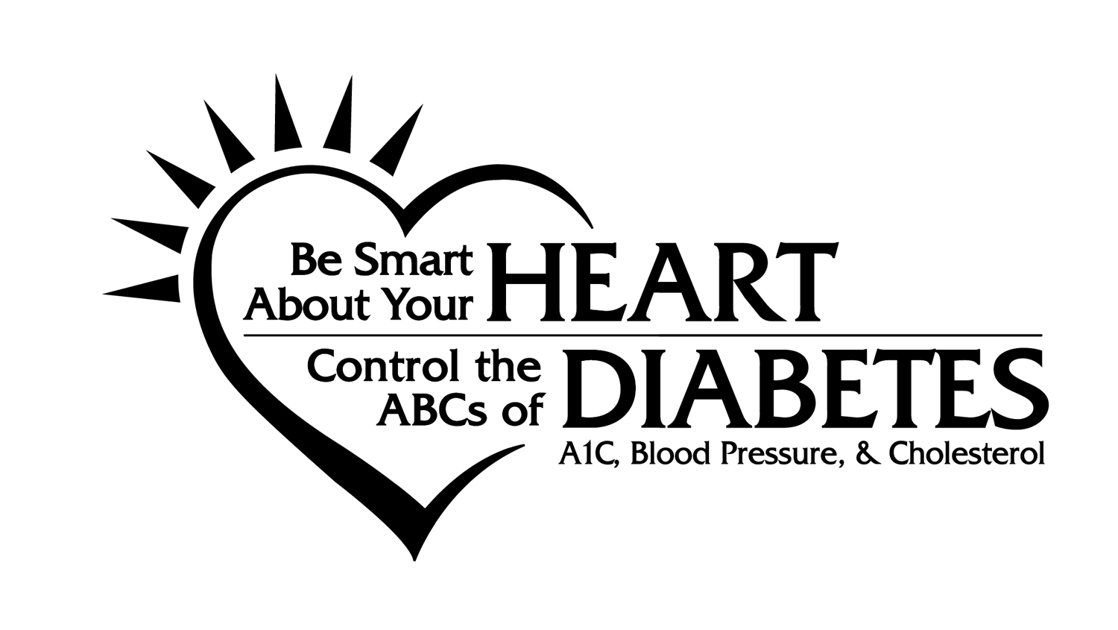

{NAME OF ORGANIZATION} JOINS NEW CAMPAIGN TO TARGET LINK BETWEEN DIABETES, HEART DISEASE & STROKE

{Name of organization} has joined the National Diabetes Education Program in a major new effort to make people with diabetes aware of their high risk for heart disease and stroke, and how they can take steps to lower that risk. The Be Smart About Your Heart. Control the ABCs of Diabetes: A1C, Blood pressure, and Cholesterol campaign was launched in June at the American Diabetes Association annual meeting where significant new research addressing the link between diabetes and cardiovascular disease was presented.

“Most Americans don’t realize that cardiovascular disease is the leading cause of premature death among people with diabetes,” said Dr. Charles M. Clark, Jr. If you have diabetes, you have the same high risk of heart attack as someone who has already had their first attack,” said Dr. Charles Clark, Chair, NDEP.

The campaign focuses on the management of three critical indicators: blood glucose (often called blood sugar), blood pressure, and blood lipids, particularly LDL cholesterol. The Be Smart About Your Heart campaign has translated this complex message into a straightforward call to action: Control the ABCs of Diabetes. A is for the A1C test that measures average blood glucose, B is for blood pressure, and C is for cholesterol.

While heart disease death rates have declined for the general population, for people with diabetes, the statistics show things are getting worse. For example, during the last 30 years, heart disease deaths in women without diabetes have dropped dramatically--by 27 percent. But for women with diabetes the death rate has actually increased--by 23 percent!

“We want people to ask their health care providers the following important questions about the ABCs,” said Dr. Judith Fradkin, Director of the Division of Diabetes, Endocrinology, and Metabolic Diseases at the National Institutes of Health. “What are my A1C, blood pressure and cholesterol numbers? What are my treatment goals? What do I need to do to reach my goals?”

A comprehensive approach to management can dramatically lower the risk for heart attack and stroke. “We have come to learn that the devastating effects of cardiovascular disease do not have to happen to people with diabetes, “ said Dr. Frank Vinicor, Director of the Division of Diabetes Translation of the CDC. “Managing the ABCs can make a real difference in the lives of people with diabetes.”

The National Diabetes Education Program (NDEP), a joint initiative of the National Institutes of Health and the Centers for Disease Control and Prevention, is engaging its 200 partner organizations in this effort. “(Name of organization) is pleased to be part of this nationwide undertaking and is committed to support and participate in activities that will reduce risk factors for heart attack and stroke in people with diabetes,” said (Organization leader).

The Be Smart About Your Heart campaign will include mass media messages, educational materials for consumers and clinical practice tools for health care providers that support and complement the efforts of the American Diabetes Association, the American Heart Association, the American College of Physicians and other groups.

“This campaign complements several activities of {Name of organization} including {Optional: talk about your current activities that relate to diabetes and cardiovascular risk factors},” said (Organization leader).
“We plan to will distribute the NDEP campaign messages and materials by {Optional: talk about ways that you will disseminate materials and messages throughout your organization.},” (he/she) added.

For more information about the National Diabetes Education Program, call
1-800-860-8747 or visit the web site at http//ndep.nih.gov on the Internet.

###

