Catherine Forest Restoration
Stewardship Project
Business Plan

Region: | Region Six – Pacific Northwest
Forest: | Administrative: Columbia River Gorge National Scenic Area  Proclaimed: Gifford Pinchot National Forest, Washington
Land Allocation: | CRGNSA Open Space, Forest, Agriculture Land Use Designations  GP LRMP Riparian Reserves
Project Location: | Township 4 North, Range 12 East Sections 30, 31  Township 3 North, Range 12 East Section 30  Township 3 North, Range 11 East Sections 2, 3, 13, 14, 15, 23, 24, 25, 26, 27, 28, 34, 35, 36
Closest Communities to Project: | White Salmon and Bingen, Washingtion  Mosier, Oregon
Forest Service Coord.: | Diana L. Ross
Collaborative Group Coord.: | Emily Platt, Gifford Pinchot Task Force (Monitoring)

Summary
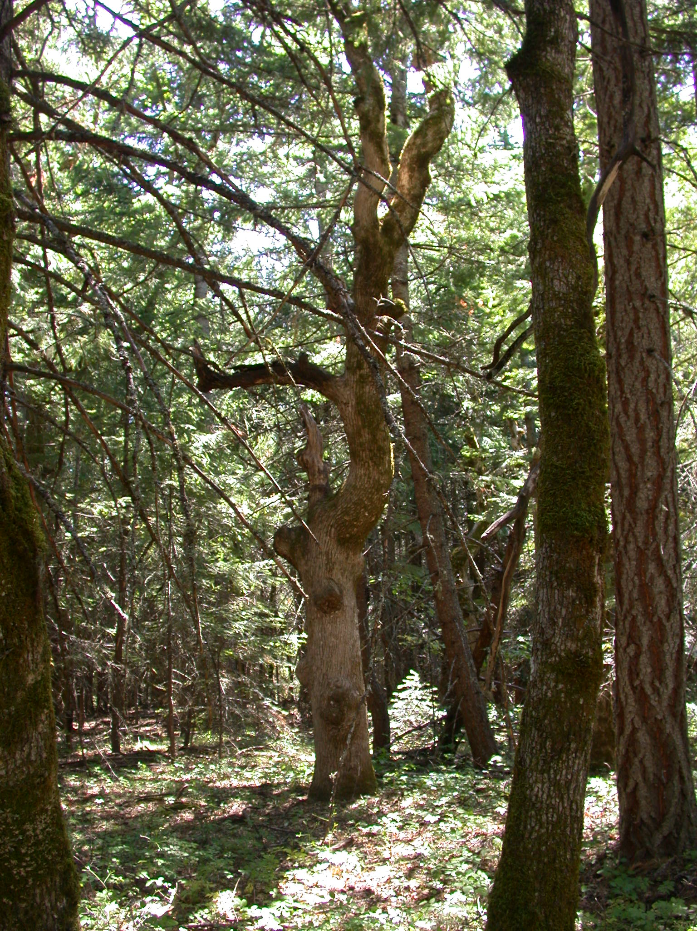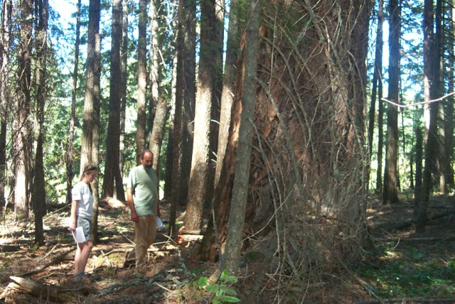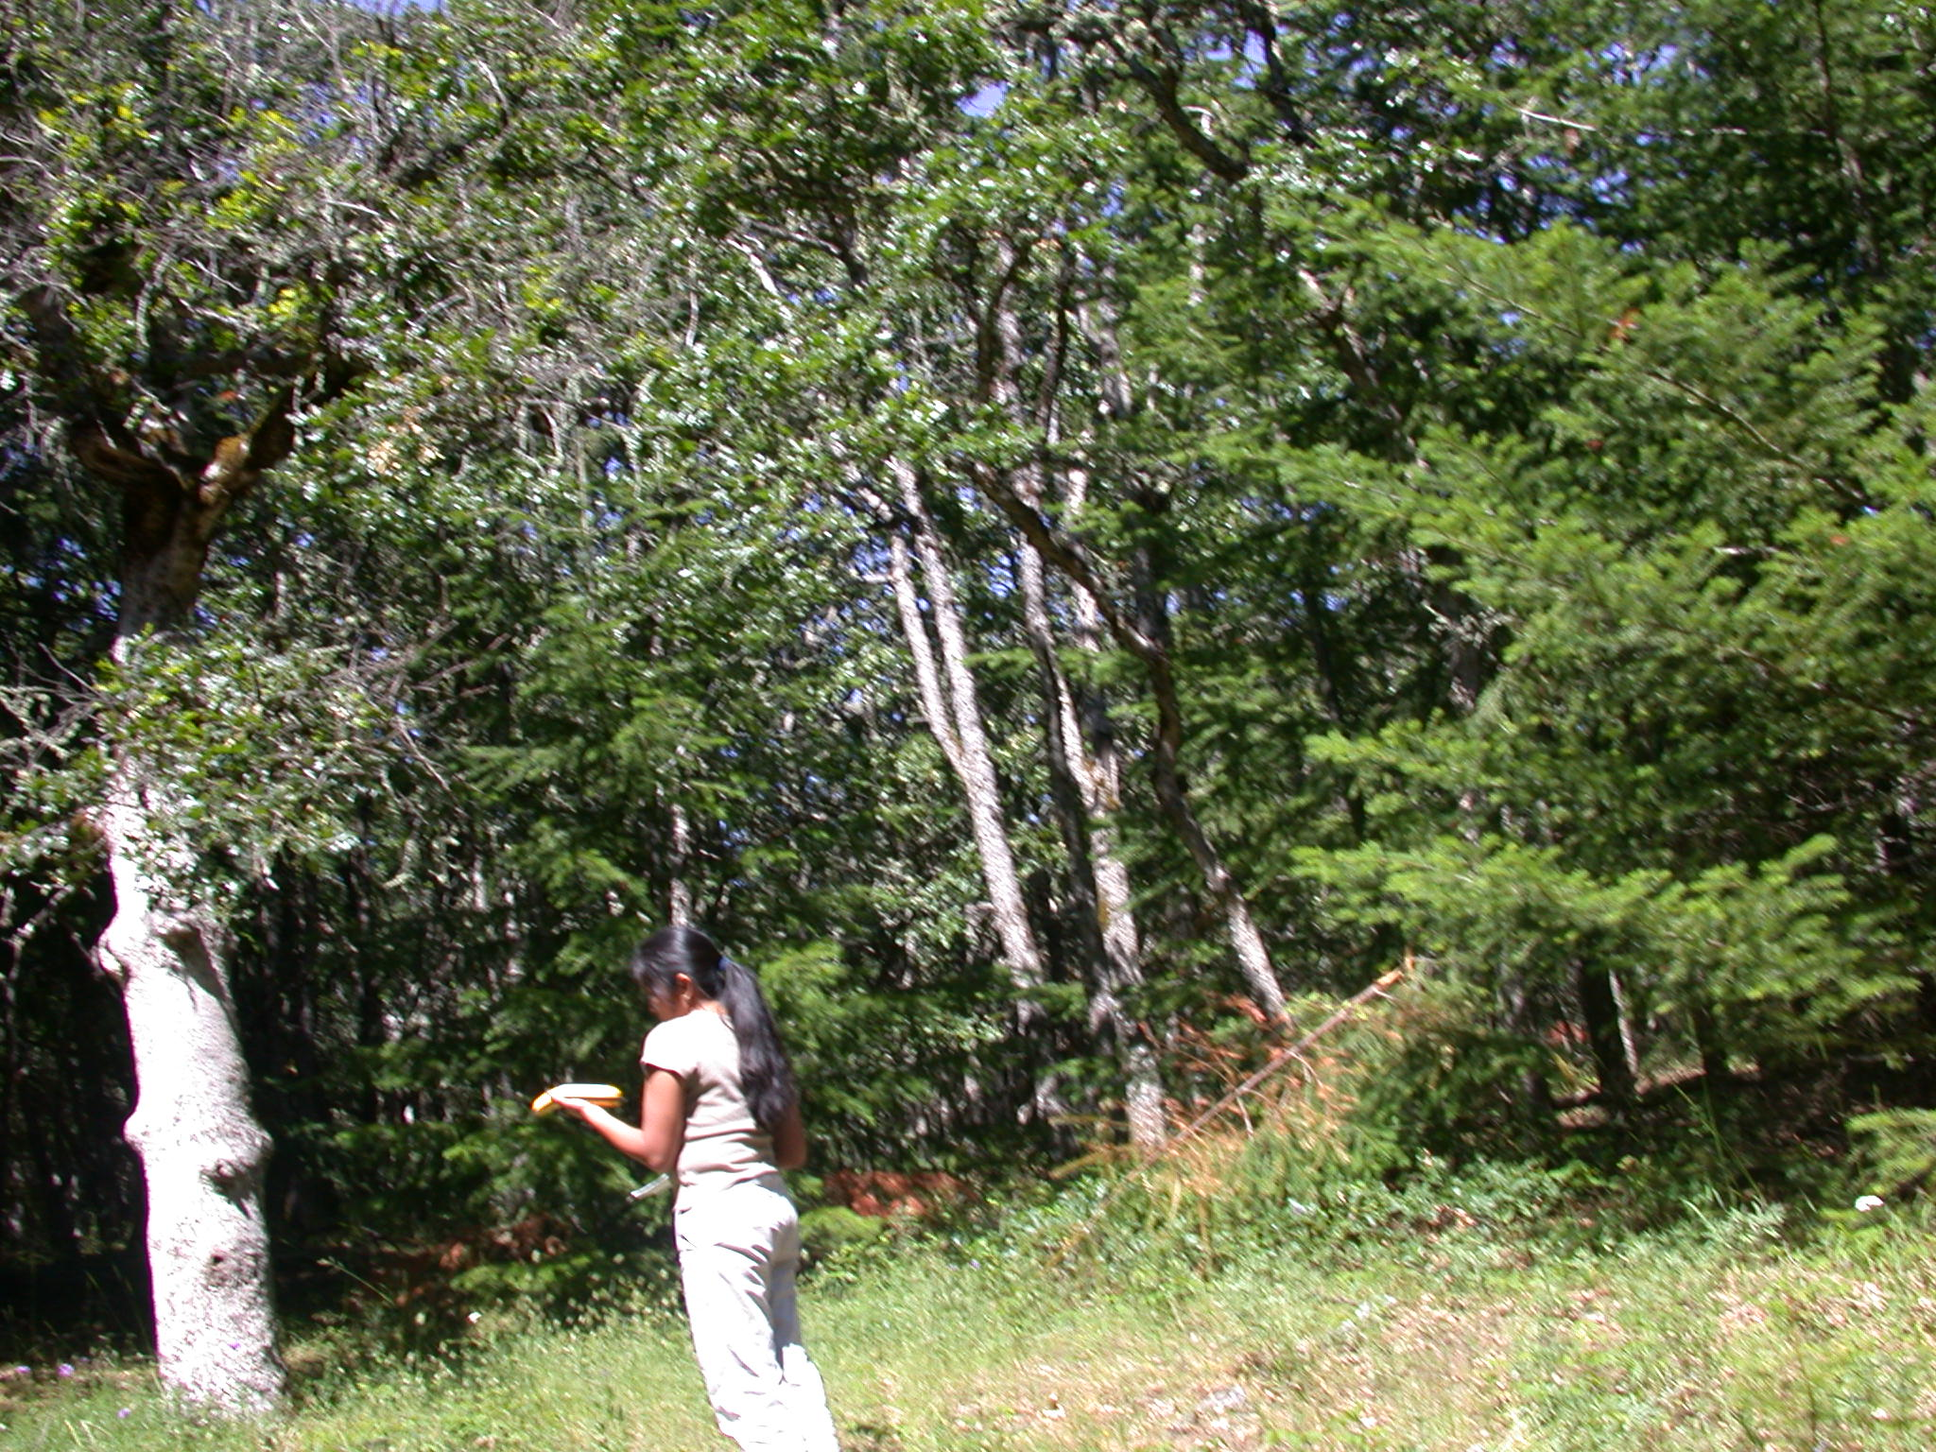

Objectives
The project is planned in a portion of the Klickitat County Wildland Urban Interface designated by the Klickitat and Skamania County, Washington Community Wildfire Protection Plan.

This proposal is designed to increase fire resilience and to restore fire-dependent habitats by reducing the unsustainable in-growth of small trees or the encroachment of Douglas-fir caused by decades of fire exclusion. The planning process benefited from an on-going public and collaborative effort that resulted in a proposed action involving a combination of tree thinning and/or prescribed underburning, implementation requirements for affected resources, and requirements for monitoring.

Project Description
The strategy to meet these objectives is to “thin and underburn” approximately 2510 acres of Fire Regime I, condition class 2 and 3 timber stands in the Wildland-Urban Interface in the Catherine Creek area, to “underburn only” approximately 1300 acres, and retain 290 acres in untreated buffers:
- The proposed action calls for thinning approximately 1,111 acres in the Catherine Creek planning area followed by underburning. Thinning will mostly include trees <21” dbh (diameter at breast height) and will require some road maintenance and landing creation, mechanical tree yarding, piling of slash, and pile burning.

- No ground-based mechanical thinning on slopes greater than 30% and in the oak-pine woodlands (which do not require it). Approximately 1,399 acres will be thinned using chain saws only followed by hand-piling of slash and pile burning.

- Thinning will be “from below” meaning that the smallest--mostly understory trees in the stands will be removed first to achieve the prescribed canopy closure, species preference and size classes after treatment. Large legacy trees will remain. Lower branches on conifers between > 12-21” dbh will be considered for pruning up to 6 ft. to reduce ladder fuels.

- The proposal includes the release of overtopped oak and of large, legacy ponderosa pine trees by removing trees around them on approximately 500 acres.
- The proposal would create a prescribed underburning schedule for thinned tree stands and areas where fire can be reintroduced without thinning in the planning area. Approximately 1300 acres are proposed for underburning only.
- Slash in excess of what can be left on the ground will be chipped and spread on existing roads, grapple or hand piled and burned. Stands may require the establishment of 2.5-3 ft. wide fire-line dug before prescribed underburning where no other fuel break exists.
- Snags will be created in areas that are below requirements of the CRGNSA Management Plan.
- All treated stands will be monitored post-activity for invasive plants.
- Haul routes are planned to be on existing roads or tracks except for a small temporary entry to a landing off Snowden Road. All decommissioned temporary access and other disturbed areas such as fire-line will be seeded with native grasses and wildflowers.
- The implementation window for project activities within ¼ mile of a bald eagle nest is August 16 - December 31, within 400 ft. of a western gray squirrel nest (or 650 ft. from a goshawk nest) is September 1 - February 28.
- The implementation window for pile burning and prescribed underburning will be set according to weather conditions, air quality requirements, and natural resource conditions specific to the exact location and season. The general season outside of bald eagle nest buffers is July 1-March 15 when moisture and weather conditions are favorable.
- The implementation window for thinning w/o hauling on native surface roads or using ground-based machine operation is July 1-February 28 unless winter range is needed for deer and elk.
- The implementation window for hauling and ground-based machine operation is July 1-October 15. This window may be extended up to February 28 in the event of a prolonged dry period as determined by the contract administrator in consultation with CRGNSA resource specialists.

Project Design and Activities

Northern East Conifer East Fork Major Creek
PRESCRIPTION:
Canopy closure is the primary prescription characteristic and shall influence all other elements.

Thin stands to the DFC average canopy closure of 45%. If large (>=20” dbh) pines are found, preserve by removing all trees within a 30’-40’ radius of the center of ponderosa pine >=20” dbh. Preserve legacy largest diameter trees (>20” dbh).

Remove grand fir < 20”, create snags> 20” dbh. (Number per acre as per Management Plan)

Thin all species from below. Thin to a total canopy no more than 20-30% less than existing canopy while maintaining an average of 45% within the DFC range of 35-65%. Exception is allowed to meet DFC canopy maximum of 65%. Emphasize future diameter growth in the spacing.

Release live oak trees >=10” dbh where found by removing all trees within a 25’ radius except leave 1-2 of the largest (>20”) conifer trees on the north side if present. Prefer pine.

Set underburning schedule (every 5-10 years) -- conditions will be monitored starting after thinning implementation and slash treatments are complete.

Openings: Created and maintained by underburning.

Snags, Downed Wood, Shrub and Herbacious Layer: Mitigate the effect of thinning and underburning with reference to invasive plants. Snag creation as per Management Plan.
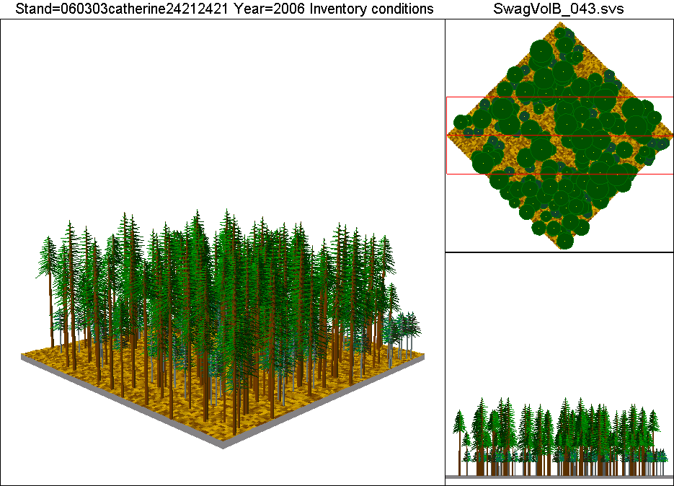
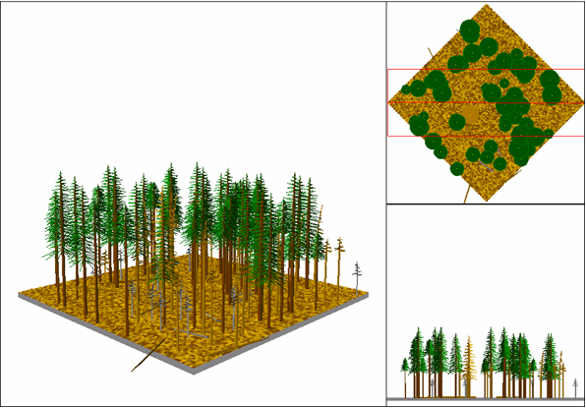
BEFORE THINNING CANOPY 82% AFTER THINNING CANOPY 60%
Forest Vegetation Simulator Model Example for Northern East Conifer

East Conifer
PRESCRIPTION:
Canopy closure is the primary prescription characteristic and shall influence all other elements.

Overstory: Emphasize protection of large legacy pines. Remove all trees within a 30’-40’ radius of the center of ponderosa pine >=20" dbh, preferring the largest pine at a rate no more than 3-4 per acre. Leave oak trees >= 12" dbh within radius if present.

No thinning of overstory pine. Remove accumulated duff around legacy pines where a distinct mound has formed. Leave largest diameter fir.

Understory: Thin all species from below. Prefer pine to fir.
Thin to a total canopy no more than 20-30% less than existing canopy while maintaining an average of 60% within the DFC range of 50-70%.

Release live oak trees >=10” dbh within a 20’ radius but leave 1-2 of the largest (>20”) conifer trees on the north side. Prefer pine.

Set underburning schedule (every 5-10 years) -- conditions will be monitored starting in 5 years from thinning implementation.

Openings: Created and maintained by underburning.

Snags, Downed Wood, Shrub and Herbacious Layer: Mitigate the effect of thinning and underburning with reference to invasive plants. Snag creation as per Management Plan.

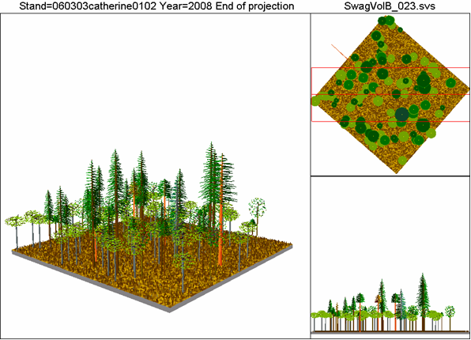
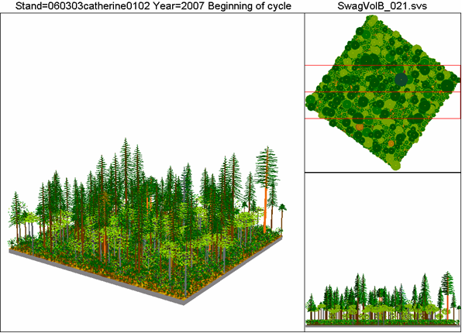
BEFORE THINNING CANOPY 66% AFTER THINNING CANOPY 59%
(Canopy is measured without seedlings—canopy is 96% with seedlings)
Forest Vegetation Simulator Model Example for East Conifer
Pine-Oak-Douglas Fir
PRESCRIPTION:
Canopy closure is the primary prescription characteristic and shall influence all other elements.

Overstory: Step 1: Emphasize protection of large pines. Remove all trees within a 30’-40’ radius of the center of Ponderosa pine >=20” dbh, preferring the largest pine at a rate no more than 3-4 per acre while leaving 1-2 oak trees >= 12” dbh if present within radius. No thinning of overstory pine.

Release DF-overtopped live oak trees >= 10” dbh within a 20’ radius but leave 1-2 of the largest (>20”) conifer trees on the north side. Prefer pine.

Step 1: Not prescribed for areas within 350 feet of western gray squirrel nest.
Step 2: Check residual canopy from Step 1, if desired total canopy allows, thin understory Douglas-fir to 10% canopy while maintaining total canopy as per “understory” below. Leave largest diameter fir (>20” dbh) unless interferes with getting the desired canopy %.

Understory: Thin all species from below. Prefer pine to fir.
Thin to a total canopy (including overstory) of no more than 20-30% less than existing canopy while maintaining an average of 50% within the DFC range of 30-70%. No thinning of oak >10” dbh. Step 2 not allowed within 50 feet of western gray squirrel nest unless canopy not affected.
Set underburning schedule (every 5-10 years) -- conditions will be monitored starting after thinning implementation and slash treatments are complete.

Openings: Created and maintained by underburning.

Snags, Downed Wood, Shrub and Herbacious Layer: Mitigate the effect of thinning and underburning with reference to invasive plants. Snag creation as per Management Plan.
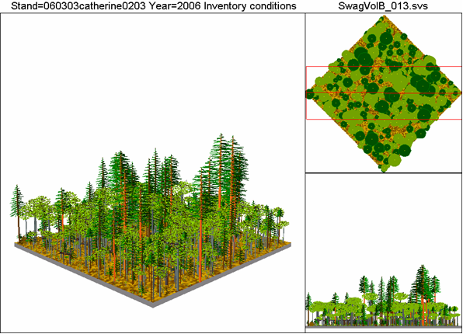
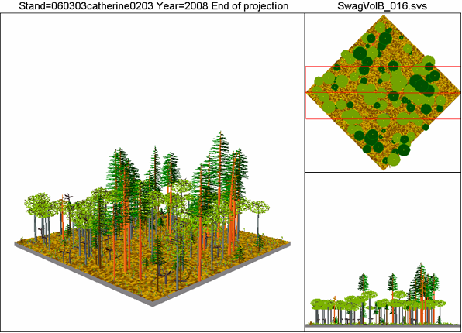
BEFORE THINNING CANOPY 84% AFTER THINNING CANOPY 59%
Forest Vegetation Simulator Model Example for Pine-Oak-Douglas Fir
Oak-Pine Woodlands
PRESCRIPTION:
Canopy closure is the primary prescription characteristic and shall influence all other elements.

Overstory: Emphasize protection of all large trees. Especially pine >20”, oak >10” dbh.
Understory: Thin Oregon oak from below. Thin to a total canopy no more than 30% less than existing canopy while maintaining an average of 50% within the DFC range of 25-60%. Thin areas above 60%. Can thin areas with 25-60% canopy from below if the residual canopy remains at existing per cent.

If existing, remove all Douglas-fir seedlings and saplings either by underburning or mechanical means.

Preserve clumps 100’ feet away from the base of cliffs, caves, or talus slopes with the following:
Leave untreated clumps of 6-10 oaks spaced 50-150 feet apart (vary).
Treated areas within the 100’ buffer are thinned from below in a manner that maintains the existing canopy cover.

Set underburning schedule (every 5-10 years) – Begin underburns in areas not requiring thinning. Monitor conditions in areas requiring thinning after implementation of both thinning and slash treatments.

Openings: Created and maintained by underburning.

Snags, Downed Wood, Shrub and Herbacious Layer: Mitigate the effect of thinning and underburning with reference to invasive plants. Snag creation as per Management Plan.

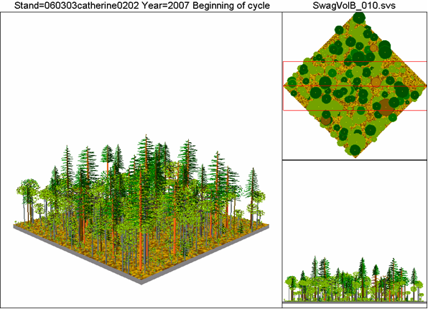
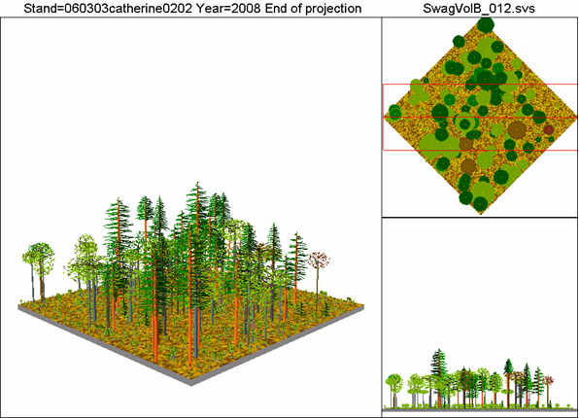
BEFORE THINNING CANOPY 72% AFTER THINNING CANOPY 58%
Forest Vegetation Simulator Model Example for Oak-Pine Woodlands

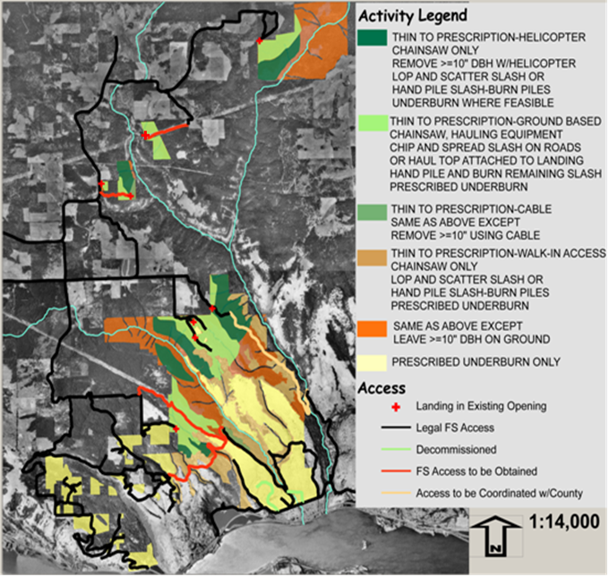
Social Benefits

Monies received from the sale of the sawlogs will be retained and applied, as funding allows, to accomplish the following stewardship projects (in priority): 1) Snag Creation, 2) Down Woody Creation, 3) Flush Cut Stumps, 4) Underburning in Thinned Areas (1,000 ac), 5) Oak/Pine Thinning (1,399 ac), 6) Burn Handpiles (1,399 ac), and 7) Underburning in Unthinned Areas (1,300 ac).

Measurement: Commercial logging/restoration activities included in this Stewardship Project are expected to generate a minimum of 10+ full-time jobs for sixteen months. Best value contracting will be used to select a primary contractor who can demonstrate a commitment to providing quality employment opportunities for local workers, be it through direct crew employment, or through the utilization of secondary services like local hotels, restaurants, etc.
Collaboration and Community Involvement
Public notification regarding the need to restore fire-dependent forest landscapes began in the Burdoin Mountain Planning Area in the winter 2001. In April of 2005, a collaborative and on-going public involvement process was developed and incrementally improved over the years. On March 22, 2006, the Columbia River Gorge National Scenic Area Manger sent a letter to known interested parties including the Indian tribal and local governments, state and federal agencies, and adjacent landowners requesting participation in a collaborative effort to design a forest restoration project in the Wildland-Urban Interface in the Rowena and Catherine Creek areas. All the meetings were announced and open to the general public with the meeting notes placed on the CRGNSA website. Discussions on the Catherine area began on June 15, 2006 with an independent facilitator. The proposed action was the result of the collaborative effort among the following interested individuals, organizations, and agencies:

- 3 private landowners or interested parties
- Washington Department of Fish and Wildlife
- Friends of the Columbia Gorge
- Gifford Pinchot Task Force
- Oregon Natural Resources Council
- USDA, Forest Service
Contracting Authorities to be Utilized and Anticipated Budget
We anticipate that an Integrated Resources Contract – Timber (IRC-Timber) will be used for the Catherine Forest Restoration Stewardship Project. The value of the saw logs is estimated at approximately $1,200,000, which will be applied against the cost of the services bundled in this project. The IRC- Timber contract will include Designation by Prescription. The Forest Service will choose a contractor that is considered Best Value to the government and the local community. If the project revenue is less than anticipated, then the stewardship projects will be reduced accordingly.

Table 1: Authorities Used
Authority | Mark if being Used
Goods for Services | X
Designation by Prescription | X
Retention of Receipts | X
Best Value Contracting | X
Multi-year Contracting | X
Less than full and open competition

Table 2: Anticipated Budget (Goods for Services)
Activity | Goods (+) | Services (-)
Product Value (6,000 mbf) (Net) | $1,200,000
Snag Creation (1,000 ac) |  | $60,000
Down Woody Creation (1,000 ac) |  | $30,000
Flush Cut Stumps (5 ac) |  | $200
Underburning in Thinned Areas (1,000 ac) |  | $500,000
Oak/Pine Thinning (1,399 ac) |  | $560,000
Burn Handpiles (1,399 ac) |  | $56,000
Underburning in Unthinned Areas (1,300 acres) |  | $650,000
Totals | $1,200,000 | $1,856,200*
- The Oak/Pine thinning, Burn Handpiles, and Underburning in Unthinned Areas projects will be prioritized, and/or reduced according to revenue from goods. These unfunded acres may be funded with appropriated funds in the future, if available.

Table 3: Supplemental Funds
None

Table 4: Timeline
Activity | Date | Date | Date | Date
NEPA EA | 5/07
Layout |  | 4/08
DxP Rx |  |  | 4/08
Advertise |  |  |  | 7/08
Multiparty Monitoring
Monitoring evaluation led by the Catherine Collaborative group will follow the monitoring plan as described in the EA and in the monitoring plan created by collaborative group and Forest Service.

SIGNATURE AND CONCURRENCES:

Prepared By
/s/ Bruce Holmson GPNF Silviculturist
/s/ Diana L. Ross CRGNSA Vegetation Team Leader March 31, 2008
Signatures Titles Date

CRGNSA Area Manager Concurrence:

/s/Daniel T. Harkenrider April 1, 2008
Daniel T. Harkenrider Date
Signature

Regional Stewardship Coordinator Concurrence:

_____________________ ______________
Signature Date

Director of Forest Management Concurrence:
_____________________ ______________
Signature Date

Director of Acquisition Mgmt Concurrence:

_____________________ ______________
Signature Date

Regional Forester Approval:

_____________________ ______________
Signature Date

