Stewardship Contract
United States
Department of
Agriculture

Forest
Service

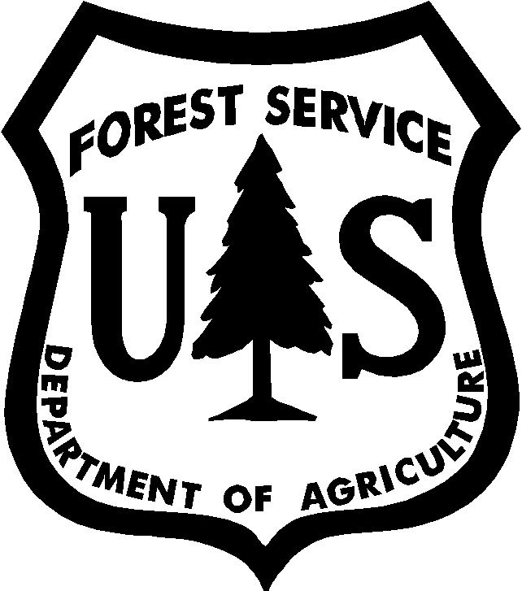

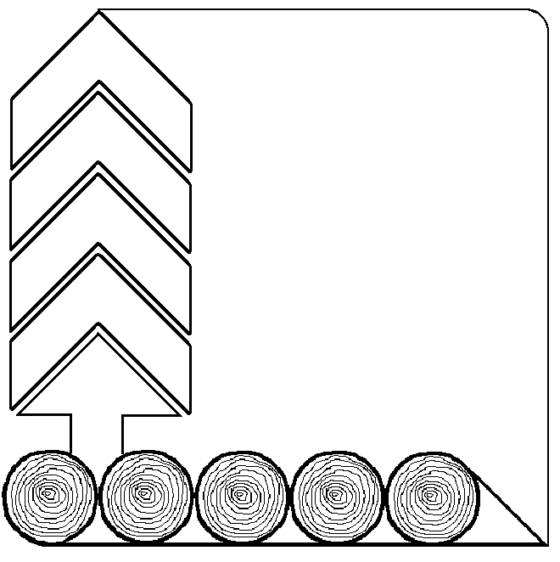

Contractor
Contract Name
Award Date
Contract No.
Region |  | R6 PNW
National Forest
Ranger District

FS-2400-13T (4/04)

