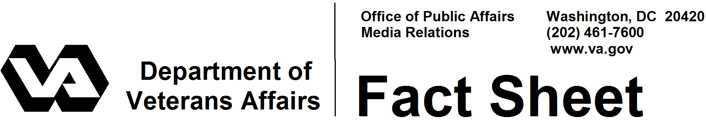

June 2008

Military Funeral Honors

The Department of Defense (DoD) provides military funeral honors at the burials of veterans on request. Funeral honors can be given at private or government-operated cemeteries.

For military funeral honors, the rights of veterans and the responsibilities of the federal government were written into a law, the National Defense Act of 2000 (Public Law 106-65), which took effect in 2000.

Military funeral honors include the presence of an honors detail to fold and present the U.S. flag to the next of kin and play “Taps,” either by a high-quality recording or by a bugler. The law defines a military funeral honors detail as two or more uniformed military persons, with at least one being a member of the veteran's branch of military service. Taps will be played by a bugle if available, but today the military services have so few buglers that they often cannot provide them.

Funeral home directors request funeral honors from DoD, whether burial is in a national cemetery or another cemetery. The Department of Veterans Affairs (VA) staff at national cemeteries also can assist to arrange funeral honors at VA national cemeteries.

Some local veterans organizations may provide military funeral honors or assist military members rendering honors. When honors are desired at a national cemetery, they are arranged by the funeral home in advance of the committal service. A few VA national cemeteries are served by veterans groups or other volunteers who regularly provide funeral honors.

DoD maintains a military funeral honors web site at www.militaryfuneralhonors.osd.mil.
Questions or comments concerning the program may be sent to this DoD address:

Department of Defense
Directorate for Public Inquiry and Analysis
Room 3A750, The Pentagon
Washington, DC 20301-1400

# # #

