Top 10 Core Competencies and Courses as Selected by Practicing Emergency Managers

A few years ago, the CEM Commissioners were discussing the CEM program and the CEM exam question bank. We knew that FEMA was changing because of changing priorities in the Department of Homeland Security, in the US government, and in the world. The question was how to capture those changes and reflect them in the CEM program specifically, and in the emergency management profession in general. The commissioners bantered about various suggestions and brainstormed ideas. We concluded that what was needed was a Common Body of Knowledge for emergency managers everywhere.

The CEM Commission Chair asked me if I would head up the project of developing a Common Body of Knowledge and I said, "Yes." The Chair had two goals in mind for this project. The first goal was to have a list of competencies that could be used to update the CEM certification program, including the exam question bank. The second goal was to use the list to develop CEM study guides and training materials.

Multiple Surveys

For more than 18 months, I surveyed emergency managers worldwide through the IAEM LISTServ to develop a Common Body of Knowledge for emergency management practitioners. The survey started out as a simple one; it only asked the respondent to list a couple of critical skills or competencies that a person working in emergency management should possess. Over time, multiple requests, and follow-up e-mails, my response rate was very low.

Previous studies indicated that people would respond to simple surveys more readily than complicated ones. The response rate would also be higher if the survey was short and easy to answer. Based on these lessons learned, I limited the survey to one question. I assumed it would be easy for people to list a few critical skills based on their personal experiences. In addition, I did not want to limit the potential answers by providing a list from which to choose. Obviously, my assumption was wrong. The responses I got were limited to comments like, “the four phases of emergency management,” or “all skills.” These responses did not meet the CEM Commissioners’ requirements, so I redesigned the survey.

The second survey listed a number of competencies and skills based on previous responses. I asked people to rank the list and left a blank space for them to add competencies or skills they though should be included. Through the IAEM LISTServ, I received many more suggestions and ideas this time. Responses came from practicing emergency managers as well as emergency management program professors and students. As before, the vast majority of respondents said to keep the four phases of emergency management. Others said to add management-type topics. Still others said to follow the requirements of NFPA 1600. The problem this time was a lack of consensus, even among the CEM Commissioners and IAEM Board members.

At the 2004 Higher-Education Workshop sponsored by FEMA, I discussed my difficulties with practitioners and academics from all over the world. Many of whom experienced the same difficulties I was with developing a list of core competencies, so we knew this was an important project for emergency managers everywhere. We then had a meeting with B. Wayne Blanchard, Ph. D., CEM, FEMA's Higher Education Project Manager and CEM Commissioner to get his insights and suggestions. Dr. Blanchard convinced us to expand the project to include the Top 10 Core Competencies required of an emergency manager in the field, and of students in emergency management degree programs at the associate's, bachelor's, and master's levels. We were also to develop a list of the Top 10 Core Courses. The findings from each project would then be presented at the Higher Education Workshop scheduled for June 7-9, 2005. The goal would be to bring together all these diverse responses, develop conclusions and come to a consensus regarding the core competencies and core courses for emergency managers.

In the 2005 survey, I refined the list of competencies based on previous survey responses. In this survey, I asked respondents to choose their Top 10 from a list of 21 competencies or to add some of their own. Here is the 2005 survey I used.

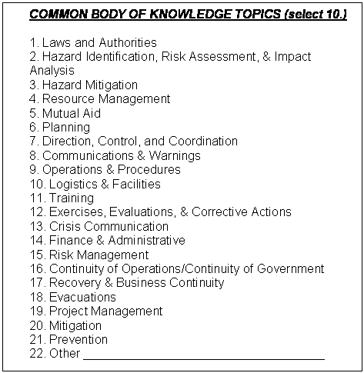
2005 Core Competencies Survey

Only 150 of 2005 surveys were returned where the respondent actually selected ten competencies. Many respondents did not want to complete a survey. They simply said, “All are important,” “I cannot choose,” “Great job,” “I agree,” or “Adopt the standards set forth by NFPA 1600.” I did not include any of those responses in the tally. It would not have made much difference in the list of competencies anyway, since many of the NFPA 1600 competencies were included in the list. In addition to the written surveys, I conducted more than 35 face-to-face interviews with the CEM Commissioners and the IAEM Board members. Their votes were included in the final tally.

The number of votes received on each competency is listed to the right of the competency.

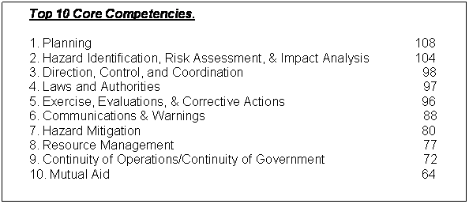
2005 Survey Top 10 Results

It is interesting to see the remaining responses for comparison purposes. The next eleven competencies are listed below along with the number of votes each received. I received 20 additional competencies, but each received only one vote.

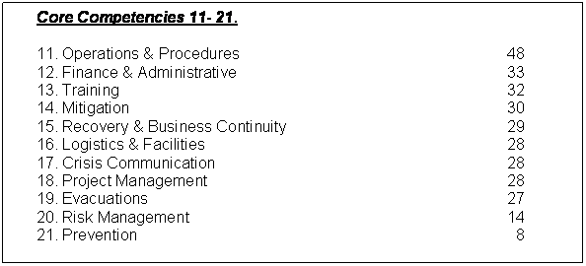
2005 Survey Top 11 - 21 Results

In totality, the competencies chosen tended to follow the four phases of emergency management we all know and the requirements listed in NFPA 1600. There were no surprises from the survey.

Core Courses

The second part of my project was to discover what practitioners believed were the most important courses emergency managers should take. It was easier to get responses on this question as most have taken multiple FEMA courses in resident or independent study. Courses taught at the university level were not mentioned. I suspect that was because most practitioners have not taken any of them. Those courses should be incorporated in the academic surveys. The Top 10 Core courses are listed below.

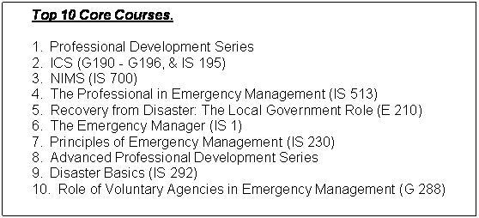
2005 Survey Top 10 Core Courses

For comparison purposes, I have included the next nine courses in the table below.

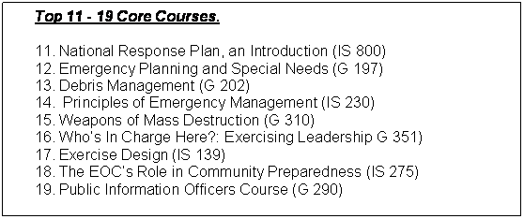
2005 Survey Top 11 - 19 Core Course Results

Summary

While the results of both surveys were based on the personal preferences of the responders, and not on any kind of scientific analysis of required tasks and job skills, they are illustrative of the competencies that practitioners view as being most critical.

My thanks and appreciation goes to all who contributed to these surveys. However, the whole project isn't completed yet. This was only the first step. The next step is to come to a consensus on the core competencies based on the results of the academic surveys and then flesh out each core competency to turn the list into a Common Body of Knowledge. What we develop here will become part of emergency management for years to come. It will affect our training and education programs, IAEM’s CEM certification program, our conferences and workshops, our profession, and our future through the knowledge, skills and abilities that will be developed in the emergency management students.

Daryl Lee Spiewak, CEM, TEM, TCFM
IAEM President 2003-2004
O 254-761-3136
daryls@brazos.org

