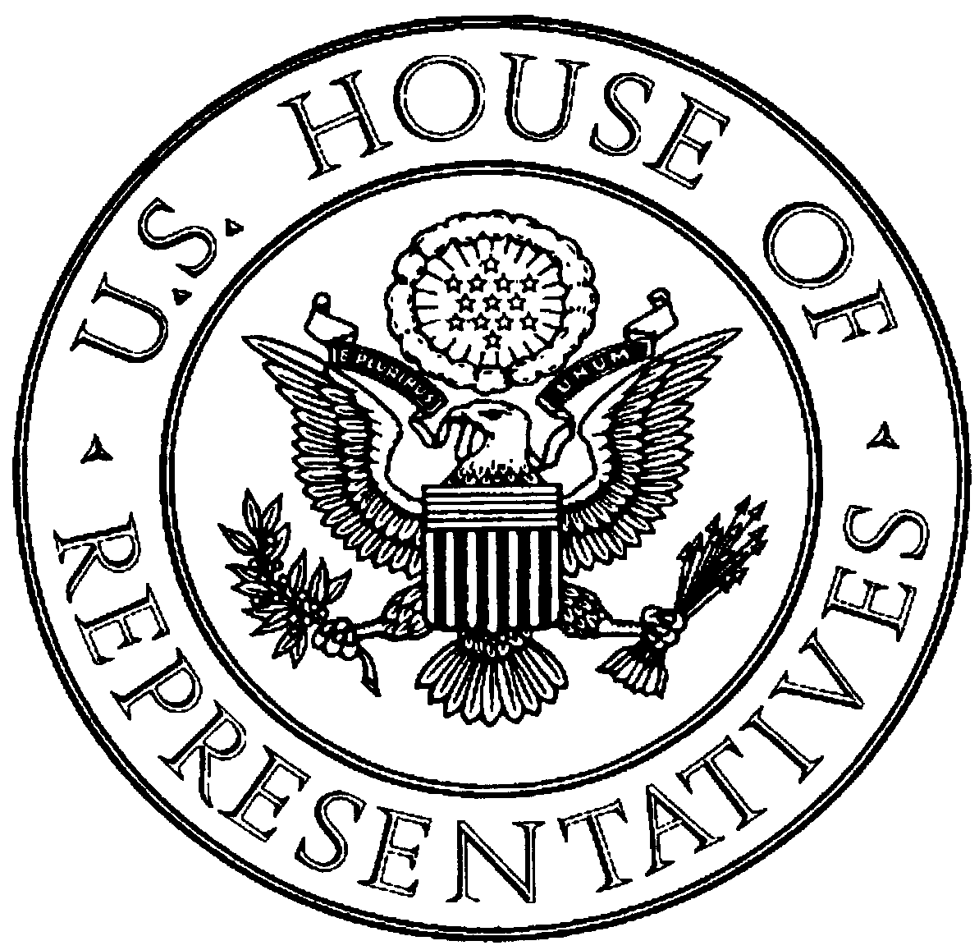Office of Congressman Dennis Moore Privacy Act Waiver
8417 Santa Fe Drive, #101
Overland Park, Kansas 66212

NAME:_______________________________  ADDRESS:____________________________  City/State/Zip______________________________  PHONE:______________________________  Work/Cell_____________________________  EMAIL:_________________________________ | SOC. SEC. #________-_______-________  DATE OF BIRTH:______/______/______  CASE NUMBER or other identifying information:________________________________________________________________________________________________________

Please explain the concerns you are having and what assistance you are requesting:

Have you contacted any other elected official to assist you problem?____________________  (Name) | Do you currently have an attorney working  on your case?_________________  (Yes or No)

I hereby authorize Congressman Dennis Moore or his staff, under the “Right to Privacy Act,” to request, receive, and copy any information regarding this matter from proper agencies. I hereby release you from any liability that may arise by furnishing the requested information.

Signature: _____________________________________ Date __________________

