slender-spiked mannagrass
Glyceria leptostachya Buckl.
Plant symbol = GLLE2

Contributed by: USDA NRCS Plant Materials Center, Corvallis, Oregon
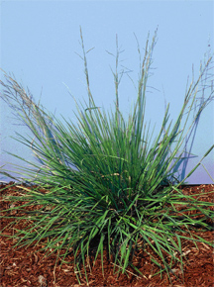
Dale Darris
USDA NRCS Corvallis PMC
Alternate Names

Other common names include davy mannagrass, slimheaded mannagrass, and soft mannagrass.

Uses
Slender-spiked mannagrass is a lesser known, mid-sized native grass suitable for wetland restoration and enhancement. It may also be used for seeding the edges of streams and lakes, as well as the bottom of low gradient drainage ditches and other watercourses. This species exhibits a low lying growth form and floating leaves that may help reduce erosion by lining banks and channels during high flows. The seed and leaves are probably a source of food for waterfowl, birds and small mammals, similar to other mannagrasses.

Forage value and palatability for livestock are unknown. However, the tender, green foliage is probably utilized by deer and other ungulates.

Low lying stems, vegetative spread, and floating leaves may enhance its value for erosion control along slower flowing ditches, streams, and waterways.

Status
Please consult the PLANTS Web site and your State Department of Natural Resources for this plant’s current status (e.g. threatened or endangered species, state noxious status, and wetland indicator values).

Description and Adaptation
Slender-spiked mannagrass is a short-lived, perennial, cool season grass with succulent foliage and erect to low lying stems that are 60 to 110 cm tall. Reportedly, this grass also produces rhizomes (underground stems), but individuals often retain a more bunchgrass appearance. Plants may spread vegetatively from lower stems that root at nodes (joints) in contact with the soil. The leaf blades are flat to rolled slightly inward, 3 to 7 (10) mm wide, and rough on both sides. On land, they develop mostly at the base of the plant but floating leaves can form when plants are submerged. The flowerhead (panicle) is open, 20 to 40 cm long, with a few branches pressed close to the main axis. Slender-spiked mannagrass occurs from Alaska south to California but not further inland.

Key to identification: In our area this species looks like a smaller version of western mannagrass (Glyceria occidentalis), which is coarser, more open, and has much larger seeds. It can also be confused with northern mannagrass (Glyceria borealis) but the latter has a smooth leaf blade while the upper blades of slender-spiked mannagrass are rough in texture. Consult a botanical key to distinguish these species.

Relative abundance in the wild: Generally uncommon throughout its natural range compared to other mannagrasses. Scattered plants are occasionally found along small streams and in riparian wetlands or marshy areas, especially in the Willamette Valley of Oregon and along the Coast. Seed ripens in July or August. Retention within the panicle is poor to fair at best. Wild collections rarely yield much seed because populations are usually small and plants are widely scattered.

Adaptation: This species is well adapted to wet meadows, the margins of streams, lakeshores, freshwater marshy areas, and other depressions that stay moist in summer. It easily withstands year round inundation by developing a floating leaf growth form. However, longevity may be reduced. This species is found on acidic soils that are coarse to fine textured. Tolerance to salinity, alkalinity, or high soil acidity is unknown. Slender-spiked mannagrass typically grows in full sun.

Establishment
Slender-spiked mannagrass seed has no strong dormancy and germinates at a moderate rate in fall or spring. Establishment rate is intermediate. Hulls are loosely attached and may be readily removed during seed processing. There are approximately 1,300,000 seeds/lb (+/- 30%). A sowing rate of 1 lb per/ac of pure live seed will result in about 30 live seeds per square foot. The potential high cost of seed may limit its use to mixtures with other native grasses. Based on seed size and seedling vigor alone, a seedling rate of 2 to 5 lbs/ac may be adequate for a single species stand.
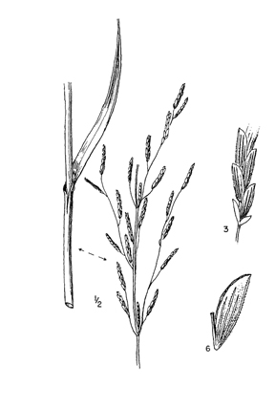
Line drawings reprinted with permission, University of Washington Press
Management
There is a lack of information about the management of slender spiked mannagrass for livestock or other purposes. Succulent growth should favor palatability, but grazing would be inappropriate or restricted under the wet environments where this species grows. Seed production requires extensive irrigation, poorly drained soils, seasonal wetlands, or shallow water impoundments. Regeneration is favored by disturbance and the presence of open mud or prolonged moist soil that is sparsely vegetated. This species may be suited to moist soil management (slow de-watering, disking, etc.) of impounded wetlands for improving waterfowl, shorebird, and other wildlife habitat.

Environmental Concerns
It is difficult to obtain seed of any volume from the wild. In western Oregon, other mannagrasses, especially western mannagrass, are considered weeds in low lying fields of Italian ryegrass (Lolium spp.) grown for seed. Apparently, slender-spiked mannagrass is of infrequent or lesser concern. It is not reported to be a competitive, weedy or invasive plant species.

Cultivars, Improved, and Selected Materials (and area of origin)
This species is rarely sold as seed or plants. Availability depends on wild collections or contract growing with producers who specialize in native herbaceous plant seed.

Prepared By:
Dale Darris, USDA NRCS Plant Materials Center, Corvallis, Oregon.

Species Coordinator:
Dale Darris, USDA NRCS Plant Materials Center, Corvallis, Oregon.

Edited: 21mar2006 jsp

For more information about this and other plants, please contact your local NRCS field office or Conservation District, and visit the PLANTS Web site<http://plants.usda.gov> or the Plant Materials Program Web site <http://Plant-Materials.nrcs.usda.gov>

The U.S. Department of Agriculture (USDA) prohibits discrimination in all its programs and activities on the basis of race, color, national origin, sex, religion, age, disability, political beliefs, sexual orientation, and marital or family status. (Not all prohibited bases apply to all programs.) Persons with disabilities who require alternative means for communication of program information (Braille, large print, audiotape, etc.) should contact USDA's TARGET Center at 202-720-2600 (voice and TDD).
To file a complaint of discrimination write USDA, Director, Office of Civil Rights, Room 326-W, Whitten Building, 14th and Independence Avenue, SW, Washington, DC 20250-9410 or call 202-720-5964 (voice or TDD). USDA is an equal opportunity provider and employer.
Read about Civil Rights at the Natural Resources Convervation Service.

