EXCLUDED PARTIES LIST SYSTEM (EPLS)
PUBLIC USERS MANUAL
(Version )

Last Revision Date:
Contract Number: GS-35F-0425K

Submitted to:

United States General Services Administration (GSA)
Office of the Chief Acquisition Officer (OCAO)

Integrated Acquisition Environment (IAE) Division
2011 Crystal Drive, Suite 911
Arlington, VA 22202

Submitted By:

Information Sciences Corporation (ISC)
3720 Farragut Avenue
Suite 301
Kensington, MD 20895
CONTENTS

1 Scope 1
1.1 System Overview 1
1.2 Document Organization 2
2 Search 3
2.1 Basic Search 4
2.2 Search Navigation 5
2.3 Advanced Search 8
2.4 Search by Multiple Names 10
2.5 Exact Name and SSN/TIN Search 12
2.6 MyEPLS 13
2.7 Basic Archive Search 14
2.8 Advanced Archive Search 14
3 Reports 15
4 Web Service Interface for Searching EPLS Data 16
5 Cause and Treatment (CT) Code Descriptions 17
6 General Information 18
6.1 Agency Contacts 18
6.2 Agency Descriptions 18
6.3 State/Country Code Descriptions 18
6.4 Search Help 18
6.5 Public User's Manual 18
6.6 FAQ 18
6.7 Acronyms 18
6.8 Privacy Act Provisions 18
6.9 News 19
6.10 Contact Information 19
Appendix A - Sample EPLS Reports 20
Appendix B - Acronyms 25

List of Figures

Figure 1: EPLS Main Page 1
Figure 2: Basic Search 4
Figure 3: Basic Search Results 5
Figure 4: Printer-Friendly Selection 7
Figure 5: Advanced Search Page 8
Figure 6: Advanced Search Results 10
Figure 7: Search by Multiple Names 11
Figure 8: Exact Name and SSN/TIN Search 12
Figure 9: MyEPLS Preferences Screen 13

Scope

System Overview
The EPLS is an electronic, web-based system that identifies those parties excluded from receiving Federal contracts, certain subcontracts, and certain types of Federal financial and non-financial assistance and benefits. The EPLS keeps its user community aware of administrative and statutory exclusions across the entire government, and individuals barred from entering the United States. The user is able to search, view, and download both current and archived exclusions.

EPLS access is available from any personal computer with Internet connectivity and a minimum web browser of Netscape 4.04 or Internet Explorer 4.0 at http://www.epls.gov. The EPLS website’s Main Page (or home page) is shown in Figure 1.

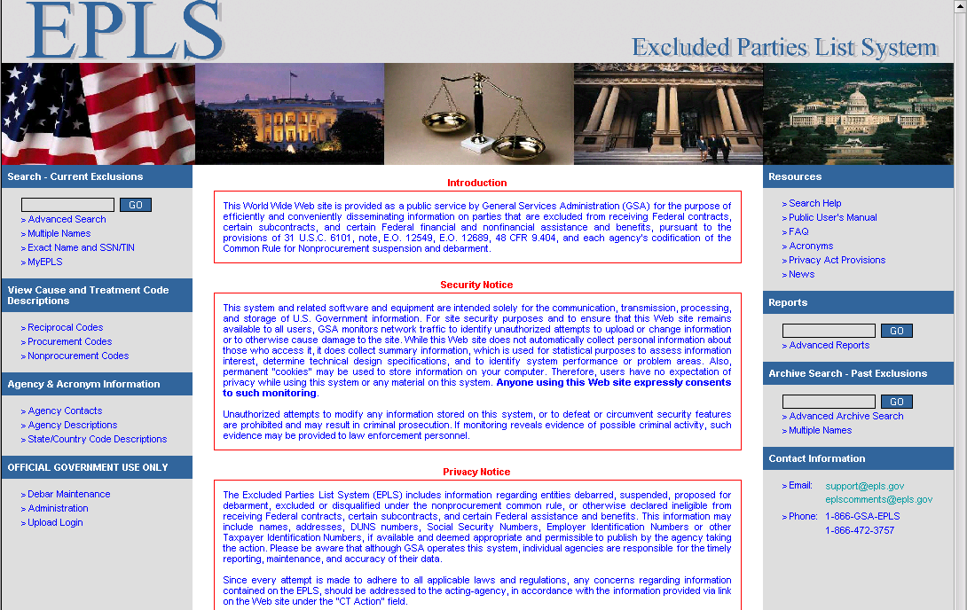
Figure 1: EPLS Main Page
The general public is not required to register for a user name and password to begin using the EPLS. For general users, the EPLS provides:

- The ability to search current and/or past exclusions.
- Points of Contact information for each agency.
- A range of standard reports for downloading.
- Definition of the Cause and Treatment Codes applied to an exclusion.
- EPLS support contact information.
- A list of frequently asked questions.
- Access link to the latest EPLS News

Document Organization
This users’ manual contains the following sections:

Section 1 Scope
Section 2 Search
Section 3 Reports
Section 4 Web Service Interface for Searching EPLS Data
Section 5 Cause and Treatment (CT) Code Descriptions
Section 6 General Information

Appendix A Sample Reports
Appendix B Acronyms

Search
You can search the EPLS database using any one of the Search options - the Current Exclusions Search menu offers three options and the Archive Search menu offers two options. After your search is complete, you can either view the search results immediately or download them to your computer. When performing any of the available search options, the entire database is queried for the search option selected.

NOTE:
While the Department of Treasury's Office of Foreign Assets Control (OFAC) List has been fully integrated in EPLS for access at a single location, it does not replace the List available at the OFAC web sites.

Instructions on how to obtain OFAC specific data only:
The OFAC List previously identified as Specially Designated Nationals (SDN) "SDN and Blocked Persons List" is searchable through the EPLS Search Menu. To obtain a complete listing of OFAC exclusions only, users can select Advanced Search, then select TREAS-OFAC from the Agency list and click on the Search button to execute the search.

The Department of Commerce's Bureau of Industry and Security (BIS) maintains two lists -- the "Denied Persons List" and the "Entity List" for Contract Officer consideration. For those transactions that may involve exports from the United States or reexports of U.S.-origin items, parties (including U.S. Government officials) are encouraged to review the Export Administration Regulations (15 C.F.R. 730 et. seq.) maintained by BIS ( www.bis.doc.gov). For any questions regarding such matters, please contact BIS's Office of Exporter Services at (202) 482-4811.

Basic Search
This type of search finds all exclusions by performing a partial name search, and it is recommended that the user search by the last name of the individual or the first word of the company’s name.
- At the Main Page, enter the name that you would like to search for (Smith in this example) in the field at the top left, as shown in Figure 2.
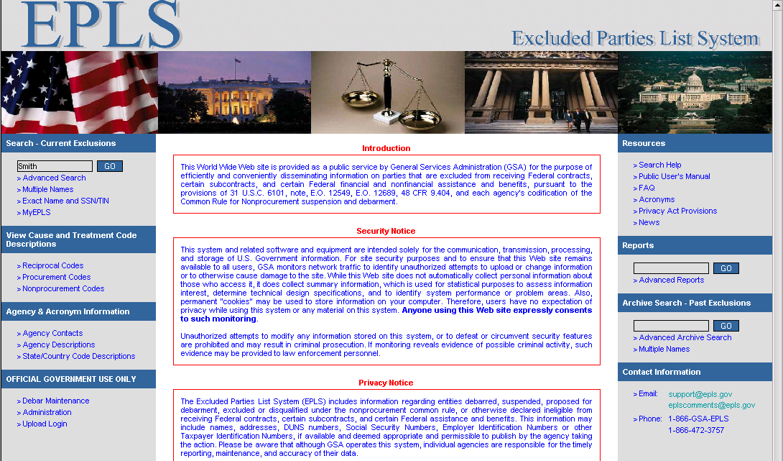
Figure 2: Basic Search

- Hit the Go button to the right of the field.
- Search results will be displayed in a screen similar to Figure 3.
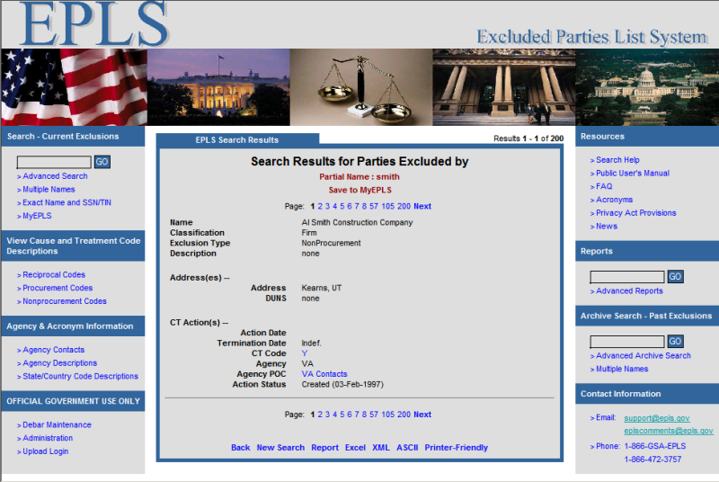
Figure 3: Basic Search Results

Search Navigation
From the search results shown in Figure 3, several options are available to help you better use the results found:
- The search query that you used to find these results may be saved for future use by clicking the Save to MyEPLS link. MyEPLS is discussed further in section 2.6
- For searches that return a large number of results, you may navigate to result pages using two different methods. The first method is to click on the page number either at the bottom or top of the search results. To assist with searches that return a very large number of pages, pages are not listed sequentially but will instead display a few that are close to your current page and a few that are fairly far away. The second method is to click on the letter that corresponds to a search results page. This method is only available when using the Advanced Search interface and is described in more detail in section 2.3.
- You may go to the Advanced Search as described in section 2.3 by selecting the Back link.
- The search results may be shown in a user readable report format by selecting the Report link. This produces the same data as the ASCII link described below, but the data will be shown in the browser window, instead of being saved to disk.
- Search results may be downloaded in Comma Separated Value (CSV) report format for use with most popular spreadsheet applications, including Microsoft Excel by clicking on the Excel link. Reports are described in further detail in section 3.
- Data may be downloaded in Extensible Markup Language (XML) report format by selecting the XML link, This option, as well as various report options may be useful for retrieving the data in machine readable format. The (Document Type Definition)DTD describing the format of the data can be found at http://www.epls.gov/EPLS.dtd. Reports are described in further detail in section 3.
- In addition to the previous machine readable formats, downloading of the results in text report format may be achieved by selecting the ASCII link. Although this format may not be very easy for a machine to process, it may be useful for manual, offline browsing by a user. Reports are described in further detail in section 3.
- To produce a printer friendly version of the results, click on the Printer Friendly link. This option will allow you to remove menus, some formatting, and images from the search results, and will display all results on a single page. If the current search results span more than one page, a screen similar to Figure 4 will be displayed. This screen contains three options for viewing the printer-frindly display: all records, only records on the current page, or a user-specified range of search results pages. Users should be careful when selecting the All option or selecting a large Pages range as this may produce a very large document and could potentially cause your web browser to terminate unexpectedly.

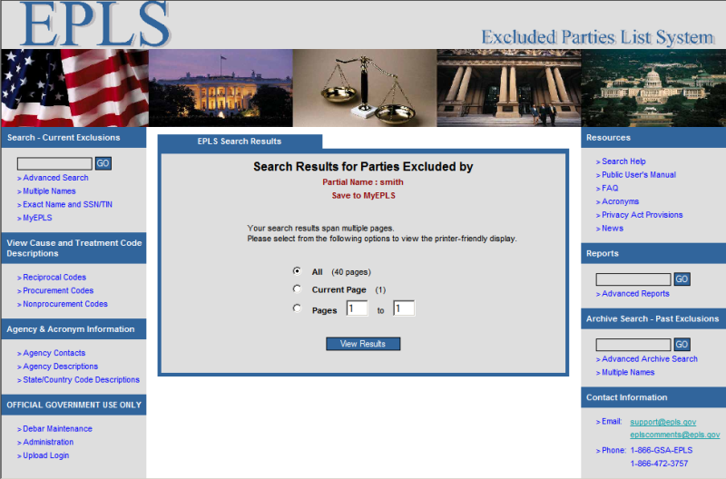
Figure 4: Printer-Friendly Selection

Advanced Search
The Advanced Search page allows you to specify a large variety of search criteria as shown in Figure 5.
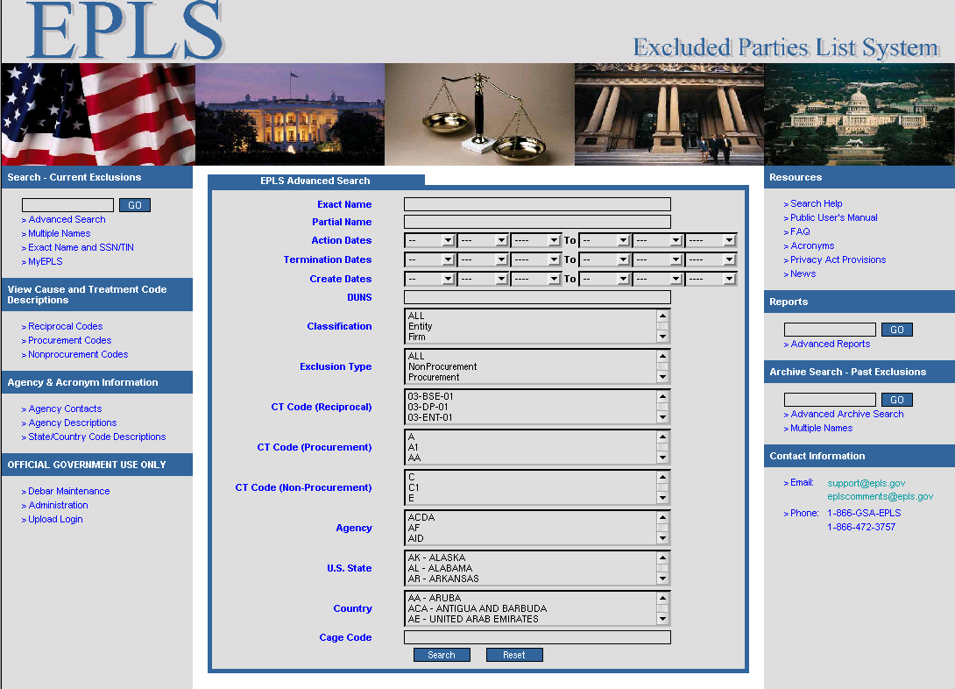
Figure 5: Advanced Search Page

These search criteria include:
- Exact Name – Enter a name exactly as it will appear in the search results. Case does not matter, but punctuation does, for example: 'Doe, John'
- Partial Name - Enter one or more search terms. A record will match the search if it contains at least one of the specified search terms. For example:

 | Search Term(s) | Matches
Single Term: | John | Doe, John
 |  | Williams, John
Multiple Terms: | John Doe | Doe, John
 |  | Doe, Jane
 |  | Williams, John

- Any portion of then name of an entity in EPLS. For example: 'John', 'building', or 'Smith'
- Action Date range – The date range when a debarment first becomes active. You must supply both a starting and an ending date.
- Termination Date range – The date range when a debarment will be terminated. You must supply both a starting and an ending date.
- Create Date range – When the data was first entered into the EPLS.
- Data Universal Numbering System (DUNS) number – The number provided by Dun & Bradstreet to uniquely identify a business. It is important to note that all EPLS records identified as “Firms” may not provide a DUNS number. Therefore, the user should also perform a Name search to ascertain that the concerned Firm is not listed in the EPLS.
- Exclusion Type – What type of exclusion is associated with the entity. Each CT code is associated with an Exclusion Type and a single code may be associated with several Exclusion Types. Consequently, CT codes may be selected for each of the available Exclusion Types. If one or more Exclusion Types are selected, all selected CT codes must correspond to the selected Exclusion Types. For example, it is incorrect to select an Exclusion Type of Procurement and a CT code from the Reciprocal list.
- Cause and Treatment (CT) Code – The reason why the entity has been debarred.
- Agency – The agency that imposed the debarment.
- US State – The US state where the entity is located.
- Country – The country where the entity is located.
- Agency specific identifiers (at the writing of this document only Cage Code) – An identifier that may be specific to one or more US federal government agencies.
More than one advanced search criterion may be selected, but they do not all need to be selected to perform a search. In fact, many searches will not return any results if more than two criteria are selected, as each one will reduce the number of returned search results.
The screen shown in Figure 6 is an example of search results provided by an Advanced Search. A search was performed for exclusions by the HHS Agency. When performing searches by criteria other than Partial Name or Exact Name, an alphabetical navigation option is displayed. When you click on a letter, the first record that begins with the letter will be displayed. Clicking on the “#” symbol will display records that begin with either a symbol or a number. If the search results do not contain records that begin with the selected letter, no results will be displayed.
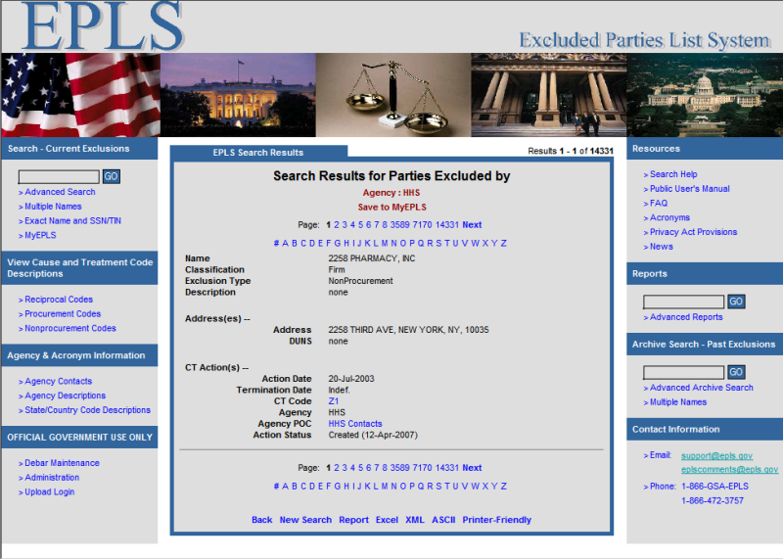
Figure 6: Advanced Search Results

Search by Multiple Names
This type of search finds all current exclusions, based on either a partial or exact match for up to five user-specified names.

- At the Main Page (Figure 1), click the Multiple Names link of the Search Menu to bring up the screen shown in Figure 7.
- Click the Match radio button to search for either Partial Names or Exact Names. Enter the names on which you wish to search in the Name 1, Name 2, etc. fields.
- Click Search.
- Navigate through the search results as described above.

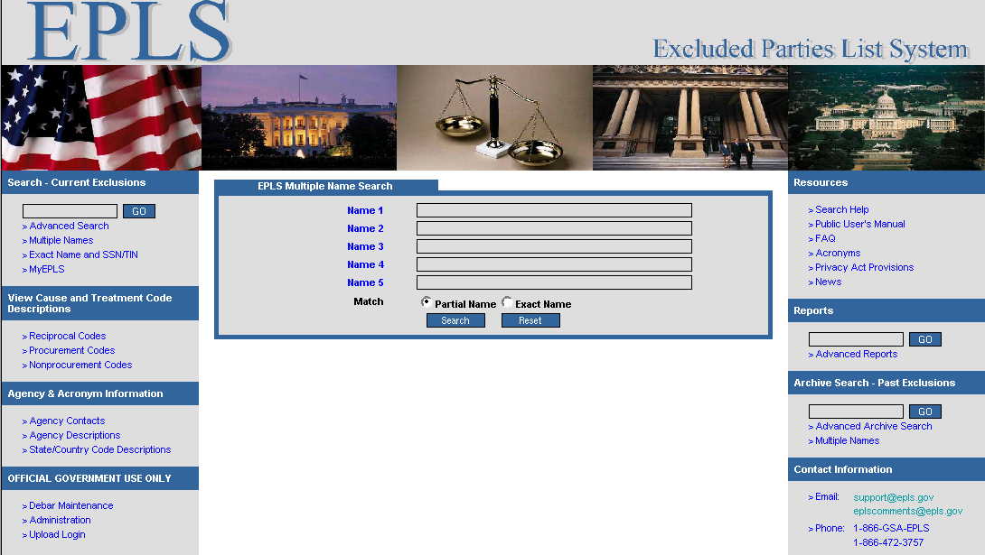
Figure 7: Search by Multiple Names

Exact Name and SSN/TIN Search
NOTE

This may not be the most optimal way to determine if an entity is excluded, because the system may not have an SSN/TIN for each listed entity. Trying another search menu option first is highly recommended.

This type of search finds a current exclusion that has an exact “Name and SSN or TIN” match based on the information entered by the user.

- Click the Exact Name and SSN/TIN link of the Search – Current Exclusions menu to bring up the screen shown in Figure 8Figure 8.

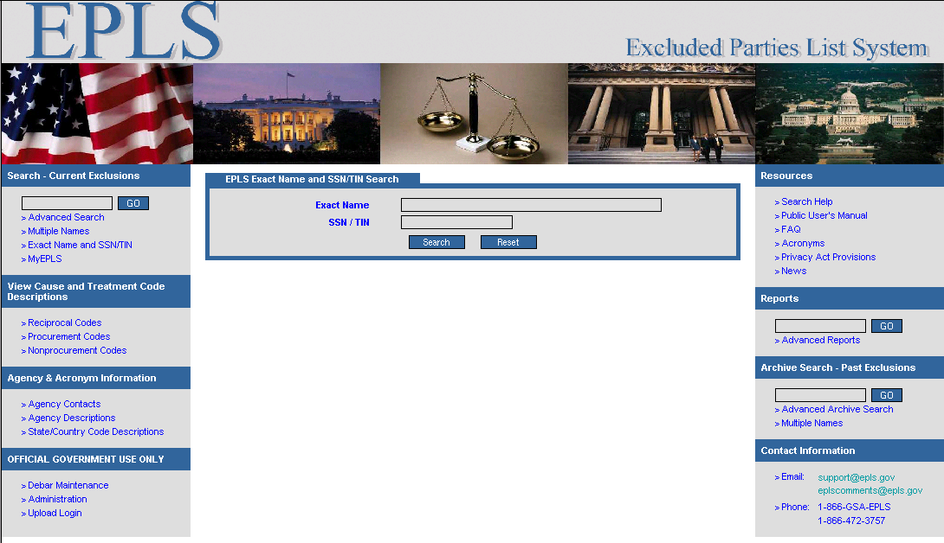
Figure 8: Exact Name and SSN/TIN Search

- Enter the name in the name field, exactly as it is stored within EPLS. If you are unsure of how the name is formatted, you should first perform a basic search as described in section 2.1.

- Enter the nine-digit SSN/TIN number you wish to search on in the fields provided. Do not include any dashes in the SSN/TIN.

- Click Search.

MyEPLS
MyEPLS allows you to customize EPLS search behavior to suit your needs, and supports the following features, which may be seen in Figure 9.
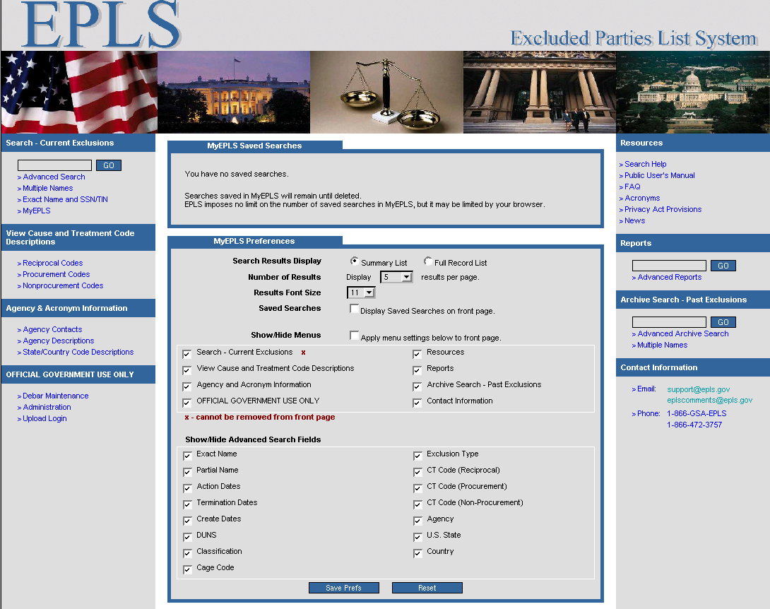
Figure 9: MyEPLS Preferences Screen
- Selectable search results display type – you may select between either Summary List or Full Record List. The summary option provides a concise display of data associated with a record and is suitable for use when a large number of records are to be displayed and need to be scanned through quickly. The full record option provides an easy to read display format, at the cost of using more screen area to display results, and is more suited to performing searches where you only want to look at a few results.
- Configurable Number of Results per page – you may set the number of search results per page to 1, 5, 10, 20, 30, 50, or 100.
- Customizable Results Font Size – you may set the search results font to be anything from point size 11 to point size 18.
- MyEPLS Saved Searches – You may execute or delete any search query that you have saved into MyEPLS from here. To save a search, see section 2.2
- Show/Hide Menus – You may show or hide most of the menus on either side of the screen.
- Show/Hide Advanced Search Fields – You may show or hide all of the fields available when performing an advanced search.

Basic Archive Search
The Basic Archive Search is identical to the Basic Current Search, except that it searches through archived data instead of current data. For a description of how to perform a basic search, please see section 2.1

Advanced Archive Search
The Advanced Archive Search is identical to the Advanced Current Search, except that it searches through archived data instead of current data. For a description of how to perform an advanced search, please see section 2.3.

Reports
Both the Basic and Advanced Reports are identical to the Basic and Advanced Current Searches respectively, except that the data displayed to the user is in CSV format. For a description of how to perform a search, please see section 2.

There are three types of data formats that are associated with reports:
- XML - This option is the preferred method for a user to retrieve data in machine readable format. The DTD describing the format of the data can be found at http://www.epls.gov/EPLS.dtd. If you would like a machine to perform the downloading, than you may want to consider using the Web Service Interface for Searching EPLS Data as described in section 4
- CSV (MS Excel) – This format may be used with most popular spreadsheet applications, including Microsoft Excel, but each record does not have a fixed number of columns, so if you would like to import this data into another computing system, then you may want to consider using the XML format.
- ASCII - Although this format may not be very easy for a machine to process, it may be useful for manual, offline browsing by a user.
Samples of each of the above formats are provided in Appendix A.

Web Service Interface for Searching EPLS Data
To facilitate computer systems that would like to automatically search data within EPLS, but would not like to have a user manually download reports, an EPLS Search Web Service has been developed. Web Service standards compliant tools may more easily integrate with EPLS to promote an easier to use interchange of data.

The Search Web Service is accessible over the Internet, and the EPLS Search Web Service Definition Language (WSDL) specification may be found at http://www.epls.gov/epls/services/EPLSSearchWebService?wsdl.

A list of all EPLS Web Services may be found at http://www.epls.gov/epls/services.

Cause and Treatment (CT) Code Descriptions
CT Codes are identified by letters or letters and numbers (for example, A, H1, JJJ) and provide descriptions describing the cause of the exclusion and the treatment accorded to the excluded party. The following definitions are important to know for this section of the EPLS website:

- Procurement is the process of initiating and obtaining supplies or services, by contract or purchase order, with appropriated or non-appropriated funds, for the use of Federal agencies. The EPLS Procurement Codes pertain to procurement exclusions only.

- Nonprocurement pertains to obtaining certain types of Federal financial and non-financial assistance and benefits. Examples of nonprocurement transactions are grants, cooperative agreements, scholarships, fellowships, contracts of assistance, loans, loan guarantees, subsidies, insurance, payments for specified use, and donation agreements. The EPLS Non-procurement Codes pertain to nonprocurement exclusions only.

- Reciprocal pertains to both procurement and nonprocurement exclusions taken after August 25, 1995. The Federal Register, on June 26, 1995, published a final rule to ensure that exclusions from Federal government procurement and nonprocurement programs were applied reciprocally. In other words, any procurement or nonprocurement action initiated on or after August 25, 1995, means exclusion from both programs.

By clicking on either Reciprocal Codes, Procurement Codes, or Nonprocurement Codes you can find explanations for the codes belonging to the type you clicked on.

General Information

Agency Contacts
The Agency Contacts link provides an alphabetical listing of Federal agency’s points of contacts (POC) names, telephone numbers and in some instances, a website address. Click on an agency acronym to bring up the contact’s name and telephone number. Each POC is responsible for responding to inquiries concerning exclusions taken by their agency.

Agency Descriptions
The Agency Descriptions link provides an alphabetical listing of Federal agency acronyms and the full name of each agency. Click on an agency acronym to bring up the agency's full name.

State/Country Code Descriptions
The State/Country Descriptions link provides an alphabetical listing of state and country acronyms and the full name of each. Click on an acronym to bring up the full name of the state or country.

Search Help
This link will provide you with help on how to perform a search, including:
- Explain each search term
- Perform wildcard, fuzzy, proximity, and boolean searches
- Group search terms
- Escape special characters

Public User's Manual
The Public User's Manual is a link to this document.

FAQ
The FAQ link contains a series of questions relating to EPLS operations. When you click on a question, you are immediately taken to an answer.

Acronyms
The Acronyms link provides an alphabetical listing of acronyms used throughout EPLS and a description of each.

Privacy Act Provisions
The Privacy Act Provisions link provides the user with rules relating to privacy by which data on the EPLS is to be treated.

News
The EPLS News link displays the latest information for the EPLS web site.

Contact Information
For assistance in navigating the EPLS web site, users can contact the EPLS help desk by E-Mail or telephone. The E-Mail address is support@epls.gov and the telephone number is 1-866-GSA-EPLS (1-866-472-3757). In addition, comments regarding EPLS may be sent to eplscomments@epls.gov.

Appendix A

Sample EPLS Reports

Users can download any of three different report formats – XML, CSV (MS Excel), or ASCII. A sample of each is included below.

Sample XML Report:

<?xml version="1.0" ?>
<!DOCTYPE Records SYSTEM "http://www.epls.gov/EPLS.dtd">

<Records>
<Record>
<Name>Abtox, Inc.</Name>
<Classification>Firm</Classification>
<CTType>Procurement</CTType>
<Addresses>
<Address>
<Street1>104 Terrace Dr.</Street1>
<Street2/>
<City>Mundelein</City>
<ZIP>60060</ZIP>
<State>IL</State>
</Address>
</Addresses>
<References>
<Reference>Caputo, Ross A.</Reference>
<Reference>Lynch, Marilyn M.</Reference>
<Reference>Pharmaceutical Systems, Inc.</Reference>
<Reference>Riley, Robert M.</Reference>
<Reference>Schmitt, Mark E.</Reference>
</References>
<Actions>
<Action>
<ActionDate>03-Jun-2003</ActionDate>
<TermDate>Indef.</TermDate>
<CTCode>B</CTCode>
<AgencyComponent>AF</AgencyComponent>
</Action>
<Action>
<ActionDate>03-Jun-2003</ActionDate>
<TermDate>Indef.</TermDate>
<CTCode>A</CTCode>
<AgencyComponent>AF</AgencyComponent>
</Action>
</Actions>
<Description/>
</Record>
<Record>
<Name>Adelphia Business Solutions Operations, Inc.</Name>
<Classification>Firm</Classification>
<CTType>Reciprocal</CTType>
<Addresses>
<Address>
<Street1>5619 DTC Pkwy.</Street1>
<Street2/>
<City>Greenwood Village</City>
<ZIP>80111</ZIP>
<State>CO</State>
</Address>
</Addresses>
<References>
<Reference>Brown, James R.</Reference>
<Reference>Coudersport Television Cable Company</Reference>
<Reference>Coudersport Theatre</Reference>
<Reference>Dobaire Designs</Reference>
<Reference>Dorellenic Cable Partners</Reference>
<Reference>Doris Holdings, LP</Reference>
<Reference>Eleni Interiors, Inc.</Reference>
<Reference>Empire Sports Services</Reference>
<Reference>ErgoArts, Inc.</Reference>
<Reference>Highland 2000, LP</Reference>
<Reference>Highland Holdings</Reference>
<Reference>Highland Prestige Georgia, Inc.</Reference>
<Reference>Highland Video Associates, LP</Reference>
<Reference>Hilton Head Communications, LP</Reference>
<Reference>Illiad Holdings, Inc.</Reference>
<Reference>Ionian Communications, L.P.</Reference>
<Reference>Mulcahey, Michael</Reference>
<Reference>NCAA Holdings, Inc.</Reference>
<Reference>Niagara Frontier Hockey, L.P.</Reference>
<Reference>Patmos, Inc.</Reference>
<Reference>Praxis Capital Management, LLC</Reference>
<Reference>Praxis Capital Partners, LLC</Reference>
<Reference>Preston Motors</Reference>
<Reference>Rigas, Doris</Reference>
<Reference>Rigas, James P.</Reference>
<Reference>Rigas, John J.</Reference>
<Reference>Rigas, Michael J.</Reference>
<Reference>Rigas, Timothy J.</Reference>
<Reference>SongCatcher Films, LLC</Reference>
<Reference>Venetis, Ellen Rigas</Reference>
<Reference>Venetis, Peter</Reference>
<Reference>Wending Creek 3656, LLC</Reference>
<Reference>Wending Creek Farms, Inc.</Reference>
</References>
<Actions>
<Action>
<ActionDate>02-Jun-2004</ActionDate>
<TermDate>Indef.</TermDate>
<CTCode>B</CTCode>
<AgencyComponent>AF</AgencyComponent>
</Action>
<Action>
<ActionDate>02-Jun-2004</ActionDate>
<TermDate>Indef.</TermDate>
<CTCode>S</CTCode>
<AgencyComponent>AF</AgencyComponent>
</Action>
</Actions>
<Description/>
</Record>
</Records>

Sample CSV (MS Excel) Report:

"Name","Address 1","Address 2","City","State/Country","Zip"
"Abtox, Inc.","104 Terrace Dr.",,"Mundelein","IL","60060","(Also Caputo, Ross A.; Lynch, Marilyn M.; Pharmaceutical Systems, Inc.; Riley, Robert M.; Schmitt, Mark E.)","B","AF","03-Jun-2003","Indef.","A","AF","03-Jun-2003","Indef."
"Adelphia Business Solutions Operations, Inc.","5619 DTC Pkwy.",,"Greenwood Village","CO","80111","(Also Brown, James R.; Coudersport Television Cable Company; Coudersport Theatre; Dobaire Designs; Dorellenic Cable Partners; Doris Holdings, LP; Eleni Interiors, Inc.; Empire Sports Services; ErgoArts, Inc.; Highland 2000, LP; Highland Holdings; Highland Prestige Georgia, Inc.; Highland Video Associates, LP; Hilton Head Communications, LP; Illiad Holdings, Inc.; Ionian Communications, L.P.; Mulcahey, Michael; NCAA Holdings, Inc.; Niagara Frontier Hockey, L.P.; Patmos, Inc.; Praxis Capital Management, LLC; Praxis Capital Partners, LLC; Preston Motors; Rigas, Doris; Rigas, James P.; Rigas, John J.; Rigas, Michael J.; Rigas, Timothy J.; SongCatcher Films, LLC; Venetis, Ellen Rigas; Venetis, Peter; Wending Creek 3656, LLC; Wending Creek Farms, Inc.)","B","AF","02-Jun-2004","Indef.","S","AF","02-Jun-2004","Indef."

Sample ASCII Report
Search Results Excluded By:
Full Text : Adelphia or Abtox
Agency : AF
as of 18-Apr-2006
================================================================================

Abtox, Inc., 104 Terrace Dr., Mundelein, IL, 60060 (Also Caputo, Ross A.; Lynch, Marilyn M.; Pharmaceutical Systems, Inc.; Riley, Robert M.; Schmitt, Mark E.) B, AF, Indef.; A, AF, Indef.

Adelphia Business Solutions Operations, Inc., 5619 DTC Pkwy., Greenwood Village, CO, 80111 (Also Brown, James R.; Coudersport Television Cable Company; Coudersport Theatre; Dobaire Designs; Dorellenic Cable Partners; Doris Holdings, LP; Eleni Interiors, Inc.; Empire Sports Services; ErgoArts, Inc.; Highland 2000, LP; Highland Holdings; Highland Prestige Georgia, Inc.; Highland Video Associates, LP; Hilton Head Communications, LP; Illiad Holdings, Inc.; Ionian Communications, L.P.; Mulcahey, Michael; NCAA Holdings, Inc.; Niagara Frontier Hockey, L.P.; Patmos, Inc.; Praxis Capital Management, LLC; Praxis Capital Partners, LLC; Preston Motors; Rigas, Doris; Rigas, James P.; Rigas, John J.; Rigas, Michael J.; Rigas, Timothy J.; SongCatcher Films, LLC; Venetis, Ellen Rigas; Venetis, Peter; Wending Creek 3656, LLC; Wending Creek Farms, Inc.) B, AF, Indef.; S, AF, Indef.

Appendix B

Acronyms

Term Definition

ASCII American Standard Code for Information Interchange
BIS Bureau of Industry and Security
CSV Comma Separated Value
CT Cause and Treatment
DTD Document Type Definition
DUNS Data Universal Numbering System
EPLS Excluded Parties List System
FAQ Frequently Asked Questions
GSA General Services Administration
IAE Integrated Acquisition Environment
ISC Information Sciences Corporation
MS Microsoft
OCAO Office of the Chief Acquisition Officer
OFAC Office of Foreign Assets Control
POC Point of Contact
SDN Specially Designated Nationals
SSN Social Security Number
TIN Taxpayer Identification Number
WSDL Web Service Definition Language
XML Extensible Markup Language

