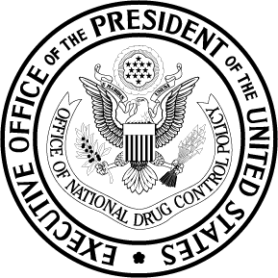

EXECUTIVE OFFICE OF THE PRESIDENT
OFFICE OF NATIONAL DRUG CONTROL POLICY
Washington, DC 20503
FOR IMMEDIATE RELEASE: CONTACT: Jennifer de Vallance
Wednesday, March 12, 2008 202-395-6648 / 202-368-8422 cell

METHAMPHETAMINE, COCAINE USE PLUMMET;
NEW WORKPLACE DRUG TESTING DATA SHOW EFFECTS OF SUPPLY CRUNCH

(Washington, DC) – John Walters, Director of National Drug Control Policy, today highlighted new data showing significant reductions in meth and cocaine positivity rates in the American workforce, as well as continued disruptions in the supply of both drugs.

According to data released today by Quest Diagnostics’ Drug Testing Index ® (DTI), results from workplace drug screenings conducted in 2007 show a more than 50 percent decline in the percentage of positive tests for methamphetamine over two years, from 28 of every 10,000 people testing positive for meth in 2005, to 14 of every 10,000 testing positive for meth in 2007.
“Dangerous drugs like methamphetamine and cocaine have scorched many American communities and ruined lives and families,” said Director Walters. “We need to put more pressure on the people and organizations profiting from the sale of these poisons. But the data released today show that when we push back, we can make progress.”

Over the last few years, changes in State and Federal laws, as well as tighter international chemical controls, have made it more difficult for meth producers to get the precursor chemicals they need to make the drug. Domestic meth lab incidents have dropped by more than 70 percent since 2004, while seizures of meth along the U.S. – Mexico border are down 32 percent from 2006. The Southwest border seizure declines coincide with aggressive actions by Mexico to limit the amount of meth precursor chemicals coming into the country. In 2004, more than 224 MT of pseudoephedrine was imported by Mexico; in 2008, the Calderon Administration has ceased to issue import permits for key meth precursor chemicals, and all remaining supplies in the country must be depleted by 2009.

The decreases in meth use have contributed to a market constriction, placing stress on dealers to maintain revenue flow by decreasing the purity of the drug, while increasing price. The latest data from the Drug Enforcement Administration’s (DEA) System to Retrieve Information on Drug Evidence (STRIDE) database indicates an 84 percent increase in price per pure gram of meth from January to December of 2007, from $152.39 to $280.06. The purity of meth during the same time period decreased 26 percent.

“Increased drug prices and decreased purity confirm what DEA agents are seeing across this country: a hard hit on the drug supply,” said DEA Acting Administrator Michele M. Leonhart. “DEA and our partners are attacking traffickers’ movement of drugs, money, and chemicals like never before, and the data is a strong indicator that we have struck the traffickers a severe blow. The impressive decline in drug use by America’s workers is further evidence that our collective efforts are working.”

According to the DTI, workplace drug tests have also found sustained decreases in cocaine positives among the U.S. workforce. Quest Diagnostics’ latest findings show a 19 percent decrease in cocaine positives, from 72 out of every 10,000 workers testing positive for cocaine in 2006 to 58 out of every 10,000 in 2007. This decline represents the lowest rate of cocaine positives since the DTI began reporting the data more than a decade ago.
-MORE-
“The Drug Testing Index emphasizes the steady reversal of a trend in which methamphetamine positivity rates in the general workforce increased by 68 percent from 2002 to 2003 and peaked in 2004. Results from the Quest Diagnostics Drug Testing Index indicate that the number of positive tests for cocaine was down 19 percent between 2006 and 2007,” said Barry Sample, Ph.D., Director of Science and Technology for Quest Diagnostics' Employer Solutions division. “This represents the biggest single-year decline in cocaine positives since 1997.”

With fewer customers, cocaine dealers are facing market pressures similar to those for meth. DEA’s STRIDE database indicates that, from January to December of 2007, the price per pure gram of cocaine increased 21 percent, while purity of the drug decreased 10 percent.

The latest DTI also supports previous findings from Federal drug use surveys that warn of a rising tide of prescription drug abuse. Positives for amphetamine – stimulants that can include prescription drugs or diet aids – increased more than seven percent from 2006-2007. To address the growing prescription drug abuse threat, President Bush and the ONDCP have launched an unprecedented advertising effort urging parents to safeguard their children by safeguarding their prescription drugs. The President has also called on Congress to pass legislation that would prevent rogue Internet pharmacies from providing controlled substances without the controls of a legitimate doctor-patient relationship or a valid prescription.

Quest Diagnostics, the largest provider of diagnostic testing, information, and services conducts employer drug testing services throughout the Nation, and their DTI, a summary of workplace drug tests, is an indicator of national drug use trends. The latest findings are based on results from more than 6.6 million general workforce drug tests performed by Quest Diagnostics across the United States in 2007. These general workforce drug tests, added to the federally-mandated safety-sensitive workforce tests, sum to an annual total of 8.4 million combined U.S. workforce tests in 2007.
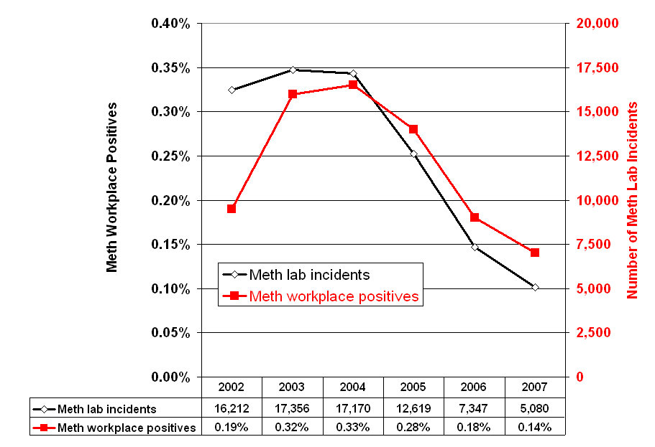

For more information, visit www.whitehousedrugpolicy.gov. To view the Quest Diagnostics 2007 Drug Testing Index, visit www.questdiagnostics.com.

###

