
Final Site Report

Evaluation of Travel
Time Methods to Support
Mobility Performance
Monitoring

Ambassador Bridge

To
Office of Freight Mgt. and Operations
Federal Highway Administration
U.S. Department of Transportation
Washington, DC 20590

April 2002

Border Crossing Freight Delay Data Collection and Analysis
FY 2001 Data Collection – Ambassador Bridge

Site Description

The Ambassador Bridge is a large, imposing structure that connects Detroit, Michigan and Windsor, Ontario (see figures 1 and 2). The bridge is the single busiest international land border crossing in North America, serving as a portal for 27% of the approximately $400 billion in annual trade between Canada and the U.S. The bridge is 1.6 miles long from tollbooth to primary inspection checkpoint in either direction. The roadway is four lanes whose directional flow is controlled by overhead changeable electronic lane markers, often in combination with cones. The bridge operates 24 hours per day, 7 days per week. It facilitates the movement of many commodities between the U.S. and Canada, with the automotive industry being the most notable.

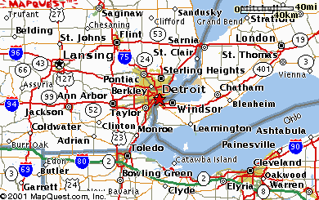
Ambassador Bridge

Figure 1. Area Map – The Ambassador Bridge.

Both trucks and autos intermingle in the same lanes as they cross, then on the far side they separate into discrete lanes as they approach separate primary checkpoints, in both the U.S. and Canada. After primary inspection, trucks and autos mix as they exit Canadian Customs into Windsor, while trucks that exit U.S. Customs are segregated from autos. The Windsor-Detroit Tunnel is only a short distance away. The tunnel is for autos only, one lane in either direction.

There is a sidewalk on the south side of the bridge only. One lane of the bridge near the middle is typically closed for a long-term bridge cable-painting project. During painting operations, traffic is typically funneled into 3 lanes by cones for about three hundred yards. When the painting is being done on the south side of the span, the sidewalk helps to accommodate equipment and decrease the length of the lane that is cordoned off for painting (see figure 2).

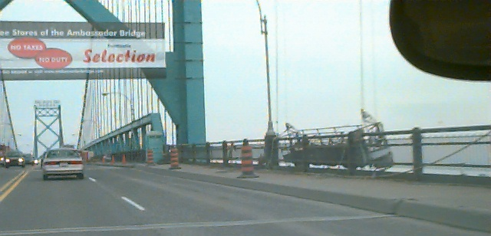

Figure 2. Maintenance Equipment on Ambassador Bridge.

On the U.S. side, the bridge is located beside I-75 near its intersection with the eastern terminus of I-96. The bridge crosses only two miles south of downtown Detroit. Since space is at a premium as a result of the developed urban/industrial setting, trucks approaching the U.S. side must make an abrupt, tight 180-degree turn to enter primary on the U.S. side. Trucks on the Canadian side have more room for a straightforward approach to primary and, as will be explained, secondary inspection is not located at the same facility. The bridge entrance/exit on the Canadian side is in a less industrial setting next to the campus of the University of Windsor. Truck traffic exits onto Highway 3 (Huron Church Road), which after 5-1/2 miles intersects Highway 401, a major route that heads northeast across Ontario.

The bridge and its collateral facilities are privately owned and operated by the entity known as the Ambassador Bridge. The mission of the Ambassador Bridge is to operate and maintain the bridge and collect tolls on both sides of the crossing. The Ambassador Bridge’s U.S. owner is the Detroit International Bridge Company and its Canadian subsidiary is The Canadian Transit Company. Ambassador Bridge owns the facilities that house Canada Customs and Immigration while GSA owns the U.S. Customs facility. Since Ambassador Bridge owns and operates the property that the tollbooths are on, the data collectors who were located by the toll collection booth in either country had to have permission from them, which was verbal.

The U.S. and Canadian Customs mission is to protect their border. They operate the facilities and control the property where their Customs facilities are located. Data collectors who were operating beside the primary Customs checkpoint in either country had to have permission to be on property operated by the Customs organization of that country. Thus on both sides of the crossing, even though that collector was only a very short distance from the collector at the tollbooth, the approval to operate at that spot came from a different organization.

Ambassador Bridge employees included three to four persons assigned to handle traffic on each side. If an accident on the bridge is minor, bridge personnel take pictures quickly and then move the vehicles. While the Ambassador Bridge’s needs are clearly different from the needs of the U.S. and Canadian Customs organizations, all parties appear to cooperate effectively with one another. For example, if some unusual event causes sudden and severe backup (which the data collection team observed once in particular), the Customs organizations responded by manning extra booths to help restore normal flow across the border. Also, for example, on the second day (Wednesday) of the second data collection period, a truck ran out of fuel on the bridge heading to Canada around 5:00 P.M. It sat for about an hour restricting traffic until it could be moved. Bridge personnel held up traffic headed to the U.S. so traffic headed for Canada could cross during part of the time that the truck was blocking traffic. But in normal operation, delays introduced by Customs operations have a greater impact on Ambassador Bridge operations than vice-versa. Lines are painted on the road occasionally. A quick-drying plastic compound is used so that traffic holdups are minimal. Ambassador Bridge personnel held up traffic at the IB-2 tollbooth for approximately ten minutes during the first collection.

Data collection activities at the Ambassador Bridge occurred during May 22-24, 2001 and June 19-21, 2001. Truck travel times across the bridge in both directions were recorded on Tuesday through Thursday each week, for approximately 12 hours each day. The times of the data collection were staggered somewhat to obtain a broader picture of activity at the bridge. Anecdotally, Canada Customs is said to have typically four lanes open during a weeknight and three lanes on a weekend, while and U.S. Customs has two to three lanes open during weeknights and one lane during weekends.

Canada-bound Traffic. For trucks heading into Canada, the connecting roadway system leading to the bridge is somewhat complex. The majority of trucks exit off of I-75 northbound and southbound, where they have to proceed along a service road – Fisher Freeway – a short distance to access the bridge. Rush hour traffic can cause this line of trucks (along with autos) to back up onto the right lane of the Interstates, particularly I-75. The trucks on Fisher Freeway that have exited from I-75 southbound have to make a sharp left turn to cross the Porter Street overpass, then turn right to access the bridge entrance at a very busy intersection that has multiple connecting roads. A smaller number of trucks arrive directly at the same intersection by the bridge entrance via a feeder route that connects to the nearby eastern terminus of I-96.

On the other side on the Interstate (the east or bridge side), some trucks and autos that have exited from I-75 northbound onto Fisher Freeway pull into the main duty-free area instead of proceeding the short distance to the bridge entrance. Trucks and autos exit from duty-free via the “west ramp” through two tollbooths which process both autos and trucks, then they make a sharp turn separated by barricades from the main bridge traffic to enter the flow across the bridge. The outbound trucks and autos that pass by the duty-free entrance on Fisher Freeway northbound make a sharp right turn after about two hundred yards onto the bridge at the complex intersection described above.

Some trucks, particularly those that have exited from I-75 southbound or I-96, pull over to the right at the bridge entrance and park to visit a small duty-free store just prior to the car/truck tollbooth entrance on U.S. side. This impromptu parking area was beside one of our data collection stations (see figure 3). Drivers who visit this duty free store walk across often-heavy car and truck traffic to reach the store, and then walk back to their parked trucks a few minutes later to proceed into Canada. Autos tend to pull over in a similar manner on the other side of the flow, next to the duty free store. All vehicles whose drivers have used any duty free store must proceed across the bridge into Canada.

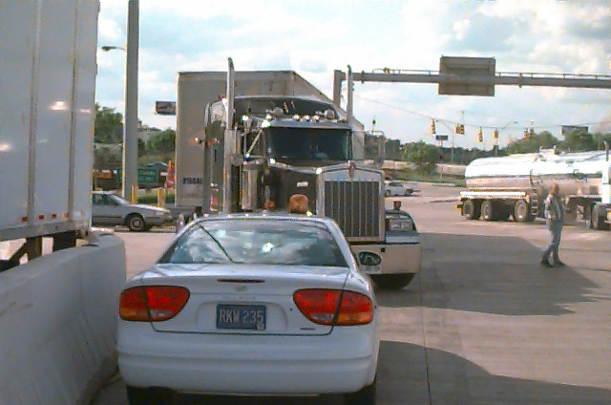

Figure 3. Some drivers park their trucks and cross
traffic on foot to reach a duty-free store.

The main truck flow across the bridge into Canada proceeds through four truck-only tollbooths in addition to the two truck/car tollbooths on the “west ramp,” for a total of six tollbooths used by trucks. There are eight tollbooths reserved for autos that are to the left of, and adjacent, to the four main truck-only booths. Autos and trucks are mixed as they enter the bridge and some have to veer across several lanes of traffic to get to the appropriate tollbooths.

Once across the bridge and in Canada, autos are directed to the left and trucks to the right to pass through one of the primary Customs inspection booths. There is a bank of twenty Canadian primary booths – ten on the left that process autos only, and ten on the right that can process autos or trucks (see figure 4). Canada shifts employees at the primary booths at 5 minutes to the hour – gates come down and hold traffic. Trucks are either released from primary or must continue on to secondary inspection, which could include completing brokerage paperwork or physical inspection of the cargo. An occasional truck is directed to a special covered inspection area adjacent to primary, but most trucks that are directed to secondary inspection proceed onto Huron Church Road, which becomes Highway 3 through Windsor.

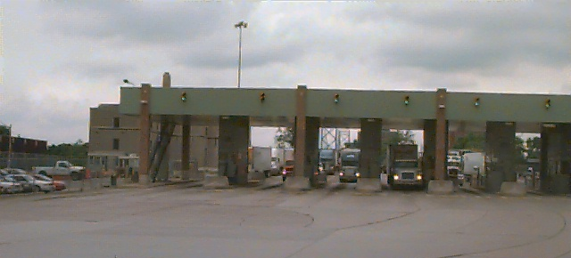

Figure 4. Primary at Canadian Customs, Windsor side.

A unique feature of Canadian Customs at the Ambassador Bridge is that their secondary inspection is not located at the same facility as primary inspection, but rather is located over a mile and a half from primary inspection off Huron Church Road. Truck drivers who are told at primary that they must go through secondary inspection will proceed to the secondary inspection facility on the honor system (although of course there are stiff penalties for anyone who does not comply). Canada, therefore, permits trucks that require additional inspection or other scrutiny to proceed into the country and onward to the remote secondary inspection site where the issues will be addressed. This is in sharp contrast to the U.S. Customs operations where a truck with brokerage issues is not permitted to leave the Customs compound until all issues are resolved.

The area immediately past Canadian primary (the bank of twenty stalls for both autos and trucks) sometimes becomes extremely congested through a combination of very heavy traffic and the geometry of traffic flow. The exits from primary are directly past where the truck stalls are located; they include three lanes straight onto Huron Church Road outbound (i.e., southbound; Windsor is geographically south of Detroit) and a curving ramp of two lanes onto Huron Church Road northbound (but this is not the road that crosses the bridge). When exiting from primary, autos have to proceed to the right almost perpendicular to truck flow (see figure 5), especially if the autos intend to exit onto the two-lane ramp for Huron Church Road northbound.

As traffic builds up, the likelihood increases that a car heading for the Huron Church Road outbound exit ramp will cut in front of a truck that is accelerating out of a booth in primary. The data collection team observed a couple of occasions when this area just past the primary booths had filled up so completely that there were about as many vehicles as close together as the area could possibly hold. This occurred because both autos and trucks were leaving the primary booths at a greater rate than they could exit onto the road system. When it reached this point, trucks started to be held at the primary booths.

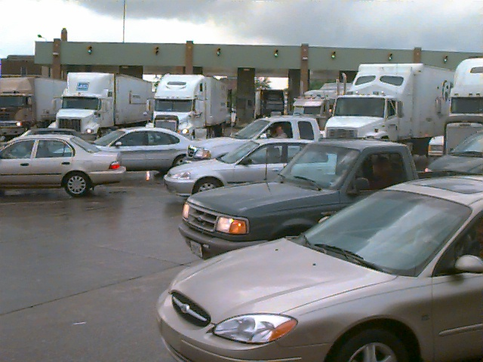

Figure 5. Rare congestion below Canadian Customs booths.

There is a railroad line that crosses Huron Church Road beside College Avenue, only 200 yards or so past primary and perhaps 400 yards upstream from the tollbooth. During the three days of data collection, trains were observed crossing several times a day, stopping traffic for an average of three to four minutes each time. This was of sufficiently short duration that it did not appear Canadian Customs needed to hold traffic at the tollbooths.

U.S.-bound Traffic.

The majority of traffic crossing to the U.S. comes from Huron Church Road/Highway 3, which terminates at the Ambassador Bridge. Just past the intersection of Huron Church Road with College Avenue and the railroad track, signs direct autos to the left and trucks to the right. Immediately past is another split, dividing local traffic and truck traffic crossing the bridge (see figure 6). Trucks wanting to enter the duty free area exit to the left about two hundred yards past the auto-truck split, into the commercial vehicle duty free parking. Trucks exiting the duty free area merge with the main truck traffic about one hundred yards past where they entered duty free, then they proceed to a bank of five truck tollbooths. When leaving duty free, they merge with the traffic flow on the truck side merge with autos after the tollbooths, and cross the bridge.

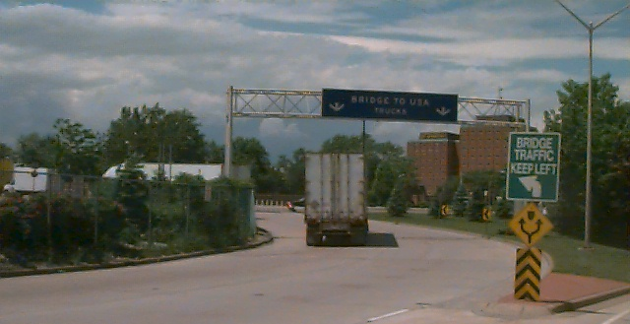

Figure 6. Truck inbound to U.S. approaching tollbooths on
Canadian side. Data collector can be seen in background.

There is also an entrance ramp coming up from Wyandotte Street West in the vicinity of the University of Windsor campus that enters the bridge approach across from the duty-free store exit. There are two tollbooths processing both trucks and autos on this ramp. The trucks and autos that exit this ramp are retained in the right hand lane by cones and barrels, separated from the main truck flow for about one hundred yards until they pass the line of tollbooths and merge.

Once across the bridge and in the U.S., autos are directed to the left and trucks veer off to the right to pass through one of the primary Customs inspection booths. As mentioned, trucks approaching the U.S. side must work their way into the right lane and make an abrupt, tight 180-degree turn to enter primary on the U.S. side. While the turn is two-lane, its geometry forces trucks to travel single-file. Then the trucks’ approach straightens out and they enter a bank of six primary booths (see figure 7).

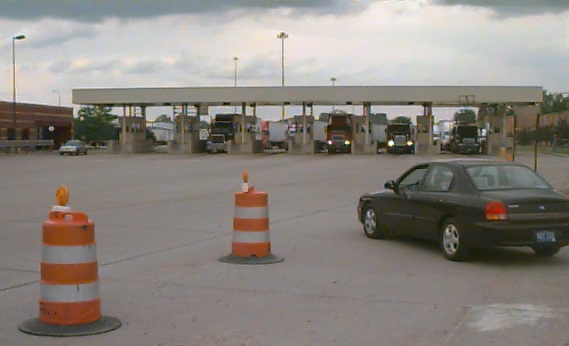

Figure 7. Primary at U.S. Customs, Detroit side.

Trucks released from primary drive straightforward one hundred yards to a traffic light and “T” at the intersection of Fort Street, where they must turn left or right. Trucks requiring physical inspections or who need to visit customs brokers veer off to the right and make a 180 degree turn clockwise around the Customs building and continue into a large truck parking lot that they circled around on their way into primary. When trucks are finally ready to depart that lot, they exit via a designated single lane running through an unmanned booth next to the customs building. The data collectors below primary were instructed to not count any trucks exiting from this lane, since these trucks had induced delay as a result of being in the secondary inspection parking lot. They merge with the trucks that have been cleared by primary inspection and use the same exit onto Fort Street to leave the Customs compound.

Just past primary on the left, before the exit to Fort Street, construction has begun on a future tollbooth plaza. Concrete has been poured for tollbooths that will include truck scales, but construction was interrupted and not in progress at the time of either data collections. Ambassador Bridge intends to relocate the tollbooth operation for U.S.-bound traffic from the Canadian side to the vicinity of primary on the U.S. side.

Data Collection Process

For this study, two data collection locations were used in each direction. The “number 1” location was immediately before the tollbooths and the “number 2” location was immediately after the primary inspection booths. For consistency among all border
crossings visited as part of the overall project, the data collection positions were distinguished by the direction of travel that they were measuring (outbound or inbound with respect to the U.S.). As already mentioned, movement from Detroit into Windsor is actually southbound; however, by designating this direction “outbound” confusion is eliminated. The Outbound 1 (OB-1) position; therefore, is in the U.S. plaza, before the tollbooths. The Outbound 2 (OB-2) position was after the Canadian Customs primary inspection booths. Inbound positions (IB-2 and IB-2) were similarly positioned (see figures 8, 9, and 10).

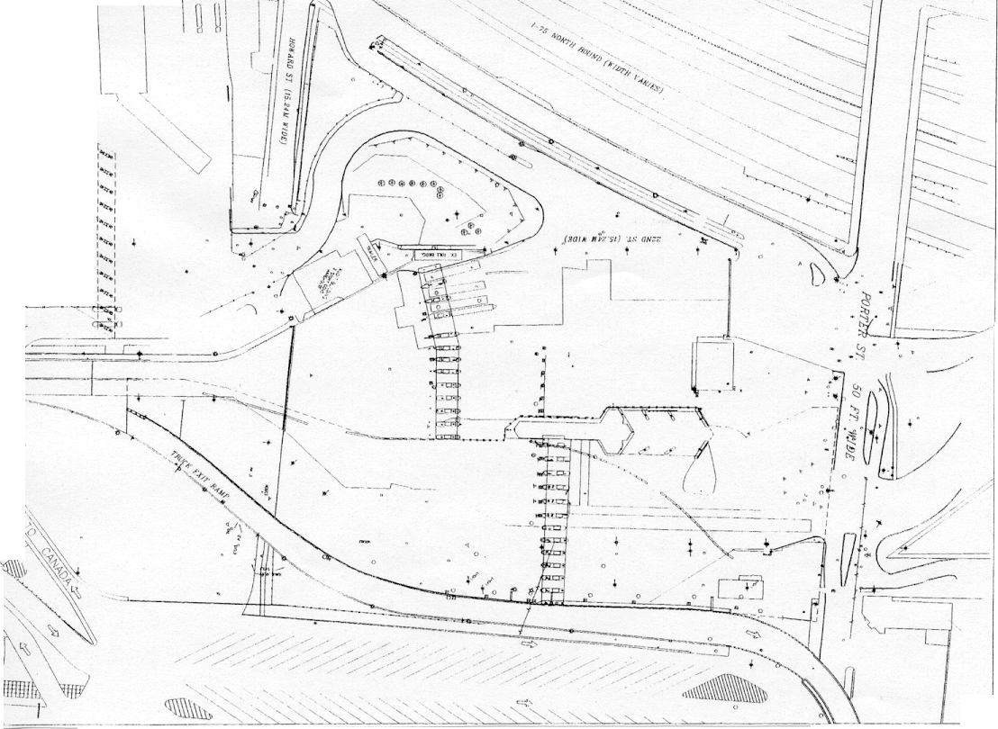
OB-1 Data Collector
(portable dividers for duty-free not shown)

Truck
Boothss

Auto
Booths
Figure 8. Layout at the Outbound 1 (OB-1) data collection site on the Detroit side.

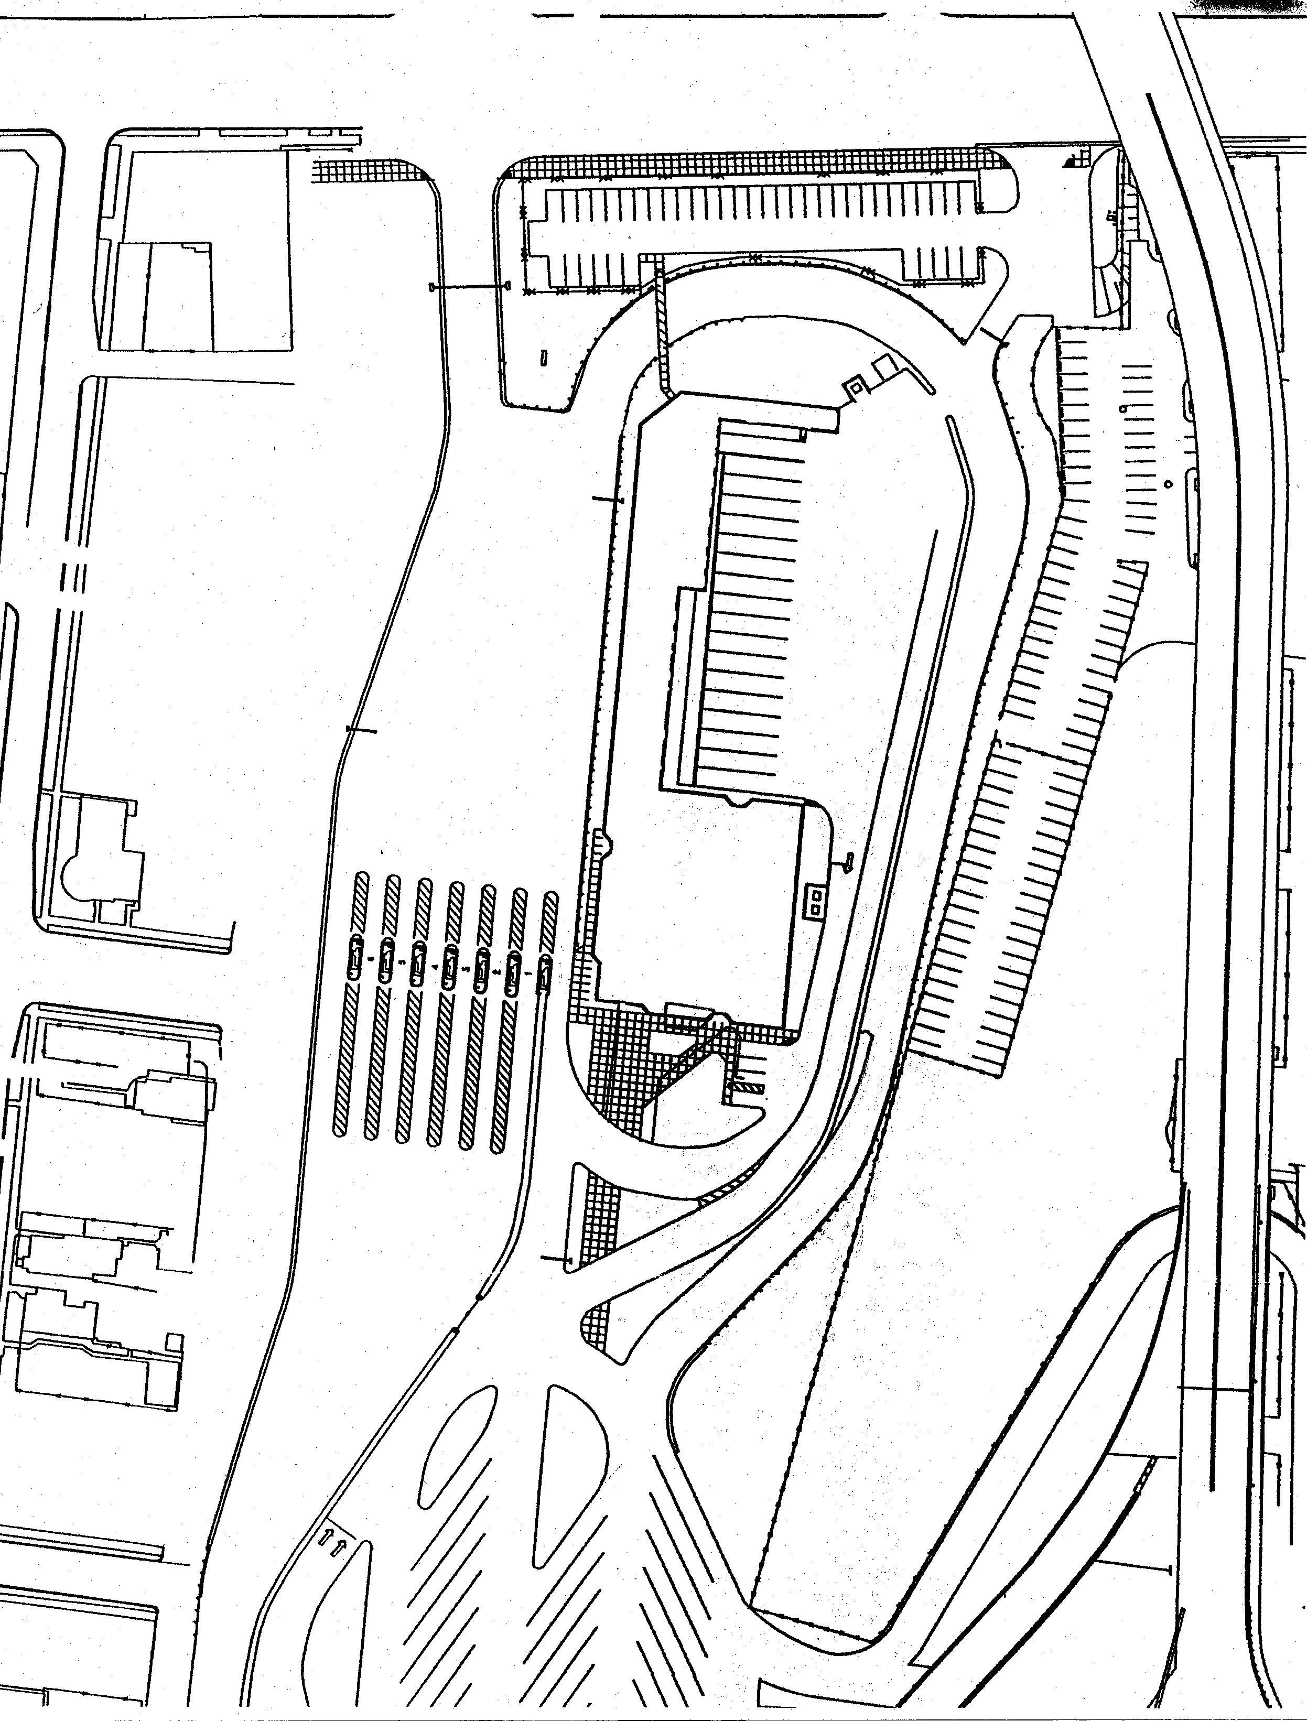
Figure 9. Layout at the Inbound 2 (IB-2) data collection site on the Detroit side.
IB-2 Data Collector
U.S.
Customs
Building

Truck
Boothss
OB-2 Data Collector
IB-1 Data Collector
Canadian Customs Building
Figure 10. Layout at the Outbound 2 (OB-2) and Inbound 1 (IB-1)
data collection sites on the Windsor side.

Each data collector used a handheld computer to record partial license plate information of all commercial vehicles that passed their location. The computer would also store the time that each license plate was entered. The data from the two locations in each direction would be combined, allowing the determination of the travel time for each vehicle that was recorded at both locations.

During both weeks of data collection, the on-site team included four data collectors and one supervisor. The supervisor provided additional support to take over data collection when a collector was given a break or lunch, or sometimes collected supplemental data during a non-typical event. All four collectors and the supervisor had cell phones, which worked well at this crossing. The length of the bridge would probably cause most if not all handheld radios (walkie-talkies) to be ineffective – at least, those handheld radios that do not require licenses because of their lower power.

As previously mentioned, the hours during which data were collected were varied during each week to ensure the greatest possible coverage of conditions, including periods of low and high traffic volume. Table 1 shows the data collection hours for each day during the two site visits. The supervisor generally brought lunch to the collectors and collected data at each station so as to allow the collector to take a meal break or rest break during the data collection, resulting in approximately 12-½ hours of data collection during each of the full days.

Table 1. Hours of Data Collection

Date | Start | End
5/22/01 | 12:30 am | 8:00 pm
5/23/01 | 8:00 am | 9:00 pm
5/24/01 | 6:00 am | 6:30 pm
6/19/01 | 9:00 am | 9:45 pm
6/20/01 | 6:00 am | 6:40 pm
6/21/01 | 5:30 am | 6:10 pm

Obtaining permission was a smooth process. Several separate meetings were held during a two-day period to secure approval. One meeting was held on June 7, 2001 with U.S. Customs officials in their facilities at the bridge, which included their Director of Field Operations, Port Director, and Chief Inspector. A meeting was held the next day at the Ambassador Bridge offices on the Detroit side. In attendance were Ambassador Bridge’s General Manager and the ITS Director, who took the Battelle representative on a tour of all facilities, pointed out logical sites for the data collectors, and provided introductions to the District Director of Canadian Customs at his office in the Canadian Customs building. During these preparatory meetings, the Battelle representative distributed several key documents (e.g., the project’s explanation, methodology and goals) to help all host organizations understand our purpose. These helped to facilitate coordination.

Ambassador Bridge talked with the local Canada Immigration Director on behalf of the Battelle team. The Director determined that – as visitors under NAFTA – the team would not need work permits to collect data on the premises. Prior to the data collection during both visits, team members had to obtain visitor’s records from Canada Immigration, for which personal information was provided. During the first visit, however, the team arrived during Victoria Day (a Canadian holiday that fell on Monday), which caused a delay in getting final permission and processing the necessary paperwork until the following day. The team completed the paperwork on Tuesday morning prior to starting the data collection, which induced a delay in the first day’s start time. During the second visit, no one on the data collection team except the supervisor had participated in the first collection, so three of the new collectors went through that process during Monday. There was no delay in data collection. Incidentally, this Visitor’s Record had the effect of facilitating the process at primary of explaining why the team needed to enter Canada via auto.

Other than the formal visitor’s records, Canadian Customs required only a simple visitor’s pass from the shift supervisor for the OB-1 collector for each day of the data collection. Neither U.S. Customs nor Ambassador Bridge required special passes or other written permission for the team to work on their premises, only verbal approval. We also contacted the FHWA Michigan Division to notify them of the nature of the data collection.

Table 2 contains a list of the individuals who were contacted and their telephone and e-mail information. With this, future data collection for this project should be able to be organized and authorized with much less effort. However, any new project would require additional time to explain the data collection objectives to the involved parties and gain their approval.

Table 2. Agency Contacts

Contact | Agency | Phone/Fax | E-mail
Kevin Weeks  Director, Field Operations | U.S. Customs | 313-226-2955 ext. 101  313-226-3118 (fax) | kevin.w.weeks@  customs.treas.gov
Angela Ryan  Port Director | U.S. Customs | 313-442-0200  313-226-3179 | angela.ryan@  customs.treas.gov
Ben Anderson  Chief Inspector | U.S. Customs | 313-226-6061  313-226-5347 (fax) | walter.b.Anderson@  customs.treas.gov
David Jolly  General Manager | Ambassador Bridge | 313-967-9816  313-967-9818 (fax) | ambassgm@att.net
Joe Polak  ITS Director | Ambassador Bridge | 313-496-1445  313-496-1446 (fax)
David MacRae  District Director | Canada Customs | 519-257-6491  519-257-7844 (fax) | David.MacRae@  ccra-adrc.gc.ca
Bonnie Brown  District Director | Canada Immigration | 519-971-2030
Morrie Hoevel | FHWA Michigan  Division Office | 517-377-1844
Aisha Hall  statistics compiler for Detroit to Windsor | Ambassador Bridge |  | Ahallambassador@  aol.com
Vicki Winter  statistics compiler for  Windsor to Detroit | Ambassador Bridge |  | bridgegm@  windsor.igs.net

Data Collection Details

Both the Canada Bridge and Tunnel Operator’s Association and Ambassador Bridge provided border crossing statistical data. This data was evaluated for an assessment of the variability in travel conditions at the Ambassador Bridge. The goal of this analysis process is to obtain statistically useful data with as few data collection days as possible. In order to customize the data collection activities at the Ambassador Bridge, the following steps were conducted:

- Define significant “seasonal” variations,
- Define significantly different days of the week,
- Identify traffic streams that experience significantly different conditions, and
- Estimate the number of days needed for the data collection survey.

As shown in Table 3, there is some variation in the commercial traffic by month, which was most pronounced in 2000. Due to project constraints, data collection needed to occur between late May and early September 2001. From Table 3, the two months with the greatest average volumes during this data collection window were May and June.

Table 3. Monthly Traffic Distribution of Commercial Vehicles

Month | 1998 | 1999 | 2000 | 1998-2000 Average
January | 231,614 | 252,146 | 289,122 | 772,882
February | 233,982 | 267,917 | 300,190 | 802,089
March | 262,051 | 310,562 | 335,595 | 908,208
April | 252,893 | 284,676 | 287,856 | 825,425
May | 253,182 | 291,085 | 315,227 | 859,494
June | 252,175 | 312,437 | 310,376 | 874,988
July | 196,751 | 234,738 | 224,327 | 655,816
August | 242,034 | 306,629 | 310,658 | 859,321
September | 258,811 | 298,182 | 293,269 | 850,262
October | 274,318 | 302,598 | 309,571 | 886,487
November | 261,163 | 300,406 | 287,644 | 849,213
December | 274,318 | 266,775 | 222,275 | 763,368
Total | 2,995,290 | 3,430,150 | 3,488,110 | 9,907,551
Source: United States – Canada Bridge and Tunnel Operator’s Association Traffic Reports

Tables 4 and 5 show that there is a significant difference in commercial traffic between weekdays and weekends and, further, there is a significant difference between Monday and Friday and the three mid-week days. Weekend traffic is 15 percent of typical weekday traffic and Monday/Friday traffic is 59 percent of typical Tuesday/Wednesday/Thursday traffic. In general, it was noted that outbound traffic increased from Tuesday through Thursday and inbound traffic decreased from Tuesday through Thursday. It was determined that collecting data three days of data, from Tuesday through Thursday, would provide an adequate number of data samples to represent “typical” conditions.

Table 4. Sample Month – Daily Traffic Distribution of
Commercial Vehicles for June 2001

Day | Day of Week | Outbound | Inbound
1 | Friday | 6,855 | 4,925
2 | Saturday | 3,398 | 2,301
3 | Sunday | 1562 | 2,541
4 | Monday | 5,373 | 6,020
5 | Tuesday | 6493 | 6,399
6 | Wednesday | 6,498 | 6,289
7 | Thursday | 7,042 | 5,863
8 | Friday | 6,589 | 4,700
9 | Saturday | 3,222 | 2,271
10 | Sunday | 1,421 | 2,280
11 | Monday | 4,928 | 5,725
12 | Tuesday | 6,242 | 6,115
13 | Wednesday | 6,432 | 6,069
14 | Thursday | 6,776 | 5,713
15 | Friday | 6,372 | 4,543
16 | Saturday | 3,145 | 2,155
17 | Sunday | 1,379 | 2,261
18 | Monday | 5,039 | 5,823
19 | Tuesday | 6,328 | 6,224
20 | Wednesday | 6,692 | 6,316
21 | Thursday | 6,029 | 5,518
22 | Friday | 6,514 | 4,683
23 | Saturday | 3,257 | 2,281
24 | Sunday | 1,419 | 2,318
25 | Monday | 4,993 | 5,473
26 | Tuesday | 6,149 | 5,839
27 | Wednesday | 6,210 | 5,837
28 | Thursday | 6,617 | 5,620
29 | Friday | 5,827 | 4,070
30 | Saturday | 2,451 | 1,823
Total |  | 151,252 | 137,995
Source: Ambassador Bridge

Table 5. Averages for Sample Month – Daily Traffic Distribution of Export Commercial Vehicles for June 2001

Day of Week | Week 1 | Week 2 | Week 3 | Week 4 | Week 5 | Average
Sunday |  | 4,103 | 3,701 | 3,640 | 3,437 | 3,720
Monday |  | 11,393 | 10,653 | 10,862 | 10,466 | 10,844
Tuesday |  | 12,892 | 12,357 | 12,552 | 11,988 | 12,447
Wednesday |  | 12,787 | 12,501 | 13,008 | 12,047 | 12,586
Thursday |  | 12,905 | 12,489 | 11,547 | 12,237 | 12,295
Friday | 11,780 | 11,289 | 10,915 | 11,197 | 9,897 | 11,016
Saturday | 5,699 | 5,493 | 5,300 | 5,538 | 4,274 | 5,261
Source: Ambassador Bridge

From discussions with the Ambassador Bridge, it was learned that backups typically did not occur on the U.S. side and, when they did, they did not grow very long. However, on the Canadian side, backups occurred more frequently and could stretch for several miles along Highway 3. Ambassador Bridge personnel on the Canadian side also related that traffic heading for the U.S. picks up around 5:00 A.M. It is busy until around 9:00 A.M. to 10:00 A.M., then plateaus until around 3:00 P.M. From 3:00 to 6:00 P.M., traffic falls off.

Data Collection Procedures

The data collection stations selected for the crossing were chosen because of the particular actions that occur at each site. Segments defined by the data collection stations were used to determine the commercial vehicle travel times and freight delay. As illustrated in Figures 3-6, the data collection sites could be located at:

- An advance station located upstream of the commercial vehicle queue – OB-1 and IB-2.
- The import station (primary inspection booths before detailed, or secondary, inspection) – OB-2 and IB-2.

The OB-1 collector was positioned about 50 yards upstream from the tollbooths at a point where all trucks can be seen entering the bridge (see figure 11). In this position, the collector could see all of the trucks entering from Porter Street (see figure 12), from the I-96 feeder road (see figure 13), from Fisher Freeway as they turned sharp right, and from the duty-free area making a sharp turn on the other side of a barricade from the main truck traffic (see figure 14). The OB-1 collector did not move out in response to a queue during either collection period. Had the collector done so, the process is one that requires care and alertness for safety’s sake. In order to stay on the U.S. side from the Outbound 1 observation site chosen, the collector has to carefully make his way onto the service road, crossing the flow of trucks that are making a sharp turn to enter the Ambassador Bridge, in order to get to the left lane and turn left.

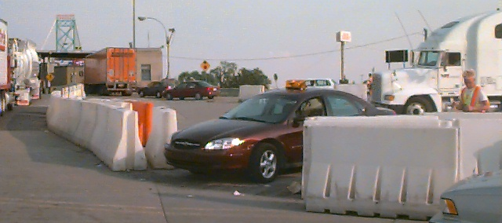

Figure 11. Outbound 1 data collection site just
upstream from tollbooths on Detroit side.

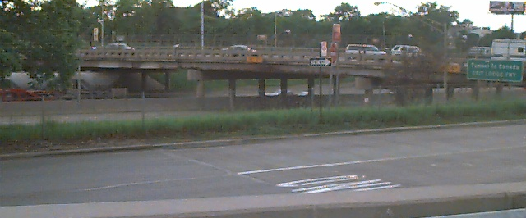

Figure 12. Outbound traffic crossing the
Porter Street overpass above I-75.

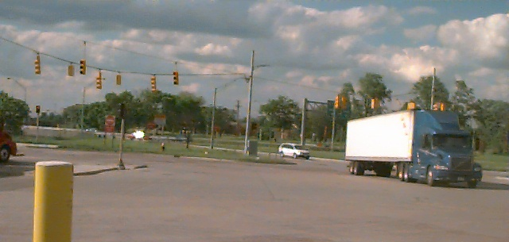

Figure 13. Outbound traffic exiting from I-96 feeder
road onto Ambassador Bridge, Detroit side.

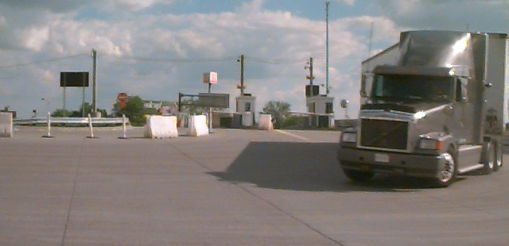

Figure 14. Outbound trucks depart main duty free store
separated from main traffic and turn right.

At that point, if moving out to get ahead of a queue the collector must either: (1) turn left onto Porter Street and left again after crossing I-75 onto the one-way street (Fisher Freeway southbound) that parallels I-75; (2) go straight coming out from the bridge and bear left to enter I-75N; or go straight coming out from the bridge and bear right onto a service road, after which there is an opportunity to cross over I-75 on Vernor Street and left again on Fisher Freeway to access the exit ramp off I-75 southbound. In the vicinity of the bridge, the crossover streets above I-75 south of Porter Street are Howard Street and West Grand, and north of Porter street is Vernor.

The OB-2 collector was about 50 yards downstream from primary, next to the flagpoles beside the Canadian Customs building (see figure 15), which gave good alignment with the axes of the tollbooths with exiting trucks. The IB-2 collector was on the left about 50 yards downstream from primary.

The IB-2 collector was located where the ramp comes up from Wyandotte Street, across from the duty free area. In this position (see figure 16), the IB-2 collector can record trucks in all lanes of the directional flow: the mainstream of truck traffic on Huron Church Road (figure 17), trucks coming up the entrance ramp from Wyandotte Street, and trucks exiting the commercial vehicle duty free parking area. When the IB-2 collector had to move out and follow the queue, there was a way he/she could exit through an adjacent part of the toll facility that is ordinarily not open except during times of special events or other heavy traffic. The way out is through a parking lot and left onto Wyandotte Street W. From there, the collector can cross under the bridge and turn left to merge onto Huron Church Road southbound, which is the best route to get upstream to the head of the queue.

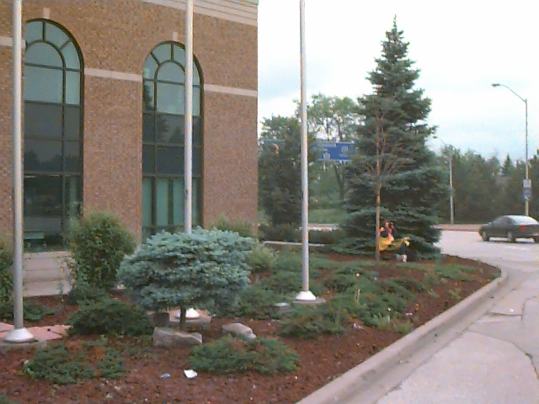

Figure 15. Outbound 2 data collector beside Canadian Customs building.

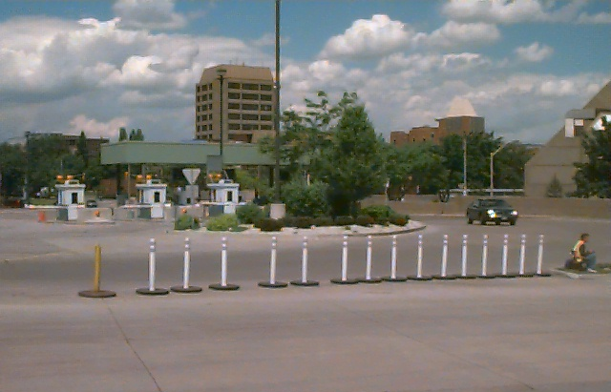

Figure 16. Inbound 1 data collector at right with
Wyandotte Street tollbooths in background.

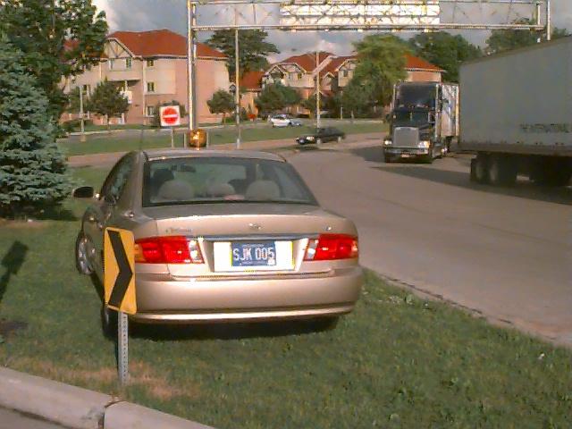

Figure 17. Inbound 1 data collection site.
Trucks shown just departed Huron Church Road.

At the Ambassador Bridge, other than an unusual event on the third day, there was no time at which trucks backed up all the way across the bridge in either direction. Data collectors in the outbound direction did not relocate due to an increasing queue length, but the collectors located in the inbound direction did have to move. Five alternate locations along Highway 3 (Huron Church Road) were chosen, depending on the conditions at the time. Any distances given are from the initial location. Of course, it was easiest to record data at that initial location close to the tollbooths where trucks move slowly approaching the bridge to depart Canada.

Two alternate locations were in generally close proximity to the original location – walking distance for the collector. The first of these was 0.15 mile upstream from the original location, where autos and trucks split as they enter the duty free and tollbooth areas. The second alternate location was 0.3 mile upstream, where the railroad track crossed the road beside an intersection with a traffic light.

The third alternate location was 0.65 mile, at the Assumption School at the intersection of Girardot Street. The fourth was at 0.95 mile, at one corner of University Mall where Tecumseh road West intersects. The final alternate location was at a Travelodge motel 2.25 miles upstream, just before Highway 3 intersects with E.C. Row Expressway (see figures 18 and 19). Of course, all alternate locations were on the same side (the east side) of Huron Church Road. Even at the intersections, trucks would pass at highway speeds and would often use both lanes, reducing the number of vehicles that could be effectively recorded.

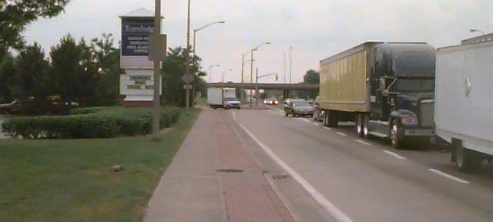

Figure 18. Site of farthest Inbound 1 data collection queue site
(5th alternate station, approximately 2 miles from regular IB-2 station).

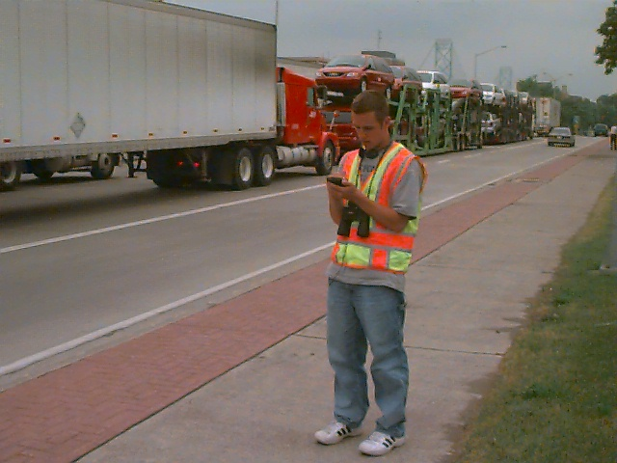

Figure 19. Inbound 1 data collector at 5th alternate location.

Data collection was conducted by recording commercial vehicle license plates as vehicles crossed fixed points within the data collection sites. Survey individuals or teams, were placed at each of the four data collection sites to record commercial vehicle license plate data. Figures 8-10 contain diagrams of the facilities on both sides of the border, including station locations and major points of inspection.

Collectors at these locations would record the last five characters of the front, lower-left license plate of as many trucks as possible that passed their location. When trucking firms register many vehicles at once, they often get assigned sequential license plate numbers. Using the last five characters helps to ensure that as different trucks operated by the same firm travel across the bridge that they are uniquely identified. License plate information was entered into handheld computers: Palm m100 PDAs for the first collection and Handspring Visor PDAs for the second collection, both having a special application designed for this project. Each entry was time-stamped with the current date and time. Prior to each day’s collection, all PDAs were synchronized to the same time. Prior experience indicated that recording the entire license plate was too time consuming and that entering only the last four characters did not provide adequate distinction between different vehicles, so the project team chose to record the last five characters.

Typically, the queue of trucks crossing the border would not extend beyond the bridge plaza. However, on occasion the queue would extend onto the highway system. When this occurred, the data collector at the #1 location would have to move further from the bridge to a point beyond the end of the queue. In this way, they could continue to record trucks before they began their wait at the end of the line. When this or any other event of interest occurred, the collectors would use an “EVENT” feature of the PDA software to record it.

For each #1 location, the supervisor would record the distance from any data collection point other than the original position (which would be in the bridge plaza). During post-processing, the data from all locations nearer to the bridge than the farthest location would be adjusted to include the additional travel time from the farthest location to the original location. The travel time would be computed at free-flow speeds, since there would have been no queue at the times that the data were collected at these closer locations. In this way, the data all would appear to be collected from the same location, the one most distant from the bridge. This method does not factor in delays caused by traffic lights, however. In the case of the Ambassador Bridge collection, there were a total of five additional data collection points that were utilized during the second data collection period, some of which extended beyond intersections with traffic lights.

Data Collection Sample Size

Sample sizes are typically not a concern with videotape or handheld data entry devices, because the data collection includes a large number of vehicles. However, minimum sample sizes should be verified with variability values from field data. Early research found that sample sizes from 25 to 100 license matches were necessary for a given roadway segment and time period (Turner, et. al.). In general, there were sufficient records each day to meet this requirement.

Data Collection Equipment

As outlined in the “Data Collection Procedures” section above, handheld computers were used as the data entry device and proved adequate to the task. For the first week of data collection, Palm m100 model handheld computers were used. It was decided, however, that subsequent data collection should be done with Handspring Visors. The Handspring Visors use the same Palm OS (operating system) and have faster processing speeds (at least in side-by-side comparison with this application) and larger screen sizes than the m100 models from Palm Computing. Low-end models with 2 Mb of storage capacity were selected as the application and data size were projected to be well below this limit.

A custom application was developed for the Palm OS that allowed the data collectors to identify their locations (e.g., OB-1, IB-2), the number of open booths (primarily used for the customs inspection booths), special events or other comments, and license plate information. A screen shot of the application interface is shown in Figure 20.

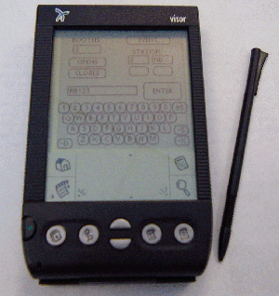

Figure 20. Data Collection Device and Software Application.

The data were downloaded via a serial cable directly from the application into a text file on the field laptop computer, which was a Dell Latitude CPx H running with a 500 MHz Pentium III processor.

Data Collection Summary

Table 6 shows the number of commercial vehicle license plates recorded for each of the stations on each of the data collection days. Table 7 shows the average daily traffic volume as recorded by the Ambassador Bridge. Hourly volumes are used in the calculation of delay and are shown with the delay calculations in Tables 8 through 19.

Table 6. Number of Commercial Vehicle License Plates Collected

Station | 5/22/01 | 5/23/01 | 5/24/01 | 6/19/01 | 6/20/01 | 6/21/01
OB-1* | 1,126 | 2,232 | 1,974 | 2070 | 1,842 | 1,320
OB-2* | 982 | 1,287 | 1,618 | 2,194 | 943 | 2,130
IB-2* | 1,114 | 2,049 | 2,169 | 2,222 | 1,965 | 1,653
IB-2* | 1418 | 2,816 | 2,677 | 1,720 | 2,455 | 1,885
Total | 4,640 | 8,384 | 8,438 | 8,206 | 7,205 | 6,988

Table 7. Average Daily Traffic at the Ambassador Bridge

Direction | 5/22/01 | 5/23/01 | 5/24/01 | 6/19/01 | 6/20/01 | 6/21/01
Outbound* | 5,923 | 6,519 | 6,855 | 6,328 | 6,692 | 6,029
Inbound* | 5,767 | 6,441 | 6,058 | 6,224 | 6,316 | 5,518
Total | 11,690 | 12,960 | 12,913 | 12,552 | 13,008 | 11,547

*Note: Outbound means into Canada, Inbound means into the U.S.

Data Quality Steps

At the end of each day of data collection, the supervisor would collect the PDAs and download the data into the field laptop computer where it was stored on the hard drive. The data would be examined for any anomalies and transferred across the Internet to a secondary location for backup purposes. The OB-1 and OB-2 data would be merged together and license plates from the two locations would be “matched” using a spreadsheet developed in Microsoft Excel. As it is easy to mistake certain characters, particularly letters that looked like numbers, the license plate data was pre-processed. All ‘I’s were replaced with ‘1’s; all ‘O’s, ‘D’s, and ‘Q’s were replaced with ‘0’s; all ‘S’s were replaced with ‘5’s; and all ‘Z’s were replaced with ‘2’s. In addition, the data collectors were instructed to always use ‘1’s for ‘I’s and ‘0’s for ‘O’s (i.e., to use the digit, rather than the letter).

Occasionally, collectors would be unsure about a license plate and would append “QQQ” to their entry. This would typically occur when several trucks passed the collector in rapid succession or if one truck blocked the license plate of another and he or she could only manage a quick glimpse. This would allow the supervisor to search the downloaded data for a potential match by using the travel times of other trucks that were recorded in the same general time frame. During this process, the supervisor could identify the few records in which the data collector forgot to press “ENTER” after recording a license plate before recording the next one. These ten-character entries could be split into two and the time for the first interpolated from the adjacent entries if they were less than a minute or so apart.

Data post-processing also included a step to identify any anomalies in the data, including outliers. Outliers, records that indicated travel times significantly greater than typical for that time period, were most often caused by recording the license plate of a vehicle only some of the time as it made repeated trips across the border during a single day. This is because the matching algorithm uses the most recent time at the #1 position when matching to a record from a #2 location. For example, if the vehicle was recorded as it headed from Canada to the U.S. early in the morning, later returned to Canada, was missed as it re-entered the U.S. later in the day, and then recorded on its subsequent return to Canada, the #1 time from its first trip would be matched with it #1 time from the first trip (for a valid travel time) an also matched to the #2 time from its second trip (an invalid travel time). This invalid travel time would be easily identified by manual inspection of the data, aided by highlighting those travel times above a specific, but variable, threshold.

Freight Delay Analysis

The measure for the freight transportation system at international roadway border crossings is travel delay per truck trip through the first inspection point in the import country. Delay is measured relative to the travel time at low volume conditions, which will allow the processing time of the inspection to be accommodated outside of the measure. Estimating the average delay per truck for each hour where congestion is present and then applying the average hourly truck volume produces an estimate of total delay.

The average delay per truck for each hour is the difference between the travel time at low volume conditions and the travel time each hour. The number of open inspection booths also affects travel time and this information was recorded on all days as it changed. To determine the average travel time for each road segment, the matched license plate data in the database is used. The number of matches is noted for statistical analysis and the travel time is noted for each hour. The travel time for each truck was assigned to the hour when they passed through the primary customs inspection location as this was the only location that remained consistent throughout the data collection. It should be noted, however, that the hourly volumes are obtained from the bridge operators and are measured at the tollbooths.

The data are presented in Tables 8 through 19. The columns illustrate the key elements for estimating delay:
- No Delay Travel Time – The time through the system at low volume conditions. For this report, the value used was that of the lowest hourly travel time in that direction for each three-day data collection period.
- Number of Matched Vehicles – The number of vehicle observation used to estimate the travel time for each hour.
- Average Travel Time – The amount of travel time from entry to exit for trucks entering the system each hour (use the time the vehicle passes the advance point as the determinant of the time period label).
- Delay per Trip – The difference between the average travel time and the “no delay” time.
- Average Traffic Volume – The average hourly truck volume for the “season” or time of year being analyzed.
- Total Delay – The product of the hourly truck volume and delay per trip.

Table 8. Total Delay – 5/22/2001 – Outbound

Table 9. Total Delay – 5/23/2001 – Outbound

Table 10. Total Delay – 5/24/2001 – Outbound

Table 11. Total Delay – 6/19/2001 – Outbound

Table 12. Total Delay – 6/20/2001 – Outbound

Table 13. Total Delay – 6/21/2001 – Outbound

Table 14. Total Delay – 5/22/2001 – Inbound

Table 15. Total Delay – 5/23/2001 – Inbound

Table 16. Total Delay – 5/24/2001 – Inbound

Table 17. Total Delay – 6/19/2001 – Inbound

Table 18. Total Delay – 6/20/2001 – Inbound

Table 19. Total Delay – 6/21/2001 – Inbound

As previously mentioned, the number of open primary Customs inspection booths was also recorded.

Weather. The Monday that the data collection team arrived for the first collection period, a tornado hit Detroit that caused the police to close certain roads. Since rain was predicted during the collection period, the team utilized a third rental car, which proved to be a good decision. During both periods of data collection there was sporadic rain, generally light. It rained lightly during the first 2 days of 1st collection then it rained hard for a short period on the 3rd day. Rain reduced effectiveness of data collection by about half. With cars, three collectors were able to record safely and comfortably during heavy rain. The fourth collector, at OB-2, went into a stairwell in the Customs building with exterior access and a window where she was able to continue recording. During the 2nd collection, there was some rain each day. It rained hard the final day of collection for a two-hour period, which was the heaviest rain of either collection.

Unusual Incidents. At approximately 1:30 on June 21, the third day of the second collection, a dramatic event caused total shutdown of traffic at this border crossing for a time and delayed traffic in total for seven hours. Two men were working atop scaffolding on the U.S. side that was erected for painting a section of one of the two huge cables that supports the bridge. The scaffolding collapsed and the men were left dangling from the cable by their safety harnesses high above the road and the Detroit River. Traffic in both directions was immediately halted and vehicles on the bridge cleared.

Emergency vehicles and helicopters showed up to assist as necessary. Colleagues finally pulled the men back onto the catwalk on top of the giant cable and eventually walked them down carefully. There was total closure of traffic across the bridge for fifty minutes. Then two lanes only were open for two hours. Final clearance occurred at 8:30 P.M. Trucks that had already left the tollbooth were allowed to continue, so that the trucks that crossed during the emergency registered travel times that were not significantly different from other hours.

During this emergency, traffic backed up along Highway 3 (Huron Church Road) as far as the E.C. Row Expressway, 1.9 miles from the tollbooth, which was the fifth alternate location. The IB-1 collector relocated to each of the five alternate locations during this time. However, it was not possible for the OB-1 collector on the other side of the bridge to safely move out of position and relocate.

On one occasion during each collection (apart from the unusual total shutdown just mentioned), the supervisor observed exiting traffic (both autos and trucks) back up on the Detroit side (see figure 21). This congestion backed up in the right lane of I-75 northbound all the way to the pedestrian crossover at Ferdinand Street, one mile from the bridge entrance. Most of this exiting truck traffic continued to turn onto the bridge, although some turned off to the right prior to the bridge to get over to Fort Street or other local roads. Also, some trucks were already on the northbound Fisher Freeway at the point where I-75 exits onto it. Some of these trucks did not enter the bridge but rather turned onto I-75, I-96, or local roads. Exiting traffic backed up in the right lane of I-75 southbound all the way to Tiger Stadium, which is approximately two miles north of the Ambassador Bridge.

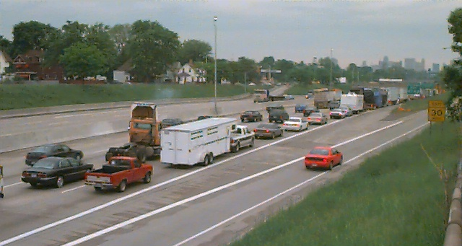

Figure 21. Traffic on I-75 northbound approaching Ambassador Bridge exit.

Detroit rush hour traffic seemed to be the major cause for this backup, which is unlike the queues encountered at border crossings in more rural settings. The part of this congestion that is related to the bridge infrastructure is difficult to separate from the part that is due to the city road system infrastructure. Traffic did not back up all the way across the bridge at any time during either collection.

During the first collection, a truck broke down right next to the OB-1 collector in the duty-free truck lane that curves around next to the OB-1 collector. Bridge operators closed off the affected truck tollbooth. A tow truck pulled up in front of the OB-1 collector’s location and bridge operators moved plastic barricades (designed to be filled with water but empty) so that the tow truck backed up to the stalled truck. Ambassador Bridge personnel then stopped traffic and moved cones and plastic barricades to allow the tow truck to cross over from outbound traffic prior to the tollbooth into the inbound traffic lane heading into U.S. Customs (see figure 22).

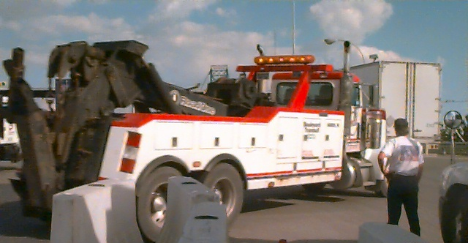

Figure 22. Tow truck crossing through barricades near duty-free ramp.

Statistics

Table 20 shows the baseline or “no delay” travel time, the average travel time, and three other measures that indicate the reliability of the travel time estimates. The baseline time (in minutes) is the time needed to travel the study distance (between the starting point in the exporting country and the initial inspection point in the importing country) in free-flow traffic conditions. The average time is computed from all vehicles measured during the data collection period over the study distance. The 95th percentile time is the time (in minutes) within which 95 percent of all trucks can cross the border. The buffer time is the additional time above the average crossing time (in minutes) that it takes for 95 percent of all trucks to cross. The buffer index expresses the buffer time in terms of the average time and is the percentage of extra time that must be budgeted to cross the border within the 95th percentile time. For example, if the average time was 10 minutes and the buffer time was 5 minutes, the buffer index would be 50 percent.

Table 20. Crossing Times

 | Baseline  Time | Average Crossing Time | 95th Percentile Time | Buffer Time | Buffer Index
Outbound | 5.7 | 8.8 | 13.9 | 4.9 | 55.7
Inbound | 12.9 | 20.4 | 33.9 | 13.4 | 65.7

From the table, it is apparent that both the average travel time and the reliability are more favorable for outbound traffic than for inbound traffic.

Figure 23 illustrates the average travel time experienced for different truck volumes per lane per hour in each direction.
Figure 23. Average Travel Time for Different Hourly Volumes

Figures 24 and 25 show typical average hourly traffic volumes per booth for the study period as well as the measured average hourly travel times. In addition, the average number of open primary Customs booths in each direction is shown.

Figure 24. Typical Inbound Traffic

Figure 25. Typical Outbound Traffic

Conclusions

Lessons learned during data collection activities in this project at this site and at others along the Canadian and Mexican borders with the U.S. have identified several issues that should be taken into consideration to assist future data collection efforts. Some apply to advance planning and the initial site visit and others apply more specifically to the data collection activities themselves.

Planning and Site Visits

- Prior to conducting any data collection project, all jurisdictional and cooperating agencies should be made explicitly aware of the purpose and objectives of the study as well as all the details associated with the data collection project (e.g. dates, times, procedures to be followed during the data collection period, etc.). Failure to do so may result in confusion and possible delay of the study. This has been very time-consuming at some ports and should be adequately accounted for in the schedule. For some agencies, including U.S. Customs, it is important to contact both the federal and local levels. Some entities that should be contacted might not be readily apparent and can include construction companies working on public rights-of-way, state police, city officials, and Thruway Authorities. Some agencies provide verbal approval for the data collection and may even provide supporting documentation to their field staff, yet are reluctant to provide documentation for the data collectors to carry. Every effort should be made to obtain written authorization that can be carried by the data collectors, particularly from bridge authorities and immigration officials. Several times at some sites, the officer at the primary auto inspection booths asked data collectors to go to secondary inspection and speak with immigration officials. Although allowed to continue, this caused some unnecessary delay in the data collection.

- Prior to data collection activities, a general idea of traffic peak periods and conditions should be understood to optimize collection of appropriate traffic data and coverage of the appropriate times. This information should be obtained from discussions with knowledgeable officials and by examining historical traffic data.

- Any additional data needs should be discussed explicitly with the appropriate officials. At some crossings, for example, average hourly truck volumes are not normally recorded and maintained, but can be if special arrangements are made in advance. Alternatively, it may be appropriate to use other means to measure truck volumes, such as roadway counters or having the data collectors indicate the vehicles that pass without their license plates being recorded (assuming continuous data collection during each day). These additional traffic volumes could be used to corroborate data provided by the local authorities or used if their planned data collection did not occur or there was some other problem in providing the data.

- It is also important to be aware of special federal or local holidays on both sides of the border when scheduling data collections as these could affect traffic flows. Some minor holidays that occur on Mondays and Fridays, might not significantly affect traffic for a Tuesday through Thursday data collection period, but may increase the likelihood that key local officials will be on vacation and unavailable should any problems arise.

- When scheduling the data collection times, consider the availability of sunlight or high-powered lighting. It becomes increasingly difficult to read license plates at night as trucks approach with their headlights on (also a problem during rain) and entering the data into the PDAs also becomes more difficult when it is dark.

- Photographs of the border facilities and data collection locations should be taken during the site visits to assist in documenting the collection effort and to better inform the data collectors prior to their arrival on-site.

- Processing, data quality, and analysis of all traffic data require the largest portion of the study time.

Data Collection Activities

- Prior to data collection activities, an explanation and understanding of the procedures to be followed and logistics should be made clear to all members of the study team (e.g., number and location of license plate characters to be recorded, all commercial vehicles should be recorded, when and how to contact the on-site supervisor, etc.).

- Proper identification for all survey members and written documentation of authorization from all jurisdictional agencies should be carried at all times by all members of the study team, especially when conducting business in a foreign country.

- The supervisor should assess all conditions upon arrival for data collection to note any changes from the site visit or prior collection activities. Sometimes unplanned construction or other events may alter the preferred data collector locations or the truck flow patterns.

- While only one supervisor was originally planned for each data collection visit, it was determined that installing one supervisor on each side of the border was highly desired. One supervisor would be designated the overall site supervisor. This presented several benefits, the most important being added safety and security for the data collectors, particularly for a collector who needed to move to a remote location upstream from the border when the queue extended beyond their original location. Other benefits were increased awareness of current conditions and the origin of backups, the increased ability to relieve data collectors for breaks and lunch while maintaining continuous data collection, and assisting with data collection during exceptionally high-volume times or in difficult locations (such as remote spots along a highway when the vehicles were passing at free-flow speeds). Without the extra supervisor, a single supervisor would make repeated trips across the border to check on the collectors, relieve them, and provide them with food and drink if they were not conveniently located nearby. Border delays would often make this an extremely time-consuming process.

- For Mexican data collection, it is recommended that Mexican nationals be used, both as supervisors and as data collectors. This helps to enhance coordination with national, state, and local officials and to minimize the likelihood of immigration or other problems with federal, state, or local agencies.

- As mentioned above, the supervisors should be used to maintain nearly constant data collection during breaks. This improves data quality by ensuring the supervisors repeatedly observe each collector and can identify and correct any problems they might be having. Further, this improves the number of trucks matched at both the #1 and #2 locations, improving the sample size for analysis.

- Communication between the data collectors and their supervisors is crucial to an efficient and successful effort, particularly when one of the data collectors must move upstream past the end of a growing queue. Communication with the supervisor is also important when a data collector is having a problem with an official questioning their authority to do their work or when some other unexpected event occurs. For example, occasionally, there may be an anomaly with the data collection equipment and the collector can receive immediate instructions on how to proceed rather than having to wait until the supervisor next visits their location. Two-way radios (FRS-type with up to a two-mile range) and cell phones work adequately in most situations, but interference and range can limit their effectiveness. Cell phone service can be spotty near border areas. Additional longer-range communication options that do not require FCC approval should be considered for future collections. Obviously, when using cell phones, ensure that long-distance charges and roaming fees will not be significant costs.

- It is important to ensure that the data collectors are safe and comfortable during their long periods of collection. If their data collection locations cannot provide adequate cover from severe rains or heat, additional vehicles should be considered. Comfortable sport chairs with attachable beach umbrellas served to protect the collectors well during light rain and moderate sun. Ensure that the collectors have an adequate supply of water and that facilities are conveniently accessible. This becomes more difficult for the remote locations upstream from the border crossing.

REFERENCES

Turner, S.M., W.L. Eisele, R.J. Benz, and D.J. Holdener. Travel Time Data Collection Handbook.Report. No. FHWA-PL-98-035. Federal Highway Administration, Texas Transportation Institute, March 1998

