USDA PRIVACY IMPACT ASSESSMENT FORM

Agency: U.S. Department of Agriculture, Farm Service Agency

System Name: Fingerprint Identification System (FIS)

System Type: Major Application

System Categorization (per FIPS 199): Moderate

Description of the System:

The Fingerprint Identification System (FIS) is a satellite system of the Department of Justice (DOJ) Civil Applicant System (CAS) that enables FSA staffs to electronically capture civil applicant fingerprints and biographical data and to transmit the data to the Federal Bureau of Investigation’s (FBI) Integrated Automated Fingerprint Identification System (IAFIS) via the CAS satellite system as part of the background investigations of new Department employees, political appointees, and contractor personnel. The current estimate is that the agency processes 9252 fingerprint checks per year.

CAS (main system) is located in the Justice Data Center, Washington, D.C. (JDC-W), and makes use of current network integration efforts to interconnect the DOJ and its components with other Federal Departments that utilize the CAS. CAS is operational 24 hours a day, 7 days a week with 99% availability to allow for regular scheduled maintenance.

Since any response from IAFIS to a civil applicant submission may contain National Criminal Information Center (NCIC) data, FSA must comply with NCIC and USDA security policies as they relate to internal controls, information security, information dissemination, user security, and user training. These policies are described in more detail in the USDA certification and accreditation documents for the CAS satellite system.

Who owns this system?

Kathy Williams
Section Head, Operations Section
USDA/FSA/DAM/HRD/KCHRO/OS
U.S. Department of Agriculture
Farm Service Agency
6501 Beacon Dr.
Kansas City, MO 64133
(816) 926-1392
kathy.williams@kcc.usda.gov
Susie Somuah-Gyamfi
Section Head, Payroll/Personnel Operations Section
USDA/FSA/DAM/HRD/PPOS
U.S. Department of Agriculture
Farm Service Agency
1280 Maryland Ave. 4th Floor
Washington, DC 20024
(202) 401-0648
susie.somuah-gyamfi@wdc.usda.gov

Who is the security contact for this system?

Brian Davies
Information System Security Program Manager (ISSPM)
FSA/DAM/ITSD/OTC/ISO
U.S. Department of Agriculture
Farm Service Agency
1400 Independence Avenue SW
Washington, D.C. 20250
(202) 720-2419
brian.davies@wdc.usda.gov

Who completed this document?

Kathy Williams
U.S. Department of Agriculture
Farm Service Agency
6501 Beacon Drive
Kansas City, MO 64133

Susie Somuah-Gyamfi
U.S. Department of Agriculture
1400 Independence Ave.
Stop 0594
Washington, DC 20250-0594

Sue Weis
Information Security Office (ISO)
FSA/DAM/ITSD/OTC/ISO
U.S. Department of Agriculture
Farm Service Agency
1400 Independence Avenue
Washington, D.C. 20250
(202) 690-4639
sue.weis@wdc.usda.gov

DOES THE SYSTEM CONTAIN INFORMATION ABOUT INDIVIDUALS IN AN IDENTIFIABLE FORM?

Indicate whether the following types of personal data are present in the system

QUESTION 1  Does the system contain any of the following type of data as it relates to individual: | Citizens | Employees
Name | Yes | Yes
Social Security Number | Yes | Yes
Telephone Number | Yes | Yes
Email address | Yes | Yes
Street address | Yes | Yes
Financial data | No | No
Health data | No | No
Biometric data | Yes | Yes
QUESTION 2  Can individuals be uniquely identified using personal information such as a combination of gender, race, birth date, geographic indicator, biometric data, etc.?  NOTE: 87% of the US population can be uniquely identified with a combination of gender, birth date and five digit zip code | Yes | Yes
Are social security numbers embedded in any field? | Yes | Yes
Is any portion of a social security numbers used? | Yes | Yes
Are social security numbers extracted from any other source (i.e. system, paper, etc.)? | Yes | Yes

If all of the answers in Questions 1 and 2 are NO,
You do not need to complete a Privacy Impact Assessment for this system and the answer to OMB A-11, Planning, Budgeting, Acquisition and Management of Capital Assets,
Part 7, Section E, Question 8c is:
3. No, because the system does not contain, process, or transmit personal identifying information.

If any answer in Questions 1 and 2 is YES, provide complete answers to all questions below.

DATA COLLECTION
- Generally describe the data to be used in the system.

Fingerprint and Biographical Data

- Is the use of the data both relevant and necessary to the purpose for which the system is being designed? In other words, the data is absolutely needed and has significant and demonstrable bearing on the system’s purpose as required by statute or by Executive order of the President.

Yes

- Sources of the data in the system.
  - What data is being collected from the customer?

Name, home address, social security number, race, sex, gender and fingerprint.

  - What USDA agencies are providing data for use in the system?

None

  - What state and local agencies are providing data for use in the system?

N/A

  - From what other third party sources is data being collected?

FBI system sending data back through CAS system

- Will data be collected from sources outside your agency? For example, customers, USDA sources (i.e. NFC, RD, etc.) or Non-USDA sources.

Yes

  - How will the data collected from customers be verified for accuracy, relevance, timeliness, and completeness?

The information is verified by a driver’s license, social security card or a passport

  - How will the data collected from USDA sources be verified for accuracy, relevance, timeliness, and completeness?

The information is verified against source documents as listed in 6.1

  - How will the data collected from non-USDA sources be verified for accuracy, relevance, timeliness, and completeness?

The information being sent from the Department of Justice, we assume it’s correct

DATA USE
- Individuals must be informed in writing of the principal purpose of the information being collected from them. What is the principal purpose of the data being collected?

To complete part of the pre-employment process for employees and contractors.

- Will the data be used for any other purpose?

No. If NO, go to question 9

  - What are the other purposes?

- Is the use of the data both relevant and necessary to the purpose for which the system is being designed? In other words, the data is absolutely needed and has significant and demonstrable bearing on the system’s purpose as required by statute or by Executive order of the President

Yes

- Will the system derive new data or create previously unavailable data about an individual through aggregation from the information collected (i.e. aggregating farm loans by zip codes in which only one farm exists.)?

Yes

  - Will the new data be placed in the individual’s record (customer or employee)?

Yes

  - Can the system make determinations about customers or employees that would not be possible without the new data?

No

  - How will the new data be verified for relevance and accuracy?
We assume the information is correct coming from the DOJ

- Individuals must be informed in writing of the routine uses of the information being collected from them. What are the intended routine uses of the data being collected?

Send information to Justice

- Will the data be used for any other uses (routine or otherwise)?

No. If NO, go to question 13

  - What are the other uses?

- Automation of systems can lead to the consolidation of data – bringing data from multiple sources into one central location/system – and consolidation of administrative controls. When administrative controls are consolidated, they should be evaluated so that all necessary privacy controls remain in place to the degree necessary to continue to control access to and use of the data. Is data being consolidated?

No. If NO, go to question 14

  - What controls are in place to protect the data and prevent unauthorized access?

- Are processes being consolidated?

No. If NO, go to question 15

  - What controls are in place to protect the data and prevent unauthorized access?

DATA RETENTION
- Is the data periodically purged from the system?

Yes

  - How long is the data retained whether it is on paper, electronically, in the system or in a backup?

Data will be retained up to 60 days electronically and then manually deleted. Paper document is filed in the Official Personnel Folder or personnel record and maintained indefinitely.

  - What are the procedures for purging the data at the end of the retention period?

Manual deletion in the CAS system

  - Where are these procedures documented?

The User Manual and Records Retention Regulations

- While the data is retained in the system, what are the requirements for determining if the data is still sufficiently accurate, relevant, timely, and complete to ensure fairness in making determinations?

The information is only used for the background investigation process.

- Is the data retained in the system the minimum necessary for the proper performance of a documented agency function?

Yes

DATA SHARING
- Will other agencies share data or have access to data in this system (i.e. international, federal, state, local, other, etc.)?

Yes

  - How will the data be used by the other agency?

Data will be shared with partner agencies via service level agreements or
Memoranda of Agreements for Contractor security clearances.

  - Who is responsible for assuring the other agency properly uses of the data?
Each agency has a security officer or FOIA staff that will promulgate procedures for proper use of data.

- Is the data transmitted to another agency or an independent site?

Yes

  - Is there the appropriate agreement in place to document the interconnection and that the PII and/or Privacy Act data is appropriately protected?
Yes
- Service Level Agreement; DOJ and Farm Service Agency dated May 14, 2007
- Interconnection Security Agreement: DOJ and OCIO-ITS dated May 10. 2007

- Is the system operated in more than one site?

Yes

  - How will consistent use of the system and data be maintained in all sites?

Sites will be independent of each other; however, both sites will use the same User Manual and policies.

DATA ACCESS
- Who will have access to the data in the system (i.e. users, managers, system administrators, developers, etc.)?

Users and System Administrators

- How will user access to the data be determined?

By System Administrators

  - Are criteria, procedures, controls, and responsibilities regarding user access documented?

Yes

- How will user access to the data be restricted?

Password protected and machine is in a locked room

  - Are procedures in place to detect or deter browsing or unauthorized user access?

Yes

- Does the system employ security controls to make information unusable to unauthorized individuals (i.e. encryption, strong authentication procedures, etc.)?

Yes – OCIO question

CUSTOMER PROTECTION
- Who will be responsible for protecting the privacy rights of the customers and employees affected by the interface (i.e. office, person, departmental position, etc.)?

USDA/FSA/DAM/Human Resource Division

- How can customers and employees contact the office or person responsible for protecting their privacy rights?

Kathy Williams - KC
Susie Somuah-Gyamfi - WDC

Both System Admistrators listed above may be contacted via telephone, mail or email.

- A “breach” refers to a situation where data and/or information assets are unduly exposed. Is a breach notification policy in place for this system?

Yes. If YES, go to question 28

  - If NO, please enter the POAM number with the estimated completion date:

- Consider the following:
- Consolidation and linkage of files and systems
- Derivation of data
- Accelerated information processing and decision making
- Use of new technologies

Is there a potential to deprive a customer of due process rights (fundamental rules of fairness)?

Yes

  - Explain how this will be mitigated?

Due process procedures are submitted to each customer upon notification of decisions.

- How will the system and its use ensure equitable treatment of customers?

Adjudicated on negative issues

- Is there any possibility of treating customers or employees differently based upon their individual or group characteristics?

No. If NO, go to question 31

  - Explain

SYSTEM OF RECORD
- Can the data be retrieved by a personal identifier? In other words, does the system actually retrieve data by the name of an individual or by some other unique number, symbol, or identifying attribute of the individual?

Yes

  - How will the data be retrieved? In other words, what is the identifying attribute (i.e. employee number, social security number, etc.)?

A Unique Id or the PIN of a person

  - Under which Systems of Record notice (SOR) does the system operate? Provide number, name and publication date. (SORs can be viewed at http://www.defenselink.mil/privacy/govwide/)

OPM/GOVT-1

  - If the system is being modified, will the SOR require amendment or revision?

Yes, if the system modification causes the system to deviate from what is permitted by the SORN.

TECHNOLOGY
- Is the system using technologies in ways not previously employed by the agency (e.g. Caller-ID)?

No. If NO, the questionnaire is complete.

  - How does the use of this technology affect customer privacy?

Upon completion of this Privacy Impact Assessment for this system, the answer to
OMB A-11, Planning, Budgeting, Acquisition and Management of Capital Assets,
Part 7, Section E, Question 8c is:

1. Yes.

PLEASE SUBMIT A COPY TO
THE OFFICE OF THE ASSOCIATE CHIEF INFORMATION OFFICE/CYBER SECURITY
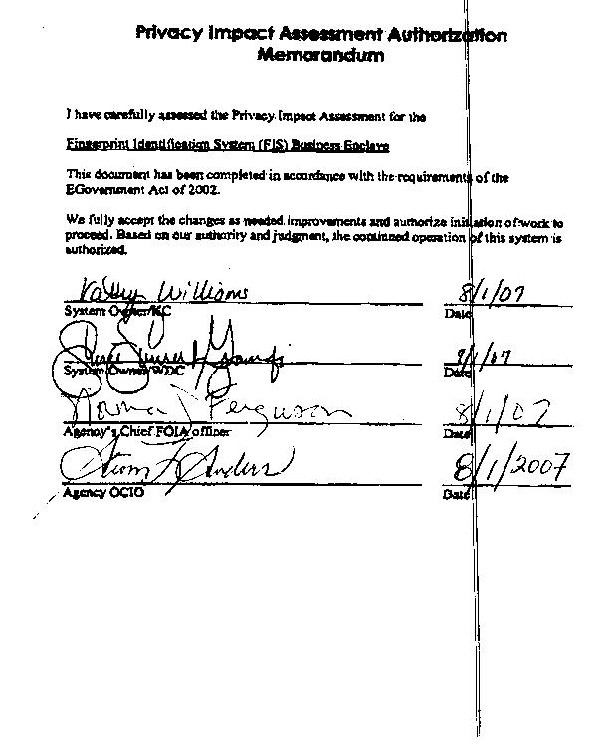

Comments of Latanya Sweeney, Ph.D., Director, Laboratory for International Data Privacy Assistant Professor of Computer Science and of Public Policy Carnegie Mellon University To the Department of Health and Human Services On "Standards of Privacy of Individually Identifiable Health Information". 26 April 2002.

