Sustain & Evolve: Case for Participation Brief

Audience
Individuals who are interested in joining a Community of Practice (CoP) and want to explain the concept to their peers or request permission to participate from their managers.

Purpose
This customizable template allows potential members to share information about the CoP as part of their plan to obtain support from their managers.

To Use This Resource
This document is in Microsoft Word to allow you to add, edit, or remove information to suit your needs. You may also change the Header to include the name or logo of your Community.

To complete this brief, you may want to work through the Case for Participation Reflection Guide You can also use the Case for Participation PowerPoint to help present this information.

After modifying the template, you can:
- Print this document and write on a hard copy
- Complete and e-mail the document to recipients
- Use the points as a discussion guide

Have an Idea for How this Resource Can be Improved?
We’d love to hear it! Use the feedback form or send an email to phin@cdc.gov to let us know how this resource can be improved or to suggest other resources you would find useful.

Overview
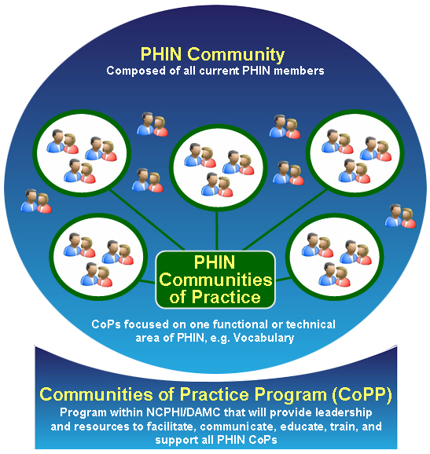
PHIN strives to improve public health use and exchange of information by promoting the use of standards and technical requirements. It is comprised of individuals with the interest and passion to work toward the application and implementation of PHIN requirements and related issues.

In addition to individuals, the PHIN Community includes a collection of Communities of Practice (CoPs) that focus on specific functional and technical areas related to PHIN.

A CoP is a group of individuals who come together to learn about a shared topic. Members meet and interact regularly in order to:
  - Collaborate
  - Solve Problems
  - Build Knowledge

Organizations benefit when their representatives participate in a CoP. When an organization allows its personnel to join, it is potentially increasing:
  - Employee efficiency, in terms of time and cost, in retrieving information
  - Industry benchmarking capacity
  - Involvement in key industry and national initiatives
  - Organizational reputation as a contributor in building new capabilities

[Enter the CoP Name] CoP is a community, aligned with PHIN, which addresses:
- [Enter Focus of CoP]
  - [Enter objective]
  - [Enter objective]
  - [Enter objective]

My Participation
I would like to participate in the [Proposed CoP] CoP. By participating I anticipate that I will
  - Develop an enhanced professional identity
  - Have an opportunity to network with peers and increase my visibility in the field
  - Gain access to Subject Matter Experts who may be able to help me focus and articulate developing ideas
  - Participate in learning and development events and activities

As a member, my role will require the following
  - [Insert anticipated role and responsibilities as identified in the Case for Participation Reflection Guide]
  - [Insert anticipated time commitment]

Benefits
My participation in the [Proposed CoP] Community will benefit our organization by:
  - [Enter project benefits identified in the Case for Participation Reflection Guide]
  - [Benefit 2]
  - [Benefit 3]
Additionally, my participation in the [Enter Proposed CoP] relates directly to my professional objectives. It relates to the following professional development goals:
  - [Enter related professional goals in the Case for Participation Reflection Guide]
  - [Goal 2]
  - [Goal 3]

Reporting on Performance
In order to document my progress and to demonstrate the value of my participation, I will provide:
  - [Enter planned update identified in the Case for Participation Reflection Guide]
  - [Update 2]
  - [Update 3]

Submitted by: _________________________________________________
To: __________________________________________________________
Date: ________________________________________________________

