The Facts about…

No Child Left Behind is the most important federal education reform in more than three decades. It is a bipartisan agreement that is being implemented in partnership with the states for the benefit of every child in public school.

On November 26, 2002, the U.S. Department of Education released a substantive package of guidance and final regulations to aid in the full implementation of No Child Left Behind.
A Guide to the Future

These regulations will serve as a critical guide to the future in our nation’s 12-year plan of record education funding and historic education reforms to help every child learn and excel.

No Child Left Behind represents a new spirit—the federal government is working with the states to support and build on local and state efforts to improve education and guarantee yearly progress.
- In a spirit of partnership with state and local governments U.S. Department of Education officials have met early and often with parents, teachers, superintendents, principals, state school chiefs, and governors to listen and learn about their concerns and to get their recommendations.
- NCLB provides flexibility to enable States with high-quality accountability systems in place to build on their previous efforts.
- State officials are responsible for defining what adequate yearly progress will be in their states as they strive toward full student proficiency in 12 years.

It Can Be Done: Reforms That Work

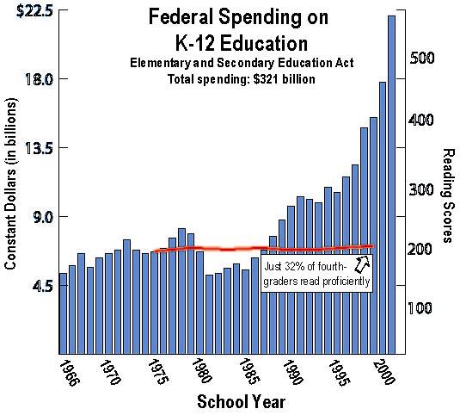
State governments and local schools have already begun to embrace the spirit and laws of No Child Left Behind.
- Hundreds of schools are proving that even schools with high-levels of poverty are showing high achievement and the opportunities open to all children when schools use good instruction and embrace accountability.
- At the local level many parents, educators and community leaders have been responding to the president’s vision. In Oregon, for instance, when several neighborhood schools were listed as “in need of improvement,” the principals gathered together with parents and presented a clear plan for action showing exactly what they will do to improve achievement.

This substantive package comes on the heels of the Department’s most ambitious effort ever to hear from every sector of America on the best way to ensure that every child learns and every state has a plan.
- All told, the Department received more than 700 comments from all 50 states in the nation.
- This is on top of the 800 pages of guidance, help, and outreach the Department has already provided since No Child Left Behind became law.
- The Department has also succeeded in responding to states at a pace far faster than the 1994 reauthorization.

The package offers additional help on numerous topics including:
- How states can improve their accountability systems to comply with the law and measure the progress of every school and every group of children;
- How states should implement “supplemental service” provisions to ensure every disadvantaged child gets extra help outside schools that are working to improve;
- How states can improve their teaching corps and classroom achievement with the help of highly qualified teachers;
- And how states can get the federal funds to open up more public schools to parents with children in danger of being left behind.

This package of regulations communicates the core of the bipartisan effort to ensure parents and the public understand how their local schools are doing and whether every boy and girl is learning.
- The regulations are intended to guide states on how to meet the requirements of No Child Left Behind and build on what was outlined by Secretary Rod Paige in a letter to state school chiefs on July 24, 2002. With these regulations in hand, every state has the information to integrate adequate yearly progress into their state accountability systems and meet the deadline of compliance by January 31, 2003.
- Many states have already begun the process of complying with the law and creating improved accountability systems.
- These regulations are an important step intended to help states continue this effort to build and augment their existing accountability systems to meet the bipartisan vision of No Child Left Behind.

Accountability through testing and high standards is the foundation of authentic education reform. And AYP is intended to ensure every child learns, every school has the opportunity to improve, and every dollar is spent wisely for those purposes.

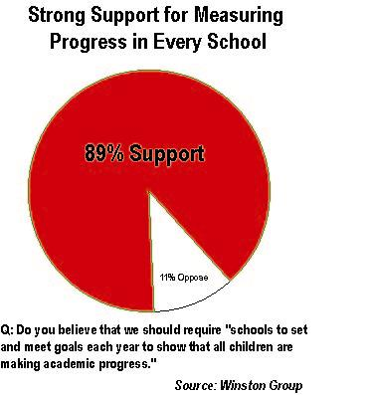
Accountability is the challenge every state must meet to ensure improvement in student achievement.
- Even states with robust accountability systems and schools with strong curricula can improve.
- The American people expect and demand more. Nearly nine in ten Americans (89%) believe that we should require “schools to set and meet goals each year to show that all children are making academic progress.”
- Early next year, the Department should be able to announce that some state plans are already in compliance with the law.
- And by the end of January, the Department is confident that every state seeking federal funds will prove that they have embraced the new era of accountability by focusing their state systems on increased student achievement for all children.

The Department will provide clear requirements, as well as help states meet the solid deadlines in January through May as America’s schools prepare to implement AYP and the other critical provisions of the law for the new school year.

No Child Left Behind is meant to ensure every dollar is spent wisely and actually helps a child learn.
- Similar to welfare reform, the federal government must work closely and in partnership with states to implement accountability systems and deliver real results. That takes leadership and cooperation.

To build on these efforts, the department has created a special inquiries review team to give state and local leaders, even teachers and principals the most comprehensive answers and solutions possible.
- These team members have strong experience implementing education reforms at the state and local level.
- They understand how to provide answers that are helpful and clear when addressing substantive questions by those working at the state and local level.

