Analyses of Economic, Environmental, and Occupant Benefits of Sustainable Design and LEED® Certification for State of Hawaii and K-12
Public School Facilities

May 10, 2007



Prepared For:

Department of Business, Economic Development
& Tourism (DBEDT)
State of Hawaii

Prepared by:

FERRARO CHOI AND ASSOCIATES LTD.
In Collaboration With:

Lincolne Scott Inc.
RMI/ENSAR Built Environment
O’Brien & Company
Disclaimer:

This material is funded by grant number DE-FG51-04R021585 from the U.S. Department of Energy. However, any opinions, findings, conclusions, or recommendations expressed herein are those of the author(s) and do not necessarily reflect the views of the U.S. Department of Energy, the State of Hawaii, or any agency or employee thereof.

Ferraro Choi And Associates Ltd.
Analyses of economic, environmental, and occupant benefits of sustainable design and
LEED® certification for State of Hawaii and K-12 public school facilities. Honolulu: Dept. of Business, Economic Development and Tourism, State of Hawaii, 2007.
1. Sustainable architecture-Hawaii. 2. School buildings-Design and
construction-Hawaii.
LB3218.H3.F4.2007

Acknowledgements:
This report is the result of a cooperative effort between key personnel of the Hawaii Department of Business, Economic Development & Tourism (DBEDT), the Hawaii Department of Education (DOE), the Hawaii Department of Accounting and General Services (DAGS), the University of Hawaii at Manoa, Hawaiian Electric Company, Punahou School, and Ferraro Choi And Associates Ltd and its consultants as a contractor for the State of Hawaii. We wish to acknowledge the following individuals for their substantial contributions in completing this effort:

Department of Business, Economic Development & Tourism (DBEDT)
Elizabeth Raman, Ph.D., Project Manager for DBEDT, Strategic Industries Division
Carilyn Shon, Energy Efficiency Program Manager, Strategic Industries Division
Dean Masai, Energy Analyst, Strategic Industries Division
John Mapes, Ph.D., Economist, Research and Economic Analysis Division
Khem Sharma, Ph.D., Economist, Research and Economic Analysis Division

Department of Accounting and General Services (DAGS)
Ralph Morita, Chief, Division of Public Works, Planning Branch

Department of Education
Nick Nichols, Project Manager, Facilities & Support Services Branch
Brenda Lowrey, Facilities Planner, Planning Branch
Duane Kashiwai, Acting Director, Facilities Development Branch
David K. Y. Chung, Architect and Quality Control, Facilities Development Branch
Francis Cheung, Director, Facilities Maintenance Branch

Hawaiian Electric Company - Energy Solutions for Business
Jim Maskrey, Program Manager

University of Hawaii at Manoa, School of Architecture
Steve Meder, Ph.D., Professor of Architecture

Punahou School
Steve Piper, Director Physical Plant
Randy Overton, Assistant Director Physical Plant

Ferraro Choi And Associates Ltd.
Bill Brooks, AIA, LEED® AP
Ira Freeman, ArchD, LEED® AP

RMI/ENSAR Built Environment
Greg Franta, FAIA
Victor Olgyay, AIA
Eric Maurer, LEED® AP
Aalok Deshmukh, LEED® AP
Will Clift, LEED® AP

O’Brien & Company
Kathleen O’Brien, LEED® AP
Jane Simmons, PE, CDT, LEED® AP

Lincolne Scott Inc.
Scott Inatsuka, PE, LEED® AP
Josiah Ives, Intern Mechanical Engineer

Analyses of Economic, Environmental, and Occupant Benefits of Sustainable Design and LEED® Certification for State of Hawaii and K-12 Public School Facilities

Table of Contents: Page

Foreword 1

Executive Summary 2

Study Team and Working Group 4

Study Methodology 4

General Conclusions Drawn from the Studies 5

Definitions of Key Terms 8

A Note About the Statement of Work 9

A Note About the Background of the Project 9

- STUDY NO. 1: Economic, Occupant, and Environmental Benefits of
Sustainable Design for State of Hawaii New Elementary Schools
  - Overview 11
  - Findings 12
  - Determination of Economic Benefits 12
    - Objectives 12
    - Methodology and Approach 13
    - Base Case Elementary School LCCA 14
      - Establish Physical Campus Attributes 14
      - Define Building Groups by Operational Profile 14
      - Develop Life Cycle Cost Calculator (LCCC) 15
    - Green Case Elementary School LCCA 16
    - Comparison of the Air-Conditioned Elementary School Base
Case and Green Case Life Cycle Cost Analyses 18
    - Comparison of the Non-Air-Conditioned Elementary School
Base Case and Green Case Life Cycle Cost Analyses 21
    - Sustainable Schools Survey – Economic Benefit Trends 25
    - LEED Certification 27
    - Findings and Conclusions 29
  - Determination of Occupant Benefits 31
    - Objectives 31
    - Methodology and Approach 31
    - LEED Silver Assessment 32
    - Sustainable Schools Survey – Occupant Benefit Trends 32
    - Related Studies 33
  - Determination of Environmental Benefits 33
    - Objectives 33
    - Methodology and Approach 33
    - LEED Silver Assessment 34
    - Sustainable Schools Survey – Environmental Benefit Trends 34
    - Findings and Conclusions 35

- STUDY NO. 2: Case Study – Waipahu Intermediate School Cafeteria
  - Objectives 37
  - Background 37
  - Methodology and Approach 39
  - LEED Certification Review 40
  - Establishing the Green Case 41
  - Establishing the Base Case 41
  - Life Cycle Cost Analysis 42
  - Economic Benefits 46
  - Occupant Benefits 46
  - Environmental Benefits 46
  - Findings and Conclusions 47

- STUDY NO. 3: Case Study – Retrofit of an Existing DOE Classroom
  - Objectives 49
  - Methodology and Approach 49
    - Background 49
    - Methodology 50
    - Predicted Mean Vote 51
  - Establishing the Base Case 52
  - Establishing the Green Case 53
    - Air Conditioning – Individual Terminal Units 56
    - Air Conditioning – Variable Refrigerant Technology 56
    - Air Conditioning – Water-Cooled Chilled Water System 57
  - Life Cycle Cost Analysis 58
  - Findings and Conclusions 58

- STUDY NO. 4: Implementation Research and Strategies
  - Implementation Research 61
    - Objectives 61
    - Methodology and Approach 61
    - Findings 63
      - Strategies with Life Cycle Benefits and Savings 63
      - Project Funding 64
      - Consultant Selection Process 65
      - Facility Planning Process 66
      - Sustainable Design Implementation (New Facilities) 68
      - LEED Certification 68
      - Parameters for Requiring LEED Certification 69
      - Special Funds 70
      - Transitional Issues for Effective Implementation 71
  - Suggested Strategies 72
    - Strategy 1: Prioritize technologies and design strategies to
achieve a 30% reduction in operational expense 81
    - Strategy 2: Establish a uniform process for monitoring and
accounting for energy and water consumption in schools 81
    - Strategy 3: Employ Life Cycle Cost Analysis (LCCA) 83
    - Strategy 4: Fund capital projects to allow for integrated design
and equipment upgrades 84
    - Strategy 5: Modify consultant selection process to ensure
expertise in sustainable design and construction 85
    - Strategy 6: Modify facility planning process to ensure
decision-making takes sustainable design goals into account 86
    - Strategy 7: Set minimum requirements for the design of
new schools and major renovations 87
    - Strategy 8: Establish a clear certification path for K-12 schools
in Hawaii 89
    - Strategy 9: Provide incentives for innovation and exemplary
implementation 93
    - Strategy 10: Provide training to enable successful
implementation of green building requirements 93
    - Strategy 11: Phase implementation to increase opportunity
for success 94

- List of Figures 95

- List of References 97

- Appendix 101
  - Sustainable Schools On-Line Surveys 101
  - LCCA – Elementary School (Air-Conditioned) 121
  - LCCA – Elementary School (Non-Air-Conditioned) 141
  - LCCA – Waipahu Intermediate School (WIS) Cafeteria 161
  - DOE Classroom Retrofit Energy Consumption Results 181

Analyses of Economic, Environmental, and Occupant Benefits of Sustainable Design and LEED® Certification for State of Hawaii and K-12 Public School Facilities

Foreword

The underlying principles of “sustainable design” and “green building design” are founded in design and development practices that conserve the environment, energy, water and raw materials, and promote occupant health.

There is a growing awareness that ignoring these principles will produce negative results in terms of investment, health, and the quality of the life for future generations. Thus, the notion of sustainable development is gaining needed recognition and application.

In Hawaii, the case for sustainable development is easily made. Even the untrained eye can perceive the physical limit of the land area and grasp the idea that Hawaii’s environment is fragile and its resources finite. Despite an abundance of natural energy systems (sun, wind, oceanic, etc.), the State remains 90% dependent upon energy generated by imported fossil fuel.

The State has a large inventory of existing facilities to operate and maintain, and many more in the planning stages. The costs to design, construct, operate, and maintain these facilities are significant, and they will likely become more so as the cost of labor and materials increases. State facilities are also a major consumer of local infrastructure and resources including water, sewer, and energy systems.

The largest segment of the State inventory comprises its K-12 public schools. Currently numbering over 260, schools accommodate a state-wide population of approximately 185,000 students and 11,000 teachers exclusive of administrative, maintenance, and custodial staff. To keep pace with an increasing and shifting population, many new schools will be needed, and of these, the greatest demand will be for elementary schools.

To achieve the economic benefits of sustainable design, elementary schools (and by extension all public schools) must be viewed as a long-term investment. Continuing the
current practice of prioritizing “least first cost” to design and construct is not an effective strategy for achieving the lowest life cycle cost of a school facility, which is the real cost to the State.

This report shows that sustainable design is the only sensible option for new public schools going forward. There is no economic, occupant, or environmental incentive to continue to design and construct public schools in the existing conventional fashion.

Executive Summary

This report is a compilation of four (4) separate studies that are related to the analysis of economic, environmental, and occupant benefits of sustainable design and LEED certification for State of Hawaii public school facilities. The report has been prepared for the Department of Business, Economic Development & Tourism in conjunction with the Department of Education.

Study No. 1: Economic, Occupant, and Environmental Benefits of Sustainable Design for State of Hawaii New Elementary Schools

Study No. 1 is an analysis of economic, occupant, and environmental costs and benefits of sustainable design and LEED certification for new elementary schools. Study No. 1 contains detailed life cycle cost analyses (LCCA), a LEED certification feasibility analysis, and an on-line survey of 12 existing sustainable schools. Air-conditioned and non-air-conditioned versions of the elementary school are considered.

The findings of this first Study indicate that it is very feasible to design new elementary schools to be sustainable and achieve economic, occupant, and environmental benefits. Economic benefits include the reduction of operational costs by 30% in comparison to a code-compliant conventional school, a savings of approximately $60,000 per year. Occupant benefits include a more comfortable and healthy environment for learning and working. Environmental benefits include conservation of resources such as water and open space, mitigating the need for landfill, and reducing Hawaii’s dependence upon imported oil.

The life cycle cost analysis finds that, over a 30-year life cycle, a sustainable school has a significantly lower Net Present Value than a conventional school. Thus, there is no economic incentive to design conventionally.

Study No.1 finds that the most effective design strategy for conservation of energy is daylighting. Effective daylighting can significantly reduce or eliminate the need for electric lighting during the daytime in classrooms and many other spaces of the elementary school, and reduce the cooling load for schools that are air-conditioned.

The on-line survey of 12 existing sustainable schools finds that strategies utilized in the sustainable design of schools are universally applicable (with minor exceptions), irrespective of climate. Thus, public schools in Hawaii that are designed to be sustainable will have much in common with sustainable schools across the country. The survey also finds that daylighting is a key strategy for conservation of energy and providing a better learning environment in 100% of the schools surveyed.

Study No. 2: Case Study – Waipahu Intermediate School Cafeteria

Study No. 2 is an analysis of economic, occupant, and environmental costs and benefits of sustainable design and LEED certification for the recently completed Waipahu Intermediate School (WIS) Cafeteria, the first LEED Certified project by the State Department of Education (DOE).

The findings of this second Study indicate that the new WIS Cafeteria has achieved economic, occupant, and environmental benefits. Economic benefits include the reduction
of operational costs by 15% in comparison to a code-compliant conventional cafeteria, a savings of approximately $3,000 per year. Occupant benefits include superior ventilation and thermal comfort for dining and multi-purpose uses. Environmental benefits include conservation of resources such as water and open space, diverting 85% of construction waste from landfill, and reducing Hawaii’s dependence upon imported oil.

The life cycle cost analysis finds that, over a 30-year life span, the sustainable WIS Cafeteria has a modestly lower Net Present Value than a conventional cafeteria. Although the difference is small, the added occupant and environmental benefits that come with the sustainable cafeteria make the choice to move away from conventional cafeteria design clear.

As for the intermediate school as a whole, the second Study also finds that the most effective design strategy for conservation of energy is daylighting.

Study No. 3: Case Study – Retrofit of an Existing DOE Classroom

Study No. 3 is an analysis of the feasibility, cost, and benefits of passive heat abatement strategies in a hypothetical retrofit of an existing DOE classroom. The school selected for this Study is Campbell High School, located in Ewa on the island of Oahu.

The findings of this third Study indicate that the benefits of passive design strategies for heat abatement at Campbell High School are very limited due to problems stemming from existing building orientation and envelope design.

This Study finds that some improvement in thermal comfort can be achieved by the addition of external shading devices, but thermal comfort for the majority of classrooms may require air conditioning. Of the air-conditioning options, both the Variable Refrigerant Technology (VRT) and Central Chilled Water systems are more favorable than the Individual Terminal Units. However, the selection of either technology would depend on initial cost constraints and life cycle duration.

Study No. 4: Implementation Research and Strategies

Study No. 4 is an analysis of existing Department of Education planning and budgeting procedures, and implementation research conducted to identify high-level strategies that would effectively integrate sustainable design and best practices into existing processes governing the planning and building of K-12 schools in Hawaii. The goal is to identify a pathway to the potential economic, occupant, and environmental benefits identified in this report’s analytical components (Studies Nos. 1, 2, and 3).

The findings of this fourth Study indicate that improvements need to be made in a number of existing processes including, but not limited to: project funding, consultant selection, facility planning, special funding, and transitioning.

This Study identifies a number of strategies to improve the way existing business is done, including prioritizing design strategies to achieve a 30% reduction in operational expense, establishing a uniform process for monitoring and accounting for energy and water consumption, employing life cycle cost analysis in the decision-making process, and modifying the consultant selection process to ensure expertise in sustainable design and construction practice.

Study Team and Working Group

The study team comprises four professional services firms:

Firm: Location: Lead:

Ferraro Choi And Associates Ltd. Honolulu, HI Sustainability and Prime
Lincolne Scott Inc. Honolulu, HI Life Cycle Cost Analysis
RMI/ENSAR Built Environment Boulder, CO Case Studies
O’Brien & Company Seattle, WA Implementation

The study team was responsible for the data gathering, research, methodology, findings, and preparation of this report.

The Working Group provided periodic review and input regarding the methodology, findings, and reporting by the study team. In addition, the Working Group provided assistance accessing relevant state data used in the Study. The Working Group included representatives from the following entities:

Department of Business, Economic Development & Tourism (DBEDT)
Department of Education (DOE)
Department of Accounting and General Services (DAGS)
Hawaiian Electric Company (HECO)
University of Hawaii at Manoa, School of Architecture
Punahou School, Physical Plant

Study Methodology

Methodologies employed in the preparation of this Study included:

- Life cycle cost analysis.

- On-line surveys of existing sustainable schools.

- Review of existing Hawaii public elementary schools data to corroborate predicted levels of consumption for electricity and water.

- Review of existing publications concerning sustainable design and LEED certification.

- Review of strategies for sustainable design implementation used, or under consideration by other states and municipalities.

- Interviews with State of Hawaii entities responsible for planning, budgeting, and operating existing public school facilities.

- Computer modeling for thermal comfort effectiveness.

- Computer modeling for daylighting effectiveness.
- Interviews with recognized experts in sustainable school design.

- Application of the Hawaii Model Energy Code.

- Team expertise in sustainable design.

- Team expertise in LEED certification.

- Team expertise in local costs of construction.

General Conclusions Drawn from the Studies

The findings of each of the four studies contained in this report lead to a number of general conclusions and recommendations listed below:

Conclusions from Study No. 1: Economic, Occupant, and Environmental Benefits of Sustainable Design for State of Hawaii New Elementary Schools

- There is no economic, occupant, or environmental benefit or incentive to the State of Hawaii for designing, constructing, maintaining, and operating schools in the conventional manner that is currently practiced. Life cycle cost analysis in this Study clearly establishes the economic benefit of sustainable design over conventional design. In addition to economic benefits, this Study finds that schools that achieve LEED Silver will enjoy a number of occupant and environmental benefits. All of these benefits are corroborated by the survey of 12 existing sustainable schools that was a part of this Study.

- The single most important strategy in achieving the economic benefits that result from operational savings is daylighting. Daylighting can minimize or eliminate electric lighting in the majority of the elementary school spaces, and reduces the size of the air-conditioning plant by reducing heat gain (from electric lighting). Daylighting has also been shown to improve performance and reduce eye strain.

- LEED Silver is very feasible for new public elementary schools. Of the minimum 33 (out of 69) credits that are required to qualify for the LEED Silver rating, it is critical that at least six (6) credits be achieved under the “Optimize Energy Performance” category. This will ensure reduced energy consumption of approximately 30%, which is essential to the operational savings projected by this Study, and a key reason why the Net Present Value of the sustainable (Green Case) school over a 30-year life is lower than a conventional (Base Case) school.

- The on-line survey of 12 existing sustainable schools identifies trends that indicate that most sustainable design strategies are common to all schools, irrespective of climate or location. These strategies include, but are not limited to, daylighting, energy conservation, water conservation, materials with recycled content, diverting construction waste from landfill, and superior ventilation.

- Budgeting for sustainable elementary schools should include added costs for
construction, special AE (Architect-Engineer) design services, commissioning, and LEED certification, but these added costs are more than offset by operational savings over the life of a school facility. This report indicates that budgets for additional up-front costs of public schools need only increase by 2.5%, assuming the impact of periodic escalation on the local cost of construction has already been accounted for in these budgets.

The specific increases include:

Construction: 1.50%
Commissioning: 0.25%
LEED Certification: 0.25%
Special AE Design: 0.50%
Total: 2.50%

Note: The percentages above are calculated from the estimated cost of construction of a public elementary school. For example, if the estimated construction cost is $35 million, the additional up-front cost to be budgeted for special AE design services would be $175,000 ($35 million x .005).

Conclusions from Study No. 2: Case Study – Waipahu Intermediate School Cafeteria

- The Waipahu Intermediates School (WIS) Cafeteria project is the first LEED Certified project for the State Department of Education, and a successful example of the economic, occupant, and environmental benefits that are achieved with sustainable design.

- The life cycle cost analysis of the WIS Cafeteria indicates that the Net Present Value of the sustainable cafeteria is lower than for a conventional cafeteria, but only slightly so. The reason for this is that a cafeteria is an energy intensive facility, and opportunities for operational savings are limited. Maximizing daylighting and passive ventilation in the dining area does allow the WIS Cafeteria to save approximately
$3, 000 in annual operational expenses, which equates to a 15% savings.

- The WIS Cafeteria has achieved a number of occupant and environmental benefits including thermal comfort, superior ventilation, use of construction materials with recycled content, use of locally manufactured materials, and diversion of 85% of construction waste from landfill.

Conclusions from Study No. 3: Case Study – Retrofit of an Existing DOE Classroom

- Passive design solutions to achieve heat abatement for existing classrooms will likely have limited application and success in improving thermal comfort. Thus, air conditioning should be considered. Variable Refrigerant Technology (VRT) and Central Chilled Water systems are both viable alternatives and the selection of either technology would depend on initial cost constraints and life cycle duration.

- Providing heat abatement with air conditioning will provide thermal comfort, but will increase school operating costs and State dependence upon imported fossil fuel. Although not addressed by this Study, providing energy for the air-conditioning system from a renewable source should be considered. Public/private partnerships between the State and a third-party vendor that would provide, install, and lease the renewable energy source are one avenue with promise.

Conclusions from Study No. 4: Implementation Research and Strategies

Achieving sustainable elementary schools (and by extension, public schools in general) will require fundamental changes in the way business is currently done. If these changes are implemented in a systematic and structured manner, in time the State will realize the economic, occupant, and environmental benefits discussed in this report.

Suggested implementation strategies discussed in this Study include:

- Prioritizing architectural and technological design strategies to achieve a 30% reduction in operational expense.

- Establishing a uniform process for monitoring and accounting for energy and water consumption.

- Employing life cycle cost analysis as a primary decision-making tool.

- Providing an add-on to fund capital projects to allow for integrated design and equipment upgrades.

- Modifying the consultant selection process to ensure expertise in sustainable design and construction.

- Modifying the facility planning process to ensure decision-making takes sustainable design goals into account.

- Setting minimum requirements for the design of new schools and major renovations.

- Establishing a clear LEED certification path for K-12 schools.

- Establishing a process for exemption from LEED certification, when applicable.

- Offering incentive programs to encourage innovation and exemplary implementation.

- Continuing to provide training to enable successful implementation of green building requirements.

- Phasing implementation to increase opportunity for success.

Definitions of Key Terms

“LEED Silver” This term refers to the U.S. Green Building Council’s (USGBC) Leadership in Energy and Environmental Design (LEED) Green Building Rating System.
When used in the context of this report for an entire elementary school, LEED Silver is defined as LEED-NC v2.1 Silver (LEED For New Construction Version 2.1 Silver Certification), which requires a minimum achievement of 33 out of 69 potential credits.

Note: At the time of this report, a working draft of LEED For Schools is in progress by the USGBC. Study No. 4 discusses the differences between LEED For New Construction and LEED For Schools, and makes related recommendations.

“LEED Certified” This term refers to the U.S. Green Building Council’s (USGBC) Leadership in Energy and Environmental Design (LEED) Green Building Rating System.
When used in the context of this report for the Waipahu Intermediate School Cafeteria, this term is defined as LEED-NC v2 Certified (LEED For New Construction Version 2 Certified), which requires a minimum achievement of 26 out of 69 potential credits.

“Sustainable Elementary School, Sustainable Design” When used in this report in Study No. 1, these terms are defined as an elementary school design that would qualify for the minimum number of credits required for LEED Silver, inclusive of six (6) credits for energy reduction as determined under the Energy & Atmosphere portion of the LEED For New Construction Version 2.1 Rating System.

“Sustainable Design” When used in this report in Study No. 2 in reference to the Waipahu Intermediate School Cafeteria, this term is defined as an elementary school cafeteria design that achieves the credits needed for LEED-NC v2 Certified, inclusive of 1 credit for energy reduction as determined under the Energy & Atmosphere portion of the LEED For New Construction Version 2 Rating System.

“Daylighting” refers to architectural design solutions that permit the controlled introduction of indirect daylight into an occupied space to an extent that the need for electric lighting is substantially reduced or eliminated for typical classroom use during daytime hours of operation. Successful daylighting design requires proper building orientation and strategies to block direct daylight and associated heat and glare, while permitting indirect daylight to enter the space for lighting purposes. Daylighting is a key strategy for saving energy as it reduces or eliminates the need for electric lighting during daytime hours and reduces heat gain from lighting (indirect daylight is cooler than electric light), thus reducing the size of the air-conditioning cooling system.

A Note About the Statement of Work

The original Statement of Work published by DBEDT as part of Solicitation No. RFP-05-01-SID sought an overview of K-12 public schools. To allow a more in-depth study within the restraints of time and funding, it was determined that more value could be gained by focusing on a detailed analysis of elementary schools only. Elementary schools were selected as they will comprise the majority of new schools to be constructed over the near term, and there is more data for existing recently constructed elementary schools than for intermediate or high schools.

The original Statement of Work also sought to research existing sustainable school retrofits. Following a web-based search for such schools, it was determined that there are none reported, and this aspect of the work was deemed not feasible. In addition, the fact that retrofits are each unique would have made the prospect of generalized conclusions problematic and of limited usefulness.

A Note About the Background of the Project

In 2002, in order to encourage high efficiency schools, DBEDT sponsored a School Decision Maker Forum for DAGS and DOE featuring “Techniques and Tools to Enhance the Learning Environment”. Continuing this effort, in 2004, DBEDT sponsored a Workshop for DOE on High Performance Schools in Hawaii. A leading international expert on sustainable buildings, Charles Eley, P.E., F.A.I.A., explored attributes and design concepts of high performance schools. Following this workshop, DOE, working with DBEDT and professional architects, developed the “Hawaii High Performance School Guidelines” which are currently being used as a guidance document by the DOE, along with related publications on life cycle cost calculations, commissioning, and high performance classroom prototypes.

In 2004, DBEDT won a competitive award from the U.S. Department of Energy Rebuild America Program to undertake this study.

In January 2006, Hawaii Governor Linda Lingle, issued Administrative Directive No. 06-01, which required facilities using state funds or state-owned lands to meet and receive certification for the U.S. Green Building Council’s Leadership in Energy and Environmental Design (LEED) Standard at the Silver level. In addition, the Administrative Directive directed the use of life cycle cost/benefit analysis (typically termed life cycle cost analysis or LCCA) to assess the purchase of energy efficiency equipment such as EnergyStar equipment and use of solar water heating. Other sustainable design features included energy and water efficiency, waste minimization and pollution prevention, and environmental product procurement. Act 96, passed in June 2006, which builds on the Administrative Order, contains similar requirements.

Training has always been a strong component of the State’s energy efficiency program. Numerous training and educational opportunities have been organized or cosponsored by DBEDT to benefit state agency employees, the private sector and general public. In FY 2006 alone, DBEDT sponsored or cosponsored more than 45 training and informational events which included participation by over 289 state employees. Many of these events included LEED training sessions.

STUDY NO. I: Economic, Occupant, and Environmental Benefits of Sustainable Design for State of Hawaii New Elementary Schools

  - Overview

This Study is a cost/benefit analysis of sustainable design and LEED certification for new State of Hawaii public elementary schools. Both air-conditioned and naturally ventilated versions of the elementary school are examined.

The Study is a predictive analysis and comparison of conventional and sustainable versions of a hypothetical elementary school that is sized and characterized in accordance with the most current version of the Department of Education’s “Facilities Assessment and Development Schedule” (FADS). The FADS document defines the useable floor area (net) and quantity of each type of space in a standard DOE elementary school. As indicated in Figure 1.01, the resulting standard elementary school has an area of approximately 61,667 net square feet. A grossing factor to account for circulation, wall thicknesses, etc. has been applied for this Study and the resulting school size is 77,084 gross square feet situated on a 12-acre campus. Hard surfaces for parking, roadways, and walkways are estimated to be approximately 50,000 square feet.

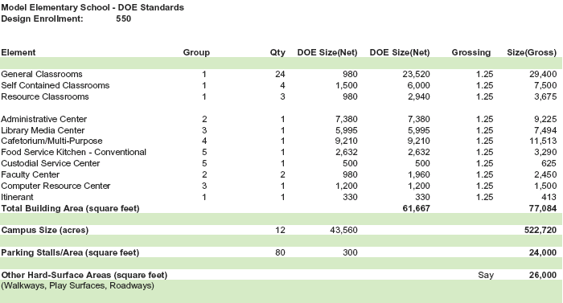
Figure 1.01 – Standard DOE Elementary School Size (Square Feet)

The conventional version of the elementary school developed in this Study is considered the “Base Case”. The costs assigned to design, construct, operate, and maintain the Base Case elementary school in this Study are based upon a number of criteria including current DOE budgeting and planning practice, current Hawaii construction costs, minimum code compliance (Hawaii model energy code, ASHRAE 90.1-1999), and study team expertise.
Calculated annual operational costs for electricity, water, sewer, and gas have been compared to, and corroborated with, actual expenses incurred by four recently completed, similar elementary schools, including Mililani Ike Elementary School, Mililani Mauka Elementary School, Nanaikapono Elementary School, and Waikele Elementary School.

The sustainable version of the elementary school developed in this Study is considered the “Green Case”. The costs assigned to design, commission, construct, operate, and maintain the Green Case elementary school in this Study are based upon the same criteria above, publications regarding the costs of LEED certification and green design, the general expertise and practice of the study team related to sustainable design and LEED certification, and proven sustainable strategies for conservation of energy, water, and materials.

  - Findings

This Study finds that there are tangible economic, occupant, and environmental benefits that will result from the sustainable design of public elementary schools. Many of these benefits will be immediate, while others will accrue over the course of a 30-year life cycle. As public schools typically remain in use longer than 30 years, it can be further reasoned that the lifetime benefits would be even greater than those determined herein.

These findings are based upon a school that has achieved a level of sustainable design equivalent to LEED Silver and a level of performance as indicated in the life cycle cost analysis contained in this Study. LEED Silver requires achieving at least 33 of 69 possible credits, and it is critical to note that at least six (6) of these 33 credits must be derived from energy conservation, reducing energy consumption by approximately 30% to obtain the level of economic benefits determined by this Study.

This Study also finds that 75% of the benefits resulting from a new sustainable elementary school achieving LEED Silver are occupant and environment benefits (as opposed to economic benefits). This finding results from the fact that, when an elementary school is taken as a whole, significant energy reduction is not achievable for spaces such as the cafeteria kitchen, computer center, and library. Thus, achieving more than a 30% overall energy reduction is considered unlikely, and a 30% reduction will only achieve six (6) of the needed 33 credits to qualify for LEED Silver.

This finding underscores the fact that sustainable design and LEED Silver require strategies that address a broad spectrum of conservation issues, including site and habitat, light pollution, water, energy, resources, and indoor air quality. Focus on energy conservation alone is not sufficient to be considered sustainable, and will not result in LEED certification. Nevertheless, the potential for reducing energy consumption by 30% in comparison to conventional design is significant.

  - Determination of Economic Benefits

    - Objectives

The objective of this section of the Study is to determine the economic benefits of sustainable design for new air-conditioned public elementary schools. In addition, the Study examines the economic benefits for a sustainable non-air-conditioned elementary school. Reviewing a non-air-conditioned school was not part of the original scope of work, but the assessment became possible because of ease of modifying inputs into the life cycle cost calculator developed as part of the Study.

Economic benefits are expressed in terms of 2007 (current) dollars.

    - Methodology and Approach

Approach:

The approach taken for predicting economic benefits was to define and model a standard, conventionally designed DOE elementary school as a “Base Case”, modify costs and performance of the Base Case to represent a sustainable version of the same school as a “Green Case” and compare capital and life cycle costs for each in terms of Net Present Value.

A hypothetical new air-conditioned elementary school was selected as the primary subject of the Study as it will be the type of school most often constructed by the State over the next 10 to 20 years. Although intermediate and high schools are beyond the scope of this Study, it can be reasoned that they can achieve benefits similar to those of the elementary school as they comprise many similar types of spaces.

To corroborate the predicted findings of this Study, an on-line survey of twelve existing sustainable schools was performed to determine if they have experienced economic benefits. Nine of the surveyed schools are on the mainland, and three are in Hawaii. The Hawaii schools surveyed included Case Middle School (Punahou), Hawaii Baptist Academy, and the Harry and Jeanette Weinberg Building at Iolani School. These schools are the only schools in Hawaii that are “sustainable” as defined in Section 1.2 above.

This Study does not address economic benefits of existing schools that have undergone a sustainable retrofit. This task was not feasible for the simple reason that the study team could not find any data on any such schools in Hawaii or on the mainland. In addition, the notion of attempting to reach general conclusions applicable to Hawaii schools from reviewing a range of Hawaii or mainland-based retrofit solutions specific to each school’s circumstances raised an immediate question as to the applicability of the findings.

Methodology:

The general methodology for assessing potential economic benefits for a sustainable elementary school was based upon the following four steps:

Step 1: Establish a Base Case elementary school in terms of facility sizes and types, and campus size, in accordance with the DOE Facilities Assessment and Development Schedule.

Step 2: Develop a 30-year Net Present Value life cycle cost analysis (LCCA) for an air-conditioned Base Case elementary school inclusive of design and management costs, construction costs, replacement costs, and operation and maintenance costs.

Step 3: Develop a 30-year Net Present Value life cycle cost analysis for the Green Case air-conditioned elementary school inclusive of design and management costs, LEED certification costs, commissioning costs, construction costs, replacement costs, and operation and maintenance costs.

Step 4: Compare the Base Case life cycle cost to the Green Case life cycle cost to determine economic benefits, if any, for the Green Case.

1.3.3. Base Case Elementary School LCCA

The Base Case life cycle cost calculator (Reference Appendix Section 7.2) was developed as follows:

1.3.3.1. Establish Physical Campus Attributes

The FADS document establishes a standard elementary school size of 61,667 net square feet. Applying an average grossing factor of 25%, the school gross area is 77,084 gross square feet.

The school facilities include instructional spaces such as: general classrooms, special education self-contained classrooms, and resource classrooms, and support facilities such as: administrative center, student support services spaces, library/information resource center, cafetorium, conventional kitchen, custodial service center, faculty centers, and a computer resource center.

Campus size is, on average, 12 acres (522,720 SF). The landscaped and lawn areas of a 12-acre campus were determined to be approximately 9.0 acres after subtracting the building footprint, parking areas, driveways, and hard-court play areas.

1.3.3.2. Define Building Groups by Operational Profile

The operational and maintenance (O&M) costs for an elementary school vary by building type and use. To develop a meaningful whole-school life cycle cost profile, the various building types and uses were organized into groups with like characteristics for O&M, as follows:

Building Group 1: General Classrooms, Itinerant Space

Attributes: Large open space, minimal plumbing for student restrooms, minimal environmental control, standard lighting, minimal plug loads, air-conditioned.

Building Group 2: Administrative Center, Self-Contained Classrooms, Resource Classrooms, Faculty Center

Attributes: Open and partitioned spaces including private offices, significant plumbing components for restrooms, kitchenettes, minimal environmental control, standard and task lighting, moderate plug loads, air-conditioned.
Building Group 3: Library Media Center, Computer Resource Center

Attributes: Open and partitioned spaces, minimal plumbing, high environmental control, standard and task lighting, high plug loads, air-conditioned.

Building Group 4: Cafetorium/Multi-Purpose

Attributes: High ceiling open space, some plumbing for restrooms, standard and stage lighting, minimal plug loads, natural ventilation with ceiling fans.

Building Group 5: Conventional Kitchen, Custodial Service Center

Attributes: Intensive water and electrical use, mechanical ventilation, high plug loads, gas use for water heating and cooking, standard and task lighting, fire suppression system.

1.3.3.3. Develop Life Cycle Cost Calculator (LCCC)

The life cycle cost calculator developed for this Study is based upon the general attributes of the “Life Cycle Cost Calculations” publication by DBEDT, as indicated below:

Life Cycle: 30 years
Methodology: Net Present Value
Discount Rate: 3%

The calculator is entirely formula based, allowing ease of “what-if” scenarios.
The Base Case calculator (See Appendix 7.2.) is an Excel spreadsheet organized into 5 parts:

LCCC Part 1 – Outputs:

This section presents the calculated Base Case life cycle cost in terms of Net Present Value.

LCCC Part 2 – Base Case Inputs:

This section calculates the Base Case life cycle inputs for the whole campus components and each building group, and calculates a one-year O&M expense profile for the Base Case.

- Whole school inputs are those related to project design and management, construction cost, replacement costs, site electrical and site water (irrigation) costs and site O&M costs.

- Building group inputs are those related to annual expenses for electricity, water, gas, wastewater, and O&M. These inputs are calculated for each building type.

- Electrical use for each building group is identified by type of electrical use, including interior lighting, ceiling fans, HVAC, and plug loads.

- Water use for each building group is identified by type of water use including domestic and kitchen use.

- Gas use for each building group is identified in terms of use for hot water and cooking.

- Wastewater is identified in terms of quantity of use, but not in terms of cost. This results from the fact that the current sewage fee assessment by the City and County of Honolulu for schools is based upon population, not quantity used.

LCCC Part 3 – Base Case Calculations:

This section calculates the year by year life cycle cost for the Base Case using the results in Section 2.

LCCC Part 4 – Assumptions:

This section identifies all assumptions used for the operations and maintenance portions of the life cycle costs for the Base Case. Assumptions include building size and groups, unit costs for electricity, gas, and water, and applied rates for each use and each building type.

LCCC Part 5 – Methodology and Source:

This section identifies the methodology used for determining each input value, and identifies the methodology source.

1.3.4. Green Case Elementary School LCCA

The Green Case calculator (Reference Appendix Section 7.2.) is the same Excel spreadsheet format used for the Base Case, and is organized into 5 parts:

LCCC Part 1 – Outputs:

This section presents the Green Case life cycle cost in terms of Net Present Value and Simple Payback. The Simple Payback includes payback of design and engineering, LEED certification, commissioning, and additional construction costs for sustainable features.

LCCC Part 2 – Green Case Inputs:

This section calculates the Green Case life cycle inputs for the whole campus components and each building group, and calculates a one-year O&M expense profile for the Green Case.

- Whole school inputs are those related to project design and management, construction cost, replacement costs, site electrical and site water (irrigation) costs and site O&M costs. For the Green Case, additional costs (expressed as a percentage of the estimated cost of construction) have been added to administration, design, and engineering for LEED certification (0.25%), special AE services to perform computer modeling, daylight analysis, etc. (0.50%), and commissioning (0.25%). Construction costs for the Green Case have been increased by 1.5%, to reflect the current industry rule-of-thumb for the cost of sustainable design features.

- Building group inputs are those related to annual expenses for electricity, water, gas, wastewater, and O&M. These inputs are calculated for each building type.

- Electrical use for each building group is identified by type of electrical use, including interior lighting, ceiling fans, HVAC, and plug loads. For the green case, electrical use has been reduced to reflect sustainable strategies such as building envelope enhancements to reduce heat gain, daylighting to reduce electric lighting and air-conditioning plant size, efficient HVAC equipment, Energy Star equipment, etc. Specific reductions are indicated in LCCA Section 4 – Assumptions.

- Water use for each building group is identified by type of water use including domestic and kitchen use. For the Green Case, water use has been reduced to reflect sustainable strategies such as low-flow fixtures, reduced irrigation for native drought-resistant plants, smart irrigation, etc. Specific reductions are indicated in LCCA Section 4 – Assumptions.

- Gas use for each building group is identified in terms of use for hot water and cooking. For the Green Case, gas use has been reduced somewhat to reflect energy efficient gas-fired hot water equipment. Specific reductions are indicated in LCCA Section 4 – Assumptions.

- Wastewater is identified in terms of quantity of use, but not in terms of cost. This results from the fact that the current sewage fee assessment by the City and County of Honolulu for schools is based upon population, not quantity used. For the Green Case, quantities have been reduced to reflect low-flow fixtures etc., but no cost benefit is realized due to the population assessment method.

LCCC Part 3 – Green Case Calculations:

This section calculates the year by year life cycle cost for the Green Case using the results in Section 2.

LCCC Part 4 – Assumptions:

This section identifies all assumptions used for the operations and maintenance portions of the life cycle costs for the Green Case. Assumptions include building size and groups, unit costs for electricity, gas, and water, and applied rates for each use and each building type.

LCCC Part 5 – Methodology/Justification/Citation:

This section identifies the methodology used for determining each input value, and identifies the methodology source.
1.3.5. Comparison of the Air-Conditioned Elementary School Base Case and Green Case Life Cycle Cost Analyses

The Life Cycle Cost Analysis summarized in Figure 1.02 indicates that the Net Present Value (NPV) of the Green Case air-conditioned elementary school is approximately $42,179,000, which is $668,000 less than the NPV of approximately $42,847,000 for the Base Case air-conditioned elementary school.

Up-front costs are approximately $833,000 higher for the Green Case, and operational savings are approximately $60,000 per year.

The additional up-front costs of administration, design, engineering, and construction for the air-conditioned Green Case include (See Appendix 7.2., Outputs):

- Slight increase to project administration and AE design – Basic services of approximately $30,000 results as these functions are budgeted as a percentage of construction cost, and the Green Case construction cost is slightly higher than the Base Case.

- AE design special services for computer modeling such as thermal analysis, daylighting analysis, life cycle cost analysis, and materials research, budgeted at 0.5% ($162,000) of the estimated cost of construction for the Base Case.

- Services of a commissioning agent for design review, preparation of the commissioning plan, overseeing the commissioning process, and preparing a final commissioning report budgeted at 0.25% ($81,000) of the estimated cost of construction for the Base Case. This budget is based upon the collective experience of the study team with LEED Certified projects to date.

- Services for preparing LEED certification documentation budgeted at 0.25% ($81,000) of the estimated cost of construction for the Base Case. This budget assumes documentation needed for LEED Silver (the budget may change for a lesser or higher level of certification).

- The additional construction costs for the Green Case are based upon a budget of 1.5% ($480,000) of the estimated cost of construction for the Base Case. This allowance falls at the mid-point of the 0% - 3% range recommended by “Costing Green: a Comprehensive Cost Database and Budgeting Methodology” by Davis Langdon, July 2004.
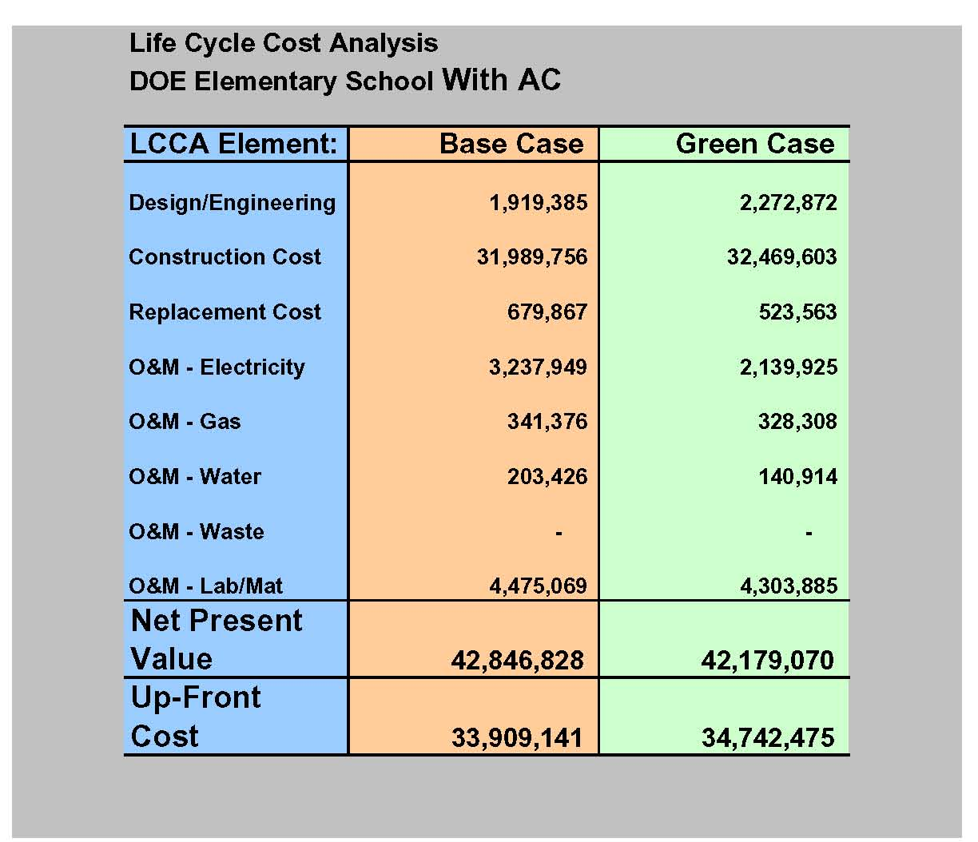

Figure 1.02 – Comparison of 30-Year Life Cycle Cost for the Base Case and
Green Case

In terms of Net Present Value, operational costs for the air-conditioned Green Case are substantially lower than those of the Base Case:

- Replacement costs are lower due to decreased size in the HVAC plant (smaller capacity equipment to replace), less frequent lamp replacement as a result of using daylighting in lieu of electric lighting, the elimination of ceiling fans in areas that can achieve superior natural ventilation such as the cafetorium, etc.

- Electrical costs are approximately 34% ($1,100,000) lower as the result of proper building orientation for daylighting and shading, selection of energy efficient HVAC systems and equipment, use of Energy Star equipment, etc.

- Gas costs are somewhat less due to the selection of higher efficiency boilers and kitchen equipment.

- Water costs are less as a result of using low-flow fixtures, drip irrigation systems, smart irrigation systems, etc.
- Waste stream (sewage) is reduced as a result of the water saving devices discussed above, but no economic savings is realized due to the current method for assessment of sewer discharge fees. These fees are assessed based upon population, not quantity of discharge. Thus, the Green Case provides an environmental benefit by reduction of quantities discharged, but achieves no economic benefit.

- Labor and materials for building maintenance are somewhat lower, as for the reasons stated above. The plant size is smaller and there is less to be replaced in the Green Case. Site maintenance and labor costs have been input as comparable for both the Base and Green cases.

Figures 1.03 and 1.04 illustrate the differences in annual operational costs for the Base Case and Green Case elementary schools. The Green Case costs are substantially lower, representing an annual savings on the order of $60,000.

For a more detailed review of the air-conditioned versions of the Base Case and Green Case LCCA, refer to Section 7.2. of the Appendix.

AC Base Case - Profile of Annual Utility Costs

Electricity:
Plug Loads
$11,183
Gas
$17,417
Water:
Irrigation
$8,000
Water:
Domestic
$2,379
Water:
Kitchen
$0
Electricity:
Site
$4,207
Electricity:
Interior Lighting
$32,860
Electricity:
Ceiling Fans
$800
Electricity:
HVAC
$116,148
Total Electricity
Total Water
Total Gas
Total
$160,991
$ 10,379
$ 17,417
$188,787

Figure 1.03 – Annual Utility Expenses - Base Case with AC
(See Appendix 7.2., “Inputs – Totals Site and Buildings”)

AC Green Case - Profile of Annual Utility Costs
Electricity:
Interior Lighting
$13,942
Electricity:
Ceiling Fans
$203
Electricity:
HVAC
$82,438
Electricity:
Site
$4,207
Water:
Domestic
$1,189
Water:
Irrigation
$6,000
Gas
$16,750
Electricity:
Plug Loads
$8,388
Total Electricity
Total Water
Total Gas
Total
$104,970
$ 7,189
$ 16,750
$128,909

Figure 1.04 – Annual Utility Expenses - Green Case with AC
(See Appendix 7.2., “Inputs – Totals Site and Buildings”)

1.3.6. Comparison of the Non-Air-Conditioned Elementary School Base Case and Green Case Life Cycle Cost Analyses

A LCCA comparison of a non-air-conditioned Base Case to a non-air-conditioned Green Case was conducted, using the same life cycle cost calculator developed for the air-conditioned version of the elementary school. Although this version is identified as “Non-Air-Conditioned”, certain areas such as the library media center and computer resource center remain air-conditioned.

The Life Cycle Cost Analysis summarized in Figure 1.05 indicates that the Net Present Value (NPV) of the Green Case non-air-conditioned elementary school is approximately $37,853,000 which is $245,000 less than the NPV of approximately $38,098,000 for the Base Case non-air-conditioned elementary school.

Up-front costs are approximately $668,000 higher for the Green Case, and operational savings are approximately $38,000 per year.

The additional up-front costs of administration, design, engineering, and construction for the non-AC Green Case include (see Appendix 7.3., Outputs):

- Slight increase to project administration and AE design – Basic services of approximately $24,000 results as these functions are budgeted as a percentage of construction cost, and the Green Case construction cost is slightly higher than the Base Case.

- AE design special services for computer modeling such as thermal analysis, daylighting analysis, life cycle cost analysis, and materials research, budgeted at 0.35% ($105,000) of the estimated cost of construction for the Base Case.

- Services of a commissioning agent for design review, preparation of the commissioning plan, overseeing the commissioning process, and preparing a final commissioning report budgeted at 0.15% ($45,000) of the estimated cost of construction for the Base Case. This budget is based upon the collective experience of the study team with LEED projects to date.

- Services for preparing LEED certification documentation budgeted at 0.15% ($45,000) of the estimated cost of construction for the Base Case. This budget assumes documentation needed for LEED Silver (the budget may change for a lesser or higher level of certification).

- The additional construction costs for the Green Case are based upon a budget of 1.5% ($445,000) of the estimated cost of construction for the Base Case. This allowance falls at the mid-point of the 0% - 3% range recommended by “Costing Green: a Comprehensive Cost Database and Budgeting Methodology” by Davis Langdon, July 2004.

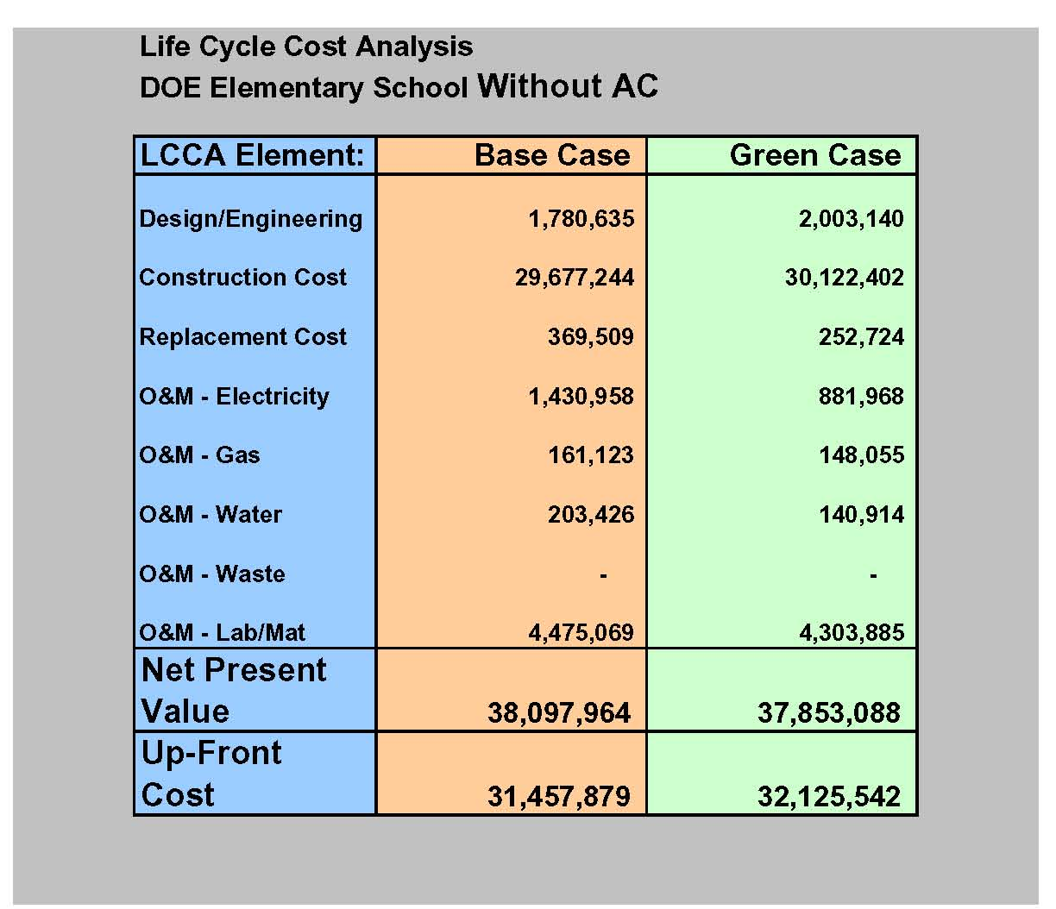

Figure 1.05 – Comparison of 30-Year Life Cycle Cost for the Base Case
and Green Case Non-Air-Conditioned Version

In terms of Net Present Value, operational costs for the non-air-conditioned Green Case are substantially lower than those of the Base Case:

- Less frequent lamp replacement as a result of using daylighting in lieu of electric lighting, and the elimination of ceiling fans in areas that can achieve superior natural ventilation such as the cafetorium, etc. For those few areas that still require air conditioning but are daylit (library, computer center), there is less replacement of equipment due to decreased size in the HVAC plant (smaller capacity equipment to replace).

- Electrical costs are approximately 38% ($549,000) lower as the result of proper building orientation for daylighting and shading, selection of energy efficient HVAC systems and equipment, use of Energy Star equipment, etc.

- Gas costs are somewhat less due to the selection of higher efficiency boilers and kitchen equipment.

- Water costs are less as a result of using low-flow fixtures, drip irrigation systems, smart irrigation systems, etc.

- Waste stream (sewage) is reduced as a result of the water saving devices discussed above, but no economic savings is realized due to the current method for assessment of sewer discharge fees. These fees are assessed based upon population, not quantity of discharge. Thus, the Green Case provides an environmental benefit by reduction of quantities discharged, but achieves no economic benefit.

- Labor and materials for building maintenance are somewhat lower, as for the reasons stated above (for the purposes of this Study, the cost of labor and materials for building and site maintenance remain the same as for the air conditioned case). The plant size is smaller and there is less to be replaced in the Green Case. Site maintenance and labor costs have been input as comparable for both the Base and Green cases.

Figures 1.06 and 1.07 illustrate the differences in annual operational costs for the Base Case and Green Case non-air-conditioned elementary schools. The Green Case costs are substantially lower, representing an annual savings on the order of $32,000.

For a more detailed review of the air-conditioned versions of the Base Case and Green Case LCCA, refer to Section 7.3. of the Appendix.

Non-AC Base Case - Profile of Annual Utility Costs
Electricity:
Interior Lighting
$34,410
Electricity:
Site
$4,207
Water:
Domestic
$2,379
Water:
Irrigation
$8,000
Gas
$8,220
Electricity:
Plug Loads
$11,183
Electricity:
HVAC
$19,677
Electricity:
Ceiling Fans
$3,530
Total Electricity
Total Gas
Total Water
Total
$ 68,799
$ 8,220
$ 10,379
$ 87,398

Figure 1.06 – Annual Utility Expenses Base Case without AC
(See Appendix 7.3., “Inputs – Totals Site and Buildings”)
Non-AC Green Case - Profile of Annual Utility Costs
Electricity:
HVAC
$14,908
Electricity:
Plug Loads
$8,388
Gas
$7,554
Water:
Domestic
$1,189
Electricity:
Site
$4,207
Water:
Irrigation
$6,000
Electricity:
Ceiling Fans
$2,933
Electricity:
Interior Lighting
$14,562
Total Electricity
Total Gas
Total Water
Total
$40,790
$ 7,554
$ 7,189
$55,533

Figure 1.07 – Annual Utility Expenses Green Case without AC
(See Appendix 7.3., “Inputs – Totals Site and Buildings”)

1.3.7. Sustainable Schools Survey – Economic Benefit Trends

An on-line survey of 12 existing sustainable schools was performed to determine the presence of trends, if any, related to sustainable design strategies used to reduce operational costs and realize economic benefits. Survey respondents included principals and/or project managers who were very familiar with each school’s project parameters, process, and results. In particular, it was of interest to see if sustainable schools were characterized by the use of strategies used in this Study to reduce operational costs, such as daylighting, water conservation, energy efficient HVAC equipment, and commissioning. If such design strategies were used, it was then of interest to determine if the surveyed school perceived reductions in operational expenses as compared to conventional schools in their locality.

The schools surveyed are indicated in Figure 1.08.

The results of the survey in their entirety are contained in Section 7.1. of the Appendix.
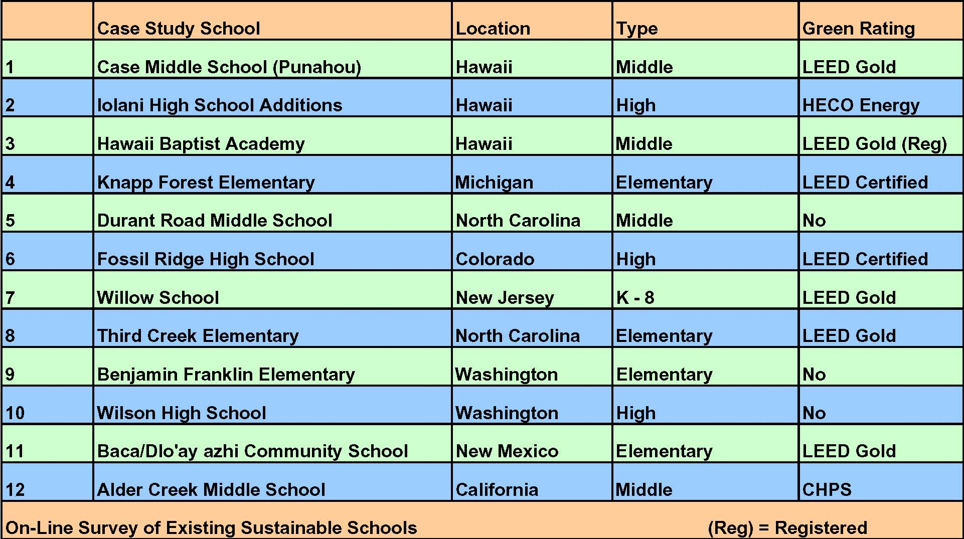

Figure 1.08 – List of Schools Participating in the On-Line Survey

The survey results point to a number of trends related to design strategies used to reduce operational costs that are common among the surveyed schools, and likely common to sustainable schools in general given the diverse climates and types of schools examined. These strategies corroborate closely with the directions taken in this Study to reduce the operational costs of the hypothetical elementary school.

The most significant trends (most of which resulted in economic benefit) that emerge from the on-line survey include:

- The use of daylighting to replace the need for electric lighting and reduce cooling load driven HVAC during school hours for 75% or more of the gross floor area of the school.

- The use of energy efficient lighting, occupancy sensors, and high efficiency HVAC equipment.

- The use of Energy Star rated equipment.

- Four of the schools surveyed use renewable energy (PV panels) for up to 10% of the total school energy requirement.

- Significant water conservation strategies include low-flow fixtures, drought-tolerant native landscaping, drip irrigation, and smart irrigation.

- 80% of surveyed schools commissioned their mechanical, electrical, and HVAC systems.

- Most schools surveyed measure electrical and water consumption.

- 100% of schools surveyed perceive that additional up-front costs for sustainable design and construction measures have been exceeded by operational savings.

1.3.8. LEED Certification

This Study included a feasibility assessment of achieving LEED Silver for a new elementary school. The assessment sought to determine the general feasibility of attaining LEED Silver as well as the implications of LEED Silver in relation to economic, occupant, and environmental benefits.

The LEED Green Building Rating System was developed by the U.S. Green Building Council (USGBC), a volunteer, consensus-based organization based in Washington D.C. The intent of the rating system was to provide a standardized, independent, third-party review and rating system that would allow a clear and consistent approach to judging claims of sustainability. First published and implemented in 2000, this point-based rating system is now the most applied green building metric in the United States, and has been used extensively abroad.

This Study finds that LEED Silver is feasible for new elementary schools, and applying the sustainable strategies necessary to achieve LEED Silver rating will achieve a number of economic, occupant, and economic benefits. Achieving LEED Silver requires a minimum of 33 points out of a possible 69. The assessment shown on the LEED Score Card in Figure 1.09 that follows indicates that achieving 32 points is very feasible, and 16 others are “possible” depending upon individual school circumstances.

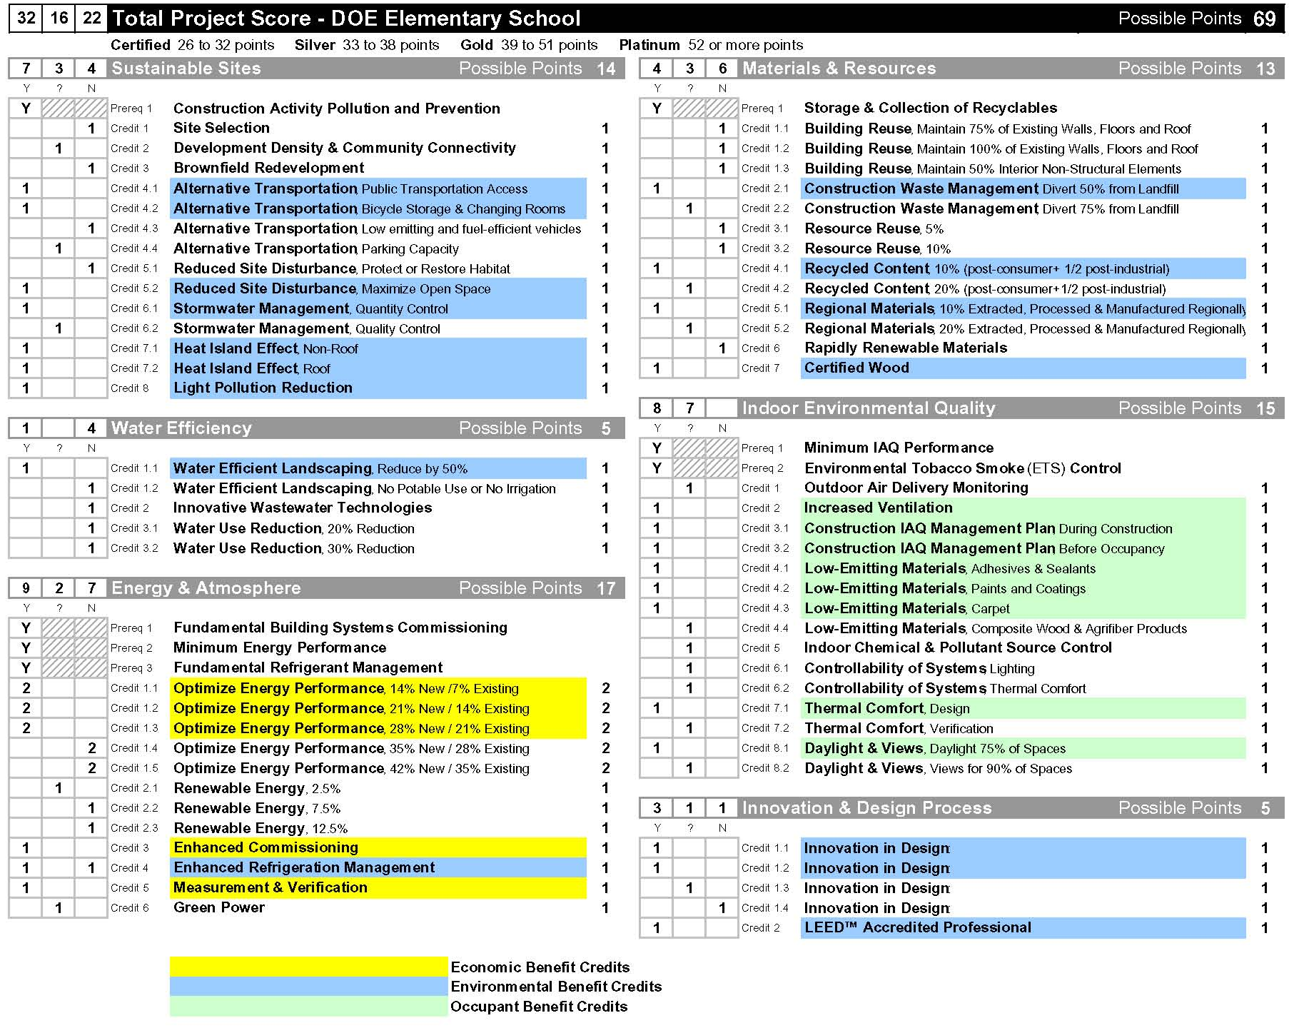
Figure 1.09 – Potential LEED Silver Score Card for a new DOE Elementary School

The potentially achievable credits on the LEED Silver Score Card shown in Figure 1.09 are color coded by the type of benefit most likely to result from each credit. Credits highlighted in yellow, green, and blue would likely result in economic, occupant, and environmental benefits respectively.

There are a number of observations of interest relative to the LEED Silver assessment. The foremost observation is that the points that are likely achievable related to economic benefits (Energy and Atmosphere (EA) Credits 1, 3, and 5) are modest, representing only 25% of the total credits required to achieve LEED Silver.

Although these credits represent a minor portion of the overall LEED Silver credits, they are of major importance relative to achieving the level of operational savings identified in this Study. Qualifying for six energy conservation credits under the LEED system equates to an approximate 30% reduction in energy cost, which is nearly identical to the annual energy savings assumed to be feasible in the LCCA for both the air-conditioned and non-air-conditioned Green Case versions of the elementary school. This operational savings is the main driver for operational savings and producing the lower Net Present Value for the Green Case.

In theory, it may be possible for the elementary school to achieve LEED Silver with few or no energy conservation credits, but as energy conservation is the primary driver to pay back additional up-front costs in the Green Case, such an approach is not recommended.

During the course of this Study, both the State of Hawaii and City and County of Honolulu have adopted guidelines requiring LEED Silver or its equivalent for qualifying new facilities. A major factor in this decision is the State’s goal to focus on energy efficiency as a means to reduce dependence upon foreign oil.

For the reasons above, State and County application of the requirement for LEED Silver for new facilities should establish a prerequisite of achieving a minimum of six (6) energy credits.

1.3.9. Findings and Conclusions

This Study finds that there are tangible economic benefits to be gained from air-conditioned and non-air-conditioned sustainable elementary schools that are designed to reduce operational costs by approximately 30% relative to a code-compliant conventional Base Case.

In terms of today’s dollars, this benefit equates to a savings of approximately $60,000 per year in reduced charges for electrical, water, and gas consumption for the air-conditioned school, and $32,000 per year for the non-air-conditioned school.

In terms of Net Present Value (NPV) calculated against a 30-year life cycle, the NPV for the air-conditioned Green Case elementary school is $668,000 less than the Base Case. For the non-air-conditioned Green Case elementary school, the NPV is approximately $245,000 less than the Base Case.

This Study also finds a number of relevant trends for an elementary school relative to energy consumption and energy savings.

Approximately 72% of the energy consumed by an air-conditioned elementary school is for HVAC and 20% of the energy consumed is for lighting. Combined, these two functions account for 92% (approximately 876,000 kWh per year) of the annual energy consumed by the school.

Figure 1.10 indicates that, of the facilities that comprise an elementary school, classrooms, administration, and faculty areas (Building Groups 1) can potentially account for 80% of the school’s annual energy savings that are calculated in the LCCA. Therefore, it can be reasoned that design strategies that minimize energy consumption for these areas must be prioritized to achieve the greatest economic benefit.

The single most effective energy conservation measure for these areas is daylighting, as effective daylighting design not only minimizes or eliminates the need for electric lighting during normal school hours, it also significantly reduces the internal heat gain produced by the electric lighting it displaces which in turn, can result in downsizing the air-conditioning plant size.

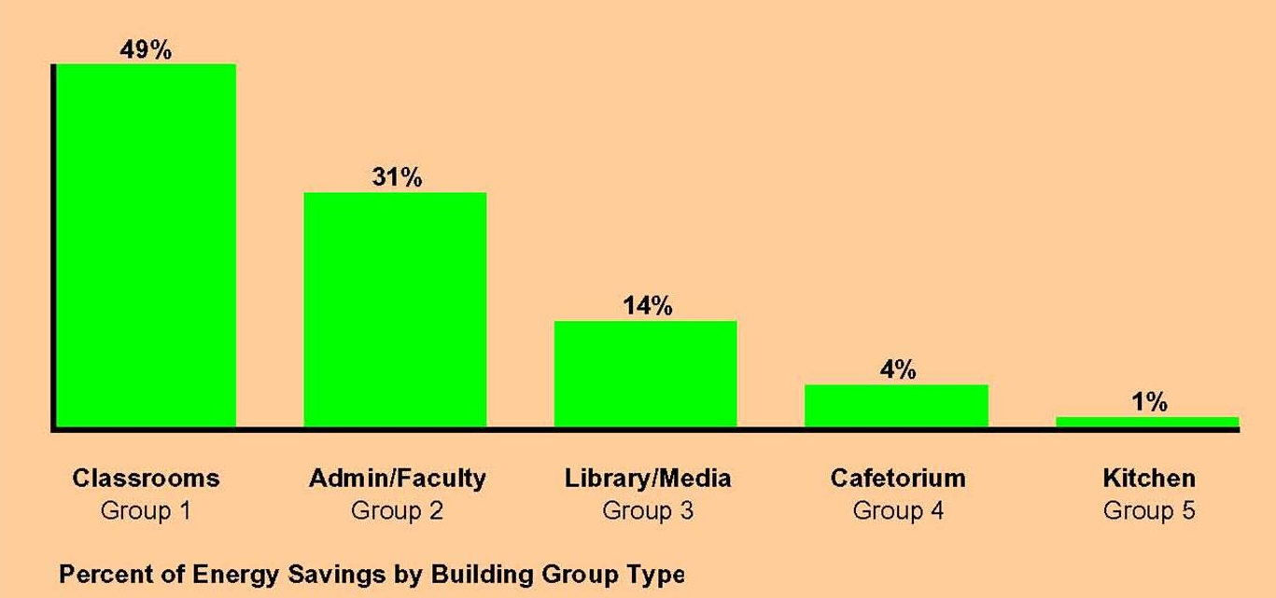

Figure 1.10 – Energy Savings by Building Group Type

Effective daylight design is not a simple matter of providing windows on buildings. The key to effective daylighting is to introduce proper levels of indirect daylight into an occupied space. Building orientation and envelope design are critical in this regard. Indirect daylight has no glare and is cooler than electric light, reducing internal heat gain. Direct daylight produces glare and unwanted heat gain and should be avoided.

Daylighting is also an excellent strategy for the cafetorium and the library. When applied where feasible school-wide, the energy conservation achieved by effective daylighting is potentially responsible for 65% to 70% of the total annual energy saved in the Green Case elementary school, and thus, the lion’s share of the resulting economic benefit.

Figure 1.11 illustrates the energy savings to be realized by type of system (HVAC, lighting, plug loads, and ceiling fans), and more interestingly, the proportion of that savings that can be realized through high efficiency equipment, or best-practice architecture (building envelope, orientation, etc.). As illustrated, architecture plays the lead role in energy conservation, and is responsible for roughly 75% of the total savings.

This fact is borne out by the LCCA (Appendix Section 7.2.) in the assumptions that reduced energy inputs for lighting and air conditioning in the Green Case. The strategy for these reductions was simply daylighting, as daylighting significantly reduced electric lighting loads as well as heat gain from electric lighting (indirect daylight is cooler). It is clear that effective daylighting must be a prioritized strategy in elementary schools for achieving the lion’s share of the reductions in energy consumption and realizing the greatest operational savings.

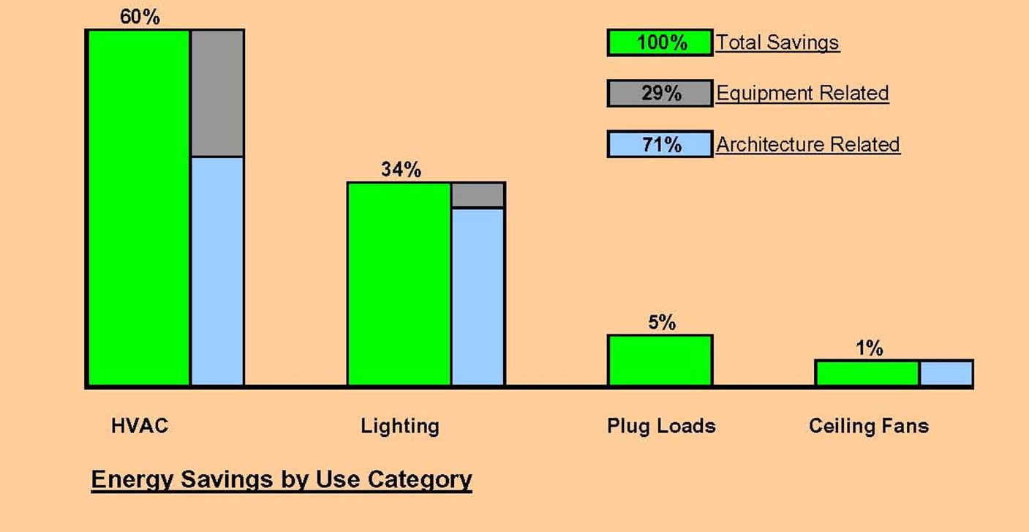

Figure 1.11 – Comparison of Energy Savings Achieved by Architecture vs. Equipment

  - Determination of Occupant Benefits

    - Objectives

The objective of this section of the Study is to determine the potential occupant benefits of sustainable design for new air-conditioned public elementary schools. Occupant benefits would include improved thermal comfort, better health, and improved performance.

    - Methodology and Approach

The approach taken for this Study was to examine the potential occupant benefits that would result from achieving the occupant-related credits for LEED Silver, and corroborating those predicted benefits with current, published studies and benefits experienced by existing sustainable schools.

The methodology utilized included:

- A feasibility assessment related to achieving LEED Silver, and a review of the portion of that certification that would relate to occupant benefits.

- An on-line survey of 12 existing sustainable schools to determine occupant benefits, if any, that are being achieved.

- A review of existing publications having to do with the occupant benefits of sustainable design.

    - LEED Silver Assessment

As discussed in Section 1.3.8. above, this Study finds that LEED Silver is feasible for new elementary schools, and applying the sustainable strategies necessary to achieve the LEED Silver rating will achieve a number of occupant benefits.

The preliminary LEED Score Card for an elementary school suggests that at least 8 credits (shown highlighted in green on Figure 1.09.) achievable for an elementary school would result in occupant benefits. These benefits include:

- Increased ventilation effectiveness (greater fresh air component in air-conditioning system ventilation).

- Less likelihood of mold or dust in ventilation via best management processes during construction to filter particulates and protect construction materials from weather and moisture.

- Low or no off-gassing of volatile organic compounds (VOC) by use of low or no-VOC emitting materials.

- Increased thermal comfort by correct selection of HVAC system type and controls.

- Access to daylight and views by best practice daylighting design and building orientation to prevent glare, etc.

    - Sustainable Schools Survey – Occupant Benefit Trends

An on-line survey of 12 existing sustainable schools was performed to determine the presence of trends, if any, related to sustainable design strategies that achieve occupant benefits. In particular, it was of interest to see if existing sustainable schools were characterized by the use of design strategies that would result in the same occupant benefits realized by achieving LEED Silver.

The schools surveyed are indicated in Figure 1.08, above.

The results of the survey in their entirety are contained in Section 7.1. of the Appendix.

The survey results point to a number of trends related to design strategies that achieve occupant benefits that are common among the surveyed schools. These strategies corroborate closely with the occupant benefits that would be achieved for public elementary schools with the LEED Silver credits highlighted in Figure 1.09. The most significant occupant benefit trends that emerge from the on-line survey include:

- The majority of schools use LEED recognized strategies to improve indoor air quality, including high efficiency filters, building flush-out between the end of construction and occupancy, pollutant source control (walk-off mats, etc.) and the use of low or no-VOC paints, sealants, adhesives, and carpet (Survey Question
# 25).

- Perception that ventilation was superior to conventional school design (Survey Question #27).

- Perception that improved ventilation has improved productivity and increased occupant comfort and health (Survey Question #28).

- Daylighting, views, user controls, better ventilation, and thermal comfort are seen as primary strategies that are directly related to occupant benefits such as better health and increased performance by staff and students (Survey Questions #30a through 30e).

    - Related Studies

Recent published studies corroborate the trends related to occupant benefits that have emerged from the on-line survey of existing sustainable schools. These studies also tend to support the emphasis placed upon indoor environmental quality (to achieve occupant benefits) in the LEED rating system.

The design strategies most often quoted in studies related to improved health and performance of occupants are daylight and views, ventilation effectiveness, thermal comfort, user controls, and low emitting materials.

A list of the studies considered can be found in Section 6 of this report.

  - Determination of Environmental Benefits

    - Objectives

The objective of this section of the Study is to determine the potential environmental benefits of sustainable design for new air-conditioned public elementary schools. Environmental benefits would include conservation of land and materials, conservation of water, reduced pollution, reduced light pollution, reduced impacts to infrastructure, and reduced need for landfill.

    - Methodology and Approach

The approach taken for this Study was to examine the potential environmental benefits that would result from achieving the environmental-related credits for LEED Silver, and corroborating those predicted benefits with current, published studies and benefits experienced by existing sustainable schools.

The methodology utilized included:

- A feasibility assessment related to achieving LEED Silver and a review of the portion of that certification that would relate to achieving environmental benefits.

- An on-line survey of 12 existing sustainable schools to determine environmental benefits, if any, that are being achieved.

- Assessment of design team experience to date on Hawaii-based sustainable projects.

    - LEED Silver Assessment

As discussed in Section 1.3.8. above, this Study finds that LEED Silver certification is feasible for new elementary schools, and applying the sustainable strategies necessary to achieve the Silver rating will achieve a number of environmental benefits.

The preliminary LEED Score Card for an elementary school suggests that at least 16 credits (shown highlighted in blue on Figure 1.09) achievable for an elementary school would result in environmental benefits. The credits would be awarded for strategies that:

- Promote alternative means of transportation and thus, reduce the use of single occupancy vehicles and related emissions.

- Reduce light pollution.

- Maintain open space.

- Reduce the heat island effect (hot surfaces that warm and alter micro-climate).

- Conserve water.

- Reduce dependence upon energy produced by fossil fuel.

- Promote recycling.

- Promote the use of rapidly renewable materials, and products from well managed forests.

- Reduce impacts to existing infrastructure.

- Reduce the impact to landfill sites.

    - Sustainable Schools Survey – Environmental Benefit Trends

An on-line survey of 12 existing sustainable schools was performed to determine the presence of trends, if any, related to sustainable design strategies that achieve environmental benefits. In particular, it was of interest to see if existing sustainable schools were characterized by the use of design strategies that would result in the same environmental benefits that would be realized by achieving LEED Silver certification.

The schools surveyed are indicated in Figure 1.08, above.

The results of the survey in their entirety are contained in Section 7.1. of the Appendix.

The survey results point to a number of trends related to design strategies that achieve environmental benefits that are common among the surveyed schools. These strategies corroborate closely with the environmental benefits that would be achieved for public elementary schools with the LEED Silver credits highlighted in Figure 1.09.

The most significant environmental benefit trends that emerge from the on-line survey include:

- Conservation of potable water resources, avoiding pollution of lakes and streams, and promotion of conservation awareness.

- Use of a construction waste management process to divert waste from landfill via recycling. Most schools diverted more than 75% of construction waste.

- Significant use of environmentally preferable materials including rapidly renewable material, certified wood, and material with recycled content.

- Use of design strategies such as light-colored, high-albedo roofing to avoid the heat island effect.

- Elimination of CFC containing refrigerants and enhanced alternative refrigerant management.

- Inclusion of some form of sustainable education in the classroom.

In general, the sustainable design strategies that result in environmental benefits that have been used by the surveyed schools corroborate with the effectiveness of the strategies that are feasible for public elementary schools in Hawaii.

Strategies that consider construction waste management, water conservation, and energy conservation appear to be common to all surveyed schools regardless of location, and underscore the universality of the principles of sustainable design.

    - Findings and Conclusions

Public elementary schools in Hawaii that are designed to achieve a level of sustainability equivalent to LEED Silver will benefit the environment in Hawaii in a number of ways including reduced impact to infrastructure, reduced impact to landfill, conservation of water, and reduced dependence on imported foreign oil through energy conservation.

These benefits will accrue from implementing sustainable design strategies that reduce water and energy consumption, promote recycling, maintain open space, promote alternative modes of transportation, and divert waste from landfill.

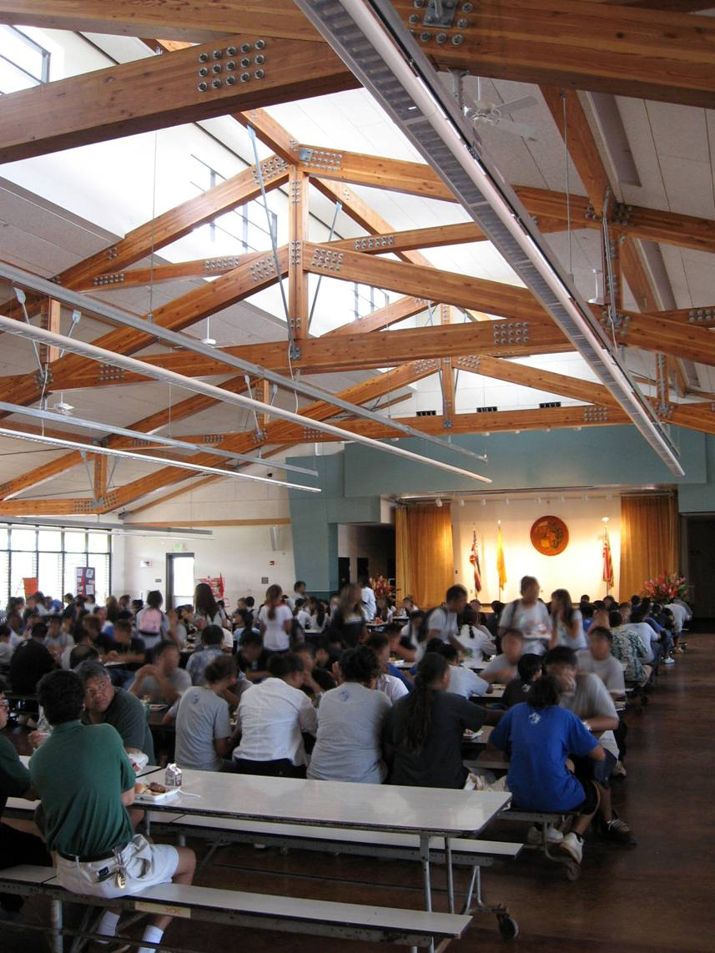
Figure 2.01 – WIS Cafeteria on Opening Day, Summer 2006

2. STUDY NO. 2: Case Study – Waipahu Intermediate School Cafeteria

  - Objectives

The objective of the Waipahu Intermediate School (WIS) Cafeteria case study is to determine the tangible economic, occupant, and environmental benefits achieved by this recently completed project.

Background

The Waipahu Intermediate School (WIS) Cafeteria is a new full-service cafeteria and multi-use facility. It is LEED Certified, and is the first sustainable/LEED project undertaken by the
State of Hawaii, Department of Education. The 20,000 square foot facility is designed to serve up to 750 students at a time and replaces an outdated serving cafeteria that was only one-third its size.

As a pilot sustainable/LEED project for the Department of Education, the WIS Cafeteria demonstrates the State’s willingness to lead by example in its commitment to conserve environmental resources and seek ways to provide better facilities for public schools.

The design objective of the WIS Cafeteria was to provide a facility that both meets Department of Education (DOE) criteria and demonstrates the effectiveness of sustainable design as a means of conserving resources, reducing operation and maintenance costs, and providing a better and healthier environment for occupants. Ultimately, the project seeks to demonstrate the compatibility between sustainable design and DOE goals and objectives for functionality, cost, maintenance, and operations.

The design features of this facility that make it unique among DOE cafeterias are its daylighting design and the dining area roof that functions as a thermal chimney to drive stack-effect ventilation.

Daylighting effectiveness is made possible by north and south facing clerestories that bring indirect daylight into the center of the dining area. The perimeter seating areas receive daylight from north and south facing jalousies and fixed glazing. Daylighting significantly reduces the need for electric lighting in the dining area during normal school hours, and is the primary strategy to reduce annual operating cost.

The roof of the cafeteria’s dining area is designed as a thermal chimney, which moves air entirely by thermal buoyancy (hot air rises) without the need for mechanical assistance. The thermal chimney enhances the facility’s cross ventilation design, and is especially effective on days with no breeze. Solar radiation heats air in the plenum cavity between the roof and insulated ceiling. This heated air flows upward and is exhausted out of four penthouse-style “chimneys” at the high point of the roof. Replacement air from outside is constantly drawn through the dining area into a series of engineered vents in the ceiling, providing thermal comfort. Air changes created by this stack effect exceed code minimums.

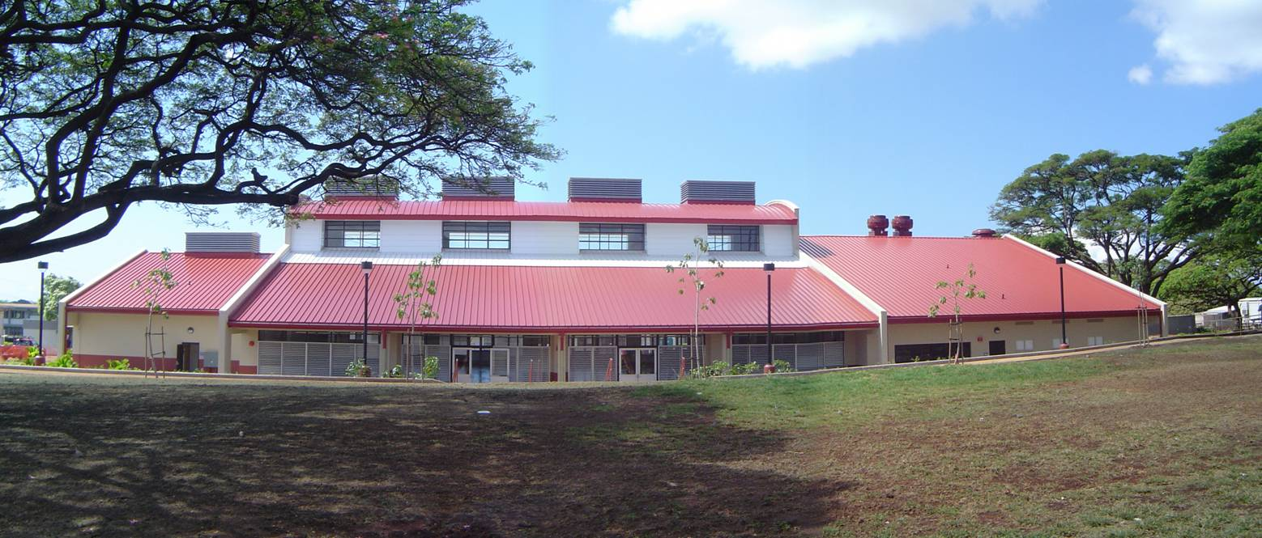

Figure 2.02 – North Elevation of the WIS Cafeteria as seen from Farrington Highway
Sustainable design strategies that were used in obtaining the LEED Certified rating include:

- Proximity to sources of alternative public transportation.

- Bicycle storage and changing rooms.

- Minimal development footprint.

- Diverted 85% of construction waste from landfill.

- No night sky light pollution or light trespass to adjacent properties.

- Overall energy consumption is 15% less than a code-compliant base case.

- Full commissioning.

- Thermal comfort.

- Daylight and views.

- Daylighting in the dining/multi-purpose space reduces electric lighting use by 58%.

- Use of effective stack-effect and cross-ventilation eliminates the need for ceiling fans at most times and maintains thermal comfort.

- Using drought-tolerant native landscaping and drip irrigation reduces potable irrigation requirements by 63%.

- Emphasis placed on use of local materials (concrete, CMU).

- Use of low to no-emitting paints, adhesives, and sealants.

- Use of certified wood.

  - Methodology and Approach

The approach taken on this case study was to review the sustainable design strategies implemented in the project and the documentation and calculations prepared in the course of applying for the LEED Certified rating to determine the resulting economic, occupant, and environmental benefits.

The methodology used for this case study included:

- Review of credits achieved as part of the LEED Certified rating, and assessment of which credits were related to economic, occupant, or environmental benefits.

- Review of supporting documentation and calculations submitted to the U.S. Green Building Council as part of the certification process.

- Life cycle cost analysis of the as-designed project, using a 30-year life cycle and the Net Present Value methodology. The as-designed project is sustainable, and therefore represents the “Green Case” for this Study. The life cycle calculator used is the same as developed for the elementary school LCCA in Study No. 1 of this report.

- Life cycle cost analysis of a Base Case as interpolated from the Green Case.

- Comparison of the Base Case and Green Case in terms of Net Present Value.

  - LEED Certification Review

The WIS Cafeteria achieved a rating of LEED Certified. This rating required qualifying for a minimum of 26 of 69 possible credits in the LEED Green Building Rating System. Figure 2.03 below indicates the credits that were achieved on the LEED Score Card. The achieved credits are color coded to indicate whether they are related to economic (yellow), occupant (green), or environmental (blue) benefits.
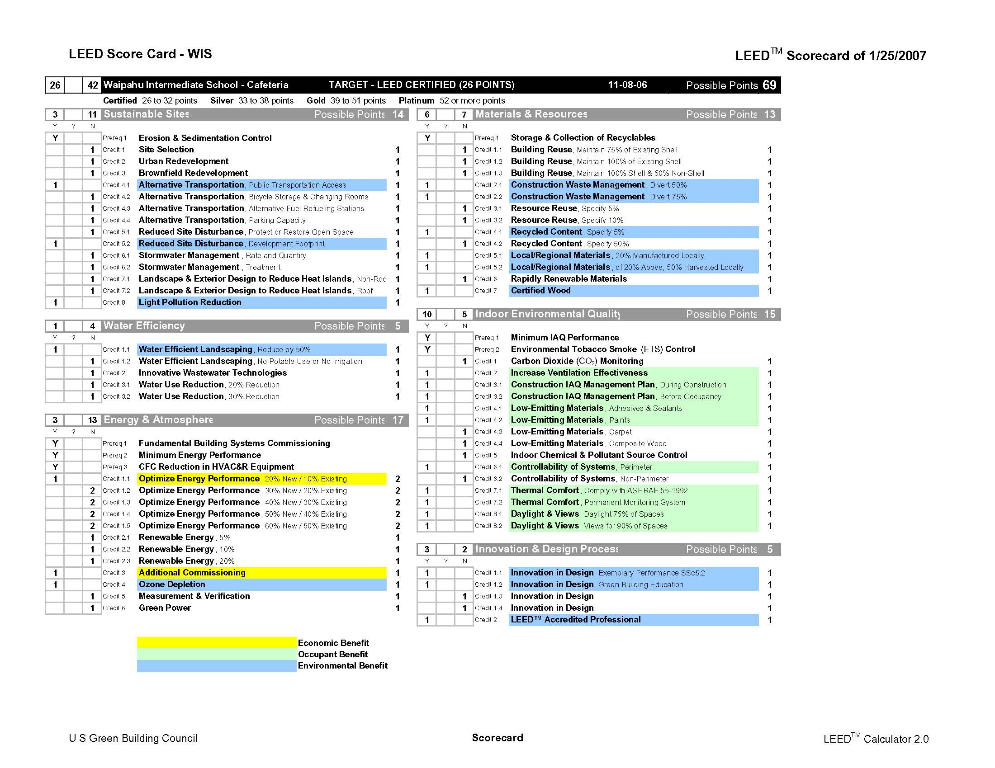

Figure 2.03 – LEED Certified Score Card for WIS Cafeteria, Highlighted to Indicate Economic, Occupant and Environmental Benefits

  - Establishing the Green Case

The Green Case for this Study is the as-designed project. For life cycle cost analysis (LCCA), the attributes of the as-designed project were entered into the life cycle cost calculator (LCCC) and calculated with the Net Present Value method for a 30-year life.

The LCCC has four parts (Reference Appendix Section 7.4.):

LCCC Part 1 – Outputs:

This section presents the Green Case life cycle cost in terms of Net Present Value.

LCCC Part 2 – Green Case Inputs:

This section calculates a one-year O&M expense profile for the Green Case.

- Actual costs for construction, AE basic services, AE special services, LEED certification, and commissioning are input under “Whole Cafeteria Inputs”.

- The predicted electrical use based upon the actual design is input for interior lighting, ceiling fans, HVAC, and plug loads. The predicted electrical use for lighting assumes the dining area functions entirely with daylighting during normal school hours (no electrical lighting is needed). The electrical use input for ceiling fans assumes no ceiling fans are needed during normal school hours.

- Water use inputs are based upon specified low-flow domestic fixtures and conventional kitchen use.

- Gas use inputs are based upon high efficiency water heating equipment specified.

- Wastewater is identified in terms of quantity of use and specified fixtures, but not in terms of cost. This results from the fact that the current sewage fee assessment by the Board of Water Supply for schools is based upon population, not quantity used.

LCCC Part 3 – Green Case Calculations:

This section calculates the year by year life cycle cost for the Green Case using the results in Part 2.

LCCC Part 4 – Assumptions:

This section identifies all assumptions used for the operations and maintenance portions of the life cycle costs for the Green Case. Assumptions include unit costs for electricity, gas and water, and applied rates for each.

  - Establishing the Base Case

The Base Case is in part an interpolation of the Green Case-based known costs for special AE services, the known cost of construction, and minimum code compliance for operational expenses.
LCCC Part 1 – Outputs:

This section presents the Base Case life cycle cost in terms of Net Present Value.

LCCC Part 2 – Base Case Inputs:

This section calculates a one-year O&M expense profile for the Base Case.

- The input for AE basic design services is the actual AE cost less AE special services, LEED certification, and commissioning. The input for DOE project management remains the same as for the Green Case.

- Construction costs for the Base Case have been input as the Green Case cost of construction reduced by 1.5%, to reflect the current industry rule-of-thumb for the cost of sustainable design features. It should be noted that this is a conservative approach to make the LCCA more robust, as it is entirely possible that the construction cost for a conventional cafeteria would have been the same as for the WIS Cafeteria (approximately $300 per square foot).

- Electrical use is input for interior lighting, ceiling fans, ventilation, and plug loads based upon minimum code compliance.

- Water use is input based upon code-compliant domestic fixtures and irrigation, and conventional kitchen use.

- Gas use input is based upon code compliant fixtures.

- Waste water is identified in terms of quantity of use, but not in terms of cost.

  - Life Cycle Cost Analysis

The Life Cycle Cost Analysis shown in Figure 2.04 indicates that the Net Present Value (NPV) of the Green Case cafeteria is approximately $7,808,000 which is $4,000 lower than the NPV of approximately $7,812,000 for the Base Case cafeteria.

Figure 2.04 also indicates that up-front costs are approximately $174,000 higher for the Green Case, and operational savings are approximately $3,000 per year.

The additional up-front administration, design, engineering, and construction costs for the Green Case include (See Appendix 7.4, Outputs):

- AE design special services for computer modeling such as thermal analysis, daylighting analysis, life cycle cost analysis, and materials research, budgeted at 0.55% ($31,600 – Actual cost for the WIS project) of the estimated cost of construction for the Base Case.

- Services of a commissioning agent for design review, preparation of the commissioning plan, overseeing the commissioning process, and preparing a final commissioning report budgeted at 0.45% ($25,900 - Actual cost for the WIS project) of the estimated cost of construction for the Base Case.
- Services for preparing LEED certification documentation budgeted at 0.50% ($28,800 - Actual cost for the WIS project) of the estimated cost of construction for the Base Case. This budget assumes documentation needed to apply for LEED Certified (the budget may change for a higher level of certification).

- The additional construction costs for the Green Case are based upon a budget of 1.5% ($85,000) of the estimated cost of construction for the Base Case. This allowance falls at the mid-point of the 0% - 3% range recommended by “Costing Green: a Comprehensive Cost Database and Budgeting Methodology” by Davis Langdon, July 2004.

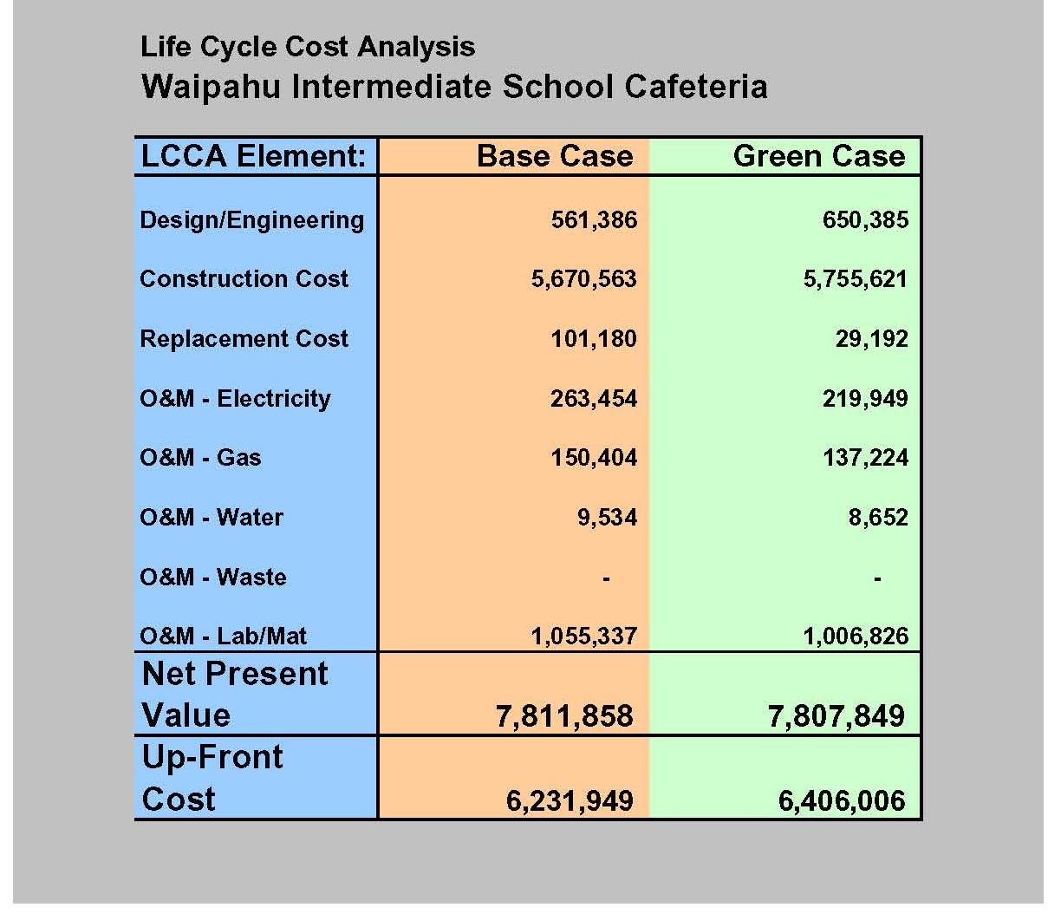

Figure 2.04 – Comparison of 30-Year Life Cycle Cost for the WIS Cafeteria Base Case and As-Designed Green Case

In terms of Net Present Value, operational costs for the as-designed Green Case are modestly lower than those of the Base Case (See Figure 2.04):

- Replacement costs are lower due to the use of metal roofing in lieu of tar and gravel, less frequent lamp replacement as a result of using daylighting in lieu of electric lighting, and the elimination of ceiling fans in the dining area.

- Electrical costs are approximately 15% ($44,000) lower as the result of proper building orientation for daylighting and shading, and the reduced need for ceiling fans.

- Gas costs are somewhat less due to the selection of higher efficiency boilers and kitchen equipment.

- Water costs are less as a result of using low-flow fixtures, drip irrigation systems, smart irrigation systems, etc.

- Waste stream (sewage) is reduced as a result of the water saving devices discussed above, but no economic savings are realized due to the current method for assessment of sewer discharge fees. These fees are assessed based upon population, not quantity of discharge. Thus, the Green Case provides an environmental benefit by reduction of quantities discharged, but achieves no economic benefit.

- Differences in cost for labor and materials for building maintenance between the Base and Green case were considered insignificant (except for less lamp replacement for the Green Case), and to be conservative, the costs were input as being identical.

Figures 2.05 and 2.06 illustrate the differences in annual operational costs for the Base Case and Green Case versions of the WIS Cafeteria. The Green Case costs are modestly lower, representing an annual savings on the order of $3,000.

For a more detailed review of the air-conditioned versions of the Base Case and Green Case LCCA, refer to Section 7.4. of the Appendix.

Figure 2.05 – Annual Utility Expenses - Base Case
WIS Base Case - Profile of Annual Utility Costs

Electricity:
HVAC
$3,787
Electricity:
Ceiling Fans
$991
Electricity:
Interior Lighting
$6,740
Electricity:
Site
$408
Water:
Kitchen
$0
Water:
Domestic
$396
Water:
Irrigation
$90
Gas
$7,673
Electricity:
Plug Loads
$1,515
Total Electricity
Total Water
Total Gas
Total
$ 13,033
$ 486
$ 7,673
$ 21,192
(See Appendix 7.4., “Inputs – Totals Site and Buildings”)
WIS Green Case - Profile of Annual Utility Costs
Electricity:
Plug Loads
$1,515
Gas
$7,001
Water:
Irrigation
$45
Water:
Domestic
$396
Electricity:
Site
$340
Electricity:
Interior Lighting
$5,377
Electricity:
Ceiling Fans
$203
Electricity:
HVAC
$3,787
Total Electricity
Total Gas
Total Water
Total
$ 10,882
$ 7,001
$ 441
$ 18,324

Figure 2.06 – Annual Utility Expenses - Green Case
(See Appendix 7.4., “Inputs – Totals Site and Buildings”)
  - Economic Benefits

A 30-year Life Cycle Cost Analysis indicates that the Net Present Value (NPV) of the as-designed Green Case cafeteria is approximately $7,808,000 compared to an NPV of approximately $7,812,000 for the Base Case cafeteria. This difference is in favor of the Green Case, but only by a modest margin (See Figure 2.04).

Up-front costs are approximately $174,000 higher for the Green Case (in 2006 dollars – See Figure 2.04), inclusive of AE fees, commissioning, and LEED certification.

Operational savings are approximately $3,000 per year.

The driver to pay back the additional up-front costs of sustainable design is typically operational savings. For a cafeteria, operational savings are very limited, and in this case the savings depend almost entirely on reduced lighting and ceiling fan costs which are minor compared to the energy required to operate a conventional kitchen.

  - Occupant Benefits

The LEED Score Card for the WIS Cafeteria indicates that 10 credits (shown highlighted in green on Figure 2.03) have been achieved that will result in occupant benefits. The occupant benefits include:

- Increased ventilation effectiveness (greater fresh air component in air-conditioning system ventilation).

- Less likelihood of mold or dust in ventilation via best management processes during construction to filter particulates and protect construction materials from weather and moisture.

- No off-gassing of volatile organic compounds (VOC) by use of Low or No-VOC emitting materials.

- Increased thermal comfort by correct building orientation for effective cross ventilation and an innovative thermal chimney design to promote stack effect ventilation on days with little or no wind.

- Access to daylight and views by best practice daylighting design and building orientation to prevent glare, etc.

Discussions with Waipahu Intermediate School principals and users corroborate many of the benefits cited above that were calculated for the LEED certification. The main comment by dining hall users is that the new cafeteria is noticeably more comfortable than the old one.

  - Environmental Benefits

The LEED Score Card for the WIS Cafeteria indicates that 16 credits (shown highlighted in blue on Figure 2.03) have been achieved that will result in environmental benefits. The environmental benefits include:

- Encouraging the use of alternative public transportation (by reasonable proximity to bus routes) to reduce the use of single occupancy vehicles and resulting emissions.

- Maintaining open space equal to or greater than the building footprint to reduce heat island effect and provide habitat.

- Reduced light pollution.

- Conservation of potable water resources by using low-flow plumbing fixtures and drip irrigation.

- Reduced dependence upon energy produced by fossil fuel.

- Conserving resources by recycling.

- Conserving resources through the use of rapidly renewable materials, and products from well managed forests.

- Reduced impacts to existing infrastructure.

- Diverting waste from landfill (reducing need for new landfill).

  - Findings and Conclusions

This Study finds that tangible economic, occupant, and environmental benefits have been achieved by the WIS Cafeteria.

The economic benefits are modest because strategies for operational savings, which provide the payback mechanism for increased initial investment, are very limited in comparison to the energy required to run a conventional kitchen. In the case of the WIS Cafeteria, energy conservation strategies include daylighting, reduced need for ceiling fans, and higher efficiency water heating equipment.

Occupant benefits are significant, and include increased thermal comfort, better ventilation, and better lighting (daylighting).

Environmental benefits are significant, and include diversion of 85% of construction waste from landfill, water conservation, energy conservation, and maintaining open space.

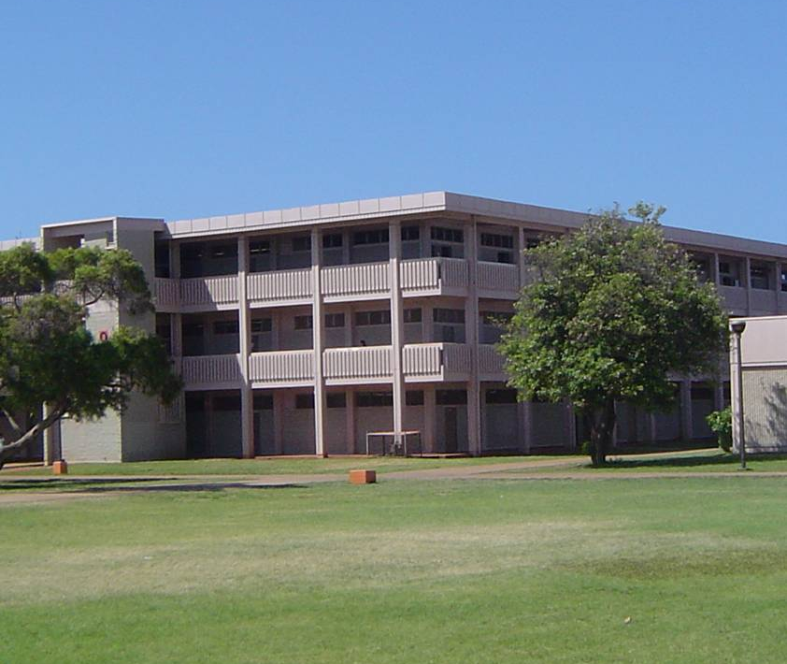

Figure 3.01 – Campbell High School Classroom Building

3. STUDY NO. 3: Case Study – Retrofit of an Existing DOE Classroom

  - Objectives

Many classrooms at Campbell High School are uncomfortably warm and are poor learning environments. The Department of Education (DOE) receives funding for heat abatement and Campbell High School (CHS) is on the list of schools that quality for an air-conditioning retrofit. Although air conditioning will improve thermal comfort, it will be expensive to install and will increase operational costs of the school.

The objective of this task is to consider the effectiveness, costs, and benefits of various passive design strategies in improving thermal comfort and/or reducing operational costs for a hypothetical heat abatement retrofit project with air conditioning.

  - Methodology and Approach

    - Background

CHS classrooms are located in 2 or 3-story concrete/masonry structures with pitch and gravel roofs, similar to Building D shown in Figure 3.02. Each classroom has room-length openings on two sides consisting of painted wood jalousies. The buildings were designed with a courtyard in the middle. The exterior walls of the classroom that face the courtyard do not have exterior shading devices such as overhangs or side fins to shade the solar radiation.
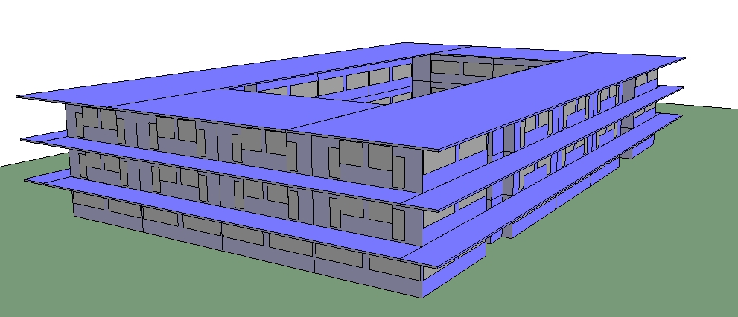
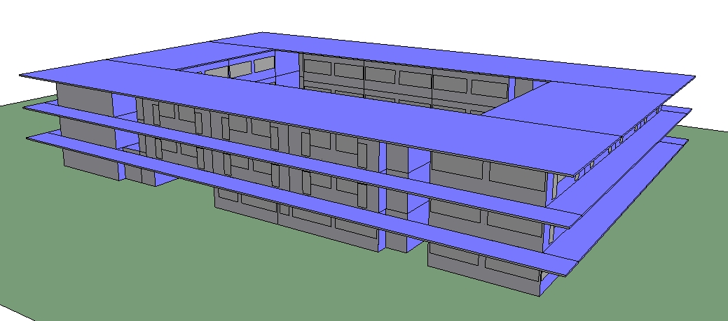
Figure 3.02 - Campbell High School, Building D

Based on our observations, the jalousies that faced the interior courtyard were closed throughout the day to prevent glare and direct solar radiation within the classroom. This would greatly reduce the ventilation through the space and make the classrooms more uncomfortable. In addition, the configuration of the building is not optimal for natural ventilation, with the courtyard creating a “dead” spot for airflow.

    - Methodology

The methodology is as follows:

- Propose relevant “passive” building features and measure the results based on PMV (see 3.2.3. for explanation of PMV).

- Secondary exterior shading system (exterior louver) to allow the jalousies to remain open throughout the school day without direct solar radiation or glare.

- Roof insulation.

- Wall insulation.

- Increased exterior shading (9’ overhang).

- Increased ventilation through full opening of jalousies.

- Ceiling fans.

- Compare the energy performance of various air-conditioning systems and measure the results based on energy consumption.

  - Individual packaged terminal units.

  - Variable refrigerant systems.

  - Central chilled water systems.
    - Predicted Mean Vote

Thermal comfort is a measure of how comfortable the indoor environment is perceived to be by its occupants. Thermal comfort modeling is used to give an indication as to the proportion of occupants who notice warmth or coolness in a space. As the proportion of occupants noticing a certain thermal environment (such as warmth or coolness) increases, the level of thermal comfort deteriorates. Where this proportion of “dissatisfied” occupants is low, the level of thermal comfort is considered to be good.
It should be noted that thermal comfort is not based solely on air temperature. An individual’s perception of temperature is based on a combination of factors. A number of heat exchanges between the body and the surrounding environment combine to affect the perception of comfort. The primary heat exchanges can be identified as the following:
- Convective heat is related to the body’s contact with the surrounding air, its temperature related to the body and its direction of flow. This provides in the order of 36% of the perceived comfort.
- Radiant effects are due to the heat radiated from all objects, including the body. The amount and direction of radiant heat exchange is dependent on the temperature of the surfaces that are in the space relative to the body’s surface temperature. This accounts for 46% of the perceived comfort.
- Evaporative effects are based on the heat lost by the body through evaporation of perspiration from the skin’s surface. The relative humidity and air velocity of a space have a strong influence on this cooling process. Evaporative effects determine approximately 18% of the perceived comfort.
As a result, the level of thermal comfort is derived from a number of environmental parameters. These parameters include air temperature, mean radiant temperature, air velocity, and relative humidity within the space. Also considered is the level of activity of the occupants (people doing heavy labor are more likely to feel hot than people seated at a desk) and the type of clothing they wear (an environment may seem warmer to someone wearing a suit, than to someone in shorts and a t-shirt).
An international standard (ISO 7730-1993(E)) has been created for determining thermal comfort. The standard describes thermal comfort using two related terms, Predicted Mean Vote (PMV) and Predicted Percentage Dissatisfied (PPD). Of these two terms, PMV is the benchmark for the international standard.
Predicted Mean Vote is a mathematically generated response, where each person in a space “votes” their opinion on the state of the indoor environment from the above-mentioned table. The PMV is the mean result from all of those “votes”.
The PPD aids in the understanding of the PMV values. This is done by relating the PMV to a predicted level of occupant dissatisfaction with the indoor environment. At a PMV of 0, only 5% of occupants would signal dissatisfaction with the indoor environment. At a PMV of 3, 95% of occupants are deemed dissatisfied.
Figure 3.03 shows that at a PMV of 1, approximately 25% of occupants are uncomfortable, with a large proportion of those occupants slightly uncomfortable (shown in orange), and a small proportion (approximately 5% - shown in red) being very uncomfortable. At a PMV of 2, the percentage of uncomfortable occupants increases to 75% (denoted by the orange and red bars), of whom a significant proportion are very uncomfortable (denoted by the red). This graph illustrates that if the PMV can be kept within +1 and -1, then the percentage of very uncomfortable occupants can be kept to a maximum of 5%, while the percentage of slightly uncomfortable occupants can be kept to less than 20%.
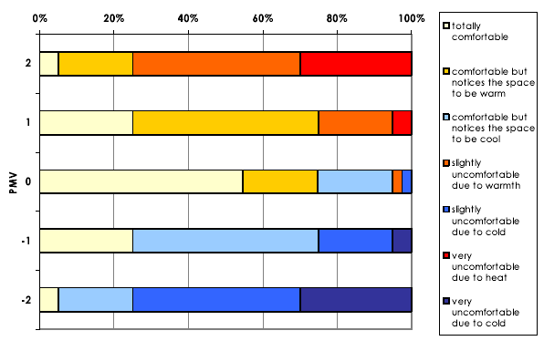
Figure 3.03 - Comfort State of Occupants for Different PMV Levels
Although ISO 7730-1993(E) is the accepted standard for evaluating thermal comfort, it must be understood that this standard is based on conditions in an air-conditioned building. Whereas the objective of an air-conditioned building is to achieve thermal comfort as prescribed by a pre-determined PMV range, the goal of a naturally ventilated building is to maintain thermal comfort to a level that is on par with the outside environment.

Acknowledging that the climate in the greater Honolulu area is generally warm, the design team has determined that the goal for this project is to maintain a PMV range between +1.5 and –1.5. This range has been determined to represent the PMV values where a majority of the occupants remain comfortable in a naturally ventilated environment.

  - Establishing the Base Case

A thermal model was developed within the Virtual Environment program (version 5.5.1) by IES. The model was based on the record documents provided to us by the DOE Facilities. The construction types are as follows:

- External wall CMU block wall, 8” thick, 38 lb/cf density

- Internal partitions 5” frame wall, w/ ½” gypsum board and 3-1/2” thick fiberglass insulation

- Floor slab 6” thick cast concrete with 1-1/2” thick acoustical tile

- Door 1-1/2” thick solid wood

- Jalousie windows ½” thick solid wood

- Roof Built-up roof with felt and bitumen on 6” thick cast concrete with 1-1/2” thick acoustical tile

During our site visit, it was noticed that the jalousie windows that faced toward the courtyard were closed, presumably to stop direct sunlight from entering the classroom. The Base Case model has the east facing jalousie windows that face the courtyard closed through the morning and open at 12 noon. The west-facing jalousie windows that face the courtyard were open in the morning and closed at 12 noon.

  - Establishing the Green Case

The rooms on the third floor were selected as the basis of our comparison because these rooms would be the most uncomfortable with the most direct solar heat gain. Each room is on a different side of the building:

- Room 302, Northwest

- Room 305, Northeast

- Room 309, Southeast

- Room 312, Southwest

The following passive design measures are as follows:

Jalousies open without sun (Base Case):

This is the Base Case as described above in section 5.3.

Jalousies open, school hours:

This measure models an external shading device such as a fixed louver installed outboard of the existing jalousies to allow the windows to be open during all school hours while also blocking any direct solar heat gain.

Jalousies open, wall insulation:

This measure incorporates the previous external shading device and the addition of 3” of fiberglass insulation on the exterior walls. This measure was modeled only in room 312.
Jalousies open, roof insulated:

This measure incorporates the previous external shading device and the addition of 5” of fiberglass insulation on the underside of the roof deck.

Jalousies open, roof insulated with 4” EPS:

This measure incorporates the previous external shading device and the addition of 5” of expanded polystyrene on the top of the roof deck.

Jalousies open, exterior shades 9’:

This measure incorporates the previous external shading device and the addition of an exterior overhang that extends 9’ from the external wall. This overhang is modeled for only the windows that face the courtyard. The windows with a lanai above were not modified.

Jalousies open, 70% exterior shades 9’:

This measure incorporates the previous external shading device, the addition of an exterior overhang that extends 9’ from the external wall and the jalousie windows open to 70% open. This overhang is modeled for only the windows that face the courtyard. The windows with a lanai above were not modified.

Jalousies open, ceiling fans:

This measure incorporates the previous external shading device, the addition of an exterior overhang that extends 9’ from the external wall, the jalousie windows 100% open to 70% open, and the addition of ceiling fans that would provide an air movement of 1.25 feet per second.

Figure 3.04 – PMV Distribution

PMV Distribution Room 305
0
100
200
300
400
500
600
Hours above 1.5 PMV
Passive Elements
Hours Per Year Above 1.5 PMV
Jalousies open without sun
Jalousies open school hours
Jalousies open, roof insul fg
Jalousies open, roof insul 4"
EPS
J.O.exterior shades 9'
J.O. 70% exterior shades 9'
Jalousies open, ceiling fans

Figure 3.05 – PMV Distribution
PMV Distribution Room 309
0
100
200
300
400
500
600
700
800
900
1000
Hours above 1.5 PMV
Passive Elements
Hours Per Year Above 1.5 PMV
Jalousies open without sun
Jalousies open school
hours
Jalousies open, roof insul fg
Jalousies open, roof insul 4"
EPS
J.O.exterior shades 9'
J.O. 70% exterior shades 9'
Jalousies open, ceiling fans

Figure 3.06 – PMV Distribution
PMV Distribution Room 312
0
200
400
600
800
1000
1200
Hours above 1.5 PMV
Passive Elements
Hours Per Year Above 1.5 PMV
Jalousies open without sun
Jalousies open school hours
Jalousies open, wall insul
Jalousies open, roof insul fg
Jalousies open, roof insul 4"
EPS

J.O.exterior shades 9'

J.O. 70% exterior shades 9'

Jalousies open, ceiling fan

Figure 3.07 – PMV Distribution

    - Air Conditioning – Individual Terminal Units

Individual terminal units were modeled as the Base Case air-conditioning retrofit. An example is shown on Figure 3.08 at Alvah Scott Elementary School. This type of system may not meet the local energy code and can accommodate the large amount of outside air required for a classroom. The terminal units have a lower first cost, but higher operating costs.

Figure 3.08 - Individual Terminal Units

    - Air Conditioning – Variable Refrigerant Technology

The second air-conditioning system to be assessed is variable refrigerant (VR) technology. Although this system looks similar to a conventional split system, there are some key differences. The differences are as follows:

- The efficiencies of VR (COP of 4-5, 15.0 – 18.5 EER) are much higher than individual terminal units (COP of 3, 10.2 EER) and result in lower operating costs.

- Multiple fan coil units (up to 13) can be connected to a single nominal 8-ton outdoor condensing unit.

- Utilizes environmentally friendly refrigerants (R-410A).

- Quiet operation.

- These units cannot accommodate the significant amounts of outside air; therefore, require a separate dedicated outside air system that preconditions the outside air prior to introduction directly into each classroom.

Figure 3.09 - Concealed Indoor Fan Coil Unit

Figure 3.10 - Outdoor Condensing Unit

    - Air Conditioning – Water-Cooled Chilled Water System

The last air-conditioning system to be assessed is a water-cooled chilled water system.

This type of system utilizes a chiller, which generates cold water (45 deg F) that is circulated around the building. The chilled water is fed through individual fan coil units that remove heat and moisture from the classrooms. The heat from the classrooms is rejected to the ambient atmosphere through a cooling tower that is connected to the chiller.

These types of systems typically have the highest efficiencies when centrifugal chillers are utilized (>100 tons).

Figure 3.11 - Water-Cooled Centrifugal Chiller

Figure 3.12 - Cooling Tower

Although these systems tend to be the most energy efficient, they also have the highest initial cost. Further, because the refrigeration equipment is large, a suitable location will need to be assessed and may require a separate structure to conceal and acoustically attenuate the equipment.

  - Life Cycle Cost Analysis

 | Individual DX |  | Variable Refrigerant |  | Chilled Water
 | kWh | kW | kWh | kW | kWh | kW
January | 31,300 | 252 | 23,028 | 146 | 21,704 | 146
February | 26,052 | 252 | 19,680 | 153 | 18,443 | 153
March | 32,871 | 253 | 24,335 | 159 | 22,779 | 159
April | 28,977 | 255 | 21,566 | 161 | 20,179 | 161
May | 33,827 | 257 | 24,705 | 166 | 22,914 | 166
June | 12,983 | 260 | 10,602 | 171 | 11,498 | 171
July | 12,840 | 260 | 10,449 | 170 | 11,120 | 170
August | 14,113 | 262 | 11,393 | 172 | 12,140 | 172
September | 32,874 | 263 | 23,778 | 174 | 21,931 | 174
October | 35,679 | 259 | 25,730 | 169 | 23,922 | 169
November | 34,568 | 257 | 24,710 | 173 | 23,719 | 173
December | 29,568 | 254 | 21,836 | 165 | 20,753 | 165
Total | 325,652 |  | 241,812 |  | 231,102
Power cost | $55,361 |  | $41,108 |  | $39,287
Installed cost | $745,000 |  | $873,519 |  | $1,167,265
Replacement  cost | $615,564 | 10 yr life | $745,030 | 15 yr life | $745,467 | 20 yr life
Maintenance cost | $45,600 | per year | $45,600 | per year | $50,000 | per year
Net Present Value (20 yr) | $2,705,082 |  | $2,641,721 |  | $2,495,630
Net Present  Value (30 yr) | $3,552,740 |  | $3,051,240 |  | $3,330,077

Figure 3.13 – Life Cycle Cost Analysis Results

Note: The air-conditioning load for the LCCA above is based on the 36,480 square feet of conditioned area and 172.5 tons of peak cooling load that would be required for CHS Building D (reference Figure 3.02)

  - Findings and Conclusions

Reviewing the graphs for the passive design measures, it is apparent the single biggest improvement in thermal comfort comes from incorporating an external shade device that allows the jalousies to be open throughout the school days.

Surprisingly, it seems the incorporation of wall insulation (only in Room 312) or roof insulation did not have any appreciable effect on thermal comfort, sometimes making the comfort conditions worse.

The incorporation of a 9’ overhang and opening the jalousies to 70% showed noticeable improvement in rooms 305 and 309 only. This would seem to indicate the overhang would be recommended only for the windows that had a westerly orientation.

Lastly, there was a significant decrease in uncomfortable hours with the use of ceiling fans only in rooms 309 and 312. This seems to point to the fact that rooms 302 and 305 are
oriented towards the prevailing winds and benefit from the natural breezes. Rooms 309 and 312 are on the leeward faces of the building and do not receive the benefit from the natural breezes.

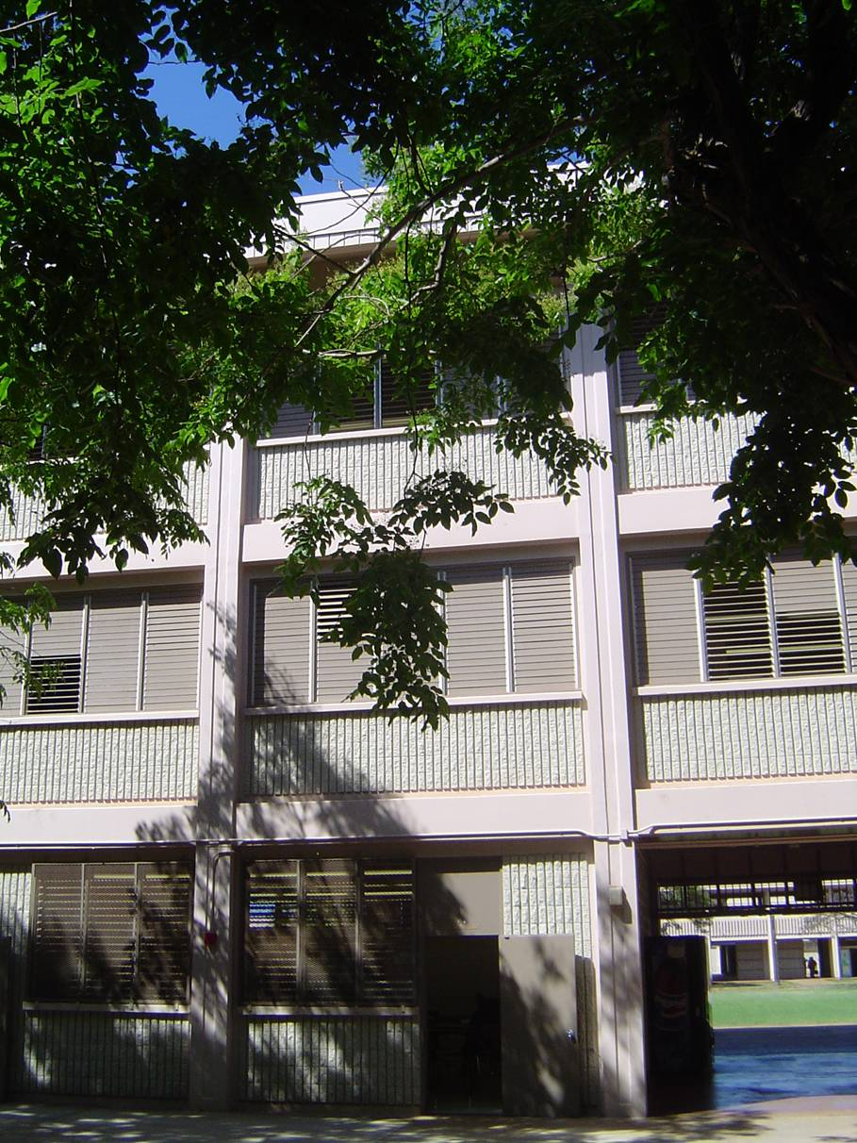

Figure 3.14 – Campbell High School Classroom Building

Should Campbell High School decide to incorporate air conditioning, the life cycle cost analysis indicates that both the Variable Refrigerant Technology and Central Chilled Water system have lower net present values compared to the Individual Terminal Units. The selection of the system does depend on the life cycle duration. If the life cycle duration is greater than the anticipated life of the Central CHW system, the Variable Refrigerant Technology has the lowest life cycle cost. Alternatively, if the life cycle duration is equal or less than the anticipated life of the Central CHW system, then the Central CHW system has the lowest life cycle cost. Therefore, both the Variable Refrigerant Technology and Central Chilled Water system are more favorable than the Individual Terminal Units. However, the selection of either technology would depend on initial cost constraints and life cycle duration.

STUDY NO. 4: Implementation Research and Strategies

  - Implementation Research

    - Objectives

The primary objective of implementation research conducted for this Study has been to identify high-level strategies that would effectively integrate sustainable design and best practices into existing processes governing the planning and building of K-12 schools in Hawaii. The goal is to identify a pathway to the potential economic, occupant, and environmental benefits identified in the Study’s analytical component(s).

Areas of concern identified in the Study Scope and as part of the Study include the following:

        - Life cycle cost analysis.

        - Project funding, including the challenges of the budgeting process.

        - Consultant selection process.

        - Facility planning process.

        - Sustainable design implementation in new facilities.

        - LEED certification.

        - Parameters for requiring LEED certification.

        - Special funding.

        - Transitional issues, including training and phasing of implementation.

For each area of concern, relevant existing conditions in Hawaii have been identified, as well as examples of how the particular concern has been addressed elsewhere. A set of eleven high-level suggested strategies have been developed for implementation based on these findings.

    - Methodology and Approach

An implementation research plan was produced by the project team that identified team researcher, potential sources of information, and status of research for each implementation topic (areas of concern listed in 4.1.1.). This plan was used to track research progress and coordinate information among team members.

A number of methods were used to gather information for this Study, including interviews, questions on the electronic survey conducted with exemplary schools (Hawaii and mainland), and literature/Internet research.

Interviews were conducted in person or by phone with Hawaii State agencies and others involved in planning schools and/or sustainable building initiatives in Hawaii, similar entities in other states with related responsibilities, and sustainable building experts with school-related experience. In all, 13 interviews were conducted with the following individuals:

        - Nick Nichols, Department of Education, Planning

        - Brenda Lowrey, Department of Education, Planning

        - Dean Masai, Department of Business, Economic Development & Tourism, Strategic Industries Division

        - Gail Suzuki-Jones, Department of Business, Economic Development & Tourism, Strategic Industries Division

        - Charles Kaneshiro, Group 70

        - Catherine Brownlee, Pennsylvania State Governor’s Green Government Council

        - Dean Evans, New Jersey Institute of Technology

        - Charles Eley, Architectural Energy and Collaborative for High Performance Schools

        - Victor Olgyay, RMI/ENSAR

        - Greg Franta, RMI/ENSAR

        - Ellen Larsen, Sustainable Building Industries Council

        - Nancy Clanton, CEO of Clanton Associates, has worked closely with LA Unified School District

        - Michael Spearnik, Poudre School District

A list of exemplary schools surveyed for the Study has been provided elsewhere in this report (See Appendix, Section 7.1.). Additional information was provided by:

        - New Jersey School Construction Corporation

        - Washington State Office of Superintendent of Public Instruction

        - U.S. Green Building Council
    - Findings

      - Strategies with Life Cycle Benefits and Savings

Life cycle cost analysis (LCCA) can be an especially valuable tool in buildings that are intended to be operated by the same owner for the life of the building, such as publicly funded schools. LCCA shows the true cost and benefit of specific technologies and practices.

Existing Process:

In January 2006, Hawaii Governor Linda Lingle, issued Administrative Directive No. 06-01, which required facilities using state funds or state-owned lands to meet and receive certification for the U.S. Green Building Council’s Leadership in Energy and Environmental Design (LEED) Standard at the Silver level. In addition, the Administrative Directive directed the use of life cycle cost/benefit analysis (typically termed life cycle cost analysis or LCCA) to assess the purchase of energy efficient equipment such as Energy Star equipment and use of solar water heating. Other sustainable design features included energy and water efficiency, waste minimization and pollution prevention, and environmental product procurement. Act 96, passed in June 2006, which builds on the Administrative Directive, contains similar requirements with regard to LCCA.

Examples:

In Washington State, schools are required to complete an energy life cycle cost analysis (ELCCA) that essentially compares three mechanical systems for energy costs. It is a somewhat limited exercise, and practitioners performing ELCCAs report it is not as useful as a full life cycle cost analysis (LCCA) would be. In recent developments, the Washington Sustainable Schools Protocol (WSSP) offers an alternative; a LCCA credit that, if applied, rewards the school one point on the rating system. In addition, the Office of Superintendent of Public Instruction (OSPI) is working with the State’s General Administration to have WSSP certification (which requires four points in superior energy performance as a minimum) satisfy the State’s ELCCA requirement, since an annual energy analysis comparing a standard design to proposed design is required to achieve energy performance points in the WSSP.

In Alaska when a school asks for funding for capital improvements, the school is required to perform some type of quantitative analysis, which is often a LCCA or cost/benefit analysis. To assist schools and districts in this task, the Alaska Department of Education and Early Development has created a manual explaining the LCCA process. The manual can be found at http://www.eed.state.ak.us/facilities/publications/LCCAHandbook1999.pdf.

In addition to these examples, interviews conducted for this Study identified some challenges that should be kept in mind when applying LCCA:

- General resistance by staff and design team to use true LCCA; the method can be perceived as complicated.

- Separate capital and operating budgets can provide little incentive to considering operating expenses in design decisions.
- LCCA fails to capture benefits that cannot be quantified (e.g., increases in student performance).

        - Project Funding

Accurate and timely funding of sustainable design and construction technologies and practices is key to making investments that provide good long-term economic and environmental benefit.

Existing Conditions:

The process for developing the capital improvement projects (CIP) budgets for school design and construction is lengthy and tends to rely on rules-of-thumb rather than up-to-date estimates. This is further exacerbated by intense escalations in construction costs currently being experienced in Hawaii. In addition, the CIP budget is developed separately from Operations and Maintenance (O&M) budget, creating a disconnect between potential savings that may result from an upfront investment in integrated design services and/or better performing equipment, such as Energy Star equipment. (This is not unique to Hawaii’s schools; it is a problem that challenges most publicly funded school construction projects in the nation.)

Project administration of public schools in Hawaii has recently undergone a change in that responsibility for planning and construction has been transferred from the Department of Accounting and General Services (DAGS) to the Department of Education (DOE). Thus, it is an advantageous time to make modifications with regard to the integration of sustainable design and construction into DOE practice.

Public schools in Hawaii are a responsibility of the State, and therefore, school construction and modernization funding is provided through legislation. The capital improvement projects (CIP) budget is developed internally by DOE planning staff and submitted to the Board of Education (BOE); after approval by the BOE, it is sent to the Governor and the Department of Budget and Finance (B&F) to be integrated into an executive budget for all State spending. CIP projects appear as line items in the budget. Budget planning is six years out, with three two-year budgets. Every other year is a “major budget” with the alternate year being a supplemental budget. Money allocated in a major budget year is available for three years; money allocated in a supplemental budget is available for two years. None of the money can be spent until released by the Governor, which typically compresses the project design time. Currently there is a significant backlog of DOE capital projects.

To determine the line item amount for individual projects, DOE Planning staff works with the school principal to develop project scope, including the project’s footprint, functional needs, and square footage. An additional and relevant factor is to determine if air conditioning is necessary, and the amount of open space desired. Project scope data is used to produce a project justification, preliminary cost estimate, and other back up, including budget assumptions. Although design and construction costs for an individual project are not generally in the same annual budget, B&F requires construction costs be allocated in the six-year plan. Thus, a budget number has to be generated for construction costs in order for a design budget to be approved. In addition, the design budget must be generated prior to a
design team being hired.

The budgeting process thus requires use of rules-of-thumb (and past experience) and not actual estimates from A&E firms and/or contractors. This is a challenge in any project (green or not) given the serious and universal escalations in construction costs. Additional concerns result when employing renewable and innovative technologies.

Examples:

In 2005, Washington State became the first state to pass a law that new state-funded buildings meet “green” design and construction standards including LEED and the Washington Sustainable Schools Protocol (WSSP). Because many public schools in Washington apply for state funding through what is known as the “D-Form” process, the law (SB5509) will have a significant impact on K-12 schools constructed in the state once the law’s requirement is applied to schools (July 2007 for Class 1 schools; July 2008 for Class 2 schools).

Although Washington State’s Office of Superintendent of Public Instruction (OSPI) anticipates the law to result in significant operational savings over the life of schools constructed with sustainable features, potential increases to design those schools must be accommodated in capital budgets. As such, OSPI plans to increase the A&E design allowance (per square foot) to account for any premiums due to the mandate. The exact amount has not been determined, but is expected to be based on the results of pilot projects (already completed) and the experience of schools that have volunteered to apply the WSSP to projects requiring state funding as of July 2006 in return for special grants to support this effort. Justification for additional state funding has included a “bridge” report to the legislature prepared by Paladino and Company for OSPI in February 2005, which concluded that investing 2% of its annual budget (about $5 million) for sustainable features would potentially return $12.7 million ($7.6 million net) over the next 25 years.

In Pennsylvania, public schools are encouraged to use LEED, but not required. Funding levels are determined by a formula which takes into account the type of school, economic status of the school’s location, enrollment, and other factors. HB 628 allows the Department of Education to provide 10% more than base if the school achieves a LEED Silver rating. A LEED certificate must be presented to receive funding.

Cost Data:

In developing a contingency fund to address possible first cost premiums, it is important to consider existing data. Greg Kats’ report, “The Costs and Financial Benefits of Green Buildings,” provides results of a study of office and school construction projects in California, and concludes that the average cost premium to achieve LEED Silver is roughly 2%. In addition, as noted earlier in this Study, the Davis Langdon study suggests an allowance of up to 3%. Also, “Greening America’s Schools Costs and Benefits,” by Greg Kats, October 2006, concludes that “the financial benefits of greening schools are about $70 per square foot, more than 20 times as high as the cost of going green.”

      - Consultant Selection Process

Cost-effective sustainable design requires a good understanding of the integrated design process, as well as familiarity with sustainable technologies and standards. Optimizing the DOE’s ability to hire a consultant team with the appropriate knowledge base and level of
experience will be a significant aspect of achieving sustainable schools.
Existing Conditions:

Once state funding is released for a project, the consultant selection process begins. The DOE Selection Committee includes Facilities Development Branch personnel (from the agency’s Project Management, Construction Management, and Planning sections) who select three consulting firms in order of prioritization. These firms are selected from a roster of pre-qualified firms, which is updated annually. Qualifications looked for include quality of previous work, design of similar projects, ability to listen and understand DOE’s facility needs, and staffing capacity/availability. The DOE Selection Committee recommends the final selection but does not negotiate fees. After selection process, the project is assigned to a Project Coordinator in DOE Project management who does the fee negotiation after going over the scope of the project with the selected consultant.

An exception to this process is if a developer provides land or cash to DOE to build a school for a new planned community. The developer may choose to do design-build, in which case the contractor is chosen earlier in the process and is involved in planning, as well as developing cost estimates.

Understandably the DOE has relied heavily on firms with prior, thus proven, experience with DOE projects. At this juncture, however, all of the schools in Hawaii that have applied LEED or sustainable features are privately owned. Thus, a team experienced in applying LEED to a school in Hawaii won’t necessarily have experience working with DOE.

Examples:

In California, school districts seeking to build to the Collaborative for High Performance Guidelines (CHPS) include that information in their RFP and include a requirement that the design firm is familiar with the high performance standards adopted by the school district.

The Poudre School District, when launching its Sustainable Building Guidelines, conducted a six-week design competition; the winner developed a prototype for the bond campaign. In general they use a pre-qualifying process for projects, with a roster each for large and small projects. The district emphasizes evaluating the entire design team, not simply the prime architect, as they believe the knowledge base of and attitude towards sustainable design goals should be imbued team-wide to achieve the kinds of savings they have achieved (for example, $100,000 savings in utility costs the first year of a new high school’s operation when compared to a similar sized school with the same number of students).

      - Facility Planning Process

To achieve sustainable schools, the facility planning process must put an appropriate and timely emphasis on sustainable design practices. The earlier sustainable building goals are introduced in the process the better (and more cost-effective) the results.

Existing Conditions:

The facility planning process for new schools varies from that for substantive additions in its early stages. Once site selection and evaluation is complete, the path is similar for both
new schools and major additions to existing schools.

New Schools:

Since virtually all new schools built in Hawaii are part of planned residential developments (private and Hawaiian Homelands) the following is generally applicable to new school planning:

- DOE Facilities Planning Section and Office of Information Technology Services (demography) determine need, based on number of residential units being developed. For private developments, the developer provides land and/or cash through a “fair share agreement” to DOE (based, again, on number of residential units).

- Developers propose site. Site sizes are standardized at 12 acres/elementary; 18 acres/middle school; and 50 acres/high school.

- Developer conducts an Environmental Impact Statement (EIS), primarily evaluating traffic and egress. The DOE may be required to include an additional site-specific traffic study. The DOE does not currently require the evaluation of sustainable design opportunities as part of site evaluation.

New Schools & Major Additions:

- Design team selection takes place (See Study Section 4.1.3.3).

- Charrette/master planning takes place. Charrettes, which are funded with Master Planning funding, are at this juncture used primarily for new schools, but DOE reports they can be conducted for major additions to existing schools. Charrette participants include all stakeholders, that is, DOE staff, students, parents, community members, and design team (architects and sub-consultants). The DOE planning charrettes are typically facilitated by an educational consultant, and currently do not include a sustainability component. Currently, custodians and O&M engineers (electrical & mechanical) have been included and, on neighbor islands projects, the DAGS CIP/R&M staff. In the future, DOE plans to make more of a direct effort to have O&M personnel included. Master planning includes:

  - Developing an Educational Plan
  - Holding three planning charrette sessions to 1) review the Educational Plan and develop two-dimensional conceptual plan; 2) develop and refine individual components of the conceptual plan; and 3) review three-dimensional drawings and conceptual plan; agree on basic design.
- Cost estimates/bidding. The architect develops a final cost estimate, usually including a base bid and alternates. A value engineering process is used if necessary to hone the estimate. As noted above, lowest-bid wins. When the design-build process is used (see Study Section 4.1.3.3.), bids are negotiated rather than competitively let.

In addition, the DOE is in the process of developing a standard Education Specification that could be used as the basis of most educational plans and design. DBEDT and DOE have discussed including sustainable design requirements in the Education Specification document; meanwhile, the DOE refers designers to a document developed by DBEDT, the “Hawaii High Performance School Guidelines,” which focuses on energy savings.

      - Sustainable Design Implementation (New Facilities)

Systematic incorporation of sustainable design in new schools is generally achieved through a requirement to achieve a particular standard. It can also be helpful to prioritize specific and appropriate technologies that help meet this standard.

Existing Process:

In 2002, in an effort to encourage high efficiency schools, DBEDT sponsored a School Decision Maker Forum for DAGS and DOE featuring “Techniques and Tools to Enhance the Learning Environment”. Continuing this effort, in 2004, DBEDT sponsored a Workshop for DOE on High Performance Schools in Hawaii. A leading international expert on sustainable buildings, Charles Eley, P.E., F.A.I.A., explored attributes and design concepts of high performance schools. Following this workshop, DOE, working with DBEDT and professional architects, developed the “Hawaii High Performance School Guidelines” which are currently being used as a guidance document by the DOE, along with related publications on life cycle cost calculations, commissioning, and high performance classroom prototypes.

As of 2007, sustainable design is not systematically incorporated into the design process of new schools in the State of Hawaii. Act 96 has directed each state agency to “design and construct buildings meeting the Leadership in Energy and Environmental Design (LEED) Silver or two Green Globes rating system or another comparable state-approved, nationally recognized, and consensus-based guideline, standard, or system” and the DOE is evaluating options.

Act 96 also directs the purchase of Energy Star and cost-effective solar water heating equipment, as well as encourages other sustainable design approaches including energy and water efficiency, waste minimization and pollution prevention, and environmental product procurement.

Example:

The incorporation of sustainable design in schools across the country has typically been achieved by benchmarking to a national green building standard or by creating a district/county/state standard for green building in schools. Using either method allows issues of sustainable design to be brought up early in the planning process and incorporated throughout design and construction. For program examples see Report Section 4.1.3.6.

      - LEED Certification

The Leadership in Energy and Environmental Design (LEED) Rating System, developed by the U.S. Green Building Council, is intended to provide a national standard for all building types. A LEED Rating System for schools is complete; it is similar to LEED-NC (for new construction) but incorporates considerations (such as acoustics and joint use) specific to the design of schools. The LEED for Schools 2007 rating system and checklist are on the US Green Building Council’s website.

Existing Conditions:

Act 96 requires the use of LEED, Green Globes, or other standards for state-funded buildings and facilities.

Examples:

There are many LEED policies in place at the state, county, and municipal level. Just a few specifically mention K-12 school construction. These policies range from requiring LEED certification, to requiring the use of LEED (but not certification with the U.S. Green Building Council) to allowing use of school-specific guidelines, to simply providing incentives for the
voluntary use of LEED or other guidelines.

As noted above, Washington State mandates use of either LEED or WSSP for state-funded K-12 schools (Study Section 4.1.3.2.). California is an example of encouraging sustainable school design and construction through voluntary means. Although LEED is required for other types of state-funded buildings, the Governor’s Executive Order directed the State Architect to select guidelines for schools. The State Architect selected the Collaborative for High Performance (CHPS) system, which has been voluntarily adopted by 20 of the state’s school districts, representing 30% of school construction in the state. The state provides 50% of the funding for schools. This base funding has been supplemented in the past for schools that have exceeded Title 24 (California State energy code). Research for this Study revealed an effort to broaden the incentive package to apply to schools documenting achievement of the CHPS standard.

In New Jersey, the state is considering how to approach the design and construction of high performance schools. While the state recognizes the advantages to requiring LEED and encourages that, it is also concerned with offering its schools flexibility. Rather than requiring LEED, the state is leaning toward requiring selected features it considers especially important (e.g., indoor air quality measures). As an example of the need for flexibility, districts in New Jersey that have not built a new school in 75 years are being allocated money for new construction. These districts are often in dilapidated areas; as such there is a desire to make the school the centerpiece of the community and a symbol of redevelopment. Thus, the district may prefer to invest money in the design of the school’s façade rather than achieving LEED certification.

      - Parameters for Requiring LEED Certification

To achieve LEED certification, documentation must be submitted to the U.S. Green Building Council for independent confirmation that specific sustainable design and construction actions have been taken. Since this represents services above and beyond typical design and construction services, it is generally helpful to define when LEED certification is required (and thus when it is not).

Existing Conditions:

Act 96’s requirement to meet LEED or other standards applies to ALL state-funded buildings and facilities. The legislation does not make exceptions for particular building types or sizes.

Examples:

The City and County of Honolulu Ordinance 06-06 calls for all new qualifying city facilities over 5,000 square feet to achieve LEED Silver status starting in 2008. Additionally, facilities where the Director of Design and Construction has determined that compliance with LEED Silver would be infeasible or inappropriate are exempt from meeting the LEED Silver standard.

In Washington State, schools over 5,000 square feet must achieve LEED Silver or meet the WSSP unless the design team determines these standards are not practicable for the project. If the design team asserts that these standards are not practicable, then they must provide reasons for this assertion to the state’s Office of Superintendent of Public Instruction (OSPI).

      - Special Funds

Special funding can help when attempting to incorporate innovative technologies or design practices into publicly funded design and construction. It should be considered as part of a transitional strategy (see also 4.1.3.9.).

Existing Conditions:

Act 96 authorized the appropriation of $5 million for fiscal year 2006-2007 to develop and implement a photovoltaic, net metered pilot project in public schools. The project sites are to be determined by the DOE, but should be located in the four counties. In addition the act authorized the appropriation of $65,000 for fiscal year 2006-2007 to establish one full-time permanent energy coordinator position to address energy efficiency in DOE facilities.

Also, the State’s utilities HECO (Oahu), HELCO (Hawaii), and MECO (Maui) offer a Sun Power for Schools program with the DOE. Through the program, the utilities install photovoltaic systems at Hawaii public schools using voluntary customer contributions. To date, twenty-two (22) public schools have received photovoltaic systems and benefited from the educational material developed as part of the program. HECO, HELCO, and MECO have extended their Sun Power for Schools program another two years (2007-2008).

Examples:

In Pennsylvania, the Governor’s Green Government Council offers planning grants to help take care of additional upfront design costs when designing sustainable schools. The program, funded through the state’s General Fund, offers a total of $200,000 a year and is distributed on a first-come, first-served basis to schools to cover the costs of eco-charrettes and LEED documentation. To qualify for the grant, the school district must present a signed commitment to certify their school using the LEED standard. If they do not achieve certification, the money must be returned.

The Poudre School District benefited initially by receiving dollars and technical support from several partners, including the Lawrence Berkeley Laboratory, the State of Colorado, the local utility, and University of Colorado. Total value of dollars and technical support is estimated at $80,000. Note that the state’s contribution was $20,000 cash.

Electrical utilities around the country – notably including privately owned examples – are financially supporting the use of LEED in their service territories. Avista, (Idaho/Eastern Washington) specifically applies its $1.25 per conditioned square foot incentive to schools. (The utility also allows schools to use the Washington Sustainable Schools Protocol, as long as the school achieves six points from the energy category.)

The Snohomish County PUD has inaugurated a schools program that provides a combination of technical assistance and funding to K-12 school construction projects in their territory. The utility offers a financial incentive per square foot for building a “highly energy efficient school.” To receive these incentives, a school district must agree to achieving a level of energy efficiency of 20, 30, 40, or 50% above code (the incentive increases as
efficiency increases). What is particularly significant is that the incentive is tied to a number of sustainable design activities, including an eco-charrette, energy modeling and/or calculations, and commissioning.

Municipalities also provide financial support. For example, King County (Washington) recently announced a new “Green Building Grant” program for projects seeking LEED certification. They anticipate providing recipients between $15,000 and $25,000 to help offset potential added first costs for design, modeling, permitting, LEED registration and documentation. Public (and private) projects in early design are eligible for grant funding.

      - Transitional Issues for Effective Implementation

Experience has shown that incorporating substantive changes in the ways buildings are designed and constructed takes some time. The design and building process is a lengthy and generally expensive one. In addition, the budgeting process used to fund schools in Hawaii is such that it will take time to adequately respond to the legislative mandate to design and build sustainable schools.

Sustainable design and construction marks a change from business as usual. Approaching the changes envisioned in this Study without a careful plan for transition is problematic, and is likely to lead to disappointment. In most situations where LEED or sustainable policies have been introduced, special funding (see Section 4.1.3.8.), training, and/or phasing have been components of transitional planning.

Existing Conditions:

Act 96, effective July 1, 2006, does not explicitly set a deadline by which DOE must incorporate green building goals in its design and construction projects. The act directs DOE (and other agencies) to implement these goals “to the extent possible” in planning and budget preparation and program implementation. One can imply from this language that only projects that enter the planning stage after the July 1, 2006 date are affected. In addition, the act provides for special funding for a pilot project and energy efficiency coordinator.

Examples:

Training:

In Pennsylvania, in addition to providing grants for charrettes and the LEED process (see 4.1.3.8.), the Pennsylvania State Governor’s Green Government Council (GGGC) offers the use of engineering staff to run 1 to 2 day charrettes, review plans, and meet with district stakeholders to help promote green building technologies for specific projects.

As High Performance Schools New Jersey (HPSNJ), the New Jersey Schools Construction Corporation (NJSCC) works closely with the New Jersey Institute of Technology (NJIT) to provide technical training and web-based resources to schools planning, designing, building, and operating high performance K-12 facilities.

In California, the non-profit Collaborative for High Performance Schools (CHPS) has conducted ten trainings a year over the last three years, averaging 30-50 individuals each time, including A&E firms, school district personnel and others involved in the design and construction of K-12 schools in the state.

Phasing:

In Washington State, the state’s green building requirement was phased in when applied to schools. Before the law was passed, the Office of Superintendent of Public Instruction (OSPI) had conducted a pilot test of the draft version of the Washington Sustainable Schools Protocol on five schools. The law then allowed the following phasing:

- 2005-2006 – OSPI developed an implementation plan and finalized WSSP. (During this time OSPI worked with the Cascadia Region Green Building Council to hold a series of workshops around Washington State for school districts and design teams working with school districts.)

- 2006-2007 – Schools voluntarily applying the standard could apply to OSPI for grants. Note that funding of $6.25 million was awarded to 19 school districts. (OSPI hired a full time staff member to manage the Washington Sustainable Schools Program.)

- 2007-2008 – School districts with 2,000 students or more must follow the law.

- 2008 – All school districts regardless of size must follow the law.

Suggested Strategies

Based on the findings of this Study, a set of eleven high-level suggested strategies have been developed for consideration by state planners. These strategies are considered both achievable and beneficial. Benefits of applying these strategies will include direct learning advantages to students who attend sustainably designed schools, operational savings, long-term predictability for DOE planning, and environmental protection.

In applying these strategies, it is anticipated that specific actions by the state DOE, the DBEDT Advisory/Policy Committee, the state’s legislative body, and/or other interested parties will need to be taken. Since most strategies necessarily involve some level of DOE activity, successful implementation will require addressing the implied and potentially significant impact on DOE personnel resources.

A Summary of Suggested Implementation Strategies is provided in Figure 4.01. The Summary outlines a description of the strategic action suggested, possible implementation methods, leadership entity(ies), suggested timing of implementation, and references to the report section where further resources or background on the specific recommendation can be found. The Summary is not intended to act as a plan, but as a starting point for planning. As part of the planning process, additional or different actions, implementation methods, or leadership entities may be identified as more appropriate for achieving the intent of these recommendations.

Figure 4.01: Summary of Suggested Implementation Strategies

Strategies w/Description | Proposed Implementation Method | Leadership Entity(ies) | Suggested Timing | Study Reference
- Prioritize technologies and design strategies to achieve a 30% reduction in operational expense.

Specify:  Daylight 75% of schools (100% of classrooms). | Include as requirement in DOE Design Guide. Reference in Scope of Services. | DOE | Immediate and on-going | 4.2.1
Install high efficiency AC. | Include as requirement in DOE Design Guide. Reference in Scope of Services. | DOE | Immediate and on-going | 4.2.1 and Study No. 3
Install high-efficiency electric lighting. | Include as requirement in DOE Design Guide. Reference in Scope of Services. | DOE | Immediate and on-going | 4.2.1
Encourage:  Employ enhanced commissioning. | Include as high priority recommendation in DOE Design Guide. Reference in Scope of Services when appropriate. | DOE | Immediate and on-going | 4.2.1
Employ measurement & verification (M&V) as defined by USGBC-LEED consistent with IPMVP Option D (savings estimation). | Include as high priority recommendation in DOE Design Guide. Reference in Scope of Services when appropriate. | DOE | Immediate and on-going | 4.2.1
- Establish a uniform process for monitoring and accounting for energy and water consumption in schools.

Create process for monitoring energy and water use in schools. Simple metering can be sufficient. Touch screens showing consumption can provide real time feedback and educate students, staff, and school visitors. | Identify responsible DOE personnel. Create report format/schedule. Employ energy performance contracting (UESCO is allowed by Act 96, but has not been implemented in state facilities to date). Utilize M&V data (see #1). For energy systems, rely on M&V capacity (see Recommendation #1). | DOE | Immediate and one-time only | 4.2.2
Create process for evaluating data and sharing progress. | Recommend evaluation criteria/process and method for sharing progress. | DBEDT/Policy Committee w/DOE input | Immediate and one-time only | 4.2.2
Implement process. | TBD: Depends on process developed. | DOE | On-going (may be for defined period) | 4.2.2
- Employ Life Cycle Cost Analysis (LCCA).

Develop process for employing LCCA. | Identify criteria for using LCCA and acceptable methods, such as the LCC Calculator developed for this Study or (for energy equipment) the LCC Calculation in DBEDT’s High Performance Guidelines. Define the role of VE in long-term planning. Create a manual that describes the required process. Prioritize design strategies with greatest cost impact. | DBEDT/Policy Committee w/DOE input | Immediate and one-time only | 4.2.3 and 4.1.3.1
Fund LCCA. | Make recommendations to legislature regarding benefit of funding LCCA in new schools and major renovations. (Confer with DOE on funding amounts to recommend.) | DBEDT/Policy Committee w/DOE input | Immediate and one-time only | 4.2.3 and 4.1.3.1
Implement process. | Require LCCA as part of design decision-making process. Include cost in budget development. (Scope of requirement may depend on budget approval.) | DOE | On-going | 4.2.3 and 4.1.3.1
- provide an add-on to Fund capital projects to allow for integrated design and equipment upgrades.

Add 2.5% to CIP budget. | Provide a single line item in overall CIP budget OR in each project budget.  Tie funding to specific conditions (see applicable Study section for suggestions).  Ensure funding for design analysis is available.  Hold an educational forum with high-level budget planners to describe integrated design and the benefits of allowing adequate time to design sustainable schools. | DOE  DBEDT/Policy Committee w/DOE input | Immediate and on-going  Immediate and one-time only | 4.2.3 and 4.1.3.2  4.2.3 and 4.1.3.2
- Modify Consultant selection process to ensure expertise in sustainable Design and Construction.

Optimize opportunities to secure proposals from A&E teams with appropriate expertise. | Update prequalification roster to include all teams with experience applying LEED to K-12 schools. Develop a pre-qualifying roster for approved sustainable building consultants to supplement teams or provide services directly to DOE. | DOE | Immediate and on-going | 4.2.5 and 4.1.3.3
Modify process of evaluating consultants. | Ensure at least one member of DOE Selection Committee has LEED experience and/or familiarity with sustainable design.  Specify in RFQ that:  1) Project(s) will be built and/or renovated using LEED and/or DBEDT High Performance Guidelines (for energy);  2) Personnel directly involved in project (including applicable design sub-consultants) offer substantive knowledge and/or experience with LEED and/or sustainable design.  Ensure evaluation criteria include how well proposal and interview team responds to these particular requirements. | DOE | Immediate and on-going | 4.2.4 and 4.1.3.3
Modify pre-bid conference process requirements. | Require as part of Scope of Services that architectural firm inform bidding contractors of the intent of the project to meet LEED guidelines or related special conditions, walking through changes that might impact their work. | DOE | Immediate and on-going | 4.2.5 and 4.1.3.3

- Modify facility planning process to ensure decision making takes sustainable design goals into account.

Ensure site analysis includes a review of opportunities for energy savings, water savings, and best practices for site development. | Require in Scope of Services. Describe process required in standard Education Specification. Identify conditions that might allow for and trigger a requirement for specific sustainable strategies related to these opportunities. | DOE | Immediate and on-going | 4.2.6 and 4.1.3.4
Ensure key players are involved in design process to ensure long-term effectiveness. | Encourage design-build alternative. (Where not possible, require in Scope of Services, that sustainable construction practices be clearly specified in CDs.)  Ensure O&M personnel participate in goal setting, charrette, and design reviews at key points of planning. | DOE | Immediate and on-going | 4.2.6 and 4.1.3.4
Employ an integrated design process that is multi- disciplinary, uses a systems approach, incorporates the needs and interests of the building’s end user, and educates stakeholders on the benefits and opportunities provided by a sustainable design approach. | Require in Scope of Services. Describe process required in standard Education Specification. Minimally process should include a multi-disciplinary goal setting and brainstorming session focused on sustainability, a LEED or other standard preliminary assessment, and at least two design reviews focused on sustainable design progress. | DOE | Immediate and on-going | 4.2.6 and 4.1.3.4
- Set minimum requirements for the design of new schools and major renovations.

Require that each project include specific design and construction elements. (A recommended list is included in applicable Study section.) | Include recommended list in DOE Design Guide. Reference specific requirements in Scope of Services. Include description of any site constraints or other conditions that might mitigate requirement(s). | DOE | Immediate and on-going | 4.2.7 and 4.1.3.5; also Figure 4.03
- Establish a clear leed certification path for k-12 schools in Hawaii.

Require that K-12 schools use the LEED for Schools Rating System to fulfill the certification requirements set by state law. | Include requirement in DOE Design Guide. Reference in Scope of Services. | DOE | Immediate and on-going | 4.2.8 and 4.1.3.6
- Offer incentive programs to encourage Innovation and exemplary implementation.

Establish special financial grants for projects that use innovative technologies that have significant energy and water savings. | Make recommendations to legislature to fund special grants; include specific criteria for funding these grants, such as level of energy and water savings or number of LEED credits in these areas. (Confer with DOE on appropriate funding amounts to recommend.) Continue to partner with utilities to develop financial incentives and rebates for energy efficiency and LEED certification. | DBEDT/Policy Committee w/DOE input | Immediate | 4.2.10 and 4.1.3.8
Establish an award process for designs that use innovative technologies or exceed sustainable building requirements. | Develop criteria for awards, such as level of energy and water savings, or level of LEED certification achieved (e.g. Gold or above). Partner with AIA or other industry organizations to design and implement the process. | DBEDT/Policy Committee w/DOE input | Immediate | 4.2.10 and 4.1.3.8
Implement incentive programs. | Manage grants and award process. | DBEDT | Immediate; for a set time period | 4.2.10 and 4.1.3.8
- continue to provide training to enable successful implementation of sustainable building requirements.

Offer seminars on the new sustainable building requirements as applied by DOE. | Identify DOE personnel or contract with a training consultant to develop seminar program. Partner with DBEDT as well as industry organizations (e.g. AIA, GCA) to publicize and conduct. | DOE | Immediate; for a set period of transition | 4.2.11 and 4.1.3.9
Continue to conduct LEED workshops, in particular focusing on the LEED for Schools Rating System. | Partner with the local provisional chapter of the USGBC to plan and conduct workshops. Contract with LEED trainers. | DBEDT | Immediate; for a set period of transition | 4.2.11 and 4.1.3.9
In partnership with the private sector and USGBC, conduct LEED AP exam study sessions for DOE facilities (and other State facilities staff). | Partner with the local provisional chapter of the USGBC to plan and conduct workshops. Contract with LEED trainers. | DBEDT | Immediate; for a set period of transition | 4.2.11 and 4.1.3.9
- consider a phased action plan to increase opportunity for success.

Phase implementation requirements. | Prepare a phased plan for implementation. | DBEDT/Advisory Committee | Immediate | 4.2.12 and 4.1.3.9

4.2.1. Strategy 1: Prioritize technologies and design strategies to achieve a 30%
reduction in operational expense

As discussed in Section 1.3.8. above, this Study finds that LEED Silver certification is feasible for new elementary schools. In addition, applying the sustainable strategies necessary to achieve the Silver rating will achieve a number of economic, occupant, and economic benefits. The Study has determined that a reasonable economic benefit is achieved when operational expenses of the sustainable school are designed to be 30% less than for a code-compliant Base Case. For projects that pursue LEED Silver certification, this translates to qualifying for a minimum of six (6) Energy and Atmosphere (EA) credits under EAc1.

To achieve a 30% reduction in operational expense (primarily a reduction in electrical consumption), there are a number of design strategies and technologies that should be prioritized. Presented in order of priority, they are:

- Priority No. 1: Daylight must be the primary lighting source for 100% of general classrooms, administrative and faculty areas, the cafetorium dining space, and portions of the library. Without daylighting approximately 75% of the overall elementary school, operational savings of 30% may not be feasible. Daylighting offsets the cost of electric lighting, provides a better source of light, improves performance, and reduces the size of the air-conditioning plant.

- Priority No. 2: High efficiency air-conditioning equipment. See Section 5 of this Study for a discussion of high efficiency air-conditioning options.

- Priority No. 3: High efficiency electric lighting.

- Priority No. 4: Commissioning.

- Priority No. 5: Measurement and verification (as defined by USGBC-LEED consistent with IPMVP Option D – Calibrated simulation {savings estimation}).

To ensure this prioritization occurs, it is suggested that the DOE’s Design Guide include Priorities 1 through 3 as a requirement, and Priorities 4 through 5 as a high priority recommendation.

4.2.2. Strategy 2: Establish a uniform process for monitoring and accounting for
energy and water consumption in schools

Energy: In Act 96, a State Energy Coordinator is tasked with identifying an advisory committee consisting of representatives from the energy and building industry and environmental, energy and consumer groups. The advisory committee is responsible for providing input on a number of energy-related issues including establishing “benchmarks and evaluating the State’s progress in incorporating energy efficiency and conservation for state facilities, vehicles, and equipment.”

This portion of the act indicates that the State will need a method to evaluate facility energy use and determine how to improve energy performance. Minimally, this can be supported at the school level through simple metering. As a best practice, however, this Study suggests incorporating energy measurement and verification (M&V) capabilities into school design (see Priority 5, Section 4.2.1.), as the benefits of this approach can be substantial.
Even so, the technology may be best suited for specific types of building systems within schools. As discussed in the LEED-NC version 2.2 Reference Guide, costs of an M&V scheme are linked to the complexity of the building systems. Costs for an M&V system arise from additional instrumentation and metering equipment, additional controls programming, and/or the labor needed to monitor and analyze building performance data. Schools that plan to incorporate sophisticated digital controls or schools with a packaged HVAC system can accommodate M&V for little added cost. On the other hand, a school designed with a series of chillers and air handlers and simple controls would need significant capital additions to add an M&V system. In that case, M&V Option B which measures isolated system performance should be considered.

Water: Water and sewer are currently billed based on student population. As such there is little to no economic incentive for conservation. Regardless, this Study recommends developing a system to monitor usage for the environmental benefit of protecting this important resource.

A statewide system of monitoring and accounting can have several benefits:

- Reduce uncertainty of particular technologies – As the State develops a performance record for schools using particular technologies, the performance uncertainty of these technologies will be reduced.

- Allow the State to monitor performance and maintenance of each school and conduct internal and external benchmarking of school performance.

- Provide ability to find schools with additional savings potential and implement tune-ups and/or retrofits that would reduce operational costs.

- Produce data that could be shared with the community to show the success of sustainable school design strategies. The data could also be used to educate students about energy issues. For example, both Green Touch Screen (www.greentouchscreen.com) and Lucid Design Group (www.luciddesigngroup.com) are companies that provide displays of real time data from energy use, CO2 emissions, energy production from on-site renewable energy technologies, and water use data.

- For energy, enable use of performance based contracts – Projects that incorporate energy measurement and verification technology can link designer/contractor pay to actual performance. This would reduce first costs and allow school design and construction costs to be spread out over the life of the school. Additionally, it would provide an incentive for designers/contractors to produce a building as energy efficient as possible given project constraints.

In addition to employing M&V, this suggested strategy includes creating and implementing processes for monitoring and evaluating data related to the energy and water use in schools. This would best be achieved by:

- Identifying the DOE personnel responsible for creating data reporting format and schedule.

- Encouraging the use of performance contracting (for energy).

- Developing criteria needed to evaluate the data.

- Developing a method of sharing progress with schools and other interested parties on no less than an annual basis.

    - Strategy 3: Employ Life Cycle Cost Analysis (LCCA)

LCCA allows long-term savings to be taken into account when making sustainable design choices. The aim is to produce the most cost-effective results with the maximum environmental benefit.

Value engineering (VE) is the process used by the DOE to analyze school construction costs. Ideally the process is used to improve a project’s value either through improving function while holding costs constant or by reducing costs while holding functionality constant.

In practice, however, the value engineering process is frequently focused on first cost reduction at the expense of function. This is always problematic, but particularly so with sustainable design, where systems are designed to be integrated; a decision to remove one element can ultimately cost money in the long-term, by reducing the overall efficacy of the whole system. For instance, it is easy to value engineer light shelves out of a design by looking at them in isolation. However, the value of light shelves becomes more apparent if one considers the cascading effect the loss of light shelves would have on the lighting system (increased lighting power density), cooling system (increased cooling load – i.e., larger system size – due to higher internal heat gain), and visual and thermal discomfort of occupants (i.e., potential productivity loss, lower test scores, etc.) through the life of the building.

This Study suggests using LCCA as the primary analytical method for determining the cost/benefit of specific design and equipment choices. This can be achieved by developing and implementing a clear process for employing LCCA and by funding it adequately. In addition providing funds in the CIP budget to allow for prudent expenditures on the front end will allow DOE to take advantage of the long-term savings that LCCA reveals. Finally, the role of the value engineering process should be clarified to include an evaluation of long-term financial benefit and functionality.

Implementing this strategy would be best achieved by:

- Identifying criteria for using LCCA. Typically this is done by defining a minimum project size. For instance the Pennsylvania Department of Transportation has been performing LCCA for road projects for many years. Pennsylvania DOT requires LCCA be performed for all interstate highway projects with estimated initial costs of more than $1 million and for all other projects with estimated initial costs of more than $10 million.

- Identifying acceptable method(s) for performing LCCA. The selected method(s) should standardize analytical techniques, inputs, and outputs. DOE can build on existing tools for this purpose. For example, templates for different school types can be adapted from the LCC Calculator developed for this Study. For energy equipment, the LCC calculation developed for the Hawaii High Performance School Guidelines can be used.

- Creating a manual that outlines applicable projects and specifies acceptable methods. The Alaska Department of Education and Early Development LCCA manual is referenced in Section 4.1.3.1. Although not specifically for a K-12 institution, Stanford University’s manual may also act as a resource: http://cpm.stanford.edu/process_new/LCCA 121405.pdf.

- LCCA guidelines should include a decision-making matrix that prioritizes design alternatives with the greatest impact on long-term cost. The matrix below is taken from Stanford University’s LCCA manual and illustrates which building systems should be prioritized (highest priorities are located in Quadrant I). These design decisions have the largest cost impact and are relatively simple to analyze.

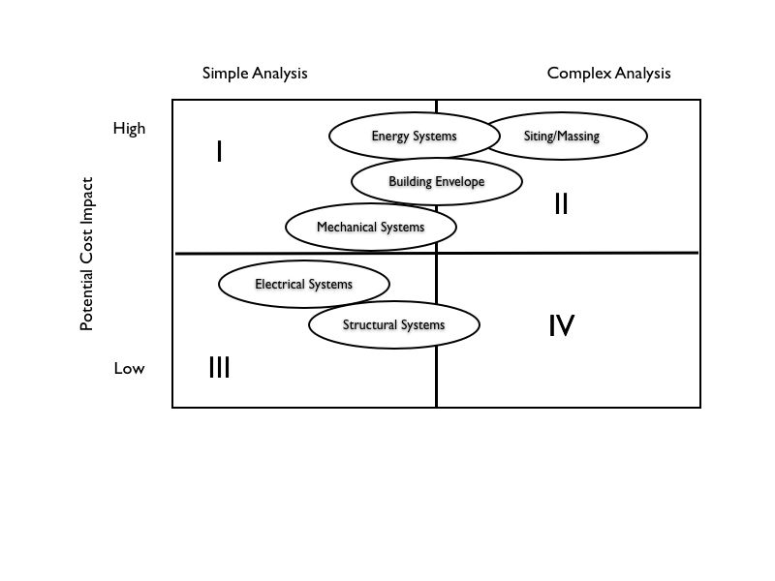

Figure 4.02 – Decision Matrix

- Budget for the use of LCCA (see Strategy 4).

- Prioritize LCCA implementation as part of overall transitional training and phasing efforts. Conducting LCCA workshops and several pilot analyses for new schools can illustrate the benefits and function of LCCA.

- Look to existing organizations that have incorporated LCCA into their building design process for advice. These organizations include the Los Angeles Unified School District, Stanford University, and the Alaska Department of Education and Early Development.

    - Strategy 4: Provide an add-on to fund capital projects to allow for integrated design and equipment upgrades

DOE Planning staff are currently considering a line item in the budget for sustainability to cover potential increases in design and construction costs. The overall amount should be equivalent to at least 2.5% of the CIP budget for new construction and major renovations. The benefit of this approach is that it allows flexibility in applying the funds, which in turn
allows the DOE to take advantage of project-specific opportunities.

An alternative is to allocate a 2.5% increase to each project itemized in the CIP budget.
Funding for a specific capital project budget should be tied to the following:

- Prioritization of technologies to meet a 30% reduction in operational expense.

- Participation in monitoring and reporting resource consumption and savings.

- Documented use of the LCCA analytical method in the design process.

- Documented use of LEED for Schools Rating System or other appropriate standard.

- Meeting minimum sustainable design requirements as set by the DOE.

Funding should be allocated for energy and daylight modeling as well as other analytical design practices. One means of linking the capital and operating budgets is to “borrow” money from the O&M budget. This shift in budgetary planning can be justified through operational savings shown through LCCA.

Additional special funds to incentivize innovation and/or efforts to achieve exemplary energy and water savings – beyond the 30% savings suggested in Strategy 1 – are not expected to come from the suggested 2.5% CIP overall budget increase. (Special Funds are addressed in Strategy 10.)

One aspect of capital projects funding in Hawaii is the delayed release of funds vs. spending deadlines and the impact of this delay on the amount of time actually allowed for design. With sustainable design, it is even more critical to allow for considered planning and analysis. It may be useful to hold an educational forum with high level budget planners to describe integrated design and the importance of having adequate time to implement it if economic and environmental benefits are to be truly attained.

    - Strategy 5: Modify consultant selection process to ensure expertise in sustainable design and construction

The primary means of ensuring teams selected to design and construct sustainable schools are capable of achieving the economic, occupant, and environmental benefits identified in this Study is to include consultant selection criteria that highlights relevant experience and technical capacity, and to include the capacity to evaluate said experience and capacity in the selection process. It is as important to have the ability to recognize the significance of experience and technical credentials when evaluating consultant applicants, as it is to set qualification requirements. Some actions to consider:

- Update the pre-qualifying roster, broadening access to firms that may not have previous experience with DOE facilities, but do have sustainable design, and in particular, LEED Rating System experience. Criteria should continue to include substantial school design experience.

- Develop a pre-qualifying roster for approved sustainable building consultants to supplement consultant teams or provide services directly to DOE.

- Add experience with sustainable design and LEED and/or other appropriate guidelines to the Selection Committee’s evaluation criteria. Consider adding LEED Accreditation on the design team to Selection Committee’s evaluation criteria for LEED projects. Person with LEED AP should be directly involved in design of project.

- Require demonstration of knowledge with regard to specific, prioritized sustainable design features. An example of this approach is used by the Poudre School District and adapted from the Naval Facilities Engineering Command Planning and Design Policy Statement -98-03. (Poudre School District Sustainable Design Guidelines Draft, 2005, 2-4.)

- For makeup of Selection Committee, include at least one member who is fully familiar with the LEED rating system and/or other school-specific guidelines that might be used.

- Specify in the Request For Qualifications that projects will be designed using an integrated design approach and meeting specific referenced standards. If LEED is specified, reference the LEED for Schools Rating System.

- Specify that major sub-consultants are experienced with, or trained in LEED or school-specific guidelines.

- Require that the pre-bid conference notifies contractors of sustainable building requirements and points out issues that may impact their scope of work.

4.2.6. Strategy 6: Modify facility planning process to ensure decision-making takes
sustainable design goals into account

Modifications to the facility planning that can improve the potential effectiveness of sustainable design have to do with when sustainability is introduced into the process and who is involved in decision-making. The key is to introduce sustainable design issues into the process as early as possible, and to ensure involvement of all those who can significantly impact implementation of the design and operation of the building as early as possible in the process.

Suggested actions include:

        - Conducting site assessments that reflect the overall goal to build a sustainable school. When conducting the site analysis for a new school or substantive addition, include a review of opportunities for energy savings, water savings, and best practices for site development. When a site affords a particular opportunity to save energy or water, addressing this opportunity in the design can be specified. For example, if a majority of irrigation needs can be satisfied with non-potable water available on site, designing an irrigation system that relies on the non-potable supply should be prioritized over one that uses the potable supply.

        - Specifying an integrated design process – one that is multi-disciplinary and uses a systems approach to facility design.

        - Incorporating sustainable design and construction goals in master planning charrette and project goal setting sessions.

        - Conducting project team design reviews to monitor progress in achieving sustainable design and construction goals and make course corrections to achieve the best results. LCCA should be integrated with reviews.

        - Ensuring O&M personnel and building users (administration and teaching faculty representatives) participate in project charrettes and/or goal setting sessions, important for successfully achieving life cycle benefits.

        - Encouraging the use of design-build alternative, as it ensures contractor participation in early planning charrettes and involvement throughout construction.

        - Investigating and establishing a pathway for “best value bids” to allow flexibility for sustainable projects.

        - Using the design process to educate the building user and community on the goals and benefits of a sustainable school.

Two resources that might be helpful include:

21st Century Schools Design Manual, New Jersey Schools Construction Corporation. 30 Sept 2004. Integrates LEED Standard into the state’s school design process. This and other resources are available at High Performance New Jersey, www.hpsnj.org.
Sustainable Design Guidelines for the construction of new facilities and the renovation of existing structures. Poudre School District. June 2000. (Note that the PSD is in the process of updating this document. Available at http://www.psd.k12.co.us/services/operations/sustainabledesign.aspx.

    - Strategy 7: Set minimum requirements for the design of new schools and major renovations

Specific sustainable design strategies should be required as a minimum when designing and building sustainable schools in Hawaii. Suggested design strategies include the prioritized strategies from Strategy 1, as well as additional techniques that, when combined, produce a school that addresses key issues of sustainable design. All of them are contained (and fully described) in the LEED Rating System and can contribute toward certification (see Strategy 8):

Top Priorities

- Daylight 75% of school and 100% of all classrooms.

- Optimize energy performance by 21% over ASHRAE/IESNA 90.1-2004 baseline (with a special focus on two priorities – energy efficient AC and electric lighting).

- Ensure fundamental commissioning of the building energy systems.

- Measure and verify (as defined by USGBC-LEED consistent with IPMVP Option D – Calibrated simulation savings estimation or Option B which measures savings from isolated systems).

- Prevent construction activity pollution.

- Eliminate use of CFC-refrigerants in new base building HVAC&R systems.

- Provide easily accessible recycling facilities for school occupants.

- Provide outdoor air delivery monitoring.

- Deliver increased ventilation, 30% better than ASHRAE 62.1-2004.

- Create and implement a Construction Indoor Air Quality Plan.

- Perform a one-time building flush out prior to occupancy.

- Incorporate low-emitting materials for adhesives and sealants, paints and coatings, carpet, and composite wood and agri-fiber.

- Design HVAC systems and building envelope to conform to ASHRAE Standard 55-2004 to improve thermal comfort or, for naturally ventilated spaces, comply with 90% acceptability limits of adaptive comfort temperature boundaries in CHPS Best Practices Manual.

- Provide a minimum acoustical performance. Using methods described in ANSI Standard S12.60-2002, achieve a maximum background noise level in classrooms and other primary learning spaces of 40 dBA.

- Create and implement a low impact cleaning and maintenance policy.

- Use 20% less water than a baseline calculated for the building after meeting the Energy Policy Act of 1992 fixture performance requirements.

- Reduce potable water consumption for irrigation by 50% from a calculated mid-summer baseline case.

Further, in planning a school’s design, it is important to employ the following principles:

- Fully understand the micro-climate and design to best respond to its conditions.

- Use analytical design tools to inform and refine the design right from the early stages.

- Prioritize the design and orientation of classroom spaces before other elements of the design program.

- Design first for natural light and ventilation; then design other systems to respond to those conditions.

- Never lose sight of the building as a system.

    - Strategy 8: Establish a clear LEED certification path for K-12 schools in Hawaii

Act 96 provides some flexibility in meeting the law by allowing multiple certification paths of varying rigor and accountability. A clear LEED certification path appropriate for K-12 schools will ease implementation. The U.S. Green Building Council approved the LEED for Schools Rating System in April 4, 2007. (It should be noted that the Hawaii High Performance Guidelines should be used to assist projects in attaining LEED EAc1 (Energy Optimization).)

Requiring LEED certification establishes a third-party verification process according to a set of pre-established standards. This type of verification makes the design team accountable to a set of auditable standards, and increases the likelihood that the State will reap a good return on its investment in sustainable design.
To achieve LEED certification at the Silver level in the LEED for Schools Rating System, 37 credits must be earned. The list of strategies suggested as a minimum for new schools and major renovations in Strategy 7 can contribute as many as 19 credits using LEED for Schools. Figure 7.03 provides a summary of the LEED credits that could be earned.
Note that strategies suggested by this Study as a minimum can contribute only up to 17 credits towards certification in LEED for New Construction (LEED NC). This is because LEED-NC does not include some school-specific credits. Because it has fewer credit opportunities, LEED-NC has slightly lower thresholds (e.g. 33 points for LEED Silver).

The use of LEED is quickly growing throughout the building industry. The strategies the LEED for Schools Rating System requires should be achievable by most K-12 projects. However, the accountability certification provides does come with a price. Although there is a fee for certification, the primary cost is due to additional time needed for documentation. Some projects may not lend themselves to full certification. Completing a LEED for Schools checklist should be a minimum requirement for all projects.

    - Strategy 9: Offer incentive programs to encourage innovation and exemplary implementation

Incentives to support exemplary projects and specific innovative technologies should be part of a transitional strategy. Incentives can include utility rebates, direct cash grants, awards, and technical assistance. Suggested actions include:

- Developing a system (and funding base) to award grants to schools that get certified, demonstrate innovative technologies, or achieve exemplary energy and water savings.

- Taking more advantage of utility demand-side management (DSM) rebates for energy efficiency. From 1999 to 2005, the DOE saved an aggregate of 11 million kWh from DSM lighting programs alone. Annual energy consumption is 146 million kWh. Since 1996, the DOE received $1,213,038 in utility rebates, mainly for facilities on Oahu.

- Partnering with local electrical utilities to create new incentive programs. Potential utility rebates for new programs could include renewable energy, commissioning and retrocommissioning, more emphasis on energy modeling, and/or certifying to LEED. If the latter is the case, the incentive could be based on a per square foot amount, based on the total square footage of the building being constructed.

- Partnering with AIA or other industry organizations to create and administer an award process for State facilities that use innovative technologies or exceed green building requirements, similar to the annual Green Business Award Program.

    - Strategy 10: Continue to provide training to enable successful implementation of green building requirements

Training has always been a strong component of the State’s energy efficiency program. Numerous training and educational opportunities have been organized or cosponsored by DBEDT to benefit state agency employees, the private sector and general public. In FY 1996 2006 alone, DBEDT sponsored or cosponsored more than 45 training and informational events which included participation by over 289 state employees. Many of these events included LEED training sessions. Additional training of DOE staff and of practitioners involved in designing and constructing schools is strongly recommended. Suggested actions include:

- Continue to conduct seminars to share information on the State’s new green building requirements and resulting modifications in the DOE facility planning, consultant selection, and other processes. This is best accomplished through partnerships with professional and trade organizations. Specific DOE requirements (such as several suggested by this Study) should be covered in the seminars.

- Continue to conduct LEED training and workshops, in particular those featuring the LEED for Schools Application Guide and practical applications of its principles. For local training opportunities, this is likely to require partnering with the local provisional chapter of the USGBC, ASHRAE, etc.

- Continue to conduct workshops on design strategies and technologies that have been shown by this Study to provide significant benefits in Hawaii – for example those recommended as pre-requisites for all new schools and major additions. These workshops should be technically oriented, and include case studies and lessons learned. Targeting the training to the separate interests and skills of DOE program managers, project managers, and design and construction practitioners would be ideal.

- Continue to partner with DBEDT and the private sector to conduct LEED exam study sessions to enable more DOE and other state staff to achieve LEED Accreditation and develop capacity to manage LEED projects.

    - Strategy 11: Consider a phased action plan to increase opportunity for success

Since Act 96 provides some flexibility in both the green building standards used and the extent they are applied to a given project, a phased action plan to implement sustainable building requirements is recommended. Phasing can allow time for making modifications to the DOE facility planning process, to allow training of DOE staff and industry practitioners in the new requirements, and to adjust budgets if needed. For the purposes of this report, a three-phase transitional period is recommended. The following phases are suggested:

- Phase 1: Modifications to DOE Process incorporating sustainable design and construction requirements and training of DOE staff and industry practitioners take place. Exceptions to the requirements (and the process for becoming an exception) are clearly defined.

- Phase 2: School design projects begin using LEED for Schools Rating System and the LEED for Schools checklist as a guideline for all projects. Although certification with the USGBC for these projects may not be required, at a minimum the LEED for Schools checklist should be required.

- Phase 3: All applicable projects must undergo a formal certification process. Projects must complete a formal process for exemption if they meet certain criteria.

- List of Figures

1.01. Standard DOE Elementary School Size (Square Feet)
1.02. Comparison of 30-Year Life Cycle Cost for the Base Case and Green Case
1.03. Annual Utility Expenses Base Case with AC
1.04. Annual Utility Expenses Green Case with AC
1.05. Comparison of 30-Year Life Cycle Cost for the Base Case and Green Case Non-Air-Conditioned Version
1.06. Annual Utility Expenses - Base Case without AC
1.07. Annual Utility Expense - Green Case without AC
1.08. List of Schools Participating in the On-Line Survey
1.09. Potential LEED Silver Score Card for a new DOE Elementary School
1.10. Energy Savings by Building Group Type
1.11. Comparison of Energy Savings Achieved by Architecture vs. Equipment

2.01. WIS Cafeteria on Opening Day, Summer 2006
2.02. North elevation of the WIS Cafeteria as seen from Farrington Highway
2.03. LEED Certified Score Card for WIS Cafeteria, Highlighted to Indicate Economic, Occupant, and Environmental Benefits
2.04. Comparison of 30-Year Life Cycle Cost for the WIS Cafeteria Base Case and As-Designed Green Case (Numbers are Rounded)
2.05. Annual Utility Expenses - Base Case
2.06. Annual Utility Expenses - Green Case

3.01. Campbell High School Classroom Building
3.02. Campbell High School, Building D
3.03. Comfort State of Occupants for Different PMV Levels
3.04. PMV Distribution
3.05. PMV Distribution
3.06. PMV Distribution
3.07. PMV Distribution
3.08. Individual Terminal Units
3.09. Concealed Indoor Fan Coil Unit
3.10. Outdoor Condensing Unit
3.11. Water-Cooled Centrifugal Chiller
3.12. Cooling Tower
3.13. Life Cycle Cost Analysis Results
3.14. Campbell High School Classroom Building

4.01. Summary of Suggested Implementation Strategies
4.02. Decision Matrix
4.03. LEED Credit Category

- List of References

Sick Building Syndrome:

Burge, P.S. “Sick Building Syndrome.” OEM Online. 2004. Accessed 17 Oct. 2006
http://oem.bmjjournals.com/cgi/content/full/61/2/185.

Chen, Qingyan. “Re: Natural Ventilation Studies.” E-mail to the author. 24 Oct. 2006.

Fisk, W. J., and O. Seppanen. “Association of Ventilation System Type with SBS Symptoms in Office Workers.” Indoor Air 12 (2002): 98-112.

Industry Standard for Cost of AE Sustainable Design Services:

“The Incremental Costs and Benefits of Green Schools in Massachusetts.” HMFH Architects, Inc. / Vermont Energy Investment Corp., 19 Dec. 2005. Accessed 18 Oct. 2006 http://www.mtpc.org/renewableenergy/green_schools/HMFHstudy121905.pdf.

Costs of Sustainable Design:

Kats, Greg et al. “The Costs and Financial Benefits of Green Buildings - a Report to California's Sustainable Building Task Force.” Capital E, Oct. 2003.
Accessed 18 Oct. 2006 http://www.usgbc.org/Docs/News/News477.pdf.

Matthiessen, Lisa F. and Peter Morris. “Costing Green: a Comprehensive Cost Database and Budgeting Methodology.” Davis Langdon, July 2004.
Accessed 18 Oct. 2006 http://www.davislangdon.com/pdf/USA/2004CostingGreen.pdf.

“The Incremental Costs and Benefits of Green Schools in Massachusetts.” HMFH Architects, Inc. / Vermont Energy Investment Corp., 19 Dec. 2005. Accessed 18 Oct. 2006 http://www.mtpc.org/renewableenergy/green_schools/HMFHstudy121905.pdf.

Daylighting and Reduction of Air-Conditioning Plant Size:

“Daylight Dividends Case Study: Smith Middle School Chapel Hill, N.C.” Rensselaer
Polytechnic Institute, 2004. http://www.lrc.rpi.edu/programs/daylightdividends/
pdf/SmithCaseStudyFinal.pdf.

Loftness, Vivian. “Improving Building Energy Efficiency in the US: Technologies and Policies for 2010 to 2050.” Prepared for PEW Center on Global Climate Change 2004. May 2004. Carnegie Mellon. United States House of Representatives. http://www.house.gov/science/hearings/energy04/may19/loftness.pdf.

Daylighting Benefits for Schools including Health, Performance, Reduced Absenteeism:

“A High Performance School.” Oregon Department of Energy. Accessed 18 Oct. 2006 http://www.oregon.gov/ENERGY/CONS/school/highperform.shtml.

“Daylighting Resources – Health.” Sponsored by California Energy Commission, Connecticut Light & Power, Efficiency Vermont, Lighting Research Center, North Carolina Daylighting Consortium, Northwest Energy Efficiency Alliance, NYSERDA, US Department of Energy. Lighting Research Center. Accessed 19 Oct. 2006 http://www.lrc.rpi.edu/programs/daylighting/dr_health.asp.

Kellum, Shana and Stephen L. Olson. “The Impact of Sustainable Buildings on Educational Achievements in K-12 Schools.” Wisconsin: Leonardo Academy Inc., 25 Nov. 2003.
Cleaner and Greener. http://www.cleanerandgreener.org/download/
sustainableschools.pdf#search='environmental%20impact%20toxins%20in%20school.

Cost of LEED Certification:

“LEED for New Construction.” USGBC. Accessed 19 Oct. 2006
http://www.usgbc.org/DisplayPage.aspx?CMSPageID=220.

Northbridge Environmental Management Consultants (prepared for The American Chemistry
Council). “Analyzing the Cost of Obtaining LEED Certification.” Northbridge Environmental Management Consultants, Westford. 16 Apr. 2003. http://www.greenbuildingsolutions.org/s_greenbuilding/docs/800/776.pdf.

Reed, William. “The Cost of LEED Green Buildings.” Natural Logic. Jan. 2003.
http://www.natlogic.com/Articles/BillReed_CostOfGreen.pdf#search='Natural%
20Logic%3A%20The%20Cost%20of%20LEED%20Green%20Buildings'.

Other References:

“The Costs and Financial Benefits of Green Buildings – A Report to California’s Sustainable Building Task Force.” October 2003. Greg Kats, Capital E.

“Information on: The Costs of Green Buildings & A List of LEED Projects.” University of Hawaii, Center for Smart Building and Community Design. 14 February 2005.

“Life Cycle Cost Calculations.” An Undated Flyer published by the State of Hawaii, Department of Business, Economic Development & Tourism.

“Commissioning For Schools.” An Undated Flyer published by the State of Hawaii, Department of Business, Economic Development & Tourism.

“High Performance Hawaii Classroom Prototypes.” An Undated Pamphlet prepared for the State of Hawaii, Department of Business, Economic Development & Tourism by Architectural Energy Corporation.

“Energy Design Guidelines for High Performance Schools.” June 2002. Prepared for the US Department of Energy, Office of Building Technology, State and Community Programs by the National Renewable Energy Laboratory.

“Hawaii Schools: Recommendations for Energy Efficiency and Sustainable School Design and Retrofit.” October 30, 2003. Prepared by Eley Associates for the Hawaii Department of Business, Economic Development & Tourism (DBEDT), Hawaii Department of Education (DOE), and Hawaii Department of Administrative and General Services (DAGS).

“Hawaii High Performance School Guidelines.” March 31, 2005. Prepared for Department of Business, Economic Development & Tourism (DBEDT) by Architectural Energy Corporation.

“High Performance Schools New Jersey.” www.hpsnj.org. Accessed 25 July 2006.

“U.S. Green Building Council, LEED Initiatives in Government and Schools.” www.usgbc.org. Accessed 1 June 2006.

Personal Communications:

Bohi, Barbara. New Jersey Schools Construction Corporation. Personal Communication. 2 Jul. 2006.
Brownlee, Catherine. Pennsylvania State Governor’s Green Government Council. Personal Communication, 1 Aug. 2006.
Clanton, Nancy. Clanton Associates. Personal Communication.
Eley, Charles. Architectural Energy. Personal Communication. 27 Jul. 2006.
Evans, Dean. New Jersey Institute of Technology. Personal Communication.
Franta, Greg, RMI/ENSAR. Personal Communication.
Kaneshiro, Charles. Group 70. Personal Communication. 26 Jul. 2006.
Larson-Vaughan, Ellen. Sustainable Building Industries Council. Personal Communication. 7 Aug. 2006.
Lintz, Gary. Snohomish County PUD. Personal Communication. 3 Nov. 2006.
Lowrey, Brenda. Department of Education, Planning. Personal Communications. 5 May 2006 and 25 Jun. 2006.
Masai, Dean. Department of Business, Economic Development & Tourism, Strategic Industries Division. Personal Communication. 31 Jul. 2006.
Nichols, Nick. Department of Education, Planning. Personal Communications. 5, May 2006 and 25 Jun. 2006.
Olgyay, Victor. RMI/ENSAR. Personal Communication.
Spearnik, Michael. Poudre School District. Personal Communication. 9 Jun. 2006.
Suzuki-Jones, Gail. Department of Business, Economic Development & Tourism, Strategic Industries Division. Personal Communication. 31 Jul. 2006.

- Appendix

  - Sustainable Schools On-Line Surveys

1. Baca/Dlo'ay azhi Community School

Location: Prewitt, NM
School Type: K – 6th grade
Project Type: New Construction
Setting: Rural
School Size (SF): 78,900 sf
Campus Size: NA
Enrollment: 390
Faculty/Staff: NA
Cost of Construction: $12.5 million
Year Completed: 2003
Sustainable Rating: LEED NC v2.1 Certified
Energy Star Score: NA

2. Benjamin Franklin Elementary

Location: Kirkland, WA
School Type: Elementary
Project Type: New Construction
Setting: Suburban
School Size (SF): 56,792 sf
Campus Size: 8 Acres
Enrollment: 450
Faculty/Staff: 33
Cost of Construction: $9.6 million
Year Completed: 2005
Sustainable Rating: 2006 AIA Top 10 Green Buildings
Washington State Sustainable School (52 pts.)
Energy Star Score: NA

3. Durant Road Middle School

Location: Raleigh, NC
School Type: Middle
Project Type: New Construction
Setting: Suburban
School Size (SF): 149,250 sf
Campus Size: 25 Acres
Enrollment: 1,300
Faculty/Staff: NA
Cost of Construction: $12.3 million
Year Completed: 1995
Sustainable Rating: No
Energy Star Score: No

4. Fossil Ridge High School

Location: Ft. Collins, CO
School Type: High School
Project Type: New Construction
Setting: Suburban
School Size (SF): 269,375 sf
Campus Size: NA
Enrollment: 1,800
Faculty/Staff: 131
Cost of Construction: $36 million
Year Completed: 2004
Sustainable Rating: LEED NC v2.1 Silver
Energy Star Score: Yes, current score is 81

5. Hawaii Baptist Academy

Location: Honolulu, HI
School Type: Middle
Project Type: New Construction
Setting: Suburban
School Size (SF): 28,000 sf
Campus Size: 4.71 Acres
Enrollment: 230
Faculty/Staff: 18
Cost of Construction: $9.5 million
Year Completed: 2006
Sustainable Rating: Targeting LEED NC v2.1 Gold
Energy Star Score: No

6. Iolani High School Classroom Addition

Location: Honolulu, HI
School Type: High School
Project Type: New Construction
Setting: Urban
School Size (SF): 250,000 sf
Campus Size: 25 Acres
Enrollment: 1,000
Faculty/Staff: 40 (new classroom bldg. only)
Cost of Construction: $25 million
Year Completed: 2003
Sustainable Rating: HECO energy efficiency award
Energy Star Score: No

7. Knapp Forest Elementary

Location: Ada, MI
School Type: Elementary
Project Type: New Construction
Setting: Suburban
School Size (SF): 96,654 sf
Campus Size: 11 Acres
Enrollment: 696
Faculty/Staff: 74
Cost of Construction: $17 million
Year Completed: 2004
Sustainable Rating: LEED NC v2.1 Certified
Energy Star Score: No

8. Case Middle School (Punahou School)

Location: Honolulu, HI
School Type: Middle
Project Type: New Construction
Setting: Urban
School Size (SF): 156,000 sf
Campus Size: 4.25 Acres
Enrollment: 1,012
Faculty/Staff: 56
Cost of Construction: $57.8 million
Year Completed: 2004
Sustainable Rating: LEED NC v2.1 Gold
Energy Star Score: NA

9. Third Creek Elementary

Location: Statesville, NC
School Type: Elementary
Project Type: New Construction
Setting: Suburban
School Size (SF): 92,000 sf
Campus Size: 74 Acres
Enrollment: 800
Faculty/Staff: 55
Cost of Construction: $10.1 million (excludes land)
Year Completed: 2002
Sustainable Rating: LEED NC v2 Gold
Energy Star Score: No

10. Willow School Phase 1

Location: Gladstone, NJ
School Type: K – 8th Grade
Project Type: New Construction
Setting: Rural
School Size (SF): 15,000 sf
Campus Size: 34 Acres
Enrollment: 80 this year, 216 when complete
Faculty/Staff: 15 this year, 30 when complete
Cost of Construction: $4.5 million
Year Completed: 2003
Sustainable Rating: LEED NC v2 Gold
Energy Star Score: No

11. Wilson High School

Location: Tacoma, WA
School Type: High School
Project Type: New Construction
Setting: Urban
School Size (SF): 97,700 sf
Campus Size: 41.4 Acres
Enrollment: 1,800
Faculty/Staff: 131
Cost of Construction: $19.2 million
Year Completed: 2006
Sustainable Rating: NA
Energy Star Score: NA

12. Alder Creek Middle School

Location: Truckee, CA
School Type: Middle School
Project Type: New Construction
Setting: Rural
School Size (SF): 87,000 sf
Campus Size: 28 Acres
Enrollment: 1,000
Faculty/Staff: 38
Cost of Construction: $24.0 million (included site development)
Year Completed: 2004
Sustainable Rating: CHPS Certified
Energy Star Score: NA

  - LCCA – Elementary School (Air-Conditioned)

LCCA Section: Page:

Outputs (Present Values) 123

Full School Inputs 124

Inputs – Group 1 (Standard Classrooms) 125
Inputs – Group 2 (Admin/Faculty/Special Classrooms) 126
Inputs – Group 3 (Library/Media Center/Computer Resource) 127
Inputs – Group 4 (Cafetorium/Multi-Purpose) 128
Inputs – Group 5 (Conventional Kitchen, Custodial Center) 129
Inputs – Totals Site and Buildings 130

Assumptions 131

Resource Use 132

Derivation of Resource Use 133

Life Cycle Calculations 134

Present Value Calculations 136

Methodology/Justification/Citation 137

  - LCCA – Elementary School (Non-Air-Conditioned)

LCCA Section: Page:

Outputs (Present Values) 143

Full School Inputs 144

Inputs – Group 1 (Standard Classrooms) 145
Inputs – Group 2 (Admin/Faculty/Special Classrooms) 146
Inputs – Group 3 (Library/Media Center/Computer Resource) 147
Inputs – Group 4 (Cafetorium/Multi-Purpose) 148
Inputs – Group 5 (Conventional Kitchen, Custodial Center) 149
Inputs – Totals Site and Buildings 150

Assumptions 151

Resource Use 152

Derivation of Resource Use 153

Life Cycle Calculations 154

Present Value Calculations 156

Methodology/Justification/Citation 157

  - LCCA – Waipahu Intermediate School (WIS) Cafeteria

LCCA Section: Page:

Outputs (Present Values) 163

Full School Inputs 164

*Inputs – Group 1 (Standard Classrooms) - NA 165
*Inputs – Group 2 (Admin/Faculty/Special Classrooms) - NA 166
*Inputs – Group 3 (Library/Media Center/Computer Resource) - NA 167
Inputs – Group 4 (Cafetorium/Multi-Purpose) 168
Inputs – Group 5 (Conventional Kitchen, Custodial Center) 169
Inputs – Totals Site and Buildings 170

Assumptions 171

Resource Use 172

Derivation of Resource Use 173

Life Cycle Calculations 174

Present Value Calculations 176

Methodology/Justification/Citation 177

*Note: The LCCA format used for the WIS Cafeteria analysis is the same as developed for the elementary school (Appendix Sections 7.2. and 7.3.). Thus, the three input categories noted above do not apply and are indicated as “Not Applicable” (NA).

  - DOE Classroom Retrofit Energy Consumption Results

Air-Conditioning Option: Page:

Alternative 1: Individual DX 183

Alternative 2: Variable Refrigerant 184

Alternative 3: Chilled Water 185

Leadership Entities are those that are significantly impacted by the suggested strategy and therefore should play a major role in determining if, when, and how it should be approached.

