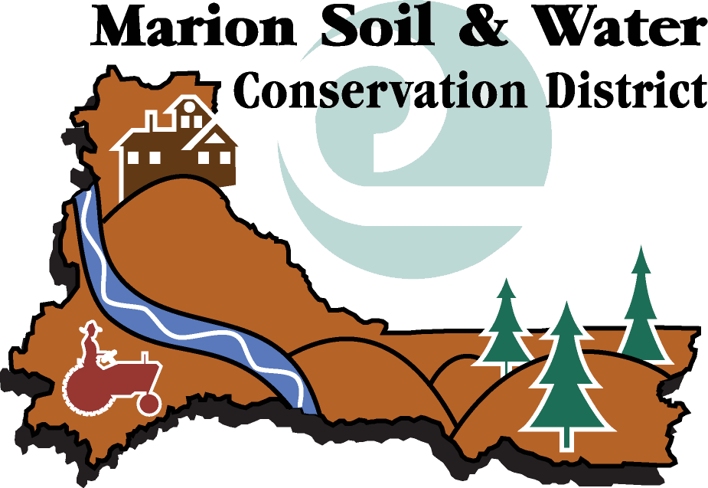
3867 Wolverine St. NE #16 – Salem, OR 97305 – Phone 503-391-9927 – FAX 503-399-5799

RELEASE FORM

PLEASE READ CAREFULLY

In exchange for the consideration of my job application by the Marion Soil and Water Conservation District (SWCD), I agree that:

If I become employed by Marion SWCD, my employment will be “at-will.” This means that either Marion SWCD or I may terminate my employment with or without cause and with or without notice. Any employment I may be offered will be at-will regardless of the contents of employee handbooks, personnel manuals, benefit plans, policy statements, or other Marion SWCD practices. The at-will nature of any employment I may be offered cannot be altered except by a written instrument signed by the Chair of the Marion SWCD. If employed, I understand that the Marion SWCD may unilaterally change or revise their benefits, policies and procedures and such changes may include reduction in benefits.

I authorize investigation of all statements contained in the PD100 application and related materials. I understand that the misrepresentation or omission of facts called for is cause for rejection of my application or dismissal from employment at any time without any previous notice. I hereby give the Marion SWCD permission to review public records regarding my personal and professional background, and to contact schools, previous employers, references, and others, and hereby release the Marion SWCD from any liability as a result of such contacts. I agree immediately to notify the Marion SWCD if I should be convicted of a crime while my job application is pending, or during my period of employment, if hired.

I further understand that, if selected as a finalist, I may be required to take and pass a drug and alcohol test prior to appointment to this position. Please fill in all information below as it is required in order to conduct a background check.

Printed Name

Signature

Date Signed

The Marion Soil and Water Conservation District is an equal employment opportunity employer. We adhere to a policy of making employment decisions without regard to race, color, religion, sex, sexual orientation, political beliefs, national origin, citizenship, age, disability, or any other status protected by law.

Thank you for completing this release form and for your interest in our organization.

