IV. What kinds of collaboration between the BLM and FS (and sometimes other natural resource agencies) are going on around the country?

The short answer is, a lot! In 1996, when Service First was formally getting started (it was then called The Trading Post), there were just 15 projects underway in a small number of states. By 2001, Service First had mushroomed to over 270 projects in 14 states.



Some BLM and FS offices are

- sharing staff
- sharing equipment/space
- conducting training programs for both agencies’ staff together
- giving supervisors dual delegation of authority, to supervise staff from both agencies, and make decisions regarding both agencies and their lands
- integrating their operations
In some field units, the two agencies collaborate across agency boundaries on certain natural resource services and programs:

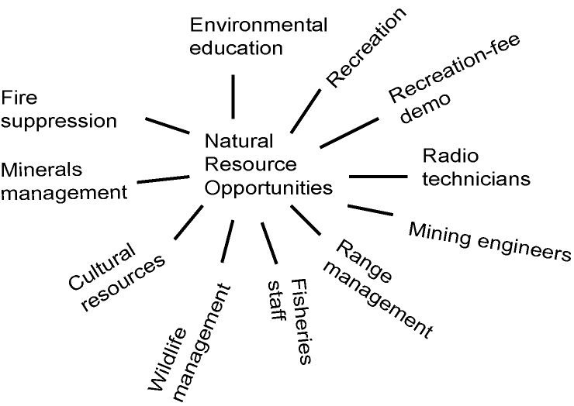

They also collaborate on a number of admin functions:

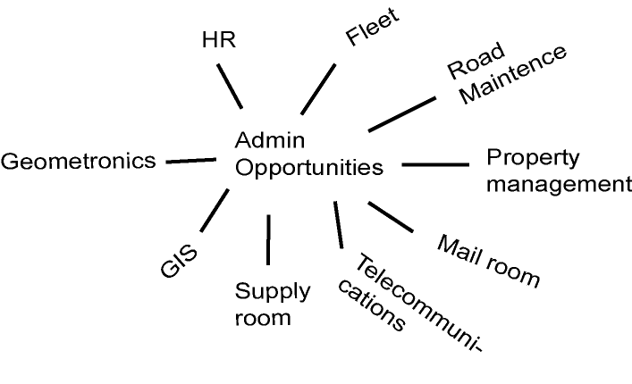
And many have a shared front desk, where staff members from either agency help visitors with all of their needs.

