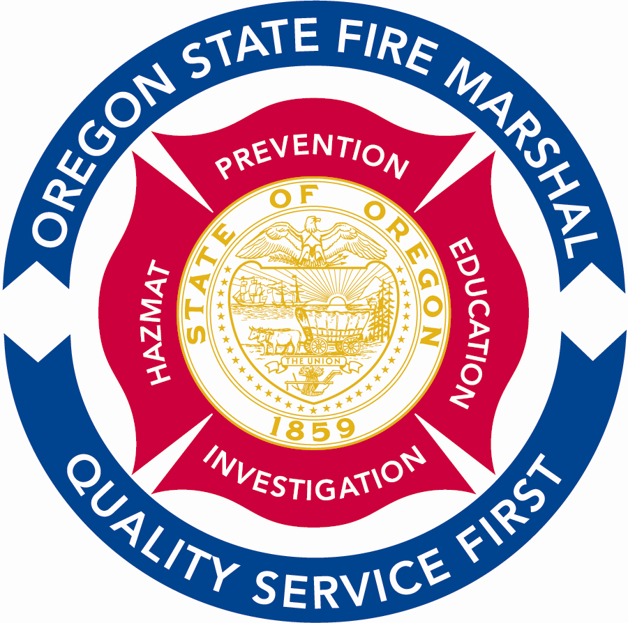
Office of Homeland Security

Office of State Fire Marshal
4760 Portland Road NE
Salem, OR 97305-1760
(503) 378-3473
Fax (503) 373-1825 fax
TTY (503) 390-4661
E-mail: Oregon.sfm@state.or.us
www.sfm.state.or.us
OREGON
Theodore R. Kulongoski, Governor

May 23, 2006

For Immediate Release
Contact: Tim Birr (503) 866-8151
Donna Disch (503) 373-1540, ext.275 (503) 945-0329, pager
Capt. Joe Hyatt, Fire Marshal Rural/Metro Fire Department (541) 474-1218

Grants Pass fatal fire highlights fire-safer cigarette issue

A fatal home fire in Grants Pass early Monday morning followed, by three days, the adoption of a law in Illinois designed to prevent such events.

A Grants Pass woman died early Monday morning after firefighters responded to a fire causing estimated $75,000 damage. As of late Monday, no name has been released. Fire investigators believe the fire was started by a cigarette in the home's master bedroom.

On Friday, Illinois Governor Rod Blagojevich signed into law a bill making Illinois the fourth state to adopt fire safety standards for cigarettes. The law adopted in Illinois mirrors legislation previously adopted by the states of New York, Vermont, and California; as well as the entire nation of Canada. All of these laws are based on a uniform standard for cigarette fire safety developed by the federal government in the mid-1980s.

This same legislation was proposed in the 2005 Oregon Legislature. The state senate passed the measure, but it was not heard in the house. Since the start of the 2005 Legislature, fatal fires confirmed or suspected of having cigarette origins have occurred in Lakeside, Pendleton, Ontario, Portland, and Beaverton. In addition, cigarette-caused fires have caused critical injuries in Beaverton and Eugene. Most recently, a cigarette caused fire on May 13 resulted in $70,000 damage to the Everett Hotel in Portland.

The Oregon Fire Safety Coalition currently represents nearly 20 fire service associations, state agencies, and public health non-profits supporting cigarette fire safety legislation in the 2007 Oregon Legislature.
For more information on the fire-safe cigarette issue, visit the National Fire Protection Association's advocacy web site at www.firesafecigarettes.org.
###

