


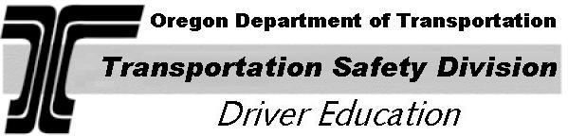
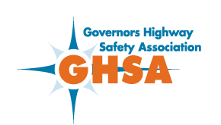



OREGON DRIVER EXCELLENCE SCHOLARSHIP APPLICATION
October 18 - 19, 2008
High School:
School Address: |  | Street:
 |  | City: |  |  |  |  |  |  |  |  |  |  |  | Zip:
Phone: |  |  |  |  |  |  | E-Mail Address:
ODOT-TSD
Approved Provider:
Provider Address: |  | Street:
 |  | City: |  |  |  |  |  |  |  |  |  |  |  | Zip:
Phone: |  |  |  |  |  |  | E-Mail Address:
PARTICIPANT INFORMATION:
Name:
License Number: |  |  |  |  |  |  |  |  |  | Date of Birth:
Have you had any moving violations or accidents in the last three years? |  |  |  |  |  |  |  |  |  |  | yes no
Grade point average for last grading period:
Participation Location: |  | Linn-Benton CC, Albany Redmond HS, Redmond
Home Address: |  | Street:
 |  | City: |  |  |  |  |  |  |  |  |  |  |  | Zip:
Phone: |  |  |  |  |  |  | E-Mail Address:
Name of parent or guardian:
Parent/Guardian Signature:

Please return this form to: John L. Harvey, Program Manager
ODOT - Transportation Safety Division
Driver Education Program
235 Union Street NE
Salem, OR 97301-1054 Phone: 503 986-4413 FAX: 503 986-3143

