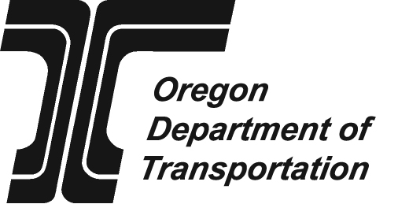 | Driver education Program Assurance  Due date: October 15
 |  | For school year |  | to
 |  |  | mm/dd/yyyy |  | mm/dd/yyyy
School information
Name of school district, high school, esd, other |  | DE Coordinator name
address | County | Phone | Fax
City, state, zip |  | e-mail
Does your school district provide a driver education program? Yes No
Does your school district contract out for driver education? Yes No
If yes, complete the following:
Driver education contractor information
Name of contractor providing driver education | contact person name
address | Phone | Fax
City, state, zip | e-mail
Complete the certification below and return this form to the ODOT Transportation Safety Division.
Oregon Administrative Rules (OAR) for Traffic Safety Education, Division 15:
737-015-0010 Purpose
737-015-0020 Definitions
737-015-0030 Curriculum Requirements
737-015-0050 Instructional Materials and Equipment
737-015-0060 Use of Driving Simulators
737-015-0070 Qualifications of an approved ODOT-TSD Traffic Safety Education Instructor
737-015-0090 Recordkeeping
737-015-0100 Reimbursement for Traffic Safety Education courses
737-015-0110 Audits and Investigation
Full text of these rules available online at www.sos.state.or.us/archives/rules/OARS_700/OAR_737/737_tofc.html
Certification
I certify that |  |  | is in compliance with and implementing as required all of the
 | name of school or district
Standards for Traffic Safety Education as set out in OAR Chapter 737, Division 15. Any Division 15 standards with which the school or district does not comply are noted below and explained in attachments to this form,
LIST any OAR(s) to which the school or district is not in compliance and attach explanatory documents

Signature of driver education Coordinator  X |  | Print name |  | date

Send completed and signed form to:
ODOT Transportation Safety Division
Driver Education Program
235 Union St. SE
Salem OR 97301-1054
Driver Education Program contact information:
Phone: (503) 986-4291
Fax: (503) 986-3143
E-mail: Shari.C.DAVIS@ODOT.state.or.us
Web: www.oregon.gov/ODOT/TS/drivers_ed.shtml

