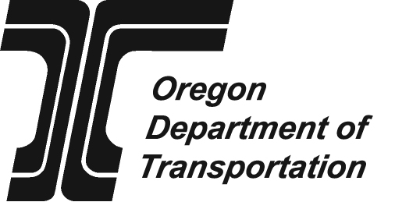 | Application for Reimbursement for  Driver education Program  Due date: Aug. 1
 |  | For school year |  | to
 |  |  | mm/dd/yyyy |  | mm/dd/yyyy
School information
Name of school district, high school, esd, other |  | DE Coordinator name
address | County | Phone | Fax
City, state, zip |  | e-mail
Driver education contractor information (if applicable)
Name of contractor providing driver education | contact person name
address | Phone | Fax
City, state, zip | e-mail
Instructions: Submit the completed, signed original of this application to the Transportation Safety Division of the Oregon Department of Transportation. This form must be completed fully* and accurately** to ensure correct reimbursement and continued eligibility for reimbursement. Submission deadline is Aug. 1.
1. Total number of driver-education students completing a minimum of 30 hours of classroom instruction,
6 hours of practice driving and 6 hours of behind-the-wheel observation by June 30
2. Teacher salaries chargeable to driver education (prorated from total salaries)
a. Portion of salary chargeable to classroom phase
b. Portion of salary chargeable to behind-the-wheel phase
c. Portion of salary chargeable to administration of program
3. Vehicle expenses
a. Lease or rental costs of training car(s) (Number of cars: )
b. If public-provider owned, depreciated cost of car(s) purchased
4. Insurance cost of training car(s) (Number of cars: )
5. Operating expenses for car(s), i.e., gas, oil, repairs, etc. (Include instructional expenses only)
6. Cost of instructional materials
7. Non-salary administrative costs, i.e., advertising, memberships, building rental, etc.
8. Total driver education cost (sum of Lines 2 through 7) | $ 0.00
9. Total driver education tuition collected and retained: fees at $0.00 each | $ 0.00
10. Total driver education cost less tuition (Line 8 minus Line 9) | $ 0.00
11. Average driver education cost per pupil (Line 10 divided by Line 1) | $ 0.00
Certification
I certify by my signature below that the above information is true and correct; that any driver-education fees that have been collected and retained are reported on Line 9; that no part of this claim has heretofore been paid; that a list of students instructed by this program has been sent electronically to the Oregon Department of Transportation and a copy has been retained for the public provider files, along with such other information as is necessary to substantiate the cost items listed above; that the public providers program complies with all applicable requirements of ORS 336.790 to 336.815 and OAR 737-015; and that the required instructor report forms have been submitted during the current school year prior to submission of this application.
Signature of driver education authorizing official  X | Print name | date

Send completed and signed form to:
ODOT Transportation Safety Division
Driver Education Program
235 Union St. SE
Salem OR 97301-1054
* If the district employs a contractor to provide driver education services, obtain information from contractor before submitting the application.
** Make corrections to any information on this form by noting, initialing, and resubmitting.
Driver Education Program contact information:
Phone: (503) 986-4291
Fax: (503) 986-3143
E-mail: Shari.C.DAVIS@ODOT.state.or.us
Web: www.oregon.gov/ODOT/TS/drivers_ed.shtml
Office Use Only
reimbursement AMT  $ | Approved by | Date

