
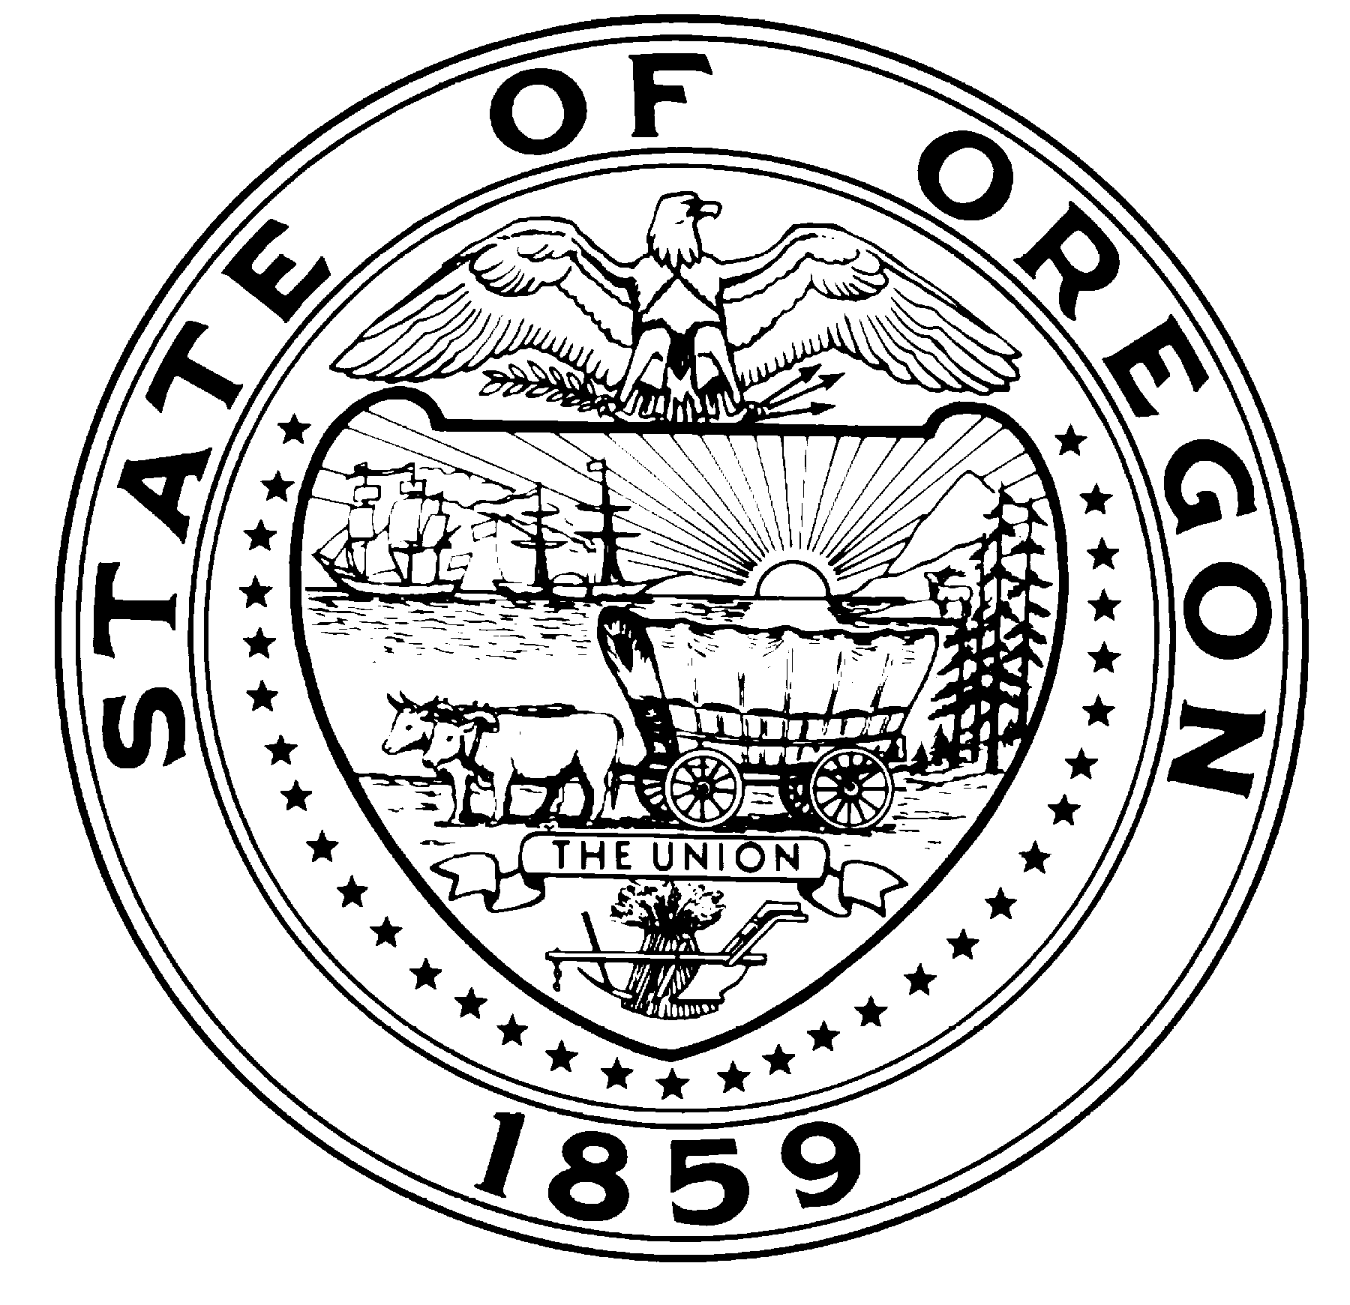
Theodore R. Kulongoski, Governor

State Library
250 Winter St. NE
Salem, OR 97301-3950
(503) 378-4243
FAX (503) 588-7119
TTY (503) 378-4334

CONTACT: Jim Scheppke Oregon State Librarian
(503) 378-4243
February 28, 2008

FOR IMMEDIATE RELEASE

The Executive Committee of the Oregon State Library Board of Trustees will meet by phone on
Thursday, March 13, 2008. Doug Henrichs of Milton-Freewater will chair the meeting, which will begin at 4:00 p. m.

Members of the public who wish to attend the meeting may come to Room 205 of the State Library where a conference phone will be provided.

Sign language interpretation will be provided for the public if requested prior to 48 hours before the meeting; notice prior to 72 hours before the meeting is preferred. Handouts of meeting materials may also be requested in alternate formats prior to 72 hours before the meeting. Requests may be made to Robin Speer at 503-378-2464.

-30-

OREGON STATE LIBRARY BOARD OF TRUSTEES
EXECUTIVE COMMITTEE MEETING
March 13, 2008
Room 205, State Library
Doug Henrichs, Chair

Agenda

4:00 p. m. Report of the State Librarian Scheppke

4:30 Set Agenda for April 11, 2008, Board Meeting Henrichs

4:45 Questions of Executive Committee Members Henrichs

5:00 Adjournment Henrichs

NOTE: The times of all agenda items are approximate and subject to change.

