OMB Control Number 1205-0420

Expiration Date 02/28/2009

Workforce Investment Act Quarterly Report:
General Reporting Instructions and ETA Form 9090
Revised 2006

Prepared By
Office of Performance and Technology
Employment and Training Administration

This reporting requirement is approved under the Paperwork Reduction Act of 1995, OMB Control No. 1205-0420, expiring 02/28/2009. Persons are not required to respond to this collection of information unless it displays a currently valid OMB number. Public reporting burden for this collection of information is estimated to average 160 hours per quarterly report per state, including time for reviewing instructions, searching existing data sources, gathering and reviewing the collection of information. Respondent’s obligation to reply is mandatory. The reason for the collection of information is general program oversight, evaluation and performance assessment. Send comments regarding this burden estimate or any other aspect of this collection, including suggestions for reducing this burden, to the U. S. Department of Labor, Employment and Training Administration, Office of Performance and Technology, 200 Constitution Avenue, NW, Room S-5206, Washington, D.C. 20210 (Paperwork Reduction Project 1205-0420).

GENERAL INSTRUCTIONS

Each state must submit an ETA Form 9090 (WIA Quarterly Report) to provide DOL with the most recent performance information available. The aggregate performance data contained in this WIA Quarterly Report are used to determine the levels of participation and program accomplishments for the most recent quarter and four-quarter period. This rolling four-quarter data collection methodology provides ETA and the grantees with greater flexibility in discussing annual performance results according to any four-quarter reporting period (e.g., Calendar Year, Program Year, and Federal Fiscal Year). Reports must include a “snapshot” of the most recent performance data available for each performance item included on the WIA Quarterly Report for the current quarter, and then a cumulative total that includes the current quarter and the last three quarters prior to the current quarter.

To allow for the data collection delays inherent in many of the performance measures, particularly those that utilize UI wage records, the WIA Quarterly Report collects information on each performance item depending on when outcome data become available. For instance, because the total count of participants is available without any delay, grantees will be able to report this performance information through the end of the most recent reporting quarter. Alternatively, measures that make use of wage records, such as the adult entered employment rate or youth placement in employment or education, will use exit cohorts from the third complete quarter prior to the reporting quarter. This situation exists because relatively complete wage records for any quarter are not available for up to another two quarters afterward. In this case, the reporting schedule allows states six and one-half months to process wage record reports from employers, merge the wage data with participant files, and generate the WIA Quarterly Report.

COVERED PROGRAMS

The WIA Quarterly Report will cover participants who receive services financially assisted by formula or statewide reserve funds under the following ETA programs:

- WIA Adult Program
- WIA Dislocated Worker Program (including dislocated workers participating in programs funded under WIA section 134(a)(2)(A)(ii) – rapid response additional assistance)
- WIA Youth Program
- National Emergency Grants (except HCTC grants)

Except for Health Care Tax Credit (HCTC) grants, performance information about all participants who receive services financially assisted by National Emergency Grants (NEGs), whether co-enrolled in the WIA Title IB programs or served exclusively with NEG funds, will be included. In addition, WIA statewide activities that are included in the Quarterly Report are those statewide activities that involve the enrollment of individuals eligible to receive WIA Title I-B services (e.g., adult, dislocated worker, or youth). Conversely, if state or local activities do not involve the enrollment of individuals to receive services, performance information is not included in the WIA Quarterly Report.
Examples of such exceptions include activities where (a) the state is conducting a statewide activity that does not involve direct services (e.g., research or evaluation), or (b) the statewide activity is structured to provide services that are highly specialized, such as in a pilot or demonstration activity (e.g., incumbent worker training, project for chemically dependent TANF recipients).

QUARTERLY REPORT SPECIFICATIONS

The Quarterly Report reflects performance outcome information that becomes available by the time the Quarterly Report is due to ETA. Appendix A outlines the applicable four quarter reporting periods that states should use when preparing performance information for the WIA Quarterly Report.

The reporting format for the WIA Quarterly Report can be found under Appendix B. In addition to the value of each performance item, the state must report both the numerator and denominator for the current quarter and cumulative totals for the four quarter reporting period. This detail is needed so that the information can be aggregated over states to provide national estimates. Reporting specifications for preparing all calculations of numerators and denominators that support the performance measurement values can be found under Appendix C.

DUE DATE

The report is due no later than 45 days after the end of each report quarter. The table below shows the expected due dates for each reporting quarter.

Report Quarter | Due Dates
January – March | May 15th
April – June | August 14th
July – September | November 14th
October – December | February 14th

Should the due date of the report fall on a Saturday or Sunday, the quarterly report is due the Friday before.

SUBMISSION PROCEDURES

Information contained on the WIA Quarterly Report must be submitted directly to ETA’s Enterprise Business Support System (EBSS) (formerly called the Enterprise Information Management System (EIMS)) via technical instructions available through the appropriate Regional Office or the ETA performance website (www.doleta.gov/performance).

APPENDIX A

Time Periods for Reporting Performance Information on the

WIA Quarterly Report

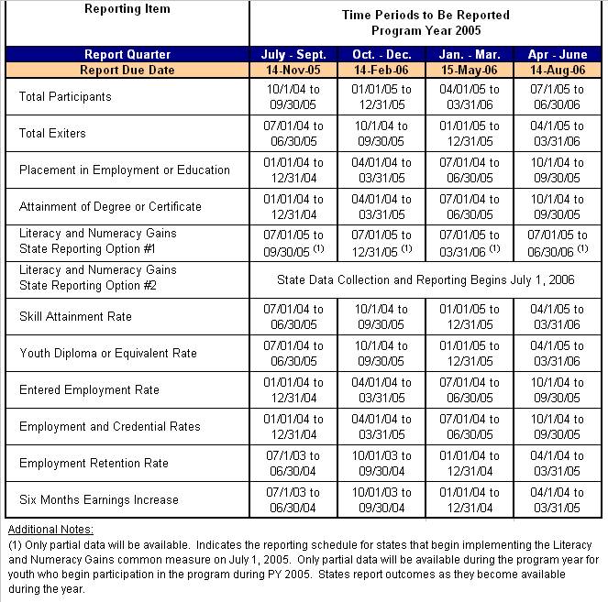

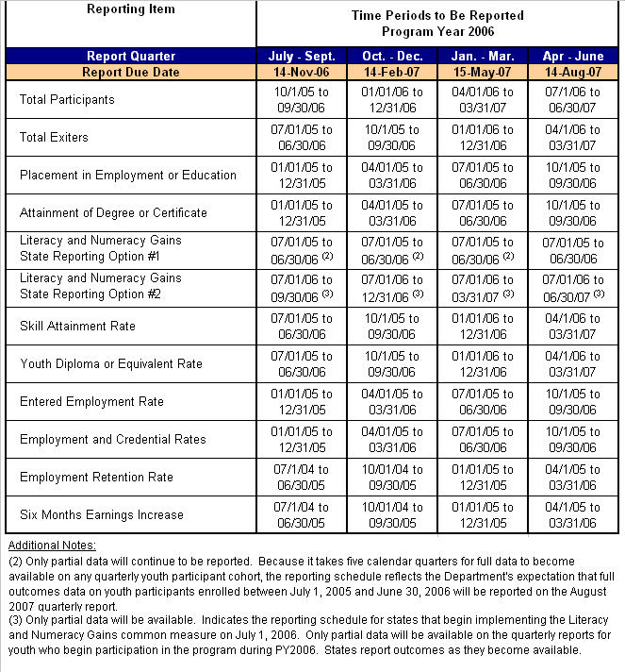



APPENDIX B
WIA Quarterly Report Format (ETA Form 9090)

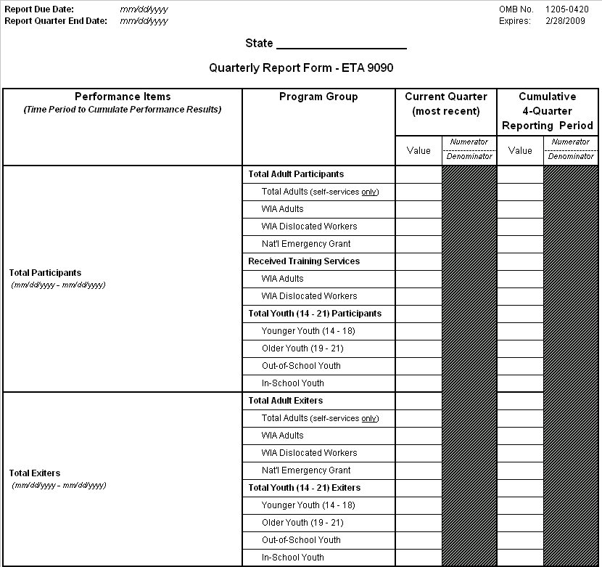
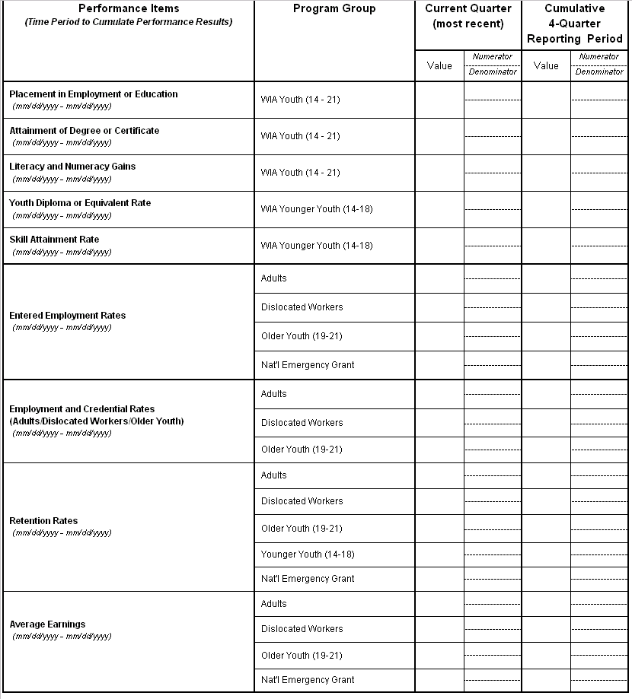
APPENDIX C
Reporting Specifications for WIA Quarterly Report

Use the following specifications to complete the performance calculations for each measure identified on the WIA Quarterly Report. The chart below provides an explanation of how program participants are classified as adults, dislocated workers, and youth for the purposes of calculating program performance. These classifications are based upon one or more data elements contained within the WIASRD. In order for a participant to be included in a particular program performance group, at least one of the corresponding conditions in “Specifications” column needs to be true. For instance, as shown in the row labeled “Adult,” if either Adult (Local Formula) (WIASRD Element 304) = 1 or Adult (Statewide 15% Activities) (WIASRD Element 310) = 1, the participant is included in the WIA Adult performance measures.

WIA Performance Group Specifications
Program | Specifications
Self-Service Only | RECEIVED CORE SELF-SERVICES AND INFORMATIONAL ACTIVITIES = 1 and DATE OF FIRST STAFF-ASSISTED CORE SERVICE is null and DATE OF FIRST INTENSIVE SERVICE is null and DATE ENTERED TRAINING is null and (TYPE OF TRAINING SERVICE #1 = 0 or TYPE OF TRAINING SERVICE #1 is null).
More than Self-Service | (DATE OF FIRST STAFF-ASSISTED CORE SERVICE is not null or DATE OF FIRST INTENSIVE SERVICE is not null or (DATE ENTERED TRAINING is not null and TYPE OF TRAINING SERVICE #1 > 0).
Adult | (ADULT (LOCAL FORMULA) = 1 or ADULT (STATEWIDE 15% ACTIVITIES) = 1)
Dislocated  Worker | (DISLOCATED WORKER (LOCAL FORMULA) = 1 or DISLOCATED WORKER (STATEWIDE 15% ACTIVATES) = 1 or RAPID RESPONSE (ADDITIONAL ASSISTANCE) = 1)
Older Youth | DATE OF FIRST YOUTH SERVICE is not null  and (DATE OF FIRST YOUTH SERVICE - DATE OF BIRTH) >=19  and (DATE OF FIRST YOUTH SERVICE - DATE OF BIRTH) <= 21
Younger Youth | DATE OF FIRST YOUTH SERVICE is not null  and (DATE OF FIRST YOUTH SERVICE - DATE OF BIRTH) >=14  and (DATE OF FIRST YOUTH SERVICE - DATE OF BIRTH) <= 18
Youth | DATE OF FIRST YOUTH SERVICE is not null  and (DATE OF FIRST YOUTH SERVICE - DATE OF BIRTH) >=14  and (DATE OF FIRST YOUTH SERVICE - DATE OF BIRTH) <= 21
National  Emergency  Grant | (NEG PROJECT ID is not null and NEG PROJECT ID <> ‘0000’) or (SECOND NEG PROJECT ID is not null and SECOND NEG PROJECT ID <> ‘0000’) or (THIRD NEG PROJECT ID is not null and THIRD NEG PROJECT ID <> ‘0000’).

It is important to note that participant records can be included in more than one WIA performance group. Participants who are co-enrolled in multiple funding streams are included in the calculation of the performance measures for all funding streams in which they are enrolled. For example, a participant record could have Date of First Youth Service populated (WIASRD Element 306) and Adult (local) (WIASRD Element 304) = 1. In this case, the participant is included in the performance measure calculations both for youth and for adults.

Report Due Date: Enter the month, day, and year (MM/DD/YYYY) on which the Quarterly Report is due to ETA.

Report Quarter End Date: Enter the last month, day, and year (MM/DD/YYYY) of the quarter on which the report is being prepared. For example, if the report is being prepared for submission on February 14th, 2006, the Report Quarter End Date format should be represented as 12/31/2005.

State: Record the name of your state.

Current Quarter (most recent): Represents the most recent quarter of outcomes data available for the applicable performance item in the four quarter reporting period. For example, the four quarter reporting period for Total Participant counts on the quarterly report due November 14th, 2005, covers the period 10/1/2004 through 09/30/2005. States will report the most recent quarter (07/1/2005 through 09/30/2005) of Total Participant counts in the Current Quarter (most recent) column.

Important Note: States may, but are not required to, update the Current Quarter (most recent) column when the subsequent quarterly report is submitted, since any updates to the previous quarter will be captured in the Cumulative 4-Quarter Report Period totals.

Cumulative 4-Quarter Report Period: Represents the cumulative total of the most recent four quarters of outcome data available for the applicable performance item. This column includes performance information in the Current Quarter (most recent) column plus the last three quarters prior to the Current Quarter (most recent).

Total Participants: These performance items report the total number of participants (new plus carried-over participants) served by WIA Title I-B funds and/or NEGs during the applicable reporting period.

Total Exiters: These performance items report the total number of WIA Title I-B and/or NEG participants who exited the program during the applicable reporting period.

Use the following specifications to calculate the Current Quarter (most recent) and Cumulative 4-Quarter Reporting Period values for each performance item under “Total Participants” and “Total Exiters”:

TOTAL PARTICIPANTS
Performance Item | Specification
Total Adult Participants | Count of UNIQUE RECORDS where (ADULT or DISLOCATED WORKER or NATIONAL EMERGENCY GRANT ) and DATE OF PARTICIPATION <= end of the report period and (DATE OF EXIT => beginning of the report period or DATE OF EXIT is null)
Total Adults  (self-services only) | Count of UNIQUE RECORDS where SELF-SERVICE ONLY and (ADULT or DISLOCATED WORKER or NATIONAL EMERGENCY GRANT) and DATE OF PARTICIPATION <= end of the report period and (DATE OF EXIT => beginning of the report period or DATE OF EXIT is null)
WIA Adults | Count of UNIQUE RECORDS where ADULT and DATE OF PARTICIPATION <= end of the report period and (DATE OF EXIT => beginning of the report period or DATE OF EXIT is null)
WIA Dislocated Workers | Count of UNIQUE RECORDS where DISLOCATED WORKER and DATE OF PARTICIPATION <= end of the report period and (DATE OF EXIT => beginning of the report period or DATE OF EXIT is null)
National Emergency Grant | Count of UNIQUE RECORDS where NATIONAL EMERGENCY GRANT and DATE OF PARTICIPATION <= end of the report period and (DATE OF EXIT => beginning of the report period or DATE OF EXIT is null)
Participants Who Received Training Services | Count of UNIQUE RECORDS where (ADULT or DISLOCATED WORKER ) and DATE OF PARTICIPATION <= end of the report period and (DATE OF EXIT => beginning of the report period or DATE OF EXIT is null) and DATE ENTERED TRAINING <= end of the report period and (DATE COMPLETED TRAINING >= the beginning of the report period or DATE COMPLETED TRAINING is null)
WIA Adults Who Received Training Services | Count of UNIQUE RECORDS where ADULT and DATE OF PARTICIPATION <= end of the report period and (DATE OF EXIT => beginning of the report period  or DATE OF EXIT is null) and DATE ENTERED TRAINING <= end of the report period and (DATE COMPLETED TRAINING >= the beginning of the report period or DATE COMPLETED TRAINING is null)
WIA Dislocated Workers Who Received Training Services | Count of UNIQUE RECORDS where DISLOCATED WORKER and DATE OF PARTICIPATION <= end of the report period and (DATE OF EXIT => beginning of the report period or DATE OF EXIT is null) and DATE ENTERED TRAINING <= end of the report period and (DATE COMPLETED TRAINING >= the beginning of the report period or DATE COMPLETED TRAINING is null)

TOTAL PARTICIPANTS (continued)
Performance Item | Specification
Total Youth Participants (14-21) | Count of UNIQUE RECORDS where YOUTH and DATE OF FIRST YOUTH SERVICE <= end of the report period and (DATE OF EXIT => beginning of the report period or DATE OF EXIT is null)
Younger Youth (14-18) | Count of UNIQUE RECORDS where YOUNGER YOUTH and DATE OF FIRST YOUTH SERVICE <= end of the report period and (DATE OF EXIT => beginning of the report period or DATE OF EXIT is null)
Older Youth (19-21) | Count of UNIQUE RECORDS where OLDER YOUTH and DATE OF FIRST YOUTH SERVICE <= end of the report period and (DATE OF EXIT => beginning of the report period or DATE OF EXIT is null)
Out-of-School Youth | Count of UNIQUE RECORDS where YOUTH and DATE OF FIRST YOUTH SERVICE <= end of the report period and (DATE OF EXIT => beginning of the report period or DATE OF EXIT is null) and (SCHOOL STATUS AT PARTICIPATION > 3 or (SCHOOL STATUS AT PARTICIPATION = 3 and BASIC LITERACY SKILLS DEFICIENCY = 1))
In-School-Youth | Count of UNIQUE RECORDS where YOUTH and DATE OF FIRST YOUTH SERVICE <= end of the report period and (DATE OF EXIT => beginning of the report period or DATE OF EXIT is null) and ((SCHOOL STATUS AT PARTICIPATION => 1 and SCHOOL STATUS AT PARTICIPATION <= 2) or (SCHOOL STATUS AT PARTICIPATION = 3 and (BASIC LITERACY SKILLS DEFICIENCY = 2 or BASIC LITERACY SKILLS DEFICIENCY is null)))

TOTAL EXITERS
Performance Item | Specification
Total Adult Exiters | Count of UNIQUE RECORDS where (ADULT or DISLOCATED WORKER or NATIONAL EMERGENCY GRANT) and DATE OF EXIT is within the report period
Total Adults (self-services only) | Count of UNIQUE RECORDS where SELF-SERVICE ONLY and (ADULT or DISLOCATED WORKER or NATIONAL EMERGENCY GRANT) and DATE OF EXIT is within the report period
WIA Adults | Count of UNIQUE RECORDS where ADULT and DATE OF EXIT is within the report period
WIA Dislocated Workers | Count of UNIQUE RECORDS where DISLOCATED WORKER and DATE OF EXIT is within the report period
National Emergency Grant | Count of UNIQUE RECORDS where NATIONAL EMERGENCY GRANT and DATE OF EXIT is within the report period
Total Youth (14-21) Exiters | Count of UNIQUE RECORDS where YOUTH and DATE OF EXIT is within the report period
Younger Youth (14-18) | Count of UNIQUE RECORDS where YOUNGER YOUTH and DATE OF EXIT is within the report period
Older Youth (19-21) | Count of UNIQUE RECORDS where OLDER YOUTH and DATE OF EXIT is within the report period
Out-of-School Youth | Count of UNIQUE RECORDS where YOUTH and DATE OF EXIT is within the report period and SCHOOL STATUS AT PARTICIPATION > 3 or (SCHOOL STATUS AT PARTICIPATION = 3 and BASIC LITERACY SKILLS DEFICIENCY = 1)
In-School-Youth | Count of UNIQUE RECORDS where YOUTH and DATE OF EXIT is within the report period and ((SCHOOL STATUS AT PARTICIPATION =>1 and SCHOOL STATUS AT PARTICIPATION <=2) or (SCHOOL STATUS AT PARTICIPATION = 3 and (BASIC LITERACY SKILLS DEFICIENCY = 2 or BASIC LITERACY SKILLS DEFICIENCY is null))

Youth (14 – 21) Common Performance Measures

The following specifications provide guidance to states on how to calculate youth (14 – 21) performance results for the Current Quarter (most recent) and Cumulative 4-Quarter reporting periods:

  - All youth exiters are subject to the placement in employment or education and attainment of degree or certificate measures;

  - Out-of-school youth participants and exiters who are basic skills deficient are subject to the Literacy and Numeracy Gains measure; and

  - Youth are those aged 14 through 21 on the date that they participate in WIA services.

This section outlines the mathematical formulae and data element specifications for states to report on the following youth performance measures:

Placement in Employment or Education

Of those who are not in post-secondary education or employment (including the military) at the date of participation:

# of participants who are in employment (including the military) or enrolled in post-secondary education and/or advanced training/occupational skills training in the first quarter (qtr) after the exit qtr

# of participants who exit during the qtr

Attainment of a Degree or Certificate

Of those enrolled in education (at the date of participation or at any point during the program):

# of participants who attain a diploma, GED, or certificate by the end of the third qtr after the exit qtr

# of participants who exit during the qtr

Literacy and Numeracy Gains

Of those out-of-school youth who are basic skills deficient:

# of participants who increase one or more educational functioning levels

# of participants who have completed a year in the youth program (i.e., one year from the date of first youth program service) plus the # of participants who exit before completing a year in the youth program

Youth (14 – 21) Common Performance Measures
Placement in Employment and Education | Placement Numerator | Count of UNIQUE RECORDS where YOUTH and (EMPLOYMENT STATUS AT PARTICIPATION => 2 and (SCHOOL STATUS AT PARTICIPATION <> 3 or SCHOOL STATUS AT PARTICIPATION is null) and ((YOUTH PLACEMENT INFORMATION => 1 and YOUTH PLACEMENT INFORMATION <= 4) or ((EMPLOYED 1ST QUARTER AFTER EXIT QUARTER = 1 and TYPE OF EMPLOYMENT MATCH 1ST QUARTER AFTER EXIT QUARTER = 5) or (WAGES 1ST QUARTER AFTER THE EXIT QUARTER > 0 and WAGES 1ST QUARTER AFTER THE EXIT QUARTER < 999999.99)) and DATE OF EXIT is within the report period and (OTHER REASONS FOR EXIT is null or OTHER REASONS FOR EXIT = 00 or OTHER REASONS FOR EXIT = 98).
Placement in Employment and Education | Placement Denominator | Count of UNIQUE RECORDS where YOUTH and (EMPLOYMENT STATUS AT PARTICIPATION => 2 and (SCHOOL STATUS AT PARTICIPATION <> 3 or SCHOOL STATUS AT PARTICIPATION is null)) and DATE OF EXIT is within the report period and (OTHER REASONS FOR EXIT is null or OTHER REASONS FOR EXIT = 00 or OTHER REASONS FOR EXIT = 98).
Attainment of Degree and Certificate | ADC Numerator | Count of UNIQUE RECORDS where YOUTH and ENROLLED IN EDUCATION = 1 and ATTAINED DIPLOMA, GED, OR CERTIFICATE > 0 and ATTAINED DIPLOMA, GED, OR CERTIFICATE < 4 and DATE ATTAINED DEGREE OR CERTIFICATE <= end of quarter of DATE OF EXIT + 3 quarters and DATE OF EXIT is within the report period and (OTHER REASONS FOR EXIT is null or OTHER REASONS FOR EXIT = 00 or OTHER REASONS FOR EXIT = 98).
Attainment of Degree and Certificate | ADC Denominator | Count of UNIQUE RECORDS where YOUTH and ENROLLED IN EDUCATION = 1 and DATE OF EXIT is within the report period and (OTHER REASONS FOR EXIT is null or OTHER REASONS FOR EXIT = 00 or OTHER REASONS FOR EXIT = 98).
Literacy and Numeracy Gains | Literacy/  Numeracy Gains  Youth (14 - 21) Numerator | Count of unique RECORDS where YOUTH and BASIC SKILLS DEFICIENTand SCHOOL STATUS AT PARTICIPATION => 3  and  the earliest SUCCESSFUL TEST DATE IN A PARTICIPATION YEAR is within the reporting period and (OTHER REASONS FOR EXIT is null or OTHER REASONS FOR EXIT = 00 or OTHER REASONS FOR EXIT = 98))  (First year of implementation)  the earliest SUCCESSFUL TEST DATE IN A PARTICIPATION YEAR is not null and LAST DATE OF PARTICIPATION YEAR is within the reporting period and (DATE OF EXIT is null or DATE OF EXIT > LAST DATE OF PARTICIPATION YEAR or DATE OF EXIT <= DATE OF FIRST YOUTH SERVICE + 1 year). and (OTHER REASONS FOR EXIT is null or OTHER REASONS FOR EXIT = 00 or OTHER REASONS FOR EXIT = 98))  (second and subsequent years of implementation).

Youth (14 – 21) Common Performance Measures (continued)
Literacy and Numeracy Gains | Literacy/  Numeracy Gains  Youth (14 - 21) Denominator  (First year of implementation) | Count of unique RECORDS where YOUTH and BASIC SKILLS DEFICIENT and (SCHOOL STATUS AT PARTICIPATION > 3 or (SCHOOL STATUS AT PARTICIPATION = 3 and (BASIC LITERACY SKILLS DEFICIENCY = 1)  And  ((the earliest SUCCESSFUL TEST DATE IN A PARTICIPATION YEAR is within the reporting period (see numerator for definition) and (OTHER REASONS FOR EXIT is null or OTHER REASONS FOR EXIT = 00 or OTHER REASONS FOR EXIT = 98))  or  (date OF EXIT is within the reporting period and (OTHER REASONS FOR EXIT is null or OTHER REASONS FOR EXIT = 00 or OTHER REASONS FOR EXIT = 98))  or  (Last Date of Participation Year is within the reporting period and (date OF EXIT is null or DATE OF EXIT > LAST DAY OF THE PARTICIPATION YEAR) and (OTHER REASONS FOR EXIT is null or OTHER REASONS FOR EXIT = 00 or OTHER REASONS FOR EXIT = 98)))
Literacy and Numeracy Gains | Literacy/  Numeracy Gains  Youth (14 - 21) Denominator  (Second and subsequent years of implementation) | Count of unique RECORDS where YOUTH and BASIC SKILLS DEFICIENCT and SCHOOL STATUS AT PARTICIPATION => 3.  and  ((Last Date of Participation Year is within the reporting period and (DATE OF EXIT is null or DATE OF EXIT > LAST DATE IN THE PARTICIPATION YEAR) and (OTHER REASONS FOR EXIT is null or OTHER REASONS FOR EXIT = 00 or OTHER REASONS FOR EXIT = 98))  or  (DATE OF EXIT <= DATE OF FIRST YOUTH SERVICE + 1 YEAR and (OTHER REASONS FOR EXIT is null or OTHER REASONS FOR EXIT = 00 or OTHER REASONS FOR EXIT = 98)))

Additional specifications for literacy and numeracy measure
Constructed Variables for Literacy/ Numeracy Gains | Definition of Constructed Variables:  In order to calculate the Literacy and Numeracy rate it will be necessary to analyze various fields in the WIASRD record and to create a new set of variables:  These variables include  1. BASIC SKILLS DEFICIENT  2. FIRST DATE OF PARTICIPATION YEAR  3. LAST DATE OF PARTICIPATION YEAR  4. SUCCESSFUL TEST COMPLETION DATE  5. EARLIEST SUCCESSFUL TEST COMPLETION DATE IN A PARTICIPATION YEAR
Constructed Variables for Literacy/ Numeracy Gains | Definition of BASIC SKILLS DEFICIENT  and  BASIC LITERACY SKILLS DEFICIENCY = 1  and  ((DATE ADMINISTERED POST-TEST #1 prior to the report period and EDUCATIONAL FUNCTIONING LEVEL POST-TEST #1 > 0 and EDUCATIONAL FUNCTIONING LEVEL POST-TEST #1 < 5) or (DATE ADMINISTERED POST-TEST #1 after the start of the report period or DATE ADMINISTERED POST-TEST #1 is null)) and ((DATE ADMINISTERED POST-TEST #2 is prior to the report period and EDUCATIONAL FUNCTIONING LEVEL POST-TEST #2 > 0 and EDUCATIONAL FUNCTIONING LEVEL POST-TEST #2 < 5) or (DATE ADMINISTERED POST-TEST #2 is after the start of the report period or DATE ADMINISTERED POST-TEST #2 is null)) and ((DATE ADMINISTERED POST-TEST #3 is prior to the report period and EDUCATIONAL FUNCTIONING LEVEL POST-TEST #3 > 0 and EDUCATIONAL FUNCTIONING LEVEL POST-TEST #3 < 5) and (DATE ADMINISTERED POST-TEST #3 is after the start of the report period or DATE ADMINISTERED POST-TEST #3 is null))  and  ((DATE ADMINISTERED POST-TEST #4 prior to the report period and EDUCATIONAL FUNCTIONING LEVEL POST-TEST #4 > 0 and EDUCATIONAL FUNCTIONING LEVEL POST-TEST #4 < 5) or (DATE ADMINISTERED POST-TEST #4 after the start of the report period or DATE ADMINISTERED POST-TEST #4 is null)) and ((DATE ADMINISTERED POST-TEST #5 is prior to the report period and EDUCATIONAL FUNCTIONING LEVEL POST-TEST #5 > 0 and EDUCATIONAL FUNCTIONING LEVEL POST-TEST #5 < 5) or (DATE ADMINISTERED POST-TEST #5 is after the start of the report period or DATE ADMINISTERED POST-TEST #5 is null)) and ((DATE ADMINISTERED POST-TEST #6 is prior to the report period and EDUCATIONAL FUNCTIONING LEVEL POST-TEST #6 > 0 and EDUCATIONAL FUNCTIONING LEVEL POST-TEST #6 < 5) and (DATE ADMINISTERED POST-TEST #6 is after the start of the report period or DATE ADMINISTERED POST-TEST #6 is null))  and  ((DATE ADMINISTERED POST-TEST #7 prior to the report period and EDUCATIONAL FUNCTIONING LEVEL POST-TEST #7 > 0 and EDUCATIONAL FUNCTIONING LEVEL POST-TEST #7 < 5) or (DATE ADMINISTERED POST-TEST #7 after the start of the report period or DATE ADMINISTERED POST-TEST #7 is null)) and ((DATE ADMINISTERED POST-TEST #8 is prior to the report period and EDUCATIONAL FUNCTIONING LEVEL POST-TEST #8 > 0 and EDUCATIONAL FUNCTIONING LEVEL POST-TEST #8 < 5) or (DATE ADMINISTERED POST-TEST #8 is after the start of the report period or DATE ADMINISTERED POST-TEST #8 is null)) and ((DATE ADMINISTERED POST-TEST #9 is prior to the report period and EDUCATIONAL FUNCTIONING LEVEL POST-TEST #9 > 0 and EDUCATIONAL FUNCTIONING LEVEL POST-TEST #9 < 5) and (DATE ADMINISTERED POST-TEST #9 is after the start of the report period or DATE ADMINISTERED POST-TEST #9 is null))
Constructed Variables for Literacy/ Numeracy Gains | Definition of FIRST DATE OF PARTICIPATION YEAR:  FIRST DATE OF PARTICIPATION YEAR N = DATE OF FIRST YOUTH SERVICE is + (N-1) Years  Each Youth Record may have up to three participation years

Additional specifications for literacy and numeracy measure (continued)
Constructed Variables for Literacy/ Numeracy Gains | Definition of LAST DATE OF PARTICIPATION YEAR:  FIRST DATE OF PARTICIPATION YEAR N+1 minus 1 day where exit date is null or EXIT DATE => FIRST DATE OF PARTICIPATION YEAR N+1
Constructed Variables for Literacy/ Numeracy Gains | Definition of SUCCESSFUL TEST COMPLETION DATE:  Date Administered (Post-Test #1) where EDUCATIONAL FUNCTIONING LEVEL (POST-TEST #1) minus EDUCATIONAL FUNCTIONING LEVEL >0  or  Date Administered (Post-Test #2)  where EDUCATIONAL FUNCTIONING LEVEL POST-TEST #2 minus EDUCATIONAL FUNCTIONING LEVEL > 0  or  Date Administered (Post-Test #3)  where EDUCATIONAL FUNCTIONING LEVEL(POST-TEST #3) minus EDUCATIONAL FUNCTIONING LEVEL >0  (This set of conditions repeats for each functional area)
Constructed Variables for Literacy/ Numeracy Gains | Definition of EARLIEST SUCCESSFUL TEST COMPLETION DATE IN A PARTICIPATION YEAR:  From all SUCCESSFUL TEST COMPLETION DATEs >= FIRST DATE OF PARTICIPATION YEAR and <= LAST DATE OF PARTICIPATION YEAR  select the earliest date. This repeats for each participation year.

Younger Youth (14 – 18) Performance Measures

The following specifications provide guidance to states on how to calculate younger youth (14 - 18) performance results for the Current Quarter (most recent) and Cumulative 4-Quarter reporting periods:

      - All younger youth exiters except those who are still in secondary school at exit are subject to the diploma or equivalent attainment rate measure; and

      - Younger youth are those aged 14 through 18 on the date that they participate in WIA youth program services.

This section outlines the mathematical formula and data element specifications for states to report on the following younger youth performance measures:

Diploma or Equivalent Attainment Rate

Of those who participate in the program without a diploma or equivalent:

# of participants who attained a secondary school diploma or equivalent by the end of the first quarter (qtr) after the exit qtr

# of participants who exit during the qtr (except those still in secondary school at exit)

Skill Attainment Rate

Of all in-school youth and any out-of-school youth assessed to be in need of basic skills, work readiness skills, and/or occupational skills:

Total # of basic skills goals attained + Total # of work readiness skills goals attained + Total # of occupational skills goals attained

Total # of basic skills goals + Total # of work readiness skills goals + Total # of occupational skills goals set

YOUNGER YOUTH (14 – 18) PERFORMANCE MEASURES
Diploma or Equivalent Rate (DER) | Younger Youth DER Numerator | Count of Unique RECORDs where YOUNGER YOUTH and (SCHOOL STATUS AT PARTICIPATION = 1 or SCHOOL STATUS AT PARTICIPATION = 2 or SCHOOL STATUS AT PARTICIPATION = 4) and (ATTAINED DIPLOMA, GED, OR CERTIFICATE = 1 or ATTAINED DIPLOMA, GED, OR CERTIFICATE = 2) and DATE ATTAINED DEGREE OR CERTIFICATE <= end of quarter of DATE OF EXIT + 1 quarter and (SCHOOL STATUS AT EXIT is null or (SCHOOL STATUS AT EXIT <> 1 and SCHOOL STATUS AT EXIT <> 2)) and DATE OF EXIT is within the reporting period and (OTHER REASONS FOR EXIT is null or OTHER REASONS FOR EXIT = 00 or OTHER REASONS FOR EXIT = 98).
Diploma or Equivalent Rate (DER) | Younger Youth DER Denominator | Count of Unique RECORDs where YOUNGER YOUTH and (SCHOOL STATUS AT PARTICIPATION = 1 or SCHOOL STATUS AT PARTICIPATION = 2 or SCHOOL STATUS AT PARTICIPATION = 4) and (SCHOOL STATUS AT EXIT is null or (SCHOOL STATUS AT EXIT <> 1 and SCHOOL STATUS AT EXIT <> 2)) and DATE OF EXIT is within the reporting period and (OTHER REASONS FOR EXIT is null or OTHER REASONS FOR EXIT = 00 or OTHER REASONS FOR EXIT = 98).
Skill Attainment Rate (SRR) | Younger Youth SRR Numerator |  | Of all in-school youth and any out-of-school youth assessed to be in need of basic skills, work readiness skills, and/or occupational skills:  Total # of basic skills goals attained + Total # of work readiness skills goals attained + Total # of occupational skills goals attained  divided by  Total # of basic skills goals + Total # of work readiness skills goals + Total # of occupational skills goals set
Skill Attainment Rate (SRR) | Younger Youth SRR Denominator

Entered Employment Rate Performance Measures

The following specifications provide guidance to states on how to calculate entered employment rates on adults, dislocated workers, older youth, and NEG participants for the Current Quarter (most recent) and Cumulative 4-Quarter reporting periods.

This section outlines the mathematical formulae and data element specifications for states to report on the following performance measures:

For adults, dislocated workers, and NEG exiters, use the following mathematical formula:

Of those who are not employed at the date of participation:

# of participants who are employed in the first quarter (qtr) after the exit qtr

# of participants who exit during the qtr

For older youth, use the following mathematical formula:

Of those who are not employed at the date of participation and who are either not enrolled in post-secondary education or advanced training in the first quarter (qtr) after the exit qtr or are employed in the first quarter after the exit quarter:

# of participants who are employed in the first qtr after the exit qtr

# of participants who exit during the qtr

Entered Employment Rate PERFORMANCE MEASURES
WIA Adults | Adult EER Numerator | Count of UNIQUE RECORDS where ADULT and MORE THAN SELF-SERVICE and (EMPLOYMENT STATUS AT PARTICIPATION = 2 or EMPLOYMENT STATUS AT PARTICIPATION = 3) and ((EMPLOYED 1ST QUARTER AFTER EXIT QUARTER = 1 and TYPE OF EMPLOYMENT MATCH 1ST QUARTER AFTER EXIT QUARTER = 5) or (WAGES 1ST QUARTER AFTER THE EXIT QUARTER > 0 and WAGES 1ST QUARTER AFTER THE EXIT QUARTER < 999999.99)) and DATE OF EXIT is within the report period and (OTHER REASONS FOR EXIT is null or OTHER REASONS FOR EXIT = 00 or OTHER REASONS FOR EXIT = 98)
WIA Adults | Adult EER Denominator | Count of UNIQUE RECORDS where ADULT and MORE THAN SELF-SERVICE and (EMPLOYMENT STATUS AT PARTICIPATION = 2 or EMPLOYMENT STATUS AT PARTICIPATION = 3) and DATE OF EXIT is within the report period and (OTHER REASONS FOR EXIT is null or OTHER REASONS FOR EXIT = 00 or OTHER REASONS FOR EXIT = 98)
WIA Dislocated Workers | Dislocated Worker EER Numerator | Count of UNIQUE RECORDS where DISLOCATED WORKER and MORE THAN SELF-SERVICE and (EMPLOYMENT STATUS AT PARTICIPATION = 2 or EMPLOYMENT STATUS AT PARTICIPATION = 3) and ((EMPLOYED 1ST QUARTER AFTER EXIT QUARTER = 1 and TYPE OF EMPLOYMENT MATCH 1ST QUARTER AFTER EXIT QUARTER = 5) or (WAGES 1ST QUARTER AFTER THE EXIT QUARTER > 0 and WAGES 1ST QUARTER AFTER THE EXIT QUARTER < 999999.99)) and DATE OF EXIT is within the report period and (OTHER REASONS FOR EXIT is null or OTHER REASONS FOR EXIT = 00 or OTHER REASONS FOR EXIT = 98)
WIA Dislocated Workers | Dislocated Worker EER Denominator | Count of UNIQUE RECORDS where DISLOCATED WORKER and MORE THAN SELF-SERVICE and (EMPLOYMENT STATUS AT PARTICIPATION = 2 or EMPLOYMENT STATUS AT PARTICIPATION = 3) and DATE OF EXIT is within the report period and (OTHER REASONS FOR EXIT is null or OTHER REASONS FOR EXIT = 00 or OTHER REASONS FOR EXIT = 98)
WIA Older Youth | Older Youth EER Numerator | Count of Unique RECORDs where OLDER YOUTH and (EMPLOYMENT STATUS AT PARTICIPATION = 2 or EMPLOYMENT STATUS AT PARTICIPATION = 3) and ((WAGES 1ST QUARTER AFTER THE EXIT QUARTER > 0 and WAGES 1ST QUARTER AFTER THE EXIT QUARTER < 999999.99) or (EMPLOYED IN 1ST QUARTER AFTER EXIT QUARTER = 1 and TYPE OF EMPLOYMENT MATCH 1ST QUARTER AFTER EXIT QUARTER = 5)) and DATE OF EXIT is within the reporting period and (OTHER REASONS FOR EXIT is null or OTHER REASONS FOR EXIT = 00 or OTHER REASONS FOR EXIT = 98)
WIA Older Youth | Older Youth EER Denominator | Count of Unique RECORDs where OLDER YOUTH and (EMPLOYMENT STATUS AT PARTICIPATION = 2 or EMPLOYMENT STATUS AT PARTICIPATION = 3) and ((YOUTH PLACEMENT INFORMATION = 0 or YOUTH PLACEMENT INFORMATION >= 3 or YOUTH PLACEMENT INFORMATION is null) or ((WAGES 1ST QUARTER AFTER THE EXIT QUARTER > 0 and WAGES 1ST QUARTER AFTER THE EXIT QUARTER < 999999.99) or (EMPLOYED IN 1ST QUARTER AFTER EXIT QUARTER = 1 and TYPE OF EMPLOYMENT MATCH 1ST QUARTER AFTER EXIT QUARTER = 5))) and DATE OF EXIT is within the reporting period and (OTHER REASONS FOR EXIT is null or OTHER REASONS FOR EXIT = 00 or OTHER REASONS FOR EXIT = 98).

Entered Employment Rate PERFORMANCE MEASURES (continued)
NEG Exiters | NEG EER Numerator | Count of UNIQUE RECORDS where NATIONAL EMERGENCY GRANT and MORE THAN SELF-SERVICE and (EMPLOYMENT STATUS AT PARTICIPATION = 2 or EMPLOYMENT STATUS AT PARTICIPATION = 3) and ((EMPLOYED 1ST QUARTER AFTER EXIT QUARTER = 1 and TYPE OF EMPLOYMENT MATCH 1ST QUARTER AFTER EXIT QUARTER = 5) or (WAGES 1ST QUARTER AFTER THE EXIT QUARTER > 0 and WAGES 1ST QUARTER AFTER THE EXIT QUARTER < 999999.99)) and DATE OF EXIT is within the report period and (OTHER REASONS FOR EXIT is null or OTHER REASONS FOR EXIT = 00 or OTHER REASONS FOR EXIT = 98)
NEG Exiters | NEG EER Denominator | Count of UNIQUE RECORDS where NATIONAL EMERGENCY GRANT and MORE THAN SELF-SERVICE and (EMPLOYMENT STATUS AT PARTICIPATION = 2 or EMPLOYMENT STATUS AT PARTICIPATION = 3) and DATE OF EXIT is within the report period and (OTHER REASONS FOR EXIT is null or OTHER REASONS FOR EXIT = 00 or OTHER REASONS FOR EXIT = 98)

Employment and Credential Rate Performance Measures

The following specifications provide guidance for states to calculate employment and credential rates on adults, dislocated workers, and older youth participants for the Current Quarter (most recent) and Cumulative 4-Quarter reporting periods.

This section outlines the mathematical formulae and data element specifications for states to report on the following performance measures:

For adults and dislocated workers, use the following mathematical formula:

Of those who receive training services:

# of participants who were employed in the first qtr after the exit qtr and received a credential by the end of the third qtr after the exit qtr

# of participants who exit during the qtr

For older youth, use the following mathematical formula:

# of participants who were either employed, in post-secondary education, or in advanced training in the first qtr after the exit qtr and received a credential by the end of the third qtr after the exit qtr

# of participants who exit during the qtr

EMPLOYMENT AND CREDENTIAL RATE PERFORMANCE MEASURES
WIA Adults | Adult ECR Numerator | Count of Unique RECORDs where ADULT and MORE THAN SELF-SERVICE and ((EMPLOYED 1ST QUARTER AFTER EXIT QUARTER = 1 and TYPE OF EMPLOYMENT MATCH 1ST QUARTER AFTER EXIT QUARTER = 5) or (WAGES 1ST QUARTER AFTER THE EXIT QUARTER > 0 and WAGES 1ST QUARTER AFTER THE EXIT QUARTER < 999999.99)) and DATE ENTERED TRAINING is not null and TYPE OF TRAINING #1 > 0 and TYPE OF RECOGNIZED CREDENTIAL > 0 and DATE OF EXIT is within the reporting period and (OTHER REASONS FOR EXIT is null or OTHER REASONS FOR EXIT = 00 or OTHER REASONS FOR EXIT = 98)
WIA Adults | Adult ECR Denominator | Count of Unique RECORDs where ADULT and MORE THAN SELF-SERVICE and DATE ENTERED TRAINING is not null and TYPE OF TRAINING #1 > 0 and DATE OF EXIT is within the reporting period and (OTHER REASONS FOR EXIT is null or OTHER REASONS FOR EXIT = 00 or OTHER REASONS FOR EXIT = 98)
WIA Dislocated Workers | DW ERC Numerator | Count of Unique RECORDs where DISLOCATED WORKER and MORE THAN SELF-SERVICE and ((EMPLOYED 1ST QUARTER AFTER EXIT QUARTER = 1 and TYPE OF EMPLOYMENT MATCH 1ST QUARTER AFTER EXIT QUARTER = 5) or (WAGES 1ST QUARTER AFTER THE EXIT QUARTER > 0 and WAGES 1ST QUARTER AFTER THE EXIT QUARTER < 999999.99)) and DATE ENTERED TRAINING is not null and TYPE OF TRAINING #1 > 0 and TYPE OF RECOGNIZED CREDENTIAL > 0 and DATE OF EXIT is within the reporting period and (OTHER REASONS FOR EXIT is null or OTHER REASONS FOR EXIT = 00 or OTHER REASONS FOR EXIT = 98)
WIA Dislocated Workers | DW ECR  Denominator | Count of Unique RECORDs where DISLOCATED WORKER and MORE THAN SELF-SERVICE and DATE ENTERED TRAINING is not null and TYPE OF TRAINING #1 > 0 and DATE OF EXIT is within the reporting period and (OTHER REASONS FOR EXIT is null or OTHER REASONS FOR EXIT = 00 or OTHER REASONS FOR EXIT = 98)
WIA Older Youth | Older Youth Credential Rate  Numerator | Count of Unique RECORDs where OLDER YOUTH and ((YOUTH PLACEMENT INFORMATION >= 1 and YOUTH PLACEMENT INFORMATION < 3) or ((WAGES 1ST QUARTER AFTER EXIT QUARTER > 0 and WAGES 1ST QUARTER AFTER EXIT QUARTER < or (EMPLOYED 1ST QUARTER AFTER EXIT QUARTER = 1 and TYPE OF EMPLOYMENT MATCH 1ST QUARTER AFTER EXIT QUARTER = 5))) and TYPE OF RECOGNIZED CREDENTIAL > 0 and DATE OF EXIT is within the reporting period and (OTHER REASONS FOR EXIT is null or OTHER REASONS FOR EXIT = 00 or OTHER REASONS FOR EXIT = 98)
WIA Older Youth | Older Youth Credential Rate Denominator | Count of Unique RECORDs where OLDER YOUTH and DATE OF EXIT is within the reporting period and (OTHER REASONS FOR EXIT is null or OTHER REASONS FOR EXIT = 00 or OTHER REASONS FOR EXIT = 98)

Retention Rate Performance Measures

The following specifications provide guidance to states on how to calculate retention rates on adults, dislocated workers, older youth, younger youth, and NEG participants for the Current Quarter (most recent) and Cumulative 4-Quarter reporting periods.

This section outlines the mathematical formulae and data element specifications for states to report on the following performance measures:

For adults, dislocated workers, and NEG exiters, use the following mathematical formula:

Of those who are employed in the first quarter after the exit qtr:

# of participants who are employed in both the second and third qtrs after the exit qtr

# of participants who exit during the qtr

For older youth, use the following mathematical formula:

Of those who are employed in the first qtr after the exit qtr and who are either not enrolled in post-secondary education or advanced training in the third qtr after the exit qtr or are employed in the third qtr after the exit qtr:

# of participants who are employed in the third qtr after the exit qtr

# of participants who exit during the qtr

For younger youth, use the following mathematical formula:

# of participants who were found in either post-secondary education, advanced training, employment, military service, or a qualified apprenticeship in the third qtr after the exit qtr

# of participants who exit during the qtr (except those still in secondary school at exit)

RETENTION RATE PERFORMANCE MEASURES
WIA Adults | Adult Retention Rate Numerator | Count of UNIQUE RECORDS where ADULT and MORE THAN SELF-SERVICE and ((EMPLOYED 1ST QUARTER AFTER EXIT QUARTER = 1 and TYPE OF EMPLOYMENT MATCH 1ST QUARTER AFTER EXIT QUARTER = 5) or (WAGES 1ST QUARTER AFTER THE EXIT QUARTER > 0 and WAGES 1ST QUARTER AFTER THE EXIT QUARTER < 999999.99)) and ((EMPLOYED 2ND QUARTER AFTER EXIT QUARTER = 1 and TYPE OF EMPLOYMENT MATCH 2ND QUARTER AFTER EXIT QUARTER = 5) or (WAGES 2ND QUARTER AFTER THE EXIT QUARTER > 0 and WAGES 2ND QUARTER AFTER THE EXIT QUARTER < 999999.99)) and ((EMPLOYED 3RD QUARTER AFTER EXIT QUARTER = 1 and TYPE OF EMPLOYMENT MATCH 3RD QUARTER AFTER EXIT QUARTER = 5) or (WAGES 3RD QUARTER AFTER EXIT QUARTER > 0 and WAGES 3RD QUARTER AFTER EXIT QUARTER < 999999.99)) and DATE OF EXIT is within the report period and (OTHER REASONS FOR EXIT is null or OTHER REASONS FOR EXIT = 00 or OTHER REASONS FOR EXIT = 98)
WIA Adults | Adult Retention Rate Denominator | Count of UNIQUE RECORDS where ADULT and MORE THAN SELF-SERVICE and ((EMPLOYED 1ST QUARTER AFTER EXIT QUARTER = 1 and TYPE OF EMPLOYMENT MATCH 1ST QUARTER AFTER EXIT QUARTER = 5) or (WAGES 1ST QUARTER AFTER THE EXIT QUARTER > 0 and WAGES 1ST QUARTER AFTER THE EXIT QUARTER < 999999.99)) and DATE OF EXIT is within the report period and (OTHER REASONS FOR EXIT is null or OTHER REASONS FOR EXIT = 00 or OTHER REASONS FOR EXIT = 98)
WIA Dislocated Workers | DW Retention Rate  Numerator | Count of UNIQUE RECORDS where DISLOCATED WORKER and MORE THAN SELF-SERVICE and ((EMPLOYED 1ST QUARTER AFTER EXIT QUARTER = 1 and TYPE OF EMPLOYMENT MATCH 1ST QUARTER AFTER EXIT QUARTER = 5) or (WAGES 1ST QUARTER AFTER THE EXIT QUARTER > 0 and WAGES 1ST QUARTER AFTER THE EXIT QUARTER < 999999.99)) and ((EMPLOYED 2ND QUARTER AFTER EXIT QUARTER = 1 and TYPE OF EMPLOYMENT MATCH 2ND QUARTER AFTER EXIT QUARTER = 5) or (WAGES 2ND QUARTER AFTER THE EXIT QUARTER > 0 and WAGES 2ND QUARTER AFTER THE EXIT QUARTER < 999999.99)) and ((EMPLOYED 3RD QUARTER AFTER EXIT QUARTER = 1 and TYPE OF EMPLOYMENT MATCH 3RD QUARTER AFTER EXIT QUARTER = 5) or (WAGES 3RD QUARTER AFTER EXIT QUARTER > 0 and WAGES 3RD QUARTER AFTER EXIT QUARTER < 999999.99)) and DATE OF EXIT is within the report period and (OTHER REASONS FOR EXIT is null or OTHER REASONS FOR EXIT = 00 or OTHER REASONS FOR EXIT = 98)
WIA Dislocated Workers | DW Retention Rate Denominator | Count of UNIQUE RECORDS where DISLOCATED WORKER and MORE THAN SELF-SERVICE and ((EMPLOYED 1ST QUARTER AFTER EXIT QUARTER = 1 and TYPE OF EMPLOYMENT MATCH 1ST QUARTER AFTER EXIT QUARTER = 5) or (WAGES 1ST QUARTER AFTER THE EXIT QUARTER > 0 and WAGES 1ST QUARTER AFTER THE EXIT QUARTER < 999999.99)) and DATE OF EXIT is within the report period and (OTHER REASONS FOR EXIT is null or OTHER REASONS FOR EXIT = 00 or OTHER REASONS FOR EXIT = 98)

RETENTION RATE PERFORMANCE MEASURES (continued)
WIA Older Youth | Older Youth Retention Rate  Numerator | Count of Unique RECORDs where OLDER YOUTH and ((WAGES 1ST QUARTER AFTER THE EXIT QUARTER > 0 and WAGES 1ST QUARTER AFTER THE EXIT QUARTER < 999999.99) or (EMPLOYED 1ST QUARTER AFTER EXIT QUARTER = 1 and TYPE OF EMPLOYMENT MATCH 1ST QUARTER AFTER EXIT QUARTER = 5)) and ((WAGES 3RD QUARTER AFTER THE EXIT QUARTER > 0 and WAGES 3RD QUARTER AFTER THE EXIT QUARTER < 999999.99) or (EMPLOYED 3RD QUARTER AFTER EXIT QUARTER = 1 and TYPE OF EMPLOYMENT MATCH 3RD QUARTER AFTER EXIT QUARTER = 5)) and DATE OF EXIT is within the reporting period and (OTHER REASONS FOR EXIT is null or OTHER REASONS FOR EXIT = 00 or OTHER REASONS FOR EXIT = 98)
WIA Older Youth | Older Youth Retention Denominator | Count of Unique RECORDs where OLDER YOUTH and ((EMPLOYED 1ST QUARTER AFTER EXIT QUARTER = 1 and TYPE OF EMPLOYMENT MATCH 1ST QUARTER AFTER EXIT QUARTER = 5) or (WAGES 1ST QUARTER AFTER THE EXIT QUARTER > 0 and WAGES 1ST QUARTER AFTER THE EXIT QUARTER < 999999.99)) and ((YOUTH RETENTION INFORMATION = 0 or YOUTH RETENTION INFORMATION >= 3 or YOUTH RETENTION INFORMATION is null) or ((WAGES 3RD QUARTER AFTER THE EXIT QUARTER > 0 and WAGES 3RD QUARTER AFTER THE EXIT QUARTER < 999999.99) or (EMPLOYED 3RD QUARTER AFTER EXIT QUARTER = 1 and TYPE OF EMPLOYMENT MATCH 3RD QUARTER AFTER EXIT QUARTER = 5))) and DATE OF EXIT is within the reporting period and (OTHER REASONS FOR EXIT is null or OTHER REASONS FOR EXIT = 00 or OTHER REASONS FOR EXIT = 98)
WIA Younger Youth | Younger Youth Retention Rate  Numerator | Count of Unique RECORDs where YOUNGER YOUTH and ((YOUTH RETENTION INFORMATION > 0 and YOUTH RETENTION INFORMATION <= 4) or ((WAGES 3RD QUARTER AFTER THE EXIT QUARTER > 0 and WAGES 3RD QUARTER AFTER THE EXIT QUARTER < 999999.99) or (EMPLOYED 3RD QUARTER AFTER EXIT QUARTER = 1 and TYPE OF EMPLOYMENT MATCH 3RD QUARTER AFTER EXIT QUARTER = 5))) and (SCHOOL STATUS AT EXIT is null or (SCHOOL STATUS AT EXIT <> 1 and SCHOOL STATUS AT EXIT <> 2)) and DATE OF EXIT is within the reporting period and (OTHER REASONS FOR EXIT is null or OTHER REASONS FOR EXIT = 00 or OTHER REASONS FOR EXIT = 98)
WIA Younger Youth | Younger Youth Retention Rate Denominator | Count of Unique RECORDs where YOUNGER YOUTH and SCHOOL STATUS AT PROGRAM EXIT is null or (SCHOOL STATUS AT EXIT <> 1 and SCHOOL STATUS AT EXIT <> 2)) and DATE OF EXIT is within the reporting period and (OTHER REASONS FOR EXIT is null or OTHER REASONS FOR EXIT = 00 or OTHER REASONS FOR EXIT = 98)

RETENTION RATE PERFORMANCE MEASURES (continued)
National Emergency Grant Exiters | NEG Retention Numerator | Count of UNIQUE RECORDS where NATIONAL EMERGENCY GRANT and MORE THAN SELF-SERVICE and ((EMPLOYED 1ST QUARTER AFTER EXIT QUARTER = 1 and TYPE OF EMPLOYMENT MATCH 1ST QUARTER AFTER EXIT QUARTER = 5) or (WAGES 1ST QUARTER AFTER THE EXIT QUARTER > 0 and WAGES 1ST QUARTER AFTER THE EXIT QUARTER < 999999.99)) and ((EMPLOYED 2ND QUARTER AFTER EXIT QUARTER = 1 and TYPE OF EMPLOYMENT MATCH 2ND QUARTER AFTER EXIT QUARTER = 5) or (WAGES 2ND QUARTER AFTER THE EXIT QUARTER > 0 and WAGES 2ND QUARTER AFTER THE EXIT QUARTER < 999999.99)) and ((EMPLOYED 3RD QUARTER AFTER EXIT QUARTER = 1 and TYPE OF EMPLOYMENT MATCH 3RD QUARTER AFTER EXIT QUARTER = 5) or (WAGES 3RD QUARTER AFTER EXIT QUARTER > 0 and WAGES 3RD QUARTER AFTER EXIT QUARTER < 999999.99)) and DATE OF EXIT is within the report period and (OTHER REASONS FOR EXIT is null or OTHER REASONS FOR EXIT = 00 or OTHER REASONS FOR EXIT = 98)
National Emergency Grant Exiters | NEG Retention Denominator | Count of UNIQUE RECORDS where NATIONAL EMERGENCY GRANT and MORE THAN SELF-SERVICE and ((EMPLOYED 1ST QUARTER AFTER EXIT QUARTER = 1 and TYPE OF EMPLOYMENT MATCH 1ST QUARTER AFTER EXIT QUARTER = 5) or (WAGES 1ST QUARTER AFTER THE EXIT QUARTER > 0 and WAGES 1ST QUARTER AFTER THE EXIT QUARTER < 999999.99)) and DATE OF EXIT is within the report period and (OTHER REASONS FOR EXIT is null or OTHER REASONS FOR EXIT = 00 or OTHER REASONS FOR EXIT = 98)

Average Earnings Performance Measures

The following specifications provide guidance to states on how to calculate six month average earnings on adults, dislocated workers, older youth, and NEG participants for the Current Quarter (most recent) and Cumulative 4-Quarter reporting periods.

This section outlines the mathematical formulae and data element specifications for states to report on the following performance measures:

For adults, dislocated workers, and NEG exiters, use the following mathematical formula:

Of those who are employed in the first, second, and third quarters after the exit quarter (as determined through wage records):

[Total earnings in the second quarter plus total earnings in the third quarter after the exit quarter]

# of participants who exit during the qtr

For older youth, use the following mathematical formula:

Of those who are employed in the first qtr after the exit qtr and who are either not enrolled in post-secondary education or advanced training in the third qtr after the exit qtr or are employed in the third quarter after the exit quarter:

[Earnings in the second + third qtrs after the exit qtr] minus [Earnings in the second + third qtrs prior to the participation qtr]

# of participants who exit during the qtr

AVERAGE EARNINGS PERFORMANCE MEASURES
WIA Adults | Adult Average Earnings Numerator | Sum of (WAGES 2nd QUARTER AFTER THE EXIT QUARTER and WAGES 3rd QUARTER AFTER THE EXIT QUARTER) where ADULT and MORE THAN SELF-SERVICE and (WAGES 1ST QUARTER AFTER EXIT QUARTER > 0 and WAGES 1ST QUARTER AFTER EXIT QUARTER < 999999.99) and (WAGES 2nd QUARTER AFTER EXIT QUARTER > 0 and WAGES 2nd QUARTER AFTER EXIT QUARTER < 999999.99) and (WAGES 3rd QUARTER AFTER EXIT QUARTER > 0 and WAGES 3rd QUARTER AFTER EXIT QUARTER < 999999.99) and DATE OF EXIT is within the reporting period and (OTHER REASONS FOR EXIT is null or OTHER REASONS FOR EXIT = 00 or OTHER REASONS FOR EXIT = 98)
WIA Adults | Adult Average Earnings Denominator | Count of unique RECORDS where ADULT and MORE THAN SELF-SERVICE and (WAGES 1ST QUARTER AFTER EXIT QUARTER > 0 and WAGES 1ST QUARTER AFTER EXIT QUARTER < 999999.99) and (WAGES 2nd QUARTER AFTER EXIT QUARTER > 0 and WAGES 2nd QUARTER AFTER EXIT QUARTER < 999999.99) and (WAGES 3rd QUARTER AFTER EXIT QUARTER > 0 and WAGES 3rd QUARTER AFTER EXIT QUARTER < 999999.99) and DATE OF EXIT is within the reporting period and (OTHER REASONS FOR EXIT is null or OTHER REASONS FOR EXIT = 00 or OTHER REASONS FOR EXIT = 98)
WIA Dislocated Workers | DW Average Earnings Numerator | Sum of (WAGES 2nd QUARTER AFTER THE EXIT QUARTER and WAGES 3rd QUARTER AFTER THE EXIT QUARTER) where DISLOCATED WORKER and MORE THAN SELF-SERVICE and (WAGES 1ST QUARTER AFTER EXIT QUARTER > 0 and WAGES 1ST QUARTER AFTER EXIT QUARTER < 999999.99) and (WAGES 2nd QUARTER AFTER EXIT QUARTER > 0 and WAGES 2nd QUARTER AFTER EXIT QUARTER < 999999.99) and (WAGES 3rd QUARTER AFTER EXIT QUARTER > 0 and WAGES 3rd QUARTER AFTER EXIT QUARTER < 999999.99) and DATE OF EXIT is within the reporting period and (OTHER REASONS FOR EXIT is null or OTHER REASONS FOR EXIT = 00 or OTHER REASONS FOR EXIT = 98)
WIA Dislocated Workers | DW Average Earnings Denominator | Count of unique RECORDS where DISLOCATED WORKER and MORE THAN SELF-SERVICE and (WAGES 1ST QUARTER AFTER EXIT QUARTER > 0 and WAGES 1ST QUARTER AFTER EXIT QUARTER < 999999.99) and (WAGES 2nd QUARTER AFTER EXIT QUARTER > 0 and WAGES 2nd QUARTER AFTER EXIT QUARTER < 999999.99) and (WAGES 3rd QUARTER AFTER EXIT QUARTER > 0 and WAGES 3rd QUARTER AFTER EXIT QUARTER < 999999.99) and DATE OF EXIT is within the reporting period and (OTHER REASONS FOR EXIT is null or OTHER REASONS FOR EXIT = 00 or OTHER REASONS FOR EXIT = 98)

AVERAGE EARNINGS PERFORMANCE MEASURES (continued)
WIA Older Youth | Older Youth Earnings Increase Numerator | Sum of (WAGES 3RD QUARTER AFTER THE EXIT QUARTER plus WAGES 2ND QUARTER AFTER THE EXIT QUARTER) minus sum of (WAGES 2ND QUARTER PRIOR TO PARTICIPATION QUARTER and WAGES 3RD QUARTER PRIOR TO PARTICIPATION QUARTER) where OLDER YOUTH and WAGES 1ST QUARTER AFTER EXIT QUARTER > 0 and WAGES 1ST QUARTER AFTER EXIT QUARTER < 999999.99 and TYPE OF EMPLOYMENT MATCH 1ST QUARTER AFTER EXIT QUARTER >= 1 and TYPE OF EMPLOYMENT MATCH 1ST QUARTER AFTER EXIT QUARTER <= 4 and ((YOUTH RETENTION INFORMATION = 0 or YOUTH RETENTION INFORMATION >= 3 or YOUTH RETENTION INFORMATION is null) or (WAGES 3RD QUARTER AFTER EXIT QUARTER > 0 and WAGES 3RD QUARTER AFTER EXIT QUARTER < 999999.99)) and (TYPE OF EMPLOYMENT MATCH 3RD QUARTER AFTER EXIT QUARTER <> 5 or TYPE OF EMPLOYMENT MATCH 3RD QUARTER AFTER EXIT QUARTER is null) and ((WAGES 2ND QUARTER PRIOR TO PARTICIPATION QUARTER < 999999.99 or WAGES 2ND QUARTER PRIOR TO PARTICIPATION QUARTER is null) and (WAGES 3RD QUARTER PRIOR TO PARTICIPATION QUARTER < 999999.99 or WAGES 3RD QUARTER PRIOR TO PARTICIPATION QUARTER is null) and DATE OF EXIT is within the report period and (OTHER REASONS FOR EXIT is null or OTHER REASONS FOR EXIT = 00 or OTHER REASONS FOR EXIT = 98)
WIA Older Youth | Older Youth Earnings Increase Denominator | Count of Unique RECORDs where OLDER YOUTH and WAGES 1ST QUARTER AFTER EXIT QUARTER > 0 and WAGES 1ST QUARTER AFTER EXIT QUARTER < 999999.99 and TYPE OF EMPLOYMENT MATCH 1ST QUARTER AFTER EXIT QUARTER >= 1 and TYPE OF EMPLOYMENT MATCH 1ST QUARTER AFTER EXIT QUARTER <= 4 and ((YOUTH RETENTION INFORMATION = 0 or YOUTH RETENTION INFORMATION >= 3 or YOUTH RETENTION INFORMATION is null) or (WAGES 3RD QUARTER AFTER EXIT QUARTER > 0 and WAGES 3RD QUARTER AFTER EXIT QUARTER < 999999.99)) and (TYPE OF EMPLOYMENT MATCH 3rd QUARTER AFTER EXIT QUARTER <> 5 or TYPE OF EMPLOYMENT MATCH 3rd QUARTER AFTER EXIT QUARTER is null) and ((WAGES 2ND QUARTER PRIOR TO PARTICIPATION QUARTER < 999999.99 or WAGES 2ND QUARTER PRIOR TO PARTICIPATION QUARTER is null) and (WAGES 3RD QUARTER PRIOR TO PARTICIPATION QUARTER < 999999.99 or WAGES 3RD QUARTER PRIOR TO PARTICIPATION QUARTER is null) and DATE OF EXIT is within the report period and (OTHER REASONS FOR EXIT is null or OTHER REASONS FOR EXIT = 00 or OTHER REASONS FOR EXIT = 98)
National Emergency Grant Exiters | NEG Average Earnings Numerator | Sum of (WAGES 2nd QUARTER AFTER THE EXIT QUARTER and WAGES 3rd QUARTER AFTER THE EXIT QUARTER) where NATIONAL EMERGENCY GRANT and MORE THAN SELF-SERVICE and (WAGES 1ST QUARTER AFTER EXIT QUARTER > 0 and WAGES 1ST QUARTER AFTER EXIT QUARTER < 999999.99) and (WAGES 2nd QUARTER AFTER EXIT QUARTER > 0 and WAGES 2nd QUARTER AFTER EXIT QUARTER < 999999.99) and (WAGES 3rd QUARTER AFTER EXIT QUARTER > 0 and WAGES 3rd QUARTER AFTER EXIT QUARTER < 999999.99) and DATE OF EXIT is within the reporting period and (OTHER REASONS FOR EXIT is null or OTHER REASONS FOR EXIT = 00 or OTHER REASONS FOR EXIT = 98)
National Emergency Grant Exiters | NEG Average Earnings Denominator | Count of unique RECORDS where NATIONAL EMERGENCY GRANT and MORE THAN SELF-SERVICE and (WAGES 1ST QUARTER AFTER EXIT QUARTER > 0 and WAGES 1ST QUARTER AFTER EXIT QUARTER < 999999.99) and (WAGES 2nd QUARTER AFTER EXIT QUARTER > 0 and WAGES 2nd QUARTER AFTER EXIT QUARTER < 999999.99) and (WAGES 3rd QUARTER AFTER EXIT QUARTER > 0 and WAGES 3rd QUARTER AFTER EXIT QUARTER < 999999.99) and DATE OF EXIT is within the reporting period and (OTHER REASONS FOR EXIT is null or OTHER REASONS FOR EXIT = 00 or OTHER REASONS FOR EXIT = 98)

Italicized text refers to constructed variables; these variables are not in the WIASRD. Definitions for these variables are provided at the end of the literacy/numeracy specification.

