Subject: NSF Request for Information No. DCCA-050044; Time Charter Party Agreement for Ice-Breaking Vessel(s) to Assist Re-supply of McMurdo Station, Antarctica

To Whom It May Concern:

The National Science Foundation, an independent agency of the United States Government, is seeking information regarding the availability of capable ice-breaking vessels to support the re-supply of the U.S. Antarctic Program’s McMurdo Station. The National Science Foundation is the lead U.S. Government Agency responsible for directing and funding the U.S. Antarctic Program (USAP).

The Foundation is interested in chartering an ice-breaking vessel or a combination of vessels that can break the channel, and escort an ice-strengthened tanker and an ice-strengthened cargo ship to the pier at McMurdo Station, located at 77°51’ S, 166°40’ E. We are specifically interested in vessels that are available for the Austral summer of 2005-2006. We are also seeking information on vessels that may be available for one or more periods from the Austral summer of 2006-2007 through the Austral summer of 2010-2011. NSF is not seeking binding offers to contract at this time; however, based upon the information received the Foundation may initiate discussions, seek offers, and award a contract or contracts with one or more owners or operators per the authority at 42 U.S.C. 1870(c).

The United States Antarctic Program -- Scientific research, and operational support of that research, is the principal activity supported by the United States Government in Antarctica. The goals are to expand fundamental knowledge of the region, to foster research on global and regional problems of current scientific importance, and to utilize the region as a platform from which to support research. For projects involving fieldwork, the U.S. Antarctic Program supports only that research that can be done exclusively in Antarctica, or that can be done best from Antarctica.

The program has been in continuous operation since the 1957-1958 International Geophysical Year; continuation into the foreseeable future is anticipated. U.S. activities in Antarctica support the Nation's adherence to the Antarctic Treaty, which reserves the region for peaceful purposes and encourages international cooperation in scientific research. At present, 45 nations adhere to the treaty, and 29 of them are involved in Antarctic field activities. The United States cooperates scientifically and operationally with many of the Antarctic Treaty nations.
The National Science Foundation funds and manages the U.S. Antarctic Program (USAP). The major logistics hub for the support of this science is McMurdo Station. McMurdo is located on Ross Island in the Southern edge of the Ross Sea. It is the furthest south exposed land that a ship can sail to. Refer to http://nsf.gov/od/opp/prss/ for a description of the USAP research support facilities including McMurdo Station.

The icebreaker typically arrives at the McMurdo ice edge on or about December 31. Anticipated departure is mid-February of the following year (6-8 weeks after arrival). The basic tasks are to break a channel to the McMurdo Station pier, and escort a tanker and a freighter through the sea ice and channel to the pier.

The freighter used during the 2004/2005 season was the AMERICAN TERN (17,350 tons, 158.8m/23.16m). This vessel will be replaced by another vessel in the 2005/2006 season, but the vessel size is expected to remain similar. The tanker to be used will be one of five sister ships of the T-5 class (33,093 tons, 187.5m/21.2m). Additional information for the former can be found at …

http://www.msc.navy.mil/inventory/ships.asp?ship=americantern&type=ContainerShip

… and for the latter at :

http://www.msc.navy.mil/inventory/ships.asp?ship=paulbuck&type=GovernmentownedTanker.

The U.S. Navy, Military Sealift Command provides these vessels for the USAP. The tanker arrives at the McMurdo ice edge on or about January 16 each year, and departs on or about January 20 each year. The freighter is arrives at the McMurdo ice edge on or about February 1 each year, and departs on or about February 11 each year.

Previously, the USAP has used one U.S. Coast Guard POLAR class icebreaker to perform this task. However, because of the extraordinary ice conditions over the past four years due at least in part to the large icebergs partially blocking McMurdo Sound it is expected that there will be extensive first year ice with some inclusions of second year extending from McMurdo to about 100 miles north. Further, second year ice is expected to extend from the McMurdo ice pier to a point approximately 10 miles north.

Maintenance and funding issues have made the availability of USCG icebreakers uncertain for the 2005/2006 season. It is a certainty that no more than one USCG icebreaker will be available. It is not likely, but possible, that no USCG icebreaker will be available. While we believe that one POLAR class vessel can do the mission alone, there is a risk of failure. We believe that using two icebreakers will reduce the risk considerably.

Satellite images and an ice thickness measurement chart for the 2004/2005 season are attached. Respondents should review the ice images at http://rapidfire.sci.gsfc.nasa.gov/subsets/?RossSea/, and http://www.polar.org/sat_image/
for archival information regarding McMurdo Sound Sea ice and iceberg images. In particular: http://rapidfire.sci.gsfc.nasa.gov/subsets/?RossSea/2005057/RossSea.2005057.aqua.250m.jpg
clearly shows break-out of ice to within about ten miles from the ice pier in February of 2005.

Information Being Sought – Interested parties are free to provide any information that they believe may assist NSF; however, the Foundation will not pay for any information submitted. Except as identified herein, no specific format is required. To assist your efforts, the Foundation has identified topics of particular interest, as follows:

- Vessel’s or vessels’ name and specifications using BIMCO Supplytime 89, Annex A as the format
- Vessel’s or vessels’ owner
- Period of availability
- Ship’s registry
- Certificate of current classification
- Time remaining prior to any major maintenance activity and dry docking
- Approximate price per day, and any extras (e.g., taxes, victuals, commissions, communications)
- Expected mobilization and demobilization charges
- Past performance contact information
- Preferred charter terms and conditions (e.g., MSC Specialtime 99 Charter Party, BIMCO Supplytime 89 Charter Party, BIMCO BALTIME 1939 Charter Party or some other form)
- Special operating restrictions or conditions
- Preferred rules and forum for dispute resolution

Given the uncertainty of the USCG icebreaker availability, we are seeking information regarding availability of two commercial icebreakers. Respondents to this RFI are asked to provide availability of one or two ships and a discussion of your concept of operations to provide the requested support. You should discuss whether you believe that your one proposed ship can perform the work alone or if two ships would be required.

McMurdo has an all purpose diesel fuel, JP-5. Specifications for this fuel are set forth on Page 4 of the publication titled Fuel Users Guide, 2000. It can be found at http://usapc.army.mil/miscellaneous/2000%20fuel%20users%20guide%20(sep%202000).pdf. Respondents are asked to review this fuel specification and comment on its suitability. If another diesel fuel must be used, NSF can have it delivered by the tanker coming to McMurdo. Please provide an estimate of the quantity of fuel that must be delivered estimating fuel consumed during mobilization and during ice breaking operations up to the time of the scheduled tanker arrival. The tanker cannot deliver heavy fuels. In the event of a need for heavy fuel, if necessary, the icebreaker could go to New Zealand to refuel – this will take time away from icebreaking duties and is not desirable. It may be wise for the icebreaker to refuel in Hobart or New Zealand (Timaru or Lyttleton) prior to heading to Antarctica.

Thank you in advance for your interest in the acquisition programs of the National Science Foundation. Though NSF will consider any information interested parties choose to submit at any time, the privilege of your submission on or prior to April 4, 2005 is requested. Inquiries of a technical nature may be addressed to Mr. Al Sutherland, Ocean Projects Manager, at the letterhead address, Office of Polar Programs, Room 755; by telephone to +1 (703) 292-7457; or by e-mail to alsuther@nsf.gov. Submissions and other inquiries may be addressed to the undersigned at the letterhead address, Division of Contracts and Complex Agreements, Room 475; by telephone to +1 (703) 292-4593; or by e-mail to bbridwel@nsf.gov.

Sincerely,

Bart Bridwell
Contracting Officer

Listing of Attachments:

- Attachment 1 – 2004-2005 Temperature Monitoring Stations
- Attachment 2 – Coast Guard Recon Stations, 16 December 2004
- Attachment 3 – Sea Ice Map, November 8, 2004
- Attachment 4 – Sea Ice Monitoring – 2003
- Attachment 5 – Sea Ice Monitoring – 2004

[balance of page intentionally left blank]

Attachment 1

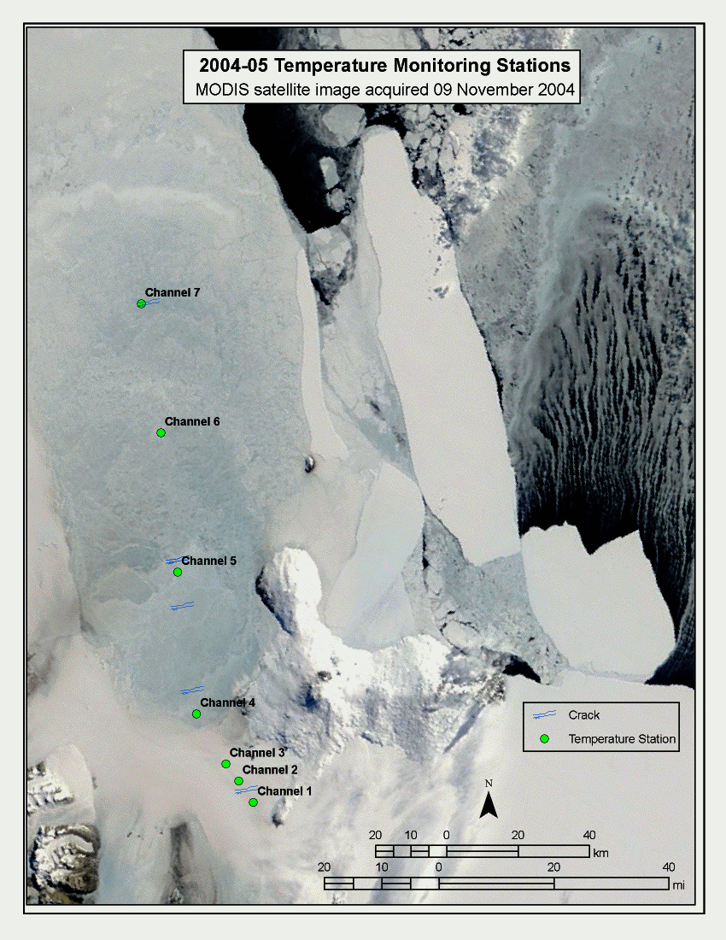
Attachment 2

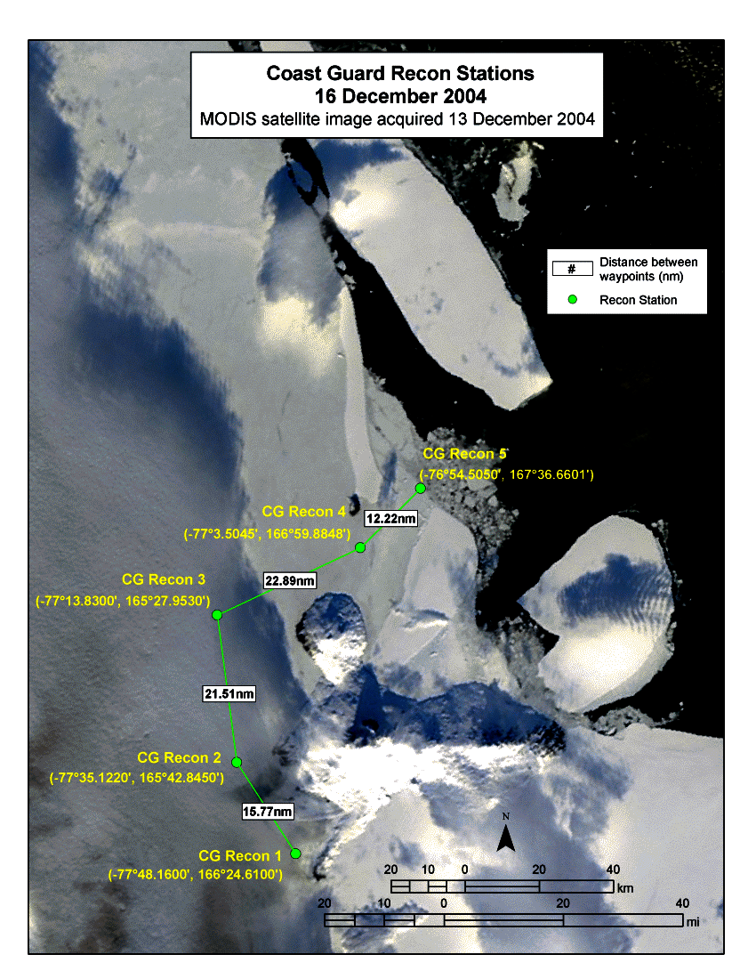
Attachment 3

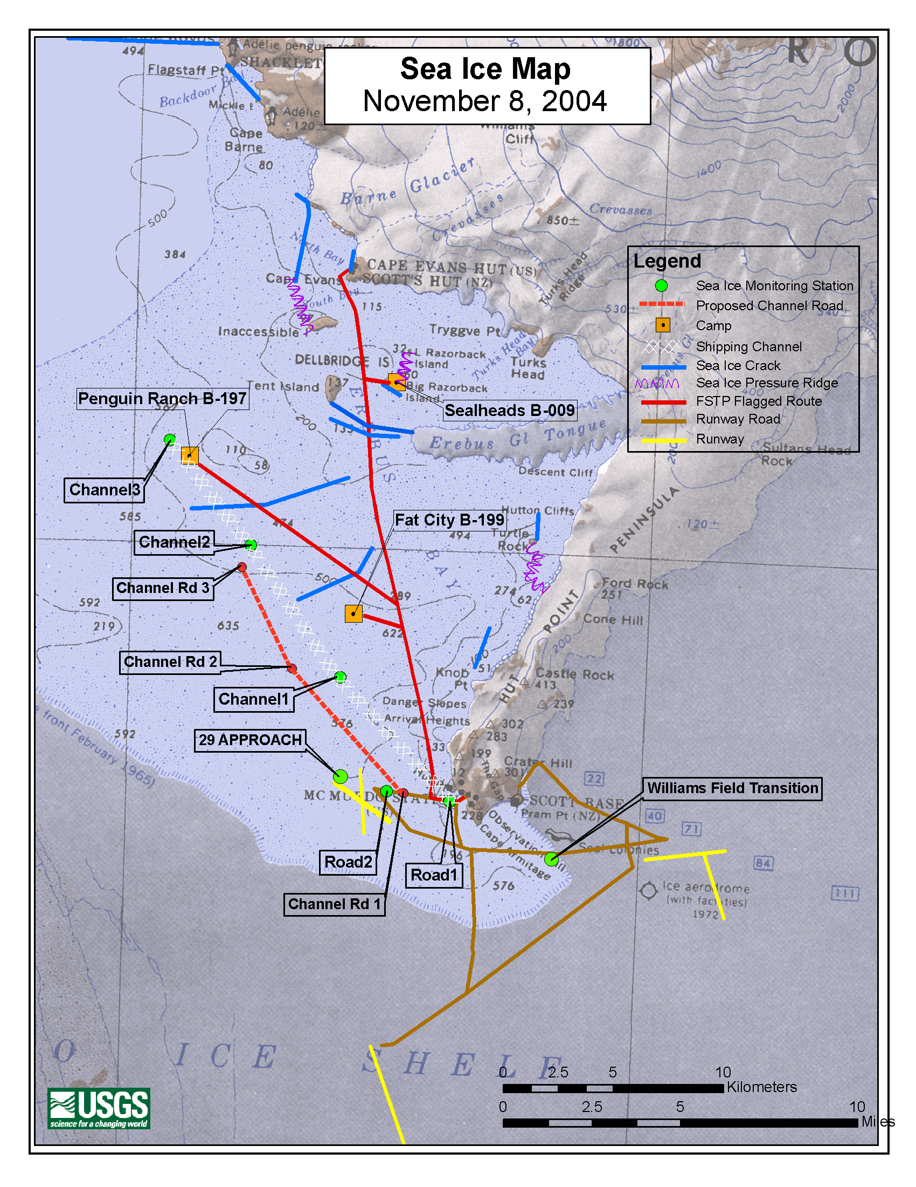
Attachment 4

Attachment 5

