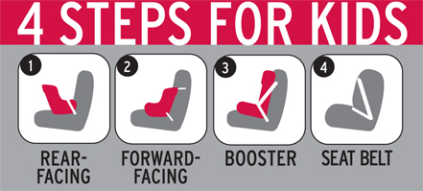
CPS Week Planner
SAMPLE PROCLAMATION
[394] WORDS

WHEREAS, Saturday September 20, 2008, has been declared [State or Community Name] National Seat Check Saturday; and

WHEREAS, September 21-27, 2008, has been declared National Child Passenger Safety Week; and

WHEREAS, All 50 States, the District of Columbia, Puerto Rico, and the United States Territories have enacted laws requiring the use of child passenger safety systems; and

WHEREAS, In 2006 an average of 5 children 14 and younger were killed and 640 children were injured in motor vehicle crashes every single day; and

WHEREAS, According to the National Highway Traffic Safety Administration, while 98 percent of America’s infants and 96 percent of children age 1 to 3 are now regularly restrained, not enough children of all ages are restrained properly for their size and age; and

WHEREAS, Only 37 percent of children age 4 to 7 who should be using booster seats to protect them are actually in them, and this puts children at an unnecessary risk of being injured or killed in crashes because they are simply in the wrong restraint for their size; and

WHEREAS, According to a study by the Children’s Hospital of Philadelphia, children age 4 to 7 who use booster seats are 59 percent less likely to be injured in car crashes than children who are restrained only by seat belts; and

WHEREAS, The 4 Steps for Kids start at birth, with rear-facing child safety seats, a forward-facing child safety seat (when at the minimum age of 1 and at least 20 pounds), a booster seat (when around age 4 and at least 40 pounds) and finally an adult seat belt (when at age 8 or at least 4’9” tall); and

WHEREAS, The safest place for all children up to age 13 is in the back seat; and

WHEREAS, National Seat Check Saturday and Child Passenger Safety Week provide communities and organizations an opportunity to join together through public information, education, and enforcement efforts to work toward increasing the correct use of safety seats and booster seats by focusing public attention on the lifesaving benefits that will help to significantly reduce death and serious injury to children in [State or Community Name]:

NOW, THEREFORE, I, [GOVERNOR or MAYOR’S NAME], [GOVERNOR/MAYOR] OF [STATE or COMMUNITY NAME], do hereby proclaim Saturday September 20, 2008, as Seat Check Saturday
And,

September 21-27, 2008, as

Child Passenger Safety Week

[State or Community Name]

###

