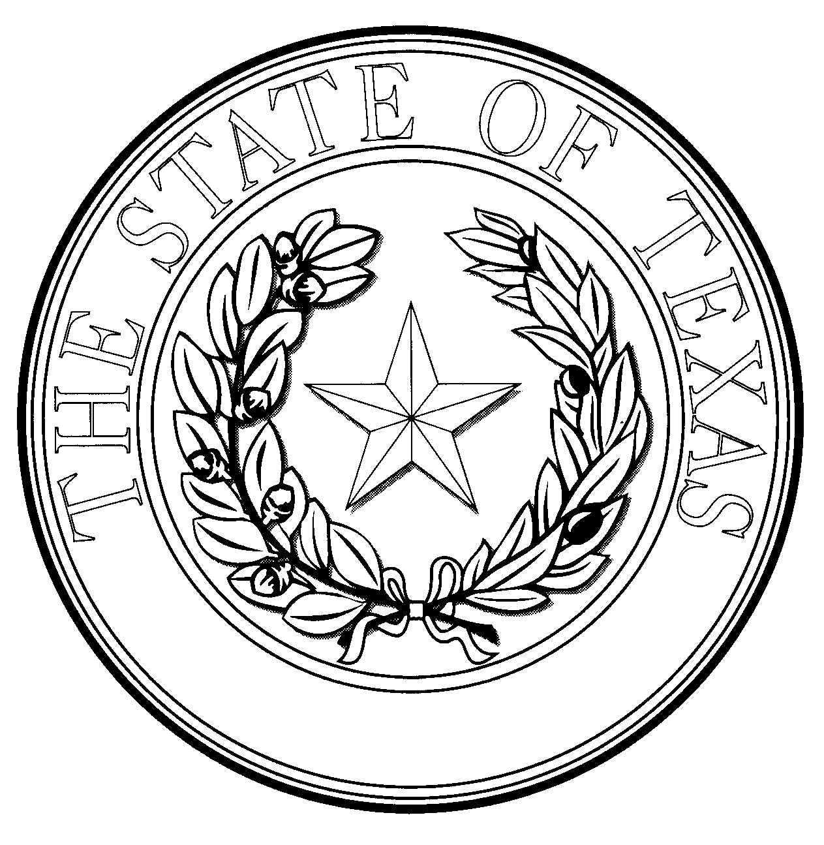 | TEXAS DEPARTMENT OF STATE HEALTH SERVICES
DAVID L. LAKEY, M.D.  COMMISSIONER |  | 1100 W. 49th Street • Austin, Texas 78756  1-888-963-7111 • http://www.dshs.state.tx.us  TDD: 512-458-7708

Dear Registry Applicant:

Thank you for contacting Vital Statistics, Central Adoption Registry. We are in the business of reuniting adult adoptees, birth parents, and biological siblings who are looking for one another. There is no second-guessing on our part, because we have the ability to view the contents of the original sealed birth file. This gives you the comfort of knowing that when we make a match, it will be with an enthusiastic birth parent, sibling or adult adoptee.

Every year our registry makes increasingly more matches. We welcome you to register with us by completing the enclosed two-page application. Please mail it and the following items to:

VS-CAR (MC-1966), P.O. Box 149347, Austin, TX 78714-9347:

- A $30.00 check or money order, payable to: DSHS.

- Proof of your age and identity (a copy of a government-issued photo ID). If your name has changed by marriage or other legal means, provide in addition to the above, a copy of your birth or marriage certificate, court order, or other legal document that identifies your maiden name and your name after the legal name change.

- If you are a birth sibling, please provide us in addition to your photo ID, a copy of your birth certificate.

After registering with us, whether we have a match or not, we will send you a letter regarding your application’s status. If a match occurs at anytime, we will notify you. Please note that if a match does not occur immediately, it may occur a few months later or years later when the person you are looking for registers. When that happens, we will instruct you to attend at least one hour of counseling. With those instructions, we will also send a list of related issues that should help prepare and educate you for the anticipated reunion. A counselor of your choice is used, but he or she must have expertise in post-adoption issues.

Information for the Adoptee:
1. If a child-placing agency was involved in your placement, you may be able to request a non-identified or redacted copy of your birth/adoption record from the adoption agency files. We maintain the following out-of-business child-placing agency records. If one of them placed you for adoption, and you would like a redacted copy of your record, please indicate this on your application. We will then prepare a cost estimate for your approval before proceeding with extracting the confidential information from the agency record.

Central Adoption Registry
Page 2

The following agency records are available:

- About Life, Dallas  - Adopt a Special Kid, Texas  - Adoption Inc., Dallas  - Adoption Associates, Houston  - Adoption Resource Consultants, Inc., Richardson  - Adoptions Abroad, Houston  - Alamo Adoption Agency, San Antonio  - Care Connection - San Marcos  - Catholic Charities - San Angelo  - Child & Family Services, Austin  - Children's Aid Society of West Texas, Wichita Falls  - Children’s Service Bureau, San Antonio  - Children's Shelter of San Antonio  - Christ's Haven, Keller |  | - Direct Adoption Center, Midland  - Family Counseling & Children's Services, Waco  - For Children’s Sake, Austin  - Girl's Haven, Orange  - Homestead, Fort Worth (listing only)  - Leslie Thacker, Houston  - Memorial Hospital, Dumas  - Presbyterian Children's Home, Dallas  - Quality of Life, Dallas  - Rest Cottage, Pilot Point  - Texas Child Placing Agency, Houston  - Texas Children's Home Finding Society, San Antonio  - Therapeikos, Abilene  - Volunteers of America, Ft Worth  - Waco State Home, Waco

2. If interested in knowing the identity of the court and the cause number of your adoption, please submit an additional $10 fee (total of $40) to us when sending in your application and indicating same on the application (Part V) or in a separate letter. The adopting court requires this information if you wish to petition it to order the unsealing of your adoption record, based on good cause.

All Applicants: The registration process may take as long as 45 days. Please do not be alarmed if you do not hear from us before that period has elapsed. Though we receive a great many applications, we will attend to yours just as soon as possible. If we may be of further assistance or to answer any questions, please call us at 1-888-963-7111 x7388 or x6279, write to at the address below, or email us. Thank you.

Sincerely,

Patricia Molina y Vedia
Program Specialist III

Enclosure

