★

Fire

Safety
for Texans

Fire and Burn Prevention

Curriculum Guide Developed by

Texas State Fire Marshal’s Office

Texas Department of Insurance

Third Grade

Positively

Fire Safe

Fire Safety for Texans
The complete series from the State Fire Marshal’s Office

Kindergarten
Fire Safe Together
First Grade
Fire Safety: Any Time, Any Place
Second Grade
Making Me Fire Safe
Third Grade
Positively Fire Safe
Fourth Grade
Fire Safety: Stop the Heat
Fifth Grade
Charged Up For Fire Safety
Sixth Grade
Fire Safety Power
Seventh Grade
Responsible For Fire Safety
Eighth Grade
Fire Safety's My Job
Health (High School)
A Lifetime For Fire Safety
Economics (High School)
Fire Safety For Consumers

Published December 1993, revised February 1999. Texas State Fire Marshal’s Office, G. Mike Davis, State Fire Marshal. PO Box 149221, Austin, TX 78714-9221, 512-305-7900. The State Fire Marshal’s Office and the Texas Department of Insurance do not discriminate on the basis of race, color, national origin, sex, religion, age or disability in employment or activities. For additional fire prevention information, contact the State Fire Marshal’s Office. This publication may be reproduced in its entirety. Such reproduction must include credit to the original producer, specifically the State Fire Marshal’s Office. Copies of this publication have been distributed in compliance with the State Depository Law and are available for public use through the Texas State Publications Depository Program at the Texas State Library and other state depository libraries.

Introduction

Introduction

Why teach fire and burn prevention?
Each year during the past decade, about 300 Texans have died in fires. The State Fire Marshal’s Office is committed to reducing this alarming statistic. Analysis of fire statistics shows that the vast majority of fires — and the resulting fire deaths — could have been prevented. Regretfully, most people do not know or practice even simple actions that can prevent fires and burns.
The State Fire Marshal’s Office believes the key to reducing fires and fire deaths is education. Fire safety education has traditionally been concentrated in elementary school observances of Fire Prevention Week. While these observances can produce effective results, thoughtful analysis of the fire problem and fire safety educational programs shows that a more comprehensive, age-appropriate approach to fire safety education can multiply its benefits.
Recognizing the limits of classroom instruction time, the State Fire Marshal’s Office has examined the Texas essential elements of instruction to determine the most appropriate topics with which to integrate fire prevention and fire safety. Teachers from across the state have provided feedback on topics appropriate for each grade level, kindergarten through high school.
The result of this extensive research is "Fire Safety for Texans," a series of curriculum guides teaching fire and burn prevention. Each grade-level program has been coordinated with essential elements in that grade and with the unique specific fire safety needs of that age group. The lesson plans have been field tested in classrooms across the state. On average, students who have been taught using these materials score 26 percent higher than students in control groups.
As you use this guide, you and teachers in other grade levels will be part of a continuum of fire safety education spanning all grades. The State Fire Marshal’s Office believes this continuum will help create a generation of Texans who will be fire-safety aware. In turn, all Texans can benefit from a decrease in the number of needless fire deaths and an increase in safer homes and worksites — a benefit we all deserve.

This Booklet
This booklet, "Positively Fire Safe," is specifically designed for third-grade students. The following sections give specific information on the essential elements applicable to fire and burn prevention and on the age-specific needs of third-grade students related to fires and burns. You will also find additional information on the format and materials found in this booklet.
This booklet has three sections:
• Lesson Plans. This section includes all steps in the lesson cycle.
• Teacher Materials. This section includes all teaching aids and tests.
• Student Materials — Duplicating Masters. This section includes master copies of materials to be used by students.
General Objectives: To acquire basic knowledge of hazards and safe storage of flammable liquids
To develop positive actions to prevent fires and burns or to reduce injuries, especially related to electrical and/or metallic objects
Essential Elements: The student will be provided opportunities to:
§75. 25 (d) 8A. use observations to form definitions of objects, actions, organisms, events, and processes.
§75. 26 (d) 2B. recognize the health of the family depends upon contributions of each of its members.
§75.25 (d) 6B. state generalizations about similarities and differences among objects, organisms, and events.
§75.25 (d) 7A. compare and contrast objects, organisms, and events.
§75.25 (d) 7B. relate classroom objects, science principles, and activities to daily life.
§75.25(d) 3B. classify matter and forces, organisms, action, and events from the environment according to similarities and differences.
§75.26 (d) 1D. practice general emergency procedures.
§75.26 (d) 1E. recognize hazards in the environment, and acquire knowledge and skills needed to avoid injury and to prevent accidents.
§75.29 (d) 2A. describe ways a community satisfies needs for food, clothing and shelter.
§75.29 (d) 6B. describe how individuals and families change over time.
Science Content: Content from the sciences that shall be emphasized at the grade level shall include:

Physical Science
3.1 energy ... kinds of energy ... forms of energy ... sources of energy.
3.5 phases of matter: solids, liquid and gas.
3.6 structure of matter ... families of elements: metals and nonmetals....

Background: Age Profile
Stage of industry vs. inferiority, which means the child needs opportunities to maximize her successes and to minimize and correct failures. She will work hard to receive recognition and improve skills.
Areas of development include neuromuscular and social. The child is developing many new physical skills, both gross and fine motor skills. He is making a social move from the home into peer groups and school. He is developing his own self-attitudes and seeks significant human relationships.
Operating under the morality of constraint, the child recognizes that rules are made by authorities and tends to focus on consequences rather than reasons for rules. She also seeks benefits in return for obeying rules. The child can understand causes and consequences of actions.
The child is moving into the concrete operational state, which means he can solve a variety of problems but needs concrete objects to solve those problems. He must be active in the instructional process, and activities and materials must be relevant to the child's life or environment. Instruction will be more effective if it involves both the affective and cognitive domains.
The third-grader is interested in social, occupational and civic matters. She is becoming able to move from the simple to complex, concrete to abstract, undifferentiated to differentiated, discrete to organized.

Fire And Burn Hazards
Curiosity about fires — playing with matches and lighters, candles, fireplace, heaters, other locations where the child can observe a flame; overconfidence in dealing with fires.
Scalds — cooking; tap water; hot foods, especially heated sweet foods.
Appliances — cooking at stoves or with microwave ovens, especially unsupervised; overconfidence in using appliances, such as irons, toasters, etc.
Clothing ignition — playing with matches; flammable clothing and costumes; walking or sleeping too close to heater or other open flame; knowing how to reduce injury.
Outdoor hazards — campfires and barbecues; mini-bikes and lawn mowers; fire works; high-tension wires.
Other — Flammable liquids; fires caused by parents' smoking; injury from smoke and fire gases; knowing how to escape from fire.
Teacher's Note On Materials: Illustrations and activity sheets in this booklet are intended to serve as masters. Photocopy, then use the photocopy as directed.
Pre-Test and Post-Test: Conduct the pre-test prior to presenting the first lesson and the post-test following the fifth lesson.
Teacher's Note on Closure Activities: Some activities included in the closure phase of the lesson cycle may be effectively used in the next lesson's focus activity.
Key To Icons: The following icons can be used to easily identify activities in the lesson plans:
 Lesson objectives
Focus and closure
Creative group activity, including role playing
 Lecture
 Demonstration
 Group problem-solving activity
 Answering questions
 Guest presenter
 Investigation or research
 Creative writing activity
 Cut-and-paste activity
 Group discussion
 Drawing, artwork or illustration

Lesson Plans

LESSON ONE:
Discovering Fire and Burn Safety
Goal: To focus on positive actions in a generally hazardous environment, especially with appliances
 Objectives: The student will:
• identify positive behaviors with hazardous appliances *26(d)1E
• classify metallic and non-metallic objects *25(d)3B, **3.6
• distinguish metallic objects as contact burn hazards *25(d)6B,8A, 26(d)1E
* ** See "Essential Elements" on Page 5.
Materials: Pre-tests (p. 15); pitchers of ice water and warm water; two each of plastic, wooden and metal bowls; "Warning: Hot Metals" activity sheets (p. 26); "Hunt for Hot Metal Hazards" investigation sheets (p. 27); letters to parent(s)/guardian(s) (p. 25); answer keys (pp. 20-21).
 Focus: Administer pre-test. Introduce unit on fire and burn safety by telling students that they will be learning many new ways to be "positively fire safe." Tell students that the purpose of this unit is to:
• Develop awareness of hazards and safe storage of flammable liquids.
• Develop and reinforce positive actions to prevent fires and burns or to reduce injuries, especially related to metallic objects.
Optional: Introduce Lesson Five activity. Students may select their groups or teams now so that they can prepare for the activity throughout the unit.
Tell students that the first lesson focuses on many objects found in the school and at home. Outline lesson objectives (paragraph above).
 Presentation Of Content: Review types of heat sources and combustible objects, including the three elements of fire. (These topics are generally included in first and second grade curricula.)
 Experiment: Have students identify the three types of bowls (metal, plastic and wooden). Show the two pitchers of water. Pour some ice water into one of each type bowl. Have students predict which of the three bowls will feel coldest. Select students to touch the outside of the bowls and describe which one feels coldest (metal).
Pour some warm water in the three remaining bowls. Have students predict which of the three bowls will feel warmest. Select students to touch the outside of the bowls and describe which one feels warmest (metal).
Teacher: "One way to identify metals is by its ability to transfer heat and cold. This means that metal objects will feels like the temperature near them. For example, if the oven of a stove is heated to cook a cake, then the metal outside the stove will also feel hot. If a metal spoon is left in a pan of hot food, then the spoon will feel hot."
Ask students for other examples.
 Guided Practice: Distribute "Warning: Hot Metal" activity sheet. On Part 1, have students read items in the list and classify as metallic or non-metallic.
On Part 2, have students identify the objects, then write why they are dangerous and how to avoid injury. Have students name a safer option for at least one object.
 Independent Practice: Distribute investigation sheet. Tell students that they should look for objects from their environment (school, home, stores, etc.) that are metallic and non-metallic, then write the names on the investigation sheet. Tell students that they are to write a general statement about heat and metallic objects, based on what they observed in the classroom demonstration, then relate that to the objects they have identified and describe whether that object might cause burns or fires.
 Reteaching: Allow students to conduct the experiment activity with teacher supervision.
✴ Enrichment: Add a glass bowl to the experiment, and have students make generalizations about heat transfer in glass.
 Closure: Have selected students tell what types of metallic and non-metallic objects they identified. Record some of their general statement on the chalkboard or overhead transparency. Point out similarities. Option: Have students develop a consensus definition through group discussion or by voting.
Introduce the next lesson by telling students that they will learn about another way to classify matter and how they can help them identify another type of fire hazard.

LESSON TWO:
Safety With Combustible and Flammable Materials
Goal: To explore the definitions of "combustible" and "flammable" and to apply safety rules at home by focusing on home inspection and holiday hazards
✪ Objectives: The student will:
• define and give examples of combustible, noncombustible, flammable and nonflammable materials, with relation to gas, liquid and solid states *25(d)7A, **3.1,3.5
• conduct inspection for safe flammable storage with parents using provided checklist *26(d)1E,2B
• identify fire safety for holidays in each month *26(d)1E
* ** See "Essential Elements" on Page 5.
Materials: dictionary, "Safety With Combustible and Flammable Materials" overhead transparency (p. 17); "Every Day Is A Safety Day" calendar activity sheets (p. 28); "Check for Flammable Liquids" home inspection sheets (p. 29); answer key (p. 20).
 Focus: Have students list items that will burn. (Students will generally list solid objects and perhaps a few liquids.) Have students read the definitions of combustible and flammable from the dictionary. Ask if these words apply to the list they have made. (Yes) Then explain that safety experts have special definitions for combustible and flammable when describing liquids that will burn. Outline lesson objectives (paragraph above).
 Presentation Of Content: Group discussion: Have students list adjectives or phrases to describe the three states of matter. (Solid: hard, doesn't move easily. Liquid: flowing, moves easily, takes shape of container. Gas: moves very easily, flowing, sometimes invisible)
Display overhead transparency. Have students read definition of combustible and flammable. Beginning with solid, discuss the three states of matter and the list of substances that are in each group.
Have students read definitions of flammable liquid and combustible liquid. Tell students that the government requires special labels on all flammable and combustible liquids to help protect us.
Also note that many safety experts simply refer to these objects as "flammable/combustible liquids" because both are very dangerous.
❖ Guided Practice: Group problem-solving activity: Distribute "Every Day Is A Safety Day" activity sheets. Have students look at the illustration for each month, and list the flammable and combustible materials in each scene. (Hint: Ask, "What might cause a fire in each picture?") Have students circle flammable or combustible liquids.
 Independent Practice: Investigation: Distribute "Check for Flammable Liquids" home inspection sheet. Direct students to complete the definitions of combustible and flammable. Have students take the sheet home to look with parents for safe storage of flammable liquids.
NOTE: Emphasize that students should never touch a container of flammable liquid. Evaluate students on their participation in this activity.
 Reteaching: Ask students to describe what they smell when gasoline is being pumped into the car or when an adult is cooking on a gas stove. Emphasize that the smells indicate the presence of a gas and that these two gases are flammable.
Discuss other smells from flammable liquids (rubbing alcohol, paint thinner, some cleaners). Add that some flammable liquids don't have smells.
 Enrichment: Have students research how heat and cold are involved in materials changing physical state.
 Closure: Review definitions of combustible and flammable. Ask students about their experiences with their families while conducting the flammable liquids inspection. Discuss successes as well as questions or problems. Reinforce positive experiences.
Introduce the next lesson by telling students they will be learning about what to do in case of a fire.

LESSON THREE:
Planning and Responding
Goal: To recognize the importance of planning and to personally plan for emergencies
✪ Objectives: The student will:
• describe or demonstrate what to report in an emergency situation *26(d)1D
• assist parent in maintaining smoke alarm using provided guidelines *25(d)7B, 26(d)1E,2B
• identify low battery warning on smoke alarm*26(d) 1D
* ** See "Essential Elements" on Page 5.
Materials: "Ready, Set, Be Safe" key word overhead transparency (p. 17) (optional; words may be written on chalkboard), "Ready, Set, Be Safe" activity sheets (p. 30); "Test Your Smoke Alarms" smoke alarm checklist (p. 31); answer keys (p. 21).
NOTE: If the area is not served by 9-1-1 service, write in the local emergency number in the space provided on "Ready, Set, Be Safe" before reproducing.
 Focus: Review emergency telephone number for the area. Be sure to consider students who live outside the town or city. Discuss what they know about smoke alarms. (It is appropriate for this age to identify smoke alarms as a warning devise in case of fire, especially when sleeping, and that smoke alarms should be located near bedrooms.)
Outline lesson objectives (paragraph above).
 Presentation Of Content: Group problem-solving activity: Introduce story activity by telling students that planning for a fire emergency and knowing how to report a fire are important skills in keeping a family safe.
Display key word overhead transparency, or write key words on chalkboard. Begin reading story, having students fill in the blanks with words from the key word list. Discuss each key word as it is used.
Following the story, have students discuss in small groups which person in the family has the greatest effect on their safety. Lead discussion to awareness that everyone in the family is important in keeping the family safe.
 Guided Practice: Direct student attention to the bottom block. Have students write the emergency telephone number. Discuss what types of information an emergency operator would need in order to send help. (Address, your name, what the problem is, any information that might be helpful, such as color of house or landmarks.)
Have students write what they would say if there were a fire at home, including address of the fire and the type of fire.
 Independent Practice: Distribute "Test Your Smoke Alarm" smoke alarm checklist. Review the instructions for completing the activity at home. Encourage students to work with their parents/guardians and other family members. Because smoke alarms operate on electricity, remind students that they should not try this activity without assistance from their parents or other adults.
NOTE: Evaluate students on their participation in this activity and not on the specific results of the checklist. Check that each student answers "yes" to "Is there a smoke alarm in or near each bedroom?"
 Reteaching: Have students practice in pairs reciting what to say to report a fire emergency. Encourage them to practicing at home with family members.
✴ Use a portable smoke alarm to demonstrate use of the test button. With the battery removed, show that the alarm will not sound when the test button is pushed.
 Enrichment: Have students write scripts for one or more of the following situations:
• reporting a fire emergency at school or a retail store
• questions that the 9-1-1 operator should ask
• reporting a medical emergency
 Closure: Have selected students tell what they would say when they call 9-1-1 (or local emergency number) about a fire. Ask students about their experiences with their families while conducting the smoke alarm inspection. Discuss areas where they felt successful and areas where they experienced questions or problems. Reinforce positive experiences.
Introduce next lesson by telling students that they will learn more about how to react to fire emergencies as well as how to be responsible for staying safe from fire.

LESSON FOUR:
Being Responsible
Goal: To demonstrate responsibility by applying safe practices in the home
✪ Objectives: The student will:
• give details of action at home alone in suspected fire situations *26(d)1D
• write rules for baby-sitter or care giver for family, with parents' assistance and consideration of ages of family members *26(d)2B, 29(d)2A, 6B
* ** See "Essential Elements" on Page 5.
Materials: "Being Responsible" role-playing cards (p. 18); "Being Responsible" activity sheet (p. 32); "Fire Safety for Baby-Sitters" activity sheet (p. 33); answer keys (p. 21).
NOTE: On "Being Responsible" activity sheet, fill in the local emergency number before duplicating.
 Focus: Ask students if they are ever at home alone. (Most third-graders are generally not left along for extended periods of time; however, this is an appropriate age to begin practicing skills for self-management in responding to emergencies.) Have the student list some things they need to know how to do when left alone.
Tell students that they will learn some important skills for fire safety, for themselves, and for baby-sitters. Outline lesson objectives (paragraph above).
 Presentation Of Content: Role-playing activity: Divide students into six groups. Distribute one role-playing card to each group. Have students read the cards, then act out each scene, providing an appropriate ending. Have students discuss other possible activities.
Recommended actions:
1. Get everyone outside right away, then go to the nearest phone or a neighbor's house for help.
2. Go outside right away, if possible. Yell for help if others are at home. Go out your second exit (such as a window) if smoke blocks the normal exit.
3. Go to the next house or find the nearest phone. Go to your home for help if it is close by.
4. Asks an adult for help. Check on all people in the house. Don't open a door if smoke is coming under or around the door.
5. Quickly close the front door. Then go to the nearest phone or a neighbor's house to call 9-1-1 or the local emergency number.
6. Tell an adult and make sure that the cigarette is put out. If necessary, pour water in the ashtray yourself.
❖ Guided Practice: Distribute "Being Responsible" activity sheet. Have students read the pairs of sentences. In each group, mark out the sentence that describes an inappropriate action.
 Independent Practice: Distribute "Fire Safety for Baby-Sitters" activity sheet. Using the basic list, have students write rules as appropriate actions for a baby-sitter. Encourage students to consider younger persons, senior citizens (grandparents) and other special people in their homes. Be sure that their rules will create a safe home for everyone.
 Reteaching: Review "Being Responsible" activity sheet. Discuss what might happen if they did a dangerous action. Have students describe why the safe action is better.
Enrichment: Have students compile the "Fire Safety for Baby-Sitters" activity sheets and prepare a list of general rules based on all student answers. Review the list with them.
 Allow students to make illustrations and print on one page. Reproduce and distribute to all students.
 Closure: Review "Fire Safety for Baby-Sitters" activity. Ask students if they learned anything about their families. Review several of the role-playing scenarios. Encourage students to practice safe actions and think about what they would do if they thought there might be a fire.
Introduce the final lesson by telling students: "Being able to tell someone else about something you know shows that you really know it. It also helps you become more sure of it yourself. You will have a chance to practice that in our last lesson on fire safety."

LESSON FIVE:
Telling Others About Fire and Burn Safety
Goal: To apply what has been learned about safety to teaching or telling other people about fire safety
✪ Objectives: The student will:
• explain injury reduction skills to others through song, dance, story, demonstration, etc. *26(d)1D,1E
• describes how matches can be used safely *26(d)1E
* ** See "Essential Elements" on Page 5.
Materials: "Match Safety" planning sheets (p. 34); "Telling Others About Fire and Burn Safety" sheets (p. 35); post-test (p. 19); answer key (p. 20).
 Focus: Review key points from previous lessons:
• Metallic objects frequently cause burns.
• You must be very careful with flammable liquids.
• You must have a smoke alarm and care for it properly.
• Everyone must be prepared for fire emergencies.
Tell students that in this last lesson they will look at one more dangerous object and then how they can help others. Outlines lesson objectives (paragraph above).
 Presentation Of Content: Review three primary injury skills: crawl low in smoke; roll on ground to put out clothing fires; run cool water on burns. (Most third-graders have been taught these skills.)
Divide students into small groups, and discuss other ways to prevent being injured by fires or other burn hazards. Have each group prepare a list of three ideas; have each group share their list. Be sure "Don't play with matches" is included.
Point out that playing with matches is one of the most common ways that children their age are burned.
❖ Guided Practice: Distribute "Match Safety" activity sheet. Still in groups, have students read the safety guidelines and discuss how they could tell others how matches can be used safely.
Have each group write a short description of their ideas. Encourage them to describe something they could actually do, but discourage using only posters. Examples:
• Write a rap song, and tell it to their friends.
• Make a match safety sign and have their parents put it in their kitchen.
• Make small "stickers" that could be glued to book covers.
Discuss several students ideas. Reinforce positive approaches to group cooperation.
 Independent Practice: When students understand how to plan in the guided practice activity, distribute "Telling Others About Fire and Burn Safety" sheet and tell the groups that now they are going to plan and carry out a plan for their own special message on how to reduce fire injuries.
When their activities are complete, have each group present their creative projects to the class. Evaluate presentation on correctness of safety information and involvement in the project.
 Reteaching: Have students practice and/or act out what they should do if:
• Smoke is in the house (crawl out)
• Clothes are on fire (drop to ground and roll)
• Red burn from touching a hot pan (hold under cool running tap water)
Enrichment: Invite other classes or parents to see presentations. Record the presentations on audiotape or videotape. Share products (signs, songs, stickers, etc.) with other classes or schools.
Have students write letters to the local fire department, telling them about their ideas.
Closure: Review match safety. Congratulate students on their creative projects. Discuss how the students felt as they planned and presented their projects. Reinforce feelings of accomplishment and pride in telling others about fire safety. Discourage comparisons among presentations so that all students recognize that they can influence others to be safe. Ask students what lesson they felt was most valuable, that applied to them most.

Administer post-test.

Teacher Supplemental Materials

Name

Third Grade: Positively Fire Safe PRE-TEST

Circle the letter of the item that best answers the question:
1. Which sentence best defines "flammable"?
A. Another word for "fire"
B. Something that burns very easily
C. A person who starts fires
2. Which is an example of a "flammable" liquid?
A. Gasoline
B. Water from a fire truck
C. Coffee
3. Even if there is no fire, ____________ surfaces can get hot enough to burn.
A. plastic
B. metal
C. wood

Answer the following questions:
4. What telephone number should you call to report a fire?

5. What is the most important thing to say when reporting a fire?

6. How do you test a smoke alarm?

7. Give an example of something that is combustible.

Circle true or false.
8. Small children can take care of themselves in case of a fire. True False
9. Matches can be used safely. True False
10. Every person in a family, even you, can help prevent fires. True False
11. Nothing is my house is combustible. True False
12. Flammable liquids should be kept away from anything hot. True False
Teacher: Use prior to beginning Lesson One, Page 7. Duplicate for student use.

Safety With Combustible and Flammable Materials

 Definitions

Combustible: capable of burning
(To burn means to consume fuel and give off heat and light)

Flammable: capable of being easily ignited and burning quickly

Three States of Matter

fumes from gasoline
G A S
natural gas (used in cooking)

gasoline
LIQUID
paint thinner
alcohol
cooking oil

wood
SOLID
cotton (used in clothing)
plastic

 New Definitions

Flammable liquid: a liquid that is capable of burning or exploding when the temperature is normal room temperature or colder.
Combustible liquid: a liquid that is capable of burning when the temperature is warmer than normal room temperature.

Teacher: Use with Lesson Two, Page 8. Transfer to overhead transparency.

Ready, Set, Be Safe

Key Word List

Use these key words to complete the story:
battery
tweeting
neighbor's house
sleeping area
test button
bedrooms
loud horn
smoke alarm
9-1-1
(or local emergency number
__________________)

Teacher: Use with Lesson Three, Page 9. Transfer to overhead transparency. If your area does not use 911, write in the local emergency telephone number.

Being Responsible

Role-Playing Cards
❶  Your group is watching TV in the family room. While watching TV, you hear the smoke alarm go off. One person says that they should go look in the kitchen to see what's on fire. Another person says they should go outside right away.  What should you do? | ❷  Your group is playing computer games in the bedroom. Someone sees smoke coming from another room. The smoke alarm is located in the hallway, but it has not gone off. Everyone is confused.  What should you do?
❸  Your group is walking home from school. While passing a neighbor's house, you find a trash can on fire. One person knocks on the door of the house, but no one is home.  What should you do? | ❹  Your group is working on a school project. Two people say that they smell smoke, but no one can see any smoke. You can't tell where the smell is coming from.  What should you do?
❺  Your group is walking home from school. One person opens the front door to his (or her) house, and smoke comes out of the house. No one else is at the house.  What should you do? | ❻  Your group is at a party at a friend's house. The adults in this house smoke cigarettes. You find a cigarette burning in an ashtray.  What should you do?

Teacher: Use with Lesson Four, Page 10. Copy, clip apart; and distribute to students.

Name

Third Grade: Positively Fire Safe POST-TEST

Circle the letter of the item that best answers the question:
1. Which sentence best defines "flammable"?
A. Another word for "fire"
B. Something that burns very easily
C. A person who starts fires
2. Which is an example of a "flammable" liquid?
A. Gasoline
B. Water from a fire truck
C. Coffee
3. Even if there is no fire, ____________ surfaces can get hot enough to burn.
A. plastic
B. metal
C. wood

Answer the following questions:
4. What telephone number should you call to report a fire?

5. What is the most important thing to say when reporting a fire?

6. How do you test a smoke alarm?

7. Give an example of something that is combustible.

Circle true or false.
8. Small children can take care of themselves in case of a fire. True False
9. Matches can be used safely. True False
10. Every person in a family, even you, can help prevent fires. True False
11. Nothing is my house is combustible. True False
12. Flammable liquids should be kept away from anything hot. True False
Teacher: Use following Lesson Five, Page 11. Duplicate for student use.

ANSWER KEY-1

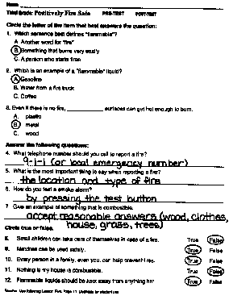 |  | 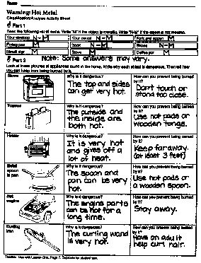
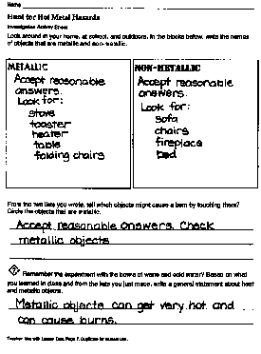 |  | 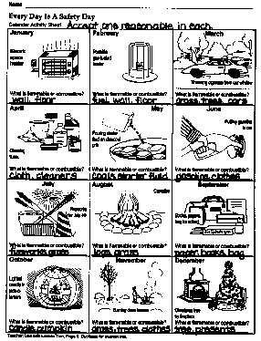

ANSWER KEY-2

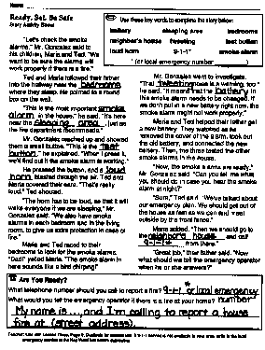 |  | 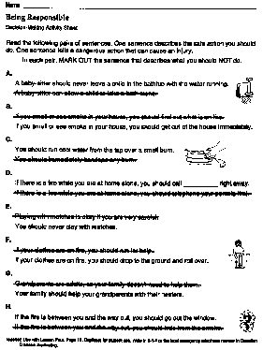
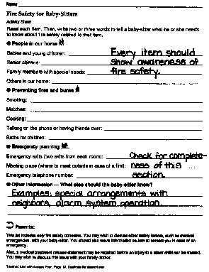

Student Materials —

Duplicating Masters

Letter to Parent(s)/Guardian(s)

Dear Parent (s)/Guardian(s):
Our class is beginning a unit of study on fire and burn prevention titled "Positively Fire Safe," which was developed by the State Fire Marshal’s Office. The goals of this unit are to help students:
• Develop awareness of hazards and safe storage of flammable liquids.
• Develop and reinforce positive actions to prevent fires and burns or to reduce injuries, especially related to metallic objects.
The unit includes three activities that should be completed by the student with his/her family at home. Each activity includes a worksheet for recording the results of a home investigation. Please help your child with these activities, which are titled:
• Hunt for Hot Metal Hazards
• Check for Flammable Liquids
• Test Your Smoke Alarms
A fourth activity asks students to prepare a list of simple fire safety rules for baby-sitters. Your help can enrich this activity for your child.
Fire safety involves every member of the household. This unit is designed to help third-graders begin developing an awareness that they can contribute positively to the safety of their families. Your assistance with these activities will be very valuable.
Sincerely,

Teacher

Teacher: Use with Lesson One, Page 7. Duplicate and distribute to students when beginning unit

Name

Warning: Hot Metal

Classification/Analysis Activity Sheet
 Part 1
Read the following list of items. Write "M" if the object is metallic. Write "N-M" if the object is not metallic.
Your desktop | Your pencil | Fork and spoon
Frying pan | Book | Shoes
Street sign | Stove | Coffee pot
 Part 2
Look at these pictures of appliances found in the home. Write why each object is dangerous. Then tell how you can keep from being burned by it.
Stove  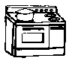 | Why is it dangerous? | How can you prevent being burned by it?
Toaster 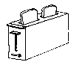 | Why is it dangerous? | How can you prevent being burned by it?
Heater 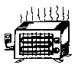 | Why is it dangerous? | How can you prevent being burned by it?
Metal spoon in pan 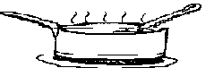 | Why is it dangerous? | How can you prevent being burned by it?
Hot engine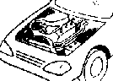 | Why is it dangerous? | How can you prevent being burned by it?
Curling iron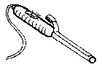 | Why is it dangerous? | How can you prevent being burned by it?
Teacher: Use with Lesson One, Page 7. Duplicate for student use.

Name

Hunt for Hot Metal Hazards

Investigation Activity Sheet
Look around in your home, at school, and outdoors. In the blocks below, write the names of objects that are metallic and non-metallic.

Metallic | Non-Metallic

From the two lists you wrote, tell which objects might cause a burn by touching them? Circle the objects that are metallic.

 Remember the experiment with the bowls of warm and cold water? Based on what you learned in class and from the lists you just made, write a general statement about heat and metallic objects.

Teacher: Use with Lesson One, Page 7. Duplicate for student use.

Name

Every Day Is A Safety Day

Calendar Activity Sheet
January  Electric  Space  heater  What is flammable or combustible? | February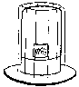  Portable  gas-fueled  heater  What is flammable or combustible? | March  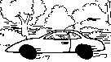  Throwing cigarette from car window  What is flammable or combustible?
April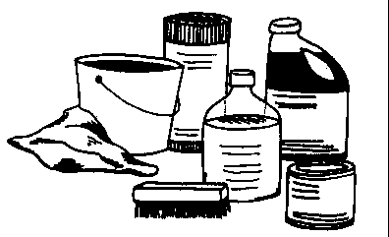  Cleaning  Fluids  What is flammable or combustible? | May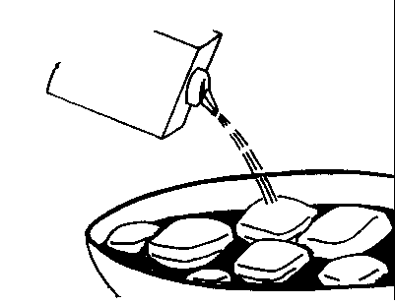  Pouring starter fluid on charcoal grill  What is flammable or combustible? | June  Putting gasoline in car  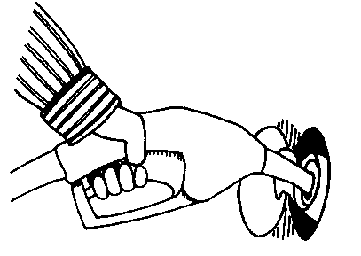  What is flammable or combustible?
July  Fireworks for July 4th  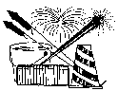  What is flammable or combustible? | August  Campfire  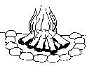  What is flammable or combustible? | September  Books, papers, bag for school  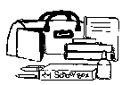  What is flammable or combustible?
October  Lighted candle in jack-o-lantern  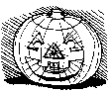  What is flammable or combustible? | November  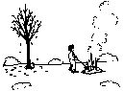  Burning dead leaves  What is flammable or combustible? | December  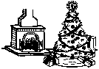  Christmas tree by fireplace  What is flammable or combustible?
Teacher: Use with Lesson Two, Page 8. Duplicate for student use.

Name

Check For Flammable Liquids

Home Inspection Activity Sheet
 Write the definitions:  Combustible:  Flammable: |  | What is a flammable liquid?  100° Very hot day  Warmer than room temperature — Combustible liquids can burn.  80° Normal room temperature  Cooler than room temperature — Flammable liquids can burn or explode.  32° Cold day (water freezes)  Flammable liquids are very dangerous! They give off invisible gases that cannot be seen. These gases, or vapors, can easily catch fire or explode.
Labels on Flammable Liquids
The government requires special labels on flammable liquids and combustible liquids to warn us of the dangers. Follow the directions for safety on these products very carefully.
With help from your parents (or other adults in your home), look for products with these labels:

DANGER — EXTREMELY FLAMMABLE
WARNING — FLAMMABLE
CAUTION — COMBUSTIBLE
If you find anything with these labels, write the names below. Then write where you found them. Have your parents read the directions on how these products should be stored. Should any products be moved to a safer location? If so, write the new location.
Example: You find a can of paint thinner in the kitchen. Here's what you would write:
Product | Where it was | Where it should be moved
Paint thinner | Kitchen | Garage, far away from heat
Here's the table for your information:
Product | Where it was | Where it should be moved
Teacher: Use with Lesson Two, Page 8. Duplicate for student use.

Name

Ready, Set, Be Safe

Story Activity Sheet

"Let's check the smoke alarms," Mr. Gonzalez said to his children, Maria and Ted. "We want to be sure the alarms will work properly if there is a fire."
 Use these key words to complete the story below:
battery sleeping area bedrooms
neighbor's house tweeting test button
loud horn 9-1-1* smoke alarm
* (or local emergency number _________)
Ted and Maria followed their father into the hallway near the ____________ where they sleep. He pointed to a round box on the wall.
"This is the most important ________ ________ in the house," he said. "It's here near the ____________ ________, just as the fire department recommends."
Mr. Gonzalez reached up and showed them a small button. "This is the ______ ________," he explained. "When I press it, we'll find out if the smoke alarm is working."
He pressed the button, and a ______ _______ blasted through the air. Ted and Maria covered their ears. "That's really loud," Ted shouted.
"The horn has to be loud, so that it will wake everyone if we are sleeping," Mr. Gonzalez said. "We also have smoke alarms in each bedroom and in the living room, to give us extra protection in case of fire."
Maria and Ted raced to their bedrooms to look for the smoke alarms. "Dad!" yelled Maria. "The smoke alarm in here sounds like a bird chirping!"
Mr. Gonzalez went to investigate. "That __________ noise is a warning, too." he said. "It means that the __________ in this smoke alarm needs to be changed. If we don't put in a new battery right now, the smoke alarm might not work properly."
Maria and Ted helped their father get a new battery. They watched as he removed the cover of the alarm, took out the old battery, and connected the new battery. Then, the three tested the other smoke alarms in the house.
"Now, the smoke alarms are ready," Mr. Gonzalez said. "Can you tell me what you should do in case you hear the smoke alarm at night?"
"Sure," Ted said. "We've talked about our emergency plan. We should get out of the house as fast as we can and meet outside by the front fence."
Maria added, "Then we should go to the ____________ _________ and call _____________ from there."
"Great job," their father said. "Now what should we tell the emergency operator when he or she answers?"

 Are You Ready?
What telephone number should you call to report a fire?
What would you tell the emergency operator if there is a fire at your home?

Teacher: Use with Lesson Three, Page 9. Duplicate for student use. If 9-1-1 service is not available in your area, write in the local emergency number in the Key Word box before duplicating.

Name

Test Your Smoke Alarms

Smoke Alarm Checklist

Do you have enough smoke alarms?
One smoke alarm should be located next to every sleeping area (group of bedrooms). For best protection, have an extra smoke alarm in each bedroom.
Is there a smoke alarm in or near each bedroom? ________________
In the table below, write where each smoke alarm is located.

Is each smoke alarm working?
Follow these steps to test your smoke alarms. Write the results in the table below.
Step 1 Locate the smoke alarm in your home.
Step 2 With help from an adult, press the test button.
Step 3 If the alarm sounded loudly, the smoke alarm is operating.
If the alarm did not sound, have an adult remove the cover and check the type of battery needed. Immediately get a new battery and have an adult install the new battery. Then press the test button again.
If the alarm does not sound after replacing the battery, get a new smoke alarm immediately.

Results of Smoke Alarm Inspection: Write what you found in your home.
Location of smoke alarm | What happened when the test button was pressed? | Is the smoke alarm working properly now?
➲ Note to Parents/Guardians:
Having working smoke alarms triples your family's chances of surviving a fire. Test the smoke alarms in your home at least once a month. This activity is designed to teach students that they can help the family avoid the dangers of fire.
Read and follow the manufacturer's directions for your smoke alarms. On some smoke alarms, pressing the test button checks the batteries or power supply as well as the detection device itself. Other smoke alarms require the use of smoke to test the detection device; on those models, pressing the test button tests only the battery or power supply.
Teacher: Use with Lesson Three, Page 9. Duplicate for student use.

Name

Being Responsible

Decision-Making Activity Sheet

Read the following pairs of sentences. One sentence describes the safe action you should do. One sentence tells a dangerous action that can cause an injury.

In each pair, MARK OUT the sentence that describes what you should NOT do.

A.
A baby-sitter should never leave a child in the bathtub with the water running.
A baby-sitter can allow a child to take a bath alone.

B.
If you smell or see smoke in your house, you should find out what is on fire.
If you smell or see smoke in your house, you should get out of the house immediately.

C.
You should run cool water from the tap over a small burn.
You should immediately bandage any burn.

D.
If there is a fire while you are at home alone, you should call __________ right away.
If there is a fire while you are at home alone, you should telephone your parents first.

E.
Playing with matches is okay if you are very careful.
You should never play with matches.

F.
If your clothes are on fire, you should run for help.
If your clothes are on fire, you should drop to the ground and roll over.

G.
Grandparents are adults, so your family doesn't need to help them.
Your family should help your grandparents with their heaters.

H.
If the fire is between you and the way out, you should go out the window.
If the fire is between you and the way out, you should hide from the smoke.
Teacher: Use with Lesson Four, Page 10. Duplicate for student use. Write in 9-1-1 or the local emergency telephone number in Question D before duplicating.

Name

Fire Safety for Baby-Sitters

Activity Sheet
Read each item. Then, write two or three words to tell a baby-sitter what he or she needs to know about fire safety related to that item.
❶ People in our home
Babies and young children:
Senior citizens:
Family members with special needs:
Others in our home:
❷ Preventing fires and burns
Smoking:
Matches:
Cooking:
Talking on the phone or having friends over:
Baths for children:
❸ Emergency planning
Emergency exits (two exits from each room):
Meeting place (where to meet outside in case of a fire):
Emergency telephone number:
❹ Other information — What else should the baby-sitter know?

➲ Parents:
This list includes only fire safety concerns. You may wish to discuss other safety factors, such as medical emergencies, with your baby-sitter. You should also leave information on how to contact you in case of an emergency.
Also, a medical treatment release statement may be required before an injury to a minor child can be treated. You may wish to discuss this issue with your family doctor.
Teacher: Use with Lesson Four, Page 10. Duplicate for student use.

Name

Match Safety

Planning Activity

Match Safety Guidelines
1. Stored safely away from children.
2. Use matches only when necessary.
3. Strike in a safe area.
4. Blow out immediately.
5. Wet with water to completely put out.
6. Throw away.
How our group could tell other people how matches can be used safely. (Just tell your ideas.)

(Ideas: make signs to hang in your kitchen, design "stickers" that could be glued to book covers, write a rap song telling why you must be careful with matches. Think of something that is interesting to you!)
Teacher: Use with Lesson Five, Page 11. Duplicate for student use.

Name

Telling Others About Fire and Burn Safety

Creative Problem-Solving Activity

Your group will write a plan about telling other people about how to avoid being injured by fires or how to prevent other types of burns (like from hot coffee or bath water). Then, as a team, you will carry out your plan. This sheet is designed to help you in planning.

What we want to tell other people about fire and burn safety:

How we are going to tell them (song, poem, signs, flyers, stickers, demonstrations — use your imagination):

Who is going to do what job:

Name Assigned job

Use the space below for other notes or ideas:

Teacher: Use with Lesson Five, Page 11. Duplicate for student use.

