★

Fire

Safety
for Texans

Fire and Burn Prevention

Curriculum Guide Developed by

Texas State Fire Marshal’s Office

Texas Department of Insurance

Second Grade

Making Me

Fire Safe

Fire Safety for Texans
The complete series from the State Fire Marshal’s Office

Kindergarten
Fire Safe Together
First Grade
Fire Safety: Any Time, Any Place
Second Grade
Making Me Fire Safe
Third Grade
Positively Fire Safe
Fourth Grade
Fire Safety: Stop the Heat
Fifth Grade
Charged Up For Fire Safety
Sixth Grade
Fire Safety Power
Seventh Grade
Responsible For Fire Safety
Eighth Grade
Fire Safety's My Job
Health (High School)
A Lifetime For Fire Safety
Economics (High School)
Fire Safety For Consumers

Published December 1993, revised February 1999. Texas State Fire Marshal’s Office, G. Mike Davis, State Fire Marshal. PO Box 149221, Austin, TX 78714-9221, 512-305-7900. The State Fire Marshal’s Office and the Texas Department of Insurance do not discriminate on the basis of race, color, national origin, sex, religion, age or disability in employment or activities. For additional fire prevention information, contact the State Fire Marshal’s Office. This publication may be reproduced in its entirety. Such reproduction must include credit to the original producer, specifically the State Fire Marshal’s Office. Copies of this publication have been distributed in compliance with the State Depository Law and are available for public use through the Texas State Publications Depository Program at the Texas State Library and other state depository libraries.

Introduction

Introduction

Why teach fire and burn prevention?
Each year during the past decade, about 300 Texans have died in fires. The State Fire Marshal’s Office is committed to reducing this alarming statistic. Analysis of fire statistics shows that the vast majority of fires — and the resulting fire deaths — could have been prevented. Regretfully, most people do not know or practice even simple actions that can prevent fires and burns.
The State Fire Marshal’s Office believes the key to reducing fires and fire deaths is education. Fire safety education has traditionally been concentrated in elementary school observances of Fire Prevention Week. While these observances can produce effective results, thoughtful analysis of the fire problem and fire safety educational programs shows that a more comprehensive, age-appropriate approach to fire safety education can multiply its benefits.
Recognizing the limits of classroom instruction time, the State Fire Marshal’s Office has examined the Texas essential elements of instruction to determine the most appropriate topics with which to integrate fire prevention and fire safety. Teachers from across the state have provided feedback on topics appropriate for each grade level, kindergarten through high school.
The result of this extensive research is "Fire Safety for Texans," a series of curriculum guides teaching fire and burn prevention. Each grade-level program has been coordinated with essential elements in that grade and with the unique specific fire safety needs of that age group. The lesson plans have been field tested in classrooms across the state. On average, students who have been taught using these materials score 26 percent higher than students in control groups.
As you use this guide, you and teachers in other grade levels will be part of a continuum of fire safety education spanning all grades. The State Fire Marshal’s Office believes this continuum will help create a generation of Texans who will be fire-safety aware. In turn, all Texans can benefit from a decrease in the number of needless fire deaths and an increase in safer homes and worksites — a benefit we all deserve.

This Booklet
This booklet, "Making Me Fire Safe," is specifically designed for second-grade students. The following sections give specific information on the essential elements applicable to fire and burn prevention and on the age-specific needs of second-grade students related to fires and burns. You will also find additional information on the format and materials found in this booklet.
This booklet has three sections:
• Lesson Plans. This section includes all steps in the lesson cycle.
• Teacher Materials. This section includes all teaching aids and tests.
• Student Materials — Duplicating Masters. This section includes master copies of materials to be used by students.
 General Objectives: To acquire basic understanding of how to prevent and put out fires
To develop greater self-direction to prevent and react to fire, smoke or burn situations
Essential Elements: The student will be provided opportunities to:
§75.25 (c) 3B. classify matter and forces, organisms, actions, and events from the environment according to similarities and differences.
§75.25 (c) 4B. describe objects, organisms, and events from the environment.
§75.25 (c) 6A. predict the outcomes of actions based on experience or data.
§75.25(c)7B. relate objects, science principles, and activities to daily life.
§75.26 (c) 1C. recognize hazards in the environment, and acquire knowledge and skills needed to avoid injury and to prevent accidents.
§75.26 (c) 2B. recognize the health of the family depends upon contributions of each of its members.
§75.26 (c) 3A. recognize interdependence of people and the environment, and recognize personal responsibility for protecting the environment.
§75.29 (c) 1C. volunteer for leadership.
§75.29 (c) 4A. identify some government services in the community.
§75.29 (c) 6B. describe family traditions and customs.
** Science Content: Content from the sciences that shall be emphasized at the grade level shall include:

Earth Science
2.9 human responsibility regarding earth science phenomena ... natural resources.

Background: Age Profile
Stage of industry vs. inferiority, which means the child needs opportunities to maximize her successes and to minimize and correct failures. She will work hard to receive recognition and improve skills.
Areas of development include neuromuscular and social. The child is developing many new physical skills, both gross and fine motor skills. He is making a social move from the home into peer groups and school. He is developing his own self-attitudes and seeks significant human relationships.
Operating under the morality of constraint, the child recognizes that rules are made by authorities and tends to focus on consequences rather than reasons for rules. She also seeks benefits in return for obeying rules. The child can understand causes and consequences of actions.
The child is moving into the concrete operational state, which means he can solve a variety of problems but needs concrete objects to solve those problems. He must be active in the instructional process, and activities and materials must be relevant to the child's life or environment. Instruction will be more effective if it involves both the affective and cognitive domains.
The second-grader is interested in social, occupational and civic matters. She is becoming able to move from the simple to complex, concrete to abstract, undifferentiated to differentiated, discrete to organized.

Fire And Burn Hazards
Curiosity about fires — playing with matches and lighters, candles, fireplace, heaters, other locations where the child can observe a flame; overconfidence in dealing with fires.
Scalds — cooking; tap water; hot foods, especially heated sweet food.
Appliances — cooking at stoves or with microwave ovens, especially unsupervised; overconfidence in using appliances, such as irons, toasters, etc.
Clothing ignition — playing with matches; flammable clothing and costumes; walking or sleeping too close to heater or other open flame; not knowing how to reduce injury.
Outdoor hazards — campfires and barbecues; mini-bikes and lawn mowers; fire works; high-tension wires.
Other — flammable liquids; fire caused by parents' smoking; injury from smoke and fire gases; knowing how to escape from fire.
Teacher's Note On Materials: Illustrations and activity sheets in this booklet are intended to serve as masters. Photocopy, then use the photocopy as directed.
Pre-Test and Post-Test: Administer the pre-test prior to the first lesson and the post-test after the final lesson.
Teacher's Note on Closure Activities: Some activities included in the closure phase of the lesson cycle may be effectively used in the next lesson's focus activity.
Key To Icons: The following icons can be used to easily identify activities in the lesson plans:
 Lesson objectives
 Focus and closure
 Creative group activity, including role playing
 Lecture
 Demonstration
 Group problem-solving activity
 Answering questions
  Guest presenter
 Investigation or research
 Creative writing activity
Cut-and-paste activity
 Group discussion
Drawing, artwork or illustration

Lesson Plans

LESSON ONE:
Controlling The Three Elements Of Fire
Goal: To explore how controlling one or two of the three elements of fire can extinguish a fire or reduce the effects of fire and burns
 Objectives: The student will:
• explain putting out a fire by removing or controlling one element *25(c)3B, 26(c)1C
• explain using cool water to reduce burn injury *25(c)7B, 26(c)1C
• explain that rolling on ground keeps air from fire on clothes *25(c)7B, 26(c)1C
Materials: Pre-tests (p. 15); three-legged table constructed from supplementary materials (p. 16-17); bowl of warm water (100 degrees F maximum); bowl of cool water; thermometer; "What's Missing?" activity sheet (p. 35); "What Do You Do?" activity sheet (p. 36); fire triangle illustration (p. 18).
 Focus: Administer pre-test.
Use table to demonstrate that three legs are required to hold up the table. Encourage student participation. Read the names of the three fire elements shown on the legs of the table. Review the three elements of fire and relate to the three-legged table. Explain that this unit will focus on fire safety and ways that each student can become more safe from fire.
 Presentation Of Content: Ask students what happens when one of the three elements of fire is removed. (The fire goes out.) Describe some of the ways that one element can be removed from the fire:
• Remove the air by covering up the fire. Examples: rolling on the ground to take air away; putting a lid on a cooking pan fire to keep air out.
• Remove the heat, by covering the fire with water or by using a fire extinguisher.
• Remove the fuel by taking it away from the heat source, usually most effective in preventing a fire.
Expand the discussion to point out that the effects of fire can also be reduced by removing or reducing one element of fire.
 Demonstration: Show the two containers of water and thermometer. Read the room temperature from the thermometer. Ask the students if they expect the thermometer to read warmer or colder when it is put in the warm water.
Measure the temperature of the warm water; record and compare to student guesses. Then ask the students if they expect the thermometer to read warmer or colder when it is put the cool water.
Measure the temperature of the cool water; record and compare to student guesses. Ask the students to summarize what happened. (The temperature of the thermometer went up in warm water and down in cool water.) Ask them to relate this to skin that has been burned. (The skin is warm, so putting on cool water will reduce the temperature and stop the burning.)
Conclude discussion with additional information on burns:
• Cool a burn by holding the burned area under a moderately flowing faucet for five minutes.
• Always tell an adult if you or a friend is burned.
• Use the "cool-a-burn" technique when the burned area is pink, red or blistered, but NOT if the burn is grayish or dry.
• "Cool-a-burn" is most effective when done immediately after the burn occurs.
 Guided Practice: Distribute "What's Missing?" activity sheet. Read each scenario aloud, and have students list which one of the three elements of fire have been taken out. Discuss other actions that might have put out the fire or stopped the burn.
 Independent Practice: Distribute "What Do You Do?" activity sheet. Have the students read the short story, then write what they would do to put out the fire or stop the burn and which of the fire elements was removed.
 Reteaching: Using the fire triangle illustration and the scenarios in "What's Missing?" have students identify the three elements in the scenario and describe what has been removed.
 Enrichment: Provide thermometers and containers with water for students, and have students conduct the demonstration activity.
 Have the students create skits to act out given scenarios or their own scenarios.
 Closure: Review "What Do You Do?" activity sheet. Using triangle table, have students show which leg is removed by using "cool-a-burn" technique and rolling on the ground to put out a clothes fire.

LESSON TWO:
Knowing What's Harmful
Goal: To explore what kinds of fires and objects are harmful and how helpful fires and appliances can become harmful
 Objectives: The student will:
• define and give examples of controlled and uncontrolled fires *25(c)3B, 26(c)1C
• predict how electrical appliances can become hazards through carelessness, misuse, disrepair, including unattended cooking *25(c)6A, 26(c)1C
• identify outdoor electrical hazards (storms, tools, cooking equipment) *25(c)4B, 26(c)3A, **2.9
• describe why matches are not toys *26(c)1C
Materials: Teacher "Careful" and "Harmful" puppets (p. 20); "Story of Careful and Harmful" (p. 19); student "Careful" and "Harmful" puppets (p. 37); "It's Better To Be Careful" activity sheet (p. 38).
 Focus: Review general information from previous lesson: that removing one element of fire will put it out; to "cool-a-burn"; to stop and roll to put out a clothes fire. Point out that fires and burns can occur from many causes, but that we can keep many fires from starting by learning more about what causes fires.
Introduce "Careful" and "Harmful" puppets. Discuss meanings of "careful" and "harmful."
 Presentation Of Content: Use Careful and Harmful puppets to illustrate the story. (See story on Page 19.) Discuss questions at the end of the story. Emphasize the importance of being careful with fire and burn hazards, especially cooking appliances and matches. Discuss how the actions of one person (in this case, a parent) can affect other people.
 Guided Practice: Distribute Careful and Harmful puppets to students. Read situations from the story, omitting reference to Careful and Harmful. Have the students hold up the puppet that matches the situation. Discuss how the situation shows actions that are careful or harmful.
 Independent Practice: Distribute "It's Better To Be Careful" activity sheet. Have the students read each action, then circle the happy "Careful" face if it is a safe, careful action or the sad "Harmful" face it is a harmful, dangerous action.
 Reteaching: Continue activity in Guided Practice by first using example of more familiar careful or harmful actions, such as wearing a seatbelt or running in the classroom. Expand discussion to include actions relating to fire safety.
 Enrichment: Have the students write a creative story about identifying a harmful action and correcting it.
 Closure: Review "It's Better To Be Careful" activity sheet. Read some of the creative stories if any students completed the enrichment activity. Using the Careful and Harmful puppet activity in Guided Practice, challenge the students to name only careful actions. Introduce the next lesson by telling the students that they will learn next about an important object that every careful family must have.

LESSON THREE:
Smoke Awareness / Self-Action
Goal: To apply knowledge of smoke to need for and placement of smoke alarms and to begin self-direction in applying safety rules
 Objectives: The student will:
• describe general guidelines for smoke alarm placement (each level, outside bedrooms) *26(c)1C
• explain that smoke and gases from fire can affect thinking *25(c)7B, 26(c)1C
• write at least five rules for safe behavior *26(c)1C
Materials: "Fire Safety Guard" puppet (p. 21); role-playing labels (p. 22); "Where Smoke Alarms Go" illustration (p. 23) copied onto overhead transparency or poster; "Where Smoke Alarms Go" activity sheet (p. 39); "Rules For Fire Safety" activity sheet (p. 40).
 Focus: Introduce "Fire Safety Guard" puppet. Explain that the puppet is a picture of a smoke alarm and that a smoke alarm is a machine that warns us of smoke and fire.
 Presentation Of Content: Review and/or reinforce awareness that fires create smoke and dangerous gases that rise.
Teacher: Smoke and gases from fires are very dangerous. They cause people, like you and me, not to think properly during a fire. Most people who die in fires die because of the smoke and gases. It is very important that we get out of a fire before the smoke and gases affect our thinking.
Expand discussion to include the role of smoke alarms.
Teacher: "Smoke alarms are machines with a special purpose. Because they are not living, they can still operate when there is a fire. In fact, the job of a smoke alarm is to check for smoke or gases in the air and warn us when it senses smoke or gases.
"This is very important because the most dangerous fires happen at night when everyone is sleeping and no one notices the fire. Most smoke alarms have loud buzzers or whistles that can wake us up while we are sleeping. Some have bright flashing lights to warn people who cannot hear."
 Role playing: Use three students to role play a fire situation. Assign the roles of the smoke, the smoke alarm and a sleeping person. First have the students act out what would happen if there is a fire and smoke WITHOUT a smoke alarm (the person is affected by the smoke and can't wake up to get out), then WITH a smoke alarm (the alarm detects the smoke and sounds the alarm so the person can wake up and get out). Reinforce crawling in smoke to a safe exit.
 Guided Practice: Discuss theories that the students have on where a smoke alarm should be located. Lead discussion to the conclusion that because the most dangerous fires happen at night, smoke alarms should be located next to bedrooms or other rooms where people might sleep.
Activity sheet: Distribute "Where Smoke Alarms Go" activity sheets and display "Where Smoke Alarms Go" overhead transparency or poster. Have the students observe and describe the house, then decide where smoke alarms should be placed. Have them draw in their smoke alarms.
 Independent Practice: Review fire safety information discussed during this lesson and two previous lessons. Distribute "Five Rules For Fire Safety" activity sheets. Have the students write their own five rules for fire safety.
 Reteaching: Have the students draw two pictures of a person sleeping, one showing what happens in a smoke-filled room without a smoke alarm and one showing another smoke-filled room with a smoke alarm. Discuss what happens in each picture.
 Enrichment: Have the students (or a group) tally their rules to see which ones were listed most often.
 Closure: Post and share the students' fire safety rules. If enrichment activity was done, share the results of the tally. Encourage the students to share their fire safety rules with their family. Help students anticipate the next lesson by telling them that they will be in charge of planning a very important event — a home exit drill.

LESSON FOUR:
Helping My Family Be Fire Safe
Goal: To reinforce self-direction in being fire safe by helping family members practice fire safety
 Objectives: The student will:
• describe benefit of family working together to reduce fire and burn hazards *26(c)2B
• describe or illustrate alternate ways out of a building *26(c)1C
• organize home drill *26(c)1C,2B, 29(c)1C
• identify special holiday hazards related to family customs or traditions (as a review of previous lessons) *26(c)1C, 29(c)6B
Materials: "Team Planning Sheet" activity sheet (p. 41); "My Team Plan" activity sheet (p. 42); "Fire Safety Team Member" badges (p. 24).
 Focus: Find out which students participate in team sports. Ask them what happens when team members do not listen to the coach. (Don't work together; argue or disagree; lose games.) Explain that a family is like a team and that a family must work as a team to make the home more fire safe.
Presentation Of Content: Prepare for a role-playing activity to focus on three areas in home safety: planning two emergency exits from each room; organizing a home exit drill; identifying special fire hazards associated with holidays.
 Preparation for Role-Playing Activity: Have the students pretend that they have been assigned as special coaches to help their families' regular coaches — their parents or guardians. Explain that all families need to plan for:
• Two emergency exits from each room, especially bedrooms. The normal exit (for example, through the hallway to the front door) may be used. A second exit (such as a window or backdoor) must be planned.
• Home emergency exit drill. Just as students in schools have fire exit drills, family members should practice how they would get out during a fire.
Before having a drill, everyone should agree on a meeting place at least 50 feet from the house, such as a large tree or neighbor's front porch. The steps in a home exit drill are:
1. Everyone takes their place in their bedrooms.
2. An adult sounds the smoke alarm (press the test button).
3. Everyone leaves by one of their emergency exits.
4. Everyone goes to their meeting place.
5. Parent/guardian or other adult checks to see that everyone is at the meeting place.
The exit drill may be repeated with everyone using their other exit.
• Safer choices for special holiday hazards. Many customs associated with holidays are very dangerous. These include fireworks, candles (especially at Christmas and Halloween), overloaded electrical circuits (especially Christmas lights) and unattended appliances (such as unattended cooking and Christmas lights).
 Guided Practice: Role-Playing Activity: Distribute "Team Planning Sheet" activity sheet. Tell the students that as "special coaches," their job is to answer each question on the Team Planning Sheet as it applies to their homes and families. Encourage them to be honest in their responses; provide guidance as necessary.
 Independent Practice: Continuation of Role-Playing Activity: Distribute "My Team Plan" activity sheet. Have the students complete plans for home exit drills. Encourage them to work with their parents/guardians and other family members.
NOTE: Students will need their "Team Planning Sheet" to complete this activity. While holding a home exit drill is encouraged, the student will not be graded or evaluated on whether a exit drill was actually conducted.
 Reteaching: Have the students locate alternative emergency exit routes from the classroom. Expand activity to include alternate exits from other rooms in the school building and from other public buildings (stores, movie theaters, etc.).
 Enrichment: Encourage the students to hold exit drills in their homes and prepare short reports. Written confirmation from parents that the drill was conducted may be assigned.
 Closure: Ask students to share their exit drill plans. Present "Fire Safety Team Member" badges recognizing their work on the three target areas: two ways out, emergency exit drills, and safer choices for holiday hazards. Prepare for final lesson by telling the students that they will be learning about what happens if a fire occurs.

LESSON FIVE:
When A Fire Occurs
Goal: To expand skills in reporting an emergency and to recognize how fire fighters prevent and put out fires
 Objectives: The student will:
• demonstrate dialing emergency telephone number *26(c)1C
• demonstrate giving name and address *26(c)1C
• identify ways that fire fighters are involved in fire suppression and prevention *29(c)4A
Materials: "Two Important Jobs" activity sheets (p. 43); telephone mock-up (p. 25-26); student certificates (p. 27); post-tests (p. 28).
 Focus: Discuss meaning of word "emergency." Have one or two students describe their experiences seeing a fire engine or other emergency vehicle. Relating to previous lessons, tell students that while we work hard to prevent fires and burns, sometimes we must ask for help.
Presentation Of Content: Discuss the two major roles of the fire departments: prevention and suppression. In small groups, have the students develop definitions for "prevention" and "suppression" (one word per group; six groups total suggested). Have the students share their definitions, including these key concepts:
• "Prevention" is an action to keep a fire or burn from occurring. It includes inspecting buildings, factories, stores, etc.; teaching people about fire safety; visiting schools; helping plan new buildings; studying fires to see how they start; investigating arson fires.
• "Suppression" is an action to put out a fire. It includes operating pumpers and other equipment; manning fire hoses; entering burning buildings to apply water where it is needed. While putting out a fire, fire department workers often rescue people and help treat injuries.
Note that the students include both men and women when discussing fire fighters.
Remind the students that while many different kinds of people outside the fire department are involved in preventing fires, the fire department is the only group whose job is putting fires out. Discuss the importance of calling the fire department whenever a fire is suspected.
Write "9-1-1" (or your local fire department emergency telephone number) on the blackboard. Show the mock-up telephone and demonstrate dialing the 9-1-1. Practice reciting the number. Discuss what information should be given when reporting a fire (name, address, description of what's on fire, other information).
 Guided Practice: Distribute "Two Important Jobs" activity sheet. Read the definitions. Have the students read each activity and make "P" or "S" to indicate whether that action shows fire prevention or suppression. Have the students write their names and addresses. In pairs, have the students practice reciting their names and addresses.
 Independent Practice: Using the mock-up telephone, have the students demonstrate dialing 9-1-1 or local fire department emergency telephone number and giving appropriate information.
 Reteaching: Have students practice writing the emergency telephone number and their names and addresses. Allow practice using the mock-up telephone.
 Enrichment: Invite a fire prevention inspector to describe his job, focusing on the benefits of knowing about fire problems and how to correct them before a fire occurs.
 Closure: Discuss the variety of information presented during the week. Encourage students to show what they felt was most valuable by preparing stories, posters, etc. Present student certificates.

Administer post-test.

Teacher Supplemental Materials

Name
Second Grade: Making Me Fire Safe PRE-TEST

Read each question. Then fill in the blanks
1. Three things are needed to make a fire. What are they? (They're sometimes called the elements of fire.)

2. Rolling on the ground takes ______________________ away from the fire.
3. Putting cool water on a burn takes _______________________ away from the burn.
4. You should know at least ____________ exits from every room in your home.
5. Schools have fire exit drills. It is important to have home exit drills? (circle one) Yes No
6. What telephone number should you dial to report a fire? ________________________
7. A fire fighter's only job is to put out fires. True or false? ____________________
8. Do you know how to tell someone your address (where you live)? Yes or no. ________

Circle the letter, A, B or C, that is the correct answer.

9. What happens if you take away one of the elements of fire?
A. Nothing happens
B. The fire gets bigger.
C. The fire goes out.

10. Which is true?
A. Only parents should worry about fire safety.
B. Parents and children can work together to make their home safe.
C. My home is safe, so no one should worry about fires.

11. Which one of these is safe?
A. Using a candle in a Halloween jack-o-lantern.
B. Using an electric (battery-operated) candle at Christmas
C. Leaving Christmas tree lights on all night.

12. People cause fires in many ways. Which of these actions would cause a fire?
A. Having a broken toaster fixed.
B. Not watching pots on the stove while food is cooking.
C. Both of these.

13. Which of these actions would cause a fire?
A. Playing with matches.
B. Plugging in too many Christmas lights.
C. Both of these.

14. Smoke alarms should be placed:
A. In the kitchen.
B. Outside bedrooms.
C. Wherever you want.

15. Fire creates smoke and invisible gases. What effect do the smoke and gases have?
A. No effect.
B. Helps you think better.
C. Keeps you from thinking right.

Teacher: Use with Lesson One, Page 7. Duplicate for student use.

Three-Legged Table

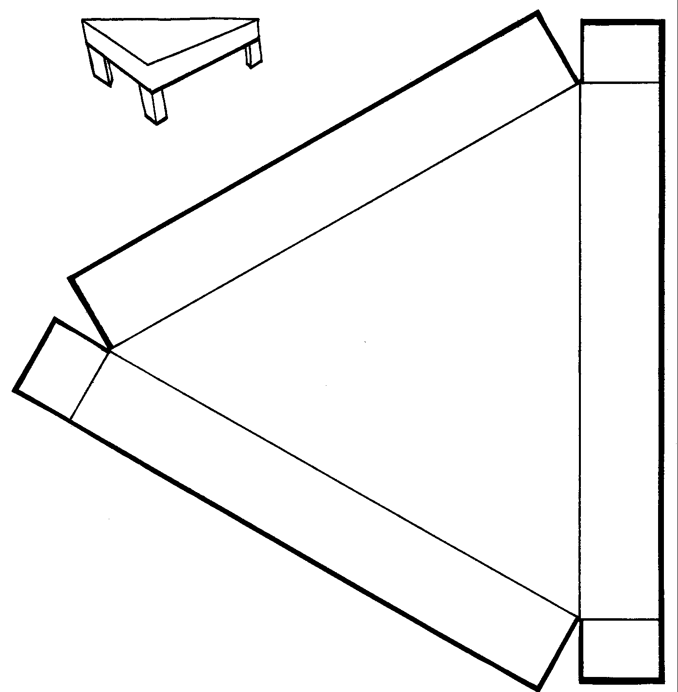

Teacher: Use with Lesson One, Page 7. Photocopy, cut out, mount on tag board and assemble as shown.

HEAT |  | AIR
 |  | (OXYGEN)

FUEL

Fire Triangle

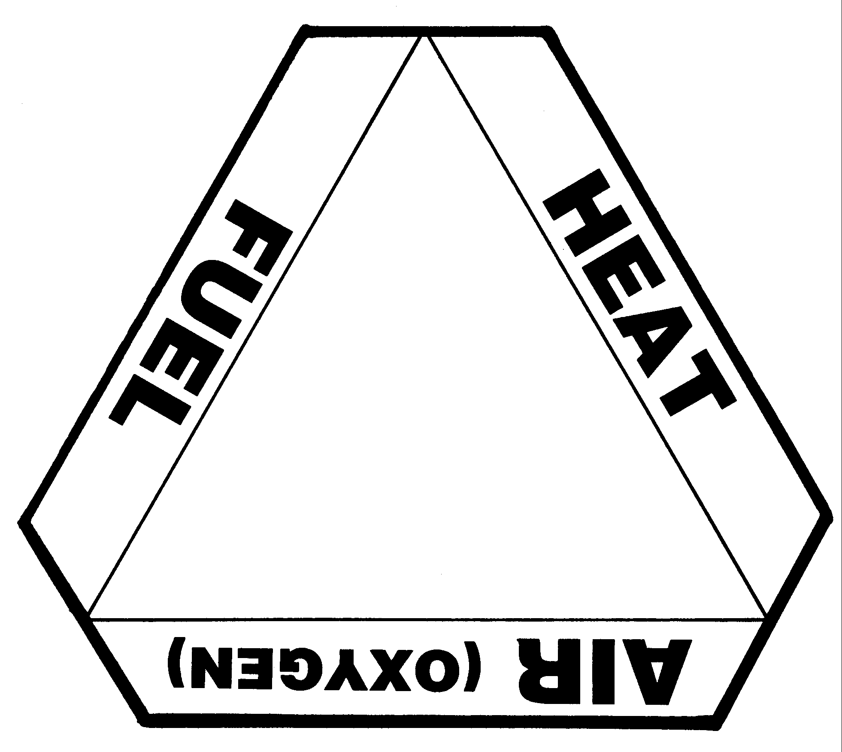

Teacher: Use with Lesson One, Page 7, as a reteaching visual aid. Copy, cut out. Color and mount on tag board if desired.

The Story of Careful and Harmful

Careful lived in a large house with his parents and brothers and sisters. Careful's parents took very good care of the family. They knew how to prevent fires and burns in their home.
Careful's parents always made sure that there was a metal screen in front of the fireplace and they never let Careful and his brothers and sisters play near the fireplace. They kept matches safely in a high cabinet where the children could not reach them. They knew that matches are not toys.
Careful's mother always made sure that anything cooking on the stove was carefully watched — no pot was ever left alone. Careful's father made sure that the cords on all the appliances, like the toaster, coffee pot, iron and hair dryer, were never worn or broken. They never put extension cords under a rug.
Whenever there was a storm, Careful's parents never let the children outside because of the lightning. And Careful's parents made sure that the electric saw and drill was used outdoors safely, according to the directions.
BUT Harmful's family was very different. Harmful also lived in a large house with his parents and brothers and sisters. Harmful's parents didn't know how to take good care of the family. They did not think about stopping fires and burns.
Harmful's parents never put a metal screen in front of the fireplace. They would let Harmful and his brothers and sisters play near the fireplace. They left matches in drawers where the children could reach them. Harmful did not know that matches are not toys.
Harmful's mother never watched anything cooking on the stove very carefully — sometimes a pot was left alone. Harmful's father never checked the cords on the toaster, coffee pot, iron and hair dryer to be sure they weren't worn or broken. They sometimes even put extension cords under a rug.
If there was a storm, Harmful's parents sometimes let the children outside because of the lightening was so exciting. And Harmful's parents were not sure how to use an electric saw or drill safely because they had lost the directions.
Who do you think was being more safe — Careful's family or Harmful's family? Who probably had a fire in their home? What could Harmful and his family do to be more safe? With which family would you like to live? Are you more like Careful or Harmful?

Teacher: Use story with Lesson Two, Page 8, using Careful and Harmful puppets

"Careful" and "Harmful" Puppets

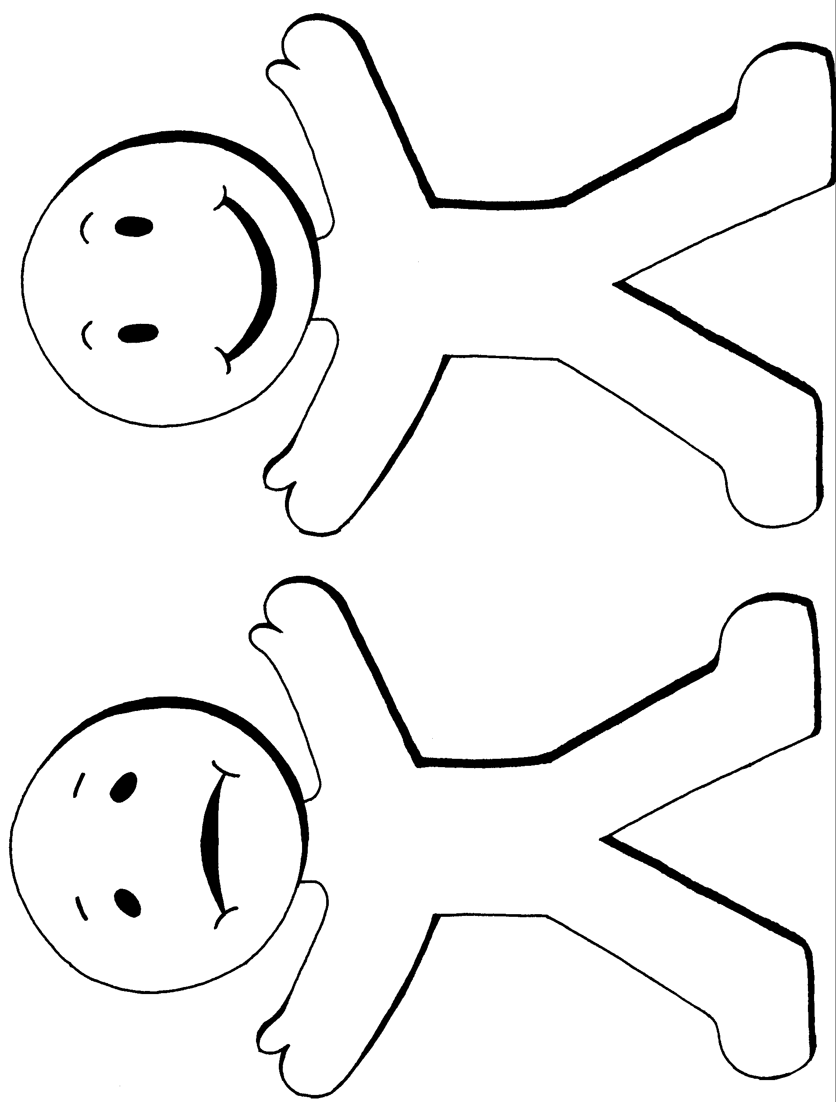

Teacher: Use with Lesson Two, Page 8. Copy, cut out and mount on craft sticks to make puppets or attach felt/Velcro dots to make flannel board characters. Color and mount on tag board if desired.

Fire Safety Guard

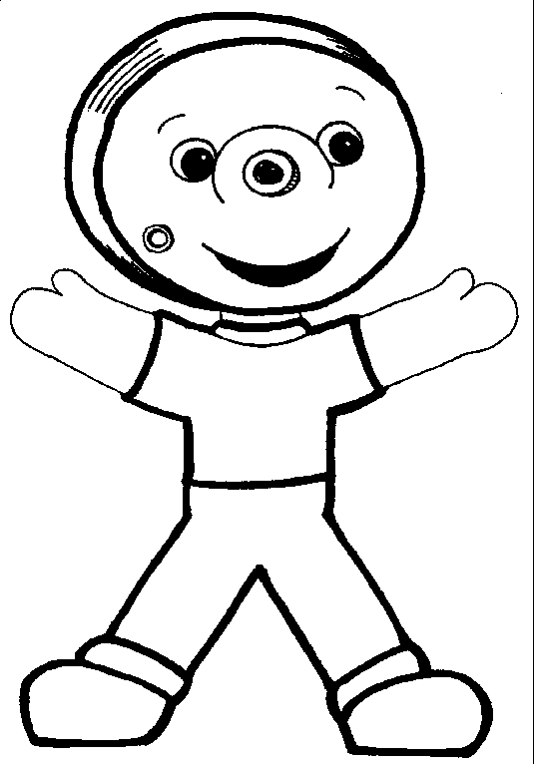

Teacher: Use with Lesson Three, Page 9. Copy, cut out and mount on craft stick to make puppet or attach felt/Velcro dots to make flannel board character. Color and mount on tag board if desired.

Role-Playing Labels

SMOKE

SMOKE ALARM

SLEEPING PERSON
Teacher: Use with Lesson Three, Page 9. Copy, cut apart. Mount on tag board if desired.

Where Smoke Alarms Go

Problem-Solving Activity Sheet

Where will the smoke go? Draw circles where this family should put their smoke alarms.

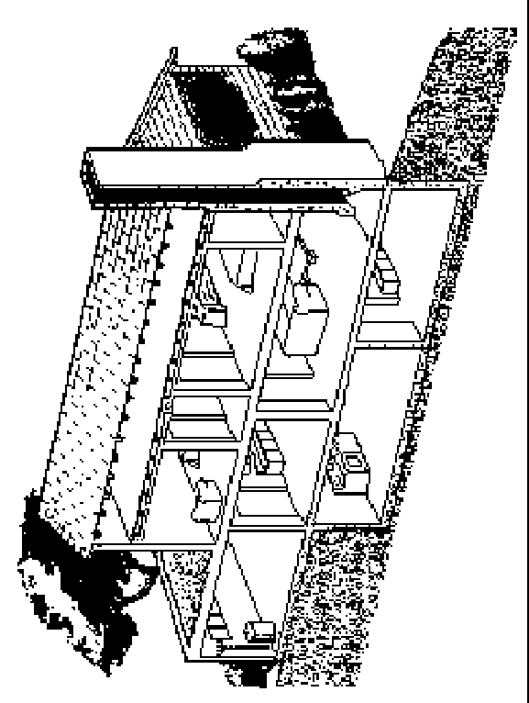

Teacher: Use with Lesson Three, Page 9. Copy illustration onto overhead transparency or poster.

Fire Safety Team Member Badge

Recognition of Student Participation
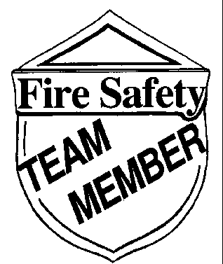

Teacher: Use with Lesson Four, Page 10. Make enough copies for one badge per student. Cut out, color and mount on tag board if desired. Attach safety pin with tape. Alternate: Use double-sided tape instead of safety pin.

Telephone Mock-Up

Independent Practice Visual Aid

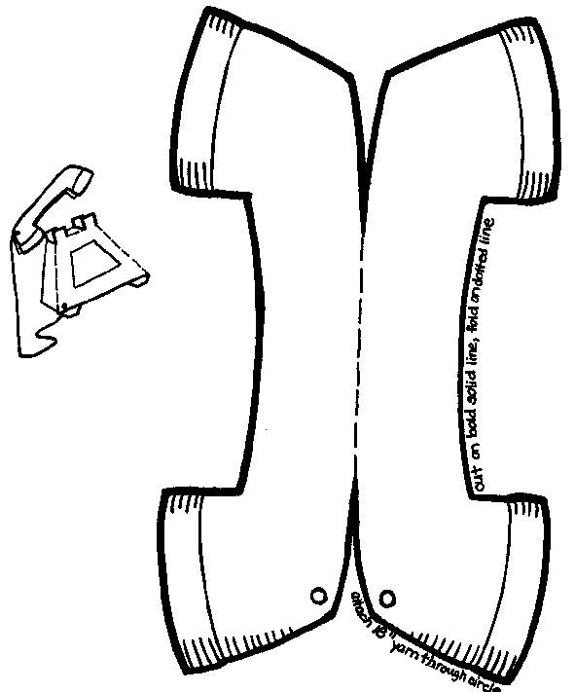

Teacher: Use with Lesson Five, Page 11. Copy, cut out and assemble as show. Color and mount on tag board if desired.

Telephone Mock-Up Continued
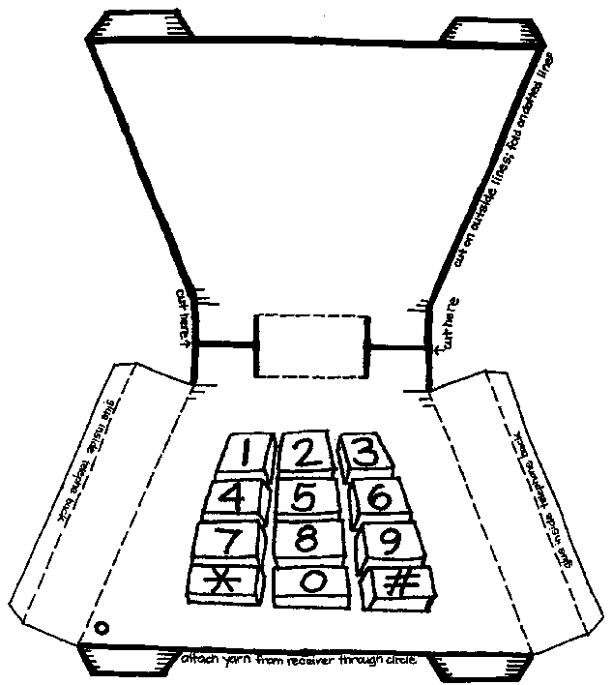

Congratulations!

_____________________________
has learned important ways for
Making Me Fire Safe
Putting out a fire by removing one element
Rolling to put out a clothes fire
Cooling a burn
Preventing fires by using electric equipment safely
Why matches are not toys
Where to put smoke alarms
Why smoke alarms are important
Planning two ways out of a building
Planning a home exit drill
Reporting a fire
Presented on this day
___________________

Friendly Fire Fighter

___________________

Your Teacher

Teacher: Use with Lesson Five, Page 11. Duplicate for all students.

Name
Second Grade: Making Me Fire Safe POST-TEST

Read each question. Then fill in the blanks
1. Three things are needed to make a fire. What are they? (They're sometimes called the elements of fire.)

2. Rolling on the ground takes ______________________ away from the fire.
3. Putting cool water on a burn takes _______________________ away from the burn.
4. You should know at least ____________ exits from every room in your home.
5. Schools have fire exit drills. It is important to have home exit drills? (circle one) Yes No
6. What telephone number should you dial to report a fire? ________________________
7. A fire fighter's only job is to put out fires. True or false? ____________________
8. Do you know how to tell someone your address (where you live)? Yes or no. ________

Circle the letter, A, B or C, that is the correct answer.

9. What happens if you take away one of the elements of fire?
A. Nothing happens
B. The fire gets bigger.
C. The fire goes out.

10. Which is true?
A. Only parents should worry about fire safety.
B. Parents and children can work together to make their home safe.
C. My home is safe, so no one should worry about fires.

11. Which one of these is safe?
A. Using a candle in a Halloween jack-o-lantern.
B. Using an electric (battery-operated) candle at Christmas
C. Leaving Christmas tree lights on all night.
12. People cause fires in many ways. Which of these actions would cause a fire?
A. Having a broken toaster fixed.
B. Not watching pots on the stove while food is cooking.
C. Both of these.

13. Which of these actions would cause a fire?
A. Playing with matches.
B. Plugging in too many Christmas lights.
C. Both of these.

14. Smoke alarms should be placed:
A. In the kitchen.
B. Outside bedrooms.
C. Wherever you want.

15. Fire creates smoke and invisible gases. What effect do the smoke and gases have?
A. No effect.
B. Helps you think better.
C. Keeps you from thinking right.

Teacher: Use with Lesson Five, Page 11. Duplicate for student use.

ANSWER KEY-1

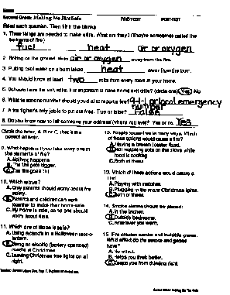 |  | 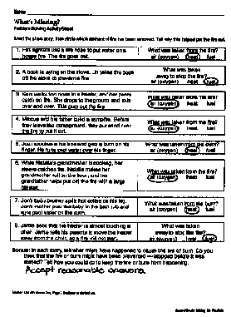
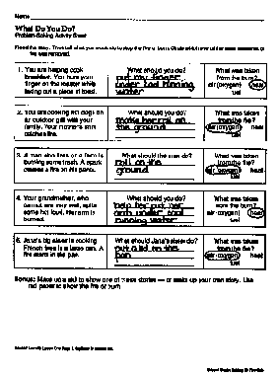 |  | 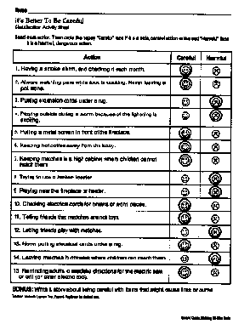

ANSWER KEY-2

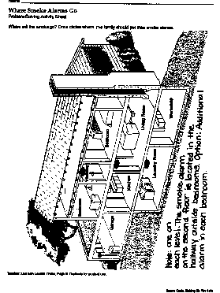 |  | 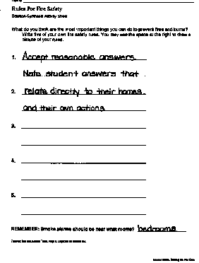
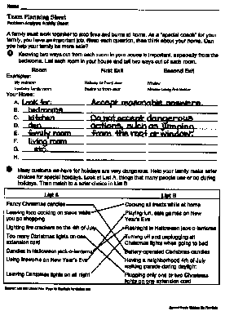 |  | 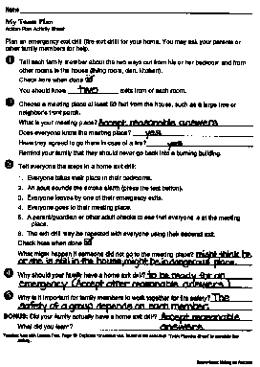

ANSWER KEY-3

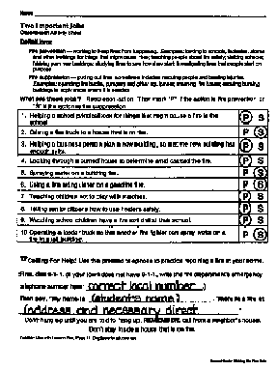

Student Materials —

Duplicating Masters

Name

What's Missing?

Problem-Solving Activity Sheet

Read the short story, then circle which element of fire has been removed. Tell why this helped put the fire out.

1. Fire fighters use a fire hose to put water on a house fire. The fire goes out. | What was taken from the fire?  air (oxygen) heat fuel
2. A book is laying on the stove. Lin takes the book off the stove to prevent a fire. | What was taken away to stop the fire?  air (oxygen) heat fuel
3. Sara walks too close to a heater, and her pants catch on fire. She drops to the ground and rolls over and over. This puts out the fire. | What was taken from the fire?  air (oxygen) heat fuel
4. Marcus and his father build a campfire. Before they leave the campground, they put sand over the fire to put it out. | What was taken from the fire?  air (oxygen) heat fuel
5. Juan touches a hot iron and gets a burn on his finger. He runs cool water over his finger. | What was taken from the burn?  air (oxygen) heat fuel
6. While Natalia's grandmother is cooking, her sleeve catches fire. Natalia makes her grandmother roll on the floor, and her grandfather helps put out the fire with a large blanket. | What was taken from the fire?  air (oxygen) heat fuel
7. Jon's baby brother spills hot coffee on his leg. Jon's mother puts the baby in the bath tub and runs cool water on the burn. | What was taken from the burn?  air (oxygen) heat fuel
8. Jamie sees that the heater is almost touching a chair. Jamie tells his parents to move the heater away from the chair, so a fire will not start. | What was taken away to stop the fire?  air (oxygen) heat fuel

Bonus: In each story, tell what might have happened to cause the fire or burn. Do you think that the fire or burn might have been prevented — stopped before it was started? Tell how you could do to keep the fire or burn from happening.

Teacher: Use with Lesson One, Page 7. Duplicate for student use.

Name

What Do You Do?

Problem-Solving Activity Sheet

Read the story. Then tell what you would do to stop the fire or burn. Circle which one of the three elements of fire was removed.

1. You are helping cook breakfast. You burn your finger on the toaster while taking out a piece of toast. | What should you do? | What was taken from the burn?  air (oxygen) heat  fuel
2. You are cooking hot dogs on an outdoor grill with your family. Your mother's shirt catches fire. | What should you do? | What was taken from the fire?  air (oxygen) heat  fuel
3. A man who lives on a farm is burning some trash. A spark causes a fire on his pants. | What should the man do? | What was taken from the fire?  air (oxygen) heat  fuel
4. Your grandmother, who cannot see very well, spills some hot food. Her arm is burned. | What should you do? | What was taken from the burn?  air (oxygen) heat  fuel
5. Jana's big sister is cooking French fries in a large pan. A fire starts in the pan. | What should Jana's sister do? | What was taken from the fire?  air (oxygen) heat  fuel

Bonus: Make up a skit to show one of these stories — or make up your own story. Use red paper to show the fire or burn.

Teacher: Use with Lesson One, Page 7. Duplicate for student use.

Name

"Careful" and "Harmful" Puppets

Student Puppets

Teacher: Use with Lesson Two, Page 8. Duplicate for student use. Have students cut out and mount on craft sticks to make puppets or attach felt/Velcro dots to make flannel board characters. Color and mount on tag board if desired.

Name

It's Better To Be Careful

Classification Activity Sheet

Read each action. Then circle the happy "Careful" face if it is a safe, careful action or the sad "Harmful" face it is a harmful, dangerous action.

Action | Careful | Harmful
1. Having a smoke alarm, and checking it each month. | ☺ | ☹
2. Always watching pans while food is cooking. Never leaving a pot alone. | ☺ | ☹
3. Putting extension cords under a rug. | ☺ | ☹
4. Playing outside during a storm because of the lightning is exciting. | ☺ | ☹
5. Putting a metal screen in front of the fireplace. | ☺ | ☹
6. Keeping hot coffee away from the baby. | ☺ | ☹
7. Keeping matches in a high cabinet where children cannot reach them | ☺ | ☹
8. Trying to use a broken toaster. | ☺ | ☹
9. Playing near the fireplace or heater. | ☺ | ☹
10. Checking electrical cords for breaks or worn places. | ☺ | ☹
11. Telling friends that matches are not toys. | ☺ | ☹
12. Letting friends play with matches. | ☺ | ☹
13. Never putting electrical cords under a rug. | ☺ | ☹
14. Leaving matches in drawers where children can reach them. | ☺ | ☹
15. Reminding adults to read the directions for the electric saw or drill (or other electric tool). | ☺ | ☹
BONUS: Write a story about being careful with items that might cause fires or burns.
Teacher: Use with Lesson Two, Page 8. Duplicate for student use.

Name

Where Smoke Alarms Go

Problem-Solving Activity Sheet

Where will the smoke go? Draw circles where this family should put their smoke alarms.
Teacher: Use with Lesson Three, Page 9. Duplicate for student use.

Name

Rules For Fire Safety

Solution-Synthesis Activity Sheet

What do you think are the most important things you can do to prevent fires and burns? Write five of your own fire safety rules. You may use the space at the right to draw a picture of your rules.
1.

2.

3.

4.

5.

REMEMBER: Smoke alarms should be near what rooms?

Teacher: Use with Lesson Three, Page 9. Duplicate for student use.

Name

Team Planning Sheet

Problem-Analysis Activity Sheet

A family must work together to stop fires and burns at home. As a "special coach" for your family, you have an important job. Read each question, then think about your home. Can you help your family be more safe?
❶ Knowing two ways out from each room in your house is important, especially from the bedrooms. List each room in your house and tell two ways out of each room.
Room First Exit Second Exit
Examples:
My bedroom Hallway to front door Window
Upstairs family room Stairs to front door Window using fire ladder
Your Home:

A.
B.
C.
D.
E.
F.
G.
H.

❷ Many customs we have for holidays are very dangerous. Help your family make safer choices for special holidays. Look at List A, things that many people use or do during holidays. Then match to a safer choice in List B.

List A | List B
Fancy Christmas candles | Cooking all treats while at home
Leaving food cooking on stove while you go shopping | Playing fun, safe games on New Year's Eve
Lighting fire crackers on the 4th of July | Flashlight in Halloween jack-o-lanterns
Too many Christmas lights on one extension cord | Turning off and unplugging all Christmas lights when going to bed
Candles in Halloween jack-o-lanterns | Battery-operated Christmas candles
Using fireworks on New Year's Eve | Having a neighborhood 4th of July walking parade during daylight
Leaving Christmas lights on all night | Plugging only one or two Christmas lights on one extension cord
Teacher: Use with Lesson Four, Page 10. Duplicate for student use.

Name

My Team Plan

Action-Plan Activity Sheet

Plan an emergency exit drill (fire exit drill) for your home. You may ask your parents or other family members for help.
❶ Tell each family member about the two ways out from his or her bedroom and from other rooms in the house (living room, den, kitchen).
Check here when done 
You should know exits from of each room.
❷ Choose a meeting place at least 50 feet from the house, such as a large tree or neighbor's front porch.
What is your meeting place?
Does everyone know the meeting place?
Have they agreed to go there in case of a fire?
Remind your family that they should never go back into a burning building.
❸ Tell everyone the steps in a home exit drill:
1. Everyone takes their place in their bedrooms.
2. An adult sounds the smoke alarm (press the test button).
3. Everyone leaves by one of their emergency exits.
4. Everyone goes to their meeting place.
5. A parent/guardian or other adult checks to see that everyone is at the meeting place.
6. The exit drill may be repeated with everyone using their second exit.
Check here when done 
What might happen if someone did not go to the meeting place?

❹ Why should your family have a home exit drill?

❺ Why is it important for family members to work together for fire safety?

BONUS: Did your family actually have a home exit drill?
What did you learn?
Teacher: Use with Lesson Four, Page 10. Duplicate for student use. Students will need their "Team Planning Sheet" to complete this activity.

Name

Two Important Jobs

Classification Activity Sheet

Definitions:
Fire prevention — working to keep fires from happening. Examples: looking in schools, factories, stores and other buildings for things that might cause fires; teaching people about fire safety; visiting schools; helping plan new buildings; studying fires to see how they start; investigating fires that people start on purpose.
Fire suppression — putting out fires; sometimes includes rescuing people and treating injuries. Examples: operating fire trucks, pumpers and other equipment; manning fire hoses; entering burning buildings to apply water where it is needed.
What are these jobs? Read each action. Then mark "P" if the action is fire prevention or "S" if the action is fire suppression.
1. Helping a school principal look for things that might cause a fire in the school. | P | S
2. Driving a fire truck to a house that is on fire. | P | S
3. Helping a business person plan a new building, so that the new building has enough exits. | P | S
4. Looking through a burned house to determine what caused the fire. | P | S
5. Spraying water on a building fire. | P | S
6. Using a fire extinguisher on a gasoline fire. | P | S
7. Teaching children not to play with matches. | P | S
8. Telling senior citizens how to use heaters safely. | P | S
9. Watching school children have a fire exit drill at their school. | P | S
10. Operating a ladder truck so that another fire fighter can spray water on a fire in a tall building. | P | S

Calling For Help! Use the pretend telephone to practice reporting a fire at your home.
First, dial 9-1-1. (If your town does not have 9-1-1, write the fire department's emergency telephone number here: __________________________________.)
Then say, "My name is _____________________________________. There is a fire at
________________________________________________________________."
Don't hang up until you are told to hang up. REMEMBER, call from a neighbor's house. Don't stay inside a house that is on fire.
Teacher: Use with Lesson Five, Page 11. Duplicate for student use.

