Employee Automated off-boarding guide

Employee
- Go into desktop dashboard
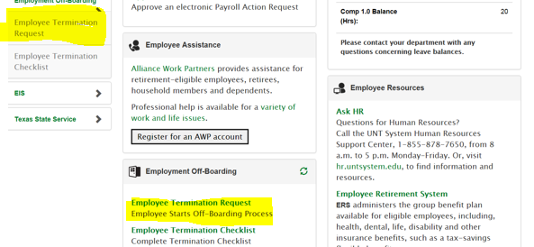

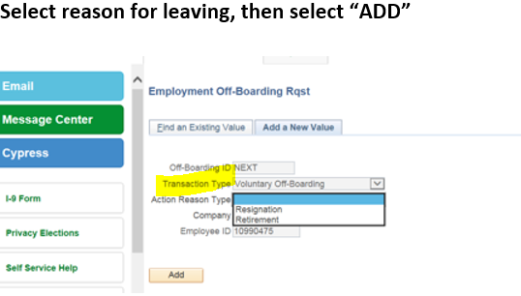

Select Off-Boarding reason from drop down list
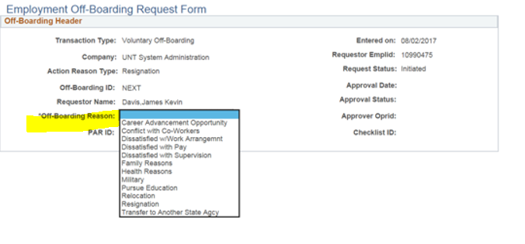
Select the active job record that are leaving from, NOTE: If you have more than one active job record you must fill out an Off-Boarding request for each active Job Record
Then enter the Requested Last Day at Work or use the drop down calendar
Select Next
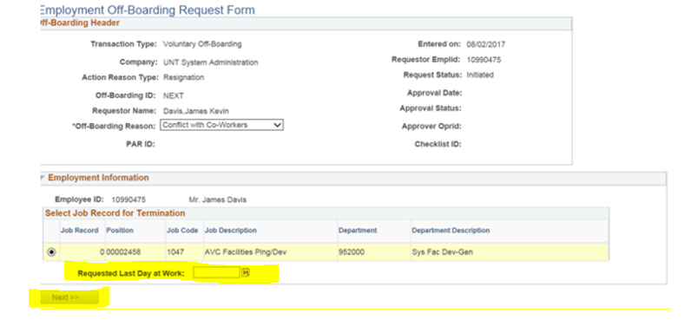

You can now either 1) save the request (to be edited at a later date) 2) save and submit the request or 3) cancel the request
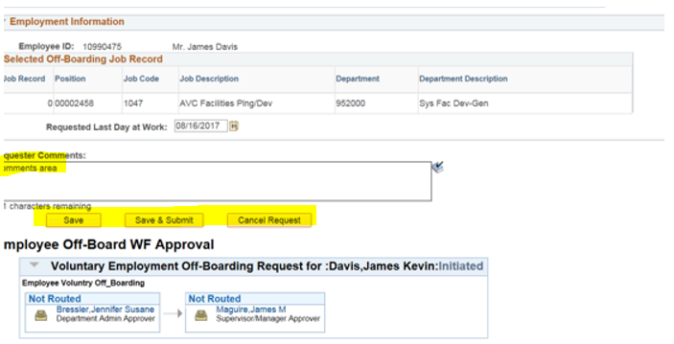
If you select Save and submit who will receive an email indicating that the request has been submitted.

