Instructions for Soft Encumbrance Requisition:

Create the Soft Encumbrance

Prepare a requisition as normal, entering a minimum of information.
Go to myfs.unt.edu > eProcurement > Requisition

Requisition Settings screen:
- Enter Requisition Name
- Enter Chartstring
- Supplier (optional – can be left blank)
- Click OK

Create Requisition screen:
- Click New Requisition link
- Complete New Requisition required information:
  - Goods/Services Description
    - Use description that tells YOU the purpose of the soft encumbrance
  - Quantity
  - Unit of Measure
  - Amount
  - Category Code
    - Be sure to use a Category Code that posts to the D-Level where you want soft encumbrance to appear
    - Requisition Category Codes file available on Budget Office website
  - Click Add to Cart
  - Click Checkout

Checkout Page
- Enter any comments you want to help YOU identify the purpose of the soft encumbrance
  - You can attach files as you would for a regular requisition
- Click “Save Before Submit”
- Click “Check Budget”
- You must receive a “Valid” budget check for the balance to be pre-encumbered

Do NOT submit the Req!!
Leave it in Open Status with Valid Budget Check
(See below)
From the Manage Requisitions Screen, you will see:
Go to myfs.unt.edu > eProcurement > Manage Requisitions

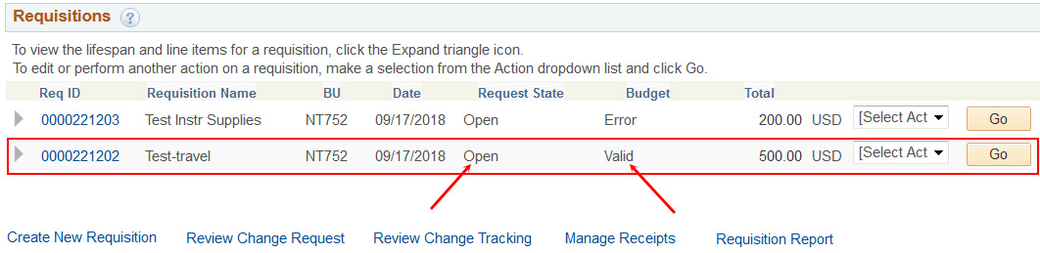

- This creates a pre-encumbrance on your chartstring. This pre-encumbrance is your “soft encumbrance.”
- In a few months when the real charges are posted, you will need to Cancel the requisition to remove the pre-encumbrance.

To Cancel the Soft Encumbrance Requisition
- From Manage Requisition screen, locate the Open Req.
- Change “Select Action” drop down menu to “Cancel” and click Go.
  - A Requisition Details page appears.
  - Click the Cancel Requisition button.
- This returns you to the Manage Requisitions page. Note the following changes:
  - Request State: Canceled
  - Budget: Not Chk’d
  - Total: 0.00 USD
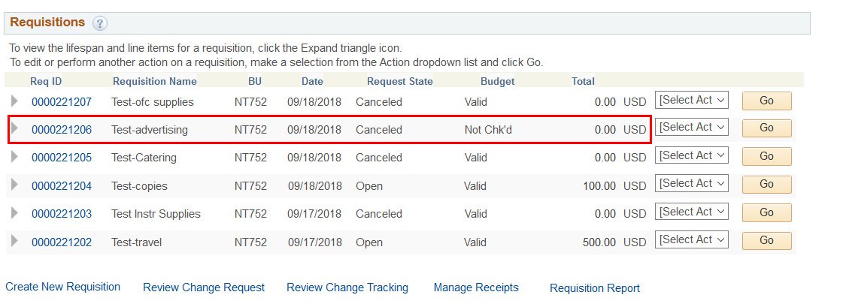
Funds are still pre-encumbered. You must complete next step to remove the soft encumbrance!
- Change “Select Action” drop down menu to “Budget Check” and click Go. Note this change:
  - Budget: Valid
- A Valid Budget of Zero means that your soft encumbrance (the pre-encumbrance) has been removed from your chartstring.

Review Soft Encumbrance Report to monitor soft encumbrances.
- Departments will be able to run reports as needed
- System will push reports on a monthly basis to req preparers.

