DEPARTMENT OF HEALTH AND HUMAN SERVICES

ADMINISTRATION FOR CHILDREN AND FAMILIES

HELP GUIDE

FUNCTIONAL MODEL

COST/BENEFIT ANALYSIS ILLUSTRATED
FOR CHILD SUPPORT ENFORCEMENT SYSTEMS

MAY 2000
Revised MARCH 2001

Change sheet

Date | Change
March 9, 2001 | The Functional Benefit Model application has been redesigned from the original five data bases or files, which were titled NewMainMenu.xls, Costs.xls, Benefits.xls, Summary.xls, and CBSummary.xls, into a single file titled Functional Model V2.xls
 | The opportunity to save input data after selecting ‘Return’ from NewMainMenu.xls, Costs.xls, Benefits.xls, Summary.xls, and CBSummary.xls, menus’ has been eliminated. The only opportunity to save will be on ‘Exit’ from Functional Model V2.xls

Table Of Contents

Benefit Analysis - Functional Model 4
Introduction 4
Model Description 4
Functional Benefit Model Spreadsheets 5
Functional Benefit Model Tutorial 5
Input Cost Data 5
Input Benefits Data 13
Review Benefits Summary Data 20
Review Costs Benefits Summary Data 25
Exit Costs Benefits Application 33
References 35

Table Of Figures

Figure 1-1. Main Menu 5
Figure 1-2. Cost Menu 6
Figure 1-3. Input Cost Data Option 7
Figure 1-4. Input Non Recurring Cost Data 8
Figure 1-5. Input Recurring Cost Data 9
Figure 1-6. Print Cost Data Option 10
Figure 1-7. Print Cost Data 11
Figure 1-8. Return to Cost Menu 12
Figure 1-9. Return to Main Menu 13
Figure 1-10. Benefits Menu 14
Figure 1-11. Input Benefits Data Option 15
Figure 1-12. Input Benefits Data 16
Figure 1-13. Print Benefits Data Option 17
Figure 1-14. Print Benefits Data 18
Figure 1-15. Select Benefits Data Option 19
Figure 1-16. Return to Main Menu 20
Figure 1-17. Benefits Summary Menu 21
Figure 1-18. Print Benefits Summary Data Option 22
Figure 1-19. Print Benefits Summary Data 23
Figure 1-20. Return to Benefits Summary Menu 24
Figure 1-21. Return to Main Menu 25
Figure 1-22. Costs Benefits Summary Menu 26
Figure 1-23. Print Costs Benefits Summary Data Option 27
Figure 1-24. Print Costs Benefits Summary Data 28
Figure 1-25. Return to Costs Benefits Summary Menu 29
Figure 1-26. Print Alternative 3 Chart Data Option 30
Figure 1-27. Print Alternative 3 Chart Data 31
Figure 1-28. Return to Costs Benefits Summary Menu 32
Figure 1-29. Return to Main Menu 33
Figure 1-30. Save Main Menu Option 34

Benefit Analysis - Functional Model

Introduction
The Functional Model shows the relationship between discrete system enhancements or components and the corresponding revenue increase. This model estimates the increase in revenue and cost-savings from increased automation, for each major PRWORA function that will be added to the new system. This benefit model supports the benefits used in the Annual and System Life Benefits Baseline in Chapter 2 of Companion Guide 3.

The weakness of this model is that it is sometimes difficult to determine which enhancement is responsible for a specific amount of revenue increase. In addition, for some enforcement techniques, there is also the potential for counting a benefit more than once.

Model Description
The following Table 1 provides a system map of the menus and sub-menus of the Functional Benefit Model. The actual menus and spreadsheets are depicted in the Functional Benefit Model Tutorial.

MAIN MENU OPTION | SUB MENU | SPREADSHEET |  | DATA ENTRY
Costs-Profile | Input Cost  Data Menu | Costs-Status-Quo |  | Yes
Costs-Profile | Input Cost  Data Menu | Costs-Alt1 |  | Yes
Costs-Profile | Input Cost  Data Menu | Costs-Alt2 |  | Yes
Costs-Profile | Input Cost  Data Menu | Costs-Alt3 |  | Yes
Benefits-Profile | Input Benefits Data Menu | Status Quo  Alt1  Alt2  Alt3 | Benefit 1 | Yes
Benefits-Profile | Input Benefits Data Menu | Status Quo  Alt1  Alt2  Alt3 | Benefit 2 | Yes
Benefits-Profile | Input Benefits Data Menu | Status Quo  Alt1  Alt2  Alt3 | Benefit 3 | Yes
Benefits-Profile | Input Benefits Data Menu | Status Quo  Alt1  Alt2  Alt3 | Benefit 4 | Yes
Benefits-Profile | Input Benefits Data Menu | Status Quo  Alt1  Alt2  Alt3 | Benefit 5 | Yes
Benefits-Profile | Input Benefits Data Menu | Status Quo  Alt1  Alt2  Alt3 | Benefit 6 | Yes
Benefits-Profile | Input Benefits Data Menu | Status Quo  Alt1  Alt2  Alt3 | Benefit 7 | Yes
Benefits-Profile | Input Benefits Data Menu | Status Quo  Alt1  Alt2  Alt3 | Benefit 8 | Yes
Benefits-Profile | Input Benefits Data Menu | Status Quo  Alt1  Alt2  Alt3 | Benefit 9 | Yes
Benefits-Profile | Input Benefits Data Menu | Status Quo  Alt1  Alt2  Alt3 | Benefit 10 | Yes
Benefits-Profile | Input Benefits Data Menu | Status Quo  Alt1  Alt2  Alt3 | Benefit 11 | Yes
Benefits-Summary | Benefits Summary Menu | Benefits-Status-Quo |  | No
Benefits-Summary | Benefits Summary Menu | Benefits-Alt1 |  | No
Benefits-Summary | Benefits Summary Menu | Benefits-Alt2 |  | No
Benefits-Summary | Benefits Summary Menu | Benefits-Alt3 |  | No
Costs-Benefits-Summary | Comparison Menu | CBA-Summary |  | No
Costs-Benefits-Summary | Comparison Menu | Chart-Status Quo |  | No
Costs-Benefits-Summary | Comparison Menu | Chart-Alt1 |  | No
Costs-Benefits-Summary | Comparison Menu | Chart-Alt2 |  | No
Costs-Benefits-Summary | Comparison Menu | Chart-Alt3 |  | No
Table 1 - Functional Model Cost/Benefit Analysis Spreadsheets

Functional Benefit Model Spreadsheets

The Microsoft Excel 97 application accompanying this guide contains integrated spreadsheets designed for entering and summarizing Child Support Enforcement Cost/Benefit Analysis data. The Functional Benefit Model application has been redesigned from the original five data bases or files, which were titled NewMainMenu.xls, Costs.xls, Benefits.xls, Summary.xls, and CBSummary.xls, into a single file titled Functional Model V2.xls.

Functional Benefit Model Tutorial

Input Cost Data
Step 1 - Open the Functional Model V2.xls program to start the application. Figure 1-1 will appear as the initial screen. From Figure 1-1 the Analyst can:

- Select ‘Costs Profile and Go To’ to access the Input Cost Data Menu, or
- Select ‘Benefits Profile and Go To’ to access the Input Benefits Data Menu, or
- Select ‘Benefits Summary and Go To’ to view the Benefits Summary Menu, or
- Select ‘Costs Benefits Summary and Go To’ to view a CBA Summary Menu, or
- Select ‘Exit’, to close the application (Go to Step 30).

For purposes of this example, select ‘Costs Profile and Go To’, and continue to Step 2.

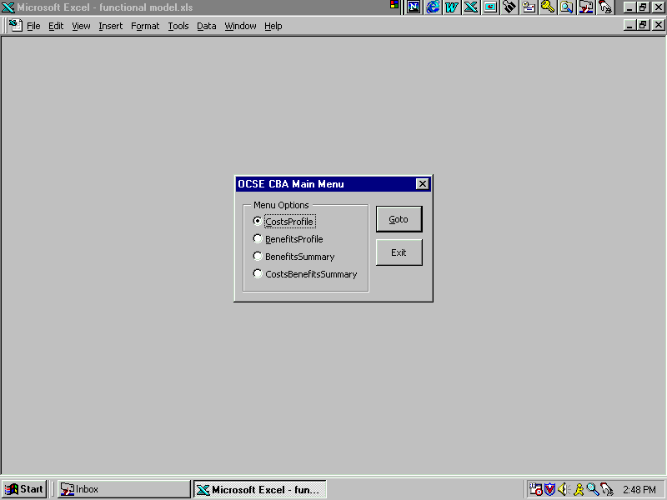

Main Menu
Step 2 - When ‘Costs Profile and Go To’ has been selected Figure 1-2 will appear as the screen. From Figure 1-2 the Analyst can:

- Select ‘Costs Status Quo and Go To’ to access the input cost data screen where recurring and non-recurring annual costs for the Status Quo can be entered, or
- Select ‘Costs Alt 1 and Go To’ to access the input cost data screen where recurring and non-recurring annual costs for Alternative 1 can be entered, or
- Select ‘Costs Alt 2 and Go To’ to access the input cost data screen where recurring and non-recurring annual costs for Alternative 2 can be entered, or
- Select ‘Costs Alt 3 and Go To’ to access the input cost data screen where recurring and non-recurring annual costs for Alternative 3 can be entered, or
- Select ‘Return’, to close the ‘Cost Data Menu’ menu and return to the ‘Main Menu’.

Note: Since the process is the same regardless of the selection, ‘Costs Status Quo’, ‘Costs Alt 1’, ‘Costs Alt 2’, or ‘Costs Alt 3’, steps 3 through 7 are only presented once.

For purposes of this example, select ‘Costs Status Quo and Go To’, and continue to Step 3.

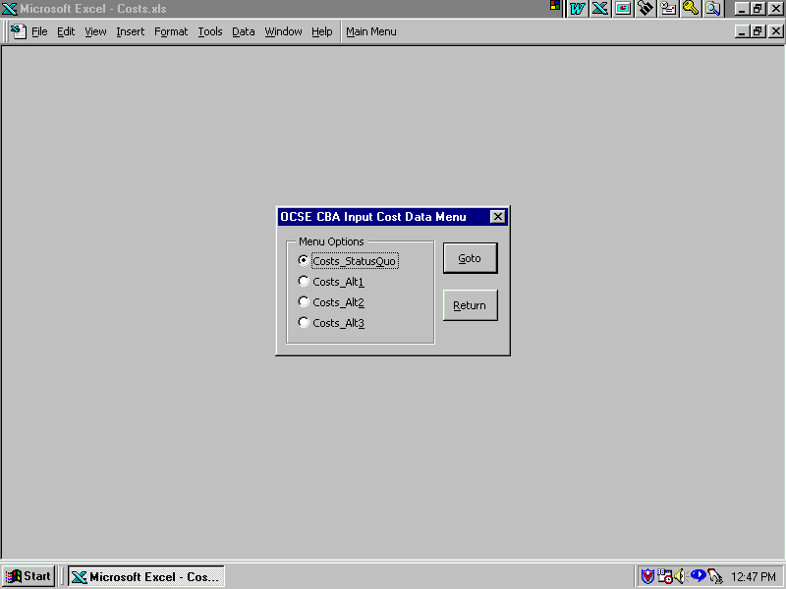

Cost Menu
Step 3 - When ‘Costs Status Quo and Go To’ has been selected Figure 1-3 will appear as the screen. From Figure 1-3 the Analyst can:

- Select ‘No’ to activate the Print Costs Data Option screen (Go to Step 6), or
- Select ‘Yes’ to Input/Change Non-Recurring Cost Data.

Select ‘Yes’, to go to the OCSE CBA Non-Recurring Cost Data screen. Continue to Step 4.

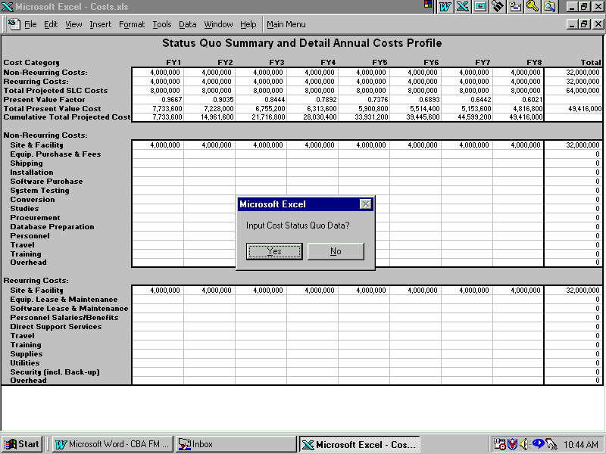

Input Cost Data Option
Step 4 - When ‘Yes’ has been selected Figure 1-4 will appear as the screen. From Figure 1-4 the Analyst can:

- Input or Change Non-Recurring Costs Data, if any
Note: To move between cells use Tab, Enter, Arrows or highlight using the Mouse.
- Select ‘X (Close Window)’ to activate the OCSE CBA Recurring Cost Data screen.

Select ‘X (Close Window)’, to go to the OCSE CBA Recurring Cost Data screen. Continue to Step 5.

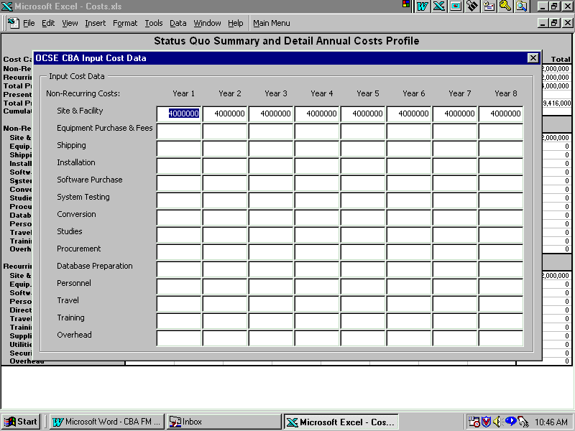

Input Non Recurring Cost Data
Step 5 - When ‘X (Close Window)’ has been selected Figure 1-5 will appear as the screen. From Figure 1-5 the Analyst can:

- Input/Change Recurring Costs Data, if any
Note: To move between cells use Tab, Enter, Arrows or highlight using the Mouse.

- Select ‘X (Close Window)’ to activate the Print Costs Data Option screen.

Select ‘X (Close Window)’, to go to the Print Costs Data Option screen. Continue to Step 6.

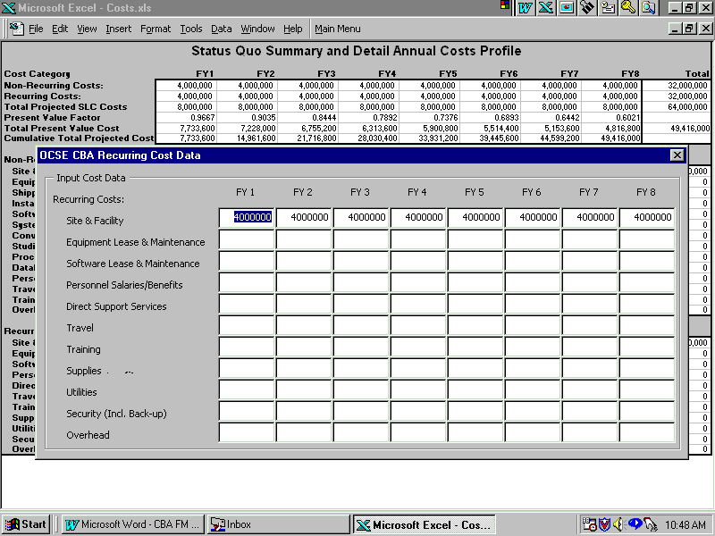

Input Recurring Cost Data
Step 6 - When ‘X (Close Window)’ from Step 5 or ‘No’ from Step 3 has been selected Figure 1-6 will appear as the screen. From Figure 1-6 the Analyst can:

- Select ‘Yes’, to Print Preview Cost data, or
- Select ‘No’, to by-pass Step 7 and go to Step 8.

For purposes of this example, select ‘Yes’, and go to Step 7.

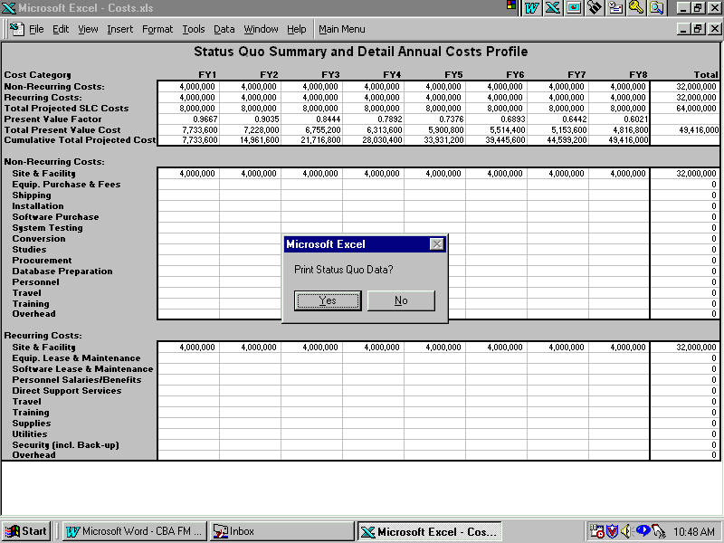

Print Cost Data Option
Step 7 - When ‘Yes’ has been selected Figure 1-7 will appear as the screen. From Figure 1-7 the Analyst can:

- Select ‘Next’, ‘Previous’, ‘Zoom’, ‘Setup’, ‘Margins’, ‘Page Break Preview’ or
Note 1: Selecting ‘Page Break Preview’ is not recommended, because it will change the spreadsheet views. If this should happen, the print view screen will automatically close and return to the Main Menu. To recover repeat Steps 2 through 7, answer ‘No’ at Step 3, and select ‘Normal View’.

- Select ‘Print’, to Print Cost data, or
Note: After various print messages, the program returns to the Cost Menu data screen.

- Select ‘Close’, to return to the Cost Menu data screen.

For purposes of this example, select ‘Print or Close’, and go to Step 8.

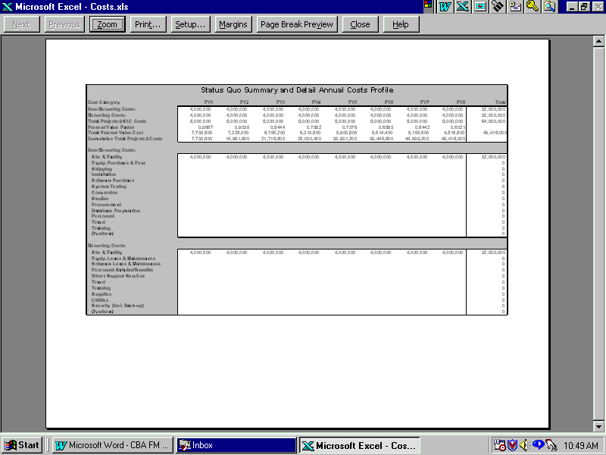

Print Cost Data
Step 8 - When ‘No’ from Step 6 or ‘Print or Close’ from Step 7 has been selected Figure 1-8 will appear as the screen. From Figure 1-8 the Analyst can:

- Select ‘Costs Status Quo and Go To’ to access the input cost data screen where recurring and non-recurring annual costs for the Status Quo can be entered, or
- Select ‘Costs Alt 1 and Go To’ to access the input cost data screen where recurring and non-recurring annual costs for Alternative 1 can be entered, or
- Select ‘Costs Alt 2 and Go To’ to access the input cost data screen where recurring and non-recurring annual costs for Alternative 2 can be entered, or
- Select ‘Costs Alt 3 and Go To’ to access the input cost data screen where recurring and non-recurring annual costs for Alternative 3 can be entered, or
- Select ‘Return’, to close the ‘Costs Profile’ application return to the ‘Main Menu’.

For purposes of this example, select ‘Return’, and continue to Step 9.

Return to Cost Menu

Input Benefits Data

Step 9 – When ‘Return’ has been selected Figure 1-9 will appear as the screen. From Figure 1-9 the Analyst can:

- Select ‘Costs Profile and Go To’ to access the Input Cost Data Menu where recurring and non-recurring Annual costs for the Status Quo and up to three alternatives can be entered, or
- Select ‘Benefits Profile and Go To’ to access the Input Benefits Data Menu where up to 11 benefits for the Status Quo and up to three alternatives can be entered by quarter, or
- Select ‘Benefits Summary and Go To’ to view the Summary of the Benefits Menu for each alternative, or
- Select ‘Costs Benefits Summary and Go To’ to see a system life cycle cost and benefit profile and graphical representations of cumulative costs and benefits and the breakeven point for each alternative, or
- Select ‘Exit’, to close the application (Go to Step 30).

For purposes of this example, select ‘Benefits Profile and Go To’, and continue to Step 10.

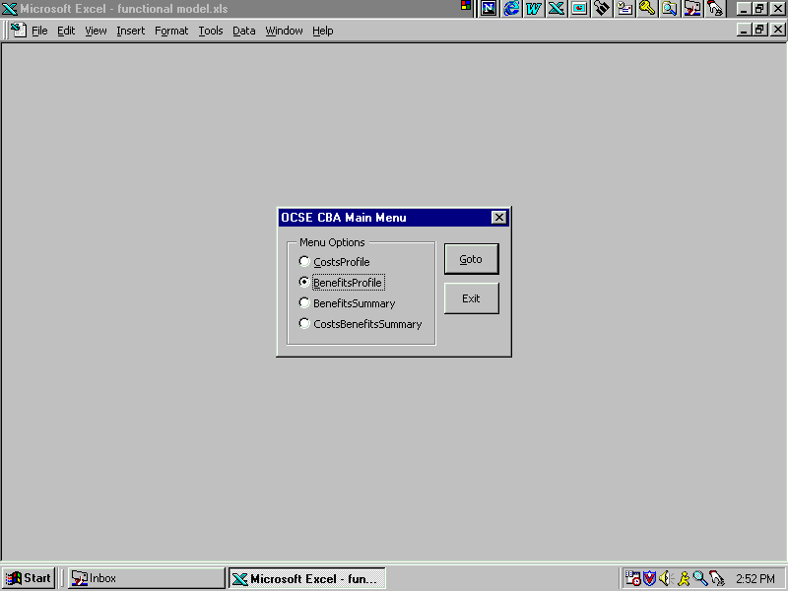

Return to Main Menu
Step 10 - When ‘Benefits Profile and Go To’ has been selected Figure 1-10 will appear as the screen. From Figure 1-10 the Analyst can:

- Select ‘Status Quo, a Benefit number and Go To’ to access the Input Benefits data screen where the Status Quo quarterly savings can be entered, or
- Select ‘Alternative 1, a Benefit number and Go To’ access the Input Benefits data screen where the Alternative 1 quarterly Benefits can be entered, or
- Select ‘Alternative 2 a Benefit number and Go To’ to access the Input Benefits data screen where the Alternative 2 quarterly Benefits can be entered, or
- Select ‘Alternative 3 a Benefit number and Go To’ access the Input Benefits data screen where the Alternative 3 quarterly Benefits can be entered, or
- Select ‘Return’, to close the ‘Benefits Profile’ application and return to the ‘Main Menu’.

Note: Since the process is the same regardless of the selection, ‘Status Quo’, ‘Alternative 1’, ‘Alternative 2’, or ‘Alternative 3’, to include Benefit 1 through Benefit 11 for each, Step 11 through Step 14 are only presented once.

For purposes of this example, select ‘Status Quo, Benefit 1 and Go To’, and continue to Step 11.

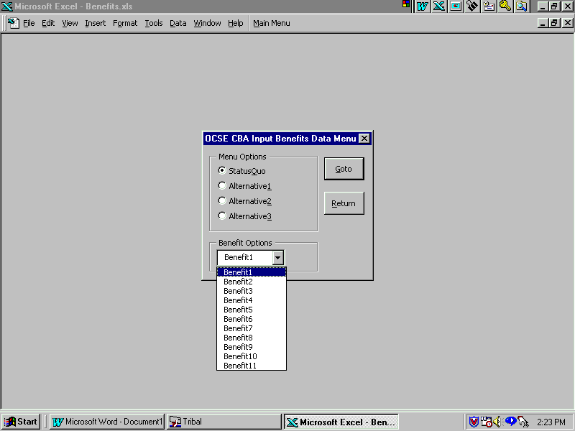

Benefits Menu
Step 11 - When ‘Status Quo, Benefit 1 and Go To’ has been selected Figure 1-11 will appear as the screen. From Figure 1-11 the Analyst can:

- Select ‘No’ to activate the Print Benefits Option screen (Go to Step 13), or
- Select ‘Yes’ to Input/Change Status Quo, Benefit 1 Data.

Select ‘Yes’, to go to the Input Status Quo, Benefit 1 Data screen. Continue to Step 12.

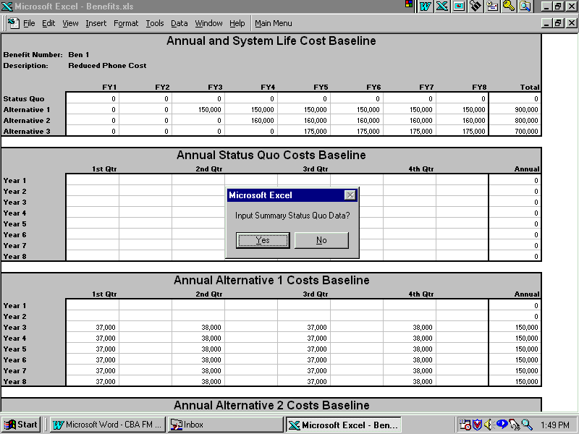

Input Benefits Data Option
Step12 - When ‘Yes’ has been selected Figure 1-12 will appear as the screen. From Figure 1-12 the Analyst can:

- Input or Change Status Quo, Benefit 1 Data, or
Note: To move between cells use Tab, Enter, Arrows or highlight a cell using the Mouse. The Status Quo screen is the only opportunity to input the Benefit Number and Description. The Benefit numbers and descriptions for Alternative 1, Alternative 2, and Alternative 3 are taken from the Status Quo screen.

- Select ‘X (Close Window)’ to activate the Print Benefits Data screen option.

Select ‘X (Close Window)’, to go to the Print Benefits Data screen. Continue to Step 13.

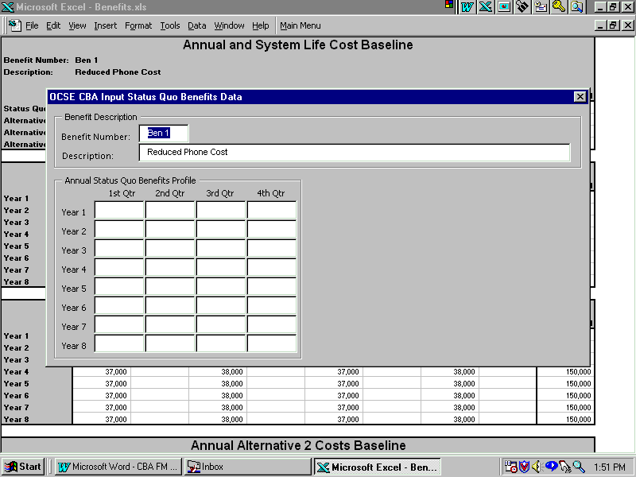

Input Benefits Data
Step 13 - When ‘X (Close Window)’ from Step 12 or ‘No’ from Step 11 has been selected Figure 1-13 will appear as the screen. From Figure 1-13 the Analyst can:

- Select ‘Yes’, to Print Preview Benefits data, or
Note: When printing benefits, all the Alternatives are printed for the selected Benefit.

- Select ‘No’, to by-pass Step 14 and go to Step 15.

For purposes of this example, select ‘Yes’, and go to Step 14.

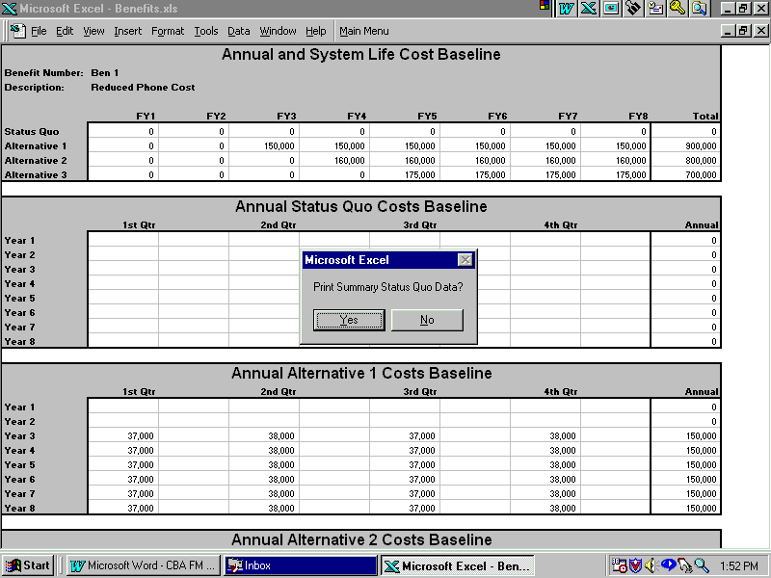

Print Benefits Data Option
Step 14 - When ‘Yes’ has been selected Figure 1-14 will appear as the screen. From Figure 1-14 the Analyst can:

- Select ‘Next’, ‘Previous’, ‘Zoom’, ‘Setup’, ‘Margins’, ‘Page Break Preview’ or
Note 1: Selecting ‘Page Break Preview’ is not recommended, because it will change the spreadsheet views. If this should happen, the print view screen will automatically close and return to the Main Menu. To recover repeat Steps 10 through 14, answer ‘No’ at Step 11, and select ‘Normal View’.

- Select ‘Print’, to Print Benefits data, or
Note: The Benefits Report includes all alternatives, plus a summary. After various print messages, the program returns to the Benefits Menu data screen.

- Select ‘Close’, to return to the Benefits Menu data screen.

For purposes of this example, select ‘Print or Close’, and go to Step 15.

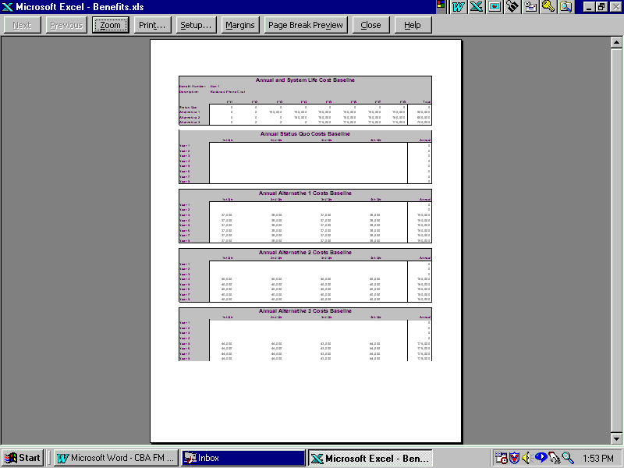

Print Benefits Data
Step 15 - When ‘No’ from Step 13 or ‘Print or Close’ from Step 14 has been selected Figure 1-15 will appear as the screen. From Figure 1-15 the Analyst can:

- Select ‘Status Quo, a Benefit number and Go To’ to access the Input Benefits data screen where the Status Quo quarterly savings can be entered, or
- Select ‘Alternative 1, a Benefit number and Go To’ access the Input Benefits data screen where the Alternative 1 quarterly Benefits can be entered, or
- Select ‘Alternative 2 a Benefit number and Go To’ to access the Input Benefits data screen where the Alternative 2 quarterly Benefits can be entered, or
- Select ‘Alternative 3 a Benefit number and Go To’ access the Input Benefits data screen where the Alternative 3 quarterly Benefits can be entered, or
- Select ‘Return’, to close the ‘Benefits Profile’ application and return to the ‘Main Menu’.

For purposes of this example, select ‘Return’, and continue to Step 16.

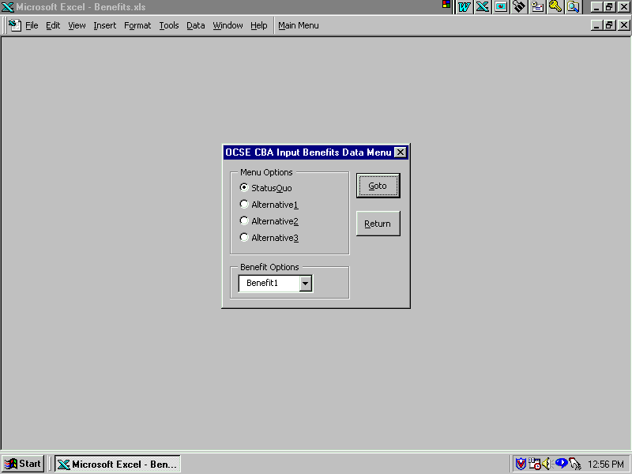

Select Benefits Data Option

Review Benefits Summary Data

Step 16 – When ‘Return’ has been selected Figure 1-16 will appear as the initial screen. From Figure 1-16 the Analyst can:

- Select ‘Costs Profile and Go To’ to access the Input Cost Data Menu where recurring and non-recurring Annual costs for the Status Quo and up to three alternatives can be entered, or
- Select ‘Benefits Profile and Go To’ to access the Input Benefits Data Menu where up to 11 benefits for the Status Quo and up to three alternatives can be entered by quarter, or
- Select ‘Benefits Summary and Go To’ to view the Summary of the Benefits Menu for each alternative, or
- Select ‘Costs Benefits Summary and Go To’ to see a system life cycle cost and benefit profile and graphical representations of cumulative costs and benefits and the breakeven point for each alternative, or
- Select ‘Exit’, to close the application (Go to Step 30).

For purposes of this example, select ‘Benefits Summary and Go To’, and continue to Step 17.

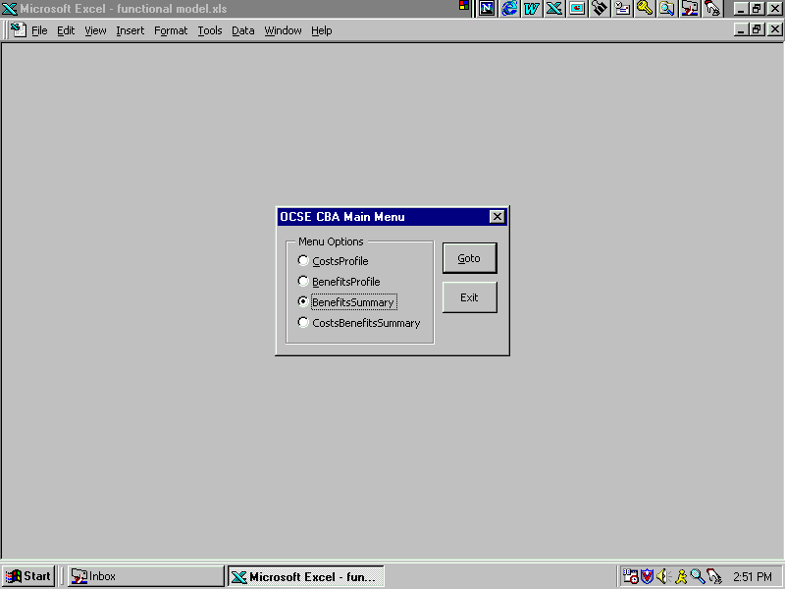

Return to Main Menu
Step 17 - When ‘Benefits Summary and Go To’ has been selected Figure 1-17 will appear as the screen. From Figure 1-17 the Analyst can:

- Select ‘Summary Status Quo and Go To’ to access the Status Quo Summary data screen, or
- Select ‘Summary Alt 1 and Go To’ to access the Alternative 1 Summary data screen, or
- Select ‘Summary Alt 2 and Go To’ to access the Alternative 2 Summary data screen, or
- Select ‘Summary Alt 3 and Go To’ to access the Alternative 3 Summary data screen, or
- Select ‘Return’, to close the ‘Benefits Summary’ application and return to the ‘Main Menu’.

Note: Since the process is the same regardless of the selection, ‘Summary Status Quo’, ‘Summary Alt 1’, ‘Summary Alt 2’, or ‘Summary Alt 3’, Step 18 through Step 19 are only presented once.

For purposes of this example, select ‘Summary Status Quo and Go To’, and continue to Step 18.

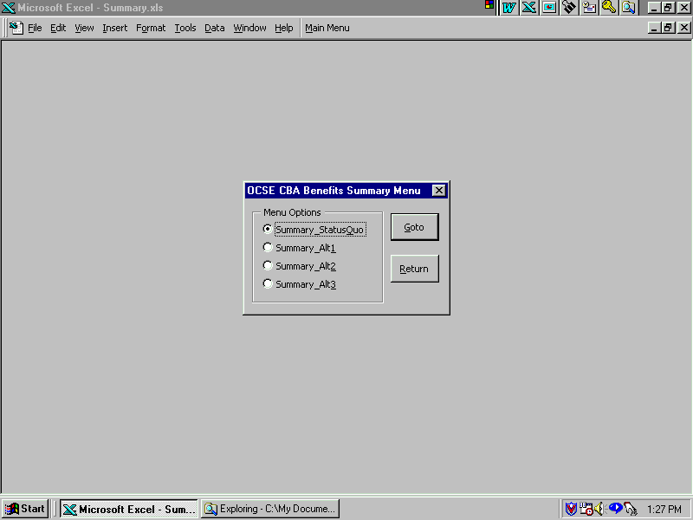

Benefits Summary Menu
Step 18 - When ‘Summary Status Quo’ has been selected Figure 1-18 will appear as the screen. From Figure 1-18 the Analyst can:

- Select ‘Yes’, to Print Status Quo Benefits Summary data, or
Note: When printing benefits, all 8 years plus a summary is printed for the selected alternative.

- Select ‘No’, to by-pass Step 19 and go to Step 20.

For purposes of this example, select ‘Yes’, and go to Step 19.

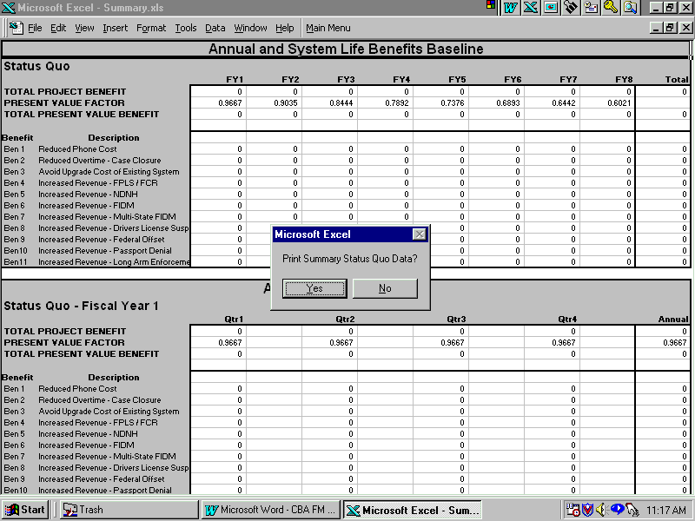

Print Benefits Summary Data Option
Step 19 - When ‘Yes’ has been selected Figure 1-19 will appear as the screen. From Figure 1-19 the Analyst can:

- Select ‘Next’, ‘Previous’, ‘Zoom’, ‘Setup’, ‘Margins’, ‘Page Break Preview’ or
Note 1: Selecting ‘Page Break Preview’ is not recommended, because it will change the spreadsheet views. If this should happen, the print view screen will automatically close and return to the Main Menu. To recover repeat Steps 17 through 19, and select ‘Normal View’.

- Select ‘Print’, to Print Benefits Summary data, or
Note: The Benefits Summary Report includes all 8 years for the selected alternative. Use ‘Next’ and ‘Previous’ to view different pages of the report. After various print messages, the program returns to the Benefits Summary Menu screen.

- Select ‘Close’, to return to the Benefits Summary Menu screen.

For purposes of this example, select ‘Print or Close’, and go to Step 20.

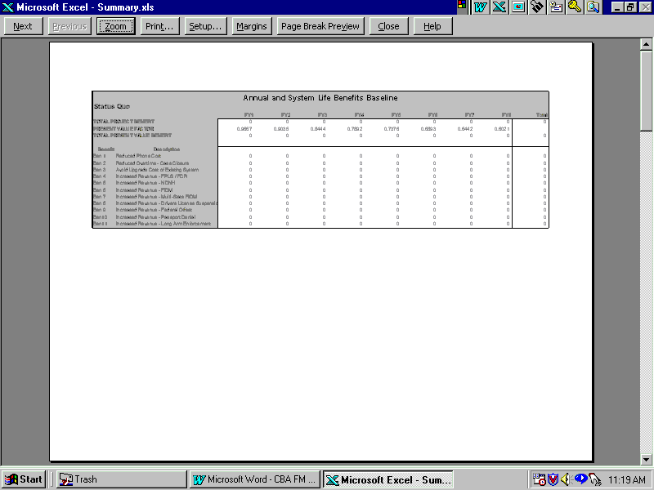

Print Benefits Summary Data
Step 20 - When ‘No’ from Step 18 or ‘Print or Close’ from Step 19 has been selected Figure 1-20 will appear as the screen. From Figure 1-20 the Analyst can:

- Select ‘Summary Status Quo and Go To’ to access the Status Quo Summary data screen, or
- Select ‘Summary Alt 1 and Go To’ to access the Alternative 1 Summary data screen, or
- Select ‘Summary Alt 2 and Go To’ to access the Alternative 2 Summary data screen, or
- Select ‘Summary Alt 3 and Go To’ to access the Alternative 3 Summary data screen, or
- Select ‘Return’, to close the ‘Benefits Summary’ application and return to the ‘Main Menu’.

For purposes of this example, select ‘Return’, and continue to Step 21.

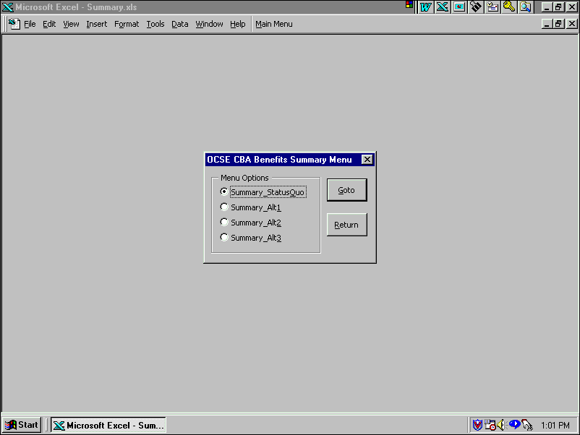

Return to Benefits Summary Menu

Review Costs Benefits Summary Data

Step 21 - When ‘Return’ has been selected Figure 1-21 will appear as the screen. From Figure 1-21 the Analyst can:

- Select ‘Costs Profile and Go To’ to access the Input Cost Data Menu where recurring and non-recurring Annual costs for the Status Quo and up to three alternatives can be entered, or
- Select ‘Benefits Profile and Go To’ to access the Input Benefits Data Menu where up to 11 benefits for the Status Quo and up to three alternatives can be entered by quarter, or
- Select ‘Benefits Summary and Go To’ to view the Summary of the Benefits Menu for each alternative, or
- Select ‘Costs Benefits Summary and Go To’ to see a system life cycle cost and benefit profile and graphical representations of cumulative costs and benefits and the breakeven point for each alternative, or
- Select ‘Exit’, to close the application (Go to Step 30).

For purposes of this example, select ‘Cost Benefits Summary and Go To’. Go to Step 22.

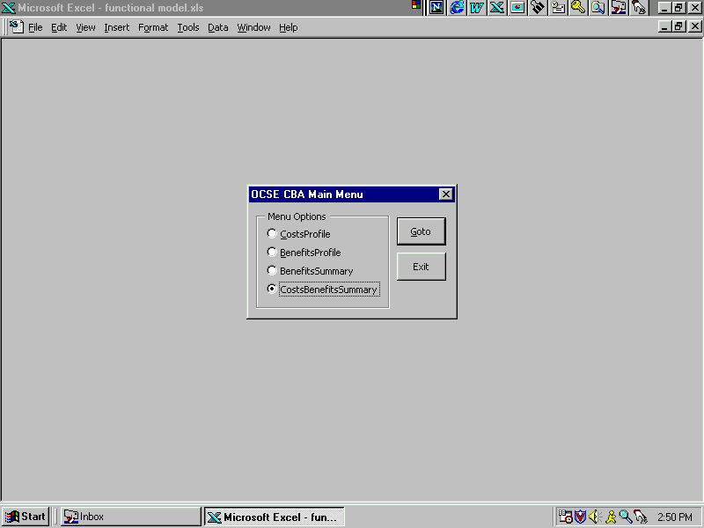

Return to Main Menu
Step 22 - When ‘Cost Benefits Summary and Go To’ has been selected Figure 1-22 will appear as the screen. From Figure 1-22 the Analyst can:

- Select ‘CBA Summary and Go To’ to view the Cost Benefits Summary screen. This screen displays annual Costs and Benefits by alternative and a Comparison of Alternatives, or
- Select ‘Chart Status Quo and Go To’ to view the Status Quo breakeven chart, or
- Select ‘Chart Alt 1 and Go To’ to view the Alternative 1 breakeven chart, or
- Select ‘Chart Alt 2 and Go To’ to view the Alternative 2 breakeven chart, or
- Select ‘Chart Alt 3 and Go To’ to view the Alternative 3 breakeven chart, or
- Select ‘Return’, to close ‘Cost Benefits Summary’ and return to the ‘Main Menu’.

For purposes of this example, select ‘CBA Summary and Go To’, and continue to Step 23.

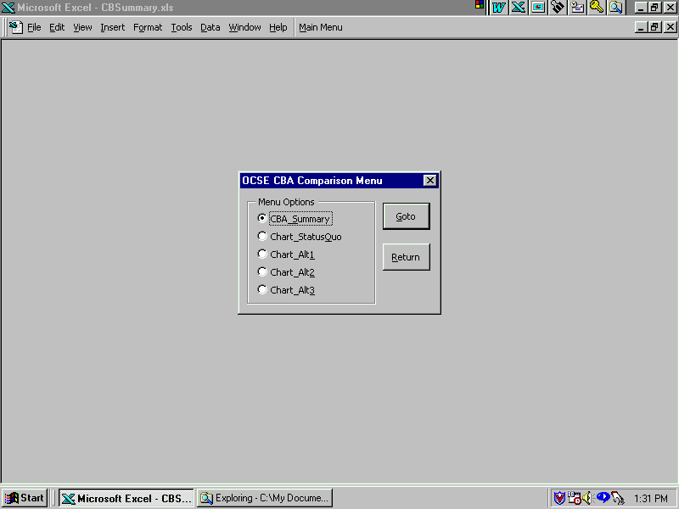

Costs Benefits Summary Menu
Step 23 - When ‘CBA Summary’ has been selected Figure 1-23 will appear as the screen. From Figure 1-23 the Analyst can:

- Select ‘Yes’, to Print Cost Benefits Summary data, or
Note: When printing Cost Benefits Summary data, all alternatives are printed.

- Select ‘No’, to by-pass Step 24 and go to Step 25.

For purposes of this example, select ‘Yes’, and go to Step 24.

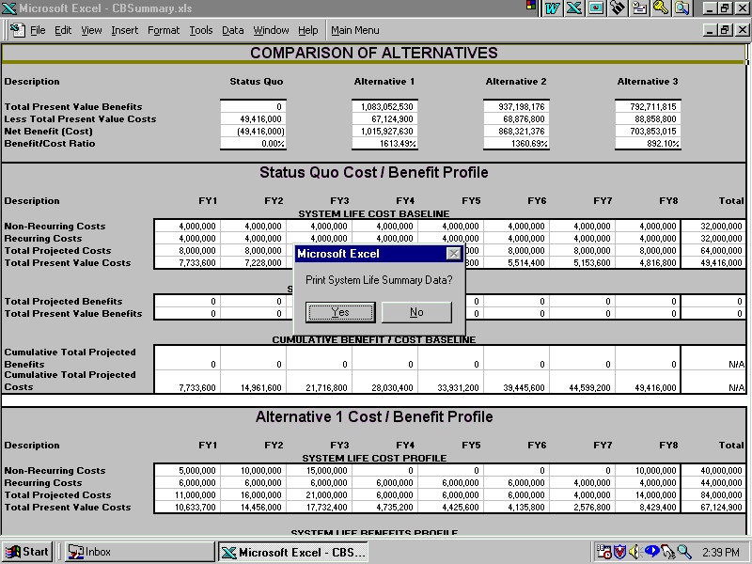

Print Costs Benefits Summary Data Option
Step 24 - When ‘Yes’ has been selected Figure 1-24 will appear as the screen. From Figure 1-24 the Analyst can:

- Select ‘Next’, ‘Previous’, ‘Zoom’, ‘Setup’, ‘Margins’, ‘Page Break Preview’ or
Note 1: Selecting ‘Page Break Preview’ is not recommended, because it will change the spreadsheet views. If this should happen, the print view screen will automatically close and return to the Main Menu. To recover repeat Steps 22 through 24, and select ‘Normal View’.

- Select ‘Print’, to Print Benefits Summary data, or
Note: The Costs Benefits Summary Report includes all alternatives. Use ‘Next’ and ‘Previous’ to view different pages of the report. After various print messages, the program returns to the Costs Benefits Summary Menu screen.

- Select ‘Close’, to return to the Costs Benefits Summary Menu screen.

For purposes of this example, select ‘Print or Close’, and go to Step 25.

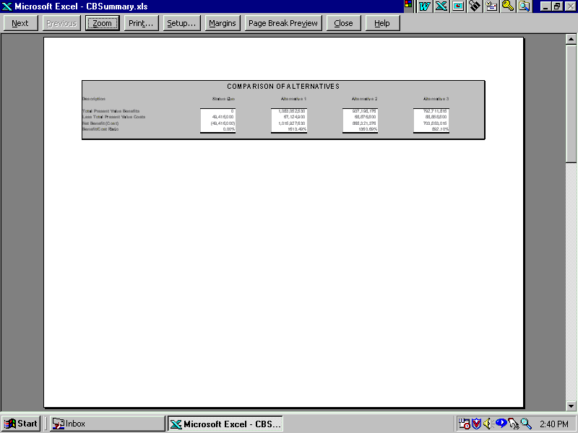

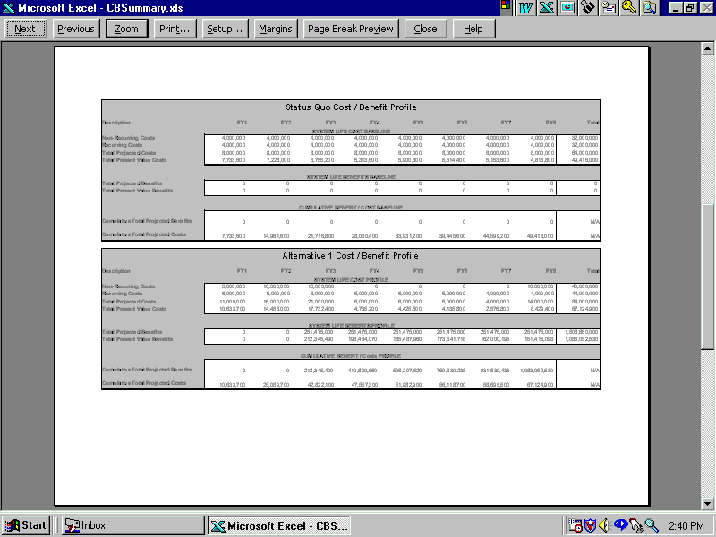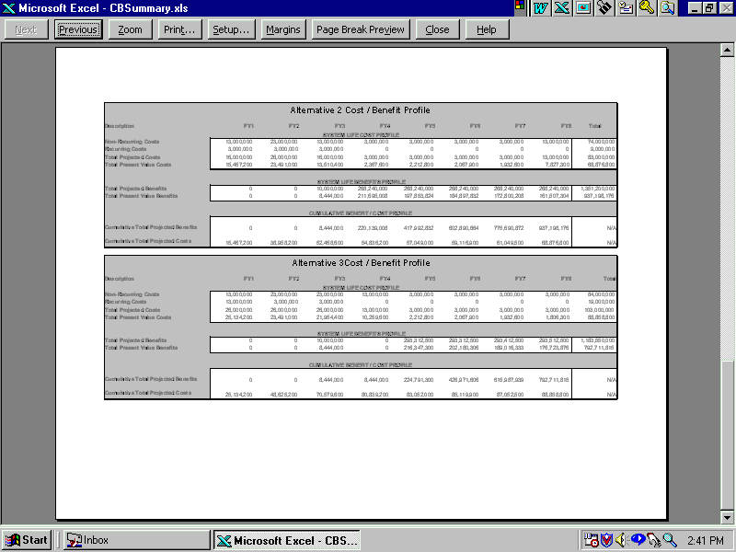

Print Costs Benefits Summary Data
Step 25 - When ‘No’ from Step 23 or ‘Print or Close’ from Step 24 has been selected Figure 1-25 will appear as the screen. From Figure 1-25 the Analyst can:

- Select ‘CBA Summary and Go To’ to view the Cost Benefits Summary screen. This screen displays annual Costs and Benefits by alternative and a Comparison of Alternatives, or
- Select ‘Chart Status Quo and Go To’ to view the Status Quo breakeven chart, or
- Select ‘Chart Alt 1 and Go To’ to view the Alternative 1 breakeven chart, or
- Select ‘Chart Alt 2 and Go To’ to view the Alternative 2 breakeven chart, or
- Select ‘Chart Alt 3 and Go To’ to view the Alternative 3 breakeven chart, or
- Select ‘Return’, to close the ‘‘Cost Benefits Summary'’ application return to the ‘Main Menu’.

Note: Since the process is the same regardless of the selection, ‘Chart Status Quo’, ‘Chart Alt 1’, ‘Chart Alt 2’, or ‘Chart Alt 3’, steps 26 through 27 are only presented once.

For purposes of this example, select ‘Chart Alt 3’, and continue to Step 26.

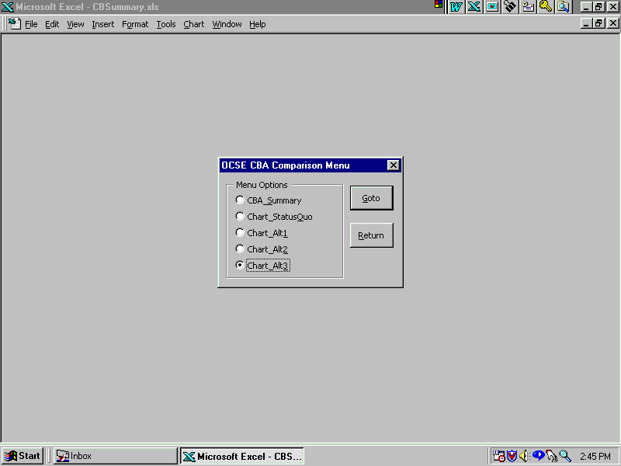

Return to Costs Benefits Summary Menu
Step 26 - When ‘Chart Alt 3’ has been selected Figure 1-26 will appear as the screen. From Figure 1-26 the Analyst can:

- Select ‘Yes’, to Print Costs Benefits Chart data, or
- Select ‘No’, to by-pass Step 27 and go to Step 28.

For purposes of this example, select ‘Yes’, and go to Step 27.

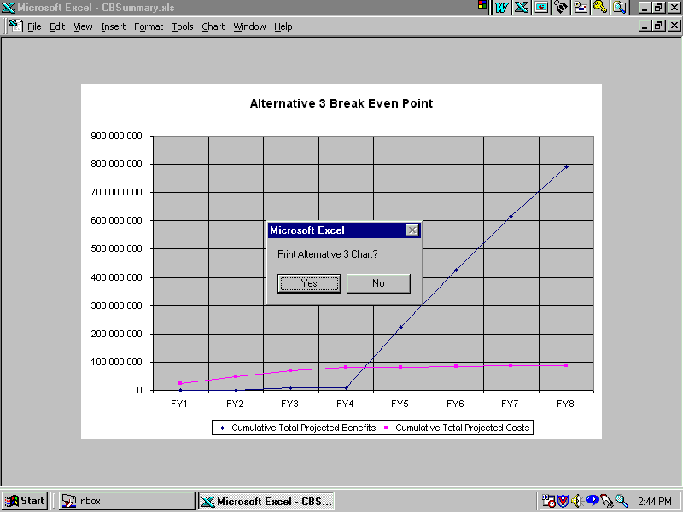

Print Alternative 3 Chart Data Option
Step 27 - When ‘Yes’ has been selected Figure 1-27 will appear as the screen. From Figure 1-27 the Analyst can:

- Select ‘Next’, ‘Previous’, ‘Zoom’, ‘Setup’, ‘Margins’, ‘Page Break Preview’ or
Note 1: Selecting ‘Page Break Preview’ is not recommended, because it will change the spreadsheet views. If this should happen, the print view screen will automatically close and return to the Main Menu. To recover repeat Steps 25 through 27, and select ‘Normal View’.

- Select ‘Print’, to Print Costs Benefits Chart data, or
Note: After various print messages, the program returns to the Costs Benefits Summary Menu screen.

- Select ‘Close’, to return to the Costs Benefits Summary Menu screen.

For purposes of this example, select ‘Print or Close’, and go to Step 28.

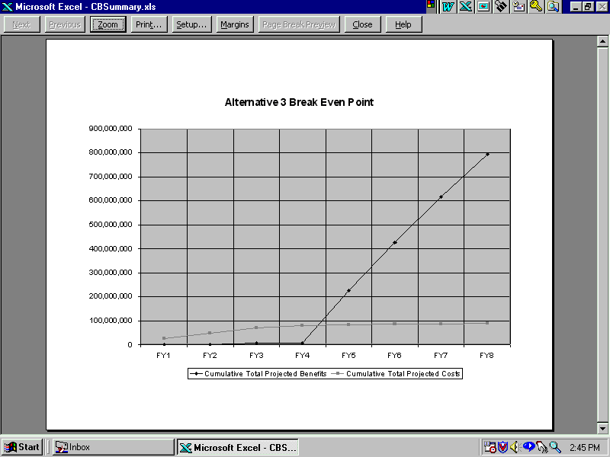

Print Alternative 3 Chart Data
Step 28 - When ‘No’ from Step 26 or ‘Print or Close’ from Step 27 has been selected Figure 1-28 will appear as the screen. From Figure 1-28 the Analyst can:

- Select ‘CBA Summary and Go To’ to view the Cost Benefits Summary screen. This screen displays annual Costs and Benefits by alternative and a Comparison of Alternatives, or
- Select ‘Chart Status Quo and Go To’ to view the Status Quo breakeven chart, or
- Select ‘Chart Alt 1 and Go To’ to view the Alternative 1 breakeven chart, or
- Select ‘Chart Alt 2 and Go To’ to view the Alternative 2 breakeven chart, or
- Select ‘Chart Alt 3 and Go To’ to view the Alternative 3 breakeven chart, or
- Select ‘Return’, to close the ‘Cost Benefits Summary' application return to the ‘Main Menu’.

For purposes of this example, select ‘Return’, and continue to Step 29.

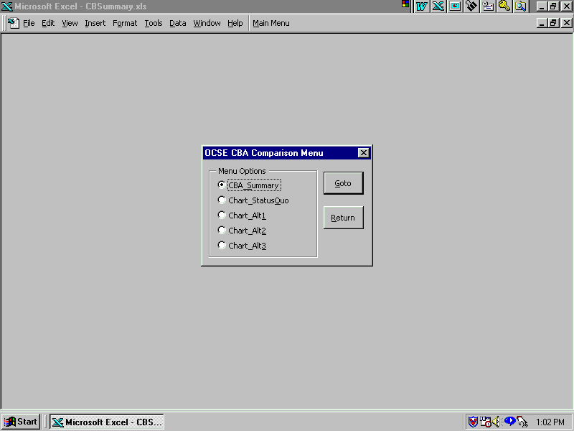

Return to Costs Benefits Summary Menu

Exit Costs Benefits Application

Step 29 - When ‘Return’ has been selected Figure 1-29 will appear as the initial screen. From Figure 1-29 the Analyst can:

- Select ‘Costs Profile and Go To’ to access the Input Cost Data Menu where recurring and non-recurring Annual costs for the Status Quo and up to three alternatives can be entered, or
- Select ‘Benefits Profile and Go To’ to access the Input Benefits Data Menu where up to 11 benefits for the Status Quo and up to three alternatives can be entered by quarter, or
- Select ‘Benefits Summary and Go To’ to view the Summary of the Benefits Menu for each alternative, or
- Select ‘Costs Benefits Summary and Go To’ to see a system life cycle cost and benefit profile and graphical representations of cumulative costs and benefits and the breakeven point for each alternative, or
- Select ‘Exit’, to close the application.

For purposes of this example, select ‘Exit’. Go to Step 30.

Return to Main Menu
Step 30 - When ‘Exit’ has been selected Figure 1-30 will appear as the screen. From Figure 1-30 the Analyst can:

- Select ‘Yes’, to save data input/changes and close the Cost Benefit application, or
Note: This is the only opportunity the Analyst will have to save Functional Model data, however it is not required.

- Select ‘No’, to close the Cost Benefits application without saving, or
- Select ‘X (Close Window) or Cancel’, to keep the application open without saving.

Caution: Unless you are familiar with Visual Basic selecting ‘Cancel’ is not recommended, because the application is vulnerable to corruption. If this should happen, close the application by clicking the ‘X’ or ‘Close’ and answer ‘No’ when asked to save.

For purposes of this example, select ‘Yes or No’ to save data, The Functional Model Application will close and exit the Excel spreadsheet.

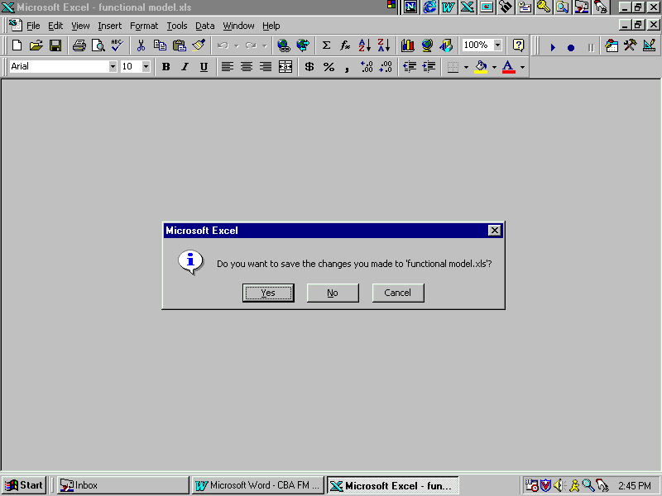

Save Data Input/Changes Option

References

Guidelines and Discount Rates for Benefit-Cost Analysis of Federal Programs
Circular No. A-94
Office of Management and Budget
October 29, 1992

Feasibility, Alternatives, and Cost/Benefit Analysis Guide
Office of Information Systems Management
July 1993

Companion Guide: Cost/Benefit Analysis Illustrated
Administration for Children and Families
U.S. Department of Health and Human Services
August 1994

Code of Federal Regulations 45 - Public Welfare
Office of the Federal Register
National Archives and Records Administration
October 1998

- CFR 45 Part 95.605 (2)(iv) - Cost/Benefit Analysis for IAPD
- CFR 45 Part 205.37 (a)(5) - ACF responsibility for Cost/Benefit Analysis
- CFR 45 Part 307.15(b)(11)-(14) - Approval of APD Cost/Benefit Analysis

