CAUTION

The 2008 CSR Handbook, which was heretofore provided only as a PDF document, is now provided in Word format for ease in quoting and excerpting for use in internal program written guidance. Grantee programs are reminded to use care when excerpting from the 2008 CSR Handbook, to ensure that important compliance requirements are not lost. LSC expects and requires all programs to use and comply with the complete 2008 CSR Handbook as issued by LSC. The complete 2008 CSR Handbook in Word format, including transmittal, is set out below:

August 3, 2007

Dear Colleagues,

I am pleased to share with you another important component of the Legal Services Corporation (LSC) Quality Initiative. Attached is the revised 2008 LSC Case Service Report Handbook (CSR Handbook). The revised CSR Handbook will be effective as of January 1, 2008.

For almost one year, LSC has been engaged in a revision of the CSR Handbook. We have worked in conjunction with an Advisory Committee with staff from LSC-funded programs. This group, along with an LSC staff committee, ably chaired by Kamala Vasagam, Program Counsel, Office of Compliance and Enforcement, shared their knowledge and experience in using the CSR system and conducted an extensive review and revision of the CSR Handbook. We solicited and received comments from a larger group of reviewers on a preliminary draft of the revised 2008 CSR Handbook. LSC sincerely appreciates the valuable input that both the Advisory Committee and the draft reviewers gave to LSC. That input was fully considered as we made our decisions about the final language of the CSR Handbook.

In revising the CSR Handbook, LSC’s objectives were to:

- clarify the standards for reporting a CSR case;
- clarify the requirements for documentation required to support each case;
- update and clarify the Case Closure Categories and Legal Problem Categories under which CSR cases are reported; and
- provide clarity on the issues relating to CSR reporting that have arisen since the last revision of the CSR Handbook.

Transitional Considerations

Any case closed in 2007 is governed by the current CSR Handbook. Any case closed in 2008 will be governed by the 2008 CSR Handbook. However, the following should be noted:

Intake Documentation Requirements of the 2008 CSR Handbook (Chapter V)

All cases opened January 1, 2008 and thereafter must follow the documentation requirements of the 2008 CSR Handbook. However, if a case was opened prior to January 1, 2008 and complied with the documentation requirements of the prior Handbook, it may still be closed and reported for an additional 12 months after January 1, 2008. In other words, the 2008 CSR may include cases opened under the old documentation requirements. As of January 1, 2009, all cases reported must comply fully with the 2008 CSR Handbook, regardless of when they were opened.

Case Closure – Problem Codes

For cases opened prior to January 1, 2008 and still open as of that date, programs may have to adjust the legal problem codes before case closure. There have been numerous changes to
the legal problem codes and an appropriate code under the 2008 CSR Handbook should be selected for all cases closed after January 1, 2008.

Case Closure – Limitations

It should be noted that there are cases that have been reportable under the current CSR Handbook which are not under the 2008 CSR Handbook. These cases may continue to be reported in 2007 but not in 2008.

Frequently Asked Questions (FAQ)

Effective January 1, 2008, all existing FAQ’s related to earlier versions of the CSR Handbook are no longer applicable. LSC will issue new FAQ’s as needed after the 2008 CSR Handbook becomes effective.

These revisions to the CSR Handbook likely will require some changes to the case management system used by your program. LSC has been working with several of the major case management system vendors and they are aware of the changes that are required. We urge you to contact your vendor directly and confirm that the changes will be available to your program prior to January 1, 2008, the effective date of the revised CSR Handbook. LSC expects all programs to implement the revised CSR Handbook requirements as of that effective date.

LSC is undertaking a national training schedule from now through December 2007, to acquaint LSC-funded program staff with the new CSR Handbook. Attached to this memorandum is the current schedule for those trainings and instructions on how to participate in any of the training events. We will be continually updating the schedule which can be found at www.lsc.gov (CSR training). All programs are encouraged to take advantage of one of these in-person training events. Staff who would benefit from the new CSR Handbook training include: staff attorneys; paralegals; other advocates; compliance responsible persons; supervisors and managing attorneys. Other staff such as intake workers may also benefit from the training, depending on the methods used by the program in conducting intake.

Limited opportunities for the scheduling of other training events exist. Please contact David de la Tour at delatoud@lsc.gov or 202-295-1525 to discuss other possible training dates. If you have questions about the CSR Handbook, please contact Kamala Vasagam at vasagamk@lsc.gov or 202-295-1535.

We hope that you will find the 2008 CSR Handbook to be improved guidance for CSR reporting.


Sincerely,

Helaine M. Barnett
President
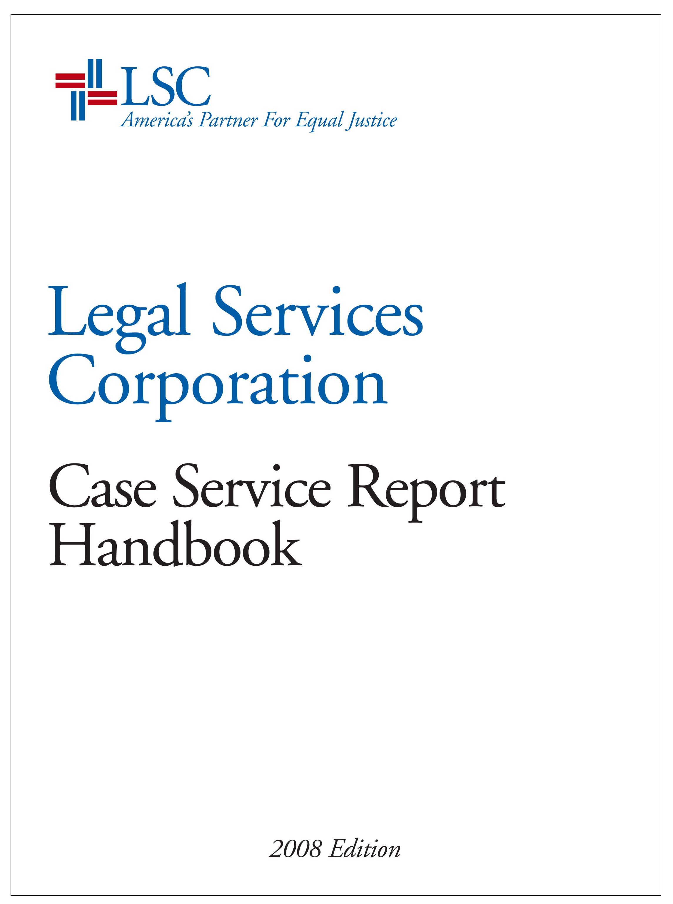
AcknowledgementS

The Legal Services Corporation sincerely thanks the following individuals who generously gave their time and talents to help draft the revised 2008 Case Service Report Handbook (CSR Handbook). The valuable counsel provided by the Advisory Committee and by the draft reviewers was fully considered as LSC made its decisions regarding the final language of the CSR Handbook.

The Advisory Committee’s knowledge, experiences, and devotion of countless hours to frequent conference calls and to the review and edit of numerous drafts, substantially enhanced the clarity of the revised CSR Handbook.

CSR Handbook Advisory Committee

Doug Canfield, Legal Services Corporation of Delaware
Jesse Gaines, Legal Aid of Northwest Texas
Breckie Hayes-Snow, Legal Advice & Referral Center (NH)
Dennis Holz, Legal Aid Society of San Diego
Alma Jones, Legal Services of North Louisiana
Mary Kavanaugh-Gahn, Legal Services of Northern Michigan
Pat McClintock, Iowa Legal Aid
John Whitfield, Blue Ridge Legal Services (VA)

The careful review provided by the draft reviewers and their commitment to high-quality legal services was evident in the thoughtful comments they shared with LSC.

Draft Reviewers

Jonathan D. Asher, Colorado Legal Services
Charlie Andrews, Community Legal Services of Mid-Florida
Al Azen, Lawyer Trust Account Board (PA)
Robert Barge, Rhode Island Legal Services, Inc.
Lorrna Blake, IOLA Fund of the State of New York
Mark Braley, Legal Services Corporation of Virginia
Robert Clyde, Ohio Legal Assistance Foundation
Julia Crockett, Mississippi Center for Legal Services
Jane Curran, The Florida Bar Foundation
Tracy Daniel, Alabama Law Foundation
Paul Doyle, Florida Bar Foundation
Sue Encherman, Northwest Justice Project (WA)
Susan Erlichman, Maryland Legal Services Corporation
Beverly Groudine, American Bar Association
Levon Henry, DNA-Peoples Legal Services, Inc. (AZ)
Phyllis J. Holmen, Georgia Legal Services Program
Joan Howard, Legal Aid and Defender Association, Inc. (MI)
Elizabeth Jones, Mid-Missouri Legal Services Corporation
Neil McBride, Legal Aid Society of Middle Tennessee and the Cumberlands
Richard McMahon, New Center for Legal Advocacy, Inc. (MA)
Irene Morales, Inland Counties Legal Services, Inc. (CA)
Linda Perle, Center for Law & Social Policy (DC)
Celia Pistolis, Legal Aid of North Carolina, Inc.
Tracie Poindexter, Montana Legal Services Association
Lonnie Powers, Massachusetts Legal Assistance Corporation
Linda Rexer, Michigan Bar Foundation
Andrew Scherer, Legal Services for New York City
Mary Schneider, Legal Services of Northwest Minnesota Corporation
Tina C. Smith, Legal Aid Bureau (MD)
Betty Torres, Texas Equal Access to Justice Foundation
Anthony White, Bay Area Legal Aid (CA)
Adrienne Worthy, Legal Aid of West Virginia, Inc.

LSC Staff

A special thanks to Kamala Vasagam, Program Counsel, Office of Compliance and Enforcement, for her exceptional leadership of both the Staff Committee and the Advisory Committee; and a special thanks to LSC Staff, David de la Tour, Michael Genz, Janet LaBella, John Meyer, Sonny Navanitikul, Joyce Raby, and Karen Sarjeant, for their dedication to ensuring the high quality of the CSR Handbook.

____________________________ Helaine M. Barnett
President, Legal Services Corporation
July 2007
LEGAL SERVICES CORPORATION

CSR Handbook

2008 Edition

Table of Contents

Chapter I: Purpose, Scope, and Effective Date 1

1.1 Purpose 1

1.2 Scope 1

1.3 Effective Date 1

Chapter II: Key Definitions 2

2.1 Definition of Case 2

2.2 Definition of Legal Assistance 3

2.3 Definition of Legal Information 3

2.4 Definition of Client 4

2.5 Who Can Provide Legal Assistance 4

Chapter III: Case Management Systems 5

3.1 Use of Automated Case Management Systems 5

3.2 Single Recording of Cases 5

3.3 Timely Closing of Cases 6

3.4 Management Review of Case Service Reports 7

3.5 Identification and De-Selection of Non-CSR Cases 7

3.6 Limitation of Defaults in Case Management Systems 8

Chapter IV: Reporting Requirements 9

4.1 General Requirement 9

4.2 Private Attorney Involvement Cases 9

4.3 Reporting LSC-Eligible Cases Irrespective of Funding Source 9

4.4 Inclusion of Certain Subrecipient Cases 9

4.5 Reporting for Separate Service Areas 10

Chapter V: Documentation Requirements 11

5.1 General Requirement 11

5.2 Requirements Pertaining to Client Eligibility 11

5.3 Income Documentation Requirements 11

5.4 Asset Documentation Requirements 12

5.5 Citizenship and Alien Eligibility Documentation Requirements 13

5.6 Legal Assistance Documentation Requirements 14

Chapter VI: Types of Case Services 15

6.1 Case Service Definitions 15

6.2 Cases Involving Multiple Levels of Assistance 15

6.3 Cases Involving Repeated Instances of Assistance 15

6.4 Cases Involving Related Legal Problems 15

6.5 Cases Involving Appeals 16

6.6 Alternative Forms of Service 17

Chapter VII: Referrals 19

7.1 Referrals of Ineligible Applicants 19

7.2 Referrals of Eligible Applicants 19

7.3 Referrals to PAI Attorneys, Subrecipients, or Program Offices 19
Chapter VIII: Case Definitions and Closure Categories 20

8.1 Purpose of Case Closure Categories 20

8.2 Limited Service Case Categories 20

CSR Category A – Counsel and Advice 20

CSR Category B – Limited Action 21

8.3 Extended Service Case Categories 21

CSR Category F – Negotiated Settlement Without Litigation 21

CSR Category G – Negotiated Settlement With Litigation 21

CSR Category H – Administrative Agency Decision 22

CSR Category I – Court Decision 22

CSR Category K – Other 23

CSR Category L – Extensive Service 23

Chapter IX: Legal Problem Code Categories and Codes 24

Chapter X: Private Attorney Involvement Cases 29

10.1 Definition of a Private Attorney Involvement Case 29

10.2 Single Recording of PAI Cases 30

10.3 Timely Closing of PAI Cases 30

10.4 Case Oversight and Follow-Up 30

10.5 PAI Case Documentation 31

Appendix 32

A. Program Letter 06-2 Violence Against Women Act 2006
Amendments 33

- Program Letter 05-2 Eligibility of Immigrant Victims of Severe
Forms of Trafficking and Family Members for Legal Services 38
LEGAL SERVICES CORPORATION

CSR Handbook

2008 Edition

Chapter I: Purpose, Scope, and Effective Date

  - Purpose

The purpose of the Case Service Report (CSR) Handbook is to provide instruction on how to count and document cases reported to the Legal Services Corporation (LSC). The Handbook guides the gathering of quantifiable information on cases and its goal is to ensure that LSC-funded programs provide consistent data that can be accurately combined to reflect the level of civil legal services provided across the nation. Case statistics are an important indicator LSC considers in evaluating a program's work. However, case statistics, taken alone, are not determinative of the effectiveness of the legal services a program provides. The accuracy of case information submitted to LSC is vital to obtaining continued Federal funding for legal services. LSC relies on statistical and other pertinent information in its annual request for Federal funding for legal services.

  - Scope

This Handbook applies to the recording and reporting of cases as defined by § 2.1 of this Handbook and 45 CFR § 1635.2(a), and sets forth requirements for using automated case management systems to account for both open and closed cases. This Handbook does not apply to matters as defined by 45 CFR § 1635.2(b) – now reported as “Other Services.”

  - Effective Date

This Handbook is effective January 1, 2008. All prior editions of the CSR Handbook are superseded. In addition, all Frequently Asked Questions and Answers provided prior to June 30, 2007 are no longer applicable as of January 1, 2008.
Chapter II: Key Definitions

  - Definition of Case

For CSR purposes, a case is defined as the provision of permissible legal assistance to an eligible client with a legal problem, or set of closely related legal problems, accepted for assistance in accordance with the requirements of the LSC Act, regulations, and other applicable law. Cases that meet LSC eligibility criteria should be reported in the CSR irrespective of funding source.

Legal services programs may record and report the provision of legal assistance as a case only if:

(a) the client is financially and otherwise eligible to receive legal assistance under the LSC Act, regulations, and other applicable law;

(b) the client’s case is within program priorities (or is an emergency case accepted under the program’s emergency case acceptance procedures);

(c) the legal services program has actually accepted the client for service through its intake system or another established procedure for ensuring client eligibility;

(d) the legal assistance provided to the client meets the criteria of one of the CSR Closure Categories described in Chapter VIII of this Handbook;

(e) the type of legal assistance provided to the client is not prohibited by the LSC Act, regulations, or other applicable law (e.g., a class action); and

- the legal problem(s) of the client are not of a type prohibited by the LSC Act, regulations, or other applicable law (e.g., an abortion case).

  - Definition of Legal Assistance
For CSR purposes, legal assistance is defined as the provision of limited service or extended service on behalf of a client or clients that meets the criteria of the CSR Closing Categories contained in Chapter VIII. Legal assistance is specific to the client’s unique circumstances and involves a legal analysis that is tailored to the client’s factual situation. Legal assistance involves applying legal judgment in interpreting the particular facts and in applying relevant law to the facts presented. The provision of legal assistance creates an attorney-client relationship.

  - Definition of Legal Information
For CSR purposes, legal information is defined as the provision of substantive information not tailored to address a person’s specific legal problem. As such, it is general and does not involve applying legal judgment and does not recommend a specific course of action. For example, providing only a pamphlet or brochure is legal information and not legal assistance. The provision of legal information does not create an attorney-client relationship.
Legal information alone is not legal assistance and the provision of legal information may not be reported as a CSR case.

  - Definition of Client

For CSR purposes, a client is defined as a person (or group under 45 CFR § 1611.6) who is:

- financially and otherwise eligible to receive legal assistance under the LSC Act, regulations, and other applicable law, regardless of source of funding used by the program; and

- accepted for legal assistance through an intake system or other established program procedure for ensuring client eligibility.

For CSR purposes, to be eligible for and accepted for legal assistance and to be reported as a CSR case, a client must meet the financial (including both income and assets), citizenship (including alien status), and other eligibility requirements of the LSC Act, regulations, and other applicable law.

  - Who Can Provide Legal Assistance
Legal assistance in a case must be provided by an attorney authorized to practice law in the jurisdiction where assistance is rendered or a non-attorney under the direct supervision of a licensed attorney in accordance with the rules of practice in the jurisdiction(s) where the program provides assistance (unless the jurisdiction or forum allows waiver of attorney supervision or allows legal assistance by a non-attorney under specific circumstances). A person providing assistance in a case need not have the job title of “attorney” or “paralegal”, but any such individual must be authorized to provide legal assistance in accordance with applicable rules of practice and must keep time records as required by 45 CFR Part 1635.
Chapter III: Case Management Systems

3.1 Use of Automated Case Management Systems

Programs shall utilize automated case management systems (CMS) and procedures that ensure that information necessary for the effective management of cases is accurately and timely recorded in a case management system. Such systems and procedures shall ensure that program management has:

(a) timely access to accurate information on cases; and

(b) the capacity to meet funding sources’ reporting requirements.

To meet reporting requirements, programs’ case management systems and procedures shall include the ability to report cases by funding source, grant type (e.g., Basic Field, Migrant, Native American), Private Attorney Involvement (PAI) component, jurisdiction (e.g., county or city), and individual office.

Case management systems should also employ sufficient technological capacity to ensure cost effective and efficient management of data and workflow. Hallmarks of sufficient technological capacity include:

- single entry of data;

- automated reporting that eliminates onerous and time consuming manual calculation or tabulation;

- the ability to readily review data and information from multiple perspectives; and

- the promotion of data integrity and assistance in the identification of erroneous data.

Furthermore, programs should keep their case management system technology sufficiently up-to-date to enable them to benefit from future technological advances.

3.2 Single Recording of Cases

Through the use of automated case management systems and procedures, programs shall ensure that cases involving the same client and same legal problem are not recorded and reported to LSC more than once as required by §§ 6.1 through 6.5 of this Handbook. Such systems and procedures shall include a process for checking for duplication among both open and closed cases. The checking process may occur either:
(a) at the point when cases are first entered into the case management system; or

(b) at a later point in time (before the cases are reported to LSC) when case information can be systematically reviewed.

One method for systematically reviewing case information involves the generation of case management reports which list instances where two or more open and/or closed cases involve the same client and legal problem. A review of such multiple cases identified in the reports may indicate that duplicate records are present in the case management system. After identifying instances of duplicate recording of cases, if any, programs shall take necessary steps to eliminate duplicate cases prior to the reporting of case service information to LSC.

3.3 Timely Closing of Cases

Programs shall ensure the timely closing of cases so that case service reports submitted to LSC contain current and accurate information about both open and closed cases for the grant year (January 1 through December 31). After the close of the grant year, LSC provides two months additional time to allow programs to take reasonable and necessary steps to ensure that cases in which legal assistance has ceased, and is not likely to resume, are closed prior to the submission of case service reports to LSC. See § 10.3 of this Handbook for specific timely case closing requirements for PAI cases.

Programs shall report cases as having been closed in the year in which assistance ceased, depending on case type:

(a) cases closed as CSR Limited Service Closure Categories A and B shall be reported as having been closed in the grant year in which the case was opened, unless:

(i) the case is opened after September 30, in which circumstance it may be
reported either in the year opened or the following year; or

(ii) there is any entry in the file or in the case management system stating a reason why the case should be held open into the following year, in which circumstance the case shall be closed in the grant year in which assistance on behalf of the client was completed.

(b) cases closed as CSR Extended Service Closure Categories F through L shall be reported as having been closed in the grant year in which assistance on behalf of the client was completed. In the absence of an entry in the case management system or file noting case closure or stating a reason why the case should be held open into the following year, work shall be deemed completed one grant year after the last assistance on behalf of the client is noted in the file. For example, if the last assistance on behalf of the client was noted in the file in June 2006, the case must be closed and reported no later than grant year 2007.

Programs shall employ one or more method(s) of ensuring timely closing of cases. Two possibilities are discussed below, but other alternative methods may be used. One method is the generation of case management reports which indicate the length of time cases have been open. A review of such reports would tend to indicate whether cases are being timely closed. Another method is to run a report of open cases that have had no time keeping entries recorded for the past 90 days. This method provides a potential indication that a case might have been completed but not closed.

3.4 Management Review of Case Service Reports

Programs shall institute procedures for ensuring management review of case service information for accuracy and completeness prior to its submission to LSC. At a minimum, such procedures shall include either a review of management reports such as those described in §§ 3.2 and 3.3 of this Handbook, or another method of review that ensures that cases are timely closed and are not reported more than once in the same year.

In addition, the executive director, or a designee, shall review the program’s case service reports prior to their submission to LSC in order to ensure that the information contained in the reports fairly represents the volume and types of CSR cases that the program provided during the grant year. When necessary to determine the accuracy of case service information, programs shall have the capacity to generate a detailed listing of open and closed cases to support case service information reported to LSC.

3.5 Identification and De-selection of Non-CSR Cases

Programs shall establish a method in their case management systems that will de-select case files for CSR reporting that were opened as LSC-eligible but are not reportable to LSC as cases. Examples of such case files include: (1) case files properly opened where the client withdrew before any legal assistance could be rendered, (2) case files where the client gave the program erroneous information at intake and the correction of which showed that the client was ineligible, (3) case files where administrative or computer error caused a case to be opened when no case should have been opened, (4) duplicate case files, (5) case files where closure is untimely as discussed in § 3.3 of this Handbook, or (6) case files where the required documentation (e.g., a citizenship attestation) is not present.

While LSC does not mandate the use of a specific method to identify and de-select non-CSR cases, the method adopted must have the ability to be easily used by case handlers and other program staff to close case files that should not be reported to LSC with some type of “exit” code or field that enables staff to de-select that case from inclusion in a CSR report. Any system that accomplishes the goal of easily de-selecting any files opened as LSC reportable that are not eligible to be closed as CSR “cases” from CSR reports is sufficient. For example, one method is to close such case files with a closing code such as X (or any other letter near the end of the alphabet) that would be used to designate the case file as a non-CSR case.

3.6 Limitation of Defaults in Case Management Systems

Defaults in important data fields tend to reduce the accuracy of the data submitted because there is no way to tell whether staff actually made an inquiry and decision as to what should go in the field or just skipped over it, allowing the default value to be recorded. Accordingly, certain fields that are critical to eligibility may not have a default. These fields are: income, assets, number in the household, citizenship/eligible alien status, and LSC-eligibility. LSC also recommends that other fields important to the accuracy of the CSR information not have defaults.
Chapter IV: Reporting Requirements

  - General Requirement

For each grant year, recipients shall report case service information to LSC as part of the annual Grant Activity Report to be submitted in the first quarter of the following year. Case information reported to LSC shall include both numbers of closed cases and numbers of open cases. Detailed instructions on submitting case information to LSC are available through the Recipient Information Network at www.rin.lsc.gov.

  - Private Attorney Involvement Cases

For each grant year, recipients of Basic Field grants shall report case information for their PAI components separately from their staff Basic Field cases. This requirement does not apply to Migrant and Native American grants; any cases closed by private attorneys using Migrant or Native American funds shall be reported as Migrant or Native American and not as PAI cases. For further guidance regarding the reporting of PAI cases, see Chapter X of this Handbook.

  - Reporting LSC-Eligible Cases Irrespective of Funding Source

Recipients should report all cases in which there has been an eligibility determination showing that the client meets LSC eligibility requirements,^{17a} regardless of the source(s) of funding supporting the cases, provided such cases are completed by the recipient or by PAI attorneys. Cases without such eligibility determinations may not to be reported to LSC. This Chapter does not require that programs document client financial eligibility for any cases that are wholly funded by non-LSC funding sources, unless such cases are reported to LSC.

  - Inclusion of Certain Subrecipient Cases

Recipients shall report only cases closed by subrecipients as defined by 45 CFR §1627.2 that are supported in whole or in part with LSC funds. Organizations receiving transfers of only non-LSC funds from a recipient are not subrecipients under 45 CFR Part 1627 and none of their cases may be reported to LSC. However, recipients using non-LSC funds to meet the LSC PAI requirement through arrangements with another organization may report the non-LSC funded PAI cases closed by that organization if such cases meet the definitions and requirements of this Handbook.

  - Reporting for Separate Service Areas

Recipients receiving funding for more than one LSC service area shall report case service information separately for each separate service area for which LSC funding is received.
Chapter V: Documentation Requirements

5.1 General Requirement

For each case reported to LSC, programs shall record case and client information necessary for effective case management, either through electronic entries in an automated case management system database, through notations on an intake sheet or other hard-copy document in a case file, or through other appropriate means. For each case reported to LSC, such information shall describe (at a minimum) the information required in §§ 5.2, 5.3, 5.4, 5.5, and 5.6 of this Handbook and:

- the client’s name;

- the client’s legal problem(s);

- the level(s) of legal assistance provided; and

- the source(s) of funding which support the case.

5.2 Requirements Pertaining to Client Eligibility

In addition, for each case reported to LSC, programs shall document that a determination of client eligibility was made in accordance with LSC requirements including §§ 5.3 (income documentation), 5.4 (asset documentation) and 5.5 (citizenship and alien eligibility documentation). The documentation of eligibility shall be recorded electronically in a case management system record, or in a simple form as provided by 45 CFR § 1611.7(b) and shall be preserved for audit purposes for a period of five years.

5.3 Income Documentation Requirements

At a minimum, for each case reported to LSC, programs shall record the number of members in the applicant’s household and the total income received by all members of the applicant’s household. Program’s intake procedures must include instructions to ask sufficient questions of the applicant to determine the total amount of household income and the program must be able to provide reasonable evidence that staff practice follows these procedures. A total amount of the applicant’s household income must be recorded even if it is zero.

For cases in which a program chooses to apply financial exceptions to applicants with household gross income exceeding 125% of the federal poverty guidelines in effect at the time of case acceptance, the documentation of eligibility shall also indicate the specific facts and factors relied on to make such a determination as required by 45 CFR § 1611.5. Additionally, the program’s automated case management system must save the applicant’s gross income as a separate and identifiable field in order to preserve a record that the applicant initially exceeded the basic income level but was served pursuant to over-income exceptions allowed under 45 CFR § 1611.5. It is critical that calculations involving exceptions to income ceilings are not applied in a manner that changes the gross income recorded in the file.

If an applicant’s total household income is derived solely from a government program for low-income individuals or families, then the program may determine that the applicant is financially eligible based on those benefits pursuant to 45 CFR §§ 1611.4(c) (provided the program’s Board has adopted policies permitting such a determination regarding that specific government program). The program must record household size, household income, and the specific identity of the government program. In support of such determination, the program must have on file a resolution, minutes or other written evidence of action by its Board stating that eligibility for that specific government program qualifies a client as financially eligible. No further documentation of income or assets is required.

5.4 Asset Documentation Requirements

At a minimum, for each case reported to LSC, programs shall document the total value of assets held by all members of the applicant’s household (except for categories of assets such as principal residence, work tools, or a vehicle needed for transportation excluded from consideration pursuant to recipient Board guidelines adopted under 45 CFR § 1611.3(d)).

Programs’ intake procedures must include sufficient questions of the applicant to determine the total amount of non-excluded household assets and the program must be able to provide reasonable evidence that staff practice follows these procedures. Programs shall use the equity value of a non-excluded asset as opposed to its fair-market value in calculating asset eligibility. A total value of the applicant’s non-excluded household assets must be recorded, even if it is below the program’s guidelines or zero. For cases in which the applicant’s household has non-excluded assets which exceed the program’s asset ceiling (adopted pursuant to 45 CFR § 1611.3(d)(1)) but the program determines that the asset ceiling should be waived, the documentation of eligibility shall also indicate the factual basis for the decision to waive the assets ceiling as required by 45 CFR § 1611.3(d)(2).

If an applicant’s total household income is derived solely from a government program for low-income individuals or families, then the program may determine that the applicant is financially eligible based on participation in that program as described in § 5.3 above, in which case no further asset documentation is required.

5.5 Citizenship and Alien Eligibility Documentation Requirements

Pursuant to 45 CFR §§ 1626.6(a) and 1626.7(a), the level of documentation necessary to evidence citizenship or alien eligibility depends on the nature of the service provided to the client. For cases involving Counsel and Advice or Limited Action (CSR Closure Categories A and B) provided exclusively over the telephone, the documentation of eligibility shall include a written notation or computer entry which reflects the client’s oral response to the program’s inquiry as to whether the client is a U.S. citizen or an eligible alien.

For cases in which program staff has in-person contact with the client or the program provides continuous representation beyond Counsel and Advice or Limited Action (CSR Closure Categories A and B), the documentation of eligibility shall include either: (a) a written attestation of citizenship, or (b) documentation of alien eligibility, as required by 45 CFR §§ 1626.6(a) and 1626.7(a). A citizenship attestation shall be stated as follows: “I am a citizen of the United States: Signature of applicant Date: .” This citizenship attestation may be on a separate document or may be contained within another document (such as an intake sheet or retainer agreement), provided there is a separate signature line tied only to the citizenship attestation. Neither a yes/no checkbox as to citizenship nor a signed statement that the client attests to the truth of intake information will suffice as a citizenship attestation.

5.6 Legal Assistance Documentation Requirements

For each case reported to LSC, the client’s case file or the CMS must contain a description of the legal assistance provided to the client. Such description should be sufficient to document that the assistance is a case and to support the level of assistance selected by the program to close the case.
Chapter VI: Types of Case Services

  - Case Service Definitions

Chapter VIII of this Handbook defines categories of case services for reporting to LSC. When closing individual cases, programs shall report each case once according to the level of case service that best reflects, in the program’s judgment and in accordance with the definitions and guidance contained in this Handbook, the level of assistance which the program provided during the course of the case.

  - Cases Involving Multiple Levels of Assistance

The program shall report only the highest level of service provided when a program provides more than one type of assistance to an eligible client during the same calendar year when attempting to resolve essentially the same legal problem, as demonstrated by the factual circumstances giving rise to the problem. For example, if a program initially provides Advice and Counsel in an attempt to resolve a client’s legal problem, and the program later negotiates a settlement with an opposing party with respect to the same legal problem, the program shall report the case only once as a Negotiated Settlement.

  - Cases Involving Repeated Instances of Assistance

The program shall report repeated instances of assistance to the client as a single case when a program provides assistance more than once within the same calendar year to an eligible client who has returned to the program with essentially the same legal problem, as demonstrated by the factual circumstances giving rise to the problem. For example, if a program assists a client on two or more occasions with an on-going problem, the factual circumstances of which remain essentially the same over time, the program shall report its assistance to the client as a single case, even if the program has provided Counsel and Advice or Limited Action to the client on more than one occasion within the same calendar year.

  - Cases Involving Related Legal Problems

For cases involving related legal problems:

(a) For Counsel and Advice (CSR Closure Category A) cases only, the presumption is that legal assistance rendered to a client on related legal issues contemporaneously or within a brief time frame is counted as one case. However, this presumption is rebutted and two or more cases may be reported if the legal issues are sufficiently different, as evidenced by the presence of:

(i) legal issues that fall into different Legal Problem Categories, such as Family and Housing;

(ii) legal issues that fall into different Legal Problem Codes within either the Individual Rights or Miscellaneous Legal Problem Categories;

(iii) legal issues that involve different potentially adverse parties, even if they are in the same Legal Problem Category or Code; or

(iv) legal issues that relate to substantially different underlying facts.

(b) For all other cases (CSR Closure Categories B to L), programs shall report related legal problems of an eligible client as a single case when the program representing the client attempts to resolve the related legal problems simultaneously through a single legal process. For court cases, if the legal problems are resolved under one Civil Action Number, only one case is reported. If there are multiple Civil Action Numbers, then multiple cases are counted. For example, if a client seeks assistance with related child custody and support problems, and the program assists the client by preparing a pleading or other document that addresses both problems, then the program shall report its assistance to the client as a single case. However, if child custody and child support are addressed in different actions or in different courts, then more than one case should be reported for the client.

6.5 Cases Involving Appeals

If a program represents a client in a case at the trial court and/or administrative agency level and then represents the client as an appellant or appellee in an appeal of that case to an appellate court as defined per 45 CFR §§ 1605.2 and 1605.3, the program should report the trial court or administrative agency decision below as one case. A separate case should be opened for the appeal. If a program represents a client in a case remanded back to the lower court or administrative agency, the appeal should be closed under CSR Closure Category I(c) in Chapter VIII and another case opened for the proceedings in the lower court or administrative agency after remand.

6.6 Alternative Forms of Service

Programs may provide alternative forms of service such as alternative dispute resolution, pro se clinics, workshops, legal education, kiosks, and web assistance.

- However, such alternative service may not be reported as a case unless:

(i) the service provided qualifies as a case, as defined by § 2.1 of this Handbook;

(ii) the service provided qualifies as legal assistance as defined by § 2.2;

  - the person receiving the service is a client as defined by § 2.4; and

  - the person providing the service is an attorney or a non-attorney under the direct supervision of a licensed attorney in accordance with the rules of practice in the jurisdiction(s) where the program provides assistance (unless the jurisdiction or forum allows waiver of attorney supervision or allows legal assistance by a non-attorney under specific circumstances) as stated in § 2.5.

(b) Related services provided to the same client with respect to essentially the same legal problem are reported to LSC only as specified by §§ 6.2 and 6.3 of this Handbook.

(c) Programs may report alternative forms of service provided in § 6.6 under the CSR category that best fits the actual service provided, as specified by Chapter VIII of this Handbook. If the program provides legal information as opposed to legal assistance, the service provided is a matter and not a case.
Chapter VII: Referrals

  - Referrals of Ineligible Applicants

Programs may report as cases only those services provided to clients who are eligible for, and have been accepted for, legal assistance through a program’s intake system or other procedure for verifying case and client eligibility. Referrals of applicants who are ineligible for assistance under the LSC Act, regulations, and other applicable law Other Services, which may not be reported as cases. Similarly, referrals of applicants who are not accepted for service, because their legal problems are outside of program priorities, are Other Services which may not be reported as cases.

  - Referrals of Eligible Applicants

Programs may not report the referral of an eligible applicant as a case when the referral is the only form of assistance which the applicant receives from the program. Pursuant to 45 CFR § 1635.2(b), assistance which does not involve direct legal advice or legal representation of a client is a matter and not a case. The referral of an eligible applicant to another provider qualifies as a case only if:

(a) the applicant is eligible for and accepted for service as required by § 2.4 of this Handbook;

(b) the applicant’s case is within program priorities and is not prohibited by the LSC Act, regulations or other applicable law, as required by § 2.1 of this Handbook; and

(c) the program provides either Counsel and Advice or another type of case service defined in Chapter VIII of this Handbook prior to referring the client.

7.3 Referrals to PAI Attorneys, Subrecipients, or Program Offices

Programs may not report referrals to PAI attorneys, subrecipients, or offices within the same program as closed cases. If a program refers a client to an attorney participating in the program’s PAI component, the case may be reported as closed only after the PAI attorney has completed all work on the case and has reported the case as closed. Similarly, if a program refers a client to a subrecipient or to another office within the same program, the case may be reported as closed only after all work on the case has been completed by the subrecipient or other office, and the subrecipient or other office reports the case as closed.
Chapter VIII: Case Definitions and Closure Categories

8.1 Purpose of Case Closure Categories

The purpose of case closure categories is to delineate the level of service provided to the client in each case. This Chapter includes definitions of common levels of case services which programs provide to eligible clients during the course of a case. All legal assistance recorded and reported to LSC as a case must:

- qualify as a case, as defined by § 2.1 of this Handbook and 45 CFR § 1635.2(a);

- be provided to an eligible client, as defined by § 2.4 of this Handbook; and

- be documented as required by Chapter V of this Handbook.

8.2 LIMITED SERVICE CASE CATEGORIES

CSR Closure Category A – Counsel and Advice

A case closed in which the program provided legal advice to an eligible client should be closed as Counsel and Advice (e.g., the advocate ascertained and reviewed relevant facts, exercised judgment in interpreting the particular facts presented by the client and in applying the relevant law to the facts presented, and counseled the client concerning his or her legal problem).

CSR Closure Category B – Limited Action

A case closed in which the program took limited action(s) on behalf of an eligible client that addressed the client’s legal problem that is not so complex or extended as to meet the requirements for CSR Category L should be closed as Limited Action. Examples include, communications by letter, telephone or other means to a third party; preparation of a simple legal document such as a routine will or power of attorney; or legal assistance to a pro se client that involves assistance with preparation of court or other legal documents.

8.3 EXTENDED SERVICE CASE CATEGORIES

CSR Closure Category F – Negotiated Settlement Without Litigation

A case closed in which the program negotiated and reached an actual settlement on behalf of a client without any court or administrative actions pending should be closed as Negotiated Settlement Without Litigation. This category should be reserved for cases in which the program conferred with another party so as to reach a resolution of the client’s legal problem. This category includes settlements negotiated with an administrative agency prior to the filing of a formal administrative proceeding.

CSR Closure Category G – Negotiated Settlement With Litigation

A case closed in which the program negotiated and reached an actual settlement on behalf of a client while a court or formal administrative action was pending should be closed as Negotiated Settlement With Litigation. This category should be reserved for cases in which the program conferred with another party so as to reach a resolution of the client’s legal problem. Settlements of pending court or administrative actions should be closed in this category even if the court or administrative agency issues an order memorializing the settlement.

This category includes only: (1) cases in which an appearance has been entered before a court or administrative agency as counsel of record; or (2) cases in which the settlement was reached prior to the program’s entry as counsel of record, provided that the program was actually representing the client in the negotiations (not assisting a pro se client) and provided that there is documentation of the settlement in the case file – preferably a copy of the actual settlement agreement, written confirmation of the settlement with the opposing party, or, if neither of these are available, a copy of a communication to the client outlining the terms of the settlement.

CSR Closure Category H – Administrative Agency Decision

A case closed in which the program represented a client in an administrative agency action that resulted in a case-dispositive decision by the administrative agency or body, after a hearing or other formal administrative process (e.g., a decision by the hearings office of a welfare department), should be closed as an Administrative Agency Decision. This category does not include settlements made during the course of litigation that are then approved by the administrative agency, voluntary dismissals or the grant of a motion to withdraw as counsel. If the case is resolved informally through contacts with an administrative agency, but without any formal administrative agency action, the case should be closed as CSR Closure Categories B – Limited Action or F – Negotiated Settlement without Litigation, depending on the level of service.

CSR Closure Category I – Court Decision

A case closed in which the program represented a client in a court proceeding that resulted in a case dispositive decision made by the court should be closed as a Court Decision. This category is divided into the following three subcategories:

(a) Uncontested Court Decisions – either there is no adverse party or the adverse party does not contest the case;

(b) Contested Court Decisions – there is an adverse party and that party contests the case;

(c) Appeals to an appellate court taken from a decision of any court or tribunal (See 45 CFR §§ 1605.2 and 1605.3). This category does not include appeals or writs taken from administrative agency decisions or lower trial court decisions to a higher level trial court acting as an appellate court, whether they are on the record or de novo proceedings.

CSR Closure Category K – Other

A closed case that does not fit any of the other CSR case closure categories should be closed as Other. Cases which fit two or more CSR categories may not be closed in this category, but should be closed in the category which best reflects the level of service provided.

CSR Closure Category L – Extensive Service (not resulting in Settlement or Court or Administrative Action)

A case closed in which the program undertook extensive research, preparation of complex legal documents, extensive interaction with third parties on behalf of an eligible client, or extensive on-going assistance to clients who are proceeding pro se should be closed as Extensive Service. Some examples of extensive service include the preparation of complex advance directives, wills, contracts, real estate documents or other legal documents, or the provision of extensive transactional work. This category also includes cases closed after extensive interaction or negotiations with another party which do not result in a negotiated settlement. In addition, cases closed after litigation is initiated in which the program appears as counsel of record that do not result in a negotiated settlement, administrative agency or court decision, or in which an order of withdrawal or voluntary dismissal is entered should be closed in this category.
Chapter IX: Legal Problem Categories and Codes

This Chapter lists common types of legal problems experienced by clients. Each closed case is to be assigned a numeric Legal Problem Code ranging from one to 99 describing the type of legal problem. Legal Problem Codes are grouped in ten broad Legal Problem Categories and are set out below:

CONSUMER/FINANCE

01 – Bankruptcy/Debtor Relief

02 – Collection (Including Repossession/Deficiency/Garnishment)

03 – Contracts/Warranties

04 – Collection Practices/Creditor Harassment

05 – Predatory Lending Practices (Not Mortgages)

06 – Loans/Installment Purchase (Not Collections)

07 – Public Utilities

08 – Unfair and Deceptive Sales and Practices (Not Real Property)

09 – Other Consumer/Finance

EDUCATION

11 – Reserved

12 – Discipline (Including Expulsion and Suspension)

13 – Special Education/Learning Disabilities

14 – Access (Including Bilingual, Residency, Testing)

15 – Vocational Education

16 – Student Financial Aid

19 – Other Education

EMPLOYMENT

21 – Employment Discrimination

22 – Wage Claims and other FLSA (Fair Labor Standards Act) Issues

23 – EITC (Earned Income Tax Credit)

24 – Taxes (Not EITC)

25 – Employee Rights

26 – Agricultural Worker Issues (Not Wage Claims/FLSA Issues)

29 – Other Employment

FAMILY

30 – Adoption

31 – Custody/Visitation

32 – Divorce/Separation/Annulment

33 – Adult Guardian/Conservatorship

34 – Name Change

35 – Parental Rights Termination

36 – Paternity

37 – Domestic Abuse

38 – Support

39 – Other Family

JUVENILE

41 – Delinquent

42 – Neglected/Abused/Dependent

43 – Emancipation

44 – Minor Guardian/Conservatorship

49 – Other Juvenile

HEALTH

51 – Medicaid

52 – Medicare

53 – Government Children’s Health Insurance Programs

54 – Home and Community Based Care

55 – Private Health Insurance

56 – Long Term Health Care Facilities

57 – State and Local Health

59 – Other Health

HOUSING

61 – Federally Subsidized Housing

62 – Homeownership/Real Property (Not Foreclosure)

63 – Private Landlord/Tenant

64 – Public Housing

65 – Mobile Homes

66 – Housing Discrimination

67 – Mortgage Foreclosures (Not Predatory Lending/Practices)

68 – Mortgage Predatory Lending/Practices

69 – Other Housing

INCOME MAINTENANCE

71 – TANF

72 – Social Security (Not SSDI)

73 – Food Stamps

74 – SSDI

75 – SSI

76 – Unemployment Compensation

77 – Veterans Benefits

78 – State and Local Income Maintenance

79 – Other Income Maintenance

INDIVIDUAL RIGHTS

81 – Immigration/Naturalization

82 – Mental Health

84 – Disability Rights

85 – Civil Rights

86 – Human Trafficking

89 – Other Individual Rights

MISCELLANEOUS

91 – Legal Assistance to Non-Profit Organization or Group (Including Incorporation/Dissolution)

92 – Indian/Tribal Law

93 – Licenses (Drivers, Occupational, and Others)

94 – Torts

95 – Wills/Estates

96 – Advance Directives/Powers of Attorney

97 – Municipal Legal Needs

99 – Other Miscellaneous
Chapter X: Private Attorney Involvement Cases

  - Definition of a Private Attorney Involvement Case

For CSR purposes, a PAI case is defined as the provision of permissible legal assistance by a private attorney participating in a recipient’s PAI program to an eligible client with a legal problem (or set of closely related legal problems) accepted for assistance in accordance with the requirements of the LSC Act, regulations and other applicable law. This provision involves only PAI cases and does not affect any other PAI activities authorized under 45 CFR Part 1614.

(a) Legal services programs may record and report the provision of legal assistance by a private attorney as a case only if:

(i) all provisions of Chapter II of this Handbook and requirements of 45 CFR § 1614.3(d) are met; and

(ii) the legal assistance to the client was provided by a private attorney participating in a recipient’s PAI program in either a compensated or a volunteer (pro bono) capacity.

(b) Programs shall report cases as follows:

(i) In cases in which a PAI referral is unsuccessful and program staff provides legal assistance to the client, the case must be closed and reported as a staff case, not a PAI case, and the time for the legal assistance should be charged to staff and not to the program’s PAI allocation. However, it is appropriate to charge the time expended for the attempted referral to PAI.

(ii) In cases in which a PAI referral is unsuccessful and program staff has not provided any legal assistance to the client, the file may not be closed as a CSR case. However, the time expended for the attempted referral may be charged to the program’s PAI allocation.

(iii) In cases in which a private attorney co-counsels a case with program staff, the case may be closed either as a PAI case or as a staff case (but not both) in the discretion of the program.

(iv) In cases in which both program staff and a private attorney provide legal assistance, but have not co-counseled the case, the program should close the case as a staff or a PAI case depending on whether the staff or private attorney provided the highest level of legal assistance. For example, if a private attorney gave some advice and counsel and staff obtained a court order, the case should be closed as a staff case.

  - Single Recording of PAI Cases

Through the use of automated case management systems and procedures, programs shall ensure that cases involving the same client and specific legal problem are not recorded and reported to LSC more than once (e.g., as a staff case and as a PAI case). Programs shall ensure single recording of PAI cases in conformity with § 3.2 of this Handbook.

  - Timely Closing of PAI Cases

Programs shall ensure the timely closing of PAI cases so that case service reports submitted to LSC contain current and accurate information about both open and closed cases for the grant year (January 1 through December 31).

(a) Compensated attorneys. For cases in which a PAI attorney is under contract to a program for PAI services, the guidelines for timely case closing articulated in § 3.3 of this Handbook for staff cases apply.

(b) Volunteer (pro bono) attorneys. For cases in which private attorneys have rendered assistance pro bono, a program shall report such PAI cases as closed no later than a year after the calendar year in which assistance ceased.

Programs shall employ one or more methods of ensuring timely closing of PAI cases. A possible method includes the generation of case management reports which indicate the length of time PAI cases have been open. A review of such reports should establish whether cases are being timely closed.

  - Case Oversight and Follow-Up

Programs shall create oversight and follow-up systems and procedures sufficient to track the timely referral, follow-up, and disposition of PAI cases.

Hallmarks of effective oversight and follow-up systems and procedures include but are not limited to:

- A program policy that articulates a specified time period for referral after which the case is either sent back for staff assistance or the client is informed that assistance cannot be provided.

- A tickler system that reminds staff to generate periodic letters, telephone calls, or e-mails to private attorneys requesting status and/or closure updates.

- The selection of appropriate closing codes by program staff for the legal assistance provided by PAI attorneys or review and approval by the program of closing codes selected by the PAI attorney.

- A program policy that articulates a plan to: (1) identify and periodically follow-up on all open PAI cases; and (2) administratively close untimely or dormant cases so that they are not included in future CSRs.

  - PAI Case Documentation

For each PAI case reported to LSC, programs shall record case and client information in accordance with Chapter V of this Handbook. For each PAI case reported to LSC, such information shall describe (at a minimum) the information required in §§ 5.2 (client eligibility), 5.3 (income), 5.4 (assets), 5.5 (citizenship and alien eligibility documentation requirements), 5.6 (legal assistance documentation requirements), the client’s name, legal problem(s), and a description of the assistance provided to the client.

APPENDIX
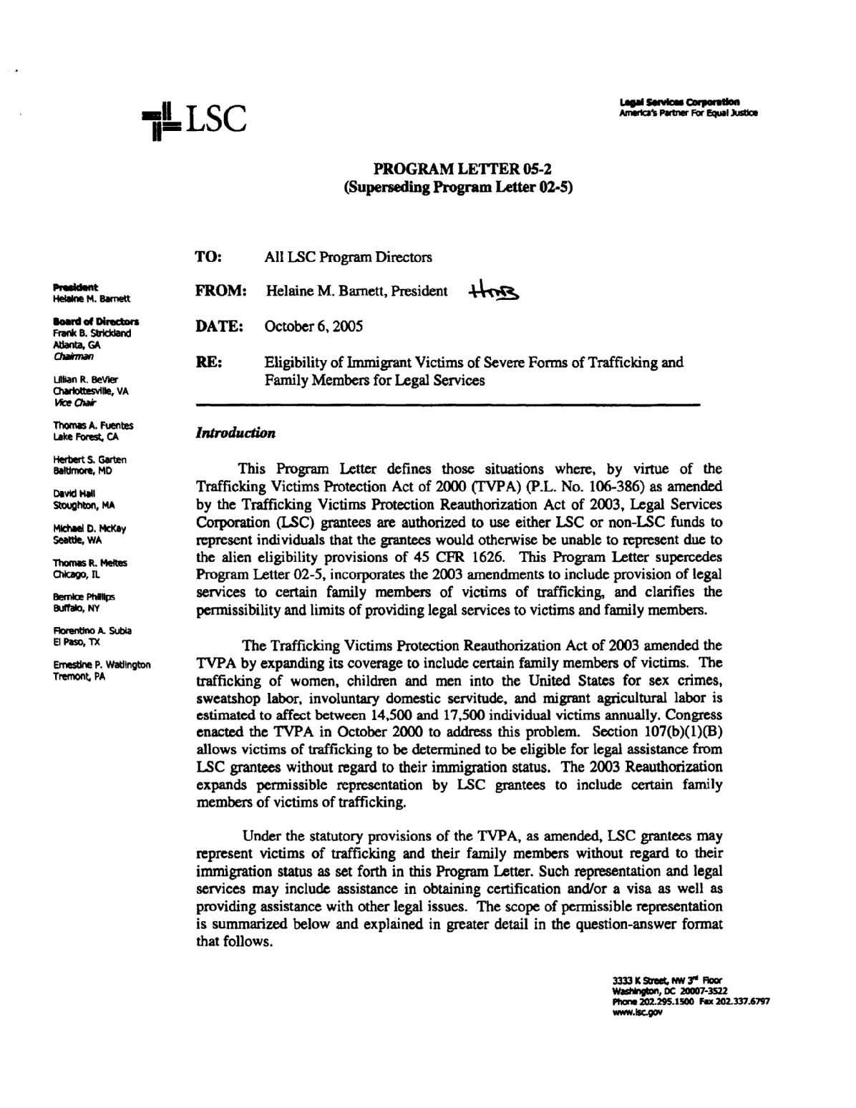
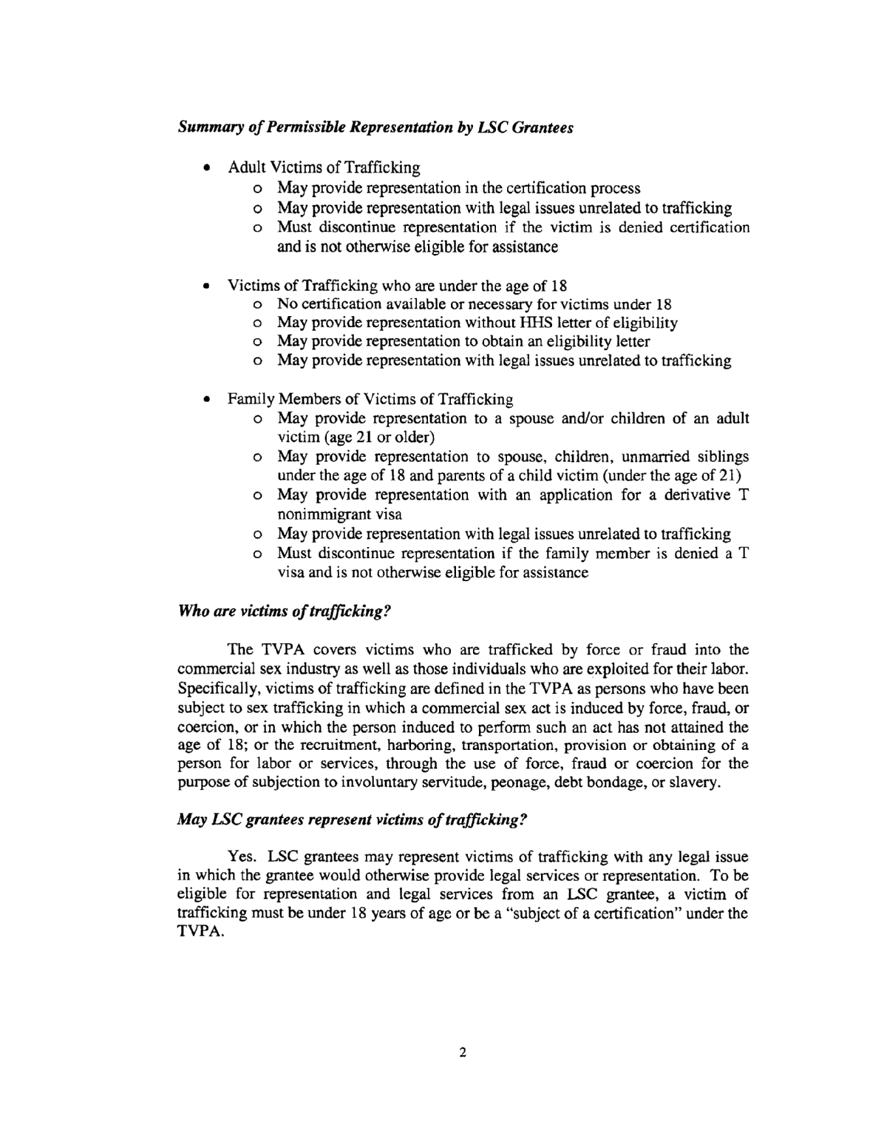
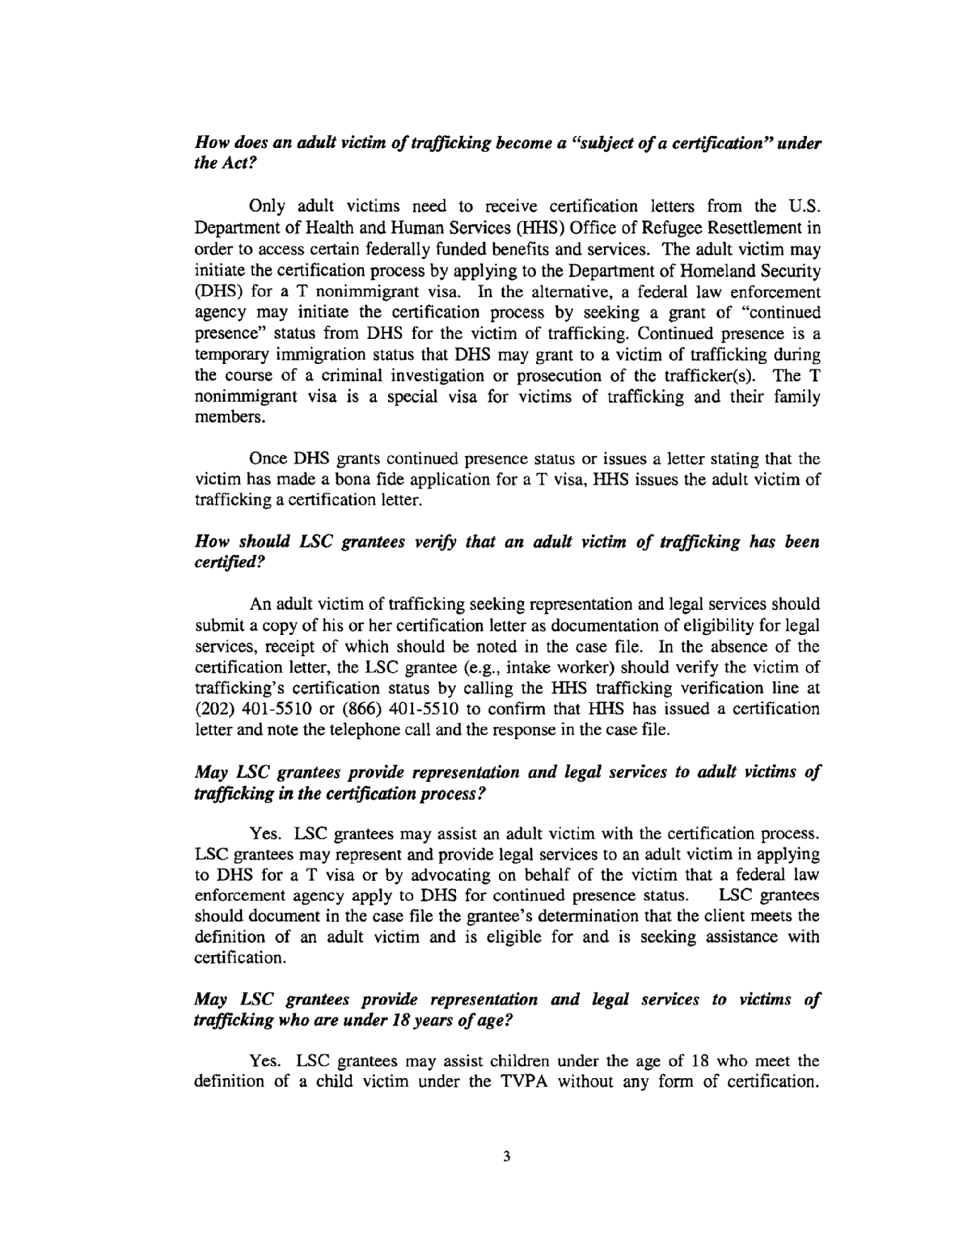
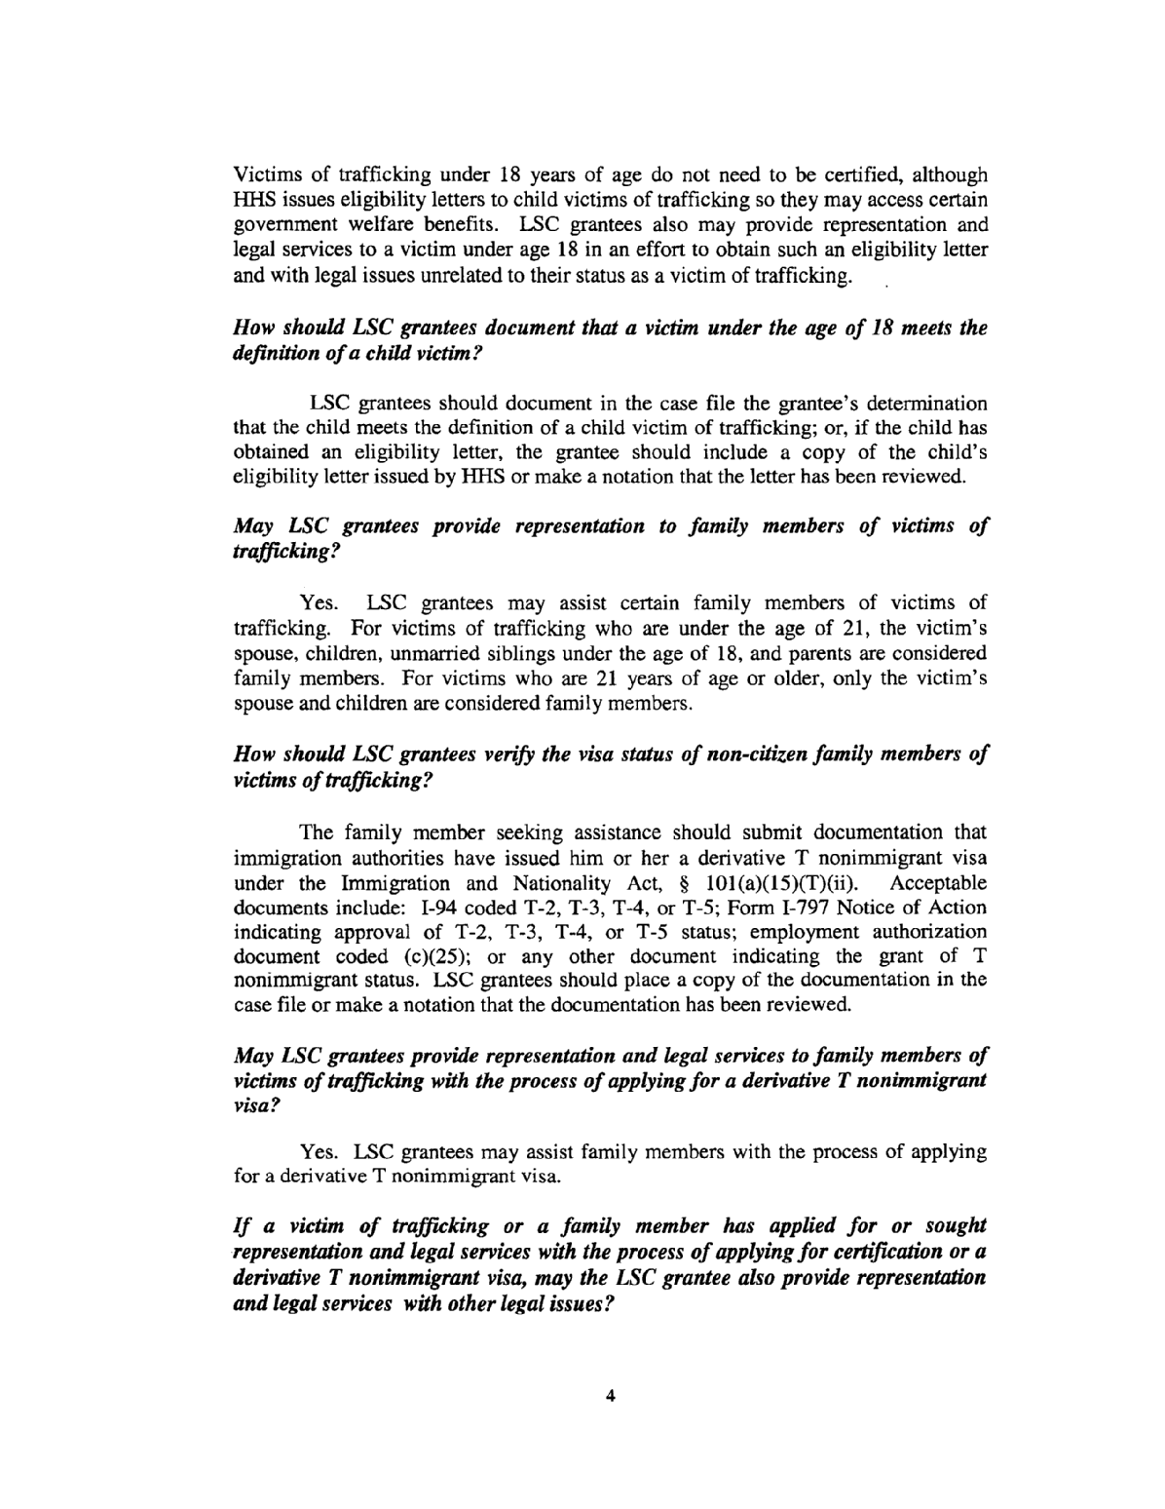
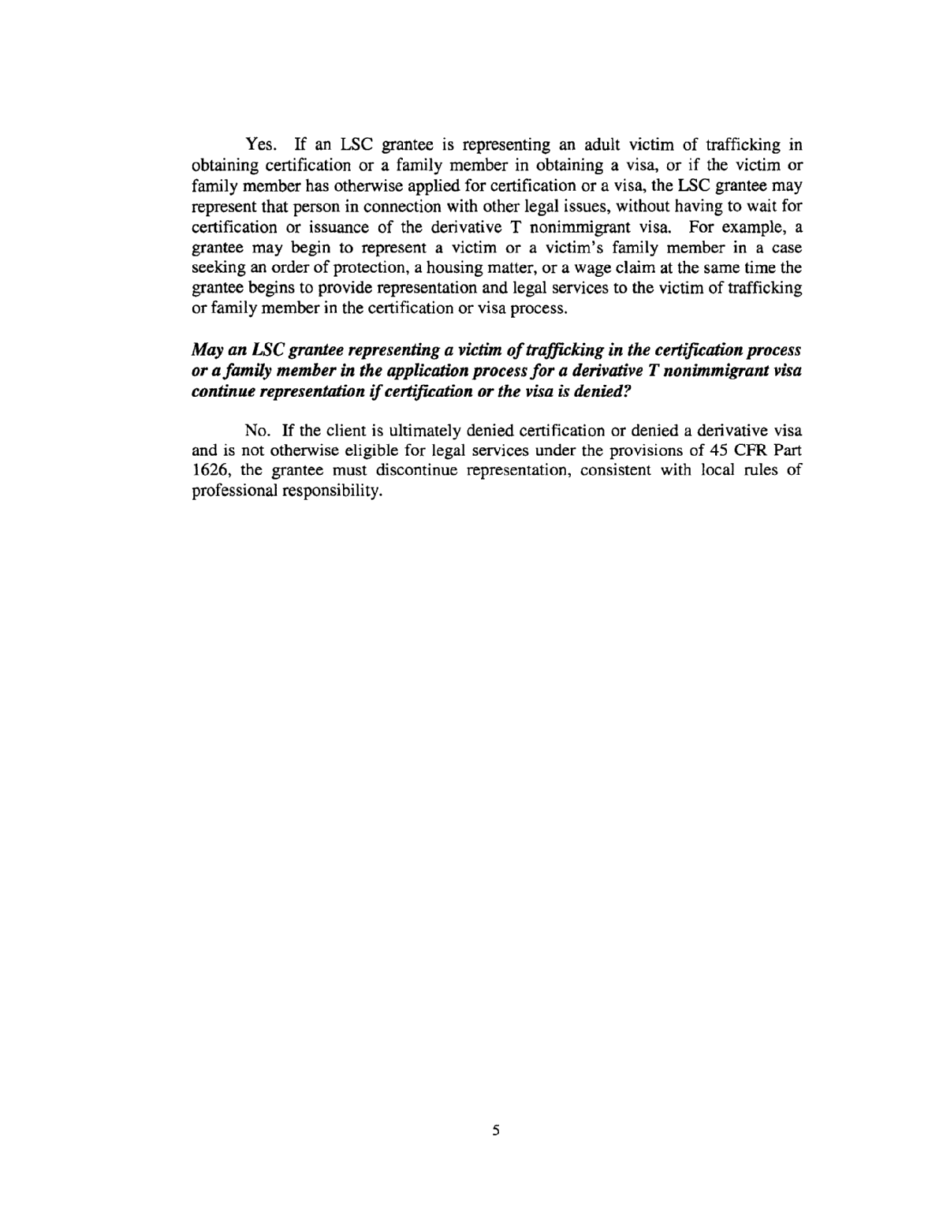

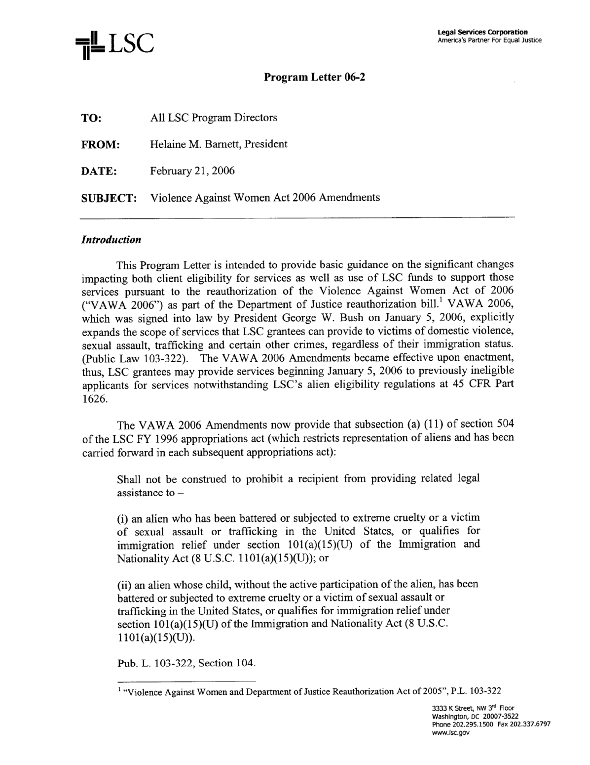
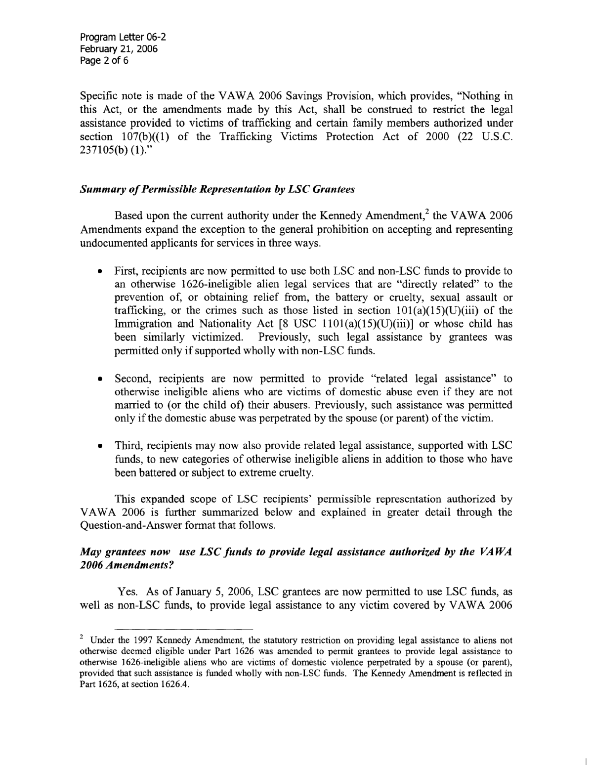
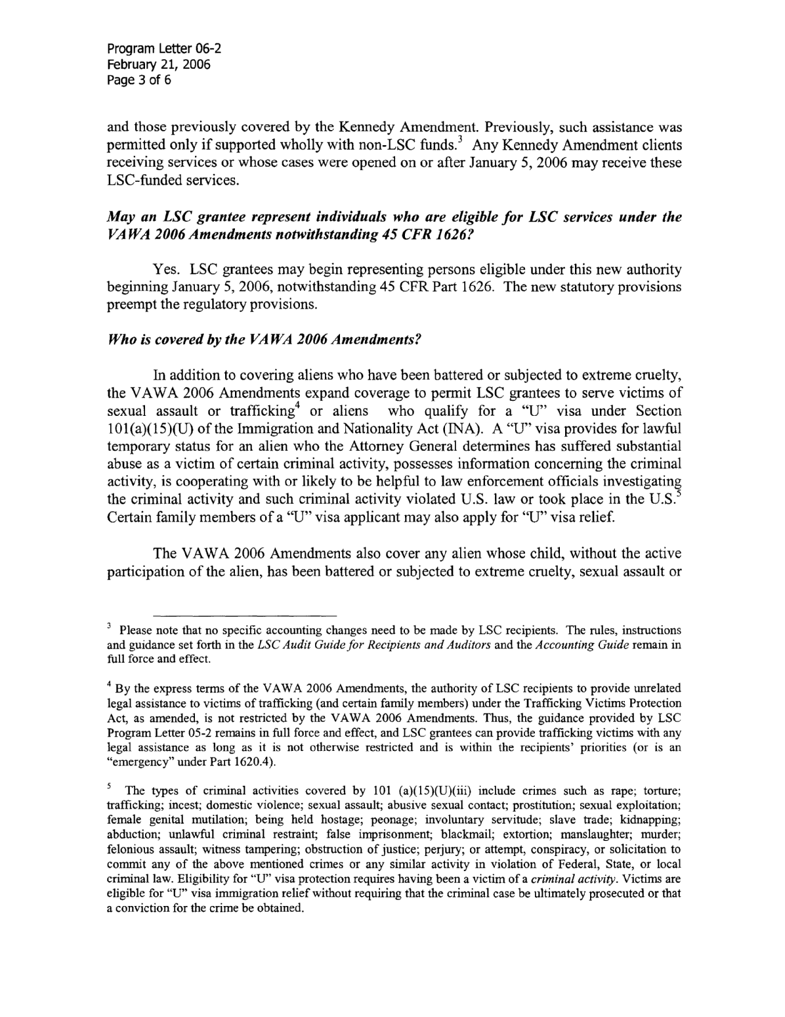
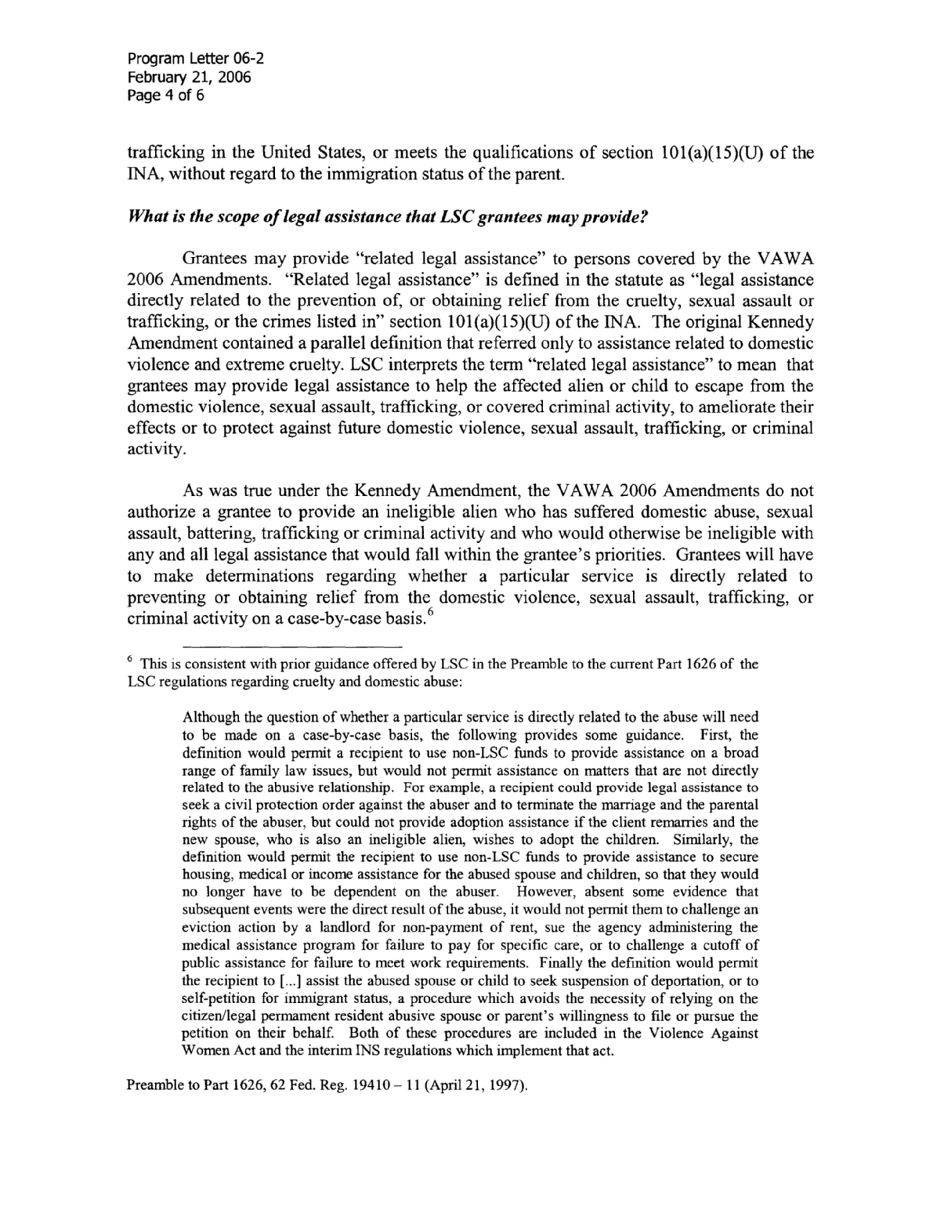
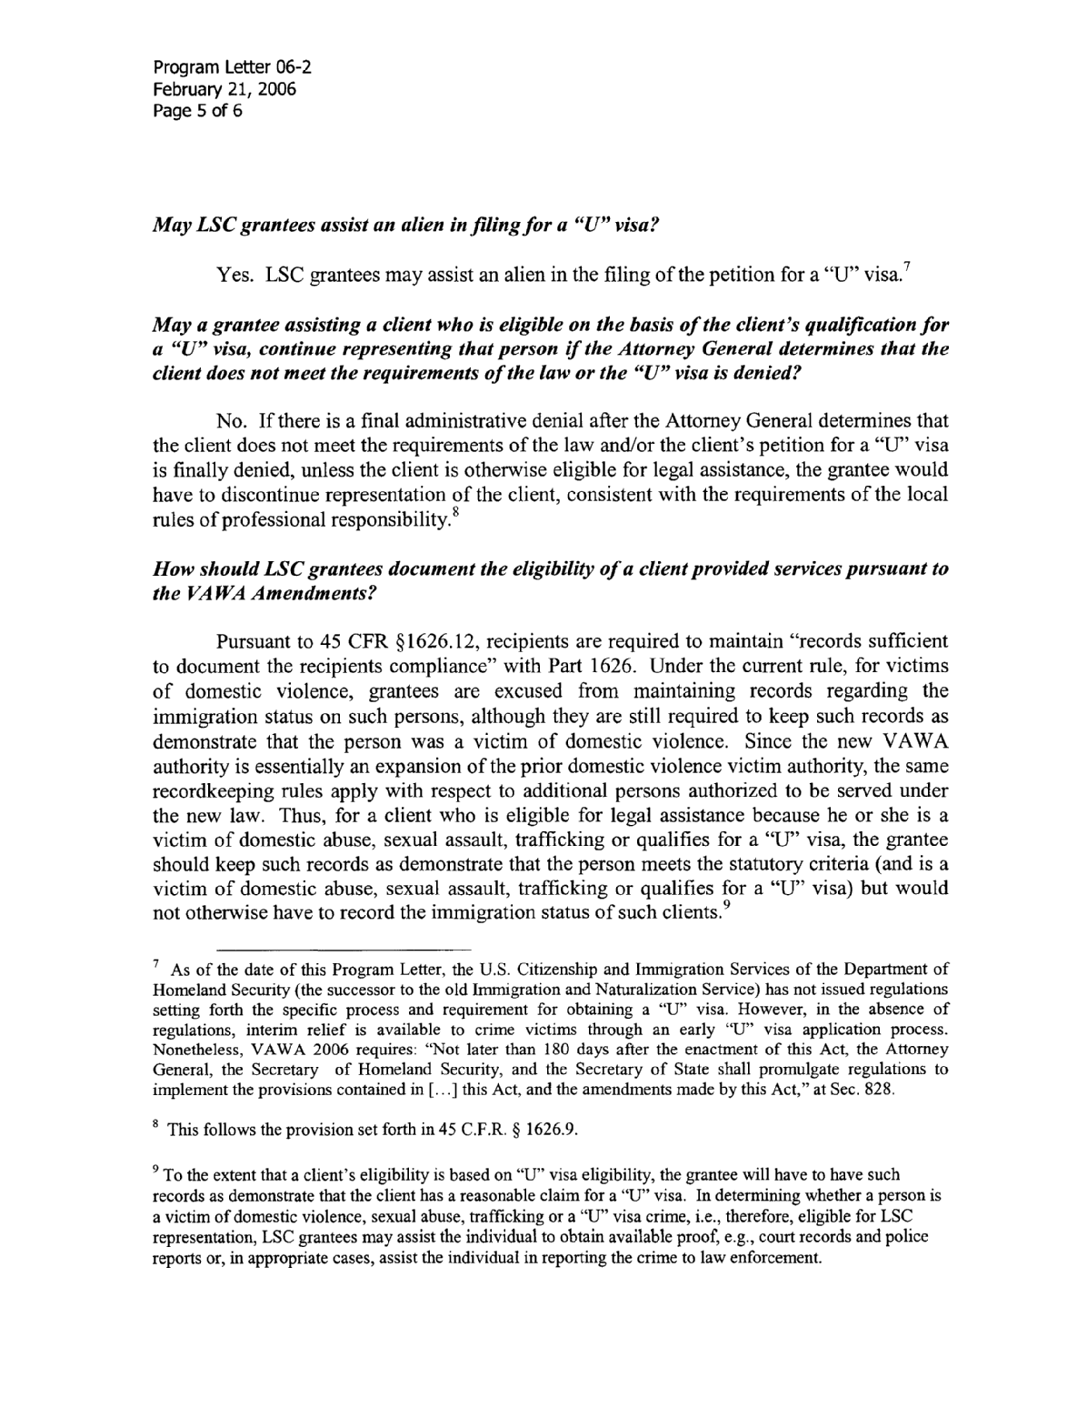
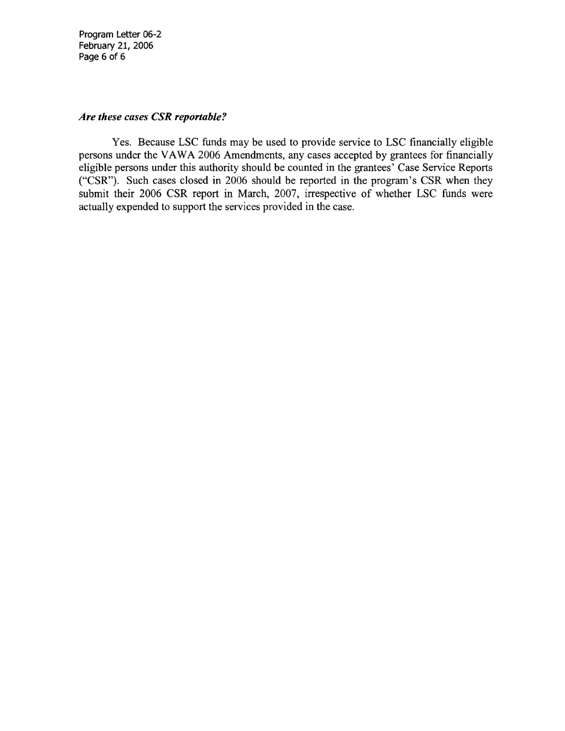

See LSC's Performance Criteria.
“Legal assistance” in this Handbook is synonymous with “legal services” in 45 CFR Part 1635. See 45 CFR § 1635.2(a) which defines “case” in reference to timekeeping requirements. Chapters VI and VII of this Handbook contain further guidance on when to treat service to a client as a case. Chapter IV of this Handbook contains additional guidance regarding LSC reporting requirements.
If an applicant is financially ineligible under LSC criteria, but not under non-LSC criteria, service to that client may be provided with non-LSC funds, but the case may not be reported to LSC for CSR purposes; however, if the client is ineligible under the “entity restrictions” because of the client’s status (e.g., an ineligible alien) or the nature of the legal services (e.g., a class action), then assistance may not be provided with any funds belonging to a recipient program. Such “entity restrictions” are based on Section 504 of the 1996 LSC appropriations act (110 Stat 321 (1996, carried forward in succeeding LSC appropriations acts), providing that services to certain classes of clients and certain activities may not be carried out by any entity that receives LSC funds, irrespective of the source of the funds actually used to support such services and/or activities. See 45 CFR Part 1610. Under the Violence Against Women Act 2006 Amendments (VAWA 2006), the Kennedy Amendment exception for service to otherwise ineligible aliens who are domestic violence victims has been expanded to broaden the allowable categories of clients and cases and to allow the use of LSC funds for such cases. Consequently, such cases on behalf of otherwise ineligible aliens are now considered LSC-eligible and may be reported in a CSR without the documentation required by 45 CFR Part 1626. Also, under the Trafficking Victims Protection Act (TVPA), as amended in 2003, otherwise ineligible alien victims of trafficking have similar expanded eligibility and cases undertaken on their behalf may also be reported in a CSR with documentation of alien eligibility as specified by LSC program letters. See Program Letters 06-2 and 05-2 in the Appendix for details of this expanded eligibility. For U.S. citizens, appropriate documentation pursuant to 45 CFR Part 1626 is required.
The point at which a case is “accepted” for service depends on the type of service provided and the process by which the program provides the service. For example, when an eligible applicant seeks advice over the telephone, “acceptance” occurs when a staff member or participating private attorney determines that the applicant qualifies for service and indicates acceptance of the case through assignment of a case number or other means of demonstrating case acceptance (e.g., a notation in the file).
The legal assistance must actually be provided to the client in order for the assistance to be reported as a case in a CSR. For example, if the program performs legal research but does not advise the client of the results of the research, this would not constitute a CSR-reportable case. Similarly, if the program sends a letter to a client containing legal advice which is then returned to the program as undeliverable (and the program has not orally advised the client), this also would not constitute a CSR-reportable case.
See Footnote 3.
See 45 CFR § 1610.2 for a list of prohibited legal problems and assistance which cannot be undertaken by a program receiving LSC funds nor reported as CSR cases. Note that CSR cases may be reported irrespective of compliance with the requirements of 45 CFR § 1611.9, Retainer Agreements, or 45 CFR Part 1636, Client Identity and Statement of Facts.
See Footnote 3.
Assistance that is not legal in nature, e.g. provision of a social service, referral for financial assistance or other assistance, is not legal assistance.
For CSR purposes, LSC has adopted the definition of legal information in the ABA Standards for the Provision of Civil Legal Aid (2006). See Standard 3.6 on the Provision of Legal Information.
The provision of legal information may only be reported as an Other Service for Other Services Report (OSR) purposes. A program may not provide or report the same level of assistance as a case for an eligible client and as a matter for an ineligible client.
See Footnote 3. Examples of LSC eligibility requirements can be found at 45 CFR Part 1611, Eligibility, 45 CFR Part 1620, Priorities in Use of Resources, 45 CFR Part 1626, Restrictions on Legal Assistance to Aliens, and 45 CFR Part 1637, Representation of Prisoners.
This does not apply to a case that is still pending before a court or administrative agency.
If there was a change in the client’s circumstances after acceptance, the case may be counted as a CSR case, but if the client was ineligible at the time of intake, the case may not be counted.
If a program uses a “rejected” code, it shall be used only for applicants who do not qualify for program services or who are otherwise not accepted for services by the program. Cases for eligible clients that have been accepted for services cannot subsequently be coded as “rejected.” Programs should have the ability to distinguish between cases that were initially rejected and cases that were initially accepted but could not be reported as closed cases in the CSR.
For purposes of this Handbook, grants to programs for legal assistance are referred to as Basic Field, Migrant, and Native American. However, all funds provided by Congress for legal assistance are appropriated under the “Basic Field” line item.
Nevertheless, Migrant or Native American funds expended to pay or support private attorneys may still be counted towards a program’s 12.5% PAI expenditure requirement. ^{17a} For most cases closed with funding under Titles III and IV of the Older Americans Act, client financial eligibility information cannot be obtained because of the requirement under this law to serve elderly clients regardless of income. While such cases cannot be reported under regular CSR rules, Program Letter 03-2 provides for special CSR reporting of the total of all Title III and IV cases closed by each grantee program that could not be reported in the regular CSR because client income eligibility could not be documented.
See Footnote 3.
A program may have more than one service area in a specific category of funding, such as Basic Field, or may have service areas in more than one category of funding, such as Basic Field and Migrant. In either case, each service area is to be reported separately.
For group clients, programs must obtain financial eligibility information as required per 45 CFR § 1611.6.
Electronic recordation may include scanned copies of any paper documents related to eligibility, including citizenship attestations, retainer agreements, etc. If a program chooses to electronically record such information, however, client signatures must be visible on the electronic copy. In addition, programs must ensure all electronically recorded compliance information is backed up in the event of a failure of the program’s computerized records system.
See 45 CFR § 1611.2(i) which states: “ ‘Income’ means actual current total cash receipts before taxes of all persons who are resident members of and contribute to the support of applicant’s household, as that term is defined by the recipient.”
Pursuant to 45 CFR § 1611.3(e), when an applicant is a victim of domestic violence, the recipient shall consider only the income and assets of the applicant and members of the applicant’s household other than those of the alleged perpetrator of the domestic violence and shall not include any assets held by the alleged perpetrator of the domestic violence or jointly held by the applicant or by any member of the applicant’s household with the alleged perpetrator of the domestic violence.
The requirement that an amount be recorded is not satisfied if a computer program defaults to zero; program staff must make an actual entry to record an amount of household income in each case.
Whatever method is used to determine income eligibility, a program must still record the client’s gross income and maintain it as a separate field from the adjusted gross income. A mathematical deduction of over-income exceptions (or “spend-down) is not required under 45 CFR § 1611.5. If a program chooses to use a mathematical deduction (or “spend-down”) to determine whether an applicant is eligible, it must still indicate in its records the factual basis for the decision to accept the client’s case, even if the deductions bring the applicant’s income below 125% of the federal poverty guidelines.
See Footnote 23 referring to the consideration of assets of domestic violence victims for eligibility purposes.
For example, a client’s asset could have a fair-market value of $30,000 but if it is encumbered by a loan in the amount of $28,000, the client’s equity value in the asset would be only $2,000.
The requirement that a value be recorded is not satisfied if a computer program defaults to zero; program staff must make an actual entry to record an amount of household assets in each case. In the event a program chooses to include the value of an excluded asset in the asset field of its CMS or intake sheet, it should label it as such in order to prevent its inclusion in the calculation of an applicant’s asset eligibility.
There are exceptions to this; see Program Letters 05-2 and 06-2 in the Appendix for further detail regarding VAWA and Trafficking cases.
The requirement for a written notation is not satisfied if a computer program defaults to an indication of eligibility; program staff must make an actual entry to record eligibility in each case.
This requirement applies during the course of the calendar year. If a program has already closed and reported a case in one calendar year, and the client returns for additional service in a subsequent calendar year, the program must report the additional service as a separate case in the subsequent year, provided that the case otherwise meets the requirements and definitions of this Handbook.
See Chapter IX for a listing of Legal Problem Categories and Codes.
Different Legal Problem Codes within one Legal Problem Category, such as Divorce and Custody are not sufficient, except as stated in subsection (ii) above.
Legal Problem Codes in these Legal Problem Categories may represent very different subject matter, (e.g. in the Miscellaneous Category, Indian/Tribal Law - 92 and Wills/Estates - 95).
Note that only appeals to an appellate court fall within the definition of appeals in this Chapter and within the parallel definition of appeals in Chapter VIII, CSR Closure Category I(c). “Appeals” from an administrative agency to a trial court or from a lower level trial court to a higher level trial court are not included in 45 CFR § 1605 and should be reported as only one case under CSR Closure Category I(b).
Prior to opening a new case as an appeal or remand under § 6.5, a new client eligibility determination is required as well as an assessment of merit.
Although 45 CFR § 1635.2(b) defines the operation of a pro se clinic as a “matter” (now reported under “Other Services), the provision of legal assistance to an attendee at a pro se clinic qualifies as a case when the service provided meets the definition of a case in § 2.1 of this Handbook and the person receiving the legal assistance meets the definition of a client in § 2.3 of this Handbook.
A program may not provide legal assistance contrary to the LSC Act, regulations and other applicable law, as discussed in Footnote 3, as part of a workshop, clinic, or other alternate form of service.
See also ABA Standards for the Provision of Civil Legal Aid (2006), Standard 3.6 on the Provision of Legal Information.
For PAI referrals, see § 10.1(b)(i).
Prior CSR Handbook Closing Categories C – Referred After Legal Assessment, D – Insufficient Merit to Proceed, E – Client Withdrew, and J – Change in Eligibility Status have been discontinued and programs shall not apply those closing codes to cases closed after January 1, 2008.
As specified by § 6.6 of this Handbook, the provision of direct legal advice to a client in a pro se clinic or workshop qualifies as a case which may be reported to LSC if the provision of advice meets the definition of a case found in § 2.1 of this Handbook and the person receiving the advice meets the definition of a client found in § 2.3 of this Handbook.
CSR Closure Categories A and B include cases in which a referral has been made after the legal assistance was provided. Referrals without the provision of legal assistance should be reported as Other Services under the OSR system. Cases in which a referral is made after the provision of legal assistance may not be reported as both a CSR case and a matter. Also note that 45 CFR § 1611.9 does not require that a retainer be obtained in limited services cases.
See the ABA Standards for the Provision of Civil Legal Aid (2006), Standard 3.6 on the Provision of Legal Information, “The giving of legal advice is legal representation and creates an attorney-client relationship.”
“Limited Action” as defined in this Handbook is synonymous with “brief services” as described in 45 CFR § 1611.2(e).
Provided it meets the definition of a “case”, legal assistance to pro se clients may be closed as CSR Closure Categories A – Advice and Counsel, B – Limited Action, or L – Extensive Service depending on the level of assistance provided to the client.
The time limitation of the prior Handbook that a Brief Services case should be closed “as a result of an action taken at or within a few days or weeks of intake” has been eliminated. However, cases closed as Limited Action are subject to the time limitation on case closure found in § 3.3(a). This category is intended to be used for the preparation of relatively simple or routine documents and relatively brief interactions with other parties. More complex and/or extensive cases that would otherwise be closed in this category should be closed in the new CSR Closure Category L – Extensive Service.
The file should contain documentation of the settlement, either an actual, written settlement, a written confirmation of the settlement with the opposing party, or, if neither of these are available, a copy of a communication to the client outlining the terms of the settlement. Pro se cases cannot be closed in this category.
See CSR Closure Categories G and L for guidance in closing such cases.
Only cases in which the program attorney or advocate or PAI attorney is entered as counsel of record may be closed as CSR Closure Category H or I. Assistance to pro se litigants cannot be closed in CSR Closure Categories H or I.
This does not include settlements made during the course of litigation approved by the administrative agency or court, voluntary dismissals or the grant of a motion to withdraw as counsel. However, although it may not be technically case dispositive, a case closed after a TRO or similar interim order made on the merits has been entered, may be closed in this category when the litigation is not pursued further.
Such cases should be closed only once as CSR Closure Category I(b) – Contested Court Decision.
If a descriptive closure category is applicable, it should be used; otherwise the case should be closed as CSR Closure Category K.
This closure category should be reserved for cases in which the assistance the program provides clearly exceeds the amount of work that would be performed for CSR Closure Categories A – Counsel and Advice or B – Limited Action and no other closing code is appropriate (e.g., F, G, H, or I). Factors that favor selection of CSR Closure Category L include but are not limited to: (1) a high level of factual complexity; (2) a highly sophisticated legal analysis; (3) drafting of non-routine original pleadings or legal documents; and (4) significant legal research. Although not controlling, programs may also consider whether a substantial amount of time was charged to the case as evidence of extensive services.
For example, in the event a volunteer PAI attorney closed an advice and counsel case in June 2005 but did not report it as closed to the program until June 2006, the program could still report the case in its 2006 CSR. However, if the volunteer PAI attorney closed the advice and counsel case in June 2005 but did not report it as closed to the program until June 2007, such case is untimely and cannot be reported in the CSR.
See 45 CFR § 1614.3(d)(3).
In the event either program staff or the PAI attorney has in-person contact with the client, the program shall ensure that the case file contains a written citizenship attestation or documentation that the client’s alien eligibility documents have been reviewed by either the program or the private attorney. See 45 CFR § 1626.6. Cases without such documentation may not be reported to LSC unless the case falls within articulated exceptions (e.g., VAWA or Trafficking cases).
There must be sufficient information in the file or in the case management system to support the closing code selected to close the case. In the absence of closing information from the PAI attorney’s office, information obtained from the court or other reliable source is sufficient.

