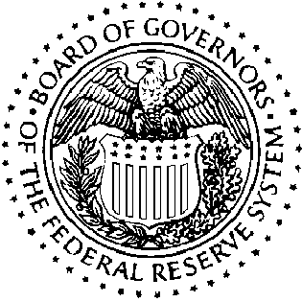
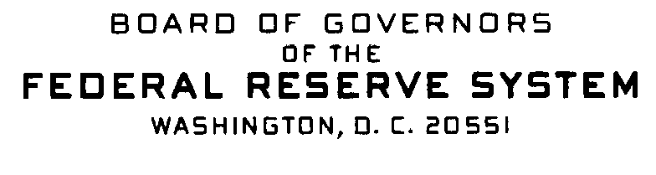


Correspondence Date: July 10, 2006

Dear Sir or Madam:

The following information is being provided in response to your recent inquiry concerning the 2006 A Guide to HMDA Reporting: Getting It Right! Since there were no major changes to Regulation C, the Staff Commentary, the HMDA file specifications or edits for 2006, it is unnecessary to update the Guide for collection and reporting of 2006 data. In addition, paper copies of the Guide will not be printed; any future clarification changes will be made to the Guide on the Web only (http://www.ffiec.gov/hmda/guide.htm). The 2004 Guide on the Web should be used for guidance on collection and reporting of calendar year 2006 HMDA data due March 1, 2007. In the near future, clarification changes will be made on the Web to pages 1 through 28, and Appendices F and G that will update the 2004 Guide for 2006.

This notice serves as a reminder of previously announced information that relates to
data collection for 2006:

Exemption threshold: The 2006 exemption threshold for depository institutions was changed to $35 million. Thus, depository institutions with assets of $35 million or less as of 12/31/2005 are exempt from 2006 data collection. The exemption thresholds for nondepository institutions have not changed.

Geographic Changes in the 2006 FFIEC Census file: Vero Beach, FL Metropolitan Statistical Area (code 46940) was changed to Sebastian-Vero Beach, FL Metropolitan Statistical Area (code 42680). The only county in MSA 42680 is Indian River (code 061).

Any questions or requests for additional information should be directed to:

Assistance Line: Internet E-Mail Address:
(202) 452-2016 hmdahelp@frb.gov

