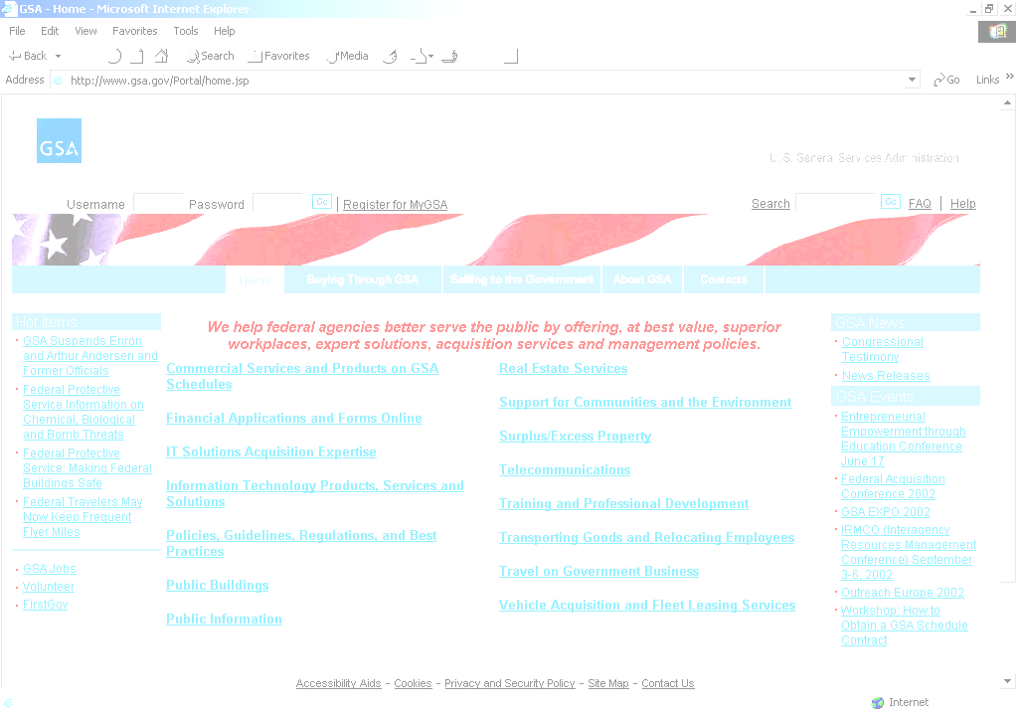
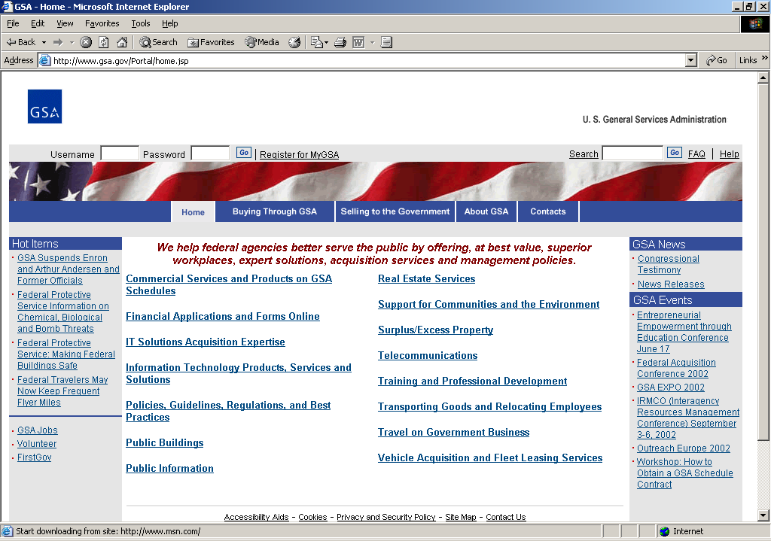

E-Government Act of 2002
Annual Status Update

Submitted by:
General Services Administration
October 20, 2006
Revised January 12, 2007

CONTENTS

OVERVIEW OF AGENCY E-GOV ACT IMPLEMENTATION 3

AGENCY PROCESS ON INTERNET INFORMATION 6

AGENCY INFORMATION DISSEMINATION ACTIVITIES 10
AND FOIA OPERATIONS

- Provide a brief overview of your agency’s implementation of the Act (E-Government Act of 2002), including a description of an internal agency-specific E-Government initiative.

The General Services Administration (GSA) has numerous initiatives which align with or support eGov initiatives and the Electronic Acquisition System (EAS) application is an integral part of the agency’s E-Government strategy within the Public Buildings Service (PBS). EAS is a centralized web-enabled electronic procurement system with a range of fully functional tools designed to support nationwide PBS acquisition preparation, tracking, and reporting. It integrates and streamlines the entire acquisition management process and supports full lifecycle contracting from requisition through contract award/purchase to final contract closeout for approximately 3,000 active users located at PBS regional offices, field offices, and other remote locations nationwide.

Describe how the initiative is transforming agency operations.

PBS has already begun to realize efficiencies of electronic government though the use of various Integrated Acquisition Environment (IAE) initiatives. PBS applies a consistent focus on ongoing improvement in data integrity and encourages review of electronic interfacing opportunities to increase the efficiency of system users, increase the accuracy of system data, and minimize entry of redundant data into multiple systems. A strong example of this is the Federal Procurement Database System - Next Generation (FPDS-NG) link within EAS. This link requires that users provide/update information in the Federal database to enable optimal data integrity and data capture standardization. This ensures trustworthiness of the information as official, government procurement information.

EAS also enables electronic interoperability with Business Partner Network/Central Contractor Registry (BPN/CCR), Federal Business Opportunities and other IAE initiatives.

During FY2006, extensive internal PBS and agency collaboration laid the groundwork to build upon these successes through planned interfaces with additional IAE initiatives in FY07 and future fiscal years. Throughout FY06, the PBS Office of the Chief Information Officer (OCIO) coordinated extensively with the agency eGov Implementation Office and IAE Program Management Office (PMO), to ensure a streamlined, practical approach to eGov implementation. Agency level efforts included review of eGov integration viability and review and collaboration on planned out-year milestones. Internally to PBS, coordination within the PBS OCIO and the Office of Vendor Alliance and Vendor Acquisition Business Line end-user community ensures an awareness of the eGov initiatives, expected benefits, a tentative implementation plan with milestones, Commercial-off-the-shelf (COTS) development contractor involvement, and buy-in from the user community.

This discussion was in part, required by the quarterly eGov reporting, but also embraced internally as an opportunity to review internal processes and apply practical Business Line process improvements.

Explain how your agency maintains an ongoing dialogue with interested parties to find innovative ways to use information technology for the initiative.

EAS was already in place with a portfolio of fully functional electronic tools designed to support nationwide PBS acquisition preparation, tracking, and reporting. The entire acquisition management process has been streamlined and continued opportunities associated with eGov will enable an elevated level of efficiency to the approximately 3,000 nationwide users.

GSA PBS collaborates with eGov stakeholders including the IAE PMO, agency eGov office, development community, and Business Line users for the various eGov opportunities with the IAE. Since the alignment of an application to an eGov initiative transcends the application itself, the Business Line users and system owners are involved in ongoing discussions to ensure enterprise-wide input, buy-in, and understanding of the opportunities and process revisions that were/are needed to fully implement electronic government improvements within GSA/PBS. This collaboration ensures that the eGov milestones are viable and can be realized within the EAS application and integrated into the Business Line processes.

Today, the IAE initiatives, Electronic Subcontracting Reporting System (eSRS), Wage Determinations Online (WDOL), and Past Performance Information Retrieval System (PPIRS) are being accessed by the PBS user community through the existing web browsers. As interface specifications are finalized by the IAE PMO, they are reviewed and a schedule is put forth to enable application integration. For example, PBS determined that integration is desirable between EAS and PPIRS, and in support of this decision, the Vendor Past Performance (VPP) module of Comprizon is in the process of being configured for implementation by PBS. This module will be developed to have the capability to feed directly into PPIRS.

Identify external partners (e.g., Federal, State or local agencies, industry) who collaborate on the initiative.

PBS coordinates with internal and external partners, both federal and private industry, to ensure a broad review of process revisions required as part of the alignment with IAE initiatives. Since EAS uses Comprizon™Suite, a COTS product, the developer is aware of and involved in ongoing application improvements requested by the Federal user community and ensures that the application meets the requirements/directives in place for the Federal community. Electronic government interfaces are reviewed and implemented in close coordination with the PBS user community.

Identify improved performance (e.g., outcome measures) by tracking performance measures supporting agency objectives and strategic goals.

The EAS application has streamlined PBS acquisition and has consistently incorporated user feedback to ensure that EAS meets PBS Business Line requirements while closely supporting the agency’s mission of helping “federal agencies better serve the public by offering, at best value, superior workplaces, expert solutions, acquisition services and management policies." The eGov milestones set forth for EAS are collaboratively reviewed within the agency and are regularly updated through briefings to the agency eGov Implementation Office.

The EAS application fully supports the mutually reinforcing IAE initiatives in the President's Management Agenda. This shows a commitment both to the idea of streamlining Government by expanding electronic access and to executing and producing results, which are the essence of the President's Management Agenda.

Quantify the cost savings and cost avoidance achieved through implementing the initiative.

The ongoing efficiencies and economies achieved through leveraging IAE initiatives are multi-fold and will enable PBS Business Line cost savings and cost avoidances. Firstly, since FY06 entailed a significant review and involvement of all eGov stakeholder groups, potential future re-work and integration issues have been mitigated. Secondly, expected cost savings and cost avoidances will be predominantly realized within the PBS Business Line user community. Reduction in duplication of effort, increased data integrity, and improved human capital efficiency are several of the benefits of eGov implementation. Just as EAS end-users have been able to minimize/eliminate the cross-checking/validation of electronic resources such as BPN/CCR, similar benefits are expected with additional IAE electronic interfaces. Thirdly, a significant qualitative benefit is the increase in end-user satisfaction with the application and the role it plays in accomplishing procurement tasks. The efficiency improvements will allow the end-users to make more effective use of their time and increase focus on the customer.

Explain how this initiative ensures the availability of Government information and services for those without access to the Internet and for those with disabilities.

The EAS application requires full compliance with Section 508 of the Rehabilitation Act for access to persons with disabilities. Section 508 compliance is specifically addressed in the requirements for EAS and the system is tested to ensure compliance is met. Section 508 compliance transcends EAS and accordingly PBS references Section 508 guidance promulgated at the agency level. GSA and PBS continue to assess the adequacy of accessibility under current enterprise architectures, including current business processes, information and data management processes, their supporting applications and information systems, and their underlying computing platforms and communications environments.

- Describe your process for determining which information will be made available on your agency’s public website and the Internet as required in Section 207(f)(2) of the Act.

Describe your process for determining which Government information the agency intends to make available and accessible to the public on the Internet and by other means.

GSA manages gsa.gov, the agency’s main portal, and FirstGov.gov, the official web portal to the U.S. government. Both gsa.gov and FirstGov.gov determine what to post on their websites based on a 3-step process: 1) customer segmentation; 2) continual analysis of customer information needs; and 3) review of what GSA and the government have to offer for the two websites, respectively. Using these processes, gsa.gov and the FirstGov.gov staff update information on the websites every day.

As the first step in this ongoing process, gsa.gov and FirstGov.gov conduct regular research to determine key customer groups and sub-groups. This research has led to the development of unique sections on gsa.gov for three primary audience segments: federal government employees, the general public, and vendors. Moreover, the research provides guidance for including unique sections on FirstGov.gov for various audience groups and sub-groups, such as: businesses, Spanish speakers, seniors, parents, kids, Americans living overseas, government employees, military personnel and veterans, etc.

As the second step, gsa.gov and FirstGov.gov determine what their audiences need and want.

We regularly review:

- visitor e-mail;
- results of the online American Customer Satisfaction Index (ACSI) survey;
- phone calls to the National Contact Center (1-800-FED-INFO);
- most visited pages;
- most popular questions from our automated Frequently Asked Questions (FAQ) system (FirstGov.gov); and
- most common search terms.

In addition, gsa.gov and FirstGov.gov conduct periodic usability testing and focus groups with our visitors, and we review the latest research, polls, and other studies to determine what types of information our various customer segments require from us.

As an example of how the research is used for gsa.gov, customer feedback has shown that customers’ requests for information from GSA include, but are not limited to:

- travel/per diem/mileage rates;
- all of the various products and services offered by GSA;
- policy and regulations;
- how to get on schedule to sell products and services to the government;
- GSA auctions, surplus/excess property, and
- public buildings/real estate.

As an example of how the research is used for FirstGov.gov, customer feedback and research has shown us that the current top requests for government information are:

- government auctions and sales;
- government jobs;
- benefits/money/taxes;
- forms, passports, and
- contacting elected officials.
We ensure that these top requests are easy to access on FirstGov.gov.

Teams of GSA Subject Matter Experts (e.g., Executive Editors, Content Owners and Content Creators) input new information, and revise and delete old information on gsa.gov using the process of continuous improvement and visitor feedback collected from the comprehensive web metrics model developed by GSA’s Web Metrics Group (including visitor e-mail analysis, usability and other studies, the ACSI, and web traffic statistics). The Enterprise Web Management Group at GSA daily publishes gsa.gov content provided to them from the GSA Subject Matter Experts.

FirstGov.gov looks for what the government has to offer, including ways to highlight government information and services that may be less well known but of great value to the public. We have built an extensive network of federal, state and local government web content managers across the country so we can stay informed of public interests and important government news, information, and services -- and provide easy access to those resources to all American citizens.

Include a copy of the priorities and schedules for making your information available and accessible.

The GSA content inventory and priority schedule is posted on gsa.gov at:
http://www.gsa.gov/gsagovinventory.
FirstGov.gov is a portal which primarily links to other government websites. Content determinations are based on the following criteria and priorities. This linking policy is posted on FirstGov.gov at http://www.firstgov.gov/About/Linking_Policy.shtml

FirstGov.gov staff evaluates all suggested links using the following criteria:
- Is the recommended website an official government-owned or supported website?
- Does the recommended website provide official government information or services?
- Does the recommended website complement existing information, products and services on gsa.gov and FirstGov.gov?
- Is the recommended website accessible and applicable to a wide audience?
- Is the recommended website's content relevant, useful and authoritative for citizens, businesses and/or government officials?
- Does the recommended website's information appear to be accurate and current?
- Is the recommended website's approach to the privacy of personal information consistent with the government's privacy and security policies?
- Is the recommended website user friendly?
- Does the recommended website meet one or more of the following "highly desirable" criteria?
  - The website crosses agency or intergovernmental boundaries (e.g., students.gov, fedforms.gov and nutrition.gov);
  - The website enables citizens, businesses and/or government officials to conduct transactions online (e.g., buying stamps or coins, replacing Medicare cards, and filing taxes);
  - The website provides citizens, businesses and/or government officials with the information they need to interact directly with government organizations (e.g., clearly available telephone numbers, street addresses, e-mail addresses and instructions);
  - The website provides citizens with information about service performance (e.g., Nursing Home Compare, AirNow and Ontime Airline Statistics); and/or
  - The website provides community-level information and services (e.g., MapStats, post office locators, Social Security Office locators, National Park Service Guides and veterans' facilities).

Explain how and when such final determinations, priorities, and schedules were available for public notice and comment.

Visitors’ priorities for GSA-related information are determined in many ways, and gsa.gov allows visitors to comment and provide feedback about what is included (and not included) on the website via a “Contact Us” page on gsa.gov. Customer feedback is also obtained from administering the ACSI survey.

FirstGov.gov provides several ways to find out the public’s priorities for government information and allows visitors to comment and provide feedback about what is included (and not included) on the website. FirstGov.gov regularly publishes a page called “What’s on Americans’ Minds,” which shows the most popular topics and links on FirstGov.gov: http://www.firstgov.gov/About/Americans_Minds.shtml

In FY2005, FirstGov.gov launched a new automated system for tracking and responding to Frequently Asked Questions (FAQs): http://answers.firstgov.gov/ . This automated FAQ system has been a huge success, containing answers to more than 2,000 of the most common questions asked about the U.S. Government. Because questions are listed in order of popularity, it allows FirstGov.gov to track the most important information requested by the public. If a new question is asked that is not in the database, we find the answer and add it to the system. In this way, we have a continuous process for knowing the public’s priorities for government information and responding quickly to address their needs. In addition, we offer a prominent “Contact Us” form on every page of the website, where the public can ask how to find a particular piece of government information, and we help them – within 2 business days.

In addition, in January of 2006, FirstGov.gov created a centrally-located page where the public can find each Department and Agency’s inventories, priorities and schedules of federal government information on the web. The page is located at: http://www.firstgov.gov/Topics/Reference_Shelf/FOIA/web_inventories.shtml

Provide the link where final determinations, priorities and schedules can be found on your principal Federal agency public website
http://www.gsa.gov/gsagovinventory.
Identify progress to date for permitting searching of all files intended for public use on the website, displaying search results in order of relevancy to search criteria, and providing response times approximately equivalent to industry best practices.

The search engine on gsa.gov was built using Verity's K2 Enterprise search software that has been specifically configured for gsa.gov to include all files intended for public use on the website. The search results are displayed in order of relevancy to the search criteria. The search also provides recommended results that are custom configured for certain search terms to ensure that the most appropriate results are provided for select search criteria. Verity's K2 Enterprise provides response times approximately equivalent to industry best practices.

The FirstGov search engine is extensive. It was relaunched in January 2006 using a new search contract with Vivisimo and MSN Search that was awarded in September 2005. The FirstGov search engine now searches over 50 million federal, state, local, tribal and territorial web pages. The service is being expanded in October 2006 to include a search of government news and images. The MSN Search Web service includes extensive coverage of government documents in its index as well as a broad set of filtering-related operators to improve relevancy and retrieval of results. With Vivisimo, FirstGov selectively crawls and meta-searches federal, state, and local government-related content and then clusters the combined MSN Search and Vivisimo results for easier navigation by FirstGov users. FirstGov has always met industry standards related to search response times, displaying search results in less than 1 second. The service ensures that citizens searching the government receive authoritative government information.

- Brief description of your agency’s information dissemination activities and FOIA operations.

Describe how your agency’s information dissemination activities are coordinated with its FOIA operations in order to improve both access to and dissemination of government information to the public.

To convey important information about the FOIA process, the FOIA Requestor Service Center maintains pages on the agency’s website, gsa.gov. This has led to an extensive amount of current information to become available to requestors. There is a direct link on the GSA homepage to the four FOIA pages. FOIA contact information by state (corresponding to GSA’s 11 geographic Regions and Central Office) is included. The FOIA section of the website includes:

- GSA’s FOIA rules for the public
- A link to DOJ’s Public Law information
- Annual GSA FOIA reports (from 1999)
- The Review and Plan in Response to Executive Order 13392
- The Public Information Handbook—a guide to filing FOIAs with GSA
- A link to DOJ’s “Your Right to Federal Records”—a citizen’s guide to accessing federal records
- A list of GSA FOIA Frequently Asked Questions.

The agency also has two ways to receive electronic FOIA requests. The first allows requestors to complete an online FOIA request form on gsa.gov. The second allows a requestor to send an email to the Regions or Central Office. GSA offers gsa.foia@gsa.gov for requestors to easily submit FOIA requests. The agency provides an automated email response that sends an acknowledgment to the requestor after successful receipt of an electronic request using the online form.

As a result of the FOIA improvement plan, additional websites, which are commonly referred to requestors, were added to a new section of the site called “Related Websites.” The links include:

- FPDS (Federal Procurement Data System)--central repository of statistical information on federal contracting)
- FedBizOpps (Federal government procurement opportunities over $25,000)
- Schedules e-Library (Schedules and GWAC contract award information)
- NARA /Federal Personnel Records Center
- DOJ’s “Principle FOIA Contacts to Federal Agencies”

In addition, the FOIA Requestor Service Center conducts a bi-annual review of its pages to ensure accuracy. This direct maintenance has led the website to becoming an excellent source of information for requestors.

Link to your agency’s Information Resources Management (IRM) Strategic Plan.

GSA IRM Strategic Plan

Link to your agency’s FOIA Improvement Plan.

Review and Plan in Response to Executive Order 13392

Describe specifically how you are fulfilling your responsibilities under three provisions of the E-Government Act of 2002:

- Section 207(d), “Categorizing of Information”

The General Services Administration provides information for the public and federal agencies through its public website, www.gsa.gov. Our homepage contains a block of information identified as For Citizens which identifies content specifically of interest to the public. Our agency website is based on a comprehensive taxonomy. The taxonomy is topically organized around policy information, buildings, technology, products and services. The website is searchable and provides numerous enhancements to the search including recommended results and metadata to help individuals find the information even if they misspell the words or use other forms of the word. An example of metadata for Per Diem Rates is perdiem, per dium, per diam, perdium, pier diem, perdium rates, etc. We also display teasers for each search result which further explain each page before the individual actually opens the content.

- Section 207(e), “Public Access to Electronic Information” and

The feature, For Citizens highlights Federal Citizen Information Center, Government Property for Sales, Pueblo.gov, Regulations.gov, Child Care, Emergency Disaster Relief. Per Diem is our most common search. The public frequently uses our electronic look-up of per diem rates. Our satisfaction rating from those who use this capability is high. GSA also offers auctions and sales of property, real estate, and vehicles and promotes Computers for Learning which provides excess computers to eligible schools. All of this information is available through www.gsa.gov.

GSA’s recordkeeping policies meet government-wide requirements as issued by the National Archives and Records Administration (NARA), and fully support the conversion to electronic recordkeeping. The GSA Records Maintenance and Disposition System, under the statutes governing Federal records management, promotes economic and efficient methods of creating, maintaining, using, and disposing of records.

Section 207 (e) of the Act requires the identification and scheduling of all electronic records in existing and new electronic information systems. GSA's existing records schedule (e.g., File Plan) addresses all electronic and paper records. GSA is complying with the provisions of 207 (e) by using our existing systems inventory and establishing if the systems are covered by existing disposition authorities and if not, developing schedules for the records (FY 2007 and beyond). As part of our Capital Planning and Investment Review process, GSA reviewed all of its major investments and most of its non-major investments for coverage under existing records schedules. Throughout FY2007, GSA will be reviewing compliance of major applications with their records management disposition plan. During FY2008, non-compliant record keeping systems will be improved through either the implementation of centralized or locally implemented electronic recordkeeping solutions.

In August 2006, GSA began an analysis designed to identify existing requirements for an enterprise-wide electronic records management process, produce a business case analysis and implementation roadmaps for alternative enterprise-wide solutions and deploy a proof-of-concept environment which meets the records management standards for active use, controlled access and disposition. One goal of the proof-of-concept is to demonstrate that the information and data contained on existing electronic medium remains available to the public, and that the medium upon which they are stored remains updated and readable.

Record keeping requirements for all existing electronic information systems are updated annually in the GSA Target Enterprise Architecture. GSA also utilizes a structured governance process which vets and approves information technology systems through a series of governing bodies including service and staff office Management Councils, the GSA Enterprise Architecture Subcommittee, the GSA IT Council, and the GSA Business Systems. These governing bodies utilize a rigorous evaluation to ensure that no redundancy across the agency will be created. In addition, GSA reviews non-duplication status of our major capital investments with eGov functions through quarterly eGov program reviews. The governing bodies also examine whether existing service components currently in use at GSA could be used to fulfill the system requirements. It is during this approval process that information systems are scheduled with NARA, if they are not already covered by an existing NARA General Records Schedule.

- If your agency funds Federal research and development (R&D) activities, Section 207(g), “Access to Federally Funded Research and Development,” including how your R&D information is available through Radius, Science.gov, or other means.

Our Agency does not fund Federal research and development (R&D) activities.

