Adding GDW Data from the ArcGIS Server into ArcMap 9.2

1) Open ArcMap and Click the Add Data Button

2) Select GIS Servers and then Add ArcGIS Server

3) Click the Use GIS Services radio button, then click Next

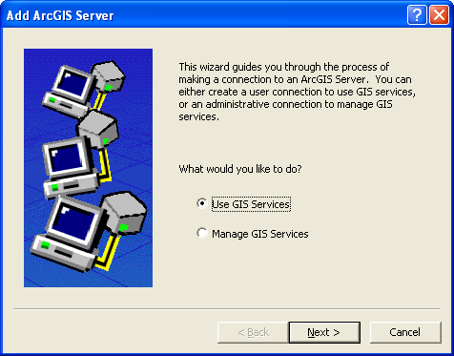

4) The Add ArcGIS Server Connection Dialog will open
4a) Click the Internet Server radio button
4b) In the Server: text box enter http://gis.apfo.usda.gov/arcgis/services
4c) Click Finish

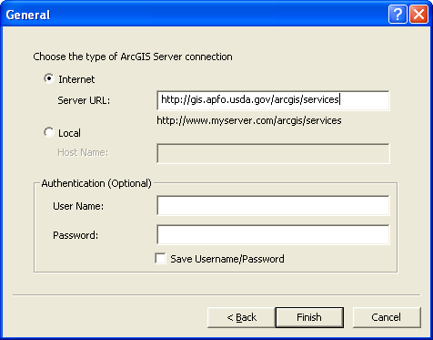

5) A new Server has been added to the GIS Servers list. The new server is called: arcgis on gis.apfo.usda.gov. This is the new GDW imagery server for FY07 NAIP imagery.
The data is organized by state.

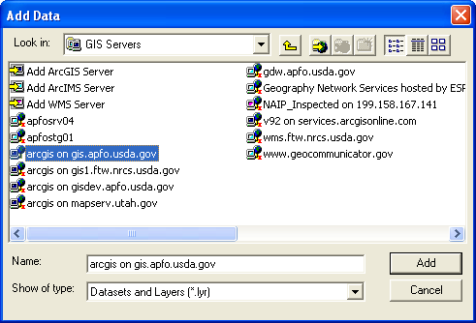

6) Double Click the new ArcGIS Server connection to access the server.

7) Double Click the NAIP_2007 folder to see the FY07 state based imagery services.

