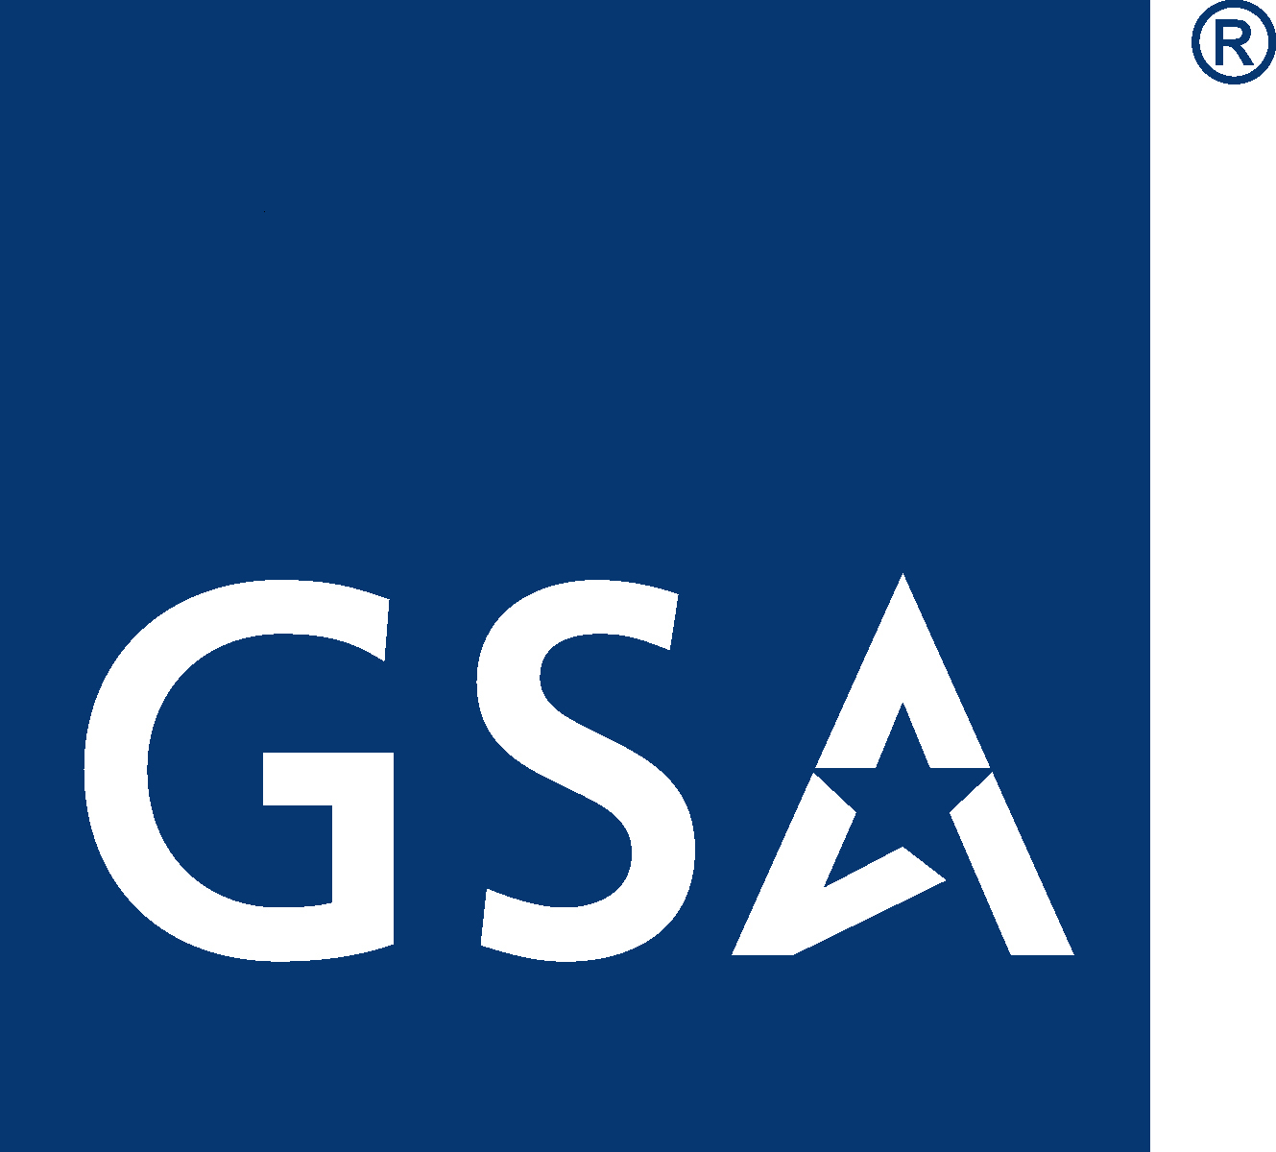GSA Office of Governmentwide Policy

Interagency Committee for Aviation Policy (ICAP)

Aviation Resource Management Survey (ARMS)

Agencies conduct Aviation Resource Management Surveys (ARMS) of their aviation programs as part of their responsibilities to maintain an effective and comprehensive safety and health program as required by the Occupational Safety and Health Act of 1970 (Section 19), Executive Order 12196, February 26, 1980 and 41 CFR 102.33.

Support to agencies conducting ARMS is facilitated by the Interagency Committee for Aviation Policy (ICAP), Safety Standards and Training Subcommittee. An ARMS offers a comprehensive survey of an agency's flight program that leads to the improvement of the agency aviation program. An ARMS team reviews any of the following areas:

- Management and Administration
- Training
- Safety Management Administration
- Operating Procedures, Manuals and Directives
- Operations Records
- Flight Operations
- Maintenance Management
- Refueling Facilities and Operations
- Aviation Life Support Equipment
- Physical Security
- Aviation Accident Response Plan
- Gold Standard Verification



Request an ARMS:

You may request an ARMS verbally or in writing. The request should be made directly to the ICAP Safety Standards and Training Subcommittee (SSTS) chairperson or to the GSA subcommittee facilitator. The initial notification should contain, at a minimum; the desired dates of the survey, an alternate start date, identification of the organization to be surveyed (the agency), and the name and phone number of the point of contact.

Following an initial request, you must send a formal letter of request to the ICAP chairperson, confirming the information in the initial request. The letter of request will also include both staffing and survey requirements, as well as any applicable restrictions.

Mailing address to request an ARMS:

Director, Aircraft Management Policy Program (MTA)
General Services Administration
Office of Travel, Transportation and Asset Management
1800 F Street, NW, Room 1221B
Washington, DC 20405

ARMS Survey Planning:

After receipt of the formal request, the SSTS chairperson will coordinate a meeting with the requester to address survey specifics, budgeting procedures, and identification of team members. The following will be addressed:
- Location(s) to be surveyed;
- Type of aircraft that are involved;
- Scope of the ARMS and what areas will be addressed during the ARMS, such as management, training, maintenance, etc.;
- Length of time anticipated for the ARMS;
- Number of people anticipated for the ARMS; and
- Types of backgrounds required for the ARMS members, i.e., pilot with B-727 experience, mechanic with UH-1 experience, attorney with knowledge of public aircraft operations, etc.

ARMS Team Development:

The ARMS team will be comprised of three to five team members having the requisite knowledge and experience pertaining to the ARMS. The GSA ICAP sub committee facilitator nominates an ARMS team leader. The ARMS team leader must have experience as an ARMS team leaver or team member and have the requisite knowledge and experience to lead the ARMS team. For example, if the ARMS involve a survey of an aviation program comprised exclusively of helicopters, the ARMS team leader must be rotorcraft qualified or have experience in rotorcraft operations.

ARMS personnel will come from within ICAP member departments or agencies. The SSTS chairperson will provide the requesting agency with team member resumes, agency affiliations, and respective areas of expertise. The requesting agency will approve each team member's participation in the ARMS.

Once the team has been approved, the requesting agency will send a detail letter to the supervisor of each team member. The ARMS team members must be detailed to the agency requesting the ARMS. The GSA ICAP subcommittee facilitator will work in conjunction with the ARMS team leader in assembling the ARMS team and keep the SSTS Chair and the requesting agency representative informed.

ARMS Survey

An ARMS usually takes about two weeks and the team must travel to the location where the aviation program is located. Following each ARMS, the team reports their observations directly to the requesting agency. ARMS are not official inspections, and the requesting agencies are the only ones who see the results.

All ARMS are conducted in accordance with the approved ICAP ARMS Guide that provides the ARMS team a guide to follow when conducting an ARMS survey of Federal agency aviation operations.

ARMS Report

The ARMS report is for the exclusive use of the requesting agency who must consider if implementing the recommendations is appropriate. The ARMS report is not an Inspector General report. Comments, justifications, or rebuttals to the report are not required or necessary. The team leader will provide the surveyed organization with an out-brief and two separate reports.

The Factual Report includes only a factual narrative summary containing the facts derived during the survey. Privileged material such as proprietary material of manufacturers will be attached in sealed addenda and released only as appropriate.

The Evaluative Report is to improve safety and prevent mishaps. This report will contain the deliberations, communications, conclusions, opinions, and recommendations of Government personnel and ARMS team members acquired during the survey. The Evaluative Report will contain a narrative evaluative description of the general health and condition of the aviation program; a listing of deficiency and observations of the functional area; overall recommendations relative to operations, safety and training; and a discussion of positive and beneficial efforts and activities. The Evaluative Report's success in improving safety and preventing mishaps depends in part on candid statements, observations, conclusions, and recommendations by Government personnel and ARMS team members. Therefore, the evaluative report is to be kept confidential. Distribution of the evaluative report is limited to two copies to the requesting official.

Limited use of the Evaluative Report
The Evaluative Report, attachments, and report endorsements are intended to be used ONLY for safety purposes.

The Factual Report is not privileged, and will be available to any government agency and/or private individuals or groups.

After the survey reports have been compiled and turned over to the agency, all related working papers will be returned to the requesting agency for retention or destruction pursuant to the organization's routine retention policies. All ARMS team member’s notes, memos, etc. will be destroyed.

TREND ANALYSIS

Trend analysis is a valuable management tool and is developed using ARMS checklist data. At the completion of a survey, the team leader will complete a survey checklist for ICAP trend analysis. The checklist will not include any written comments or agency identifying information. The checklist will be provided to the SSTS chairperson to be entered into a database, from which non-attributable trend analysis information will be developed.

Office of Travel, Transportation and Asset Management
Office of Govermentwide Policy
U.S. General Services Administration
1800 F Street NW
Washington DC 20405
www.gsa.gov

