FMS-6655 to GWA Account Statement Crosswalk

The FMS-6655 Reports formerly available through the GOALS II Information Access System were available at three different levels; Receipt Account Ledgers and Trial Balances, and the Report of Unavailable Receipt Transactions. This information is also available through the GWA Account Statement Module. This document is intended to assist Users in transitioning their reconciliation processes from using the static FMS 6655 reports to utilizing the query driven reports available in the GWA Account Statement Module.

FMS-6655 Receipt Account Ledger

This is an example of an FMS-6655 Receipt Account Ledger Report for the Department of the Treasury Account 202411 for the reporting period of May 2008.

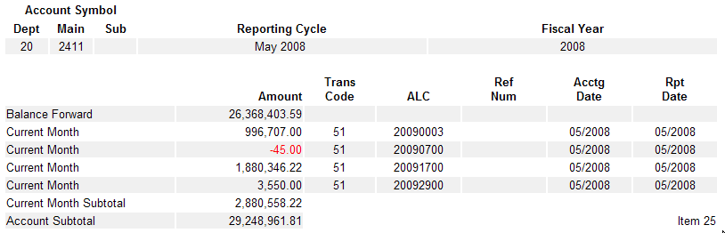

This is an example of a GWA Account Statement – Account Transactions report for the Department of the Treasury Account 202411 for the reporting period of May 2008.

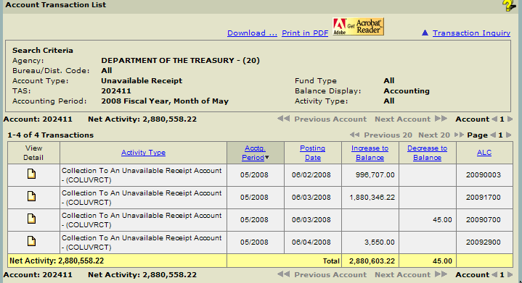

Comparing these two reports reveals that the Current Month Activity displayed in the GWA Account Statement directly correlates to the activity rows that are presented in the FMS-6655 Receipt Account Ledger. The query criteria entered to generate the GWA Account Statement Report are presented in the “Search Criteria” box at the top of the returned report. Additionally, the Current Month Subtotal for the period queried is identical in both reports.

FMS-6655 Receipt Account Trial Balance

This is an example of an FMS-6655 Receipt Account Trial Balance Report for the Department of the Treasury Account 202411 for the reporting period of May 2008.

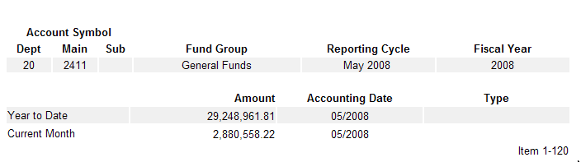

This is an example of a GWA Account Statement – Account Transactions report for the Department of the Treasury Account 202411 for the reporting period of October through May 2008. In the GWA Account Statement Module, to obtain the current Year to Date balance of an Available or Unavailable Receipt Account, a User must execute a Transaction Level query for the Account(s) and specify “October through (the current month)” (Indicated by the blue arrow in the image below) as the Accounting Period for the query. Once the Account Transaction Report is returned, the amount listed as Net Activity (Indicated by the red arrow in the image below), is the queried Account’s current Year to Date Balance.

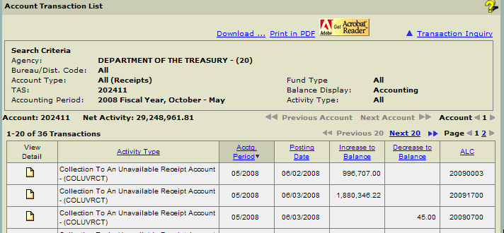

FMS-6655 Report of Unavailable Receipt Transactions

This is an example of an FMS 6655- Report of Unavailable Receipt Transactions report. In the GOALS II / IAS Undisbursed Reports, the data presented when a User requested this report was presented in a format that parsed the transactions out at the Distribution Code level which matched the security permissions in the old GOALS II / IAS Security System. GWA does not use this element for data permission purposes, therefore in the GWA Account Statement Reports all transactions reported against a specific Treasury Account Symbol are presented together regardless of the ALC that submitted it.

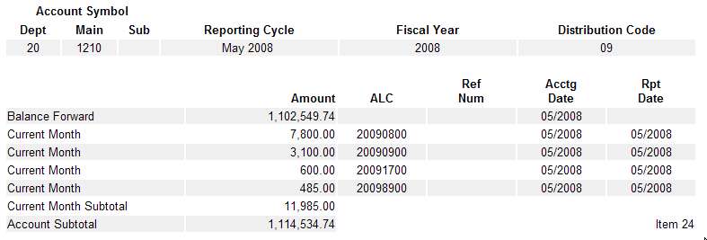

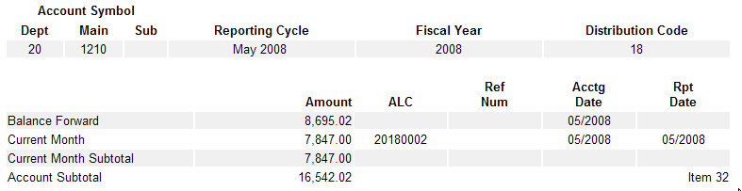

Presented below are the two GWA Account Statement Reports that provide the data formerly available via the FMS-6655 Report of Unavailable Receipt Transactions. In GWA, a User has the option of searching for transaction activity details at two different levels, by Treasury Account Symbol or by Reporting ALC. The transactions obtained via these two reports are the same, the choice between the two reports is purely User preference. If a User typically reconciles at the ALC level, the ALC Activity Report would most likely be the best choice. However if a User prefers to reconcile at the Treasury Account Symbol level, the Account Transactions report would be a better option.

GWA Account Statement – ALC Activity Report for all ALCs posting to Account 203220

To obtain the same Transaction Data using the GWA Account Statement Module, a User should generate an ALC Activity Report as displayed in the example below. This report will return all activity posted by all Reporting ALC’s to a particular Treasury Account Symbol. Notice in this report that all data is combined into a single report, however there is a direct correlation between the Reporting ALC and the Department/Distribution Code used in the GOALS II / IAS System.

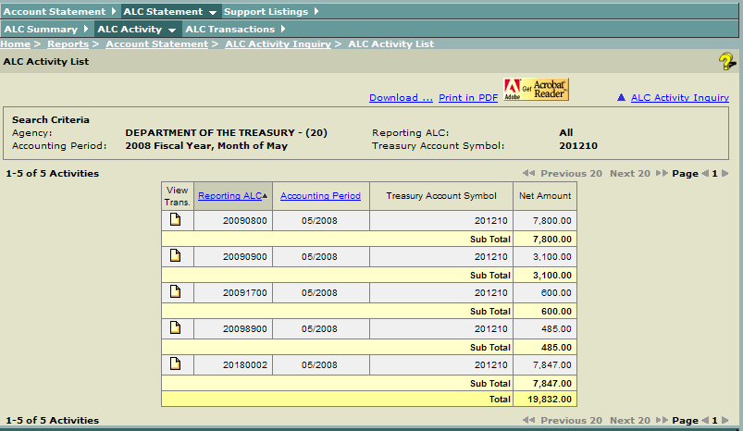
GWA Account Statement – Account Transactions Report for Account 203220

An alternate method of obtaining this information in the GWA System is to generate an Account Statement Transaction Level report for the Receipt Account in question to see the activity posted by Reporting ALC’s. As illustrated below, the same transaction information is available through this report as well as the ability to see the entire fiscal year’s reported data with Net Activity Figures.

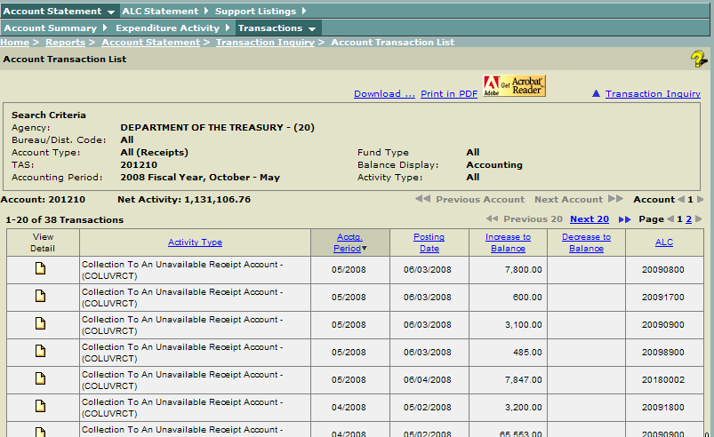

GWA Enrollment

For Users who have not yet enrolled in GWA, please access the link below and follow the appropriate instructions to complete the automated GWA Enrollment Process.

http://fms.treas.gov/gwa/forms.html

To properly gain access to the GWA Reports presented above, Users should request access to the GWA Account Statement with a role of Agency Reviewer. Please also include a list of Organizations, Accounts, and or Parent Reporting ALC’s that you need access to. This will assist our enrollment personnel in accurately completing the enrollment request.

Any questions regarding this transition may be directed to the GOALS Help Desk at (202) 874-8270.

