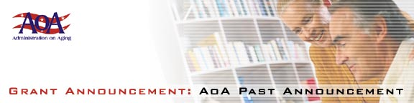

[Federal Register: June 12, 2002 (Volume 67, Number 113)]
[Notices] [Page 40303]
From the Federal Register Online via GPO Access [wais.access.gpo.gov]
[DOCID:fr12jn02-85]
-----------------------------------------------------------------------
DEPARTMENT OF HEALTH AND HUMAN SERVICES
Administration on Aging
[Program Announcement No. AoA-02-09]

Fiscal Year 2002 Program Announcement; Availability of Funds and
Notice Regarding Applications

AGENCY: Administration on Aging, HHS.

ACTION: Announcement of availability of funds and request for applications.
-----------------------------------------------------------------------

SUMMARY: The Administration on Aging announces that under the Performance Outcome Measures Project it will hold two competitions to fund grant awards for cooperative agreements to support:

(1) State-wide surveys of program performance with State Agencies on Aging, and (2) the continued development of performance outcome measures survey instruments. Under the first competition, for State-wide surveys, AoA expects to enter into cooperative agreements at a federal share of approximately $50,000 for one year with up to fifteen
(15) State agencies on aging. Under the second competition, for the development of performance outcome measures survey instruments, AoA expects to enter into cooperative agreements at a federal share of approximately $30,000 for one year with up to ten (10) State Agencies on Aging.

Purpose of grant awards: It is the purpose of the first part of this competition to provide states with the opportunity to conduct performance outcome measures surveys at the state level. AoA is conducting national performance outcome surveys which the States can use as performance benchmarks for comparison with the State-wide surveys they elect to conduct. Under the second part of this competition for the performance outcome measures project states must work collaboratively to continue to refine the current survey measures and develop new measures in additional areas.

Eligibility for grant awards and other requirements: For both competitions under this Announcement eligibility is limited to State Agencies on Aging. Grantees are required to provide a 25% non-federal match.

DATES: The deadline date for the submission of applications is July 29,
2002.

ADDRESSES: Application kits are available by writing to the U.S. Department of Health and Human Services, Administration on Aging, Office of Evaluation, 330 Independence Ave., SW, Washington, DC 20201, Attn: David Bunoski, or by calling 202/260-0669. Applications must be mailed or hand-delivered to the Office of Grants Management at the same address. Instructions for electronic mailing of grant applications are
available at http://www.aoa.gov/egrants.

Dated: May 24, 2002.
Josefina G. Carbonell,
Assistant Secretary for Aging.
[FR Doc. 02-14701 Filed 6-11-02; 8:45 am]
BILLING CODE 4154-01-P

