Bank of America
On Line Payment Tool
MyEasyPayment.com

Account Type Screen

- Go to WWW.MYEASYPAYMENT.COM
- Choose the Government Charge Card option
- Choose Continue

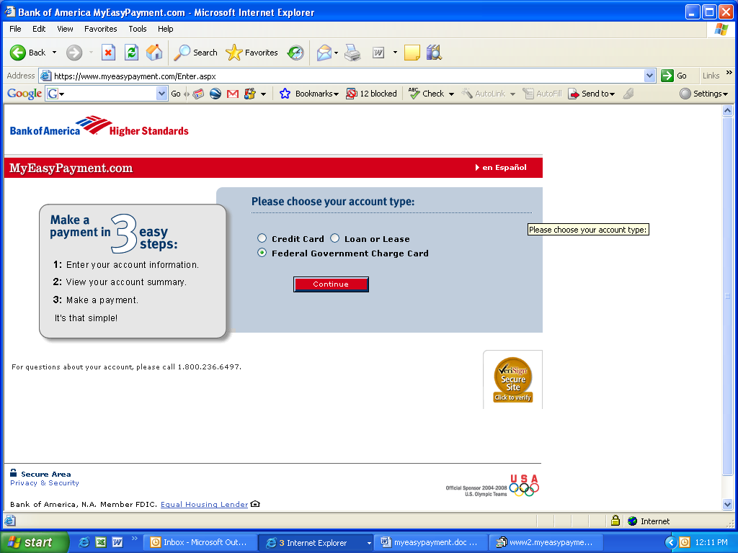
1
2
3

Welcome Screen

- Enter your Government Travel Card number
- Enter your 3 digit security code from the back of the card as shown
- Choose Continue

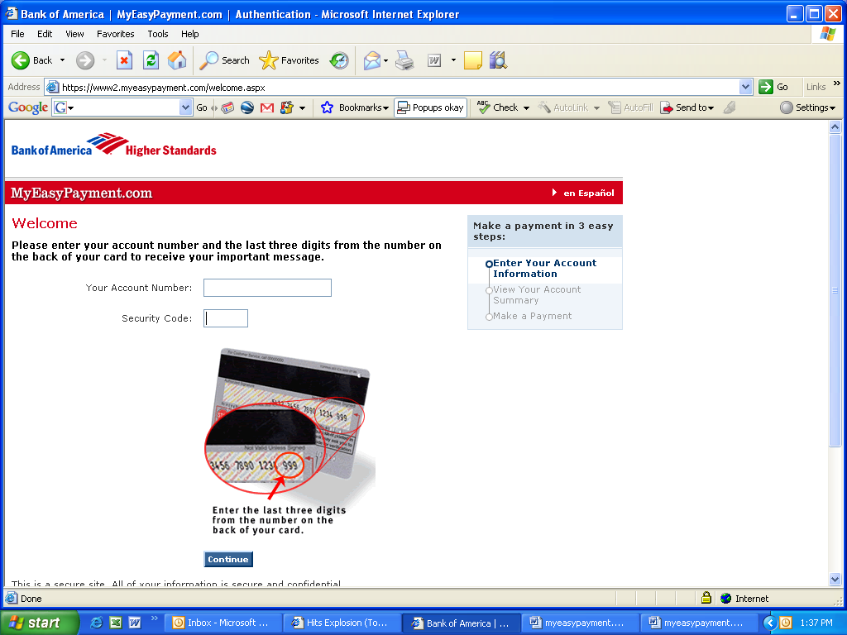
1
2
3
XXXX-XXXX-XXXX-XXXX
XXX

Account Summary-Zero Balance

- Verify summery section, if no payment is due
- Sign off

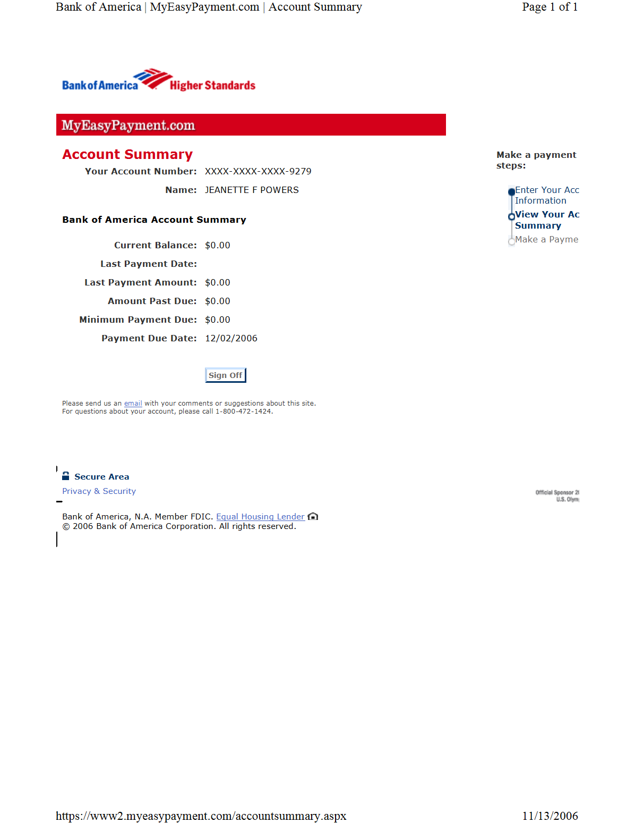
1
2
XXXX-XXXX-XXXX-XXXX
SUZY B TRAVELER

Account Summary-Balance Due

- Account Summary will show current balance, last payment date, last payment amount, amount past due, amount due now, and payment due date.
- If a payment is due, choose an option from the 4 choices
- If your account is past due, you must select “I will pay the amount past due today” to bring your account current.
- Choose Continue

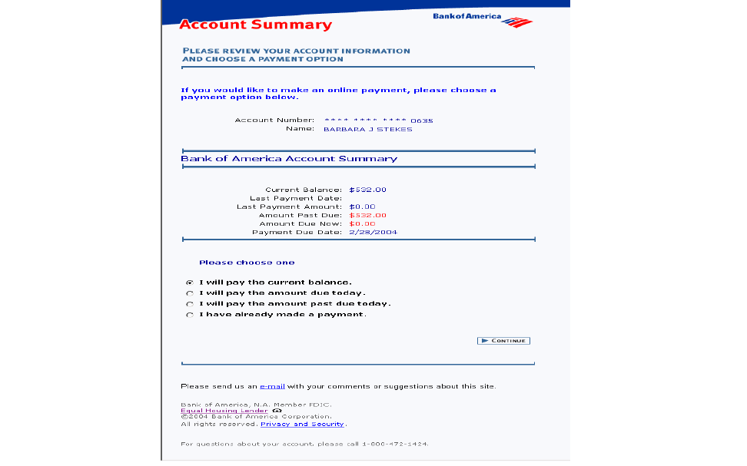
2
3
1
4
XXXX XXXX XXXX XXXX

Suzy B Traveler
$532.00
---------
$0.00
$532.00
$532.00
2/28/2004
O
O
O
O

Payment & Bank Account Information

- Enter the payment amount. Note: If you selected a payment option, MyEasyPayment will populate that amount in the “amount of payment field”; you may leave this amount or change it.
- Enter your bank’s routing number- The bank routing number is the nine digit number that identifies your bank. Found at the bottom right hand corner of your check. See below
- Enter your bank account number-The bank account number is the second set of numbers after the bank routing number. See below
- Continue

NOTE: Please verify all bank data prior to choosing continue. Incorrect bank information will create a “non-sufficient fund” (NSF) charge and your BoA account will remain unpaid. NSF transactions against your account will result in the MyEasyPayment system being unavailable for six (6) months from the transaction return date.
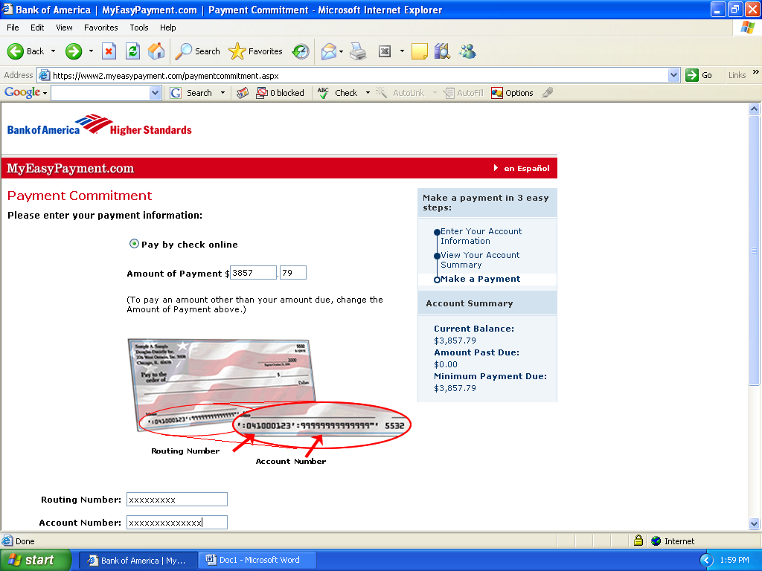
1
2 & 3
|:041000123|:9999999999;
Routing Number
Bank Account Number

Confirmation Screen

- Your payment confirmation will show-verify all bank data carefully.
- If incorrect, choose the “back” button and re-enter the bank routing and checking account numbers.
- PRINT this page for your records
- Choose “submit my payment option”

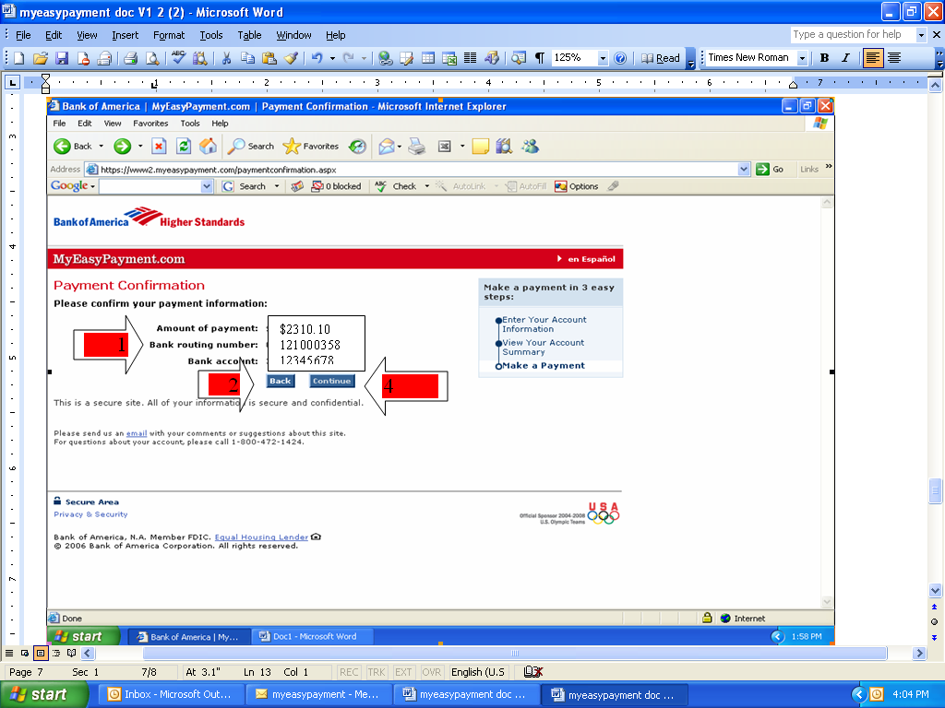
Verify Data
Thank You Screen

- For Printable Version
- Sign Off

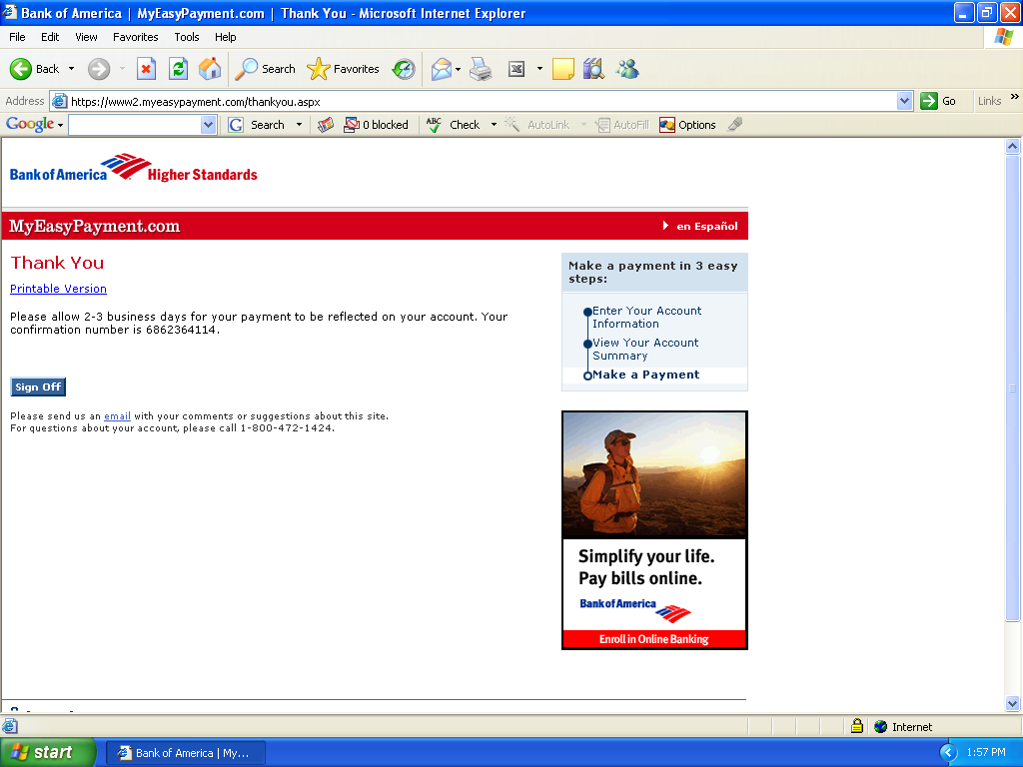
2
1

There is no charge to pay using “My Easy Payment.Com”

