U.S. Department of Health and Human Services Administration on Aging

Aging and Disability Resource Centers

A Joint Program of the Administration on Aging &

Centers for Medicare & Medicaid Services

BACKGROUND
The Aging and Disability Resource Center Program (ADRC), a collaborative effort of the Administration on Aging (AoA) and the Centers for Medicare & Medicaid Services (CMS), is designed to streamline access to long-term care.

The ADRC initiative supports state efforts to develop “one-stop shop” programs at the community level that will help people make informed decisions about their service and support options and serve as the entry point to the long-term support system. States are using ADRC funds to better coordinate and/or redesign their existing systems of information, assistance and access and are doing so by forming strong state and local partnerships.

ADRC programs provide information and assistance to individuals needing either public or private resources, professionals seeking assistance on behalf of their clients, and individuals planning for their future long-term care needs. ADRC programs also serve as the entry point to publicly administered long-term supports including those funded under Medicaid, the Older Americans Act and state revenue programs.

In particular, ADRCs streamline access to long-term care services for individuals with disabilities, older adults, and their family caregivers, particularly those at highest risk of
nursing home placement and
spenddown to Medicaid.

AoA & CMS VISION FOR RESOURCE CENTERS

The goal of the ADRC Program is to empower individuals to make informed choices and to streamline access to long-term support. Long-term support refers to a wide range of in-home, community-based, and institutional services and programs designed to help individuals with disabilities.

The vision is to provide individuals across the United States access to ADRCs, which are highly visible and trusted places where people can turn for information on the full range of long-term support options. To help and support these efforts, in 2006, the Older Americans Act was reauthorized with the inclusion of language supporting the development of ADRC efforts in every state.

In many communities, long-term support services are administered by multiple agencies and have complex,
fragmented, and often duplicative intake, assessment, and eligibility functions. Figuring out how to obtain services is difficult. A single, coordinated system of information and access for all persons seeking long-term support minimizes confusion, enhances individual choice and supports informed decision-making. It also improves the ability of state and local governments to manage resources and to monitor program quality through centralized data collection and evaluation.

ADRC GRANTEES

AoA and CMS launched the ADRC initiative in the fall of 2003. From 2003 to 2005 43 states were awarded grants to develop pilot programs. Additional funding was awarded in 2006 and 2007 to expand existing states efforts. In 2008, an additional four states were funded bringing the total number of states operating ADRCs to 47.

Thirty-five states are currently providing ADRC services in one or more communities. Twelve states are offering ADRC services statewide. The map below indicates states that have been awarded ADRC grants and the year they received their award. In addition, the map below highlights states which are pursuing ADRC efforts even without receiving specific ADRC grant funds.
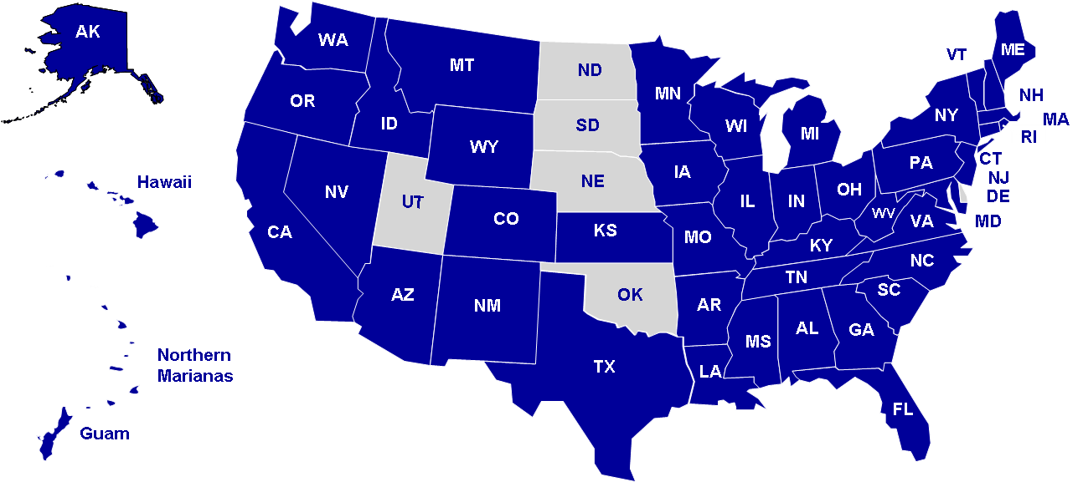
AGING AND DISABILITY RESOURCE CENTER AWARDEES 1
ADDITIONAL INFORMATION

For additional information on the ADRC initiative, please visit The ADRC Technical Assistance Exchange website at www.adrc-tae.org. The website includes contact information for AoA and CMS ADRC project officers, summary information on each of the grantees, and a variety of resources related to this initiative.

You can also find additional ADRC information on the AoA website at www.aoa.gov or the CMS web site at www.cms.hhs.gov/newfreedominitiative.

