Statement of Ambassador John O’Keefe
Executive Director
Open World Leadership Center
Before the
Subcommittee on Legislative Branch
Committee on Appropriations
United States Senate
Fiscal Year 2009 Budget Request
April 30, 2008

Madam Chairwoman, Senator Alexander, and other members of the Subcommittee, I appreciate the opportunity to submit testimony on the Open World Leadership Center’s budget request for fiscal year 2009. The Open World Leadership Center, of which I am the Executive Director, conducts the only exchange program in the U.S. legislative branch and has hosted more than 13,000 emerging leaders from Russia, Ukraine, Azerbaijan, Kyrgyzstan, Tajikistan, Georgia, Moldova, Lithuania, Uzbekistan, and Kazakhstan, our newest country. All of us at Open World are very grateful for the continued support in the legislative branch and for congressional participation in the program and on our governing board. We look forward to working with you on the future of Open World.

Over the past eight years, Open World delegates have had the opportunity to meaningfully engage and interact with an estimated 120,000 Americans throughout the United States in professional, theme-focused programming that increasingly emphasizes continuing projects and partnerships. More than 6,000 American families and individuals in all 50 states have hosted the visiting participants. And in 2007 alone, the home hosting of Open World participants by dedicated Americans in 187 different congressional districts saved the Center an estimated $1.8 million in per diem accommodation and meal costs. Over the life of the program, Open World has awarded more than $32 million in grants to hosting organizations located in every region of the country.

Open World’s impact on program participants is captured in the following statement by a Russian alumna from Orenburg who studied issues related to HIV/AIDS during her visit to Des Moines, Iowa, in 2006: “Upon return to Russia, I implemented several HIV preventive and treatment approaches. I was aware of these approaches prior to the Open World trip but it was only after seeing these efficiencies demonstrated in practice in the U.S. that I was able to actually implement them at home. To sum it up, the Open World trip to the U.S. confirmed for me the realistic possibility of implementing these very important measures in Russia.” The alumna, who is a doctor specializing in infectious diseases, met with various professional counterparts in Iowa, including an HIV/AIDS outreach specialist at the Polk County Health Department and the executive director of the AIDS Project of Central Iowa.

Open World has a track record of identifying tomorrow’s leaders today. For example, Open World alumni make up 10 percent of the newly elected Russian State Duma. I believe part of Open World’s secret for identifying leaders on the rise is its strategy of targeting all regions in Open World countries, not just the major cities. In Russia, the country with the largest and oldest Open World program, 80 percent of Open World alumni live outside Moscow and Saint Petersburg. We also select relatively young delegates—their average age is 38.

Program participants come to discuss topical issues of mutual interest and benefit, such as ways of treating post-traumatic stress disorder among war veterans, preventing the spread of avian flu, furthering the rights of women and children, and protecting the environment. Mayors and city council members see firsthand how our elected officials respond to constituents. All our delegates work with American hosts and peers who share their interests and are often eager to partner with them on collaborative projects. For example, when Open World first partnered with Rotary International in 1999, there were 33 Rotary clubs in Russia. Today there are 87 clubs and 21 Rotaracts.

Since August 2007, when we began a concerted effort to track post-visit successes, Open World has identified approximately 100 collaborative projects, partnerships, and other concrete post-visit results each month. Some illustrative examples.

Calendar Year 2007 Highlights

Russia

Open World hosted 1,165 Russian participants in calendar year 2007. Delegates came from 77 of Russia’s then 85 regions and represented a wide range of ethnic groups. Women accounted for 57 percent of the delegates. These participants were hosted in 45 U.S. states and the District of Columbia. Open World’s civic hosting themes were accountable governance, rule of law, and social issues.

Many exchanges focused on issues of importance to both countries. For example:

A group of 16 nonproliferation experts visited the U.S. Department of Energy national laboratories in Tennessee and Washington state. As a result of the visit, an American Material Protection, Control, and Accounting (MPC&A) contract with a Russian entity that was due to expire in 2007 was renewed for 2008, thereby enhancing control of nuclear materials, including weapons-grade uranium and plutonium. Another delegate who is a senior instructor in the International Relations Department at St. Petersburg State University has been selected by the university to teach a course on nonproliferation policy, which would be the first-ever such course in a Russian university.

In March 2007, Open World hosted Russian epidemiologists and community health planning leaders who worked with their counterparts in North Carolina on the preparation of a template to assist small to medium-size communities around the developed world in planning for, and responding to, outbreaks of catastrophic disease.

A delegate active in anti–human trafficking efforts was offered a $48,000 grant by her U.S. hosting organization at the completion of her 2007 Open World exchange to Arlington, Virginia. The September 2008–September 2009 grant, which is likely to be renewed annually, will support the new Center for the Study of Organized Crime and Corruption in Stavropol and its research on border security issues and irregular migration patterns that promote terrorism, human trafficking, and labor exploitation. The associate director of trafficking victims’ assistance programs at the U.S. Conference of Catholic Bishops, along with two Montgomery County, Maryland detectives who met with this delegate while she was in the United States, visited Russia in April. The delegate helped arrange for the Americans to speak at numerous events, including a gathering of top-ranking police officers from Russia’s Southern Federal District, and a colloquy of students and faculty from the Stravropol University of the Russian Ministry of Interior.

Another delegate visited United Cerebral Palsy of Pittsburgh, Pennsylvania, and was inspired to organize a daycare program for children with cerebral palsy in Volgograd, Russia. She subsequently received the Russian Presidential Award and a grant of $35,000 for establishing the program.

Four Russian mental health experts who counseled children and families affected by the 2004 Beslan school attack spent the evening of December 20, 2007, sharing experiences and strategies for healing in a Lancaster County, Pennsylvania home with members of the Amish community who had suffered from the Nickel Mines school shootings in October 2006. Grandparents of one of the victims were among those who took part in the profoundly moving session. Post-traumatic stress disorder (PTSD) was the focus of a second Russian team hosted at the same time by the University of Massachusetts Medical School in Worcester, Massachusetts. Three of the Worcester delegates had assisted Beslan survivors and continue to specialize in crisis counseling; the fourth treats military veterans of the conflict in Chechnya. During their Massachusetts visit, the delegates worked with some of America’s leading academic and clinical experts in PTSD—including several Veterans Administration specialists—and shared their own professional experiences in the North Caucasus. Potential results of these visits include journal articles, reciprocal visits by U.S. mental health experts, and curriculum sharing between U.S. and Russian institutions.

The past year also saw impressive achievements produced by participants in earlier Open World exchanges. Below are just a few examples:
Thanks to two Open World alumnae, the City of Ulan-Ude declared 2007 “The Year of Civic Initiatives” and allocated 2.8 million rubles (approximately $106,000) to 32 local NGOs to organize 100 different activities and programs throughout the year. One of the alumnae, an Ulan-Ude city administrator, was inspired to launch this campaign by learning about the work of Louisiana Eastern European Adoptive Families and other Louisiana nongovernmental community organizations during a 2005 Open World exchange. She involved a second alumna, the first deputy chairperson of her department, to help get the campaign off the ground. As part of the initiative, the Ulan-Ude city administration established an association called Family whose goal is to develop a foster-homes program to help orphans integrate into society.

This winter, cultural program alumnus Arkadiy Babchenko’s award-winning book A Soldier’s War in Chechnya, an account of his experience as a young soldier in Russia’s Chechen wars, was published in translation in the United States. Critics have compared the book to All Quiet on the Western Front and Michael Herr’s Dispatches.

Another Russian alumna-author, Kseniya Golubovich, was one of 30-plus foreign writers to take part in the 2007 Fall Residency of the University of Iowa’s renowned International Writing Program (IWP), thanks to a coveted fellowship she won while on a 2006 Open World cultural exchange hosted by IWP. Golubovich writes essays on life in modern Russia for several newspapers and journals, and publishes in a variety of genres. During her fellowship she finished her second novel; met with a high school creative-writing class; gave readings and talks at the University of Iowa, Northwestern University in Evanston, Illinois, and Harvard University; was invited to serve as a presenter for an IWP-sponsored film series; and worked with university students and faculty.

More and more Open World hosts are organizing visits to build ongoing ties with their Open World counterparts and other contacts. In 2007, 71 American judges and legal professionals visited Open World alumni in Ukraine and Russia. In another example, the Los Alamos (New Mexico)–Sarov Sister Cities Initiative, a regular Open World host organization, coordinated the reciprocal visit in June 2007 of four Los Alamos firefighters and police officials to Sarov, a city closed to most foreigners and Russians. There the Americans consulted with counterparts on specialized procedures for fighting forest fires in a nuclear city.

Ukraine

The new government seeks closer ties to Europe and the United States and, with a substantial grant from the Millennium Challenge Corporation, has begun a program to reduce corruption in the justice system and reform education. Ukraine is a pivotal state in the region, faced with pressures from east and west. Open World’s program supplements Ukraine’s efforts to move toward more accountability and transparency at all levels of government.

Open World welcomed 255 current and future Ukrainian leaders in calendar year 2007, accomplishing wide geographic representation (25 of 27 Ukrainian regions), hosting delegations across the United States (24 states and the District of Columbia), and enrolling a high percentage of women delegates (49 percent). The Open World hosting themes for Ukraine in 2007 were accountable governance, NGO development, rule of law, and elementary and secondary education. Twenty-four Ukrainian Open World alumni took part in a major international forum entitled “Ukraine’s Euro-Atlantic Future,” held in Kyiv June 11–13. Forum sponsors included the Center for US-Ukrainian Relations, the Democratic Initiatives Foundation, the Konrad Adenauer Foundation, and the NATO Information Center/Ukraine. The alumni were invited to share the impact of their U.S. visits during forum sessions. Open World alumni in attendance included government officials, judges, journalists, human rights and democracy advocates, and NGO leaders. A conference organizer said that the Open World alumni “were the most articulate and best organized group at our ... event.”

Expansion Countries

Open World hosted 130 emerging leaders from Kyrgyzstan, Tajikistan, Moldova, Georgia, and Azerbaijan in 2007. Participants included parliamentarians, environmental leaders, health specialists dealing with HIV/AIDS, judges, and prosecutors. One group of Tajik leaders involved with ecotourism visited Nevada to see how state and local officials and private individuals promote both ecotourism and cultural tourism to the state’s historic mining towns. During their exchange, they met with Thomas Tait, a former executive director of the Nevada Commission on Tourism. As a result of this meeting, the U.S. State Department has invited Mr. Tait to Dushanbe in 2008 to discuss ecotourism matters further with Open World alumni and other Tajik leaders.

A Kyrgyz rule of law delegation hosted in Utah had the privilege of taking part in a mock session of the Utah Senate with the participation of state Senate President John Valentine. The following is an excerpt from a blog post by Senator Valentine dated September 13, 2007:

Yesterday, we had the extraordinary honor of hosting fifteen people from Kyrgyzstan here at the Utah State Senate.

The Kyrgyz delegation is in Utah for a week to study America’s political processes and the Rule of Law. Senators McCoy, Bramble, Dmitrich and I, along with Rusty Butler of UVSC [Utah Valley State College], Representative Chris Herrod (who speaks Russian), and a few gifted staff replicated a legislative session and the Kyrgyz leaders played the part of Utah State Senators.
They debated a mock bill, followed parliamentary procedure, tried to amend the bill twice, and ultimately killed it. When it was time to adjourn, they voted NOT to adjourn. Apparently we were doing something right and they wanted to stay.
We had a great three hours. It was wonderful to spend time with good people from a part of the world beginning to find its way toward a stable democracy and self rule.
Senator Valentine subsequently visited Kyrgyzstan with the majority leader of the Montana State Senate, Senator Carol Williams, in part to be reunited with Open World alumni. In 1999, before her election to the Montana Senate, Senator Williams personally hosted Open World delegations through Peace Links, an Open World grantee. She had this to say upon her return from the State Department–sponsored trip to the capital city of Bishkek: “More than ever, it is important for America to maintain and grow our relationships in Central Asia.” In order to encourage the ties that are developing between the U.S. mountain states and Central Asia, Senator Valentine hosted Open World’s inaugural parliamentary delegation from Tajikistan in 2007 and plans to visit Dushanbe in 2008.

The mayor of the Azerbaijani village of Jil visited Texas in 2007. He noticed during visits to Bellaire and West University Place that “suggestion boxes” were prominently placed to gather feedback from citizens on how to improve city services. He also learned that city administrators make their city’s budget publicly available and publish a special bulletin for citizens with news on the city’s progress. Upon his return to Jil, he immediately instituted all three of these ideas in order to increase transparency and accessibility of information to citizens. What is particularly notable is that Jil is only a 35-minute drive from the border of Iran, where there are more Azeri-language speakers than in Azerbaijan itself.

The U.S. State Department Resident Legal Advisor based in Tajikistan, who confessed to harboring “skepticism regarding U.S. taxpayer-funded visits of foreigners to the United States,” had this to say after debriefing two defense attorneys who had traveled to Gainesville, Florida, in June 2007 on an Open World rule of law exchange:

I personally knew two of [the] defense attorneys before they left for the U.S., and “debriefed” them upon their return to Tajikistan. I was anxious to determine if their experience went beyond subsidized tourism. To my great pleasure I found that [it] had. For several hours they asked me about, and we discussed, critical aspects of criminal justice and Rule of Law that were prompted directly and exclusively by their “comparative law” experience in the United States. Their questions and expressions clearly indicated to me that they had done far more than merely take a tourist’s look around. In addition to experiencing the general goodness of America, they obviously saw and absorbed what I would have wanted of them in satisfaction of my strict, developmental approach. This educational opportunity will only enhance their professional status in influencing change in Tajikistan. Moreover, it is something I could vouch for in good faith to the U.S. citizens who paid for it. I look forward to my continued involvement with Open World, confident that the foregoing experience can be replicated as to diverse individuals and fields of endeavor.

Representative Larry Brown of the North Carolina General Assembly arranged for a delegation of newly elected Moldovan mayors to meet with the North Carolina Wine and Grape Council in Raleigh during a December 2007 exchange. The U.S. hosts and delegates agreed that many of North Carolina’s smaller wineries would benefit from Moldovan expertise in wine making. As a result of the meeting, the Continuing Education Division of Forsyth Tech Community College, the Moldovans’ host organization, plans to launch a distance-learning course for small North Carolina vintners taught by Moldovan wine experts. As Suzanne Stafford of Forsyth Tech observed, “The Moldovans get recognized and reimbursed for their expertise and the North Carolina winemakers improve their vintage. Everybody wins.”

Program Administration

In September 2007, the Center’s first full audit, for the 2006 fiscal year, was completed. The independent auditor concluded that “the accompanying financial statements ... present fairly, in all material respects, the financial position of the Center as of September 30, 2006, and its net costs, changes in net position, budgetary resources, and financing of operations for the year then ended, in conformity with accounting principles generally accepted in the United States of America.” The report also stated that the auditor’s “consideration of internal control over financial reporting disclosed no material weaknesses.”

Goals

In August 2006, the Open World Leadership Center Board of Trustees approved a strategic plan for fiscal years 2007–2011. The Strategic Plan was developed using the principles of the Government Performance and Results Act. It incorporates a five-year outlook for the program and includes the following goals:

- Expanding the geographic scope of the Program to include Eurasia and the Baltic States

More than 43 million Muslims reside in countries where Open World is now active, and planned expansion into another predominantly Muslim country, Turkmenistan, in 2008 would increase this figure to 47.9 million. As stated earlier, in 2007 Open World hosted 130 leaders from five expansion countries: Georgia and Azerbaijan in the strategically important Caucasus region; Moldova in Eastern Europe; and Tajikistan and Kyrgyzstan in Central Asia. Open World hosted its inaugural exchange from Kazakhstan in April 2008. Rule of law was the focus for all 12 delegates, including the members of an intellectual property rights delegation that met with a staff member of the House Judiciary Subcommittee on Courts, the Internet, and Intellectual Property in Washington, D.C., and then with the Motion Picture Association of America at the hosting site of Los Angeles. The Strategic Plan calls for Open World eventually to expand into all of Eurasia and the Baltic States.

- Enhancing productivity and improving efficiencies

To offset increasing airfare costs, Open World has distributed delegate travel more evenly throughout the year in order to take advantage of lower fares during off-peak travel seasons. Distributing travel over time in this manner has the added advantage of providing staff more time to organize higher-quality programs. Center staff comprehensively reviewed all contracts and identified and implemented additional cost efficiencies. These cost savings will help the Center maintain hosting at planned fiscal year 2008 levels.

- Continuing to enhance the quality of U.S. programming

Open World has streamlined the process for reviewing delegate program agendas and coordinating with U.S. hosting entities. The monitoring of hosting programs, regular communication with hosts, evaluative site visits, and post-visit evaluations contribute to annual reviews and evaluations of all program elements.

Last year, the Center launched its new results-tracking mechanism, called the Client Management System (CMS), which systematically gathers quantitative results to measure the Open World Program’s progress in meeting its goals.

- Establishing a mechanism that facilitates the emergence of a network of leaders in the United States and Open World countries who have participated in the Program

The new Client Management System not only tracks results but automatically notifies Americans who have hosted Open World participants about results related to these individuals. Through its privately funded alumni program, Open World works closely with Americans visiting Russia and other Open World countries to facilitate meetings and partnerships.

Open World’s multilingual website, which includes a digital directory for direct, translated communications between American professionals and hosts and Open World delegates, fosters interactive communication and facilitates ongoing projects. Open World also operates online forums and multiple list serves for Russian alumni, one with news of grants, competitions, and other sources of financial support, the other with updates on Open World news and announcements and opportunities for cooperation and partnership with fellow alumni.

- Establishing diversified funding sources

Open World is formulating a comprehensive development strategy and identifying potential funding and cost-share partners within the international organization community and the executive branch. The Board of Trustees voted in January 2008 to establish a binational business advisory board for the Russia program. Membership will consist of business leaders from both the United States and Russia who will advise the Center on sources of material support. The Center plans to partner with Russia’s Federal Culture and Cinematography Agency to cost-share the travel to the United States of up to 200 Russian cultural leaders in 2008. Open World will also work to raise private funds to pay for 100 American cultural leaders to make reciprocal visits to Russia, with hosting costs to be provided by the same Russian agency.

Open World 2008

In response to congressional recommendations and directives from the Board of Trustees, Open World is maintaining a strong program for Russia and continuing its successful Ukraine program and expansion programs in Azerbaijan, Georgia, Kyrgyzstan, Moldova, and Tajikistan, while launching a program for Kazakhstan. We will add Turkmenistan in fall 2008 if funding is available. Below are just a few highlights of this year’s activities:

Building on the successes and results generated by past Open World programs on human-trafficking prevention, Open World plans to host a number of anti–human trafficking delegations this fall. Many of the delegates will come from the Far East and southern regions of Russia, where human trafficking is a serious problem. Open World will target law enforcement officials, prosecutors, judges, legislators, NGO officials, and legal advocates for participation. By meeting with their U.S. counterparts, these delegates will learn about U.S. prevention initiatives and have opportunities to discuss how Russian laws against human trafficking might be strengthened.

The Center plans to partner with the House Democracy Assistance Commission to provide Open World programming to 25 Ukrainian and Georgian parliamentarians and parliamentary staff in 2008. We also plan to extend our acclaimed judge-to-judge rule of law program to our exchanges for expansion countries.

Overseas, the Russian government is considering establishing a mirror program to Open World. If begun, the program would be housed in the Russian legislative branch and would bring American political and civic leaders to Russia. And in May of this year, Open World will be holding an alumni conference in Ulyanovsk, Russia, for regional judges who have participated in Open World’s rule of law program. The conference will include sessions on the adversarial principle in the litigation process, judicial ethics, and norms of international law, and on how programs such as Open World can help develop professional contacts and sister-court partnerships.

Measures of Success

The Open World Leadership Center tracks the results of the Open World Program using eight categories, including projects, benefits to Americans, reciprocal visits, and partnerships. Since launching the results database in August 2007, Open World has identified more than 800 such results (see attached chart).

Fiscal Year 2009 Budget Request

The Center’s budget request of $13.9 million for fiscal year 2009 is a 3.5 percent decrease from the original fiscal year 2008 request ($14.4 million), but a slight increase over fiscal year 2007 funding ($13.86 million). The funding request will enable the Center to restore its programming to pre–fiscal year 2008 levels and fully restore its proven mission of hosting young political, civic, and cultural leaders from Russia; maintain its important program for Ukraine; and continue smaller programs with select countries as approved by the Board of Trustees, in consultation with the Subcommittee. The Board of Trustees believes that maintaining a robust grassroots-based Open World presence in Russia is necessary and important for future U.S.-Russia relations as Russia changes presidential administrations. Programs in expansion countries will account for a larger percentage of hosting than in the past, reflecting the growing geopolitical importance of Central Asia and the Caucasus. Program hosting capacity in fiscal year 2009 at the requested level remains far below the limit of 3,000 set in the Center’s authorizing legislation.

The budget request maintains hosting and other programmatic activities at a level of approximately 1,400 total participants. Actual allocations of participant slots to individual countries will be based on Board of Trustees recommendations and consultations with the Committee and U.S. Embassies. The requested funding support is also needed to meet mandatory salary and benefit increases in fiscal year 2009 and increased program costs due mainly to higher airfares and less favorable exchange rates.

Major categories of requested funding are:
- Personnel Compensation and Benefits ($1.367 mil)
- Contracts ($7.691 mil – awarded to U.S.-based entities) that include:
    - Coordinating the delegate nomination and vetting process
    - Obtaining visas and other travel documents
    - Arranging and paying for air travel
    - Coordinating with grantees and placing delegates
    - Providing temporary health insurance for participants
  - Grants ($4.7 mil – awarded to U.S. host organizations) that include the cost of providing:
    - Professional programming for delegates
    - Meals outside of those provided by home hosts
    - Cultural activities
    - Local transportation
    - Professional interpretation
    - Administrative support
On March 31, 2008, as required by Public Law 110-161, the Consolidated Appropriations Act, 2008, the Open World Board of Trustees submitted a report entitled “Potential Options for the Structure and Funding of the Open World Leadership Center” to the Chairmen of the Senate and House Appropriations Committees. We look forward to discussing with you and the congressional leadership the report recommendations and the next steps to assure the Center’s future.

Conclusion

Funding the 2009 Open World Program will allow more than 15,000 Americans to meet and work with legislators, mayors, government administrators, judges, environmentalists, experts in human-trafficking prevention, and other leaders from across Eurasia. Many of our participants will engage in collaborative projects and ongoing partnerships with their new American contacts. Program participants will come from countries that share more than 1,145 miles of borders with Afghanistan and Iran. Americans will, once again, open their doors to leaders from Open World countries and give generously by contributing an estimated $1.8 million in donated accommodations and meals—freeing up appropriated funding that is applied to more grants to U.S. organizations to host delegates.

While these results are measurable and visible, there are innumerable “soft” benefits that merit mention. In his “2007 Year-End Report on the Federal Judiciary,” Chief Justice John G. Roberts, Jr., of the United States Supreme Court discusses a recent Open World–hosted visit to the United States by Russian Supreme Court Justice Yuri Sidorenko, who chairs the Council of Judges of the Russian Federation. Chief Justice Roberts writes that Justice Sidorenko, while visiting the grave of Chief Justice William H. Rehnquist at Arlington National Cemetery, met with a group of American schoolchildren and recounted his friendship with the late Chief Justice, initiated during an earlier Open World visit, and their shared interest in the rule of law. These powerful “defining moments” occur regularly.

The fiscal year 2009 budget request will enable the Open World Leadership Center to fully continue making major contributions to an understanding of democracy, civil society, and free enterprise in a region of vital importance to the Congress and the nation. The Subcommittee’s interest and support have been essential ingredients in Open World’s success.

Appendix A
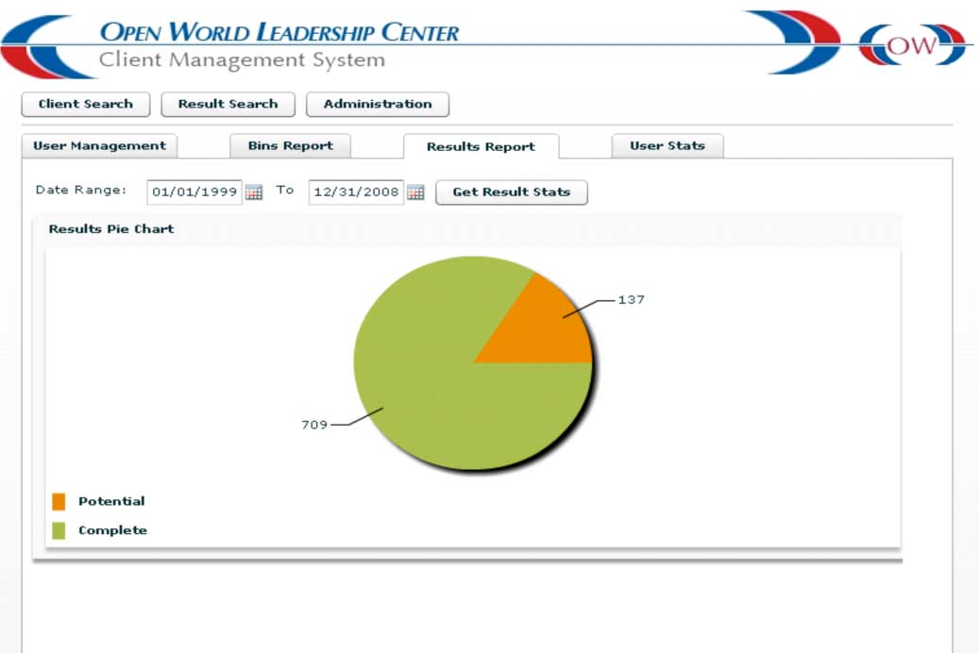
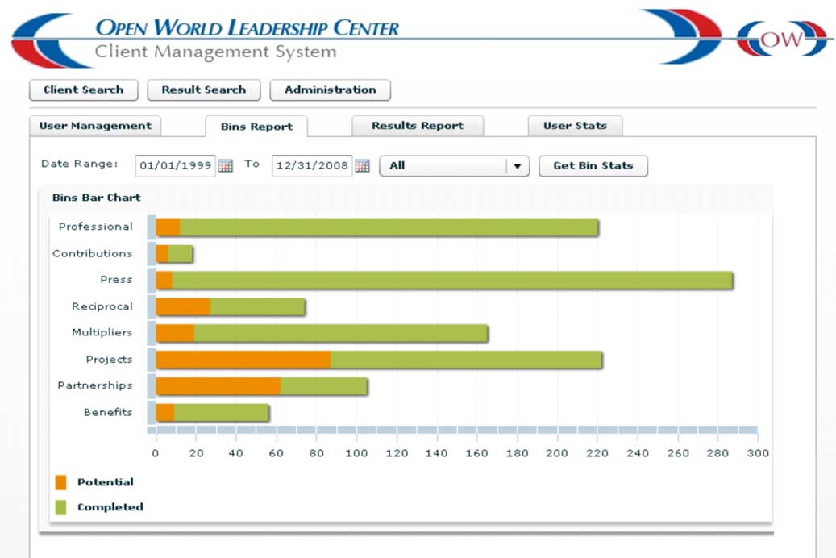

Eurasia here means Russia, Ukraine, Belarus, Moldova, Armenia, Georgia, Azerbaijan, Turkmenistan, Kazakhstan, Uzbekistan, Tajikistan, and Kyrgyzstan.

