Forage kochia
Kochia prostrata (L.) Schrad.
Plant Symbol = KOPR80

Contributed by: USDA NRCS Idaho State Office

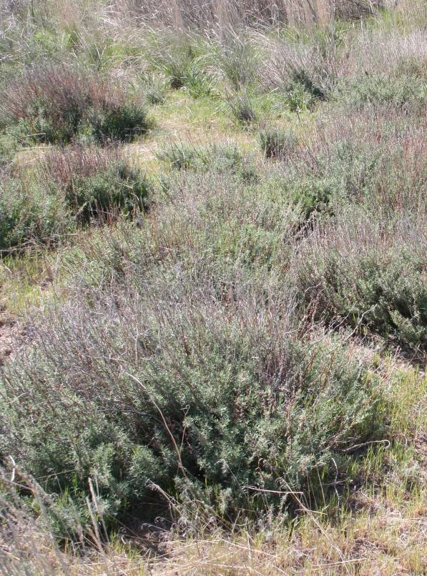
Forage kochia
Photo by Derek J. Tilley.

Alternate Names
Bassia prostrata (L.) A.J. Scott, prostrate summer cypress, perennial summer cypress

Uses
Range/livestock:
Forage kochia is highly nutritious to cattle and is most commonly used for standing fall and winter forage as an alternative to harvested hay. Crude protein levels range from 7 to 14% during fall and winter months (August to March) with higher protein levels than perennial cool season grasses, forbs and legumes during that period. Forage kochia plants do not develop nitrate accumulation or oxalate toxicity (Koch & Asay 2001). For the best nutritional benefits, a combination of forage kochia and dormant grass during fall and winter months is recommended (ZoBell et al 2004).

Range Rehabilitation:
Forage kochia was originally introduced into the U.S. to compete with halogeton (Halogeton glomeratus). It has since been shown to compete well against other aggressive, exotic annual weeds such as cheatgrass, Russian thistle and medusahead. (Koch & Asay 2001; Young and Clements 2004). Studies have shown that forage kochia begins growth at very cool temperatures and thus photosynthesizes at the same time of year as cheatgrass providing direct competition for limited water resources (Monaco 2004). Plantings of forage kochia can decrease densities of annual weeds, thus decreasing fire intervals of degraded rangelands while providing valuable forage to livestock and forage and cover for wildlife and upland game birds.
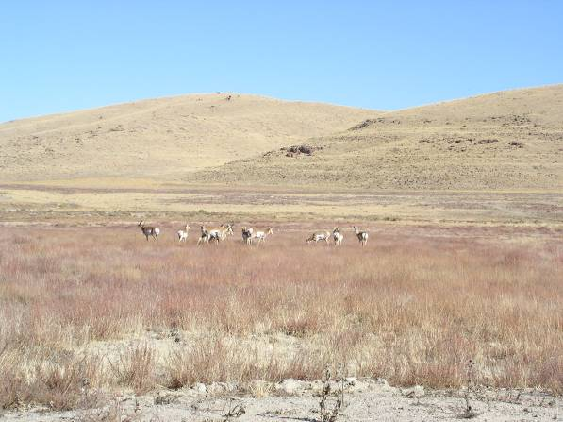
Antelope grazing on forage kochia in fall-winter.
Photo by Burke Davenport.

Greenstrip Plantings:
Forage kochia has been successfully used for greenstrip plantings in the Intermountain West for several reasons. Forage kochia is well adapted to the very dry areas of the region and establishes easily. Plants are competitive against annual weeds, thus decreasing the fine fuel load and fire interval. Forage kochia forms open stands, with individual plants having an open canopy. Forage kochia is fire tolerant and remains green through the fire season. (Pellant 1994). The evaluated fuel moisture content of species commonly used in greenstrip plantings following a wildfire including forage kochia was estimated at 40
percent as compared to crested wheatgrass (10 percent) and cheatgrass (1 percent). Forage kochia plants will burn with sufficient fuel but the plants quickly recover (Monsen and Kitchen 1999). Studies show that forage kochia reduces flame intensity and can suppress or even stop wildfires (Harrison et al 2002).

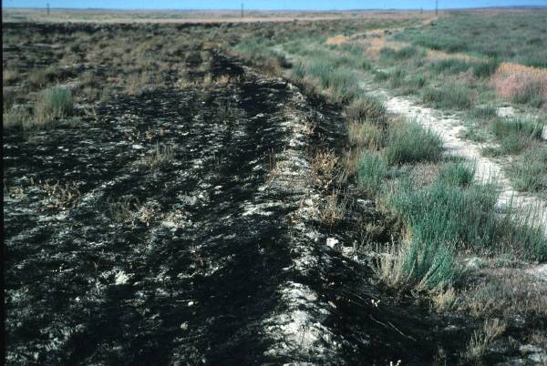
Forage kochia firebreak
Photo by Mike Pellant.

Status
Consult the PLANTS Web site and your State Department of Natural Resources for this plant’s current status (e.g. state noxious status).

Description
General:
Goosefoot Family (Chenopodiaceae). Forage kochia is an introduced, semi-evergreen, half-shrub. Plants are 0.3 to 1 m (1 to 3 ft) tall with a deep tap root and an extensive fibrous root system, and it may live up to 10 to15 years. Although it is commonly only medium-lived, it readily re-establishes from seed. Leaves are linear, 3 to 12 mm long (0.1 to 0.5 inches) and hairy. Flowers are clustered on a spicate to paniculate inflorescence in the upper stems. Seed stalks and upper stems turn red in late summer and fall, while the lower branches retain a green appearance year round. (Harrison et al 2000). Flowers bloom from July to September (McArthur and Monsen 2004).

Forage kochia should not be confused with its weedy relative, Kochia scoparia. Forage kochia differs in that it is a perennial shrub and not an annual herb.

Distribution:
This species has been successfully seeded in Arizona, Colorado, Idaho, Montana, Nevada, New Mexico, Oregon, Texas, Utah, Washington and Wyoming at elevations ranging from 490 to 2,200 meters (1,600 to 7,300 ft). For current distribution, consult the Plant Profile page for this species on the PLANTS Web site.

Habitat:
Forage kochia is well adapted to a broad range of growing conditions found in the Intermountain West. Plants are commonly found in shadscale-saltbush, (saline desert and desert shrub), sagebrush steppe and piñon-juniper communities where it has been planted as a greenstrip species or for rangeland rehabilitation.

Adaptation
Forage kochia is well suited to rangelands receiving 15 to 40 cm annual precipitation (6 to 16 inches), and is adapted to a wide range of soil textures including sands, gravels, clays, silts and loams. Plants do best in medium-textured soils. Forage kochia is highly saline and sodic tolerant. Plants perform well and will spread in high saline sites including slick spots (Harrison et al 2000). Stevens et al (1984) reported that forage yields were not reduced when forage kochia plants were grown in soil salinity of 17.0 mmho/cm².

Establishment
Best establishment comes from dormant fall or winter seedings which allow the seed to germinate and begin growth very early in the spring. Seed should be broadcast, aerially seeded, or drilled onto the soil surface which have been lightly disturbed by harrowing or spread directly onto snow. Seed drilled and pressed into soil to depths more than 1/16 inches (1.5 mm) will rarely germinate or establish. Burning prior to seeding has positively affected establishment (Monaco et al 2003). Aerial seeding should be performed at altitudes from 50 to 70 meters (165 to 230 ft) with wind velocities less than 13 feet per second (Harrison et al 2000).

For wildlife plantings, forage kochia should be used as part of a seed mixture. Seeding rates range from 0.025 to 0.25 lb PLS per acre depending on conditions and objectives. Planting 0.025 lb PLS per acre as a seed mixture component provides approximately 400 plants per acre (Ogle et al 2006).

For greenstrip plantings, where forage kochia is planted as a monoculture with a drill and seed is pressed into soil, higher seeding rates (2.0 – 3.0 lb/acre or 18 to 27 seeds/ft²) are recommended to create a thick stand of kochia with smaller, lower-growing plants, which provide little fuel for wildfires and reduces annual weed production. Under greenstrip conditions, when seed is broadcast planted, seeding rates should be increased to 3.0- 4.0 lb/acre or 27 to 36 seeds/ft².

Forage kochia seed loses viability quickly, even when processed and stored under proper conditions. Always use current year’s seed that has received a recent germination test to ensure the best chances for establishment success.

Management
Forage kochia can be used as year-round forage under proper management. Spring grazing can be more detrimental to forage production than fall or winter grazing; however, it is rarely grazed during the spring when green grass is available. The earliest grazing occurs in late June to mid July when the grasses have gone dormant. Its “preference” increases throughout the summer and early fall. Plants grazed to less than two inches will show reduced growth the following year. In one study in Box Elder County, Utah, forage yields ranged from 500 to 700 lbs per acre (ZoBell et all 2004).

Pests and Potential Problems
Although forage kochia does not appear to be affected by insect pests, it may serve as a host for lygus bugs (Harrison et al 2000).

Environmental Concerns
There is concern that forage kochia could become invasive similar to the herbaceous kochia, K. scoparia, but this is mostly unwarranted. Studies indicate that plants will spread under favorable conditions into bare or disturbed sites where competition is limited. Forage kochia competes with and establishes readily into sites dominated by annual weeds, but it does not seem to reduce the density of stands of established perennials. Spread of forage kochia has been found to be related to the following: soil disturbance, predominant wind direction, lack of vegetative competition and open space near established plants (Harrison, 2000).

One source of concern is its ability to invade slick spot communities in southern Idaho. These sites are habitat for the state-listed sensitive species, slickspot peppergrass (Lepidium papilliferum) (Pellant 2004).

It has been shown that forage kochia is only distantly related to annual kochia and Grey Molly (Kochia americana), and will not hybridize with either species (Lee et al 2005).

Weediness
This plant may become weedy or invasive in some regions or habitats and may displace desirable vegetation if not properly managed. Consult your local NRCS Field Office, Cooperative Extension Service office, state natural resource, or state agriculture department regarding its status and use. Weed information is also available from the PLANTS Web site at plants.usda.gov. Consult the Related Web Sites on the Plant Profile for this species for further information.

Control
Forage kochia can be effectively controlled with
2,4-D (Harrison et al 2000). Contact your local agricultural extension specialist or county weed specialist to determine the best control methods in your area and how to use it safely. Always read and follow label and safety instructions for each chemical control method. Trade names and control measures appear in this document only to provide specific information. USDA NRCS does not guarantee or warranty the products and control methods named, and other products may be equally effective.

Seeds and Plant Production
Seed production fields should be planted at a rate of 1.5 lb PLS per acre or planted with transplants with 12 inch in-row plant spacing and three feet between-row spacing (Harrison et al 2000; Cornforth et al 2001). Seed production fields produce between 400 and 600 pounds per acre of clean seed (Cornforth et al 2001). Stevens et al 1984 reported production as high as 1500 pounds per acre during one production year, however seed production rates this high should not be expected under normal circumstances.

Seed requires hard fall frost before it will mature. Seed fields in areas with a tendency to early to mid fall snowfall have resulted in complete seed production failure because the snow caused seed to drop before seed harvest could occur. Seed production begins to decline after plants are approximately 5 to 6 years old.

There are an estimated 395,000 PLS per pound. (Koch & Asay 2001; Harrison et al 2000). Seed needs to be dried to less than 7 percent moisture and stored in cool, dry conditions, 36 to 50º F (2.2 to 10º C).

Cultivars, Improved, and Selected Materials (and area of origin)
‘Immigrant’ forage kochia was released in 1984 by the USDA Forest Service, USDA Natural Resources Conservation Service, Utah Division of Wildlife Resources and the Idaho, Nevada, Oregon and Utah Agriculture Experiment Stations. The original collection was from the Stravopol Botanical Gardens, USSR, in May 1966. Immigrant was released for use as forage and soil erosion control on rangelands in the Intermountain West (Stevens et al 1984). Breeder and Foundation seed is maintained by Utah Crop Improvement Association.

Use of ‘Immigrant’ forage kochia for winter grazing is limited due to the plant’s fairly low stature. Currently numerous accessions collected by USDA Agricultural Research Service (ARS) are being evaluated by the ARS and Utah State University to identify ecotypes of taller plants with forage extending above snow levels (Harrison et al 2000).

Contact your local Natural Resources Conservation Service office for more information. Look in the phone book under, “United States Government”. The Natural Resources Conservation Service will be listed under the subheading “Department of Agriculture.”

References
Cornforth, B., L. St. John and D.G. Ogle. 2001. Technical Note 14: Seed production standards for conservation plants in the Intermountain West. USDA-NRCS, Boise, ID. 13 p.

Harrison, R.D., N.J. Chatterton, B.L.Waldron, B.W. Davenport, A.J. Palazzo, W.H. Horton and K.H. Asay. 2000. Forage kochia-its compatibility and potential aggressiveness on intermountain rangelands. Utah Agricultural Experiment Station. Utah State University. Research Report 162. 66 p.

Harrison, R.D., B.L. Waldron, K.B. Jensen, R. Page, T.A. Monaco, W.H. Horton and A.J. Palazzo. 2002. Forage kochia helps fight range fires. Rangelands 24(5): 3-7.

Koch, D.W. and W. Asay. 2001. Forage kochia-a forage with fall and winter grazing potential. University of Wyoming Cooperative Extension Service. B-1122.5. 4p.

Lee, B.S., M.Y. Kim, R.R.-C. Wang, and B.L. Waldron. 2005. Relationships among 3 Kochia species based on PCR-generated molecular sequences and molecular cytogenetics. Genome. 48:1104-1115.)

McArthur, E.D. and S.B. Monsen. 2004. Chenopod Shrubs. In: S.B. Monsen, R. Stevens, and N.L. Shaw [compilers]. Restoring western ranges and wildlands. Fort Collins, CO: USDA Forest Service, Rocky Mountain Research Station. General Technical Report RMRS-GTR-136-vol-2. p. 467-491.

Monaco, T.A. 2004. Photosynthesis and water relations of the salt desert shrub Kochia prostrata. p. 19-21. In: Proceedings-Forage Kochia Workshop and Tour. 9-10 Nov 2004. Logan, UT. URL: http://www.advs.usu.edu/people/dzobell/Forage%20Kochia%20Proceedings/ (accessed 10 Feb 2006). Utah State University.

Monaco, T.A. 2006. Personal communication. 10 February 2006.

Monaco, T.A., B.L. Waldron, R.L. Newhall and W.H. Horton. 2003. Re-establishing perennial vegetation in cheatgrass monocultures-planting prostrate kochia in ‘greenstrips’ may be a viable option to decrease cheatgrass dominance. Rangelands 25(2): 26.29.

Monsen, S.B. 1994. Selection of plants for fire suppression on semi-arid sites. p. 363-373. In: S.B. Monsen and S.G. Kitchen (comps.). Proceedings-Symposium on ecology and management of annual rangelands. 18-21 May 1992. Boise, ID. Gen. Tech. Rep. INT-GTR-313. USDA Forest Service, Intermountain Research Station, Ogden, UT. 351 p.

Monsen, S.B. and S.G. Kitchen. 1999. Variation in burning tolerance among forage kochia accessions. p. 92-100. In: Cooperative research studies 1989-1998. USDA Forest Service, Rocky Mountain Research Station, Shrub Sciences Lab., Provo, UT. Report submitted to U.S. Dept. of Interior, Intermountain Greenstripping Program. Boise, ID. 285 p.

Ogle, D. G., L. St. John, M. Stannard and L. Holzworth. 2006. Technical Note 24: Grass, grass-like, forb, legume, and woody species for the intermountain west. USDA-NRCS, Boise, ID. 42p.

Pellant, M. 1994. History and applications of the intermountain greenstripping program. p. 63-68. In: S.B. Monsen and S.G. Kitchen (comps.). Proceedings-Symposium on ecology and management of annual rangelands. 18-21 May 1992. Boise, ID. Gen. Tech. Rep. INT-GTR-313. USDA Forest Service, Intermountain Research Station, Ogden, UT. 351 p.

Pellant, M. 2004. Greenstripping with forage kochia. p. 52-56. In: Proceedings-Forage Kochia Workshop and Tour. 9-10 Nov 2004. Logan, UT. URL: http://www.advs.usu.edu/people/dzobell/Forage%20Kochia%20Proceedings/ (accessed 10 Feb 2006). Utah State University.

Pyankov, V.I., E.G. Artyusheva, G.E. Edwards, C.C. Black Jr. and P.S. Soltis. 2001. Phylogenetic analysis of tribe Salsoleae (Chenopodiaceae) based on ribosomal ITS sequences: Implications for the evolution of photosynthesis types. American Journal of Botany 88:1189-1198.

Stevens. R., K.R. Jorgensen, E.D. McArthur, S.B. Monsen, J.N. Davis and J.R. George. 1984. Naming and release of Immigrant forage kochia for commercial production and marketing of seed. USDA, Forest Service, Intermountain Forest and Range Experiment Station, USDA-NRCS and Utah State Division of Wildlife Resources. Wildlife Restoration Project, W-82-R.

Young, J.A. and C.D. Clements. 2004. The place of forage kochia in rangeland environments. p. 14-15. In: Proceedings-Forage Kochia Workshop and Tour. 9-10 Nov 2004. Logan, UT. URL: http://www.advs.usu.edu/people/dzobell/Forage%20Kochia%20Proceedings/ (accessed 10 Feb 2006). Utah State University.

ZoBell, D.R., B.L. Waldron, K.C. Olson, R.D. Harrison, K. Jensen and H. Jensen. 2004. The use of forage kochia by beef cows for fall/winter grazing p. 30-34. In: Proceedings-Forage Kochia Workshop and Tour. 9-10 Nov 2004. Logan, UT. URL: http://www.advs.usu.edu/people/dzobell/Forage%20Kochia%20Proceedings/ (accessed 10 Feb 2006). Utah State University.

Prepared By
Derek J. Tilley, Range Conservationist (Plants) USDA NRCS Plant Materials Center, Aberdeen, ID

Dan Ogle, Plant Materials Specialist

USDA NRCS Idaho State Office, Boise, ID

Loren St. John, Manager

USDA NRCS Plant Materials Center, Aberdeen, ID

Blair L. Waldron, Research Geneticist
USDA ARS Forage and Range Research Lab,
Logan, UT

R. Dean Harrison, (retired) USDA NRCS and ARS Forage and Range Research Lab, Logan, UT

Species Coordinator

Dan Ogle, Plant Materials Specialist

USDA NRCS Idaho State Office, Boise, Idaho

Edited: 18may06djt; 20feb06lsj; 18may06dgo; 07mar06blw; 13mar06rdh; 19may06jsp

For more information about this and other plants, please contact your local NRCS field office or Conservation District, and visit the PLANTS Web site<http://plants.usda.gov> or the Plant Materials Program Web site <http://Plant-Materials.nrcs.usda.gov>

The U.S. Department of Agriculture (USDA) prohibits discrimination in all its programs and activities on the basis of race, color, national origin, sex, religion, age, disability, political beliefs, sexual orientation, and marital or family status. (Not all prohibited bases apply to all programs.) Persons with disabilities who require alternative means for communication of program information (Braille, large print, audiotape, etc.) should contact USDA's TARGET Center at 202-720-2600 (voice and TDD).
To file a complaint of discrimination write USDA, Director, Office of Civil Rights, Room 326-W, Whitten Building, 14th and Independence Avenue, SW, Washington, DC 20250-9410 or call 202-720-5964 (voice or TDD). USDA is an equal opportunity provider and employer.
Read about Civil Rights at the Natural Resources Convervation Service.

