hairy vetch
Vicia villosa Roth
Plant Symbol = VIVI

Contributed by: USDA NRCS Plant Materials Program

Alternate Names
winter vetch

Uses
Erosion control: Hairy vetch’s capacity to provide a heavy mulch aids in soil and water conservation.

Crop: Hairy vetch is grown as a cover preceding such crops as safflower, corn, tobacco, cotton, rice, tomatoes, and other vegetables. Hairy vetch is valuable for use in no-till corn rotations, especially in regions that are less favorable for clover and pea cultivation. It may also be used in orchards and vineyards. Hairy vetch is noted for its ability to fix large quantities of nitrogen.

Livestock: It is grown for hay, pasture, silage, seed, or as interim cover on disturbed soil.

Status
Please consult the PLANTS Web site and your State Department of Natural Resources for this plant’s current status (e.g. threatened or endangered species, state noxious status, and wetland indicator values).

Weediness
This plant may become weedy or invasive in some regions or habitats and may displace desirable vegetation if not properly managed. Please consult with your local NRCS Field Office, Cooperative Extension Service office, or state natural resource or agriculture department regarding its status and use. Weed information is also available from the PLANTS Web site at plants.usda.gov.

Description
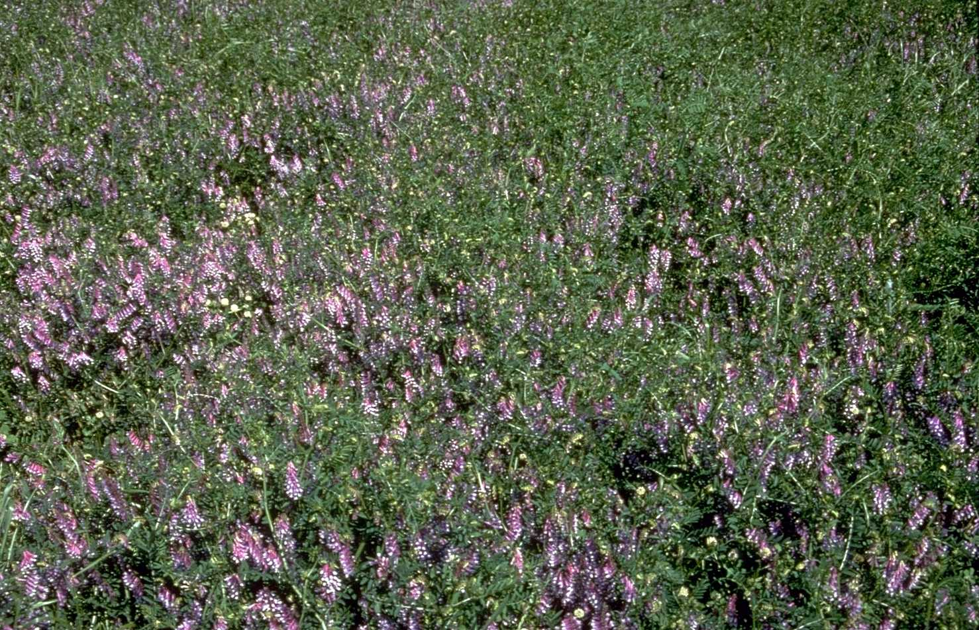
Vicia villosa Roth, hairy vetch, is a vining, winter-active legume. It may be annual or biennial. It has a shallow root system. Stems may grow 2 to 5 feet long. Leaves bearing several leaflets grow perpendicular to the stem, and may terminate in tendrils. Stems and leaves of hairy vetch are pubescent (covered with a soft woolly fuzz) and tufts are present at the tips of stems. Flowers are purple. Seeds are round and black, and develop inside elongated and flattened pods.
USDA NRCS National Plant Materials Center
Beltsville, MD

Adaptation and Distribution
Hairy vetch is a hardy type of vetch suited to wetter soil and colder winters than other winter-active legumes. Hairy vetch develops best under cool temperature conditions, on fertile loam soils; it is also productive on sandy or clay soils. It has been reported to grow well on light soils that are too sandy for crimson clover. It is only moderately sensitive to soil acidity.

Hairy vetch is distributed throughout the entire United States. For a current distribution map, please consult the Plant Profile page for this species on the PLANTS Website.

Establishment
Hairy vetch is planted in the fall wherever it is grown. It is normally seeded at 20 to 40 pounds per acre. Due to the vining, climbing habit of the plant, it is often sown in combination with rye so the rye may provide some support. In a mixture, 50 pounds of rye and 15 to 20 pounds of vetch per acre should be used.

Management
Hairy vetch performs well in rotations with conventional and no-till planted row crops. In these systems, the fall planted legume is either mechanically or chemically killed 2 to 3 weeks prior to planting or it is sprayed at planting. A heavy disking may be advantageous prior to turning or it may be sufficient as a primary operation depending on the top growth of the vetch. The row-crop is then planted conventionally or no-tilled into the cover crop. The legume decomposes, providing nitrogen for the following crop. When grown for hay, vetch is generally cut when the first pods are set. It may be cut using a mower with a swather attachment. If grown as a seed crop, hairy vetch is harvested when the lower pods are ripe to avoid shattering. If carefully managed, hairy vetch may be grown with Bermudagrass. Vetch volunteers profusely when allowed to disseminate seed.

Pests and Potential Problems
There are no serious insect or disease pests of mature hairy vetch; however, the seed is highly susceptible to vetch bruchid (Bruchus brachialis) injury. This insect pest is largely responsible for poor natural reseeding of hairy vetch in pastures.

Control
Please contact your local agricultural extension specialist or county weed specialist to learn what works best in your area and how to use it safely. Always read label and safety instructions for each control method. Trade names and control measures appear in this document only to provide specific information. USDA, NRCS does not guarantee or warranty the products and control methods named, and other products may be equally effective.

Cultivars, Improved, and Selected Materials (and area of origin)
‘Americus’ (Turkey), ‘AU Early Cover’ (Alabama naturalized stand), and ‘Madison’. Seeds are available from most commercial seed sources.

Prepared By & Species Coordinator:
USDA NRCS Plant Materials Program

Edited: 05Feb2002 JLK; 060818 jsp

For more information about this and other plants, please contact your local NRCS field office or Conservation District, and visit the PLANTS Web site<http://plants.usda.gov> or the Plant Materials Program Web site <http://Plant-Materials.nrcs.usda.gov>

The U.S. Department of Agriculture (USDA) prohibits discrimination in all its programs and activities on the basis of race, color, national origin, sex, religion, age, disability, political beliefs, sexual orientation, and marital or family status. (Not all prohibited bases apply to all programs.) Persons with disabilities who require alternative means for communication of program information (Braille, large print, audiotape, etc.) should contact USDA's TARGET Center at 202-720-2600 (voice and TDD).
To file a complaint of discrimination write USDA, Director, Office of Civil Rights, Room 326-W, Whitten Building, 14th and Independence Avenue, SW, Washington, DC 20250-9410 or call 202-720-5964 (voice or TDD). USDA is an equal opportunity provider and employer.
Read about Civil Rights at the Natural Resources Convervation Service.

