Acquisition Process Scenario: 4. Unsolicited Proposal
Roles: PO, BO, FO, OSDBU, AT, SSA, Offerors, PO/BO |  |  |  |  | Systems: C = Current, F= Future, P = Partial
PO | Program Office (Role performs: program management, sustainment/logistics, data, facility support, programmatics, end user) |  |  |  | BO |  | Buying Office (Role performs: contracting/purchasing functions)
FO | Finance Office (Role performs: accounting functions, budget functions) |  |  |  | OSDBU |  | Small Business
AT | Acquisition Team (Role performs: Defined by FAR 1.102-3) |  |  |  | SSA |  | Source Selection Authority- Determine Awardee
Offerors | Quoters, Bidders, or Offerors |  | V | Vendor | PO/BO |  | Either or PO/ BO
# | Activity | Description |  |  | Role | Systems |  |  |  | Information Exchanges | Control / Business Rules
 |  |  |  |  |  | C |  | Name | F | Information Exchanges | Control / Business Rules
X | Vendor Defined Requirements | Vendor Submits Unsolicited Proposal to Activity POC |  |  | V
X.1 | Vendor Submits Proposal to POC | Vendor provides description of unique idea plus pricing information. |  |  | V |  |  |  |  |  | FAR 6.302-1(a)(2)(i); 6.3, 6.303-2(b), 5.2
 | POC Receives Proposal | POC receives and secures proposal. |  |  | PO |  |  |  |  |  | FAR 15.606(a), 15.606-1
X.2 | POC Forwards Proposal to Reviewer | Reviewer evaluates proposal, determines if it meets a valid need, and determines if the need has been anticipated. |  |  | PO |  |  |  |  |  | FAR 15.606-2
X.3 | Reviewer Forwards Recommended Disposition to POC | Reviewer recommends if the proposal should be accepted. |  |  | PO |  |  |  |  |  | FAR 15.607
X.4 | POC Dispositions the Proposal |  |  |  | PO
X.4.1 | Reject Proposal | If the proposal is rejected for technical reasons or because it duplicates an existing requirement, return the proposal to the vendor. |  |  | PO |  |  |  |  |  | FAR 15.607(a)
X.4.2 | Approve Proposal for Sole Source Negotiation | Forward to the BO for processing with a sole source justification, adequate funding, and a complete synopsis, if required. |  |  | PO  BO |  |  |  |  |  | FAR 15.607(b), 6.302-1(a)(2)(i); 6.3, 6.303-2(b), 5.2
1. | Define Requirements
1.1 | Determine Need | Tailor requirement, if necessary. |  |  | PO |  |  |  |  |  | FAR 7.105(a), 7.107, 10.110(a), 11.002, 11.401,
1.1.1 | Estimate and Secure Funds | Research activities prepare and submit funding estimates (“wedge” in budget) to plan for award of acceptable proposals under submitted topics. |  |  | PO |  |  |  |  |  | Agency Policy
1.2 | Validate Funding | Validate funding line and budget restrictions. |  |  | FO
1.2.2 | Validate Funding | Validate funding line. |  |  | BO |  |  |  |  |  | OMB Circular A-11; DoD FMR Vol 2A, Chapter 2A Sec 0102;  FAR 32.702
1.4 | Purchase Request | Submit to Buying Office. Should include Statement of work/ specifications, other requirements, evaluation criteria and J&A. |  |  | PO |  |  |  |  |  | DoDS FMR Vol 3, Chapter 15, Sec 150202; FAR 32.7
1.4.1 | Communicate Purchase Request to BO | Transfer of purchase request data from PO thru FO to BO. |  |  |  |  |  |  |  |  | Agency-specific
1.5 | Assigned Buyer / Contract Specialist | Buying Office analyzes requirement; assigns to buyer / contract specialist. |  |  | BO |  |  |  |  |  | Agency policy;  FAR 7.102(b) OMB Cir A-11
3.0 | Issue Model Contract | Issue model contract to selected vendor.
3.3 | Pre-Solicitation Process | Pre-Solicitation Process.
3.3.2 | Build Solicitation | Develops and coordinates review of model contract. This includes technical requirements provided and reviewed by the PO. The Legal Office reviews for legal sufficiency. |  |  | BO | X |  | DOL –Wage Determination (Davis-Bacon) | X | - Extract wage determination (post in the solicitation for construction) | FAR 15.203-204
 |  |  |  |  |  | X |  | NTIS / SCA Wage Determination | X | - Obtain service contract wage determinations | FAR 15.203-204
3.4 | Solicitation Process
3.4.2 | Issue Model Contract | Issue model contract directly to selected vendor |  |  | BO | X |  | TEDS | X | - Upload technical drawings | FAR 15.205
4. | Evaluate Responses | Evaluate Responses activities based on RFP
4.8 | Exchanges with Offerors | Negotiate contract terms and conditions with selected vendor |  |  | BO | X |  | DOL –Wage Determination (Davis-Bacon) | X | - Extract wage determination (post in the solicitation for construction)
 |  |  |  |  |  | X |  | NTIS / SCA Wage Determination | X | - Obtain service contract wage determinations
4.8.1 | Receipt of Proposal Revisions | Receive proposal revisions including final offer as a result of ongoing exchange with selected vendor. |  |  | BO
4.8.2 | Evaluation of Proposal Revisions
4.8.2.1 | Evaluate Revised Business Proposal | Transmit revised documents to evaluators; Evaluate price/costs, and terms and conditions. |  |  | BO |  |  |  |  |  | FAR 13.305(a)(1), 15.3
4.8.2.2 | Evaluate Revised Technical Proposal | Evaluate revised technical proposal. |  |  | PO |  |  |  |  |  | FAR 13.305(a)(1), 15.3,
4.8.4 | Receipt of Final Proposal Revisions | Agree on final terms and conditions with vendor. Verify that the program office still feels the contract should be awarded. |  |  | BO/PO
4.9 | Pre-Award Surveys and Approvals | Verify eligibility of prospective awardee thru EEO clearance (as applicable), DCAA & DCMA. |  |  | BO | X |  | DOL pre-award Website, | x | - Check vendor EEO | FAR 9.1; 9.4; 22.805(a)
 |  |  |  |  |  | X |  | EPLS | X | - Obtain EPLS status | FAR 9.1; 9.4; 22.805(a)
 |  |  |  |  |  |  |  | BPN | X | - Obtain EPLS status | FAR 9.1; 9.4; 22.805(a)
 |  |  |  |  |  |  |  | D&B | X | - Check financials | FAR 9.1; 9.4; 22.805(a)
5.0 | Issue Award
5.1 | Verify Funds Availability | Ensure sufficient funds are available for proposed award value. |  |  | BO |  |  |  |  |  | FAR 32.702
5.2 | Prepare Award | Assemble and prepare award documentation. Execute procurement instrument. |  |  | BO |  |  |  |  |  | FAR 15.204, 15.504
5.3 | Prepare Management Award Information | Develop and submit federal procurement data regarding specific current award. |  |  | BO | X |  | FPDS | X | - Report Information | FAR 4.6
 |  |  |  |  |  |  |  | GWAC Index | X | - Post award data | FAR 4.6
5.4 | Issue Award Notices | Post required notices:  - Pre-award notices under set- asides this is an intent to award to vendor (only for vendors in competitive range)  - Congress (as applicable),  - Post award notice (FBO);  - DOL (as applicable) |  |  | BO | X |  | FBO | X | - Post award notice | FAR 5.303, 15.503,  DFARS 204.6; agency regs for reports to Congress
 |  |  |  |  |  | X |  | ECats | X | - Post vendor data to catalogs
 |  |  |  |  |  |  |  | DOL | X | - Inform award of service based contract performance
 |  |  |  |  |  | X |  | Sub-net |  | - Post subcontracting opportunities
 |  |  |  |  |  | X |  | OSDBU |  | - Post subcontracting opportunities
 |  |  |  |  |  | X |  | FACNET |  | - EDI Transaction
5.5 | Distribute Award Document | Send document / notification to:  - Finance office  - Program Office  - OSDBU  - Contractor  - Contract Administration  - DCAA  - Security |  |  | BO | P |  | EDA | X | - Post all award documents to provide for internal notifications | FAR 4.201
 |  |  |  |  |  |  |  | CADO | X | - Post contract award documents to provide for transparency and visibility | FAR 4.201
5.7 | Address Post-Award Protest | Resolve post award protests, thru Alternative Dispute resolution (ADR) or court. Rule 4 file is developed. This activity is coordinated with Legal Office. |  |  | BO | X |  | GAO website |  | - Conduct legal research | FAR 12.102(b), 13.106-3 (c), 14.408-8, 15.507, 33.1
 |  |  |  |  |  | X |  | Court of Claims Web site |  | - Conduct legal research | FAR 12.102(b), 13.106-3 (c), 14.408-8, 15.507, 33.1
 |  |  |  |  |  | X |  | Lexus/Nexus & Others |  | - Conduct legal research | FAR 12.102(b), 13.106-3 (c), 14.408-8, 15.507, 33.1
6. | Monitor Performance/Contract Administration
6.1 | Conduct Post-Award Orientation | Conduct post award conferences exchanging information to verify baseline program performance, and to create consistent expectations between the contractor and government team. Activity may be worked in conjunction with PO and Administrative Contracting Officer (ACO). |  |  | BO |  |  |  |  |  | FAR 42.5
6.3 | Monitor & Document Performance | Communication and documentation between Government and Contractor regarding quality and timeliness. Accomplished by COTR under authority of Contracting Officer (PCO or ACO). |  |  | PO | x |  | DOD CPARS | x | - Post performance information | FAR 42, 46.4
 |  |  |  |  |  | X |  | NIH CPS | x | - Post performance information | FAR 42, 46.4
 |  |  |  |  |  | X |  | NASA PPDBS | x | - Post performance information | FAR 42, 46.4
 |  |  |  |  |  | X |  | Army PPMIS |  | - Post performance information | FAR 42, 46.4
 |  |  |  |  |  | X |  | FDIC |  | - Post performance information | FAR 42, 46.4
 |  |  |  |  |  | X |  | Education |  | - Post performance information | FAR 42, 46.4
6.3.1 | Inspect Goods or Services | Preparation and completion of receiving documentation (e.g. DD250). |  |  | PO |  |  | PPIRS | x | - Collecting passive past performance information as it relates to timeliness quality, and delivery | FAR 46.5
6.3.2 | Accept Goods or Services | For each contract line item number. |  |  | BO/PO |  |  |  |  |  | FAR 46.5
6.3.3 | Manage Property | Adjust agency property (includes government furnished items or equipment or contractor purchased items or equipment). |  |  | PO | X |  | FEDS or DRMO |  | - Identify disposal of excess contractor acquired property
6.4 | Process Contract Changes | Issue modifications or change orders. Contracting Officer working in coordination with PO, ACO, FO, & Legal. |  |  | BO |  |  |  |  |  | FAR 43
6.4.1 | Verify Funding | Ensure sufficient funds are available for proposed award value. |  |  | BO |  |  |  |  |  | FAR 32.702
6.4.2 | Prepare Management Award Information | Develop and submit federal procurement data regarding specific current award. |  |  | BO | X |  | FPDS-NG | X | - Report Management Information | FAR 4.6
 |  |  |  |  |  |  |  | GWAC Index | X | - Post award Management data on GWAC index as applicable | FAR 4.6
6.4.3 | Issue Novation Agreements | Administrative modification to the contract due to changing contractor name, banking information, and addresses. ACO / PCO must approve name change. |  |  | BO |  |  | BPN | X | - Notification of name change | FAR 42.12
6.5 | Assignment of Claims | Re-designate remittance entity. |  |  | BO |  |  | BPN | X | - Change payee (EFT) | FAR 32.8
7. | Approve Payment
7.1 | Receive Invoice | Must meet requirements set forth in contract. Role is dependent on how agency writes contract. |  |  | BO, FO, PO |  |  |  |  |  | FAR 52.232-25
7.2 | Submit Invoice to Finance Office | Communicate approved invoice to Finance Office. |  |  | BO, PO |  |  |  |  |  | FAR 32.9
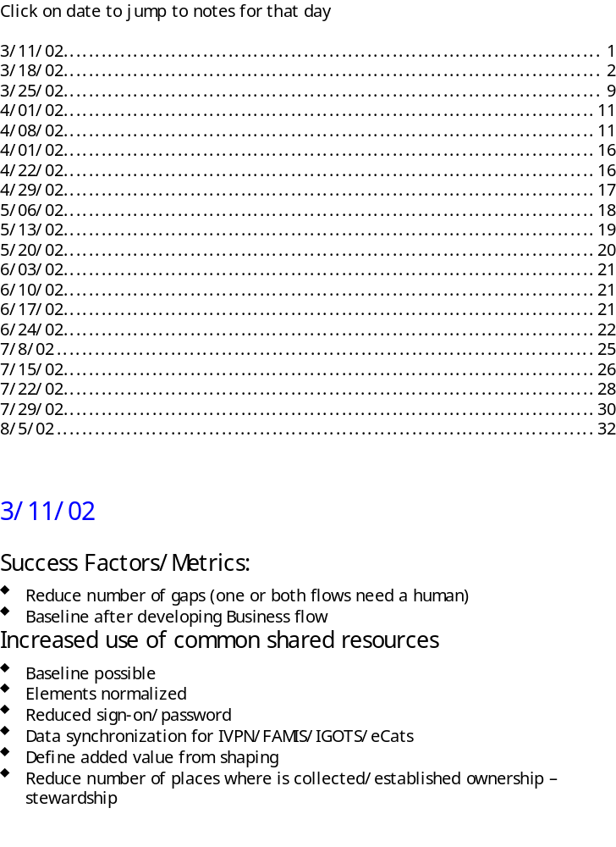7.3 | Match invoice to receiving report and obligating document | Ensure goods and services have been performed satisfactory against contract requirements. |  |  | FO |  |  |  |  |  | FAR 46.502  FAR 32.702
8. | Pay Vendor
8.1 | Receive Approved Invoice | Finance Office receives an approved invoice thru Buying Office. |  |  | FO |  |  |  |  |  | DoD FMR Vol 10, Chapter 9, Sec 0903
8.2 | Ensure Availability of Funds | Verify accounting records (matching process). |  |  | FO |  |  |  |  |  | FAR 32.702
8.3 | Verify EFT Information | Finance Office originally obtained EFT information when they received the obligating document. This information must be verified before payment. |  |  | FO | P |  | BPN/CCR | X | - Obtain EFT data from BPN | FAR 32.11
8.4 | Process Payment | Produce payment requests and create an electronic voucher that is transmitted to Treasury for disbursement. |  |  | FO |  |  |  |  |  | FAR 32.9
8.4.1 | Verify Off-sets | Verify if payment should be reduced due to amounts owed to government by contractor. |  |  | Treasury, DFAS | X |  | TOP | X | - Verify Payment e.g. TIN | Debt Collection Improvement Act PL 104-134
8.4.2 | Transfer Funds | Pay Vendor via check or EFT. |  |  | Federal Reserve, DFAS |  |  |  | X
9. | Close Out
9.1 | Certify All Work has been Completed | Check that all requirements under contract have been satisfactorily met and that there are no outstanding claims or judgments. |  |  | PO |  |  |  |  |  | FAR 4.804-5(a)
9.2 | Settle Any Claims | Negotiate outstanding claims and obtain release of claims. |  |  | BO |  |  |  |  |  | FAR 4.804-5(a)(14)
9.3 | Issue Final Past Performance Evaluation | Produce final performance evaluation identifying quality and timeliness throughout the history of the contract. |  |  | PO | X |  | DOD CPARS | X | - Update performance data for close-out | FAR 42.15
 |  |  |  |  |  | x |  | NIH CPS | x | - Update performance data for close-out | FAR 42.15
 |  |  |  |  |  | x |  | NASA PPDBS | x | - Update performance data for close-out | FAR 42.15
9.4 | Pay Final Invoice | See Pay vendor 8.1-8.42 |  |  |  |  |  |  |  |  | FAR 4.804-5(b), 52.222-7,  52.52.222-41(k)
9.5 | Maintain Archival Contract Files | Maintain official contract records in accordance agency procedures and NARA requirements. |  |  | BO |  |  | FPDS-NG | X | - Report close-out information (12c FPDS-NG requirement reason for modification “closed-out”) | FAR 4.805
 |  |  |  |  |  |  |  |  | X | - Record Mgt per NARA | FAR 4.805

